ATLAS — Pakistan Border Satellite Surveillance Report
Date: 2026-05-05 | Generated: 2026-05-06 08:52:59

Executive Summary
Total Border Crossings | 41
Unique Satellites | 20
Indian Satellites Detected | 7 crossings (4 unique)
Indian Imagery Satellites | 7 crossings
Anomalies Detected | 1
Surveillance Region | 23.5°N–37.5°N, 60.5°E–77.5°E

🇮🇳 INDIAN SATELLITE ACTIVITY (7 crossings)
Indian Space Research Organisation (ISRO) satellites detected over Pakistan:

Satellite | Type | Crossings | Primary Purpose
CARTOSAT-2 | Earth Observation | 1 | High-resolution Earth imaging for cartography, urban planning, and military reconnaissance
CARTOSAT-3 | Earth Observation | 2 | High-resolution Earth imaging for cartography, urban planning, and military reconnaissance
RESOURCESAT-2 | Earth Observation | 2 | Natural resource monitoring, agriculture, forestry, and land use mapping
RESOURCESAT-2A | Earth Observation | 2 | Natural resource monitoring, agriculture, forestry, and land use mapping

📷 INDIAN IMAGERY SATELLITES - BORDER CROSSING DETAILS
Detailed entry/exit points for Indian reconnaissance and imaging satellites:

Visual Map - All Indian Satellite Paths:
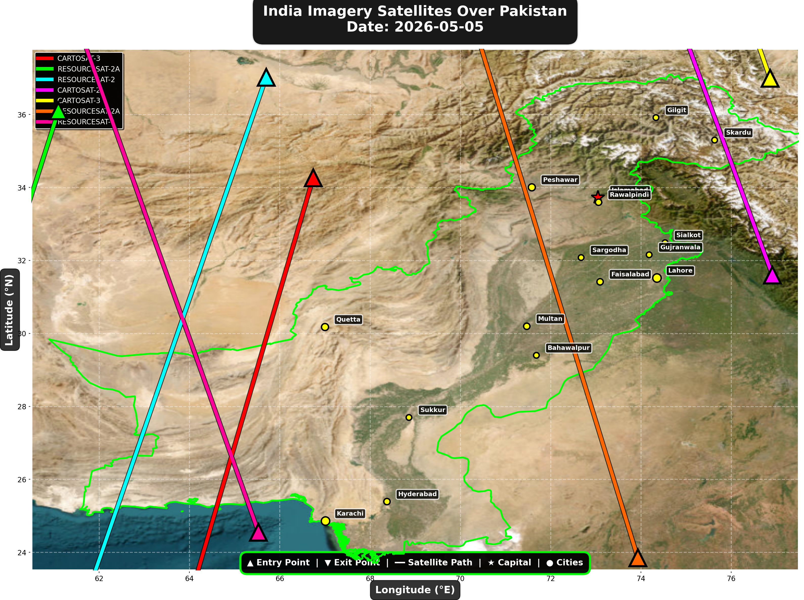

1. CARTOSAT-3 (Earth Observation)
Entry Time | 2026-05-05 05:25:00 UTC
Entry Point | 34.26°N, 66.74°E
Exit Time | 2026-05-05 05:28:00 UTC
Duration Over Pakistan | 3.0 minutes
Maximum Altitude | 514.3 km
Direction of Travel | N→S
Owner/Operator | ISRO
➤ Entered Pakistani airspace from the border region, traveling north to south. Satellite remained over Pakistan for 3.0 minutes at altitude 514.3 km.

2. RESOURCESAT-2A (Earth Observation)
Entry Time | 2026-05-05 05:49:00 UTC
Entry Point | 36.1°N, 61.1°E
Exit Time | 2026-05-05 05:50:00 UTC
Duration Over Pakistan | 1.0 minutes
Maximum Altitude | 515.3 km
Direction of Travel | N/A
Owner/Operator | ISRO
➤ Entered Pakistani airspace from the northwest (Afghanistan/China border region), traveling N/A. Satellite remained over Pakistan for 1.0 minutes at altitude 515.3 km.

3. RESOURCESAT-2 (Earth Observation)
Entry Time | 2026-05-05 06:06:00 UTC
Entry Point | 37.02°N, 65.7°E
Exit Time | 2026-05-05 06:10:00 UTC
Duration Over Pakistan | 4.0 minutes
Maximum Altitude | 832.2 km
Direction of Travel | N→S
Owner/Operator | ISRO
➤ Entered Pakistani airspace from the northwest (Afghanistan/China border region), traveling north to south. Satellite remained over Pakistan for 4.0 minutes at altitude 832.2 km.

4. CARTOSAT-2 (Earth Observation)
Entry Time | 2026-05-05 10:25:00 UTC
Entry Point | 31.6°N, 76.91°E
Exit Time | 2026-05-05 10:27:00 UTC
Duration Over Pakistan | 2.0 minutes
Maximum Altitude | 850.6 km
Direction of Travel | S→N
Owner/Operator | ISRO
➤ Entered Pakistani airspace from the east (Indian border - Punjab/Rajasthan sector), traveling south to north. Satellite remained over Pakistan for 2.0 minutes at altitude 850.6 km.

5. CARTOSAT-3 (Earth Observation)
Entry Time | 2026-05-05 16:00:00 UTC
Entry Point | 36.99°N, 76.86°E
Exit Time | 2026-05-05 16:01:00 UTC
Duration Over Pakistan | 1.0 minutes
Maximum Altitude | 513.8 km
Direction of Travel | N/A
Owner/Operator | ISRO
➤ Entered Pakistani airspace from the northeast (China/Kashmir border region), traveling N/A. Satellite remained over Pakistan for 1.0 minutes at altitude 513.8 km.

6. RESOURCESAT-2A (Earth Observation)
Entry Time | 2026-05-05 16:21:00 UTC
Entry Point | 23.85°N, 73.93°E
Exit Time | 2026-05-05 16:25:00 UTC
Duration Over Pakistan | 4.0 minutes
Maximum Altitude | 511.6 km
Direction of Travel | S→N
Owner/Operator | ISRO
➤ Entered Pakistani airspace from the south (Arabian Sea/Indian Ocean), traveling south to north. Satellite remained over Pakistan for 4.0 minutes at altitude 511.6 km.

7. RESOURCESAT-2 (Earth Observation)
Entry Time | 2026-05-05 17:22:00 UTC
Entry Point | 24.55°N, 65.53°E
Exit Time | 2026-05-05 17:26:00 UTC
Duration Over Pakistan | 4.0 minutes
Maximum Altitude | 818.8 km
Direction of Travel | S→N
Owner/Operator | ISRO
➤ Entered Pakistani airspace from the south (Arabian Sea/Indian Ocean), traveling south to north. Satellite remained over Pakistan for 4.0 minutes at altitude 818.8 km.

🇨🇳 CHINA IMAGERY SATELLITES
Visual Map - All China Satellite Paths:
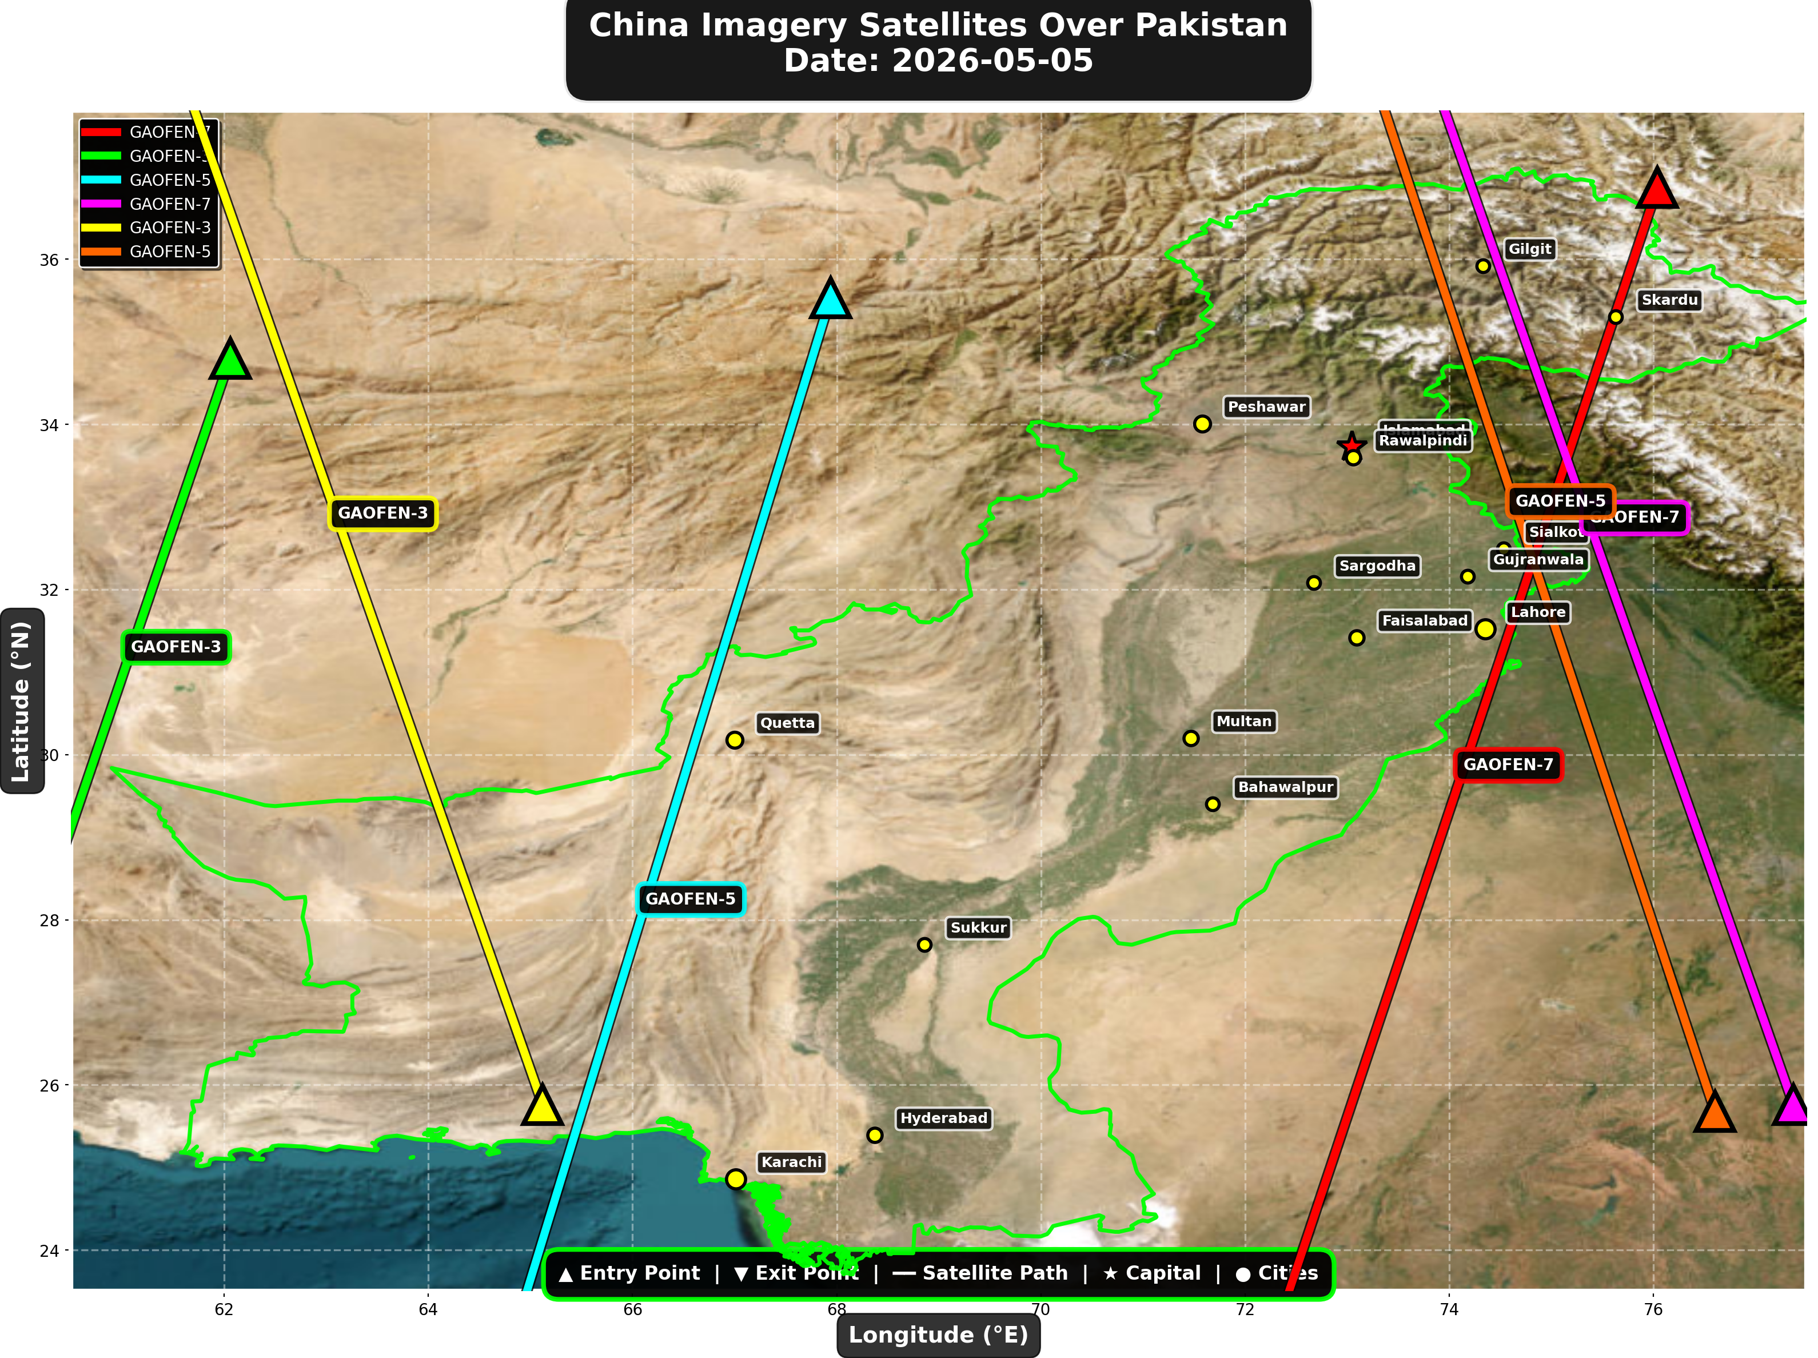

China reconnaissance and imaging satellites detected:
Satellite | Type | Entry Time | Duration (min) | Entry Point | Direction
GAOFEN-7 | Earth Observati | 01:40:00 | 4.0 | 36.87°N, 76.04°E | N→S
GAOFEN-3 | Radar/SAR | 02:21:00 | 2.0 | 34.8°N, 62.06°E | N→S
GAOFEN-5 | Earth Observati | 06:37:00 | 4.0 | 35.53°N, 67.94°E | N→S
GAOFEN-7 | Earth Observati | 12:51:00 | 4.0 | 25.76°N, 77.37°E | S→N
GAOFEN-3 | Radar/SAR | 13:27:00 | 4.0 | 25.76°N, 65.12°E | S→N
GAOFEN-5 | Earth Observati | 17:23:00 | 4.0 | 25.68°N, 76.6°E | S→N

🇺🇸 USA IMAGERY SATELLITES
Visual Map - All USA Satellite Paths:
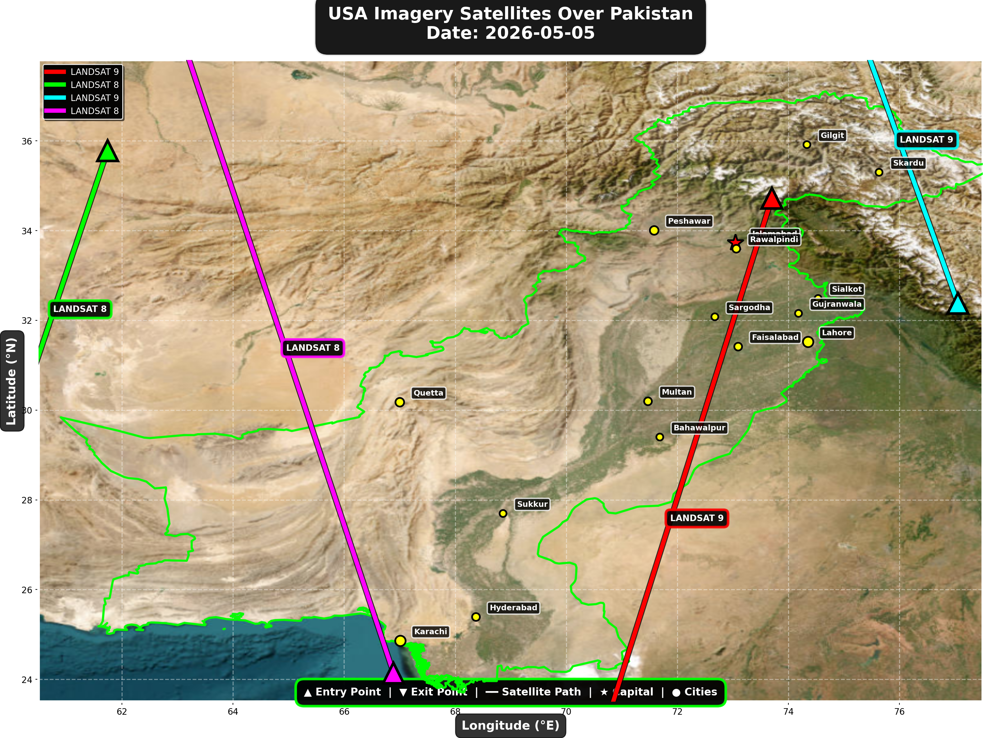

USA reconnaissance and imaging satellites detected:
Satellite | Type | Entry Time | Duration (min) | Entry Point | Direction
LANDSAT 9 | Earth Observati | 05:42:00 | 4.0 | 34.72°N, 73.7°E | N→S
LANDSAT 8 | Earth Observati | 06:31:00 | 2.0 | 35.78°N, 61.74°E | N→S
LANDSAT 9 | Earth Observati | 16:43:00 | 2.0 | 32.38°N, 77.05°E | S→N
LANDSAT 8 | Earth Observati | 17:30:00 | 4.0 | 24.14°N, 66.89°E | S→N

⚠ ANOMALIES DETECTED (1)
- [HIGH] LONG_DURATION: ISS
Owner: NASA/Roscosmos | NORAD 25544
Details: Duration 5.0min is 85% longer than avg 2.7min

Crossings by Country
Country | Crossings
China | 16
USA | 10
India | 7
Europe | 6
International | 2

Crossings by Satellite Type
Type | Crossings
Earth Observation | 15
Weather | 14
Space Station | 6
Reconnaissance | 4
Radar/SAR | 2

All Border Crossings (41 total)
# | Satellite | Owner | Country | Type | Entry Time | Duration (min) | Alt (km) | Direction
1 | ISS | NASA/Roscosmos | International | Space Station | 2026-05-05 01:32:00 UTC | 1.0 | 428.8 | N/A
2 | GAOFEN-7 | CNSA | China | Earth Observati | 2026-05-05 01:40:00 UTC | 4.0 | 792.4 | N→S
3 | GAOFEN-3 | CNSA | China | Radar/SAR | 2026-05-05 02:21:00 UTC | 2.0 | 758.1 | N→S
4 | TIANGONG | CNSA | China | Space Station | 2026-05-05 03:02:00 UTC | 1.0 | 387.7 | N/A
5 | YAOGAN-14 | PLA | China | Reconnaissance | 2026-05-05 03:48:00 UTC | 2.0 | 160.7 | N→S
6 | TIANGONG | CNSA | China | Space Station | 2026-05-05 04:37:00 UTC | 4.0 | 388.5 | W→E
7 | METOP-B | EUMETSAT | Europe | Weather | 2026-05-05 05:01:00 UTC | 4.0 | 826.0 | N→S
8 | CARTOSAT-3 | ISRO | India | Earth Observati | 2026-05-05 05:25:00 UTC | 3.0 | 514.3 | N→S
9 | METOP-C | EUMETSAT | Europe | Weather | 2026-05-05 05:32:00 UTC | 4.0 | 827.5 | N→S
10 | LANDSAT 9 | NASA/USGS | USA | Earth Observati | 2026-05-05 05:42:00 UTC | 4.0 | 709.0 | N→S
11 | RESOURCESAT-2A | ISRO | India | Earth Observati | 2026-05-05 05:49:00 UTC | 1.0 | 515.3 | N/A
12 | NOAA-18 | NOAA | USA | Weather | 2026-05-05 06:04:00 UTC | 4.0 | 844.4 | N→S
13 | RESOURCESAT-2 | ISRO | India | Earth Observati | 2026-05-05 06:06:00 UTC | 4.0 | 832.2 | N→S
14 | YAOGAN-26 | PLA | China | Reconnaissance | 2026-05-05 06:10:00 UTC | 4.0 | 838.8 | N→S
15 | NOAA-19 | NOAA | USA | Weather | 2026-05-05 06:16:00 UTC | 4.0 | 859.6 | N→S
16 | LANDSAT 8 | NASA/USGS | USA | Earth Observati | 2026-05-05 06:31:00 UTC | 2.0 | 708.9 | N→S
17 | GAOFEN-5 | CNSA | China | Earth Observati | 2026-05-05 06:37:00 UTC | 4.0 | 616.2 | N→S
18 | METOP-A | EUMETSAT | Europe | Weather | 2026-05-05 08:41:00 UTC | 4.0 | 589.2 | N→S
19 | NOAA-20 | NOAA | USA | Weather | 2026-05-05 08:42:00 UTC | 4.0 | 832.9 | S→N
20 | CARTOSAT-2 | ISRO | India | Earth Observati | 2026-05-05 10:25:00 UTC | 2.0 | 850.6 | S→N
21 | FENGYUN-3D | CMA | China | Weather | 2026-05-05 10:40:00 UTC | 4.0 | 833.8 | S→N
22 | GAOFEN-7 | CNSA | China | Earth Observati | 2026-05-05 12:51:00 UTC | 4.0 | 791.2 | S→N
23 | GAOFEN-3 | CNSA | China | Radar/SAR | 2026-05-05 13:27:00 UTC | 4.0 | 757.8 | S→N
24 | YAOGAN-14 | PLA | China | Reconnaissance | 2026-05-05 14:59:00 UTC | 3.0 | 163.5 | S→N
25 | CARTOSAT-3 | ISRO | India | Earth Observati | 2026-05-05 16:00:00 UTC | 1.0 | 513.8 | N/A
26 | METOP-B | EUMETSAT | Europe | Weather | 2026-05-05 16:17:00 UTC | 4.0 | 827.1 | S→N
27 | RESOURCESAT-2A | ISRO | India | Earth Observati | 2026-05-05 16:21:00 UTC | 4.0 | 511.6 | S→N
28 | ISS | NASA/Roscosmos | International | Space Station | 2026-05-05 16:33:00 UTC | 5.0 | 421.8 | W→E
29 | LANDSAT 9 | NASA/USGS | USA | Earth Observati | 2026-05-05 16:43:00 UTC | 2.0 | 709.3 | S→N
30 | METOP-C | EUMETSAT | Europe | Weather | 2026-05-05 16:48:00 UTC | 4.0 | 827.2 | S→N
31 | YAOGAN-26 | PLA | China | Reconnaissance | 2026-05-05 17:13:00 UTC | 4.0 | 928.2 | S→N
32 | RESOURCESAT-2 | ISRO | India | Earth Observati | 2026-05-05 17:22:00 UTC | 4.0 | 818.8 | S→N
33 | GAOFEN-5 | CNSA | China | Earth Observati | 2026-05-05 17:23:00 UTC | 4.0 | 617.9 | S→N
34 | NOAA-18 | NOAA | USA | Weather | 2026-05-05 17:23:00 UTC | 4.0 | 860.2 | S→N
35 | LANDSAT 8 | NASA/USGS | USA | Earth Observati | 2026-05-05 17:30:00 UTC | 4.0 | 709.4 | S→N
36 | NOAA-19 | NOAA | USA | Weather | 2026-05-05 17:36:00 UTC | 4.0 | 859.4 | S→N
37 | METOP-A | EUMETSAT | Europe | Weather | 2026-05-05 19:32:00 UTC | 4.0 | 771.9 | S→N
38 | NOAA-20 | NOAA | USA | Weather | 2026-05-05 21:05:00 UTC | 4.0 | 834.1 | N→S
39 | TIANGONG | CNSA | China | Space Station | 2026-05-05 21:08:00 UTC | 2.0 | 383.6 | W→E
40 | TIANGONG | CNSA | China | Space Station | 2026-05-05 22:44:00 UTC | 3.0 | 384.8 | W→E
41 | FENGYUN-3D | CMA | China | Weather | 2026-05-05 23:04:00 UTC | 4.0 | 832.2 | N→S

