ATLAS — Pakistan Border Satellite Surveillance Report
Date: 2026-05-06 | Generated: 2026-05-07 08:51:30

Executive Summary
Total Border Crossings | 37
Unique Satellites | 20
Indian Satellites Detected | 5 crossings (3 unique)
Indian Imagery Satellites | 5 crossings
Anomalies Detected | 2
Surveillance Region | 23.5°N–37.5°N, 60.5°E–77.5°E

🇮🇳 INDIAN SATELLITE ACTIVITY (5 crossings)
Indian Space Research Organisation (ISRO) satellites detected over Pakistan:

Satellite | Type | Crossings | Primary Purpose
CARTOSAT-3 | Earth Observation | 1 | High-resolution Earth imaging for cartography, urban planning, and military reconnaissance
RESOURCESAT-2 | Earth Observation | 2 | Natural resource monitoring, agriculture, forestry, and land use mapping
RESOURCESAT-2A | Earth Observation | 2 | Natural resource monitoring, agriculture, forestry, and land use mapping

📷 INDIAN IMAGERY SATELLITES - BORDER CROSSING DETAILS
Detailed entry/exit points for Indian reconnaissance and imaging satellites:

Visual Map - All Indian Satellite Paths:
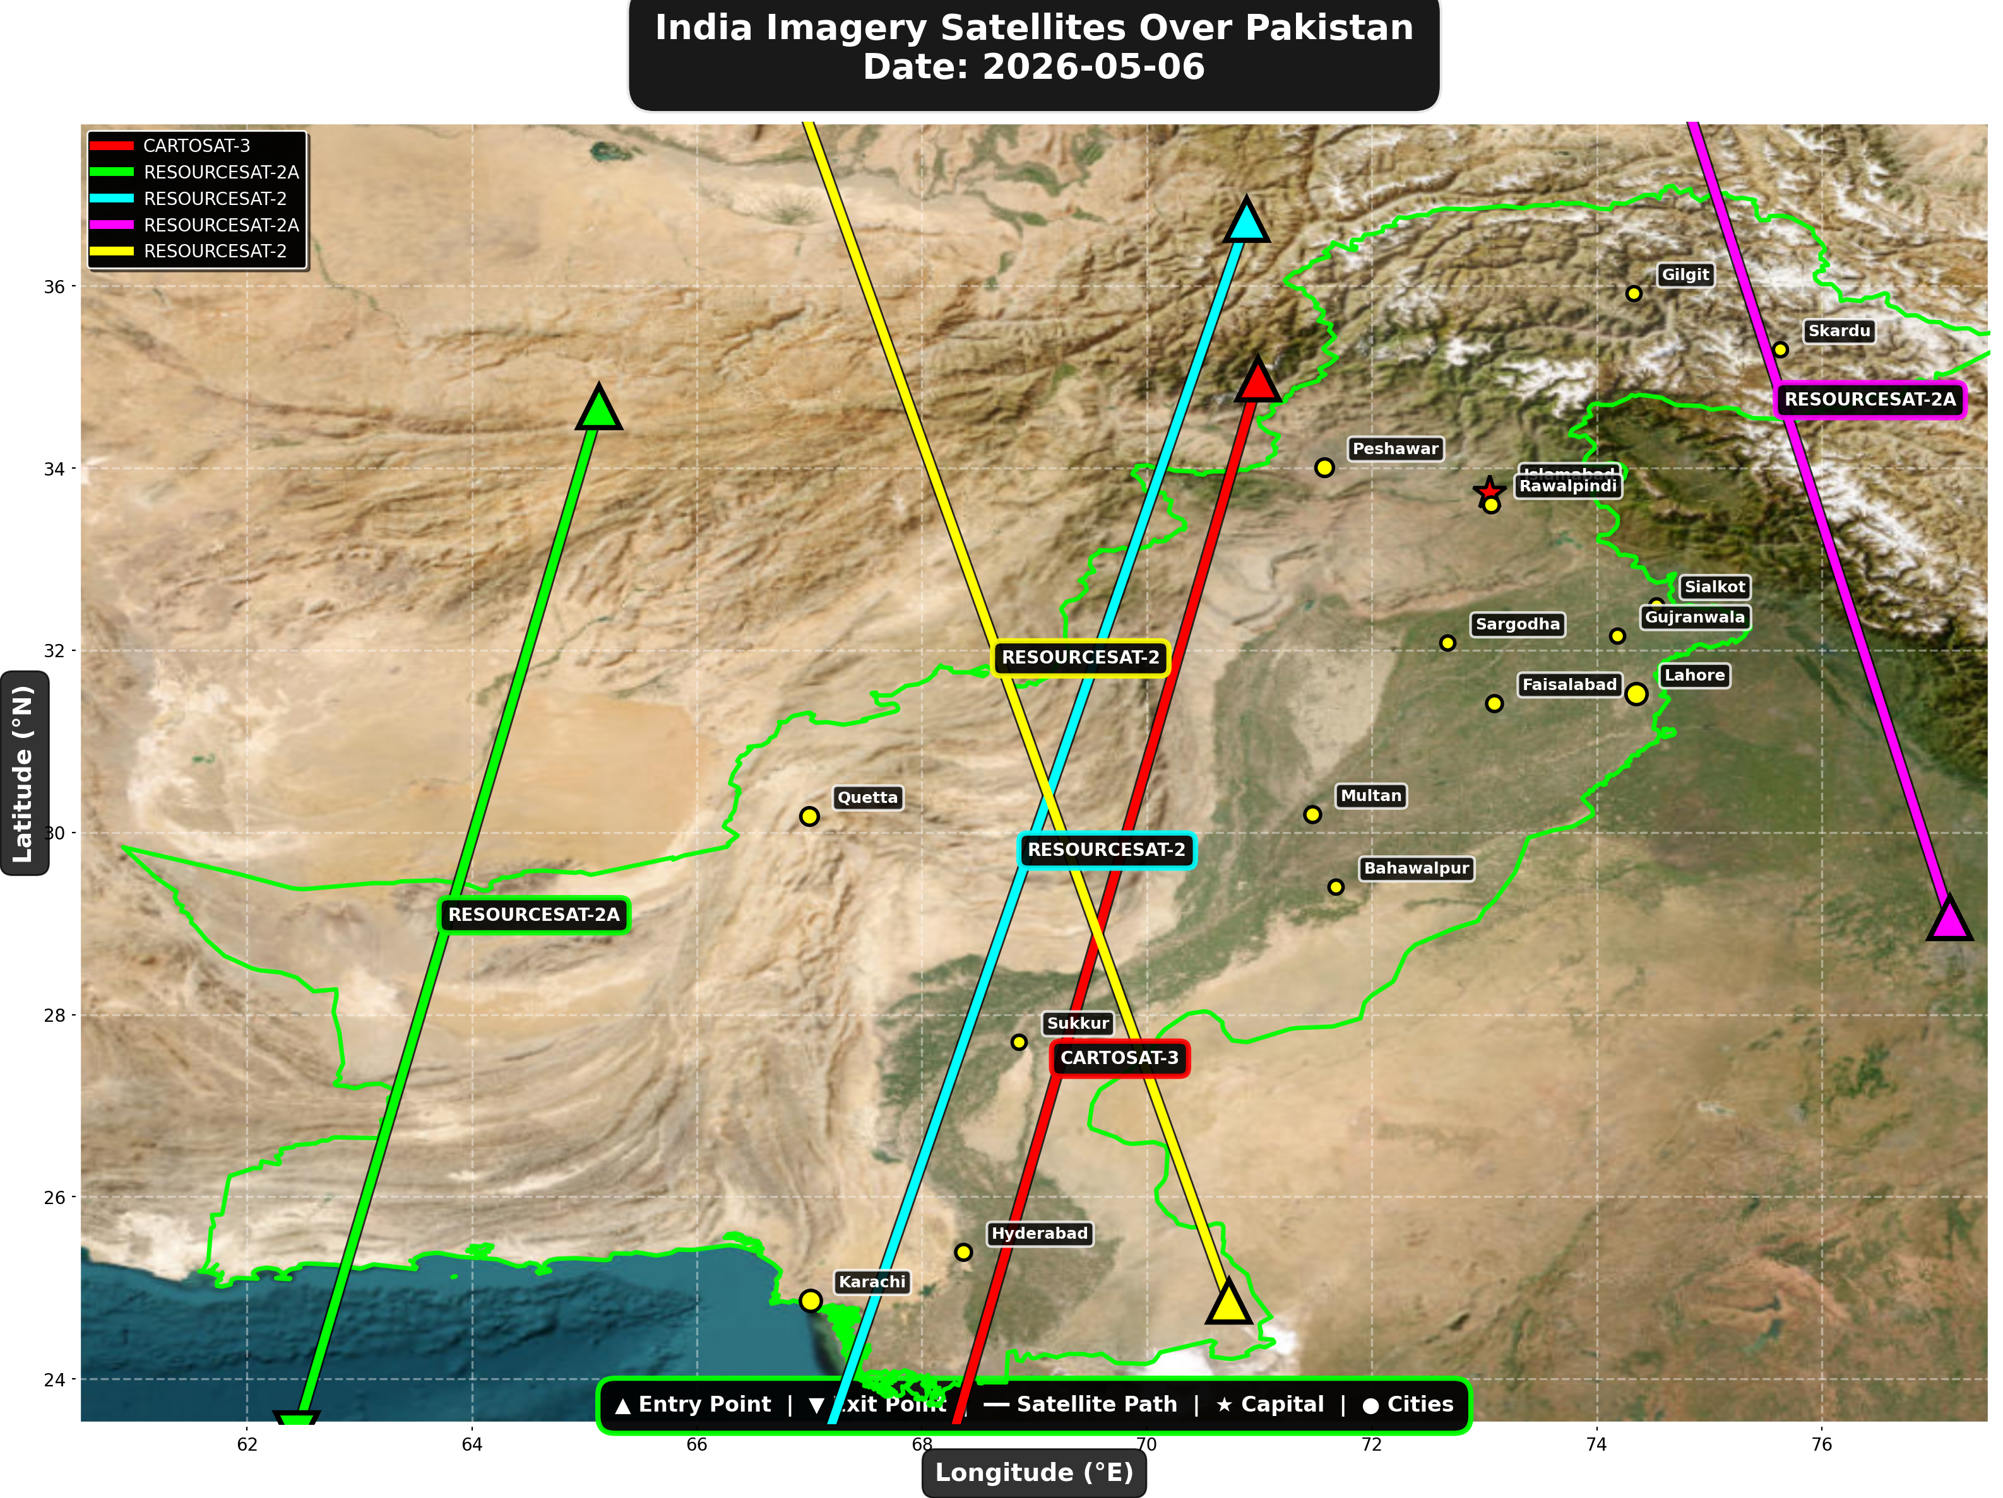

1. CARTOSAT-3 (Earth Observation)
Entry Time | 2026-05-06 05:07:00 UTC
Entry Point | 34.98°N, 70.99°E
Exit Time | 2026-05-06 05:11:00 UTC
Duration Over Pakistan | 4.0 minutes
Maximum Altitude | 514.4 km
Direction of Travel | N→S
Owner/Operator | ISRO
➤ Entered Pakistani airspace from the border region, traveling north to south. Satellite remained over Pakistan for 4.0 minutes at altitude 514.4 km.

2. RESOURCESAT-2A (Earth Observation)
Entry Time | 2026-05-06 05:32:00 UTC
Entry Point | 34.67°N, 65.13°E
Exit Time | 2026-05-06 05:35:00 UTC
Duration Over Pakistan | 3.0 minutes
Maximum Altitude | 516.0 km
Direction of Travel | N→S
Owner/Operator | ISRO
➤ Entered Pakistani airspace from the border region, traveling north to south. Satellite remained over Pakistan for 3.0 minutes at altitude 516.0 km.

3. RESOURCESAT-2 (Earth Observation)
Entry Time | 2026-05-06 05:45:00 UTC
Entry Point | 36.73°N, 70.89°E
Exit Time | 2026-05-06 05:49:00 UTC
Duration Over Pakistan | 4.0 minutes
Maximum Altitude | 832.5 km
Direction of Travel | N→S
Owner/Operator | ISRO
➤ Entered Pakistani airspace from the northwest (Afghanistan/China border region), traveling north to south. Satellite remained over Pakistan for 4.0 minutes at altitude 832.5 km.

4. RESOURCESAT-2A (Earth Observation)
Entry Time | 2026-05-06 16:05:00 UTC
Entry Point | 29.06°N, 77.14°E
Exit Time | 2026-05-06 16:08:00 UTC
Duration Over Pakistan | 3.0 minutes
Maximum Altitude | 511.5 km
Direction of Travel | S→N
Owner/Operator | ISRO
➤ Entered Pakistani airspace from the east (Indian border - Punjab/Rajasthan sector), traveling south to north. Satellite remained over Pakistan for 3.0 minutes at altitude 511.5 km.

5. RESOURCESAT-2 (Earth Observation)
Entry Time | 2026-05-06 17:01:00 UTC
Entry Point | 24.85°N, 70.73°E
Exit Time | 2026-05-06 17:05:00 UTC
Duration Over Pakistan | 4.0 minutes
Maximum Altitude | 819.0 km
Direction of Travel | S→N
Owner/Operator | ISRO
➤ Entered Pakistani airspace from the south (Arabian Sea/Indian Ocean), traveling south to north. Satellite remained over Pakistan for 4.0 minutes at altitude 819.0 km.

🇨🇳 CHINA IMAGERY SATELLITES
Visual Map - All China Satellite Paths:
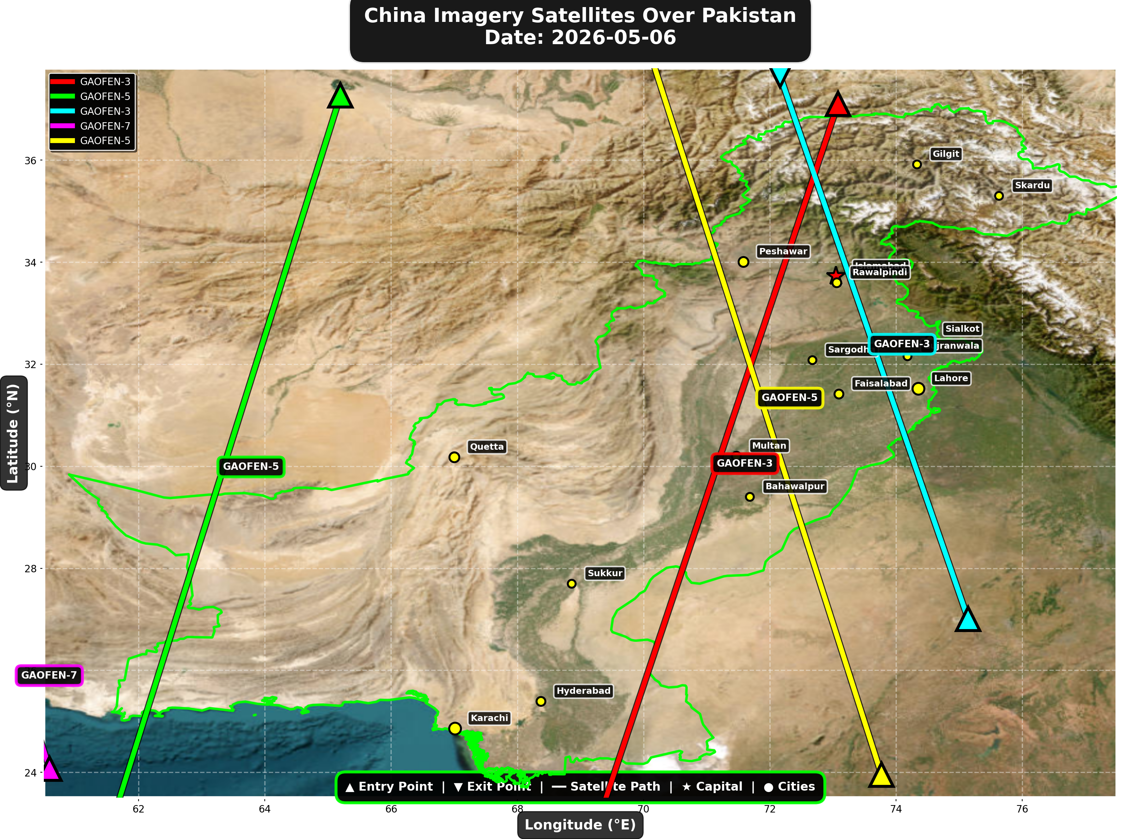

China reconnaissance and imaging satellites detected:
Satellite | Type | Entry Time | Duration (min) | Entry Point | Direction
GAOFEN-3 | Radar/SAR | 01:39:00 | 4.0 | 37.1°N, 73.08°E | N→S
GAOFEN-5 | Earth Observati | 06:50:00 | 4.0 | 37.27°N, 65.2°E | N→S
GAOFEN-3 | Radar/SAR | 12:46:00 | 3.0 | 27.01°N, 75.14°E | S→N
GAOFEN-7 | Earth Observati | 13:59:00 | 1.0 | 24.07°N, 60.59°E | N/A
GAOFEN-5 | Earth Observati | 17:36:00 | 4.0 | 23.95°N, 73.77°E | S→N

🇺🇸 USA IMAGERY SATELLITES
Visual Map - All USA Satellite Paths:
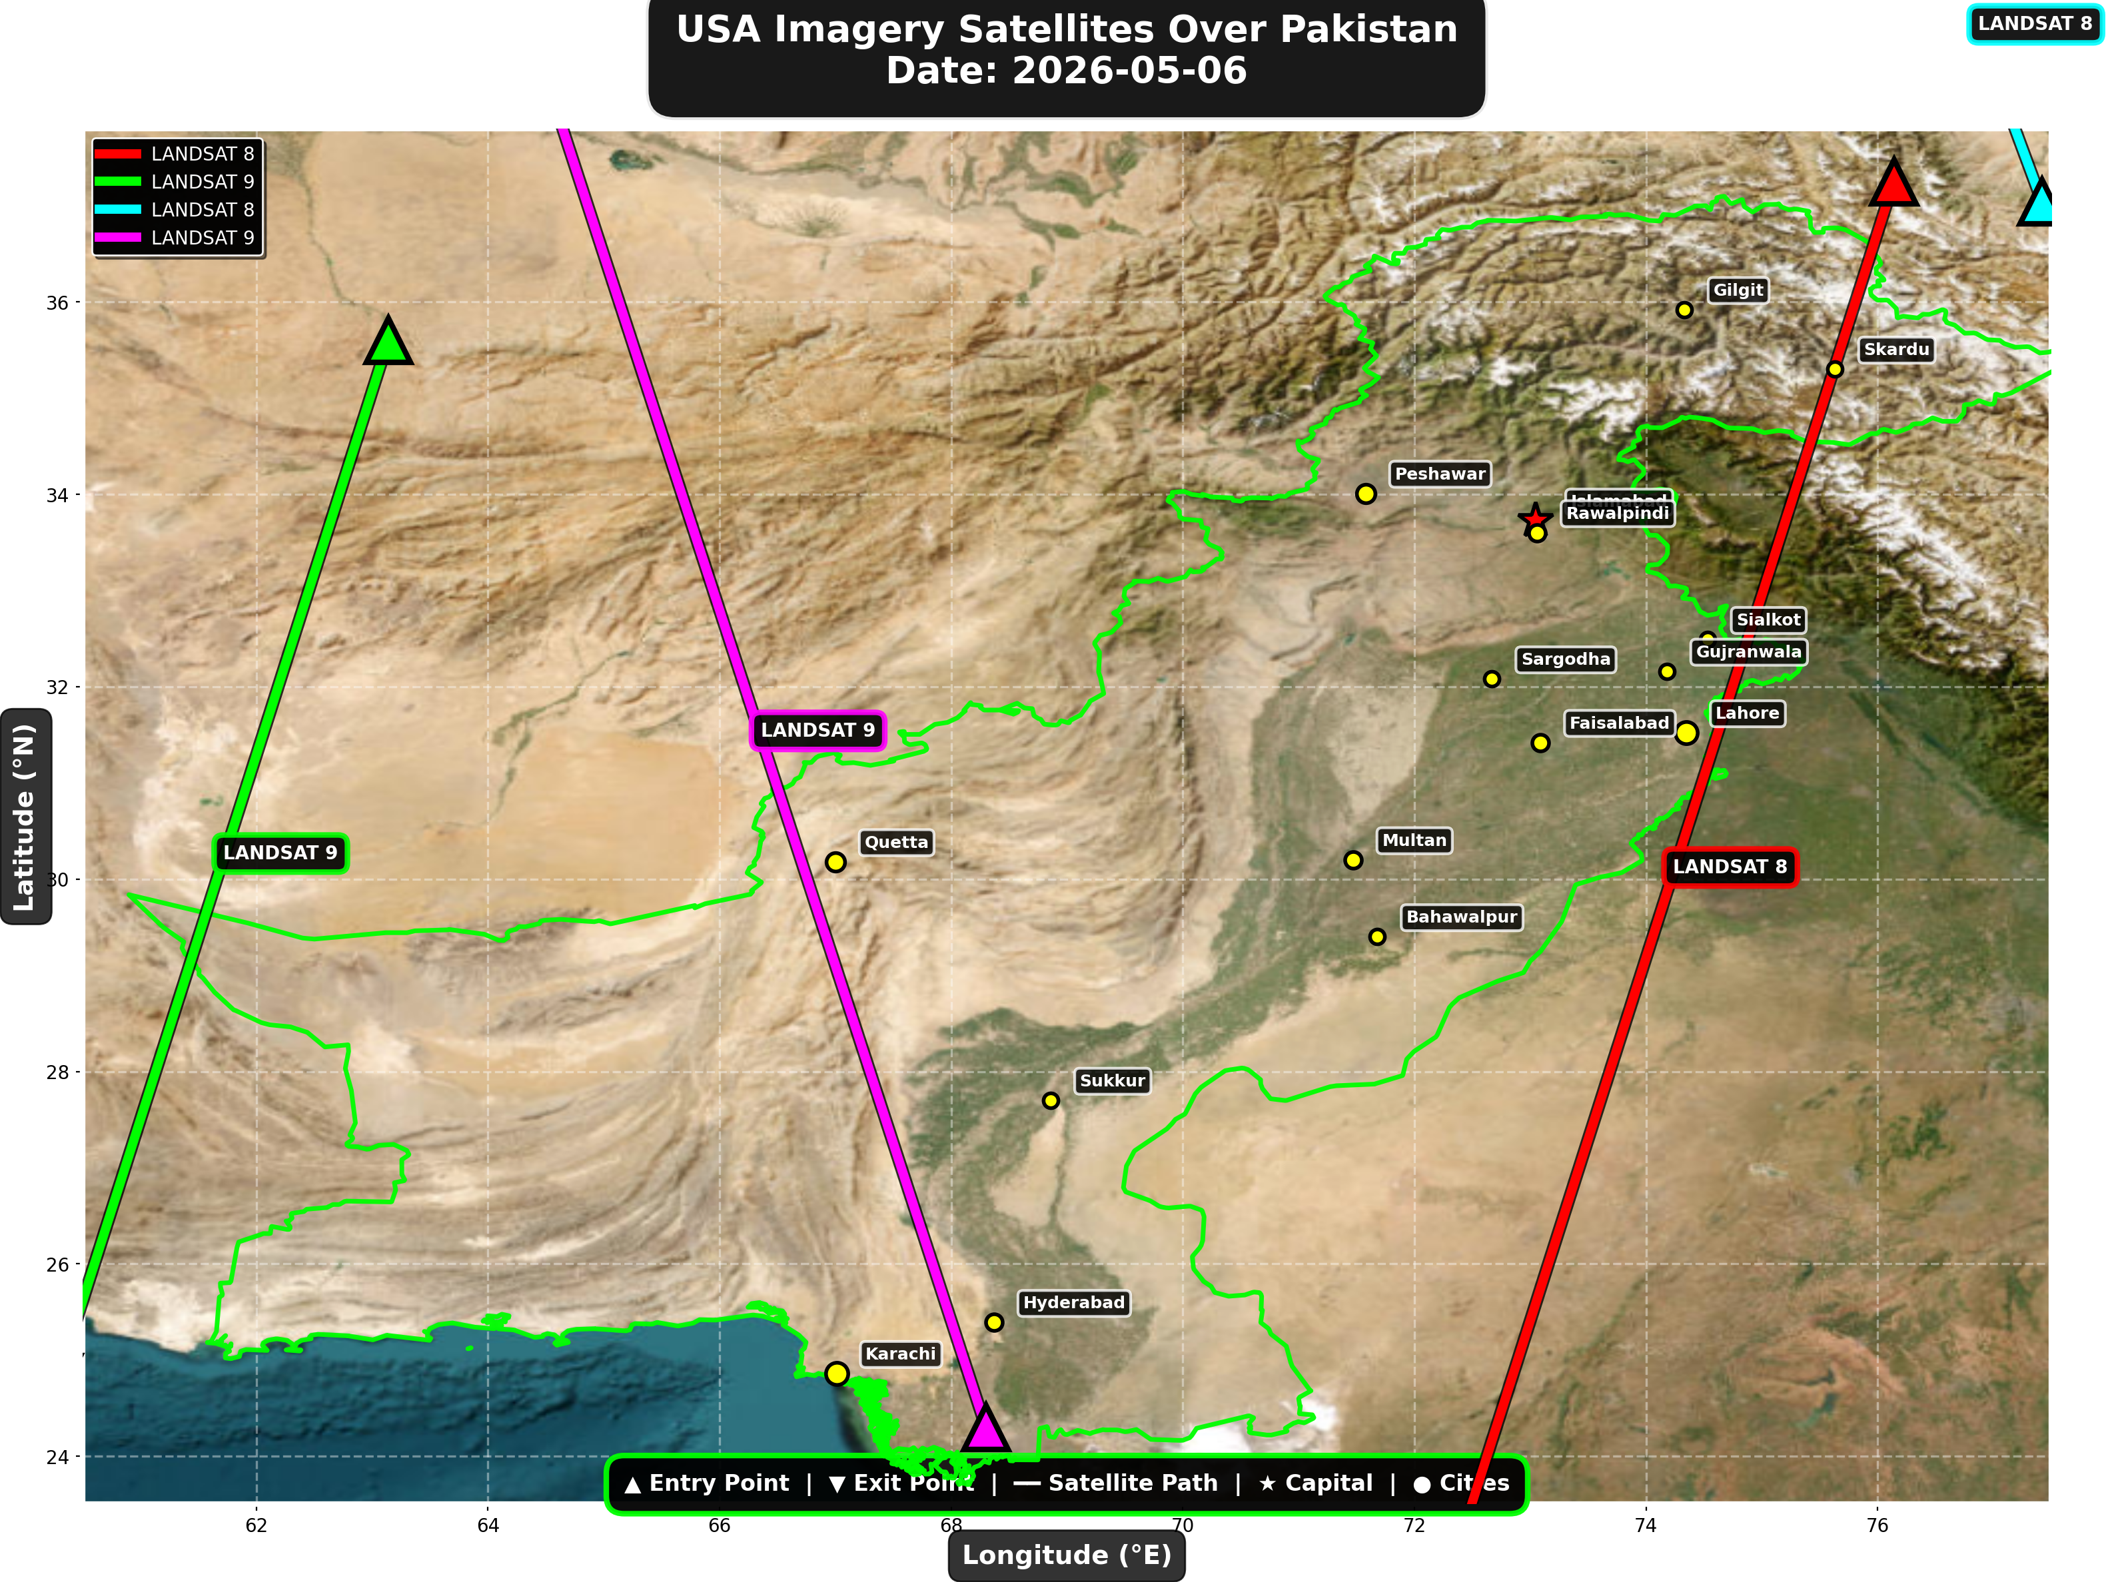

USA reconnaissance and imaging satellites detected:
Satellite | Type | Entry Time | Duration (min) | Entry Point | Direction
LANDSAT 8 | Earth Observati | 05:35:00 | 4.0 | 37.25°N, 76.14°E | N→S
LANDSAT 9 | Earth Observati | 06:25:00 | 3.0 | 35.6°N, 63.14°E | N→S
LANDSAT 8 | Earth Observati | 16:38:00 | 1.0 | 37.04°N, 77.42°E | N/A
LANDSAT 9 | Earth Observati | 17:24:00 | 4.0 | 24.3°N, 68.3°E | S→N

⚠ ANOMALIES DETECTED (2)
- [HIGH] LONG_DURATION: TIANGONG
Owner: CNSA | NORAD 48274
Details: Duration 5.0min is 62% longer than avg 3.1min
- [MEDIUM] INCREASED_FREQUENCY: FENGYUN-3C
Owner: CMA | NORAD 40069
Details: 3 crossings today vs avg 1.6 per day

Crossings by Country
Country | Crossings
China | 14
USA | 10
Europe | 5
India | 5
International | 3

Crossings by Satellite Type
Type | Crossings
Weather | 15
Earth Observation | 12
Space Station | 5
Reconnaissance | 3
Radar/SAR | 2

All Border Crossings (37 total)
# | Satellite | Owner | Country | Type | Entry Time | Duration (min) | Alt (km) | Direction
1 | FENGYUN-3C | CMA | China | Weather | 2026-05-06 00:15:00 UTC | 3.0 | 823.2 | N→S
2 | ISS | NASA/Roscosmos | International | Space Station | 2026-05-06 00:44:00 UTC | 3.0 | 428.7 | W→E
3 | GAOFEN-3 | CNSA | China | Radar/SAR | 2026-05-06 01:39:00 UTC | 4.0 | 758.2 | N→S
4 | YAOGAN-14 | PLA | China | Reconnaissance | 2026-05-06 03:08:00 UTC | 3.0 | 160.8 | N→S
5 | TIANGONG | CNSA | China | Space Station | 2026-05-06 03:34:00 UTC | 5.0 | 387.8 | W→E
6 | METOP-B | EUMETSAT | Europe | Weather | 2026-05-06 04:40:00 UTC | 4.0 | 826.0 | N→S
7 | CARTOSAT-3 | ISRO | India | Earth Observati | 2026-05-06 05:07:00 UTC | 4.0 | 514.4 | N→S
8 | METOP-C | EUMETSAT | Europe | Weather | 2026-05-06 05:11:00 UTC | 4.0 | 827.5 | N→S
9 | RESOURCESAT-2A | ISRO | India | Earth Observati | 2026-05-06 05:32:00 UTC | 3.0 | 516.0 | N→S
10 | LANDSAT 8 | NASA/USGS | USA | Earth Observati | 2026-05-06 05:35:00 UTC | 4.0 | 709.0 | N→S
11 | RESOURCESAT-2 | ISRO | India | Earth Observati | 2026-05-06 05:45:00 UTC | 4.0 | 832.5 | N→S
12 | NOAA-18 | NOAA | USA | Weather | 2026-05-06 05:51:00 UTC | 4.0 | 844.4 | N→S
13 | NOAA-19 | NOAA | USA | Weather | 2026-05-06 06:05:00 UTC | 2.0 | 858.1 | N→S
14 | LANDSAT 9 | NASA/USGS | USA | Earth Observati | 2026-05-06 06:25:00 UTC | 3.0 | 708.9 | N→S
15 | GAOFEN-5 | CNSA | China | Earth Observati | 2026-05-06 06:50:00 UTC | 4.0 | 616.0 | N→S
16 | NOAA-20 | NOAA | USA | Weather | 2026-05-06 08:23:00 UTC | 4.0 | 832.9 | S→N
17 | FENGYUN-3D | CMA | China | Weather | 2026-05-06 10:21:00 UTC | 4.0 | 833.8 | S→N
18 | FENGYUN-3C | CMA | China | Weather | 2026-05-06 11:31:00 UTC | 3.0 | 829.8 | S→N
19 | GAOFEN-3 | CNSA | China | Radar/SAR | 2026-05-06 12:46:00 UTC | 3.0 | 757.8 | S→N
20 | GAOFEN-7 | CNSA | China | Earth Observati | 2026-05-06 13:59:00 UTC | 1.0 | 790.7 | N/A
21 | YAOGAN-14 | PLA | China | Reconnaissance | 2026-05-06 14:19:00 UTC | 4.0 | 163.8 | S→N
22 | ISS | NASA/Roscosmos | International | Space Station | 2026-05-06 15:46:00 UTC | 4.0 | 421.5 | W→E
23 | METOP-B | EUMETSAT | Europe | Weather | 2026-05-06 15:56:00 UTC | 4.0 | 827.1 | S→N
24 | RESOURCESAT-2A | ISRO | India | Earth Observati | 2026-05-06 16:05:00 UTC | 3.0 | 511.5 | S→N
25 | METOP-C | EUMETSAT | Europe | Weather | 2026-05-06 16:27:00 UTC | 4.0 | 827.2 | S→N
26 | LANDSAT 8 | NASA/USGS | USA | Earth Observati | 2026-05-06 16:38:00 UTC | 1.0 | 709.2 | N/A
27 | RESOURCESAT-2 | ISRO | India | Earth Observati | 2026-05-06 17:01:00 UTC | 4.0 | 819.0 | S→N
28 | NOAA-18 | NOAA | USA | Weather | 2026-05-06 17:10:00 UTC | 4.0 | 859.8 | S→N
29 | NOAA-19 | NOAA | USA | Weather | 2026-05-06 17:23:00 UTC | 4.0 | 859.9 | S→N
30 | LANDSAT 9 | NASA/USGS | USA | Earth Observati | 2026-05-06 17:24:00 UTC | 4.0 | 709.4 | S→N
31 | GAOFEN-5 | CNSA | China | Earth Observati | 2026-05-06 17:36:00 UTC | 4.0 | 618.1 | S→N
32 | YAOGAN-26 | PLA | China | Reconnaissance | 2026-05-06 18:09:00 UTC | 3.0 | 925.8 | S→N
33 | METOP-A | EUMETSAT | Europe | Weather | 2026-05-06 19:56:00 UTC | 4.0 | 771.8 | S→N
34 | NOAA-20 | NOAA | USA | Weather | 2026-05-06 20:46:00 UTC | 4.0 | 834.1 | N→S
35 | TIANGONG | CNSA | China | Space Station | 2026-05-06 21:41:00 UTC | 5.0 | 384.1 | W→E
36 | FENGYUN-3C | CMA | China | Weather | 2026-05-06 23:53:00 UTC | 4.0 | 823.2 | N→S
37 | ISS | NASA/Roscosmos | International | Space Station | 2026-05-06 23:56:00 UTC | 4.0 | 428.3 | W→E

