ATLAS — Pakistan Border Satellite Surveillance Report
Date: 2026-05-07 | Generated: 2026-05-11 09:33:57

Executive Summary
Total Border Crossings | 36
Unique Satellites | 19
Indian Satellites Detected | 8 crossings (4 unique)
Indian Imagery Satellites | 8 crossings
Anomalies Detected | 1
Surveillance Region | 23.5°N–37.5°N, 60.5°E–77.5°E

🇮🇳 INDIAN SATELLITE ACTIVITY (8 crossings)
Indian Space Research Organisation (ISRO) satellites detected over Pakistan:

Satellite | Type | Crossings | Primary Purpose
CARTOSAT-2 | Earth Observation | 2 | High-resolution Earth imaging for cartography, urban planning, and military reconnaissance
CARTOSAT-3 | Earth Observation | 2 | High-resolution Earth imaging for cartography, urban planning, and military reconnaissance
RESOURCESAT-2 | Earth Observation | 2 | Natural resource monitoring, agriculture, forestry, and land use mapping
RESOURCESAT-2A | Earth Observation | 2 | Natural resource monitoring, agriculture, forestry, and land use mapping

📷 INDIAN IMAGERY SATELLITES - BORDER CROSSING DETAILS
Detailed entry/exit points for Indian reconnaissance and imaging satellites:

Visual Map - All Indian Satellite Paths:
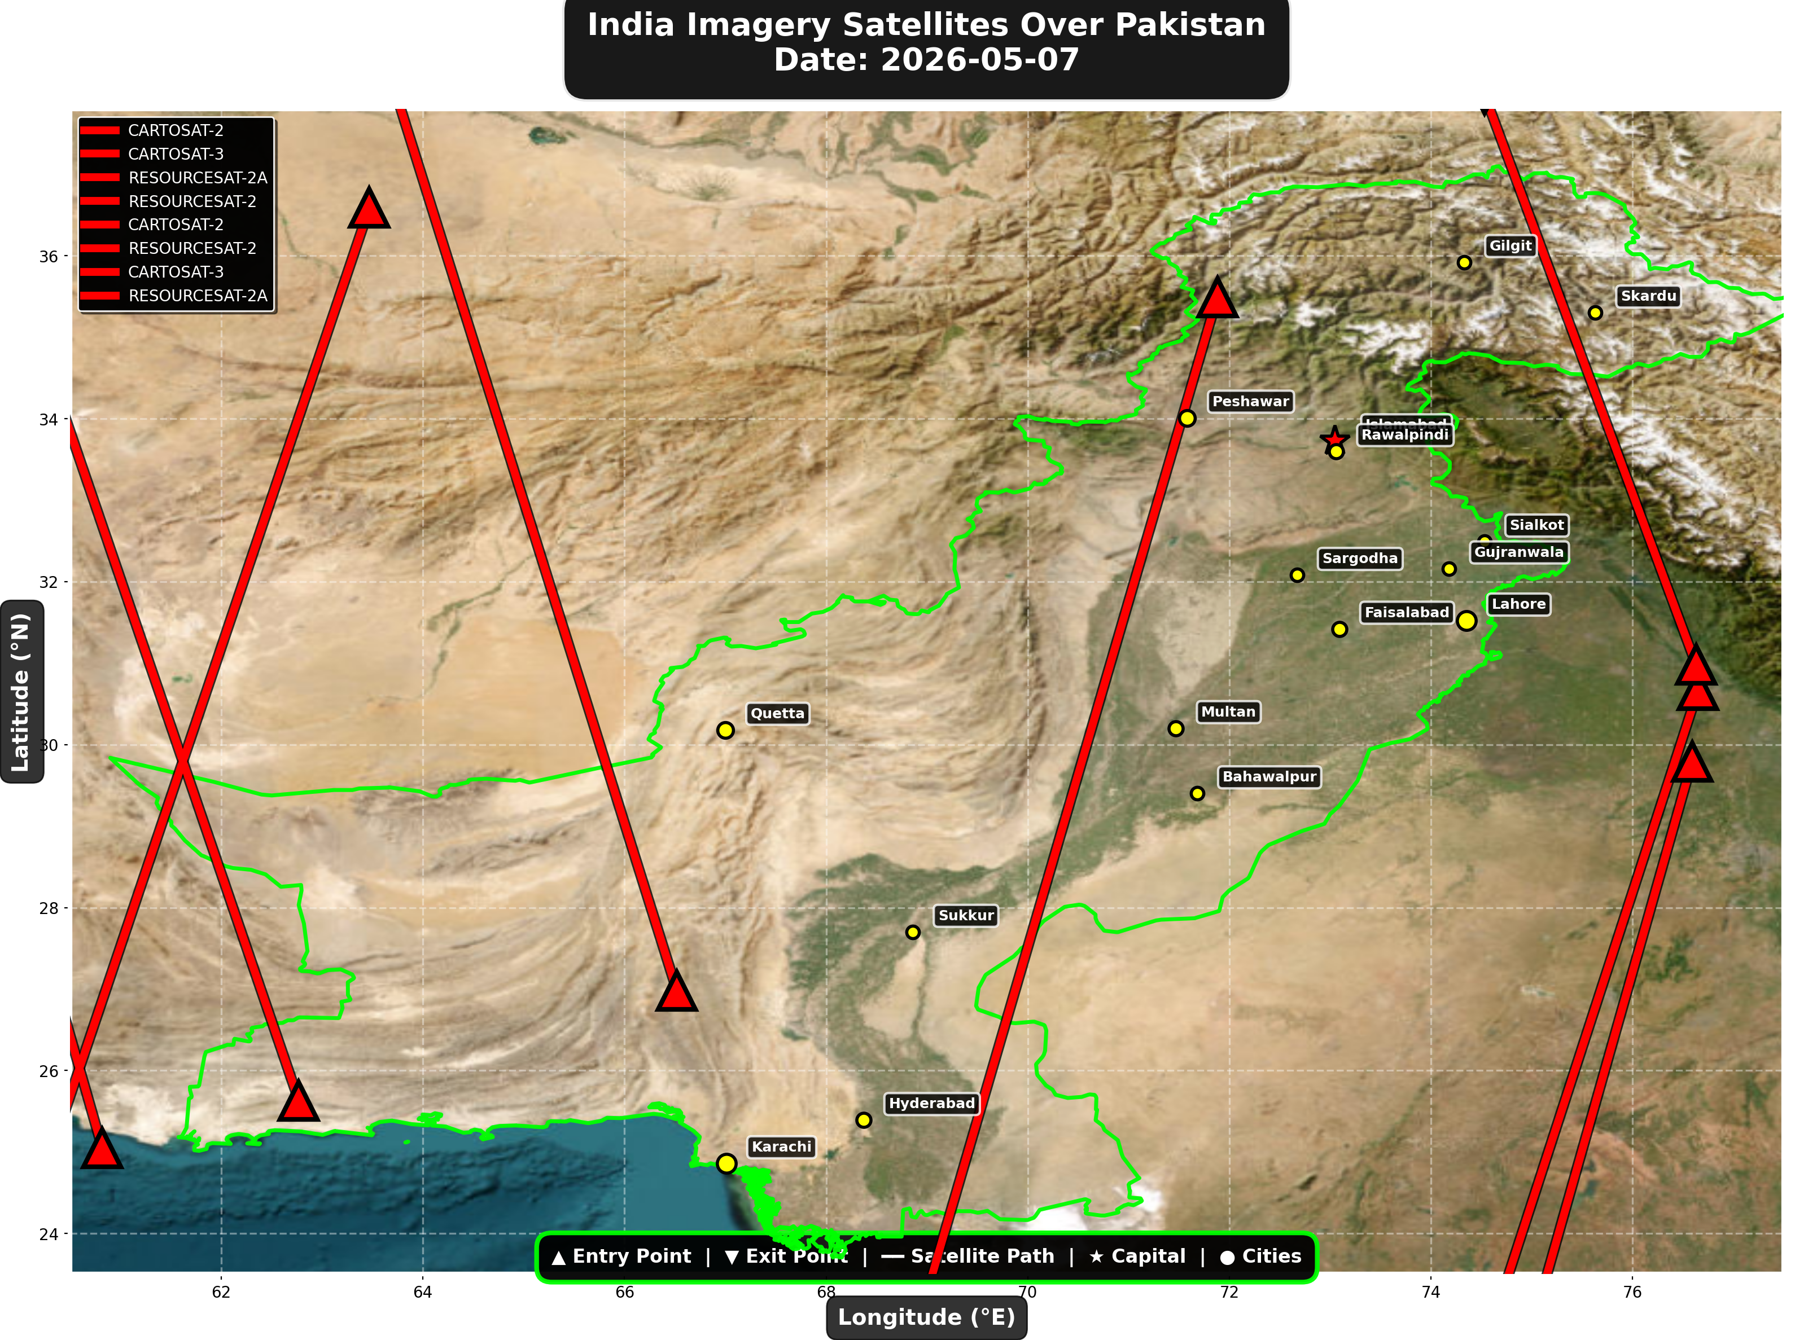

1. CARTOSAT-2 (Earth Observation)
Entry Time | 2026-05-07 00:18:00 UTC
Entry Point | 36.59°N, 63.47°E
Exit Time | 2026-05-07 00:22:00 UTC
Duration Over Pakistan | 4.0 minutes
Maximum Altitude | 836.8 km
Direction of Travel | N→S
Owner/Operator | ISRO
➤ Entered Pakistani airspace from the northwest (Afghanistan/China border region), traveling north to south. Satellite remained over Pakistan for 4.0 minutes at altitude 836.8 km.

2. CARTOSAT-3 (Earth Observation)
Entry Time | 2026-05-07 04:54:00 UTC
Entry Point | 29.79°N, 76.59°E
Exit Time | 2026-05-07 04:56:00 UTC
Duration Over Pakistan | 2.0 minutes
Maximum Altitude | 515.6 km
Direction of Travel | N→S
Owner/Operator | ISRO
➤ Entered Pakistani airspace from the east (Indian border - Punjab/Rajasthan sector), traveling north to south. Satellite remained over Pakistan for 2.0 minutes at altitude 515.6 km.

3. RESOURCESAT-2A (Earth Observation)
Entry Time | 2026-05-07 05:17:00 UTC
Entry Point | 35.49°N, 71.88°E
Exit Time | 2026-05-07 05:21:00 UTC
Duration Over Pakistan | 4.0 minutes
Maximum Altitude | 517.6 km
Direction of Travel | N→S
Owner/Operator | ISRO
➤ Entered Pakistani airspace from the northwest (Afghanistan/China border region), traveling north to south. Satellite remained over Pakistan for 4.0 minutes at altitude 517.6 km.

4. RESOURCESAT-2 (Earth Observation)
Entry Time | 2026-05-07 05:28:00 UTC
Entry Point | 30.67°N, 76.65°E
Exit Time | 2026-05-07 05:31:00 UTC
Duration Over Pakistan | 3.0 minutes
Maximum Altitude | 833.7 km
Direction of Travel | N→S
Owner/Operator | ISRO
➤ Entered Pakistani airspace from the east (Indian border - Punjab/Rajasthan sector), traveling north to south. Satellite remained over Pakistan for 3.0 minutes at altitude 833.7 km.

5. CARTOSAT-2 (Earth Observation)
Entry Time | 2026-05-07 11:37:00 UTC
Entry Point | 25.63°N, 62.77°E
Exit Time | 2026-05-07 11:40:00 UTC
Duration Over Pakistan | 3.0 minutes
Maximum Altitude | 849.2 km
Direction of Travel | S→N
Owner/Operator | ISRO
➤ Entered Pakistani airspace from the south (Arabian Sea/Indian Ocean), traveling south to north. Satellite remained over Pakistan for 3.0 minutes at altitude 849.2 km.

6. RESOURCESAT-2 (Earth Observation)
Entry Time | 2026-05-07 16:44:00 UTC
Entry Point | 30.98°N, 76.63°E
Exit Time | 2026-05-07 16:46:00 UTC
Duration Over Pakistan | 2.0 minutes
Maximum Altitude | 819.6 km
Direction of Travel | S→N
Owner/Operator | ISRO
➤ Entered Pakistani airspace from the east (Indian border - Punjab/Rajasthan sector), traveling south to north. Satellite remained over Pakistan for 2.0 minutes at altitude 819.6 km.

7. CARTOSAT-3 (Earth Observation)
Entry Time | 2026-05-07 17:00:00 UTC
Entry Point | 26.98°N, 66.52°E
Exit Time | 2026-05-07 17:03:00 UTC
Duration Over Pakistan | 3.0 minutes
Maximum Altitude | 514.2 km
Direction of Travel | S→N
Owner/Operator | ISRO
➤ Entered Pakistani airspace from the border region, traveling south to north. Satellite remained over Pakistan for 3.0 minutes at altitude 514.2 km.

8. RESOURCESAT-2A (Earth Observation)
Entry Time | 2026-05-07 17:24:00 UTC
Entry Point | 25.05°N, 60.82°E
Exit Time | 2026-05-07 17:25:00 UTC
Duration Over Pakistan | 1.0 minutes
Maximum Altitude | 511.8 km
Direction of Travel | N/A
Owner/Operator | ISRO
➤ Entered Pakistani airspace from the south (Arabian Sea/Indian Ocean), traveling N/A. Satellite remained over Pakistan for 1.0 minutes at altitude 511.8 km.

🇨🇳 CHINA IMAGERY SATELLITES
Visual Map - All China Satellite Paths:
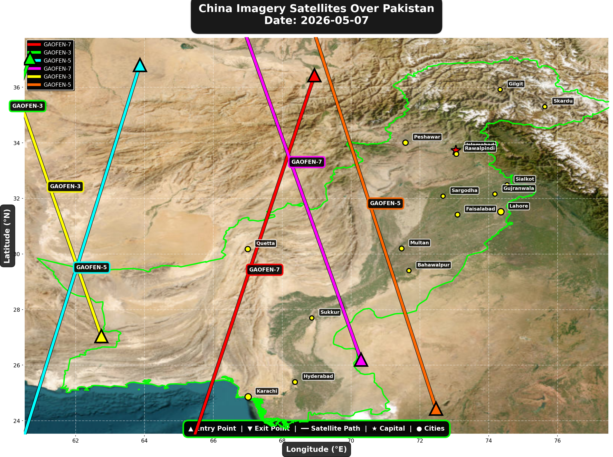

China reconnaissance and imaging satellites detected:
Satellite | Type | Entry Time | Duration (min) | Entry Point | Direction
GAOFEN-7 | Earth Observati | 02:19:00 | 4.0 | 36.43°N, 68.94°E | N→S
GAOFEN-3 | Radar/SAR | 02:40:00 | 1.0 | 37.04°N, 60.68°E | N/A
GAOFEN-5 | Earth Observati | 07:06:00 | 4.0 | 36.8°N, 63.87°E | N→S
GAOFEN-7 | Earth Observati | 13:30:00 | 4.0 | 26.2°N, 70.29°E | S→N
GAOFEN-3 | Radar/SAR | 13:47:00 | 3.0 | 27.04°N, 62.75°E | S→N
GAOFEN-5 | Earth Observati | 17:52:00 | 4.0 | 24.43°N, 72.47°E | S→N

🇺🇸 USA IMAGERY SATELLITES
Visual Map - All USA Satellite Paths:
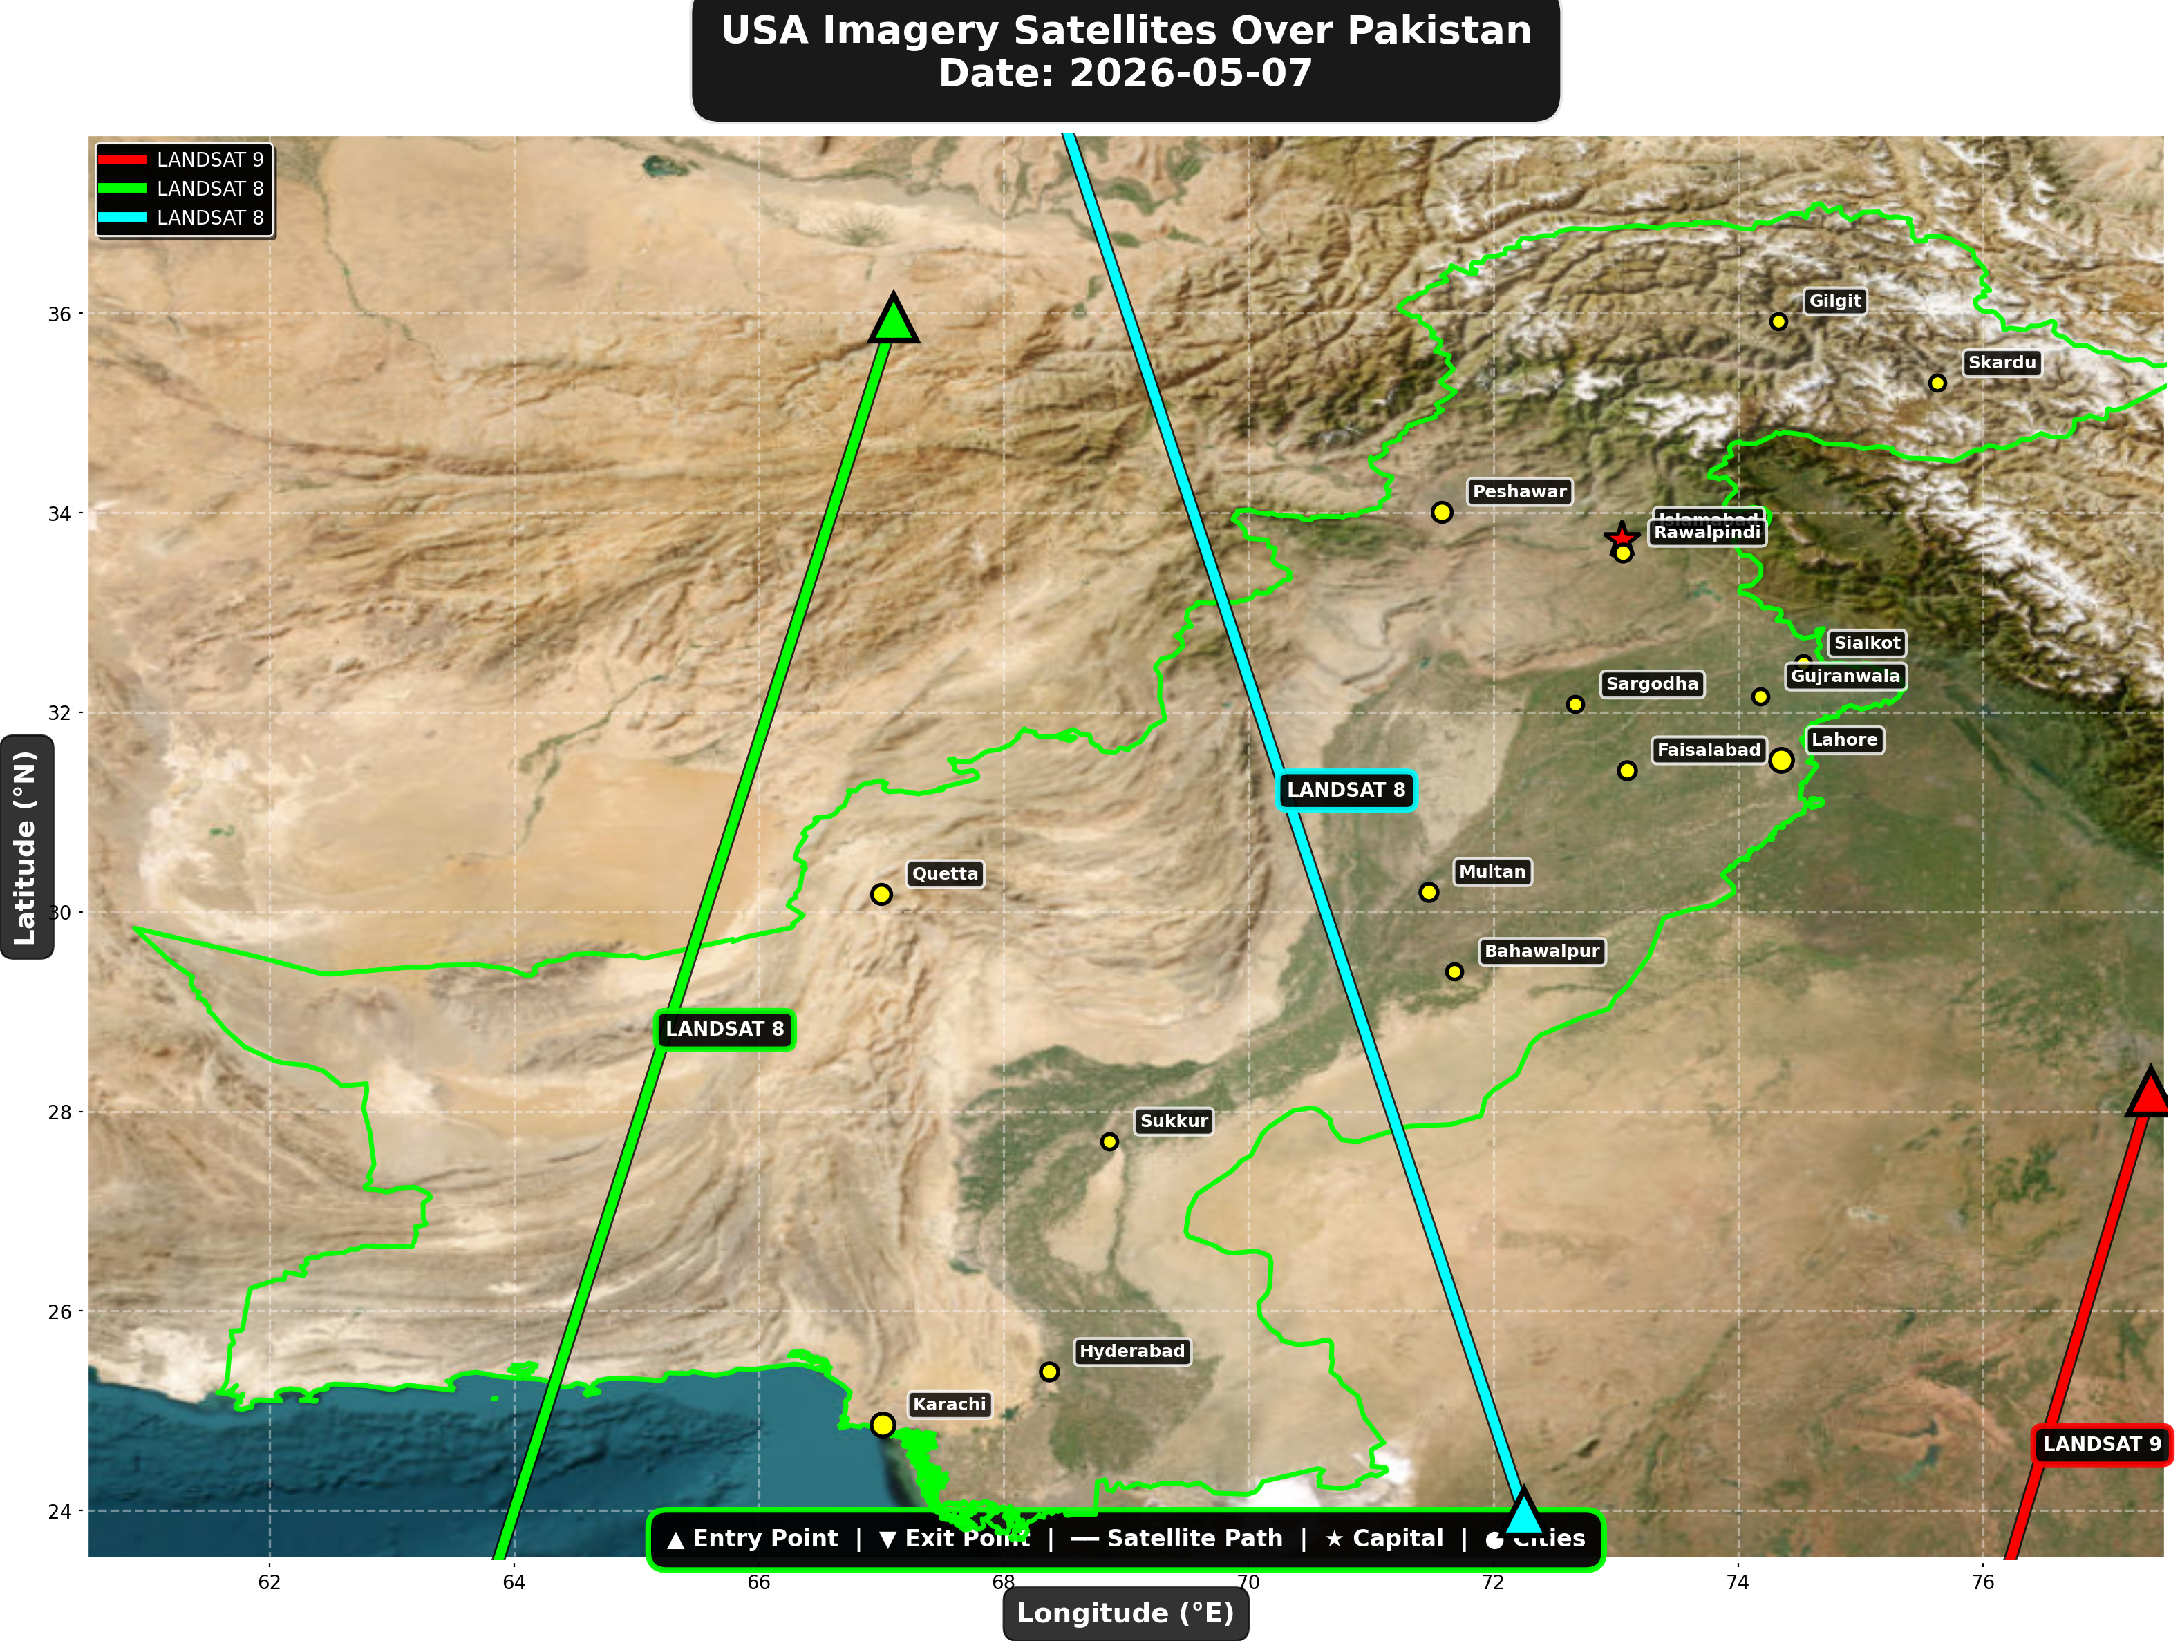

USA reconnaissance and imaging satellites detected:
Satellite | Type | Entry Time | Duration (min) | Entry Point | Direction
LANDSAT 9 | Earth Observati | 05:34:00 | 2.0 | 28.2°N, 77.37°E | N→S
LANDSAT 8 | Earth Observati | 06:21:00 | 4.0 | 35.95°N, 67.1°E | N→S
LANDSAT 8 | Earth Observati | 17:20:00 | 4.0 | 23.98°N, 72.25°E | S→N

⚠ ANOMALIES DETECTED (1)
- [HIGH] LONG_DURATION: TIANGONG
Owner: CNSA | NORAD 48274
Details: Duration 5.0min is 57% longer than avg 3.2min

Crossings by Country
Country | Crossings
China | 15
India | 8
USA | 6
Europe | 5
International | 2

Crossings by Satellite Type
Type | Crossings
Earth Observation | 15
Weather | 10
Space Station | 6
Reconnaissance | 3
Radar/SAR | 2

All Border Crossings (36 total)
# | Satellite | Owner | Country | Type | Entry Time | Duration (min) | Alt (km) | Direction
1 | CARTOSAT-2 | ISRO | India | Earth Observati | 2026-05-07 00:18:00 UTC | 4.0 | 836.8 | N→S
2 | TIANGONG | CNSA | China | Space Station | 2026-05-07 00:53:00 UTC | 1.0 | 391.6 | N/A
3 | GAOFEN-7 | CNSA | China | Earth Observati | 2026-05-07 02:19:00 UTC | 4.0 | 791.6 | N→S
4 | TIANGONG | CNSA | China | Space Station | 2026-05-07 02:28:00 UTC | 5.0 | 391.4 | W→E
5 | GAOFEN-3 | CNSA | China | Radar/SAR | 2026-05-07 02:40:00 UTC | 1.0 | 758.1 | N/A
6 | METOP-B | EUMETSAT | Europe | Weather | 2026-05-07 04:23:00 UTC | 2.0 | 826.3 | N→S
7 | CARTOSAT-3 | ISRO | India | Earth Observati | 2026-05-07 04:54:00 UTC | 2.0 | 515.6 | N→S
8 | METOP-C | EUMETSAT | Europe | Weather | 2026-05-07 04:55:00 UTC | 1.0 | 827.3 | N/A
9 | RESOURCESAT-2A | ISRO | India | Earth Observati | 2026-05-07 05:17:00 UTC | 4.0 | 517.6 | N→S
10 | RESOURCESAT-2 | ISRO | India | Earth Observati | 2026-05-07 05:28:00 UTC | 3.0 | 833.7 | N→S
11 | LANDSAT 9 | NASA/USGS | USA | Earth Observati | 2026-05-07 05:34:00 UTC | 2.0 | 709.0 | N→S
12 | NOAA-18 | NOAA | USA | Weather | 2026-05-07 05:41:00 UTC | 3.0 | 844.8 | N→S
13 | LANDSAT 8 | NASA/USGS | USA | Earth Observati | 2026-05-07 06:21:00 UTC | 4.0 | 709.0 | N→S
14 | YAOGAN-26 | PLA | China | Reconnaissance | 2026-05-07 06:25:00 UTC | 4.0 | 777.0 | N→S
15 | GAOFEN-5 | CNSA | China | Earth Observati | 2026-05-07 07:06:00 UTC | 4.0 | 614.6 | N→S
16 | METOP-A | EUMETSAT | Europe | Weather | 2026-05-07 07:57:00 UTC | 2.0 | 551.8 | N→S
17 | NOAA-20 | NOAA | USA | Weather | 2026-05-07 08:09:00 UTC | 1.0 | 832.8 | N/A
18 | FENGYUN-3C | CMA | China | Weather | 2026-05-07 11:12:00 UTC | 4.0 | 829.3 | S→N
19 | CARTOSAT-2 | ISRO | India | Earth Observati | 2026-05-07 11:37:00 UTC | 3.0 | 849.2 | S→N
20 | GAOFEN-7 | CNSA | China | Earth Observati | 2026-05-07 13:30:00 UTC | 4.0 | 792.1 | S→N
21 | GAOFEN-3 | CNSA | China | Radar/SAR | 2026-05-07 13:47:00 UTC | 3.0 | 757.9 | S→N
22 | ISS | NASA/Roscosmos | International | Space Station | 2026-05-07 14:58:00 UTC | 4.0 | 421.2 | W→E
23 | YAOGAN-14 | PLA | China | Reconnaissance | 2026-05-07 15:07:00 UTC | 1.0 | 162.9 | N/A
24 | METOP-B | EUMETSAT | Europe | Weather | 2026-05-07 15:39:00 UTC | 2.0 | 826.6 | S→N
25 | METOP-C | EUMETSAT | Europe | Weather | 2026-05-07 16:11:00 UTC | 1.0 | 827.3 | N/A
26 | RESOURCESAT-2 | ISRO | India | Earth Observati | 2026-05-07 16:44:00 UTC | 2.0 | 819.6 | S→N
27 | CARTOSAT-3 | ISRO | India | Earth Observati | 2026-05-07 17:00:00 UTC | 3.0 | 514.2 | S→N
28 | NOAA-18 | NOAA | USA | Weather | 2026-05-07 17:00:00 UTC | 4.0 | 857.8 | S→N
29 | LANDSAT 8 | NASA/USGS | USA | Earth Observati | 2026-05-07 17:20:00 UTC | 4.0 | 709.4 | S→N
30 | RESOURCESAT-2A | ISRO | India | Earth Observati | 2026-05-07 17:24:00 UTC | 1.0 | 511.8 | N/A
31 | YAOGAN-26 | PLA | China | Reconnaissance | 2026-05-07 17:28:00 UTC | 4.0 | 964.6 | S→N
32 | GAOFEN-5 | CNSA | China | Earth Observati | 2026-05-07 17:52:00 UTC | 4.0 | 618.9 | S→N
33 | TIANGONG | CNSA | China | Space Station | 2026-05-07 19:00:00 UTC | 2.0 | 390.2 | W→E
34 | TIANGONG | CNSA | China | Space Station | 2026-05-07 20:36:00 UTC | 4.0 | 391.0 | W→E
35 | ISS | NASA/Roscosmos | International | Space Station | 2026-05-07 23:08:00 UTC | 4.0 | 427.4 | W→E
36 | FENGYUN-3C | CMA | China | Weather | 2026-05-07 23:35:00 UTC | 4.0 | 823.2 | N→S

