ATLAS — Pakistan Border Satellite Surveillance Report
Date: 2026-05-08 | Generated: 2026-05-11 09:34:14

Executive Summary
Total Border Crossings | 32
Unique Satellites | 17
Indian Satellites Detected | 6 crossings (3 unique)
Indian Imagery Satellites | 6 crossings
Anomalies Detected | 3
Surveillance Region | 23.5°N–37.5°N, 60.5°E–77.5°E

🇮🇳 INDIAN SATELLITE ACTIVITY (6 crossings)
Indian Space Research Organisation (ISRO) satellites detected over Pakistan:

Satellite | Type | Crossings | Primary Purpose
CARTOSAT-2 | Earth Observation | 3 | High-resolution Earth imaging for cartography, urban planning, and military reconnaissance
CARTOSAT-3 | Earth Observation | 1 | High-resolution Earth imaging for cartography, urban planning, and military reconnaissance
RESOURCESAT-2A | Earth Observation | 2 | Natural resource monitoring, agriculture, forestry, and land use mapping

📷 INDIAN IMAGERY SATELLITES - BORDER CROSSING DETAILS
Detailed entry/exit points for Indian reconnaissance and imaging satellites:

Visual Map - All Indian Satellite Paths:
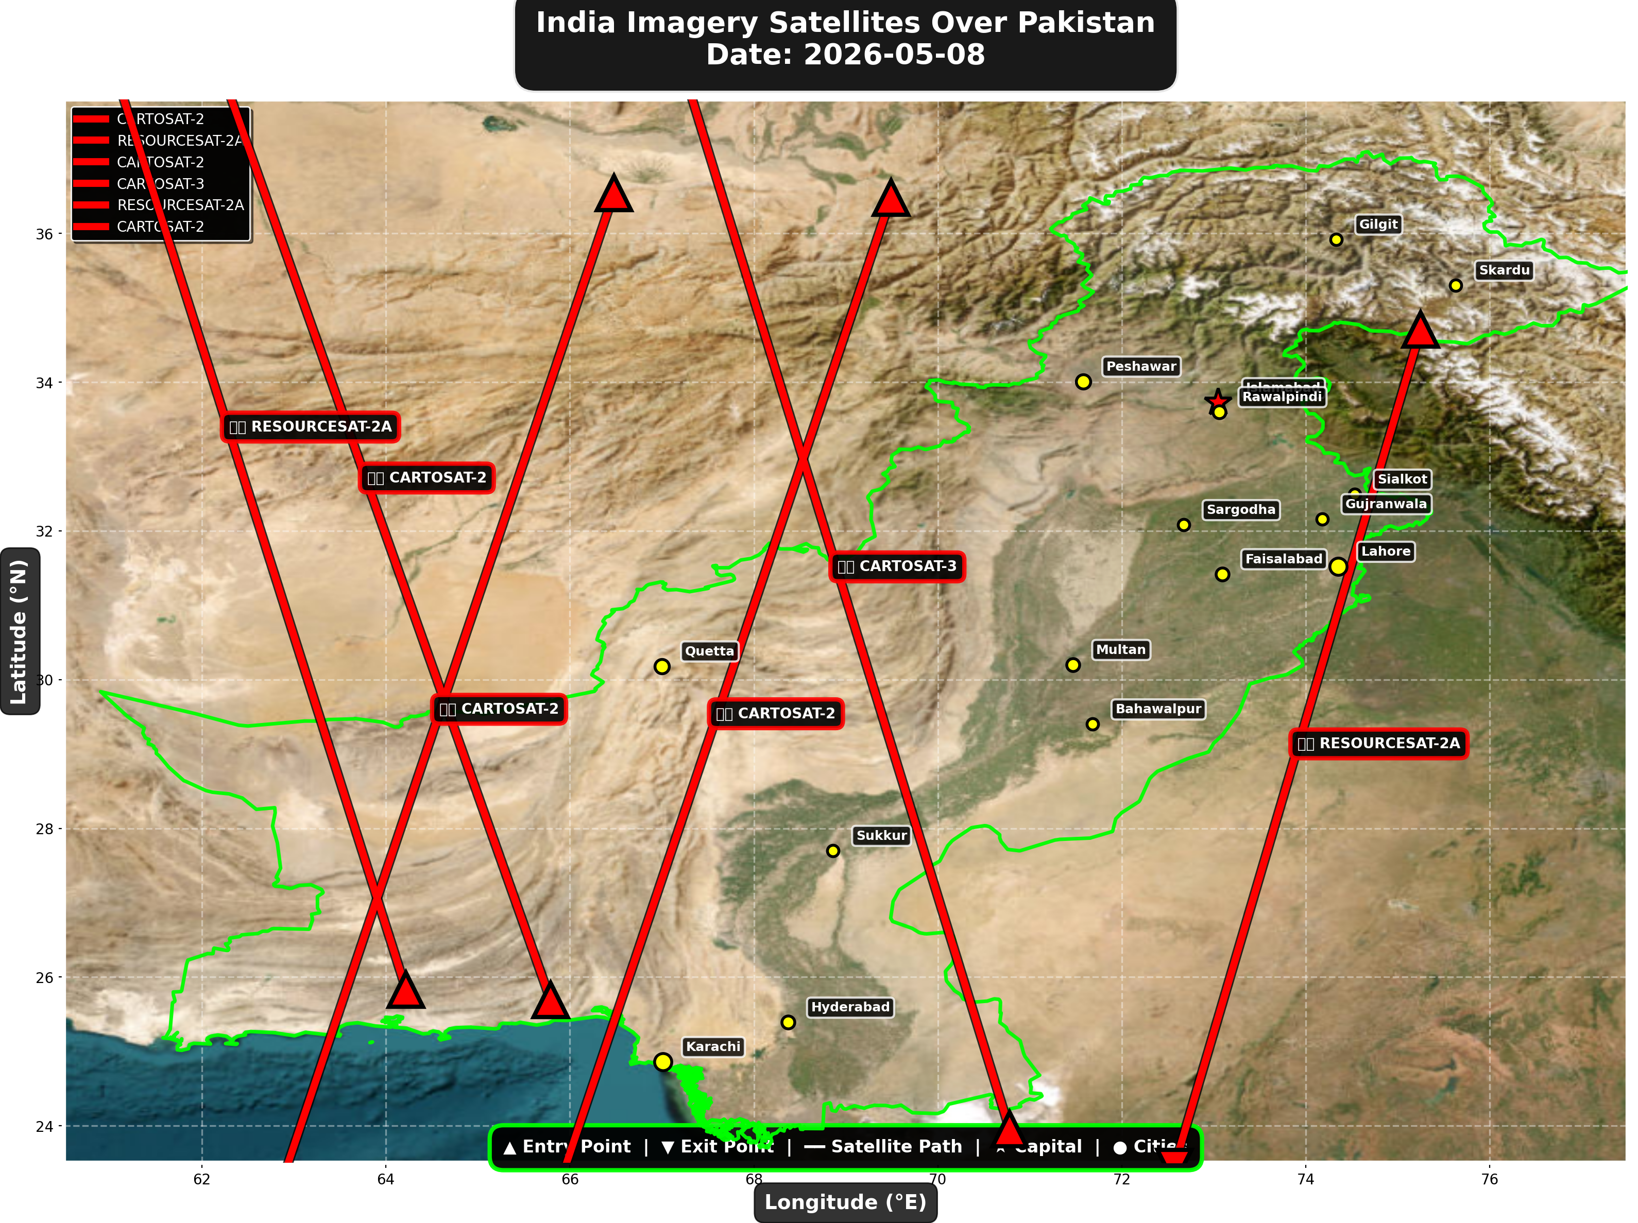

1. CARTOSAT-2 (Earth Observation)
Entry Time | 2026-05-08 00:02:00 UTC
Entry Point | 36.54°N, 66.48°E
Exit Time | 2026-05-08 00:06:00 UTC
Duration Over Pakistan | 4.0 minutes
Maximum Altitude | 836.8 km
Direction of Travel | N→S
Owner/Operator | ISRO
➤ Entered Pakistani airspace from the northwest (Afghanistan/China border region), traveling north to south. Satellite remained over Pakistan for 4.0 minutes at altitude 836.8 km.

2. RESOURCESAT-2A (Earth Observation)
Entry Time | 2026-05-08 04:59:00 UTC
Entry Point | 34.71°N, 75.25°E
Exit Time | 2026-05-08 05:02:00 UTC
Duration Over Pakistan | 3.0 minutes
Maximum Altitude | 517.5 km
Direction of Travel | N→S
Owner/Operator | ISRO
➤ Entered Pakistani airspace from the east (Indian border - Punjab/Rajasthan sector), traveling north to south. Satellite remained over Pakistan for 3.0 minutes at altitude 517.5 km.

3. CARTOSAT-2 (Earth Observation)
Entry Time | 2026-05-08 11:21:00 UTC
Entry Point | 25.69°N, 65.79°E
Exit Time | 2026-05-08 11:25:00 UTC
Duration Over Pakistan | 4.0 minutes
Maximum Altitude | 849.2 km
Direction of Travel | S→N
Owner/Operator | ISRO
➤ Entered Pakistani airspace from the south (Arabian Sea/Indian Ocean), traveling south to north. Satellite remained over Pakistan for 4.0 minutes at altitude 849.2 km.

4. CARTOSAT-3 (Earth Observation)
Entry Time | 2026-05-08 16:41:00 UTC
Entry Point | 23.95°N, 70.78°E
Exit Time | 2026-05-08 16:45:00 UTC
Duration Over Pakistan | 4.0 minutes
Maximum Altitude | 514.2 km
Direction of Travel | S→N
Owner/Operator | ISRO
➤ Entered Pakistani airspace from the south (Arabian Sea/Indian Ocean), traveling south to north. Satellite remained over Pakistan for 4.0 minutes at altitude 514.2 km.

5. RESOURCESAT-2A (Earth Observation)
Entry Time | 2026-05-08 17:06:00 UTC
Entry Point | 25.83°N, 64.22°E
Exit Time | 2026-05-08 17:10:00 UTC
Duration Over Pakistan | 4.0 minutes
Maximum Altitude | 511.9 km
Direction of Travel | S→N
Owner/Operator | ISRO
➤ Entered Pakistani airspace from the south (Arabian Sea/Indian Ocean), traveling south to north. Satellite remained over Pakistan for 4.0 minutes at altitude 511.9 km.

6. CARTOSAT-2 (Earth Observation)
Entry Time | 2026-05-08 23:46:00 UTC
Entry Point | 36.48°N, 69.49°E
Exit Time | 2026-05-08 23:50:00 UTC
Duration Over Pakistan | 4.0 minutes
Maximum Altitude | 836.8 km
Direction of Travel | N→S
Owner/Operator | ISRO
➤ Entered Pakistani airspace from the northwest (Afghanistan/China border region), traveling north to south. Satellite remained over Pakistan for 4.0 minutes at altitude 836.8 km.

🇨🇳 CHINA IMAGERY SATELLITES
Visual Map - All China Satellite Paths:
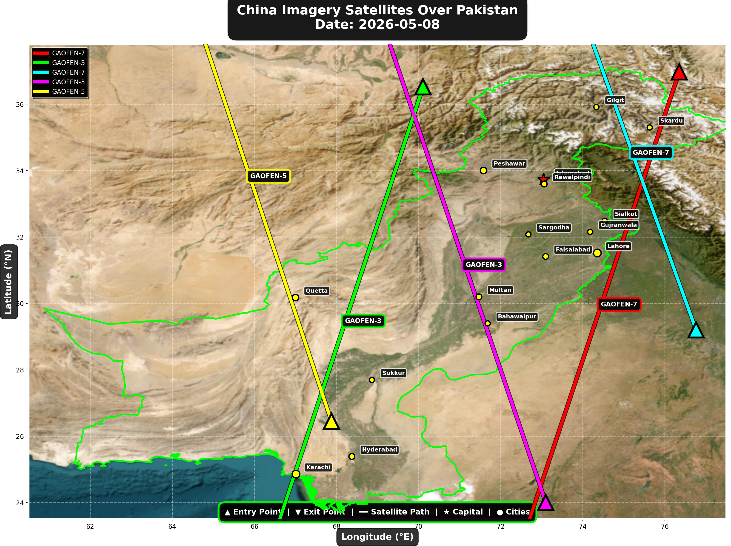

China reconnaissance and imaging satellites detected:
Satellite | Type | Entry Time | Duration (min) | Entry Point | Direction
GAOFEN-7 | Earth Observati | 01:46:00 | 4.0 | 36.97°N, 76.35°E | N→S
GAOFEN-3 | Radar/SAR | 01:58:00 | 4.0 | 36.52°N, 70.11°E | N→S
GAOFEN-7 | Earth Observati | 12:58:00 | 3.0 | 29.2°N, 76.76°E | S→N
GAOFEN-3 | Radar/SAR | 13:04:00 | 4.0 | 24.0°N, 73.1°E | S→N
GAOFEN-5 | Earth Observati | 18:05:00 | 4.0 | 26.45°N, 67.88°E | S→N

🇺🇸 USA IMAGERY SATELLITES
Visual Map - All USA Satellite Paths:
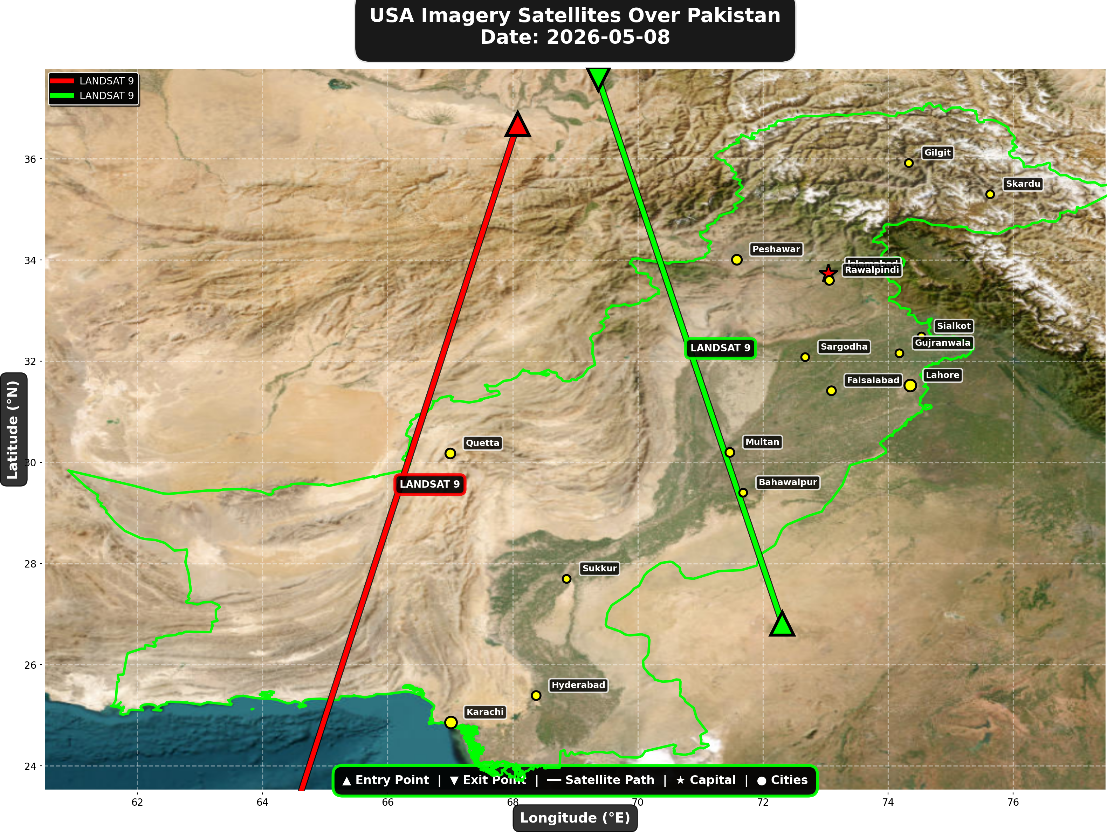

USA reconnaissance and imaging satellites detected:
Satellite | Type | Entry Time | Duration (min) | Entry Point | Direction
LANDSAT 9 | Earth Observati | 06:14:00 | 4.0 | 36.69°N, 68.08°E | N→S
LANDSAT 9 | Earth Observati | 17:14:00 | 3.0 | 26.81°N, 72.31°E | S→N

⚠ ANOMALIES DETECTED (3)
- [HIGH] LONG_DURATION: TIANGONG
Owner: CNSA | NORAD 48274
Details: Duration 5.0min is 58% longer than avg 3.2min
- [MEDIUM] INCREASED_FREQUENCY: CARTOSAT-2
Owner: ISRO | NORAD 39260
Details: 3 crossings today vs avg 1.6 per day
- [MEDIUM] INCREASED_FREQUENCY: FENGYUN-3D
Owner: CMA | NORAD 43010
Details: 3 crossings today vs avg 1.5 per day

Crossings by Country
Country | Crossings
China | 17
India | 6
USA | 5
Europe | 2
International | 2

Crossings by Satellite Type
Type | Crossings
Earth Observation | 11
Weather | 10
Space Station | 6
Reconnaissance | 3
Radar/SAR | 2

All Border Crossings (32 total)
# | Satellite | Owner | Country | Type | Entry Time | Duration (min) | Alt (km) | Direction
1 | CARTOSAT-2 | ISRO | India | Earth Observati | 2026-05-08 00:02:00 UTC | 4.0 | 836.8 | N→S
2 | FENGYUN-3D | CMA | China | Weather | 2026-05-08 00:09:00 UTC | 3.0 | 832.0 | N→S
3 | TIANGONG | CNSA | China | Space Station | 2026-05-08 01:28:00 UTC | 4.0 | 391.6 | W→E
4 | GAOFEN-7 | CNSA | China | Earth Observati | 2026-05-08 01:46:00 UTC | 4.0 | 791.6 | N→S
5 | GAOFEN-3 | CNSA | China | Radar/SAR | 2026-05-08 01:58:00 UTC | 4.0 | 758.2 | N→S
6 | TIANGONG | CNSA | China | Space Station | 2026-05-08 03:05:00 UTC | 3.0 | 391.2 | W→E
7 | YAOGAN-14 | PLA | China | Reconnaissance | 2026-05-08 03:16:00 UTC | 3.0 | 160.7 | N→S
8 | RESOURCESAT-2A | ISRO | India | Earth Observati | 2026-05-08 04:59:00 UTC | 3.0 | 517.5 | N→S
9 | LANDSAT 9 | NASA/USGS | USA | Earth Observati | 2026-05-08 06:14:00 UTC | 4.0 | 708.9 | N→S
10 | NOAA-19 | NOAA | USA | Weather | 2026-05-08 07:20:00 UTC | 1.0 | 857.4 | N/A
11 | METOP-A | EUMETSAT | Europe | Weather | 2026-05-08 08:19:00 UTC | 4.0 | 560.0 | N→S
12 | FENGYUN-3C | CMA | China | Weather | 2026-05-08 10:51:00 UTC | 4.0 | 829.1 | S→N
13 | CARTOSAT-2 | ISRO | India | Earth Observati | 2026-05-08 11:21:00 UTC | 4.0 | 849.2 | S→N
14 | FENGYUN-3D | CMA | China | Weather | 2026-05-08 11:26:00 UTC | 2.0 | 833.6 | S→N
15 | GAOFEN-7 | CNSA | China | Earth Observati | 2026-05-08 12:58:00 UTC | 3.0 | 792.0 | S→N
16 | GAOFEN-3 | CNSA | China | Radar/SAR | 2026-05-08 13:04:00 UTC | 4.0 | 757.9 | S→N
17 | ISS | NASA/Roscosmos | International | Space Station | 2026-05-08 14:11:00 UTC | 4.0 | 421.3 | W→E
18 | YAOGAN-14 | PLA | China | Reconnaissance | 2026-05-08 14:27:00 UTC | 3.0 | 163.6 | S→N
19 | CARTOSAT-3 | ISRO | India | Earth Observati | 2026-05-08 16:41:00 UTC | 4.0 | 514.2 | S→N
20 | NOAA-18 | NOAA | USA | Weather | 2026-05-08 16:49:00 UTC | 1.0 | 856.0 | N/A
21 | RESOURCESAT-2A | ISRO | India | Earth Observati | 2026-05-08 17:06:00 UTC | 4.0 | 511.9 | S→N
22 | LANDSAT 9 | NASA/USGS | USA | Earth Observati | 2026-05-08 17:14:00 UTC | 3.0 | 709.4 | S→N
23 | GAOFEN-5 | CNSA | China | Earth Observati | 2026-05-08 18:05:00 UTC | 4.0 | 619.0 | S→N
24 | YAOGAN-26 | PLA | China | Reconnaissance | 2026-05-08 18:23:00 UTC | 1.0 | 937.9 | N/A
25 | METOP-A | EUMETSAT | Europe | Weather | 2026-05-08 19:11:00 UTC | 3.0 | 762.4 | S→N
26 | TIANGONG | CNSA | China | Space Station | 2026-05-08 19:35:00 UTC | 5.0 | 390.7 | W→E
27 | TIANGONG | CNSA | China | Space Station | 2026-05-08 21:13:00 UTC | 1.0 | 390.9 | N/A
28 | NOAA-20 | NOAA | USA | Weather | 2026-05-08 21:51:00 UTC | 3.0 | 834.2 | N→S
29 | ISS | NASA/Roscosmos | International | Space Station | 2026-05-08 22:21:00 UTC | 3.0 | 426.6 | W→E
30 | FENGYUN-3C | CMA | China | Weather | 2026-05-08 23:15:00 UTC | 2.0 | 823.2 | N→S
31 | CARTOSAT-2 | ISRO | India | Earth Observati | 2026-05-08 23:46:00 UTC | 4.0 | 836.8 | N→S
32 | FENGYUN-3D | CMA | China | Weather | 2026-05-08 23:49:00 UTC | 4.0 | 832.1 | N→S

