ATLAS — Pakistan Border Satellite Surveillance Report
Date: 2026-05-09 | Generated: 2026-05-11 09:34:20

Executive Summary
Total Border Crossings | 35
Unique Satellites | 19
Indian Satellites Detected | 8 crossings (4 unique)
Indian Imagery Satellites | 8 crossings
Anomalies Detected | 0
Surveillance Region | 23.5°N–37.5°N, 60.5°E–77.5°E

🇮🇳 INDIAN SATELLITE ACTIVITY (8 crossings)
Indian Space Research Organisation (ISRO) satellites detected over Pakistan:

Satellite | Type | Crossings | Primary Purpose
CARTOSAT-2 | Earth Observation | 2 | High-resolution Earth imaging for cartography, urban planning, and military reconnaissance
CARTOSAT-3 | Earth Observation | 2 | High-resolution Earth imaging for cartography, urban planning, and military reconnaissance
RESOURCESAT-2 | Earth Observation | 2 | Natural resource monitoring, agriculture, forestry, and land use mapping
RESOURCESAT-2A | Earth Observation | 2 | Natural resource monitoring, agriculture, forestry, and land use mapping

📷 INDIAN IMAGERY SATELLITES - BORDER CROSSING DETAILS
Detailed entry/exit points for Indian reconnaissance and imaging satellites:

Visual Map - All Indian Satellite Paths:
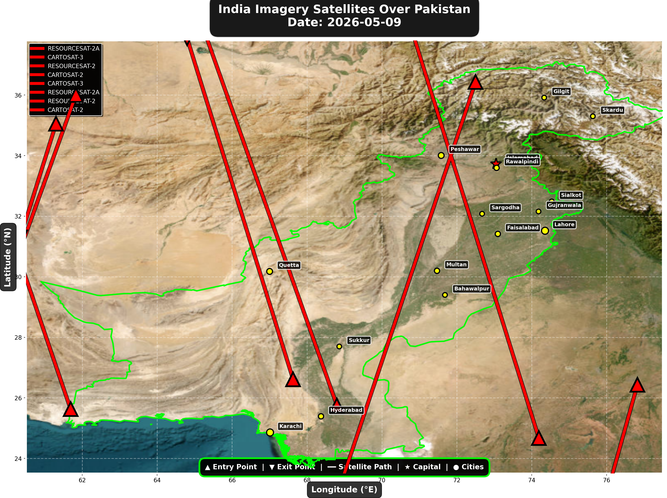

1. RESOURCESAT-2A (Earth Observation)
Entry Time | 2026-05-09 04:43:00 UTC
Entry Point | 26.43°N, 76.82°E
Exit Time | 2026-05-09 04:44:00 UTC
Duration Over Pakistan | 1.0 minutes
Maximum Altitude | 517.5 km
Direction of Travel | N/A
Owner/Operator | ISRO
➤ Entered Pakistani airspace from the east (Indian border - Punjab/Rajasthan sector), traveling N/A. Satellite remained over Pakistan for 1.0 minutes at altitude 517.5 km.

2. CARTOSAT-3 (Earth Observation)
Entry Time | 2026-05-09 05:51:00 UTC
Entry Point | 35.05°N, 61.3°E
Exit Time | 2026-05-09 05:52:00 UTC
Duration Over Pakistan | 1.0 minutes
Maximum Altitude | 515.3 km
Direction of Travel | N/A
Owner/Operator | ISRO
➤ Entered Pakistani airspace from the northwest (Afghanistan/China border region), traveling N/A. Satellite remained over Pakistan for 1.0 minutes at altitude 515.3 km.

3. RESOURCESAT-2 (Earth Observation)
Entry Time | 2026-05-09 06:24:00 UTC
Entry Point | 36.0°N, 61.83°E
Exit Time | 2026-05-09 06:26:00 UTC
Duration Over Pakistan | 2.0 minutes
Maximum Altitude | 832.9 km
Direction of Travel | N→S
Owner/Operator | ISRO
➤ Entered Pakistani airspace from the northwest (Afghanistan/China border region), traveling north to south. Satellite remained over Pakistan for 2.0 minutes at altitude 832.9 km.

4. CARTOSAT-2 (Earth Observation)
Entry Time | 2026-05-09 11:05:00 UTC
Entry Point | 25.75°N, 68.8°E
Exit Time | 2026-05-09 11:09:00 UTC
Duration Over Pakistan | 4.0 minutes
Maximum Altitude | 849.2 km
Direction of Travel | S→N
Owner/Operator | ISRO
➤ Entered Pakistani airspace from the south (Arabian Sea/Indian Ocean), traveling south to north. Satellite remained over Pakistan for 4.0 minutes at altitude 849.2 km.

5. CARTOSAT-3 (Earth Observation)
Entry Time | 2026-05-09 16:23:00 UTC
Entry Point | 24.67°N, 74.19°E
Exit Time | 2026-05-09 16:27:00 UTC
Duration Over Pakistan | 4.0 minutes
Maximum Altitude | 514.2 km
Direction of Travel | S→N
Owner/Operator | ISRO
➤ Entered Pakistani airspace from the south (Arabian Sea/Indian Ocean), traveling south to north. Satellite remained over Pakistan for 4.0 minutes at altitude 514.2 km.

6. RESOURCESAT-2A (Earth Observation)
Entry Time | 2026-05-09 16:48:00 UTC
Entry Point | 26.61°N, 67.63°E
Exit Time | 2026-05-09 16:51:00 UTC
Duration Over Pakistan | 3.0 minutes
Maximum Altitude | 511.9 km
Direction of Travel | S→N
Owner/Operator | ISRO
➤ Entered Pakistani airspace from the border region, traveling south to north. Satellite remained over Pakistan for 3.0 minutes at altitude 511.9 km.

7. RESOURCESAT-2 (Earth Observation)
Entry Time | 2026-05-09 17:40:00 UTC
Entry Point | 25.63°N, 61.69°E
Exit Time | 2026-05-09 17:42:00 UTC
Duration Over Pakistan | 2.0 minutes
Maximum Altitude | 819.3 km
Direction of Travel | S→N
Owner/Operator | ISRO
➤ Entered Pakistani airspace from the south (Arabian Sea/Indian Ocean), traveling south to north. Satellite remained over Pakistan for 2.0 minutes at altitude 819.3 km.

8. CARTOSAT-2 (Earth Observation)
Entry Time | 2026-05-09 23:30:00 UTC
Entry Point | 36.43°N, 72.5°E
Exit Time | 2026-05-09 23:34:00 UTC
Duration Over Pakistan | 4.0 minutes
Maximum Altitude | 836.8 km
Direction of Travel | N→S
Owner/Operator | ISRO
➤ Entered Pakistani airspace from the northeast (China/Kashmir border region), traveling north to south. Satellite remained over Pakistan for 4.0 minutes at altitude 836.8 km.

🇨🇳 CHINA IMAGERY SATELLITES
Visual Map - All China Satellite Paths:
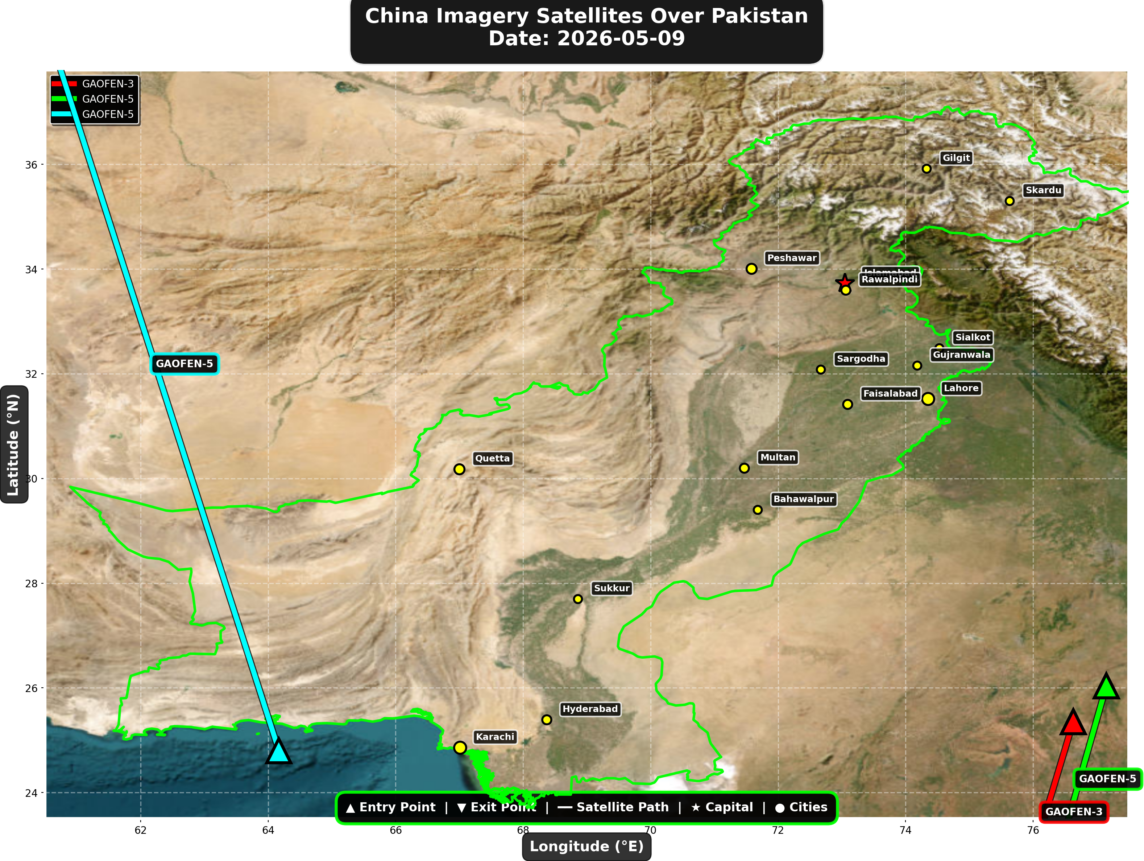

China reconnaissance and imaging satellites detected:
Satellite | Type | Entry Time | Duration (min) | Entry Point | Direction
GAOFEN-3 | Radar/SAR | 01:19:00 | 1.0 | 25.35°N, 76.63°E | N/A
GAOFEN-5 | Earth Observati | 05:57:00 | 1.0 | 26.04°N, 77.15°E | N/A
GAOFEN-5 | Earth Observati | 18:17:00 | 4.0 | 24.8°N, 64.17°E | S→N

🇺🇸 USA IMAGERY SATELLITES
Visual Map - All USA Satellite Paths:
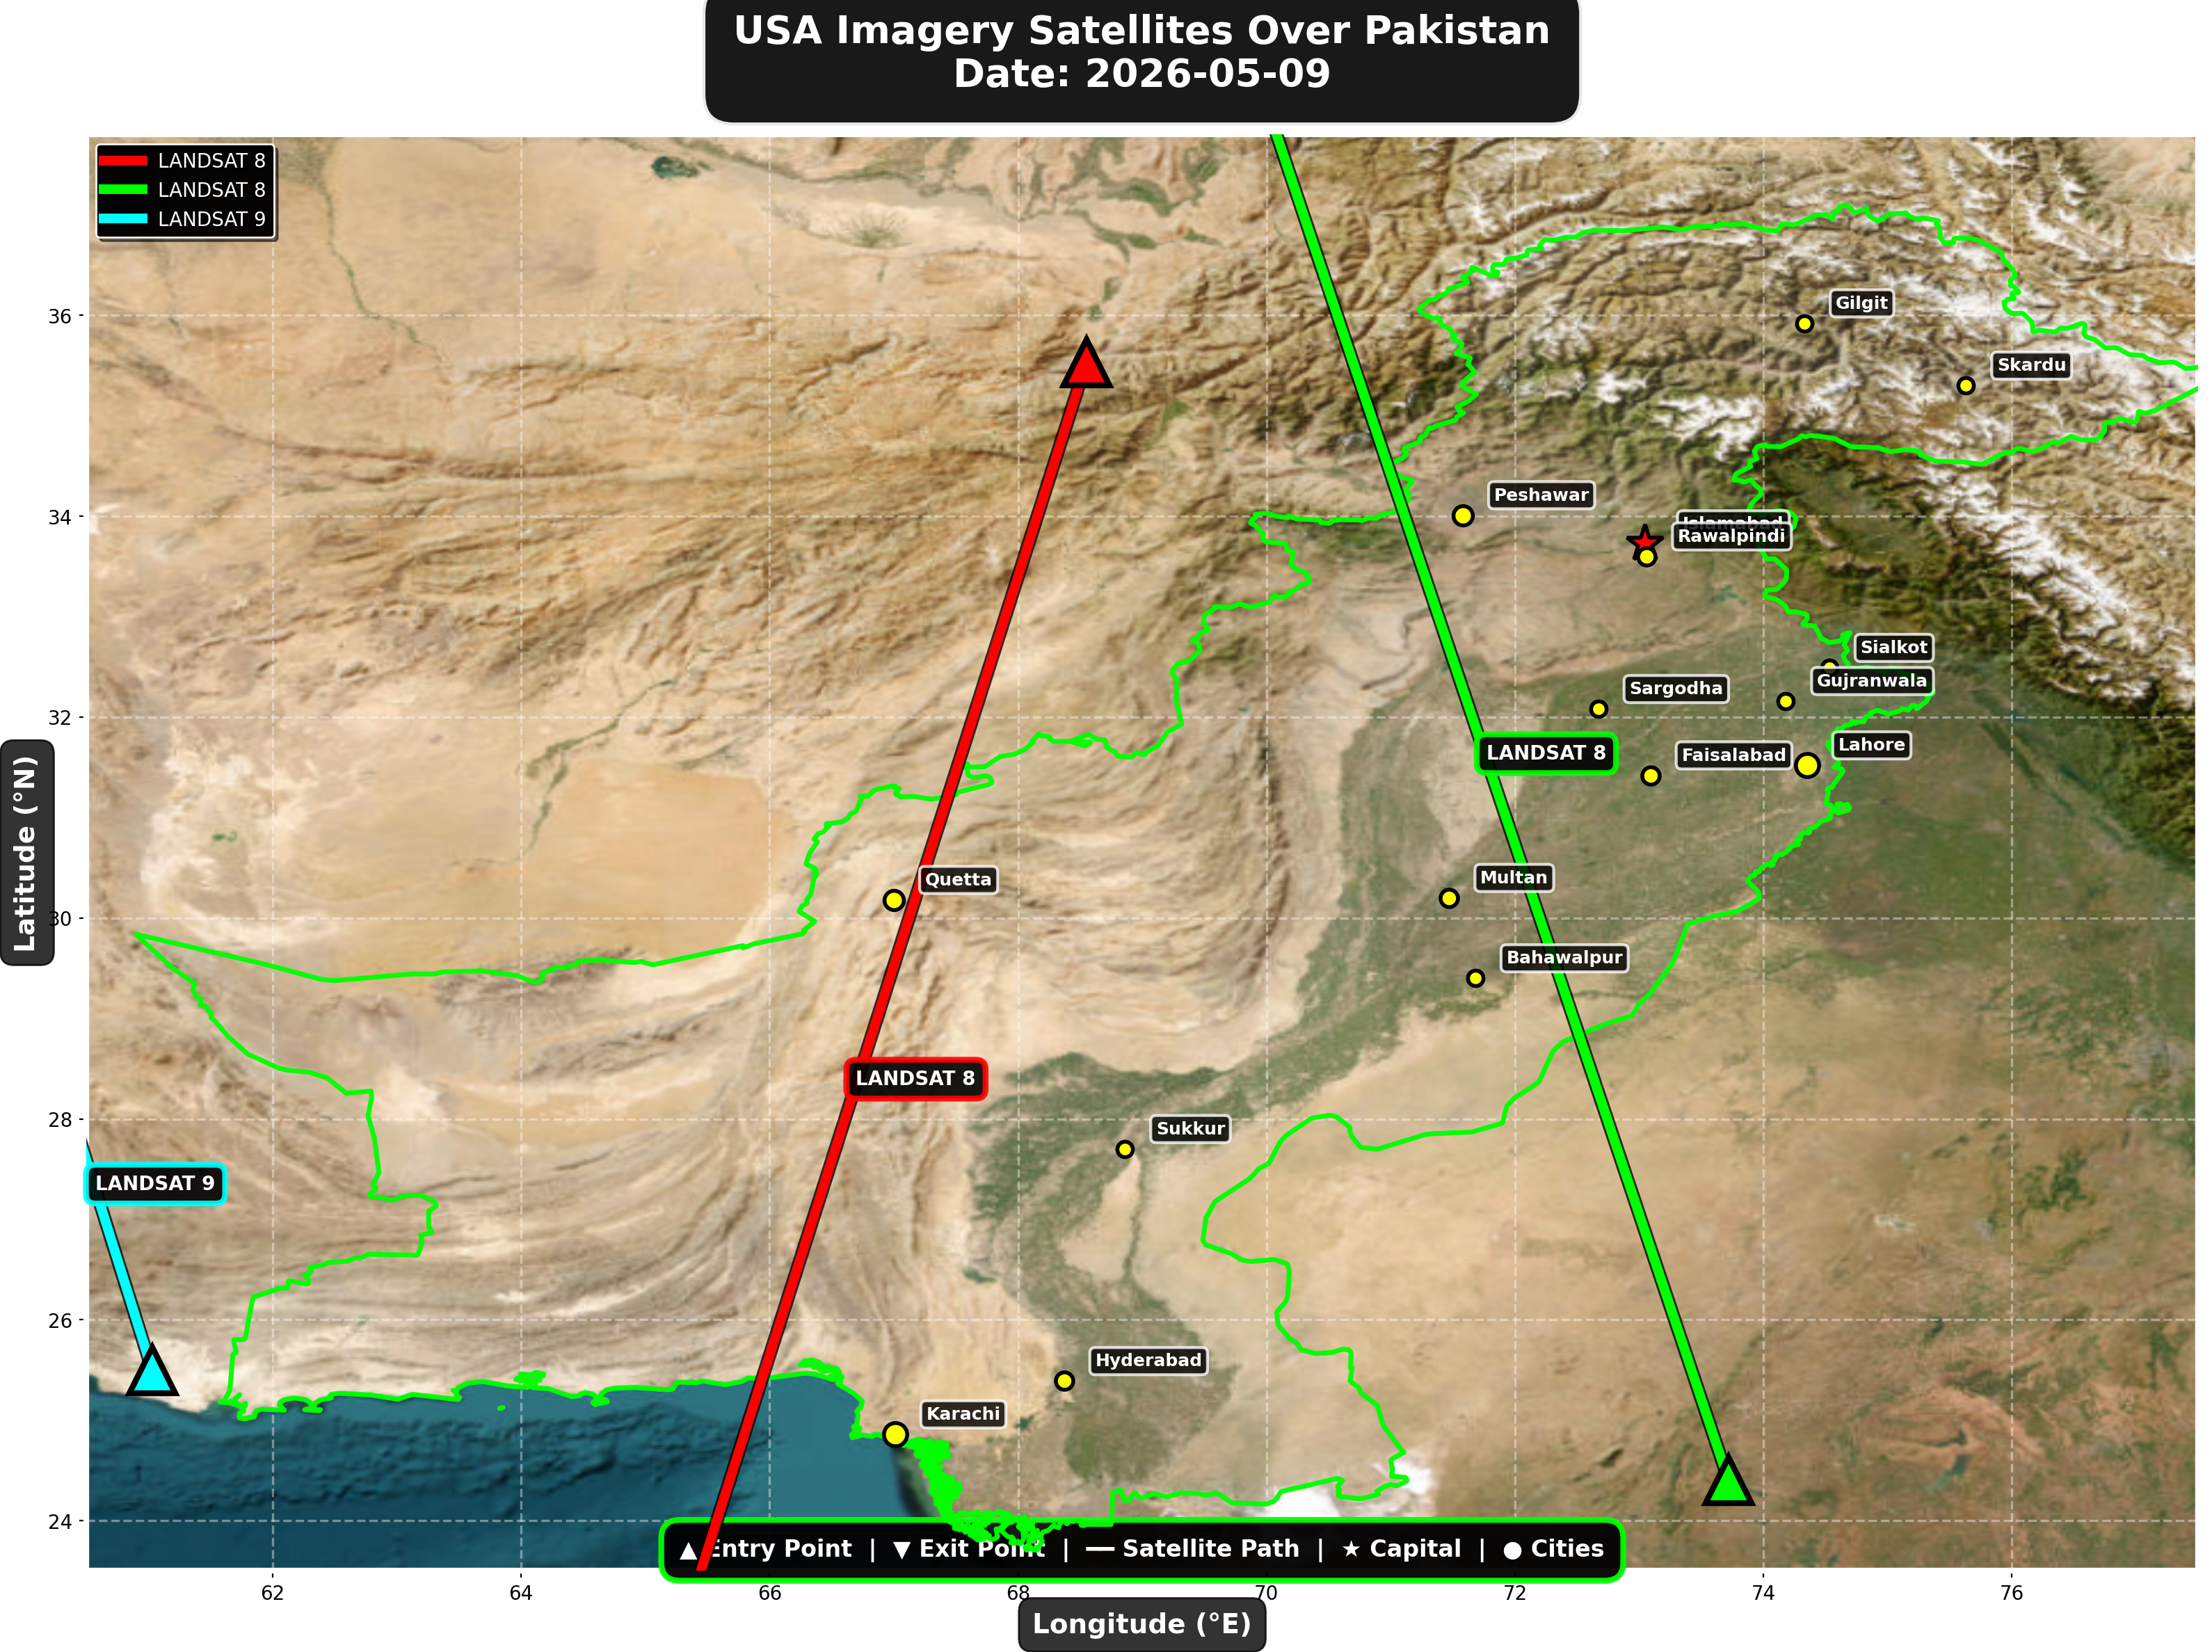

USA reconnaissance and imaging satellites detected:
Satellite | Type | Entry Time | Duration (min) | Entry Point | Direction
LANDSAT 8 | Earth Observati | 06:07:00 | 4.0 | 35.53°N, 68.55°E | N→S
LANDSAT 8 | Earth Observati | 17:06:00 | 4.0 | 24.4°N, 73.72°E | S→N
LANDSAT 9 | Earth Observati | 17:56:00 | 1.0 | 25.5°N, 61.03°E | N/A

Crossings by Country
Country | Crossings
China | 12
India | 8
USA | 7
Europe | 6
International | 2

Crossings by Satellite Type
Type | Crossings
Earth Observation | 13
Weather | 13
Space Station | 5
Reconnaissance | 3
Radar/SAR | 1

All Border Crossings (35 total)
# | Satellite | Owner | Country | Type | Entry Time | Duration (min) | Alt (km) | Direction
1 | GAOFEN-3 | CNSA | China | Radar/SAR | 2026-05-09 01:19:00 UTC | 1.0 | 758.2 | N/A
2 | TIANGONG | CNSA | China | Space Station | 2026-05-09 02:05:00 UTC | 4.0 | 391.5 | W→E
3 | YAOGAN-14 | PLA | China | Reconnaissance | 2026-05-09 02:36:00 UTC | 3.0 | 160.7 | N→S
4 | RESOURCESAT-2A | ISRO | India | Earth Observati | 2026-05-09 04:43:00 UTC | 1.0 | 517.5 | N/A
5 | METOP-B | EUMETSAT | Europe | Weather | 2026-05-09 05:19:00 UTC | 3.0 | 826.2 | N→S
6 | METOP-C | EUMETSAT | Europe | Weather | 2026-05-09 05:50:00 UTC | 3.0 | 827.3 | N→S
7 | CARTOSAT-3 | ISRO | India | Earth Observati | 2026-05-09 05:51:00 UTC | 1.0 | 515.3 | N/A
8 | GAOFEN-5 | CNSA | China | Earth Observati | 2026-05-09 05:57:00 UTC | 1.0 | 613.6 | N/A
9 | LANDSAT 8 | NASA/USGS | USA | Earth Observati | 2026-05-09 06:07:00 UTC | 4.0 | 709.0 | N→S
10 | RESOURCESAT-2 | ISRO | India | Earth Observati | 2026-05-09 06:24:00 UTC | 2.0 | 832.9 | N→S
11 | YAOGAN-26 | PLA | China | Reconnaissance | 2026-05-09 06:36:00 UTC | 4.0 | 773.8 | N→S
12 | NOAA-19 | NOAA | USA | Weather | 2026-05-09 07:06:00 UTC | 4.0 | 857.4 | N→S
13 | METOP-A | EUMETSAT | Europe | Weather | 2026-05-09 08:42:00 UTC | 4.0 | 563.5 | N→S
14 | NOAA-20 | NOAA | USA | Weather | 2026-05-09 09:08:00 UTC | 2.0 | 832.9 | S→N
15 | FENGYUN-3C | CMA | China | Weather | 2026-05-09 10:31:00 UTC | 2.0 | 828.6 | S→N
16 | CARTOSAT-2 | ISRO | India | Earth Observati | 2026-05-09 11:05:00 UTC | 4.0 | 849.2 | S→N
17 | FENGYUN-3D | CMA | China | Weather | 2026-05-09 11:06:00 UTC | 4.0 | 833.6 | S→N
18 | ISS | NASA/Roscosmos | International | Space Station | 2026-05-09 15:00:00 UTC | 3.0 | 421.2 | W→E
19 | CARTOSAT-3 | ISRO | India | Earth Observati | 2026-05-09 16:23:00 UTC | 4.0 | 514.2 | S→N
20 | METOP-B | EUMETSAT | Europe | Weather | 2026-05-09 16:35:00 UTC | 3.0 | 826.9 | S→N
21 | RESOURCESAT-2A | ISRO | India | Earth Observati | 2026-05-09 16:48:00 UTC | 3.0 | 511.9 | S→N
22 | LANDSAT 8 | NASA/USGS | USA | Earth Observati | 2026-05-09 17:06:00 UTC | 4.0 | 709.4 | S→N
23 | METOP-C | EUMETSAT | Europe | Weather | 2026-05-09 17:06:00 UTC | 3.0 | 827.3 | S→N
24 | YAOGAN-26 | PLA | China | Reconnaissance | 2026-05-09 17:39:00 UTC | 4.0 | 966.1 | S→N
25 | RESOURCESAT-2 | ISRO | India | Earth Observati | 2026-05-09 17:40:00 UTC | 2.0 | 819.3 | S→N
26 | LANDSAT 9 | NASA/USGS | USA | Earth Observati | 2026-05-09 17:56:00 UTC | 1.0 | 709.4 | N/A
27 | GAOFEN-5 | CNSA | China | Earth Observati | 2026-05-09 18:17:00 UTC | 4.0 | 619.0 | S→N
28 | NOAA-19 | NOAA | USA | Weather | 2026-05-09 18:26:00 UTC | 3.0 | 860.9 | S→N
29 | TIANGONG | CNSA | China | Space Station | 2026-05-09 18:37:00 UTC | 2.0 | 390.0 | W→E
30 | METOP-A | EUMETSAT | Europe | Weather | 2026-05-09 19:33:00 UTC | 4.0 | 766.7 | S→N
31 | TIANGONG | CNSA | China | Space Station | 2026-05-09 20:13:00 UTC | 4.0 | 391.0 | W→E
32 | NOAA-20 | NOAA | USA | Weather | 2026-05-09 21:31:00 UTC | 4.0 | 834.2 | N→S
33 | ISS | NASA/Roscosmos | International | Space Station | 2026-05-09 23:10:00 UTC | 3.0 | 427.2 | W→E
34 | FENGYUN-3D | CMA | China | Weather | 2026-05-09 23:29:00 UTC | 4.0 | 832.1 | N→S
35 | CARTOSAT-2 | ISRO | India | Earth Observati | 2026-05-09 23:30:00 UTC | 4.0 | 836.8 | N→S

