ATLAS — Pakistan Border Satellite Surveillance Report
Date: 2026-05-10 | Generated: 2026-05-11 09:34:25

Executive Summary
Total Border Crossings | 35
Unique Satellites | 19
Indian Satellites Detected | 7 crossings (4 unique)
Indian Imagery Satellites | 7 crossings
Anomalies Detected | 1
Surveillance Region | 23.5°N–37.5°N, 60.5°E–77.5°E

🇮🇳 INDIAN SATELLITE ACTIVITY (7 crossings)
Indian Space Research Organisation (ISRO) satellites detected over Pakistan:

Satellite | Type | Crossings | Primary Purpose
CARTOSAT-2 | Earth Observation | 2 | High-resolution Earth imaging for cartography, urban planning, and military reconnaissance
CARTOSAT-3 | Earth Observation | 2 | High-resolution Earth imaging for cartography, urban planning, and military reconnaissance
RESOURCESAT-2 | Earth Observation | 2 | Natural resource monitoring, agriculture, forestry, and land use mapping
RESOURCESAT-2A | Earth Observation | 1 | Natural resource monitoring, agriculture, forestry, and land use mapping

📷 INDIAN IMAGERY SATELLITES - BORDER CROSSING DETAILS
Detailed entry/exit points for Indian reconnaissance and imaging satellites:

Visual Map - All Indian Satellite Paths:
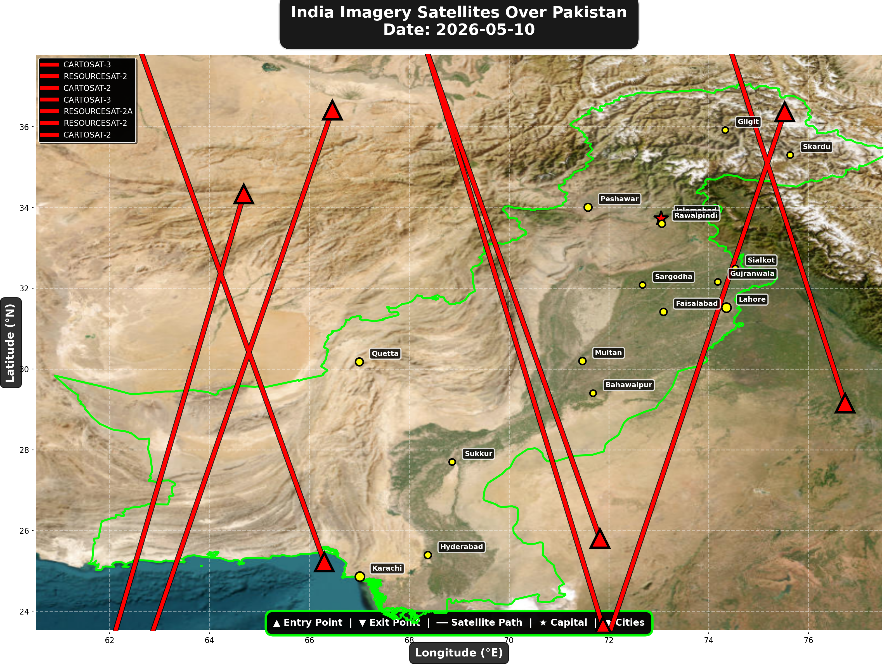

1. CARTOSAT-3 (Earth Observation)
Entry Time | 2026-05-10 05:33:00 UTC
Entry Point | 34.33°N, 64.69°E
Exit Time | 2026-05-10 05:36:00 UTC
Duration Over Pakistan | 3.0 minutes
Maximum Altitude | 515.5 km
Direction of Travel | N→S
Owner/Operator | ISRO
➤ Entered Pakistani airspace from the border region, traveling north to south. Satellite remained over Pakistan for 3.0 minutes at altitude 515.5 km.

2. RESOURCESAT-2 (Earth Observation)
Entry Time | 2026-05-10 06:02:00 UTC
Entry Point | 36.41°N, 66.46°E
Exit Time | 2026-05-10 06:06:00 UTC
Duration Over Pakistan | 4.0 minutes
Maximum Altitude | 833.5 km
Direction of Travel | N→S
Owner/Operator | ISRO
➤ Entered Pakistani airspace from the northwest (Afghanistan/China border region), traveling north to south. Satellite remained over Pakistan for 4.0 minutes at altitude 833.5 km.

3. CARTOSAT-2 (Earth Observation)
Entry Time | 2026-05-10 10:49:00 UTC
Entry Point | 25.8°N, 71.82°E
Exit Time | 2026-05-10 10:53:00 UTC
Duration Over Pakistan | 4.0 minutes
Maximum Altitude | 849.2 km
Direction of Travel | S→N
Owner/Operator | ISRO
➤ Entered Pakistani airspace from the south (Arabian Sea/Indian Ocean), traveling south to north. Satellite remained over Pakistan for 4.0 minutes at altitude 849.2 km.

4. CARTOSAT-3 (Earth Observation)
Entry Time | 2026-05-10 16:06:00 UTC
Entry Point | 29.15°N, 76.73°E
Exit Time | 2026-05-10 16:09:00 UTC
Duration Over Pakistan | 3.0 minutes
Maximum Altitude | 514.1 km
Direction of Travel | S→N
Owner/Operator | ISRO
➤ Entered Pakistani airspace from the east (Indian border - Punjab/Rajasthan sector), traveling south to north. Satellite remained over Pakistan for 3.0 minutes at altitude 514.1 km.

5. RESOURCESAT-2A (Earth Observation)
Entry Time | 2026-05-10 16:29:00 UTC
Entry Point | 23.62°N, 71.88°E
Exit Time | 2026-05-10 16:33:00 UTC
Duration Over Pakistan | 4.0 minutes
Maximum Altitude | 511.9 km
Direction of Travel | S→N
Owner/Operator | ISRO
➤ Entered Pakistani airspace from the south (Arabian Sea/Indian Ocean), traveling south to north. Satellite remained over Pakistan for 4.0 minutes at altitude 511.9 km.

6. RESOURCESAT-2 (Earth Observation)
Entry Time | 2026-05-10 17:18:00 UTC
Entry Point | 25.22°N, 66.3°E
Exit Time | 2026-05-10 17:22:00 UTC
Duration Over Pakistan | 4.0 minutes
Maximum Altitude | 819.6 km
Direction of Travel | S→N
Owner/Operator | ISRO
➤ Entered Pakistani airspace from the south (Arabian Sea/Indian Ocean), traveling south to north. Satellite remained over Pakistan for 4.0 minutes at altitude 819.6 km.

7. CARTOSAT-2 (Earth Observation)
Entry Time | 2026-05-10 23:14:00 UTC
Entry Point | 36.37°N, 75.52°E
Exit Time | 2026-05-10 23:18:00 UTC
Duration Over Pakistan | 4.0 minutes
Maximum Altitude | 836.8 km
Direction of Travel | N→S
Owner/Operator | ISRO
➤ Entered Pakistani airspace from the northeast (China/Kashmir border region), traveling north to south. Satellite remained over Pakistan for 4.0 minutes at altitude 836.8 km.

🇨🇳 CHINA IMAGERY SATELLITES
Visual Map - All China Satellite Paths:
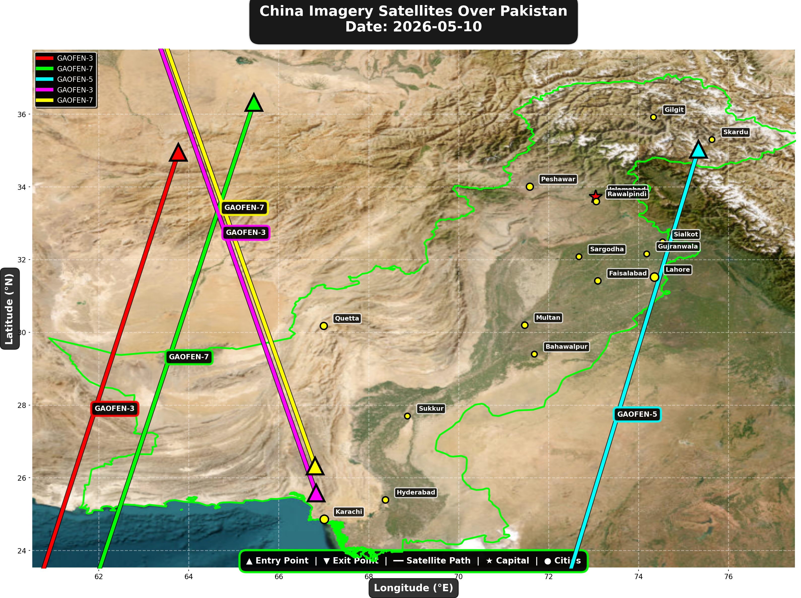

China reconnaissance and imaging satellites detected:
Satellite | Type | Entry Time | Duration (min) | Entry Point | Direction
GAOFEN-3 | Radar/SAR | 02:14:00 | 4.0 | 34.95°N, 63.77°E | N→S
GAOFEN-7 | Earth Observati | 02:21:00 | 4.0 | 36.32°N, 65.45°E | N→S
GAOFEN-5 | Earth Observati | 06:07:00 | 4.0 | 35.03°N, 75.33°E | N→S
GAOFEN-3 | Radar/SAR | 13:20:00 | 4.0 | 25.58°N, 66.83°E | S→N
GAOFEN-7 | Earth Observati | 13:32:00 | 4.0 | 26.32°N, 66.81°E | S→N

🇺🇸 USA IMAGERY SATELLITES
Visual Map - All USA Satellite Paths:
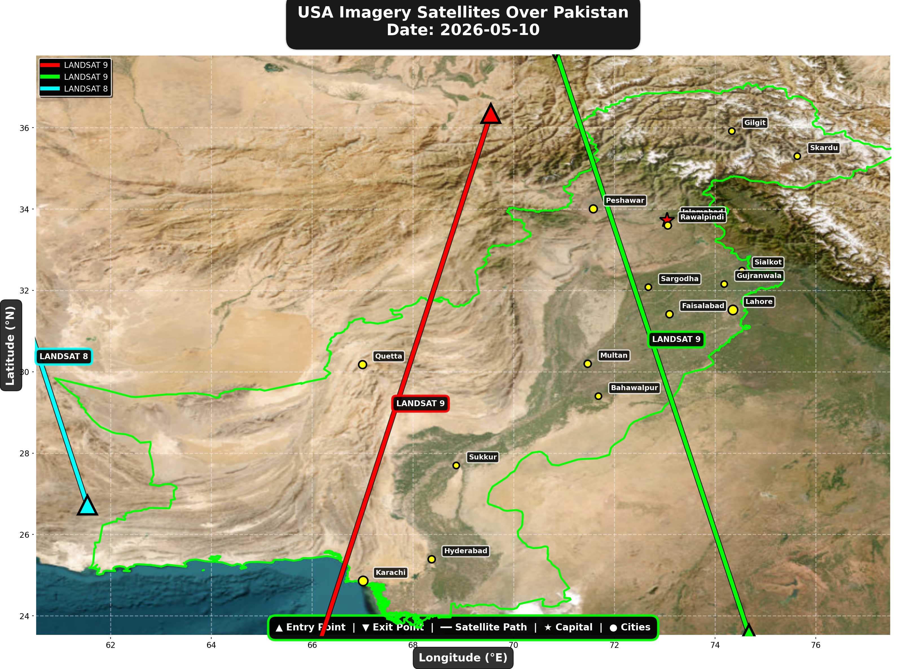

USA reconnaissance and imaging satellites detected:
Satellite | Type | Entry Time | Duration (min) | Entry Point | Direction
LANDSAT 9 | Earth Observati | 06:00:00 | 4.0 | 36.35°N, 69.55°E | N→S
LANDSAT 9 | Earth Observati | 16:59:00 | 4.0 | 23.55°N, 74.67°E | S→N
LANDSAT 8 | Earth Observati | 17:49:00 | 2.0 | 26.72°N, 61.54°E | S→N

⚠ ANOMALIES DETECTED (1)
- [HIGH] LONG_DURATION: ISS
Owner: NASA/Roscosmos | NORAD 25544
Details: Duration 5.0min is 71% longer than avg 2.9min

Crossings by Country
Country | Crossings
China | 14
India | 7
USA | 7
Europe | 5
International | 2

Crossings by Satellite Type
Type | Crossings
Earth Observation | 13
Weather | 11
Space Station | 6
Reconnaissance | 3
Radar/SAR | 2

All Border Crossings (35 total)
# | Satellite | Owner | Country | Type | Entry Time | Duration (min) | Alt (km) | Direction
1 | TIANGONG | CNSA | China | Space Station | 2026-05-10 01:06:00 UTC | 2.0 | 391.6 | W→E
2 | GAOFEN-3 | CNSA | China | Radar/SAR | 2026-05-10 02:14:00 UTC | 4.0 | 758.2 | N→S
3 | GAOFEN-7 | CNSA | China | Earth Observati | 2026-05-10 02:21:00 UTC | 4.0 | 791.6 | N→S
4 | TIANGONG | CNSA | China | Space Station | 2026-05-10 02:42:00 UTC | 3.0 | 391.3 | W→E
5 | YAOGAN-14 | PLA | China | Reconnaissance | 2026-05-10 03:23:00 UTC | 4.0 | 161.0 | N→S
6 | METOP-B | EUMETSAT | Europe | Weather | 2026-05-10 04:57:00 UTC | 4.0 | 826.3 | N→S
7 | METOP-C | EUMETSAT | Europe | Weather | 2026-05-10 05:28:00 UTC | 4.0 | 827.3 | N→S
8 | CARTOSAT-3 | ISRO | India | Earth Observati | 2026-05-10 05:33:00 UTC | 3.0 | 515.5 | N→S
9 | YAOGAN-26 | PLA | China | Reconnaissance | 2026-05-10 05:51:00 UTC | 4.0 | 782.1 | N→S
10 | LANDSAT 9 | NASA/USGS | USA | Earth Observati | 2026-05-10 06:00:00 UTC | 4.0 | 708.9 | N→S
11 | RESOURCESAT-2 | ISRO | India | Earth Observati | 2026-05-10 06:02:00 UTC | 4.0 | 833.5 | N→S
12 | GAOFEN-5 | CNSA | China | Earth Observati | 2026-05-10 06:07:00 UTC | 4.0 | 614.5 | N→S
13 | NOAA-19 | NOAA | USA | Weather | 2026-05-10 06:52:00 UTC | 4.0 | 857.4 | N→S
14 | NOAA-20 | NOAA | USA | Weather | 2026-05-10 08:48:00 UTC | 4.0 | 832.9 | S→N
15 | FENGYUN-3D | CMA | China | Weather | 2026-05-10 10:46:00 UTC | 4.0 | 833.6 | S→N
16 | CARTOSAT-2 | ISRO | India | Earth Observati | 2026-05-10 10:49:00 UTC | 4.0 | 849.2 | S→N
17 | GAOFEN-3 | CNSA | China | Radar/SAR | 2026-05-10 13:20:00 UTC | 4.0 | 757.9 | S→N
18 | GAOFEN-7 | CNSA | China | Earth Observati | 2026-05-10 13:32:00 UTC | 4.0 | 792.1 | S→N
19 | ISS | NASA/Roscosmos | International | Space Station | 2026-05-10 14:12:00 UTC | 5.0 | 421.3 | W→E
20 | YAOGAN-14 | PLA | China | Reconnaissance | 2026-05-10 14:35:00 UTC | 3.0 | 163.6 | S→N
21 | CARTOSAT-3 | ISRO | India | Earth Observati | 2026-05-10 16:06:00 UTC | 3.0 | 514.1 | S→N
22 | METOP-B | EUMETSAT | Europe | Weather | 2026-05-10 16:13:00 UTC | 4.0 | 826.9 | S→N
23 | RESOURCESAT-2A | ISRO | India | Earth Observati | 2026-05-10 16:29:00 UTC | 4.0 | 511.9 | S→N
24 | METOP-C | EUMETSAT | Europe | Weather | 2026-05-10 16:44:00 UTC | 4.0 | 827.3 | S→N
25 | LANDSAT 9 | NASA/USGS | USA | Earth Observati | 2026-05-10 16:59:00 UTC | 4.0 | 709.4 | S→N
26 | RESOURCESAT-2 | ISRO | India | Earth Observati | 2026-05-10 17:18:00 UTC | 4.0 | 819.6 | S→N
27 | LANDSAT 8 | NASA/USGS | USA | Earth Observati | 2026-05-10 17:49:00 UTC | 2.0 | 709.3 | S→N
28 | NOAA-19 | NOAA | USA | Weather | 2026-05-10 18:12:00 UTC | 4.0 | 861.3 | S→N
29 | TIANGONG | CNSA | China | Space Station | 2026-05-10 19:12:00 UTC | 4.0 | 390.4 | W→E
30 | METOP-A | EUMETSAT | Europe | Weather | 2026-05-10 19:57:00 UTC | 4.0 | 765.8 | S→N
31 | TIANGONG | CNSA | China | Space Station | 2026-05-10 20:50:00 UTC | 2.0 | 391.0 | W→E
32 | NOAA-20 | NOAA | USA | Weather | 2026-05-10 21:12:00 UTC | 4.0 | 834.3 | N→S
33 | ISS | NASA/Roscosmos | International | Space Station | 2026-05-10 22:23:00 UTC | 4.0 | 427.1 | W→E
34 | FENGYUN-3D | CMA | China | Weather | 2026-05-10 23:09:00 UTC | 4.0 | 832.1 | N→S
35 | CARTOSAT-2 | ISRO | India | Earth Observati | 2026-05-10 23:14:00 UTC | 4.0 | 836.8 | N→S

