ATLAS — Pakistan Border Satellite Surveillance Report
Date: 2026-05-11 | Generated: 2026-05-12 09:12:13

Executive Summary
Total Border Crossings | 42
Unique Satellites | 21
Indian Satellites Detected | 7 crossings (4 unique)
Indian Imagery Satellites | 7 crossings
Anomalies Detected | 2
Surveillance Region | 23.5°N–37.5°N, 60.5°E–77.5°E

🇮🇳 INDIAN SATELLITE ACTIVITY (7 crossings)
Indian Space Research Organisation (ISRO) satellites detected over Pakistan:

Satellite | Type | Crossings | Primary Purpose
CARTOSAT-2 | Earth Observation | 2 | High-resolution Earth imaging for cartography, urban planning, and military reconnaissance
CARTOSAT-3 | Earth Observation | 1 | High-resolution Earth imaging for cartography, urban planning, and military reconnaissance
RESOURCESAT-2 | Earth Observation | 2 | Natural resource monitoring, agriculture, forestry, and land use mapping
RESOURCESAT-2A | Earth Observation | 2 | Natural resource monitoring, agriculture, forestry, and land use mapping

📷 INDIAN IMAGERY SATELLITES - BORDER CROSSING DETAILS
Detailed entry/exit points for Indian reconnaissance and imaging satellites:

Visual Map - All Indian Satellite Paths:
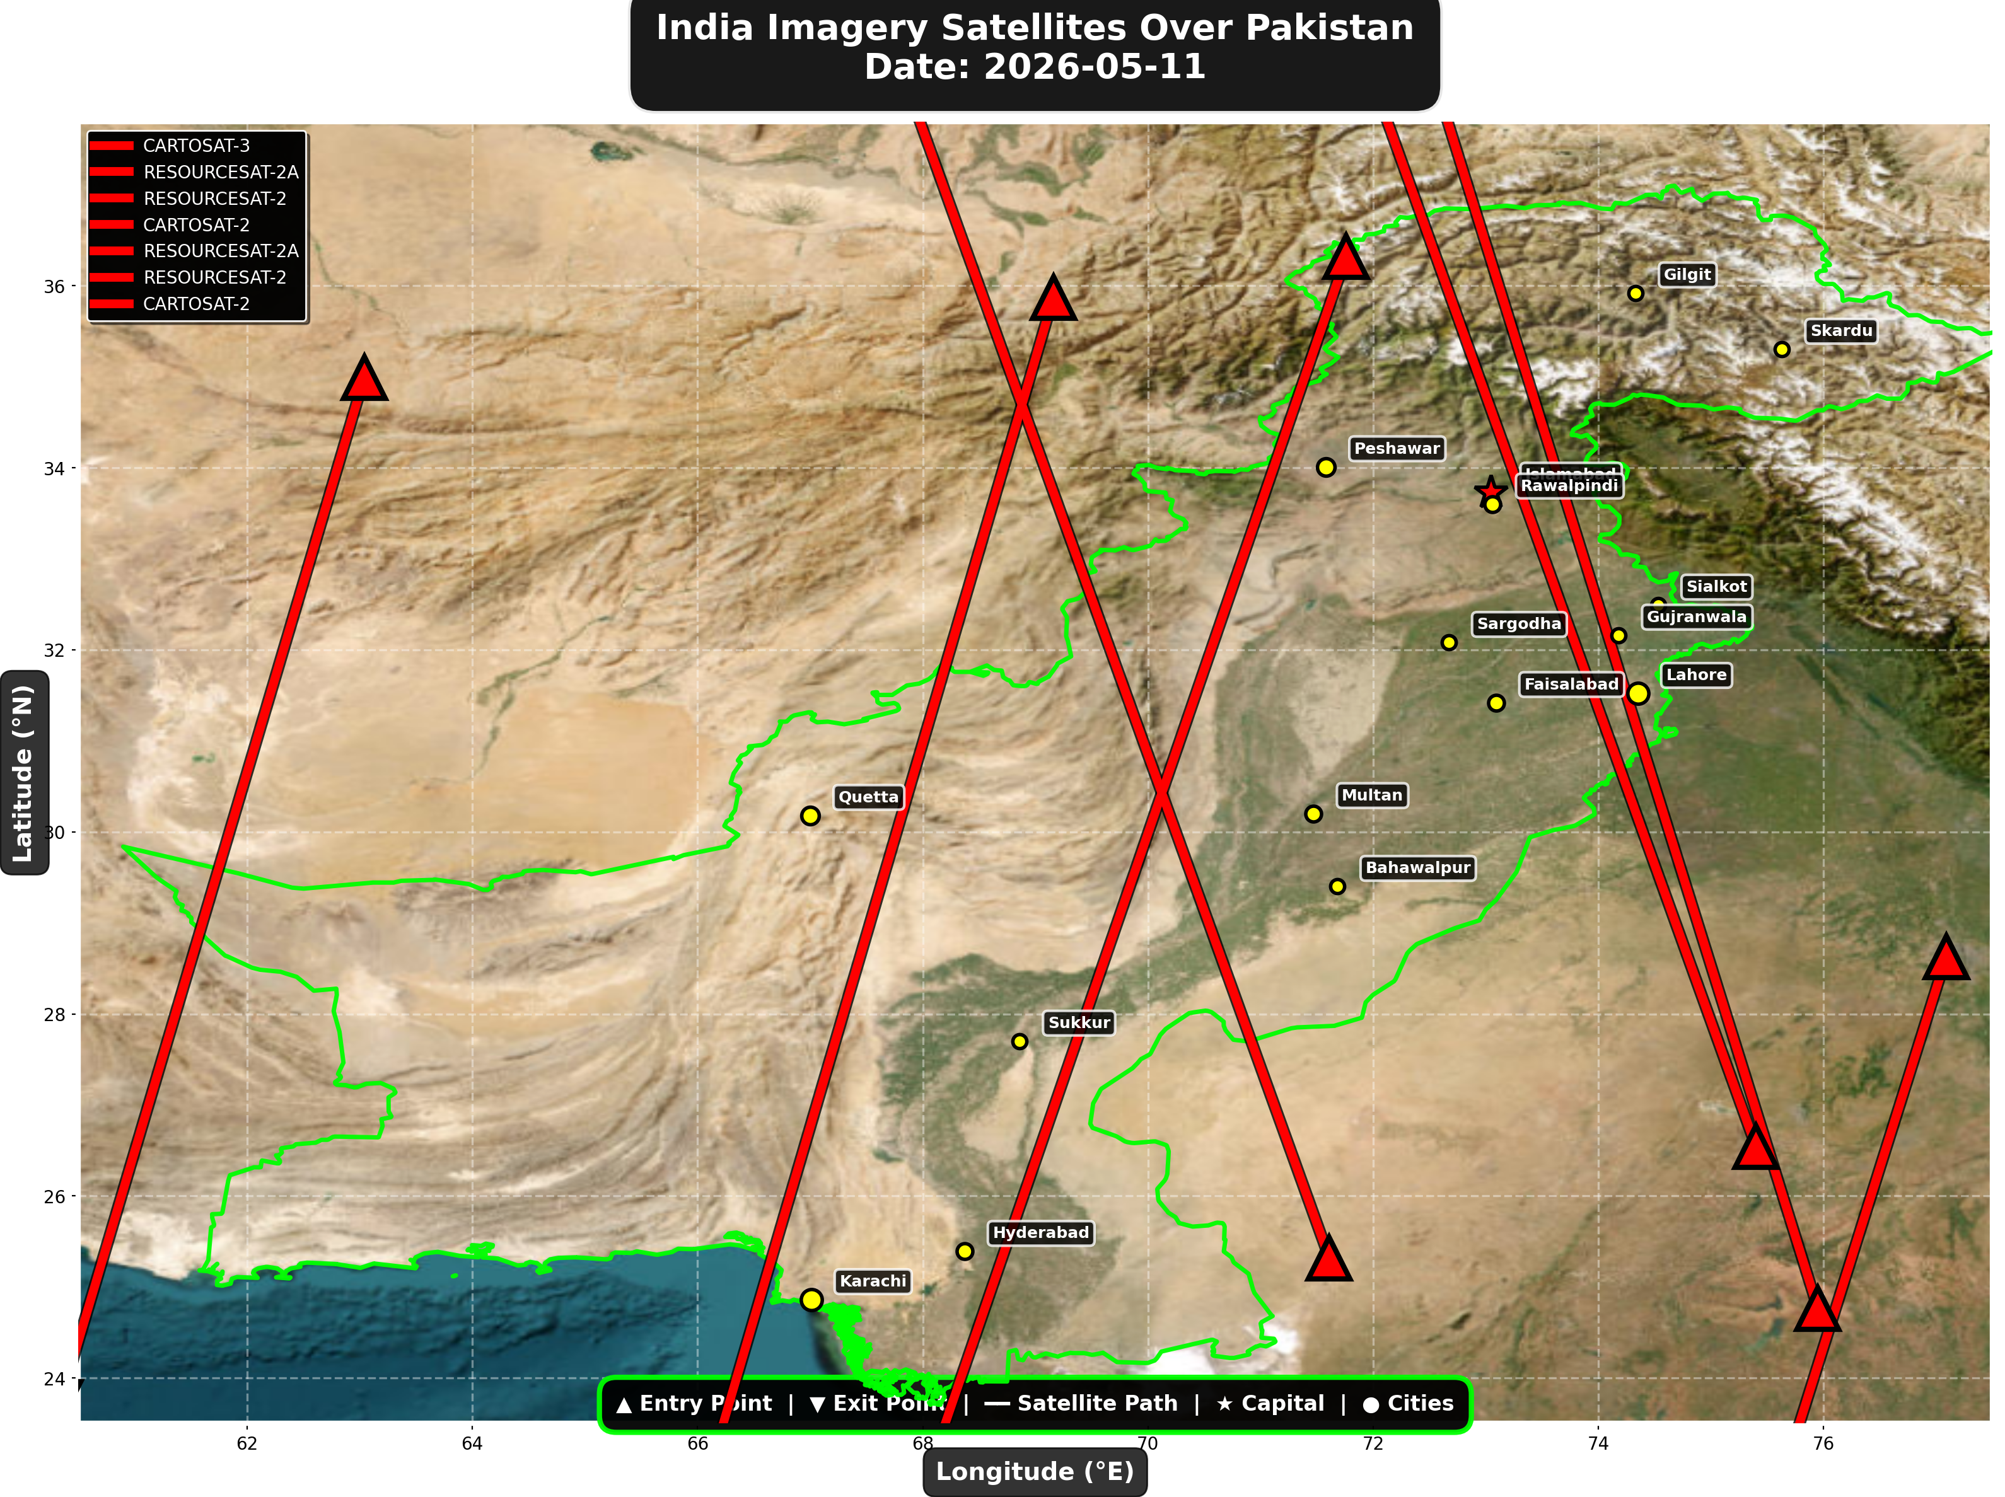

1. CARTOSAT-3 (Earth Observation)
Entry Time | 2026-05-11 05:15:00 UTC
Entry Point | 35.87°N, 69.16°E
Exit Time | 2026-05-11 05:19:00 UTC
Duration Over Pakistan | 4.0 minutes
Maximum Altitude | 515.6 km
Direction of Travel | N→S
Owner/Operator | ISRO
➤ Entered Pakistani airspace from the northwest (Afghanistan/China border region), traveling north to south. Satellite remained over Pakistan for 4.0 minutes at altitude 515.6 km.

2. RESOURCESAT-2A (Earth Observation)
Entry Time | 2026-05-11 05:40:00 UTC
Entry Point | 34.99°N, 63.04°E
Exit Time | 2026-05-11 05:43:00 UTC
Duration Over Pakistan | 3.0 minutes
Maximum Altitude | 517.6 km
Direction of Travel | N→S
Owner/Operator | ISRO
➤ Entered Pakistani airspace from the border region, traveling north to south. Satellite remained over Pakistan for 3.0 minutes at altitude 517.6 km.

3. RESOURCESAT-2 (Earth Observation)
Entry Time | 2026-05-11 05:41:00 UTC
Entry Point | 36.32°N, 71.76°E
Exit Time | 2026-05-11 05:45:00 UTC
Duration Over Pakistan | 4.0 minutes
Maximum Altitude | 833.7 km
Direction of Travel | N→S
Owner/Operator | ISRO
➤ Entered Pakistani airspace from the northwest (Afghanistan/China border region), traveling north to south. Satellite remained over Pakistan for 4.0 minutes at altitude 833.7 km.

4. CARTOSAT-2 (Earth Observation)
Entry Time | 2026-05-11 10:34:00 UTC
Entry Point | 26.54°N, 75.4°E
Exit Time | 2026-05-11 10:38:00 UTC
Duration Over Pakistan | 4.0 minutes
Maximum Altitude | 848.5 km
Direction of Travel | S→N
Owner/Operator | ISRO
➤ Entered Pakistani airspace from the east (Indian border - Punjab/Rajasthan sector), traveling south to north. Satellite remained over Pakistan for 4.0 minutes at altitude 848.5 km.

5. RESOURCESAT-2A (Earth Observation)
Entry Time | 2026-05-11 16:12:00 UTC
Entry Point | 24.76°N, 75.95°E
Exit Time | 2026-05-11 16:16:00 UTC
Duration Over Pakistan | 4.0 minutes
Maximum Altitude | 512.0 km
Direction of Travel | S→N
Owner/Operator | ISRO
➤ Entered Pakistani airspace from the south (Arabian Sea/Indian Ocean), traveling south to north. Satellite remained over Pakistan for 4.0 minutes at altitude 512.0 km.

6. RESOURCESAT-2 (Earth Observation)
Entry Time | 2026-05-11 16:57:00 UTC
Entry Point | 25.32°N, 71.61°E
Exit Time | 2026-05-11 17:01:00 UTC
Duration Over Pakistan | 4.0 minutes
Maximum Altitude | 819.9 km
Direction of Travel | S→N
Owner/Operator | ISRO
➤ Entered Pakistani airspace from the south (Arabian Sea/Indian Ocean), traveling south to north. Satellite remained over Pakistan for 4.0 minutes at altitude 819.9 km.

7. CARTOSAT-2 (Earth Observation)
Entry Time | 2026-05-11 23:01:00 UTC
Entry Point | 28.63°N, 77.09°E
Exit Time | 2026-05-11 23:03:00 UTC
Duration Over Pakistan | 2.0 minutes
Maximum Altitude | 837.1 km
Direction of Travel | N→S
Owner/Operator | ISRO
➤ Entered Pakistani airspace from the east (Indian border - Punjab/Rajasthan sector), traveling north to south. Satellite remained over Pakistan for 2.0 minutes at altitude 837.1 km.

🇨🇳 CHINA IMAGERY SATELLITES
Visual Map - All China Satellite Paths:
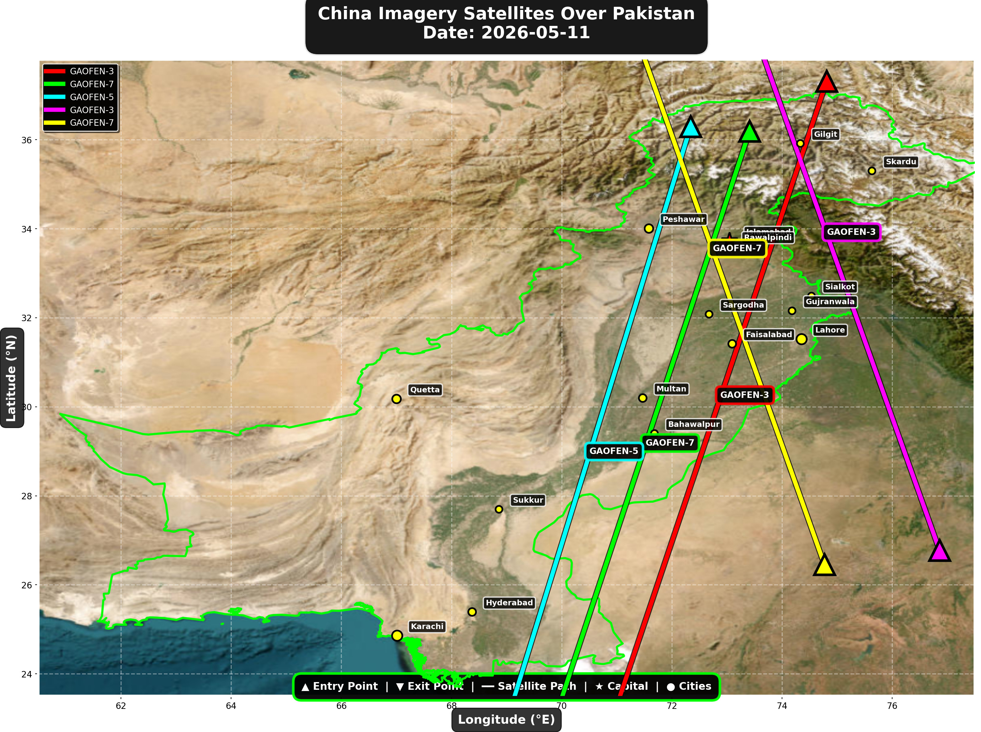

China reconnaissance and imaging satellites detected:
Satellite | Type | Entry Time | Duration (min) | Entry Point | Direction
GAOFEN-3 | Radar/SAR | 01:32:00 | 4.0 | 37.31°N, 74.81°E | N→S
GAOFEN-7 | Earth Observati | 01:49:00 | 4.0 | 36.19°N, 73.41°E | N→S
GAOFEN-5 | Earth Observati | 06:20:00 | 4.0 | 36.29°N, 72.34°E | N→S
GAOFEN-3 | Radar/SAR | 12:39:00 | 4.0 | 26.77°N, 76.86°E | S→N
GAOFEN-7 | Earth Observati | 13:00:00 | 4.0 | 26.45°N, 74.77°E | S→N

🇺🇸 USA IMAGERY SATELLITES
Visual Map - All USA Satellite Paths:
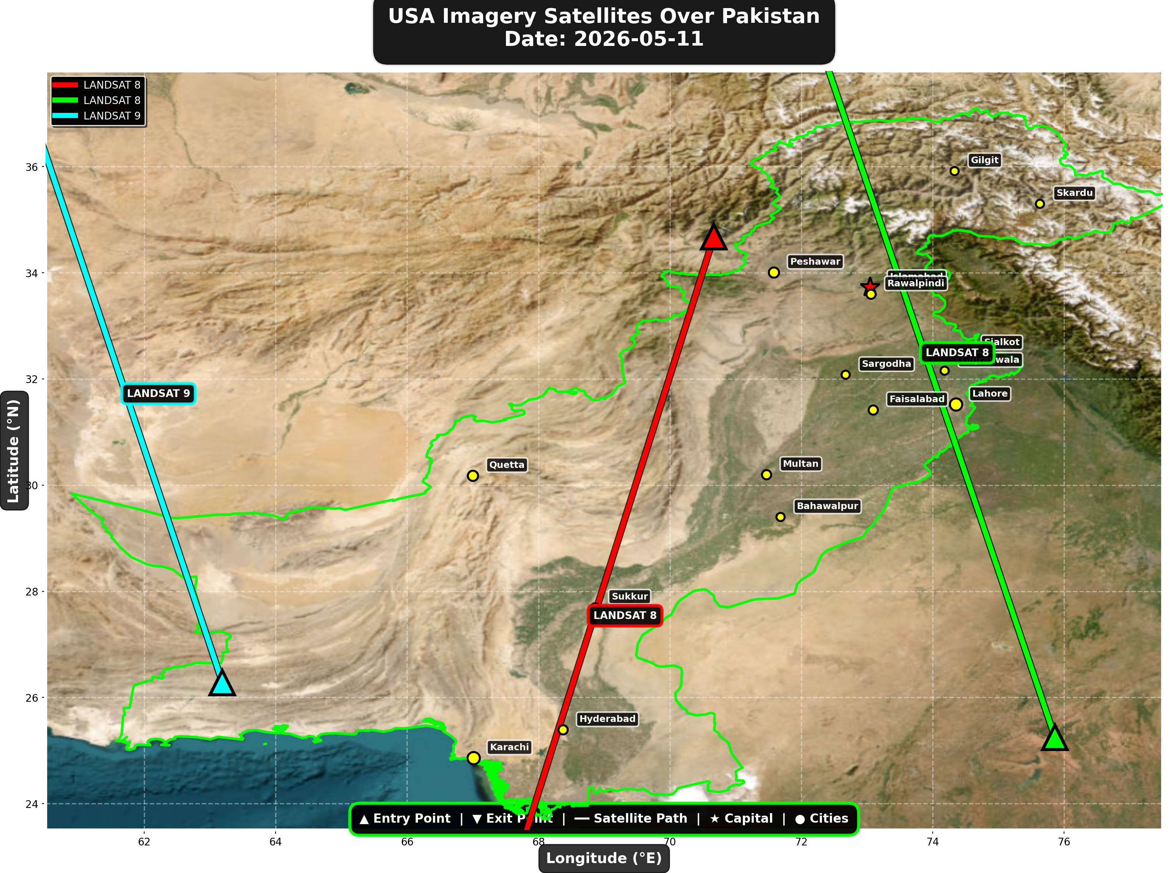

USA reconnaissance and imaging satellites detected:
Satellite | Type | Entry Time | Duration (min) | Entry Point | Direction
LANDSAT 8 | Earth Observati | 05:54:00 | 4.0 | 34.68°N, 70.67°E | N→S
LANDSAT 8 | Earth Observati | 16:53:00 | 4.0 | 25.25°N, 75.86°E | S→N
LANDSAT 9 | Earth Observati | 17:43:00 | 3.0 | 26.28°N, 63.19°E | S→N

⚠ ANOMALIES DETECTED (2)
- [HIGH] LONG_DURATION: TIANGONG
Owner: CNSA | NORAD 48274
Details: Duration 5.0min is 59% longer than avg 3.1min
- [MEDIUM] INCREASED_FREQUENCY: FENGYUN-3C
Owner: CMA | NORAD 40069
Details: 3 crossings today vs avg 1.6 per day

Crossings by Country
Country | Crossings
China | 17
USA | 9
India | 7
Europe | 5
International | 4

Crossings by Satellite Type
Type | Crossings
Weather | 16
Earth Observation | 13
Space Station | 7
Reconnaissance | 4
Radar/SAR | 2

All Border Crossings (42 total)
# | Satellite | Owner | Country | Type | Entry Time | Duration (min) | Alt (km) | Direction
1 | FENGYUN-3C | CMA | China | Weather | 2026-05-11 00:12:00 UTC | 3.0 | 823.2 | N→S
2 | GAOFEN-3 | CNSA | China | Radar/SAR | 2026-05-11 01:32:00 UTC | 4.0 | 758.2 | N→S
3 | TIANGONG | CNSA | China | Space Station | 2026-05-11 01:41:00 UTC | 5.0 | 391.4 | W→E
4 | GAOFEN-7 | CNSA | China | Earth Observati | 2026-05-11 01:49:00 UTC | 4.0 | 791.4 | N→S
5 | YAOGAN-14 | PLA | China | Reconnaissance | 2026-05-11 02:43:00 UTC | 4.0 | 161.1 | N→S
6 | METOP-B | EUMETSAT | Europe | Weather | 2026-05-11 04:37:00 UTC | 4.0 | 826.5 | N→S
7 | METOP-C | EUMETSAT | Europe | Weather | 2026-05-11 05:07:00 UTC | 4.0 | 827.3 | N→S
8 | CARTOSAT-3 | ISRO | India | Earth Observati | 2026-05-11 05:15:00 UTC | 4.0 | 515.6 | N→S
9 | RESOURCESAT-2A | ISRO | India | Earth Observati | 2026-05-11 05:40:00 UTC | 3.0 | 517.6 | N→S
10 | RESOURCESAT-2 | ISRO | India | Earth Observati | 2026-05-11 05:41:00 UTC | 4.0 | 833.7 | N→S
11 | LANDSAT 8 | NASA/USGS | USA | Earth Observati | 2026-05-11 05:54:00 UTC | 4.0 | 709.0 | N→S
12 | GAOFEN-5 | CNSA | China | Earth Observati | 2026-05-11 06:20:00 UTC | 4.0 | 614.2 | N→S
13 | NOAA-18 | NOAA | USA | Weather | 2026-05-11 06:28:00 UTC | 3.0 | 844.8 | N→S
14 | NOAA-19 | NOAA | USA | Weather | 2026-05-11 06:39:00 UTC | 4.0 | 856.9 | N→S
15 | YAOGAN-26 | PLA | China | Reconnaissance | 2026-05-11 06:47:00 UTC | 3.0 | 770.5 | N→S
16 | METOP-A | EUMETSAT | Europe | Weather | 2026-05-11 07:53:00 UTC | 4.0 | 556.2 | N→S
17 | NOAA-20 | NOAA | USA | Weather | 2026-05-11 08:29:00 UTC | 4.0 | 832.9 | S→N
18 | FENGYUN-3D | CMA | China | Weather | 2026-05-11 10:27:00 UTC | 4.0 | 833.6 | S→N
19 | CARTOSAT-2 | ISRO | India | Earth Observati | 2026-05-11 10:34:00 UTC | 4.0 | 848.5 | S→N
20 | FENGYUN-3C | CMA | China | Weather | 2026-05-11 11:28:00 UTC | 3.0 | 828.9 | S→N
21 | GAOFEN-3 | CNSA | China | Radar/SAR | 2026-05-11 12:39:00 UTC | 4.0 | 757.9 | S→N
22 | GAOFEN-7 | CNSA | China | Earth Observati | 2026-05-11 13:00:00 UTC | 4.0 | 792.2 | S→N
23 | ISS | NASA/Roscosmos | International | Space Station | 2026-05-11 13:26:00 UTC | 2.0 | 421.3 | W→E
24 | YAOGAN-14 | PLA | China | Reconnaissance | 2026-05-11 13:55:00 UTC | 3.0 | 163.6 | S→N
25 | ISS | NASA/Roscosmos | International | Space Station | 2026-05-11 15:03:00 UTC | 1.0 | 421.2 | N/A
26 | METOP-B | EUMETSAT | Europe | Weather | 2026-05-11 15:52:00 UTC | 4.0 | 826.8 | S→N
27 | RESOURCESAT-2A | ISRO | India | Earth Observati | 2026-05-11 16:12:00 UTC | 4.0 | 512.0 | S→N
28 | METOP-C | EUMETSAT | Europe | Weather | 2026-05-11 16:23:00 UTC | 4.0 | 827.4 | S→N
29 | LANDSAT 8 | NASA/USGS | USA | Earth Observati | 2026-05-11 16:53:00 UTC | 4.0 | 709.4 | S→N
30 | RESOURCESAT-2 | ISRO | India | Earth Observati | 2026-05-11 16:57:00 UTC | 4.0 | 819.9 | S→N
31 | LANDSAT 9 | NASA/USGS | USA | Earth Observati | 2026-05-11 17:43:00 UTC | 3.0 | 709.4 | S→N
32 | NOAA-18 | NOAA | USA | Weather | 2026-05-11 17:48:00 UTC | 2.0 | 857.2 | S→N
33 | YAOGAN-26 | PLA | China | Reconnaissance | 2026-05-11 17:50:00 UTC | 5.0 | 973.8 | S→N
34 | NOAA-19 | NOAA | USA | Weather | 2026-05-11 17:58:00 UTC | 4.0 | 861.3 | S→N
35 | TIANGONG | CNSA | China | Space Station | 2026-05-11 18:13:00 UTC | 2.0 | 389.8 | W→E
36 | TIANGONG | CNSA | China | Space Station | 2026-05-11 19:49:00 UTC | 4.0 | 390.8 | W→E
37 | NOAA-20 | NOAA | USA | Weather | 2026-05-11 20:53:00 UTC | 4.0 | 834.3 | N→S
38 | ISS | NASA/Roscosmos | International | Space Station | 2026-05-11 21:36:00 UTC | 2.0 | 426.0 | W→E
39 | FENGYUN-3D | CMA | China | Weather | 2026-05-11 22:53:00 UTC | 1.0 | 832.1 | N/A
40 | CARTOSAT-2 | ISRO | India | Earth Observati | 2026-05-11 23:01:00 UTC | 2.0 | 837.1 | N→S
41 | ISS | NASA/Roscosmos | International | Space Station | 2026-05-11 23:13:00 UTC | 1.0 | 427.0 | N/A
42 | FENGYUN-3C | CMA | China | Weather | 2026-05-11 23:50:00 UTC | 4.0 | 823.3 | N→S

