Vibs Example - 5DOF Lumped Mass Shear Beam 1
Beam Parameters 1
Build Beam 2
Eigen Solution 2
Form Residues 3
Summary 4
Beam Eigenvectors 5
H11 - FRF 8
H11 - Phase 9
H11 - IRF 10
H51 - FRF 10
H51 - Phase 11
H51 - IRF 12

Vibs Example - 5DOF Lumped Mass Shear Beam
Beam Details and Analysis
jdv 06232015; 07232015; 08162015; 11122015
clear all

Beam Parameters
% section
b = 1; % in
h = 12; % in
I = b*h^3/12; % in^4
A = b*h; % in^2
E = 29e6; % psi
% geometry
L = 100*12; % ft -> in; total length
nn = 5; % number of inner dof (discretization)
nel = nn+1; % number of beam elements
mchk = 1; % 1 = lumped mass, else = continuous
% mass
ro = .29; % density [lb/in^3]
grav = 386.4; % in/sec^2;
mbar = A*ro; % lbf/in - weight
mbar = mbar/grav; % lbm/in (m = f/a)

Build Beam
% build bernoulli beam
[K,M] = beam_builder(E,I,L,nel,mbar,mchk);
% make shear beam
% -remove rotation dof
ind = 2:2:length(K);
K = removerows(K,'ind',ind);
K = removerows(K','ind',ind);
M = removerows(M,'ind',ind);
M = removerows(M','ind',ind);

Eigen Solution
[V,D] = eig(K,M); % solve
[val,ind] = sort(diag(D)); % sort eigenvalues
V = V(:,ind); % apply sort to eigenvectors
W = sqrt(val); % [rad/sec]
F = W/2/pi; % [hz]
% decouple system matrices
Mr = V'*M*V; % modal mass, Mr
Kr = V'*K*V; % modal stiffness, Kr
% form mass normalized modeshapes
Vn = zeros(size(V));
ne = size(V,2); % number of effective modes
for ii = 1:ne
Vn(:,ii) = V(:,ii)/sqrt(Mr(ii,ii));
end
% get scaled modal mass and stiff
Mr = Vn'*M*Vn;
Kr = Vn'*K*Vn;
% add proportional damping
dampr = [.05 .05 .05 .05 .05]'; % damping ratio [% critical damping]
dampf = -dampr.*W; % damping factor [rad/sec]
Wn = sqrt(W.^2 + dampf.^2); % damped natural frequency [rad/sec]
root = dampf + 1j.*Wn; % form positive poles

Form Residues
Get residue [A]r for each mode r from eigenvectors to form partial fraction expansion
% form radial frequency vector
ns = 2^9; % number of spectral samples
w = linspace(-150,150,ns); % [rad/sec]
inLoc = 1:5; % index for input locations (columns of H)
outLoc = 1:5; % index for output locations (rows of H)
no = length(outLoc); % number of outputs
ni = length(inLoc); % number of inputs
ne = 5; % number of effective modes
% define modal scaling for unit mass
% notes: -true unity mass due to mass normalize eigenvector
% -5 modes solved for
Qr = 1./(2j.*diag(Mr).*Wn);
% get FRF via residues
AA = zeros(no,ni,ns); HH = zeros(no,ni,ns);
for ii = 1:ne % loop modes
% form [A] for mode ii -> [no x ni x ns]
AA(:,:,ii) = Qr(ii) * V(:,ii) * V(:,ii)';
for jj = 1:no % loop outputs
for kk = 1:ni % loop inputs
out = outLoc(jj); % output DOF index
in = inLoc(kk); % input DOF index
for ll = 1:ns % loop spectral lines
% form [H] - add mode ii contribution -> [no x ni x ns]
% complex conjugate
tt = AA(out,in,ii) ./ (1j*w(ll) - root(ii)) + ...
conj(AA(out,in,ii))./(1j*w(ll) - conj(root(ii)));
% add each mode for total response
HH(jj,kk,ll) = HH(jj,kk,ll) + tt;
end
end
end
end
% convert HH [no x ni x ns] -> H [ns x no*ni] (legacy format)
H = zeros(ns,no*ni);
hInd = 1:no*ni;
hInd = reshape(hInd,no,ni);
for ii = 1:ns
for jj = 1:no
for kk = 1:ni
H(ii,hInd(jj,kk)) = HH(jj,kk,ii);
end
end
end

Summary
System State Information:
fprintf('Mass: \n');
disp(M);
fprintf('Stiffness: \n');
disp(K);
fprintf('Natural Frequencies [Hz]: \n');
disp(F);
fprintf('Damped natural frequencies [rad/sec]: \n');
disp(Wn);
fprintf('Modal Mass: \n');
disp(Mr);
fprintf('Modal Stiffness: \n');
disp(Kr);
fprintf('Complex Roots:\n')
fprintf('Pole %d\t Damping Factor: %6.3f\t Positive Pole: %6.3f\n',...
[1:length(root); real(root)'; imag(root)'])
Mass:
1.8012 0 0 0 0
0 1.8012 0 0 0
0 0 1.8012 0 0
0 0 0 1.8012 0
0 0 0 0 1.8012
Stiffness:
12528 -6264 0 0 0
-6264 12528 -6264 0 0
0 -6264 12528 -6264 0
0 0 -6264 12528 -6264
0 0 0 -6264 12528
Natural Frequencies [Hz]:
4.8583
9.3856
13.2732
16.2563
18.1315
Damped natural frequencies [rad/sec]:
30.5639
59.0448
83.5020
102.2687
114.0659
Modal Mass:
1.0000 -0.0000 0.0000 0.0000 0.0000
-0.0000 1.0000 -0.0000 0 -0.0000
0.0000 -0.0000 1.0000 -0.0000 -0.0000
0.0000 0 -0.0000 1.0000 0.0000
0.0000 -0.0000 -0.0000 0.0000 1.0000
Modal Stiffness:
1.0e+04 *
0.0932 -0.0000 0.0000 0.0000 0.0000
-0.0000 0.3478 -0.0000 -0.0000 -0.0000
0.0000 -0.0000 0.6955 -0.0000 -0.0000
0.0000 -0.0000 0 1.0433 0.0000
0.0000 -0.0000 -0.0000 0.0000 1.2979
Complex Roots:
Pole 1 Damping Factor: -1.526 Positive Pole: 30.564
Pole 2 Damping Factor: -2.949 Positive Pole: 59.045
Pole 3 Damping Factor: -4.170 Positive Pole: 83.502
Pole 4 Damping Factor: -5.107 Positive Pole: 102.269
Pole 5 Damping Factor: -5.696 Positive Pole: 114.066

Beam Eigenvectors
% create figure
fh = figure;
ah = axes;
fh.PaperPositionMode = 'auto';
fh.Position = [100 100 1300 600];
% loop to plot
for ii = 1:5
fprintf('Mode: %d',ii);
beam_plotshape(ah,V(:,ii),1,L,nn);
title(['Mode: ' num2str(ii)],...
'fontweight','normal')
snapnow
end
Mode: 1
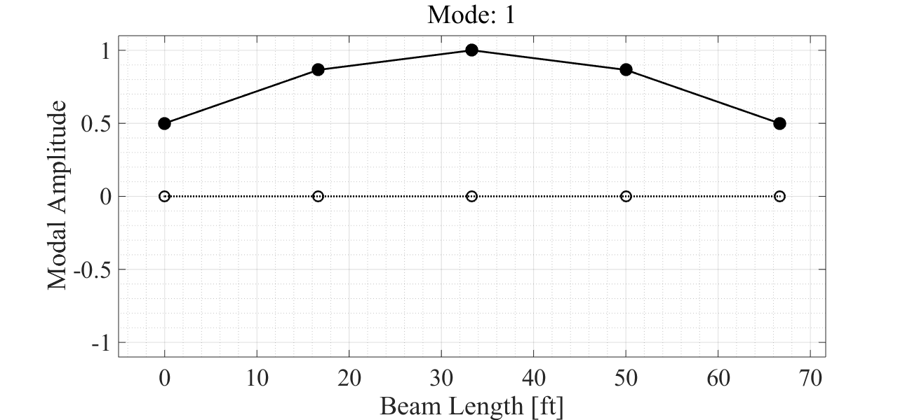
Mode: 2
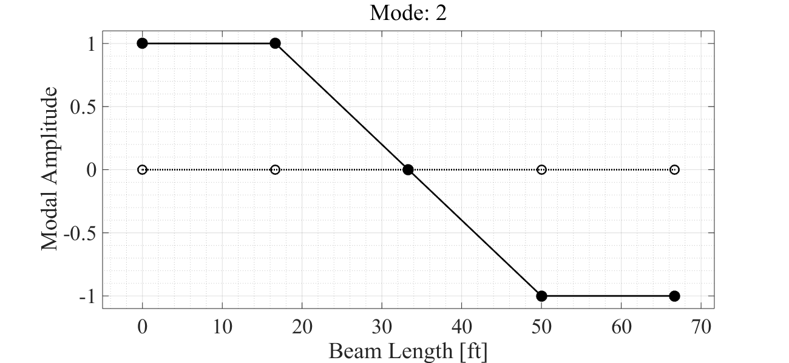
Mode: 3
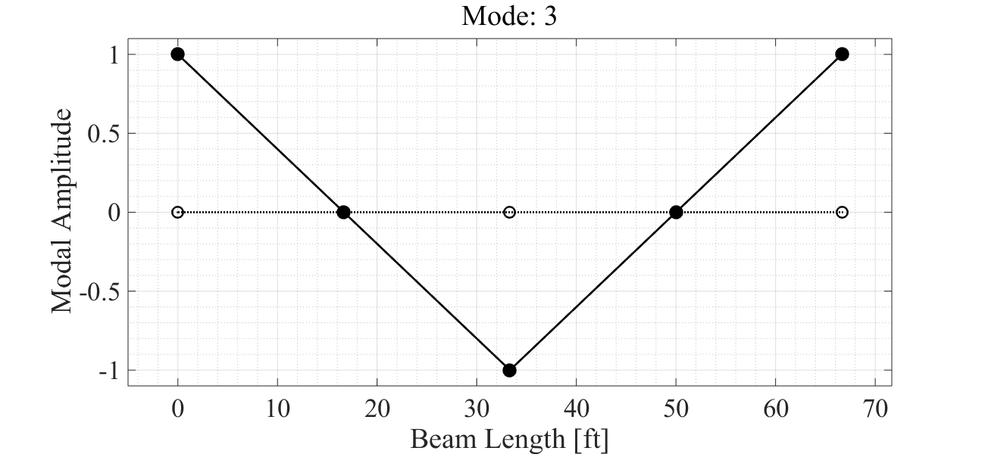
Mode: 4
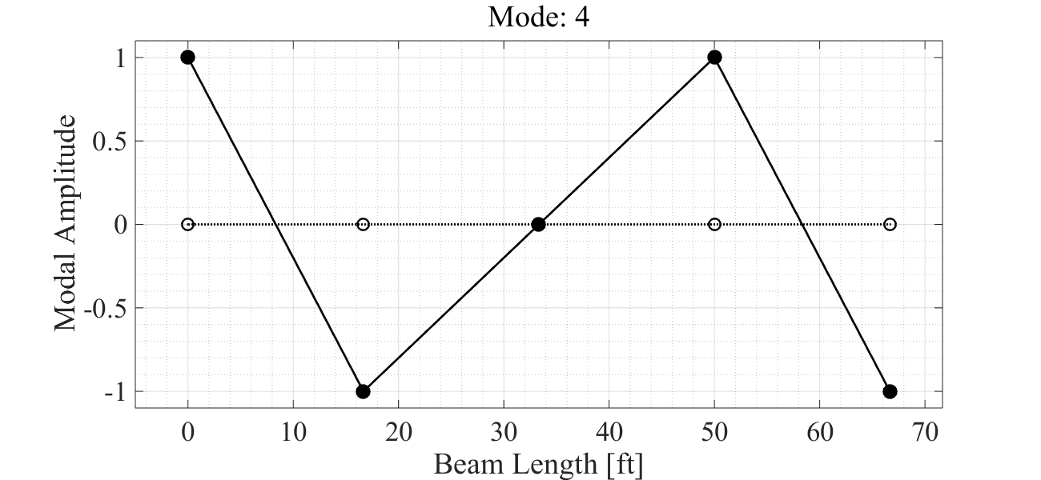
Mode: 5
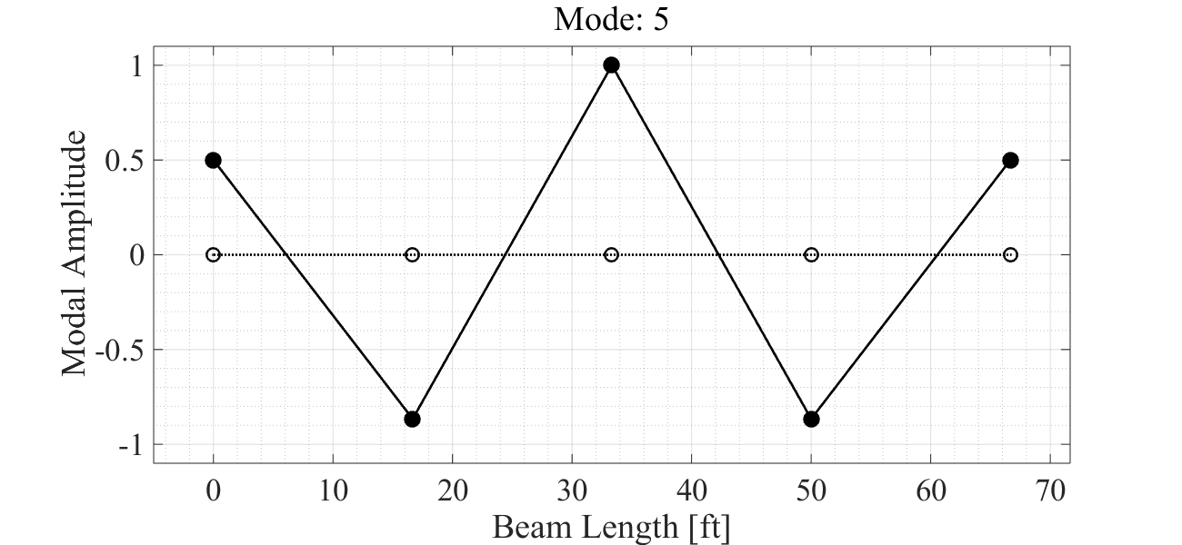

H11 - FRF
Input 1, Output 1 Driving Point
% index dof
in = 1; % H column index
out = 1; % H row index
% form frf from residues and poles
[Hs,hh] = vibsFRF(AA,root,in,out,w);
% plot frf
fprintf('H%d%d Magnitude\n',out,in);
vibsFRFplot(Hs,hh,in,out,w);
snapnow
H11 Magnitude
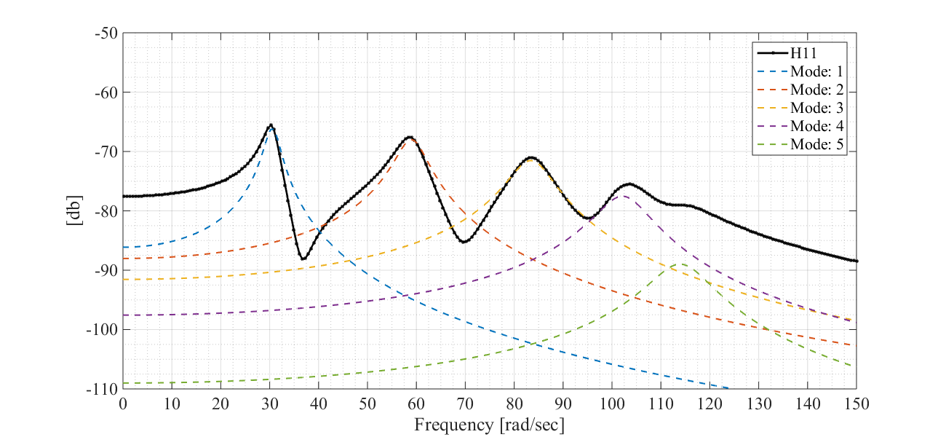

H11 - Phase
% plot phase
fprintf('H%d%d Phase\n',out,in);
vibsPhaseplot(Hs,hh,in,out,w);
snapnow
H11 Phase
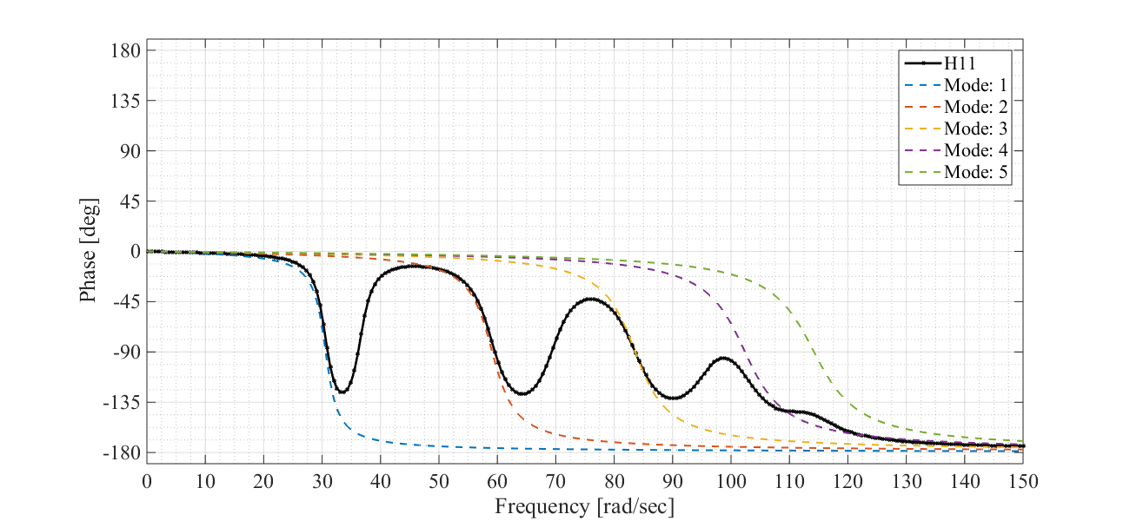

H11 - IRF
% plot irf
fs = 200; % sampling freq
l = .5; % length [sec]
[hs,h] = vibsIRF(AA,root,in,out,fs,l);
fprintf('H%d%d - Impulse Response Function\n',out,in);
vibsIRFplot(hs,h,in,out,fs,l);
snapnow
H11 - Impulse Response Function
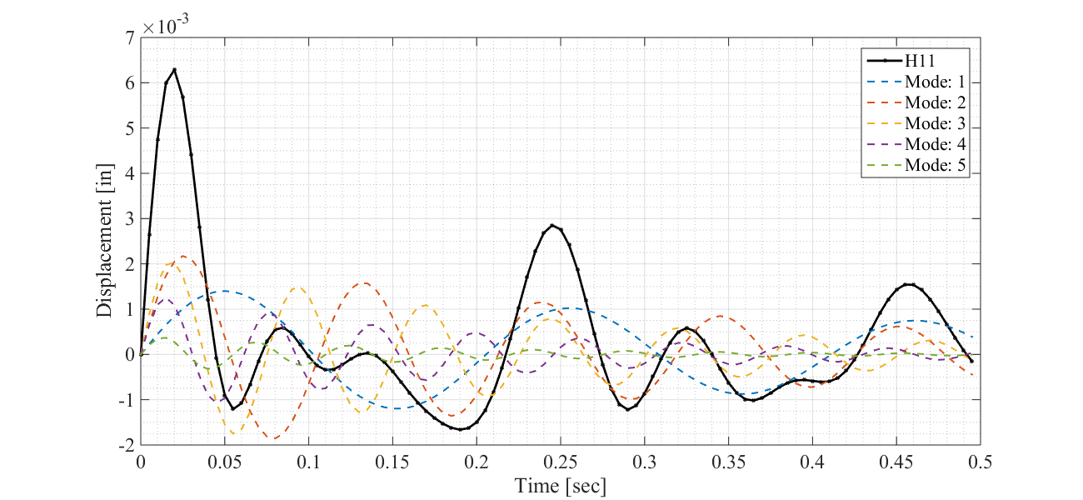

H51 - FRF
Input 1, Output 5 Symmetric DOF
% index dof
in = 1; % H column index
out = 5; % H row index
% form frf from residues and poles
[Hs,hh] = vibsFRF(AA,root,in,out,w);
% plot frf
fprintf('H%d%d Magnitude\n',out,in);
vibsFRFplot(Hs,hh,in,out,w);
snapnow
H51 Magnitude
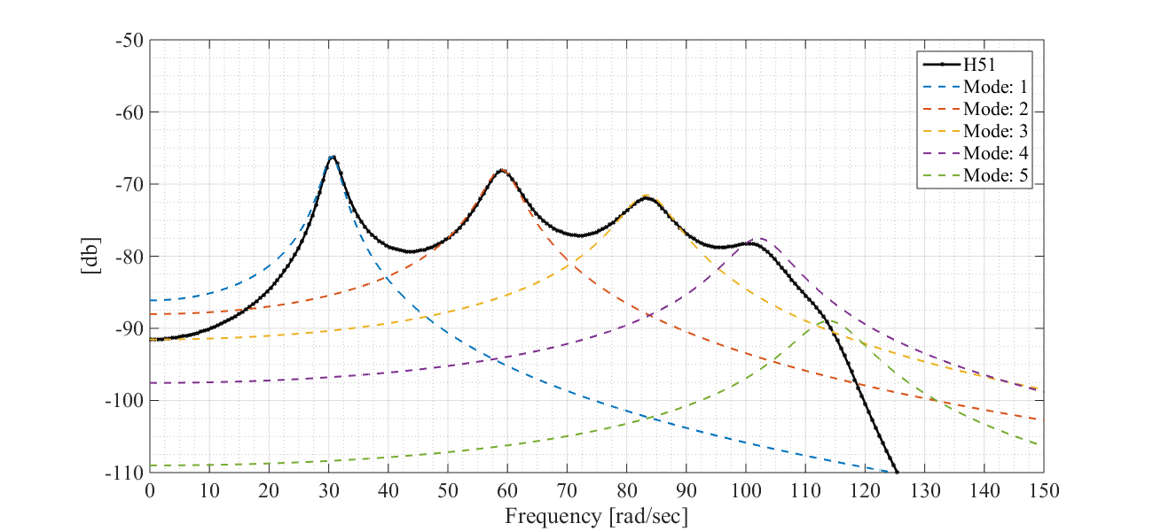

H51 - Phase
% plot phase
fprintf('H%d%d Phase\n',out,in);
vibsPhaseplot(Hs,hh,in,out,w);
snapnow
H51 Phase
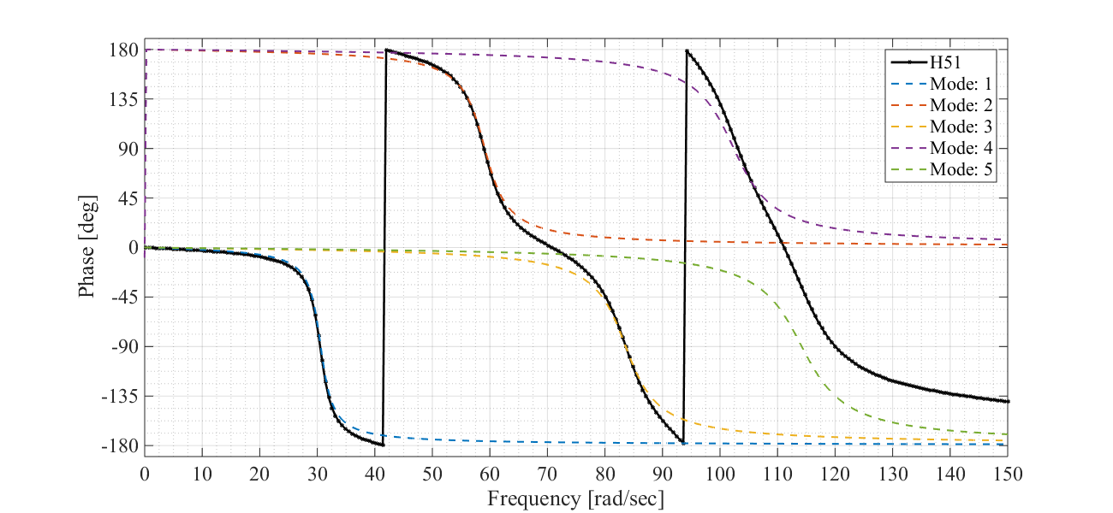

H51 - IRF
% plot irf
fs = 200; % sampling freq
l = .5; % length [sec]
[hs,h] = vibsIRF(AA,root,in,out,fs,l);
fprintf('H%d%d - Impulse Response Function\n',out,in);
fh = vibsIRFplot(hs,h,in,out,fs,l);
snapnow
H51 - Impulse Response Function
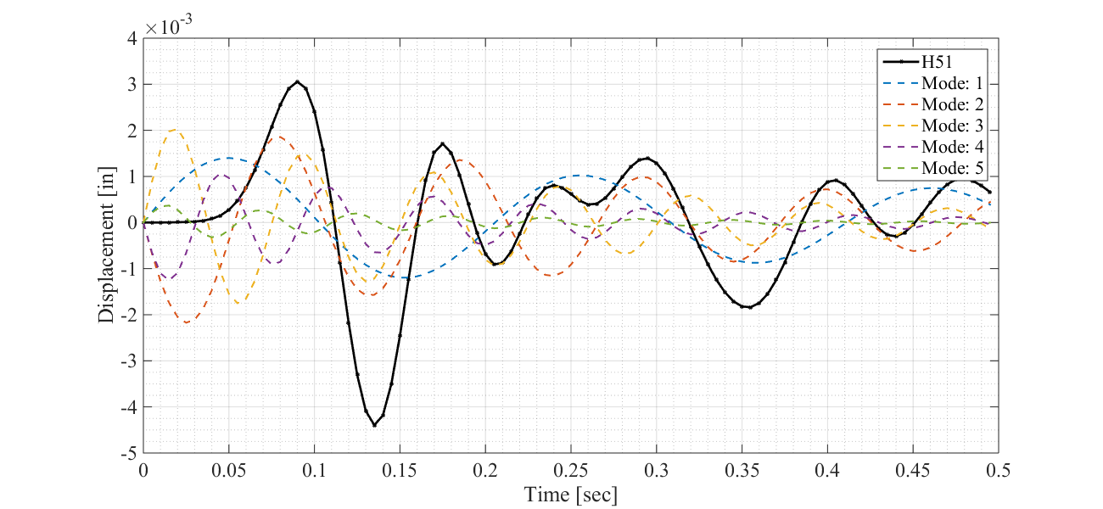
Published with MATLAB® R2014b

