BDA400
Data Science Tools and Techniques
Assignment 2
Technical Analysis using R, Preliminary Stage
Student: John Diaz
Institution: CD College
Course: BDA400 - Data Science Tools and Techniques
Due: Session 3
GitHub repository:
https://github.com/johndi24221614-web/TechnicalAnalysis

Introduction
This report documents the preliminary stage of the technical analysis project in R. It covers the setup of a GitHub account and the TechnicalAnalysis repository, the installation of R and RStudio, the installation of the R packages quantmod and TTR, the creation of the portfolio.txt file, and the R functions that import stock data, compute basic statistics and display the results. Each step includes the screenshots taken during the process.

Repository structure
TechnicalAnalysis/
Assignment1/
Assignment2/
JohnDiaz_BDA400_A02.docx (this report)
portfolio.txt
TechnicalAnalysis_A02.Rmd

1. GitHub Account and Repository Setup
- Open https://github.com and select Sign up (skip if the account already exists).
- Install Git following https://github.com/git-guides/install-git and configure it with git config --global user.name and user.email (https://docs.github.com/en/get-started/quickstart/set-up-git).
- On GitHub, select New repository and name it TechnicalAnalysis. Add a README and create it.
- Create one subfolder per assignment (Assignment2 for this work) and upload the files into it.

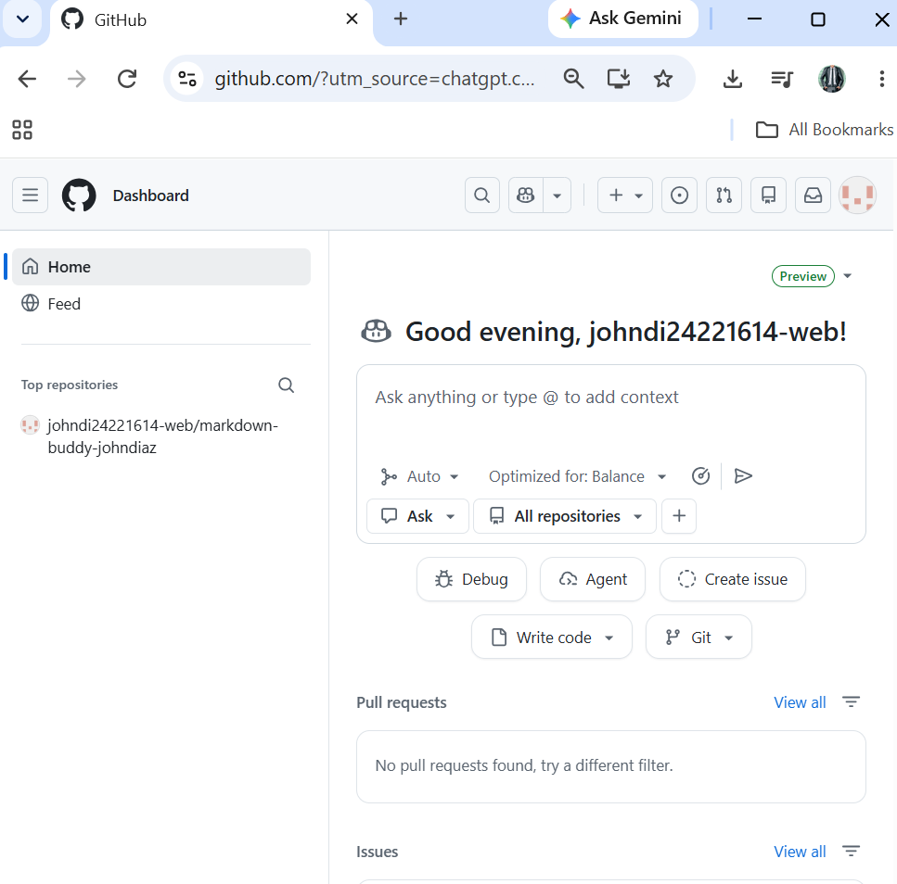
Figure 1.1 - GitHub account created and signed in (user johndi24221614-web)

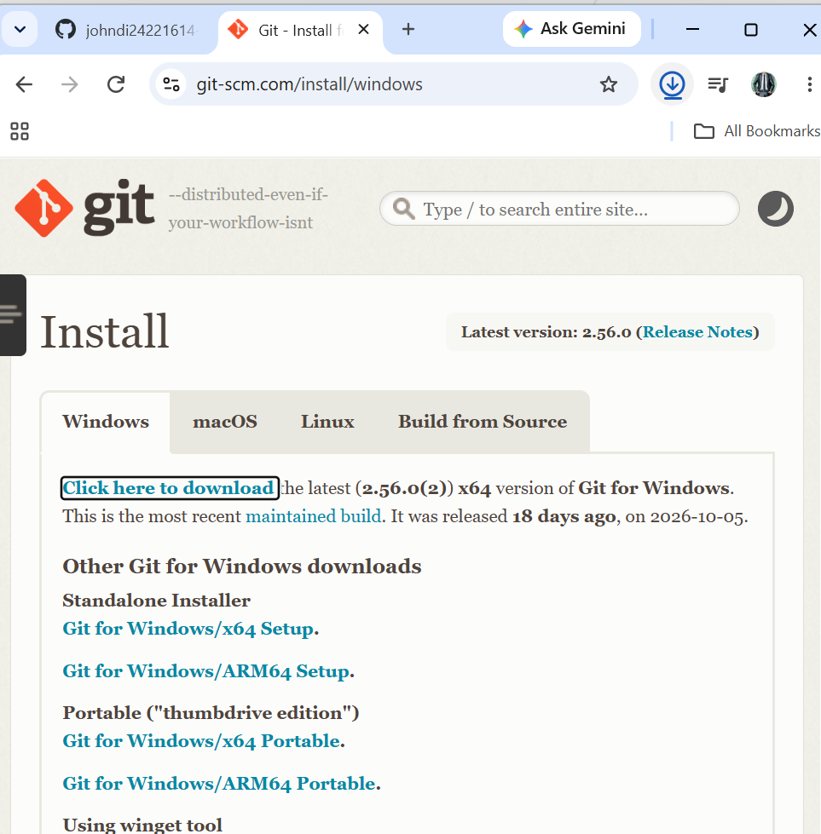
Figure 1.2a - Git for Windows download page (git-scm.com, version 2.56.0)

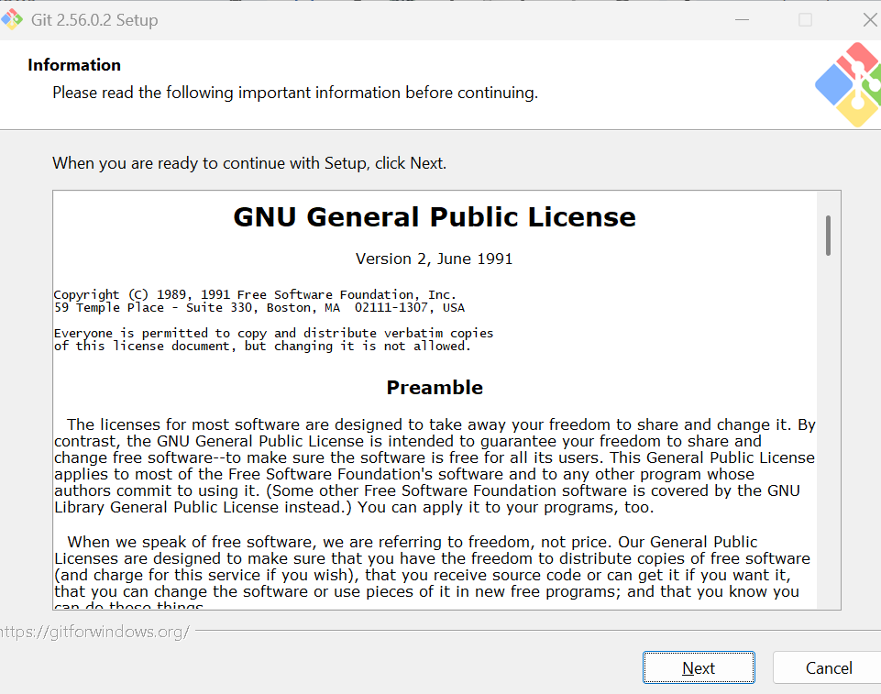
Figure 1.2b - Git 2.56.0.2 Setup wizard started

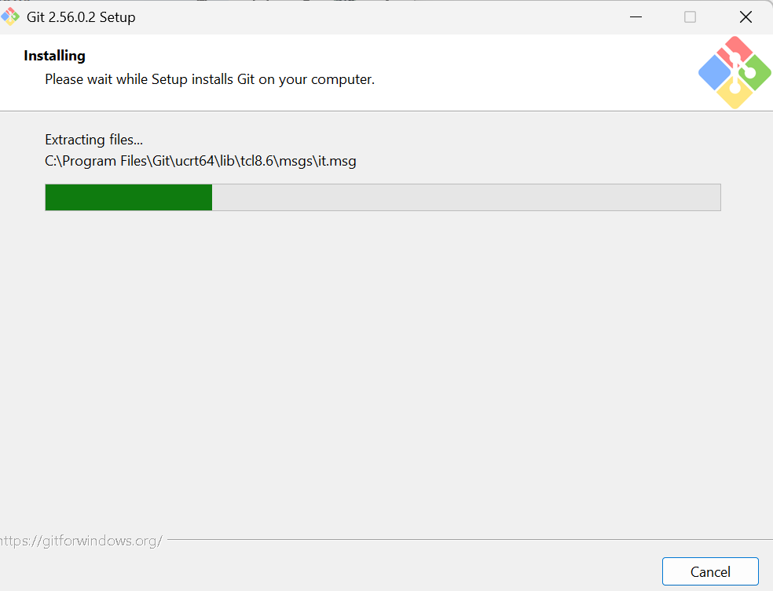
Figure 1.2c - Git installation in progress (extracting files)

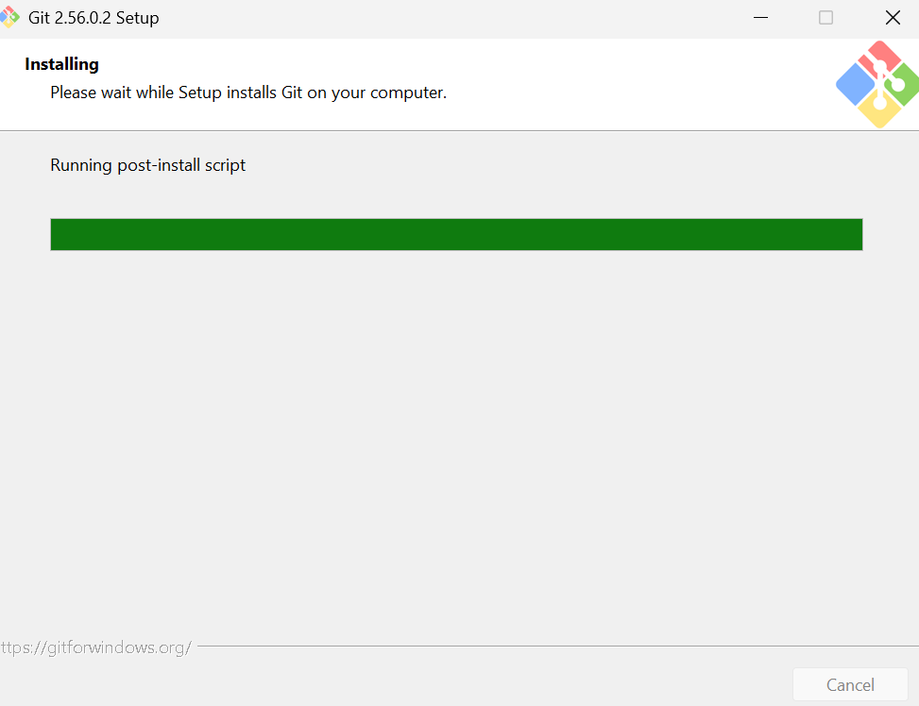
Figure 1.2d - Git installation running the post-install script

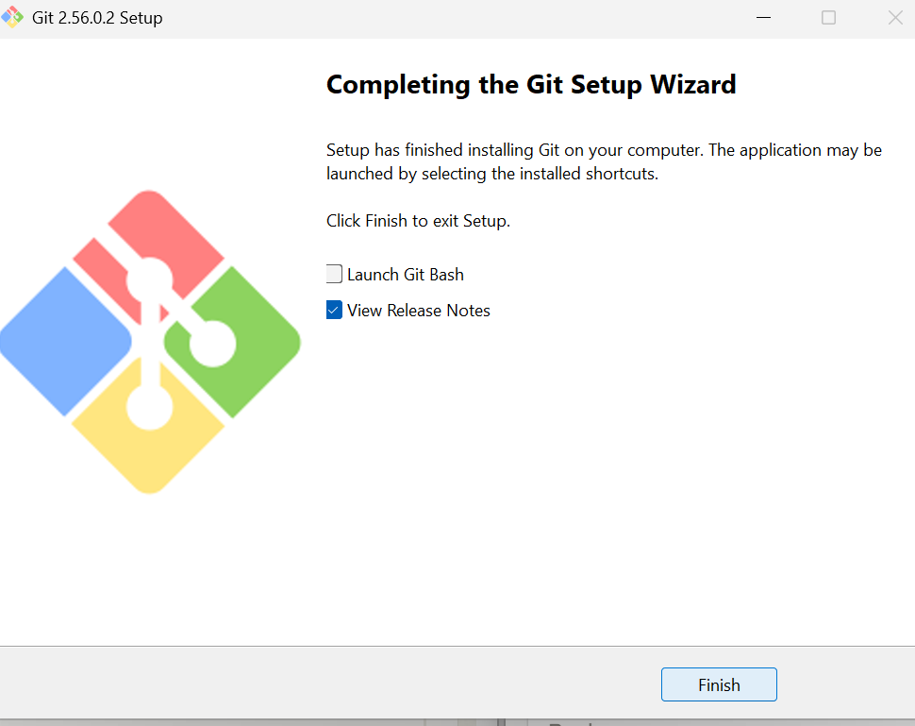
Figure 1.2e - Completing the Git Setup Wizard

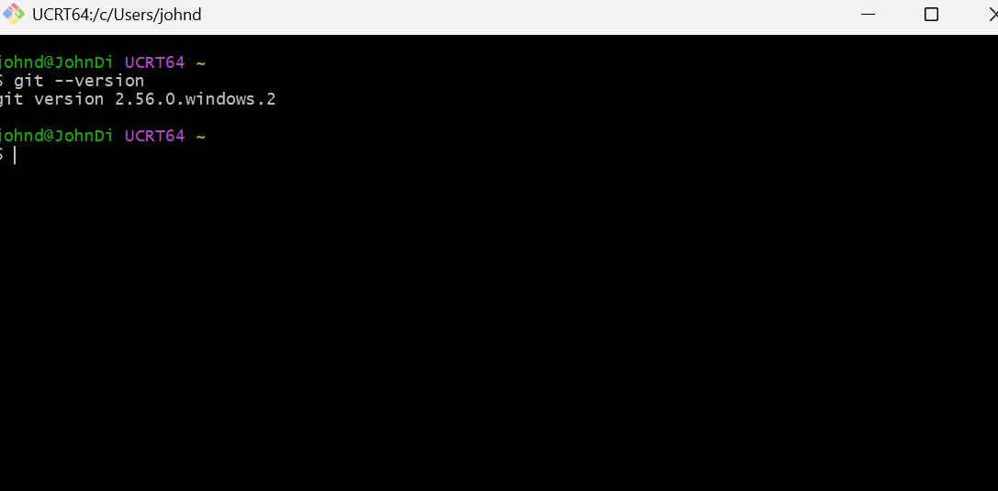
Figure 1.2f - Git installed: git --version in Git Bash (version 2.56.0.windows.2)

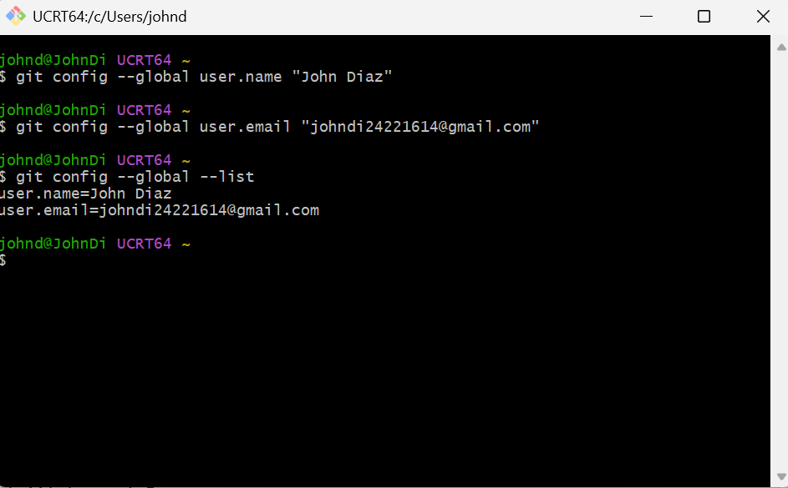
Figure 1.2g - Git configured: user.name and user.email set with git config --global

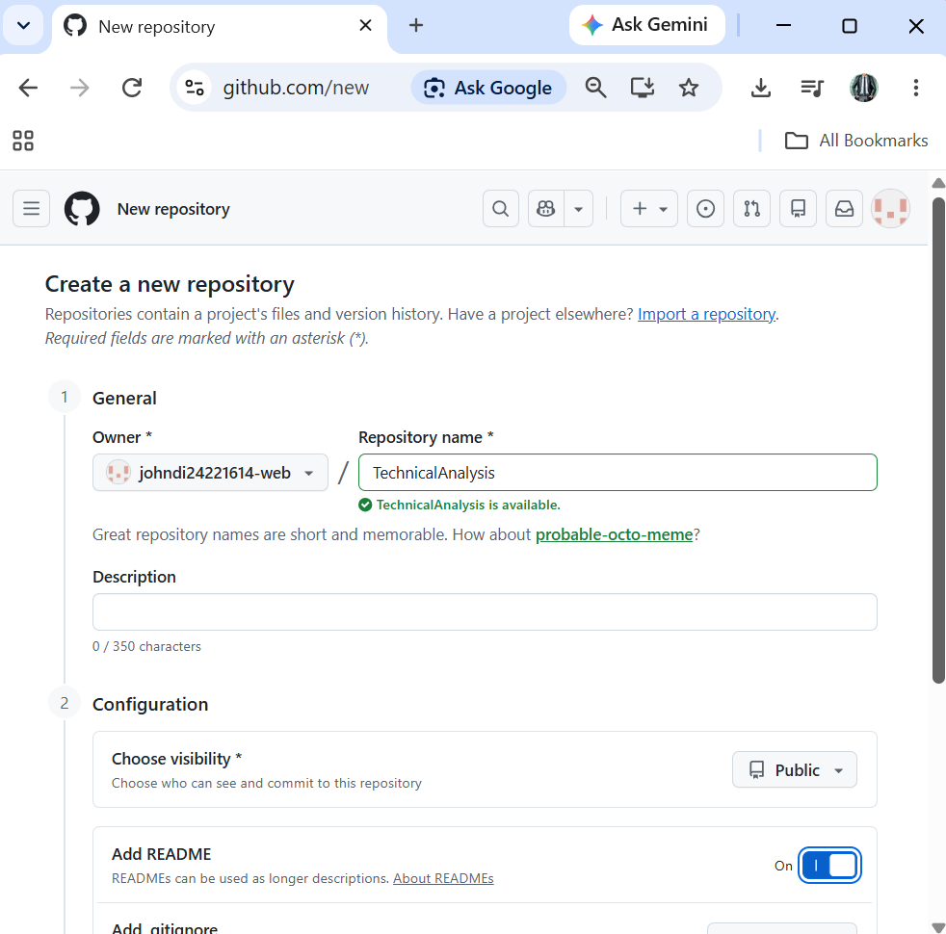
Figure 1.3 - Create a new repository: name TechnicalAnalysis, Public, README enabled

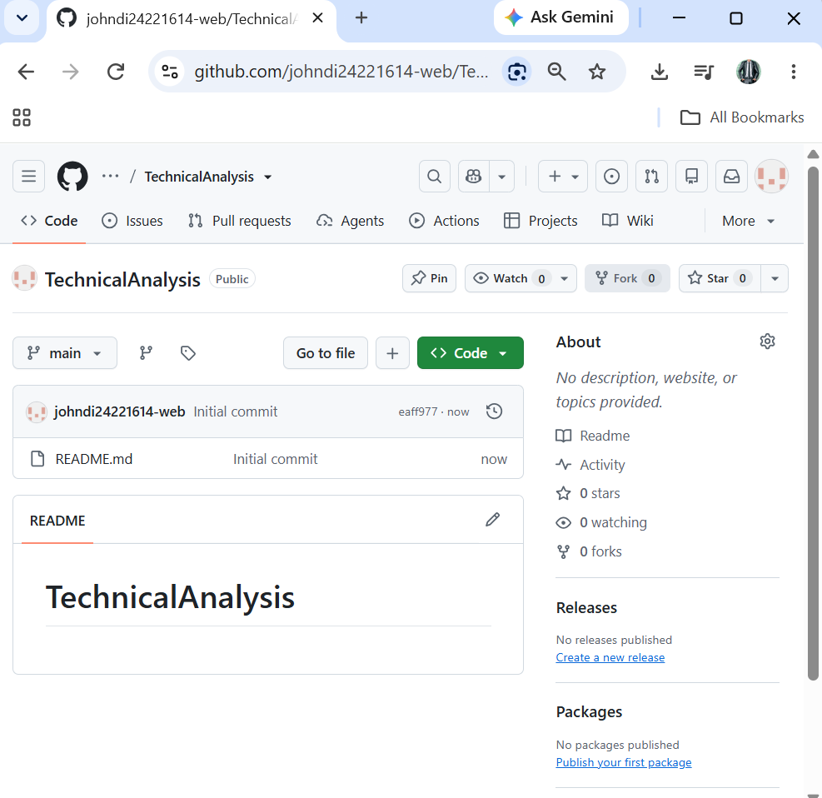
Figure 1.3b - Repository TechnicalAnalysis created (Public, with README.md)

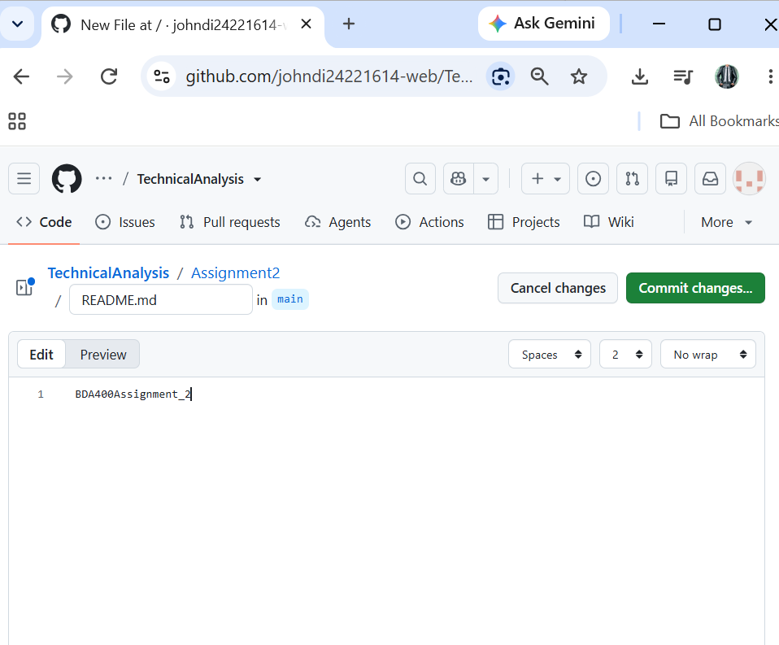
Figure 1.4a - Creating the Assignment2 folder by typing Assignment2/README.md

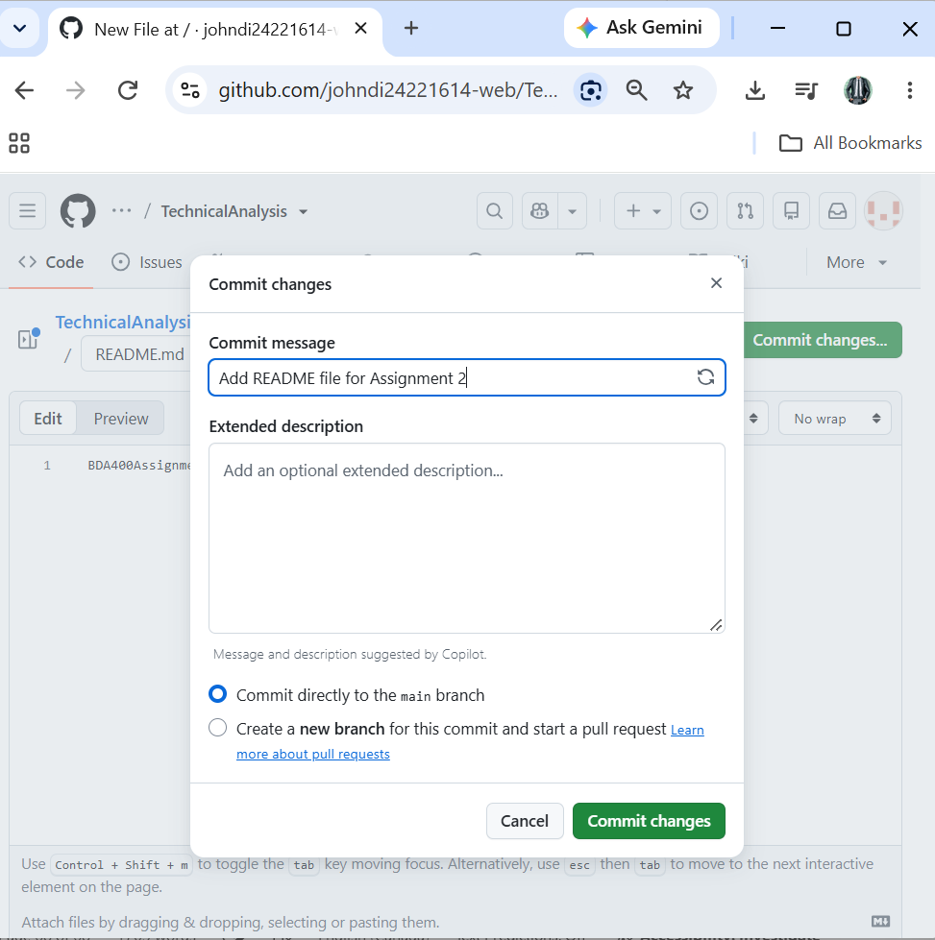
Figure 1.4b - Commit changes dialog (commit directly to the main branch)

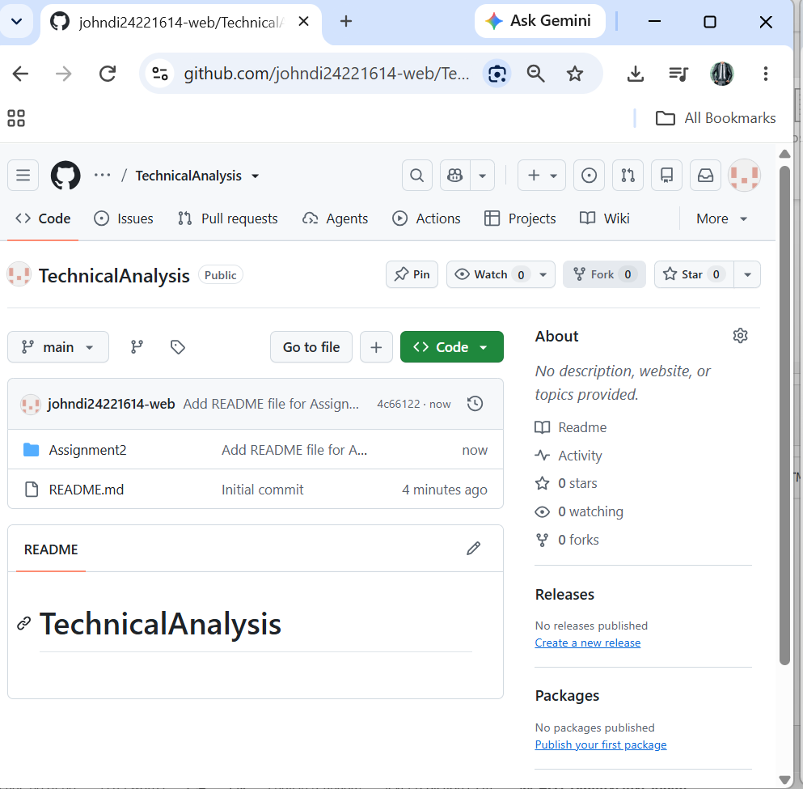
Figure 1.4c - Repository page showing the Assignment2 folder

2. Installing and Configuring R and RStudio
- Go to https://cran.rstudio.com/ and download R for the operating system in use. Run the installer with the default options.
- Download RStudio Desktop from the Posit website and install it.
- Open RStudio and confirm that the R version appears in the Console.

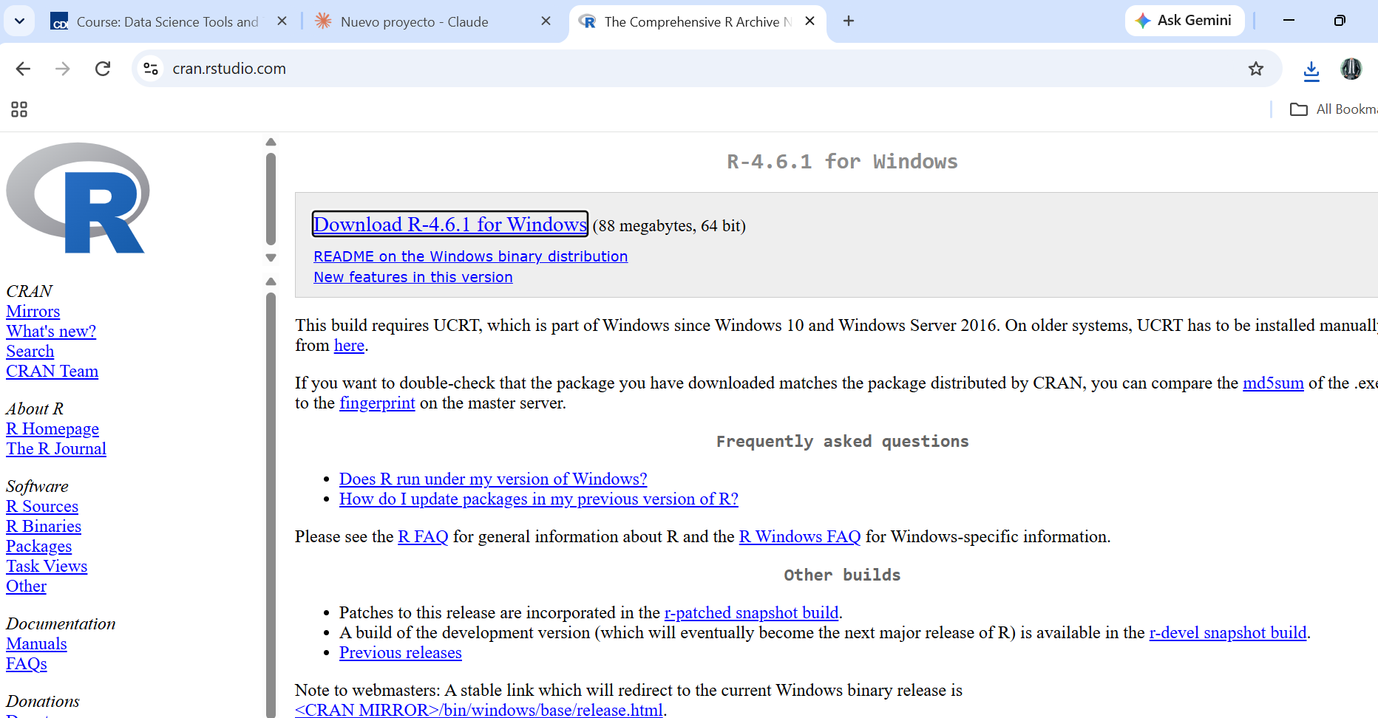
Figure 2.1 - CRAN download page for R 4.6.1 (Windows)

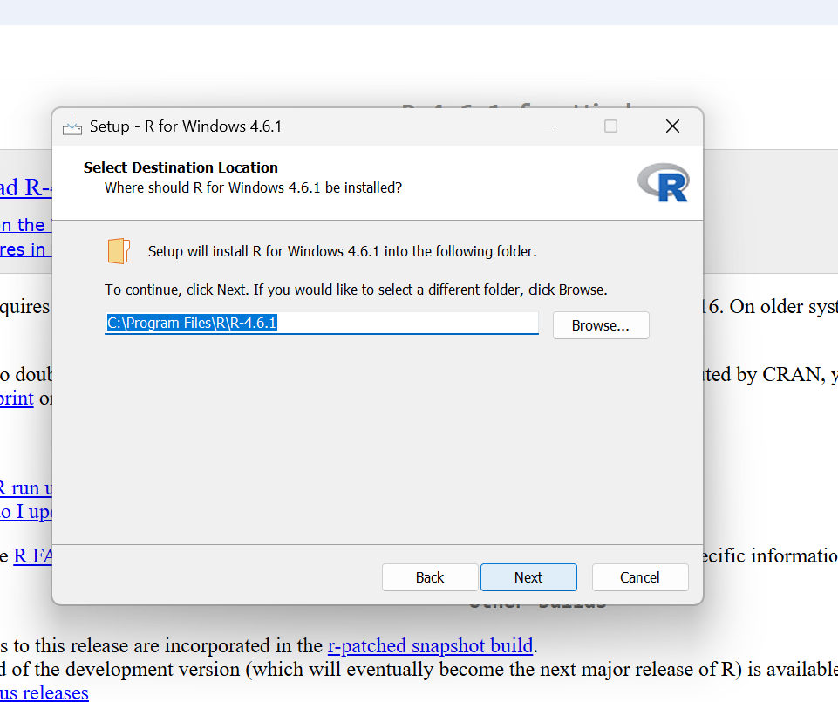
Figure 2.2 - R for Windows 4.6.1 setup wizard (destination folder)

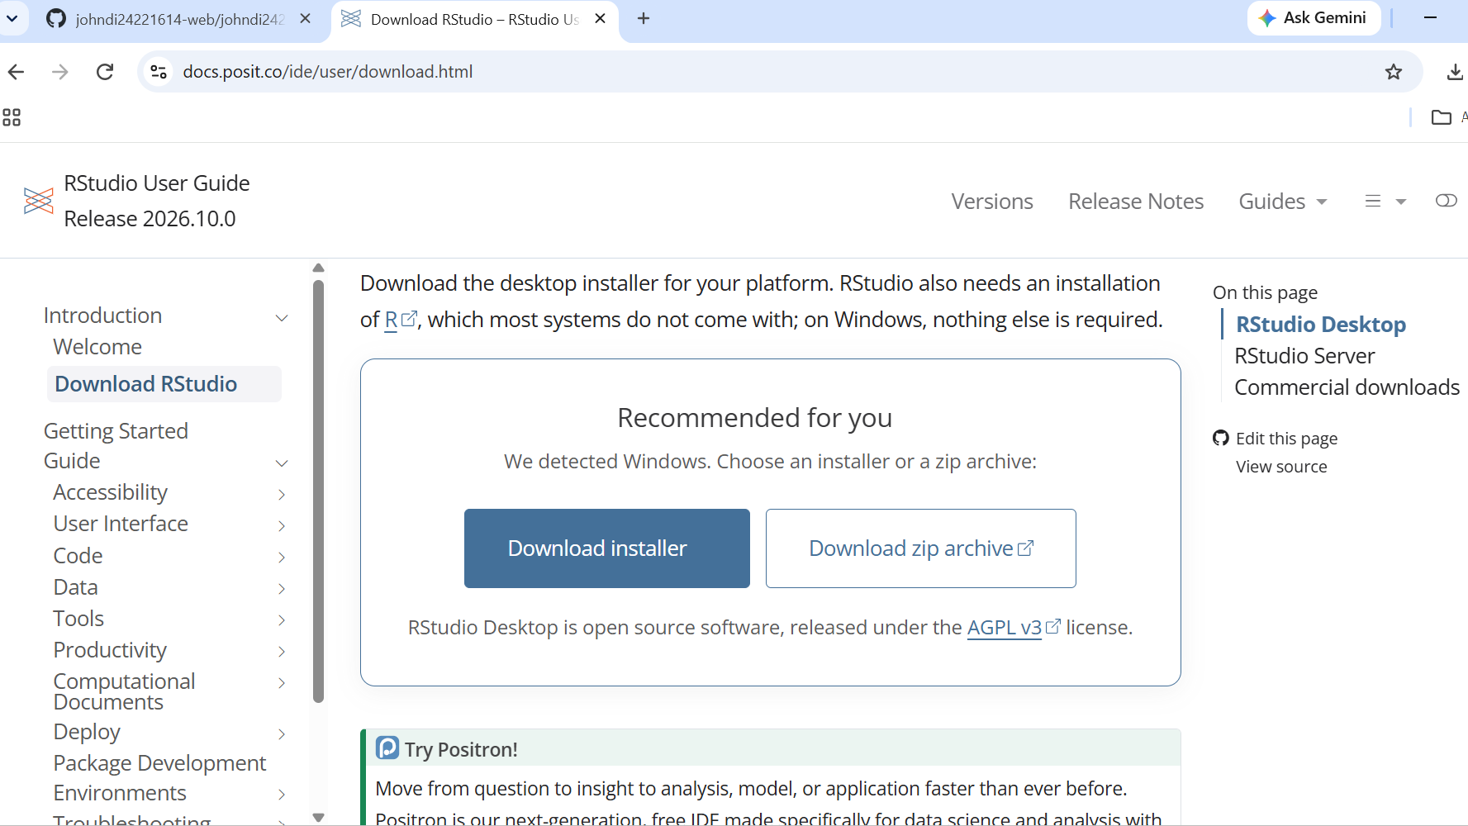
Figure 2.3 - RStudio Desktop download page (docs.posit.co)

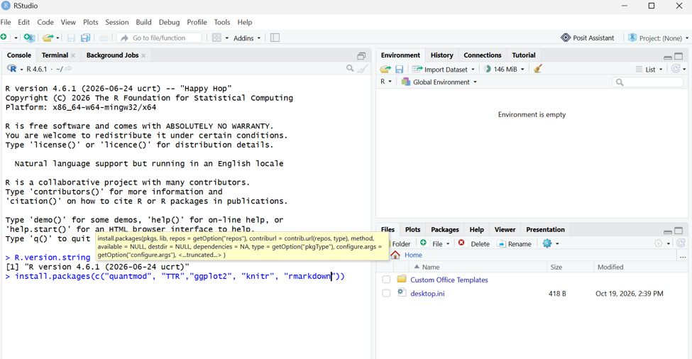
Figure 2.4 - RStudio open, R 4.6.1 shown in the Console

3. Installing R Packages for Technical Analysis
The following packages are used: quantmod (download and chart market data), TTR (technical trading rules such as moving averages), ggplot2 (extra plotting), knitr and rmarkdown (needed to knit the R Markdown file).
install.packages(c("quantmod", "TTR", "ggplot2", "knitr", "rmarkdown"))
library(quantmod)
library(TTR)

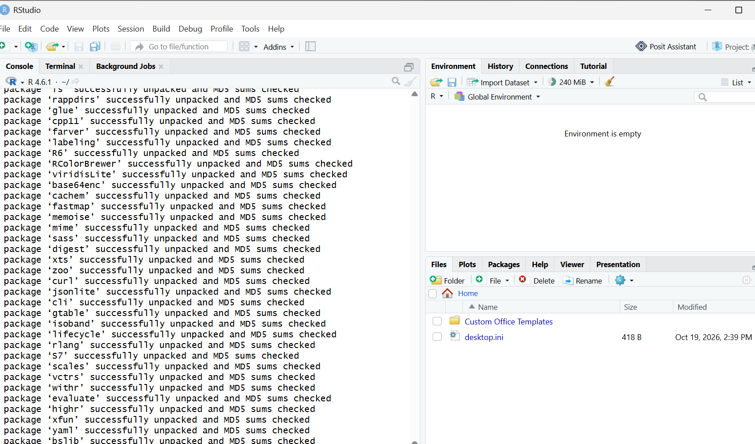
Figure 3.1 - install.packages() running in the Console

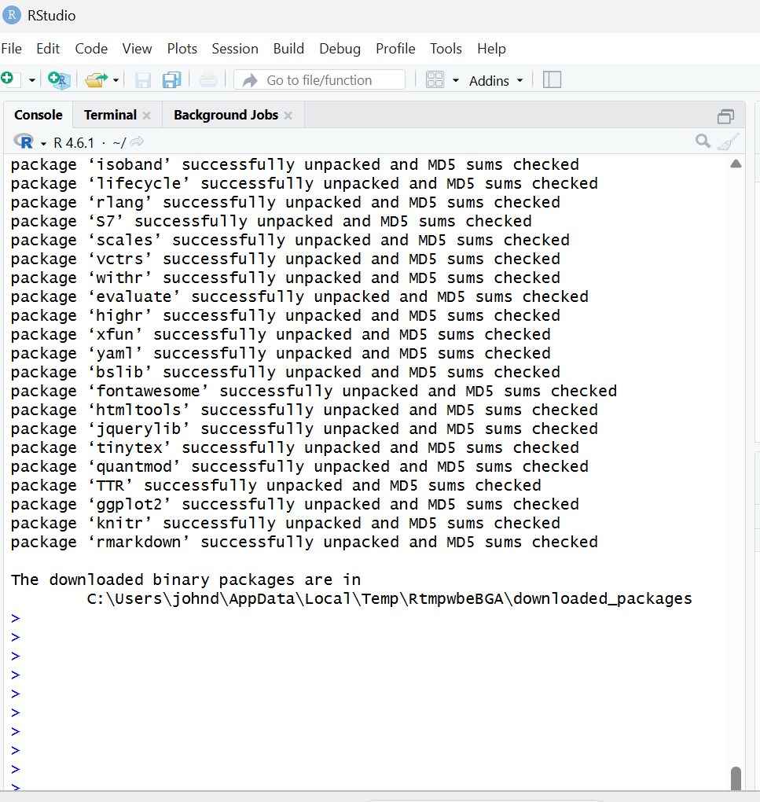
Figure 3.2 - Installation finished: packages unpacked and console ready

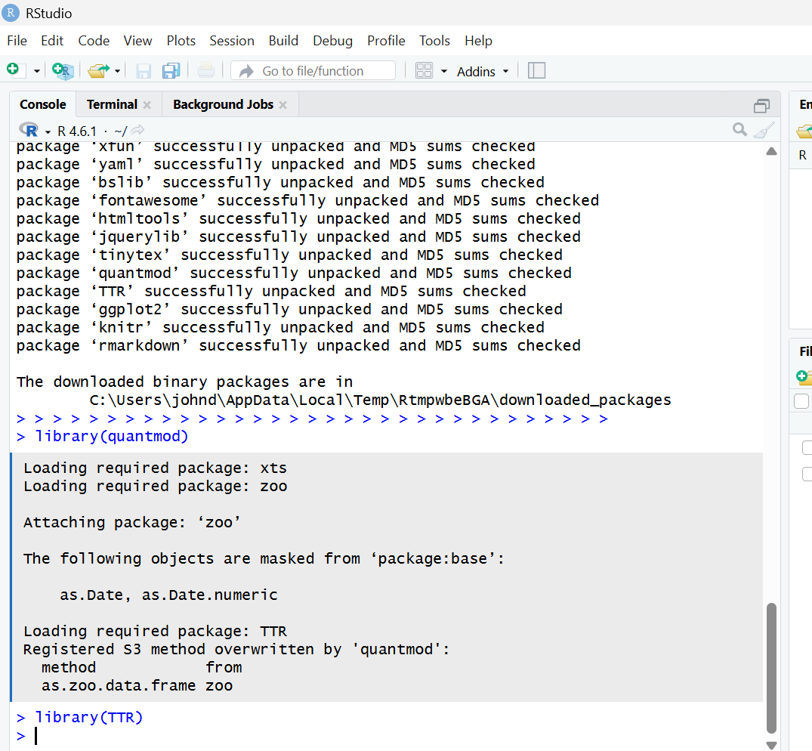
Figure 3.3 - library(quantmod) and library(TTR) loaded without errors

4. Project Configuration and Initialization
A text file named portfolio.txt was created with one stock symbol per line. The portfolio mixes technology companies and automotive manufacturers:
AAPL
MSFT
TSLA
GM
F
TM

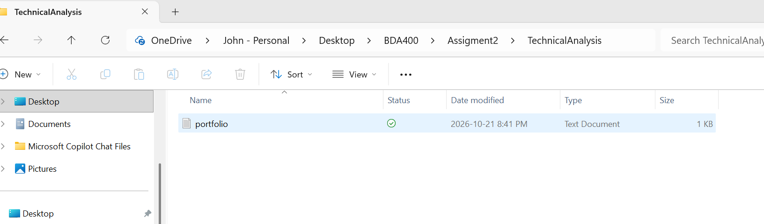
Figure 4.1 - portfolio.txt saved in the project folder (TechnicalAnalysis)

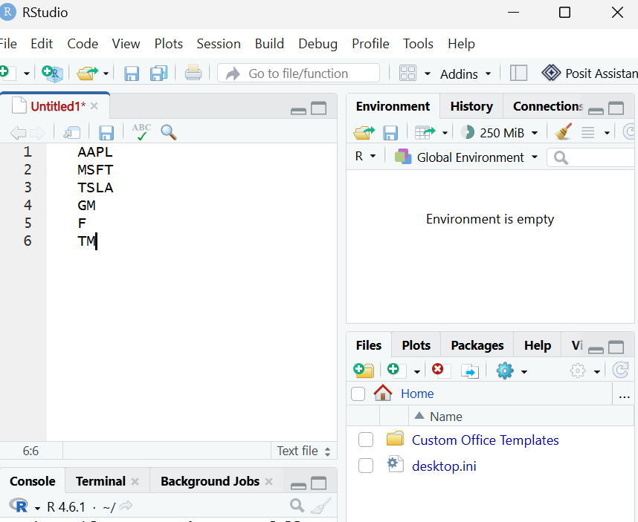
Figure 4.2 - Stock symbols listed in portfolio.txt, one per line (RStudio)

5. Function to Import and Load Stock Data
load_stock_data() reads portfolio.txt, downloads each symbol with quantmod::getSymbols() and stores every stock as its own data frame inside a named list. Symbols that fail to download are reported and skipped. The full code is in TechnicalAnalysis_A02.Rmd.

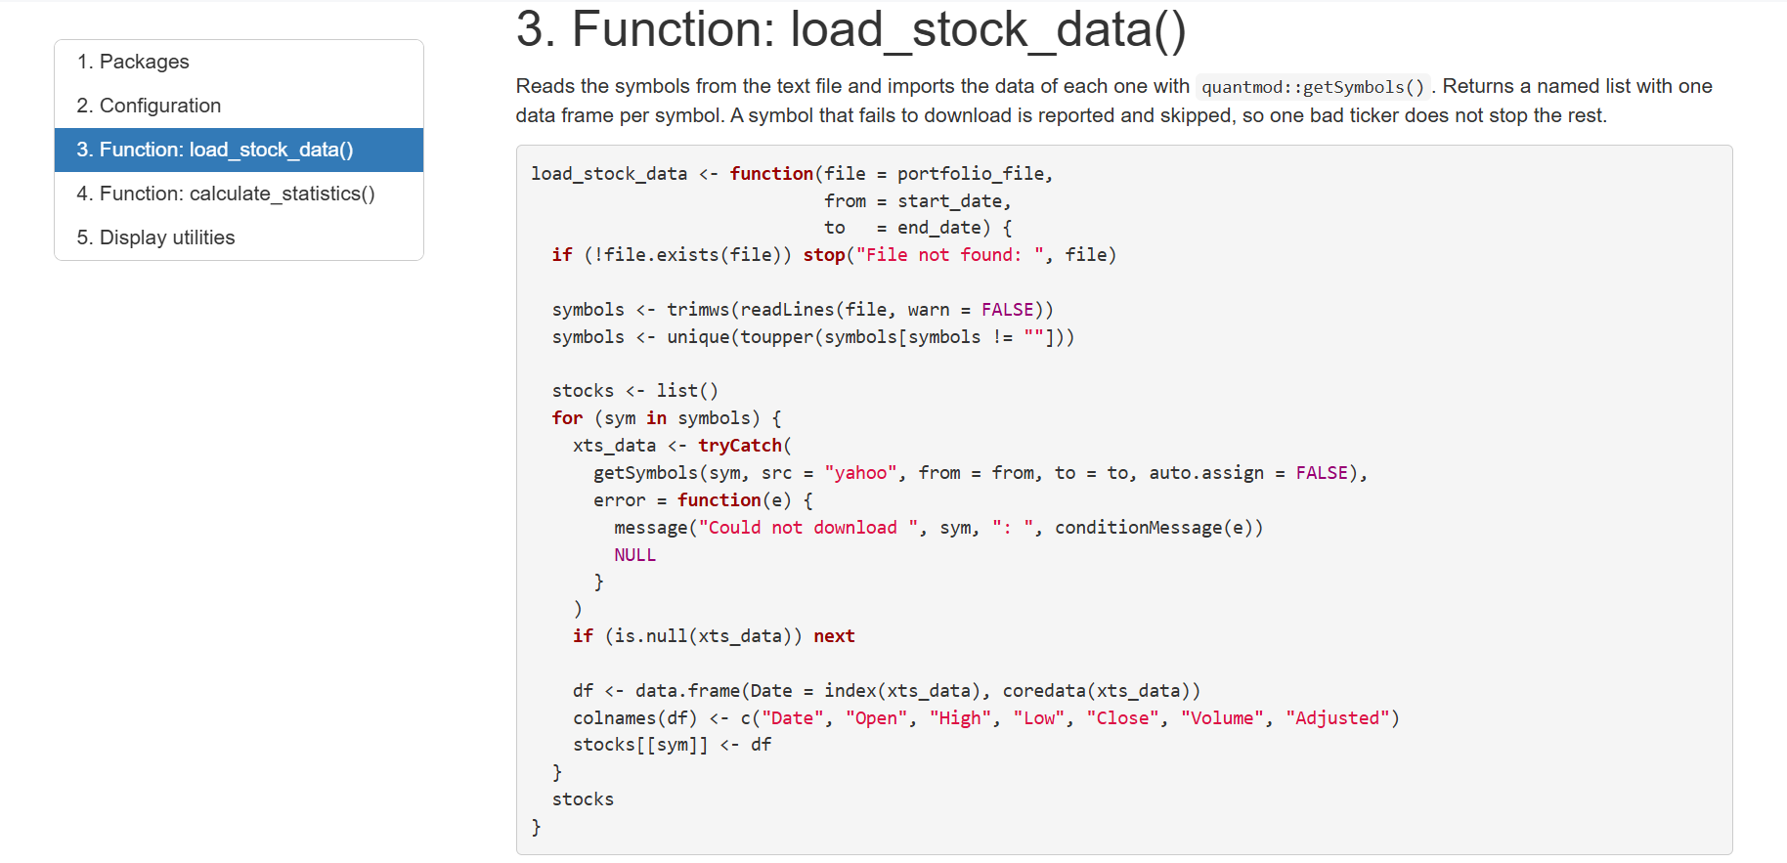
Figure 5.1 - load_stock_data() code (Knit output)

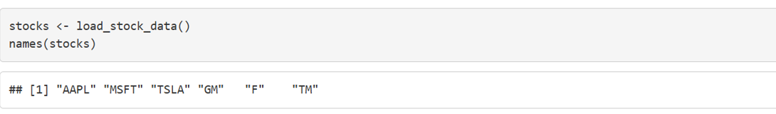
Figure 5.2 - Loading the data and listing the six stock symbols with names(stocks)

6. Functions to Compute Basic Statistics
calculate_statistics() receives one stock data frame and returns the mean, median, mode, standard deviation and a 20-day simple moving average of the closing price (TTR::SMA). R has no built-in statistical mode, so a helper function get_mode() was written. Results are stored in a list (summary data frame and moving-average data frame) per stock, and combined into one summary table.

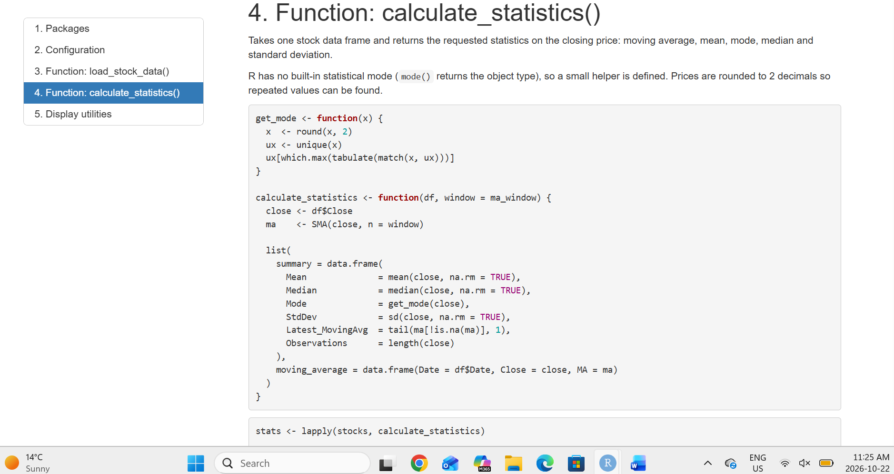
Figure 6.1 - get_mode() and calculate_statistics() code (Knit output)

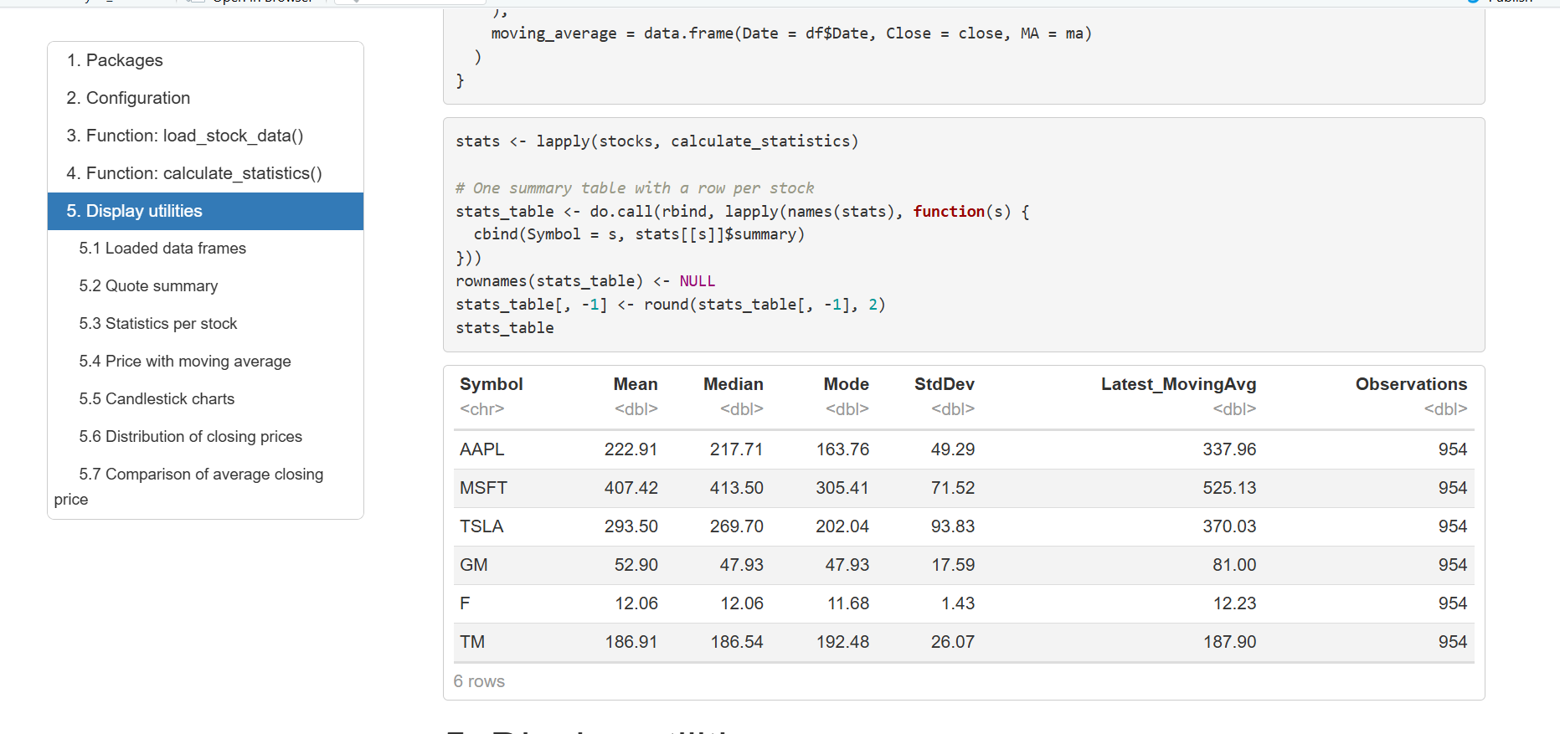
Figure 6.2 - Statistics summary table for all stocks

7. Utilities to Display Output
Several ways of presenting the data were written, inspired by Yahoo Finance:
- display_data_frames(): head and tail of each stock data frame.
- display_quote_summary(): last price, daily change, 52-week low/high and volume.
- plot_price_ma(): close price with the 20-day moving average.
- plot_candlestick(): candlestick chart with volume and moving average.
- plot_histogram(): distribution of closing prices with mean and median.
- Bar chart comparing the mean closing price of all stocks.

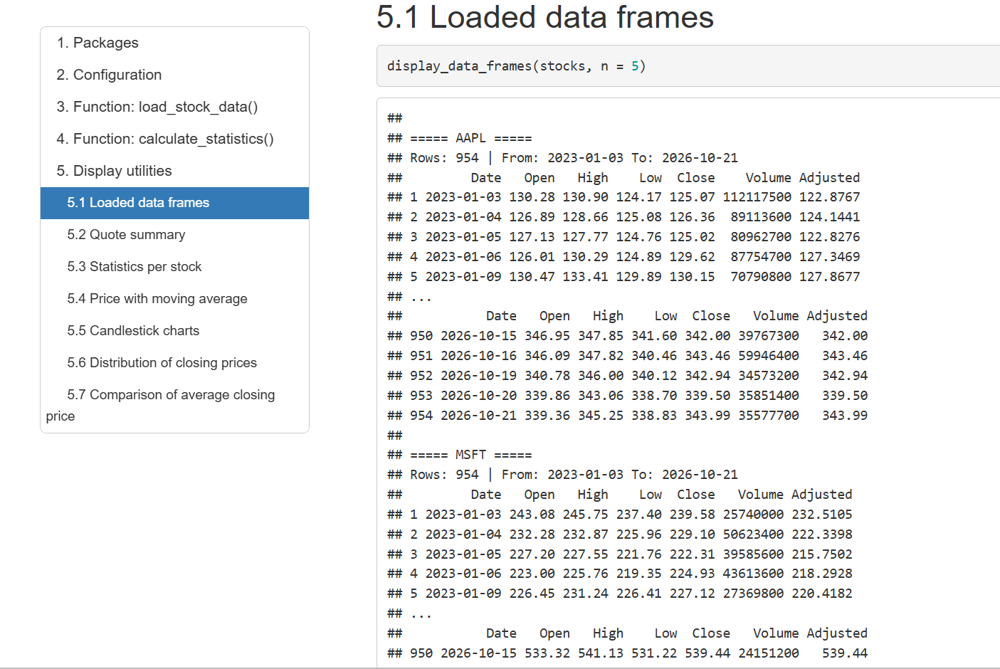
Figure 7.1 - Data frames loaded for each stock (head and tail)

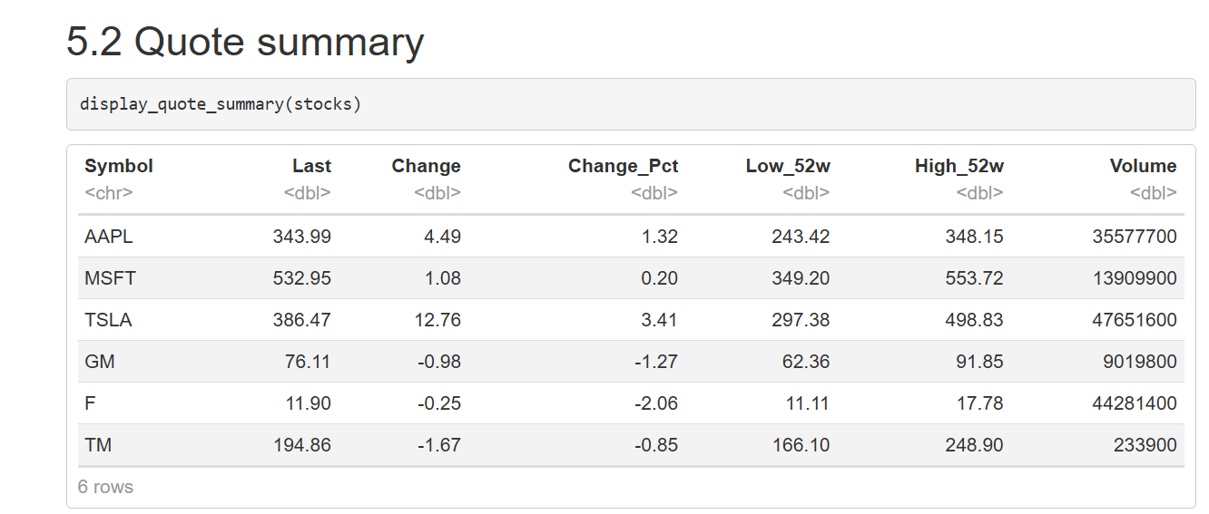
Figure 7.2 - Quote summary table (last price, change, 52-week range, volume)

Close price with 20-day moving average
The blue line is the daily close and the red line is the 20-day simple moving average.
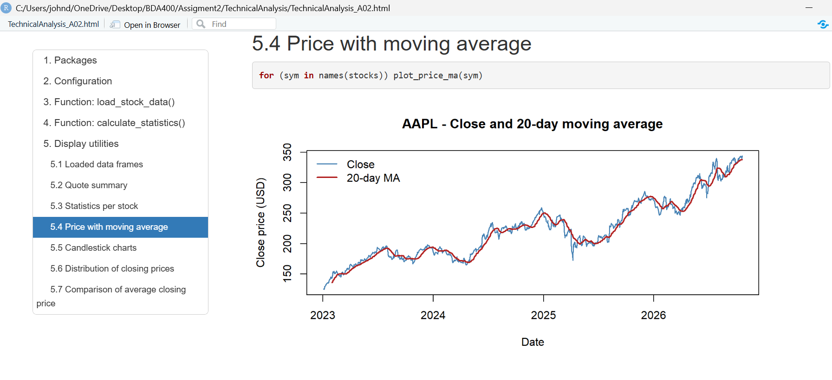
Figure 7.3a - AAPL

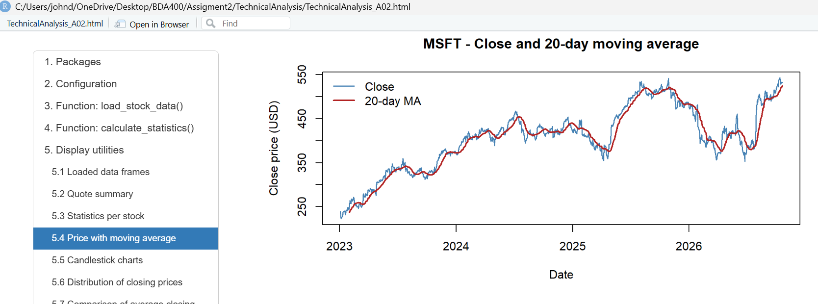
Figure 7.3b - MSFT

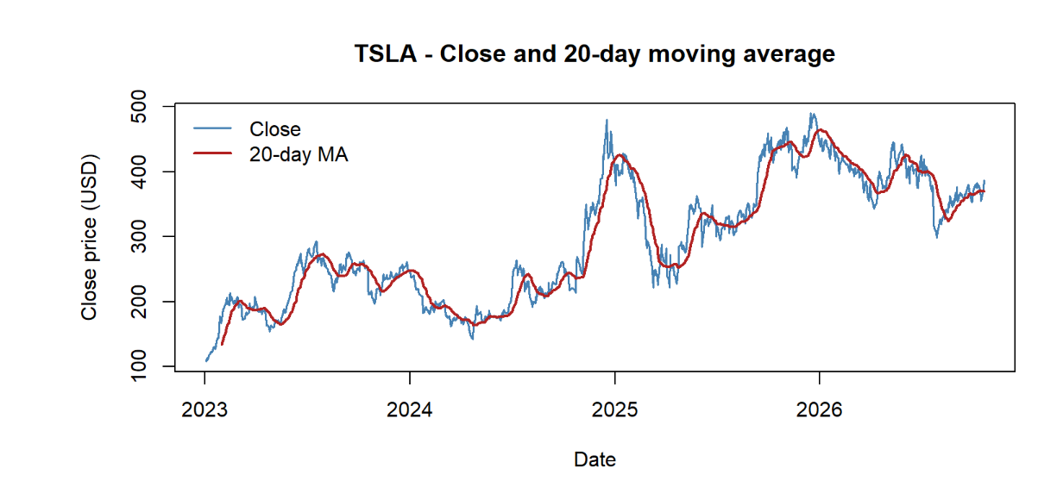
Figure 7.3c - TSLA

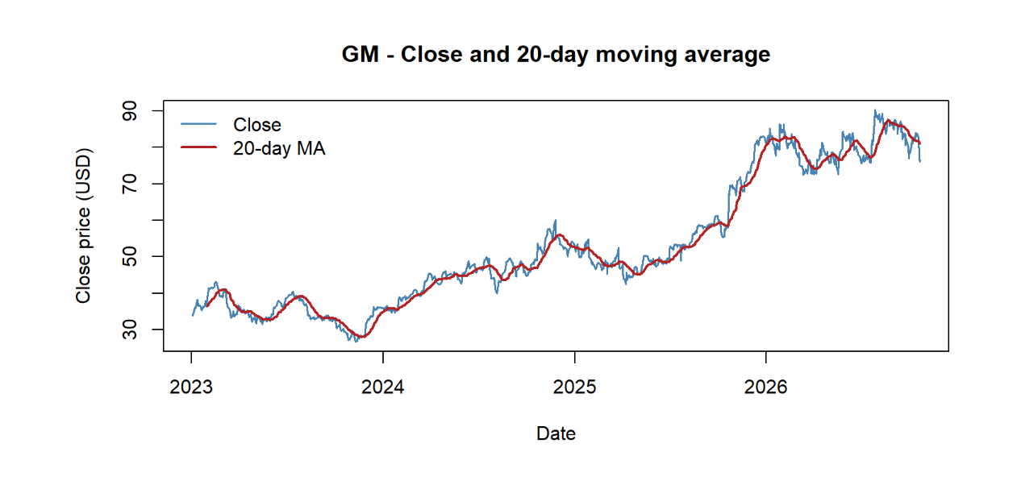
Figure 7.3d - GM

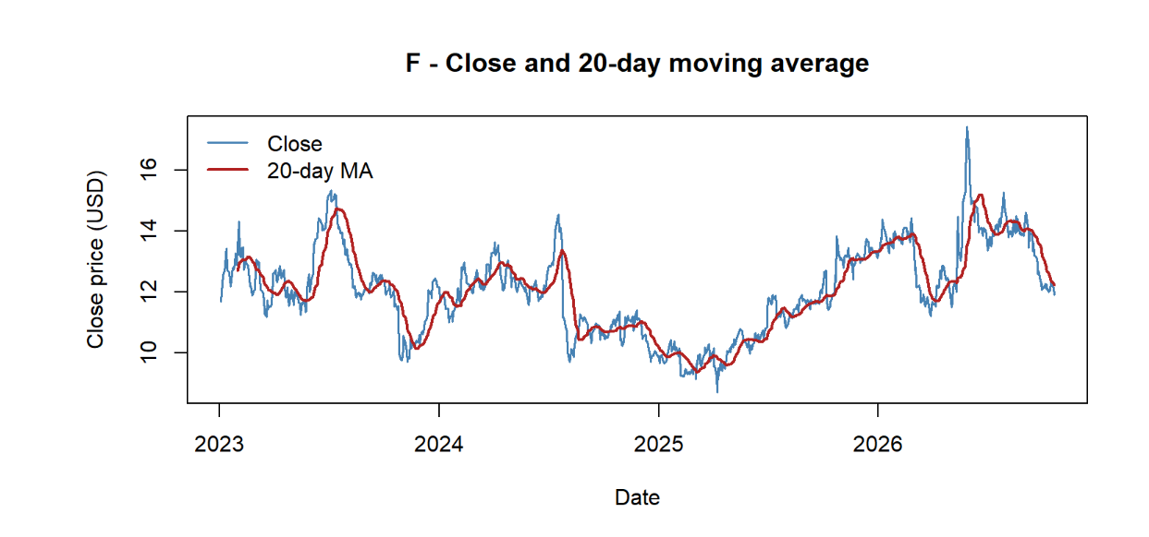
Figure 7.3e - F

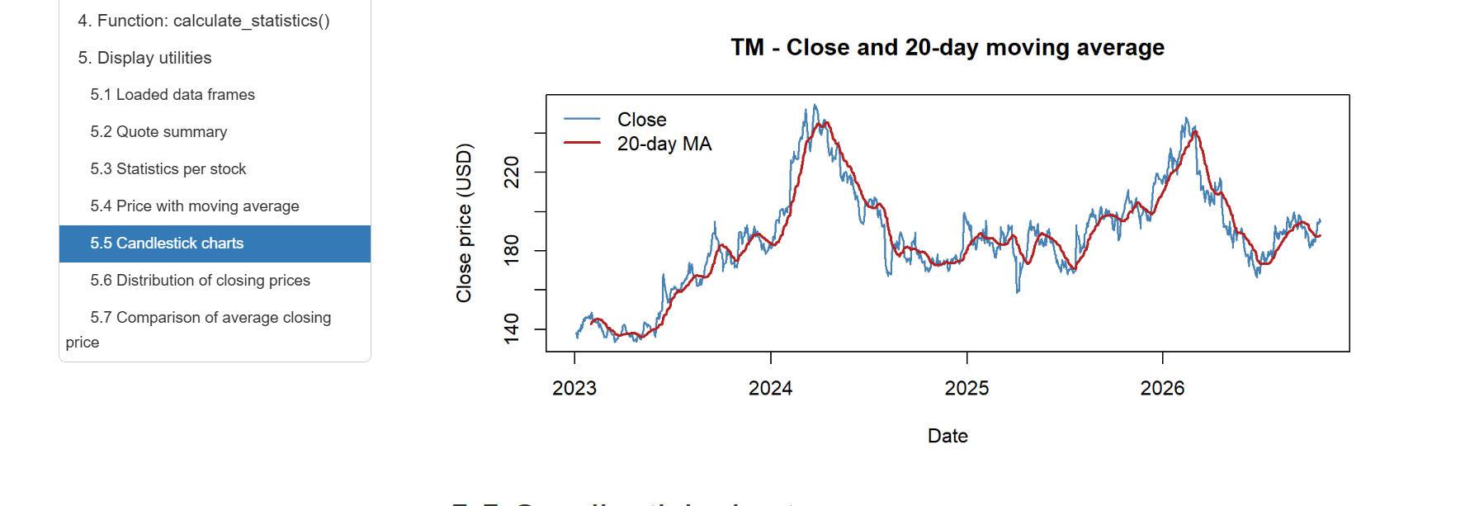
Figure 7.3f - TM

Candlestick charts with volume (last 90 days)
Each candle shows open, high, low and close; the red line is the 20-day moving average and the bars below show the volume.
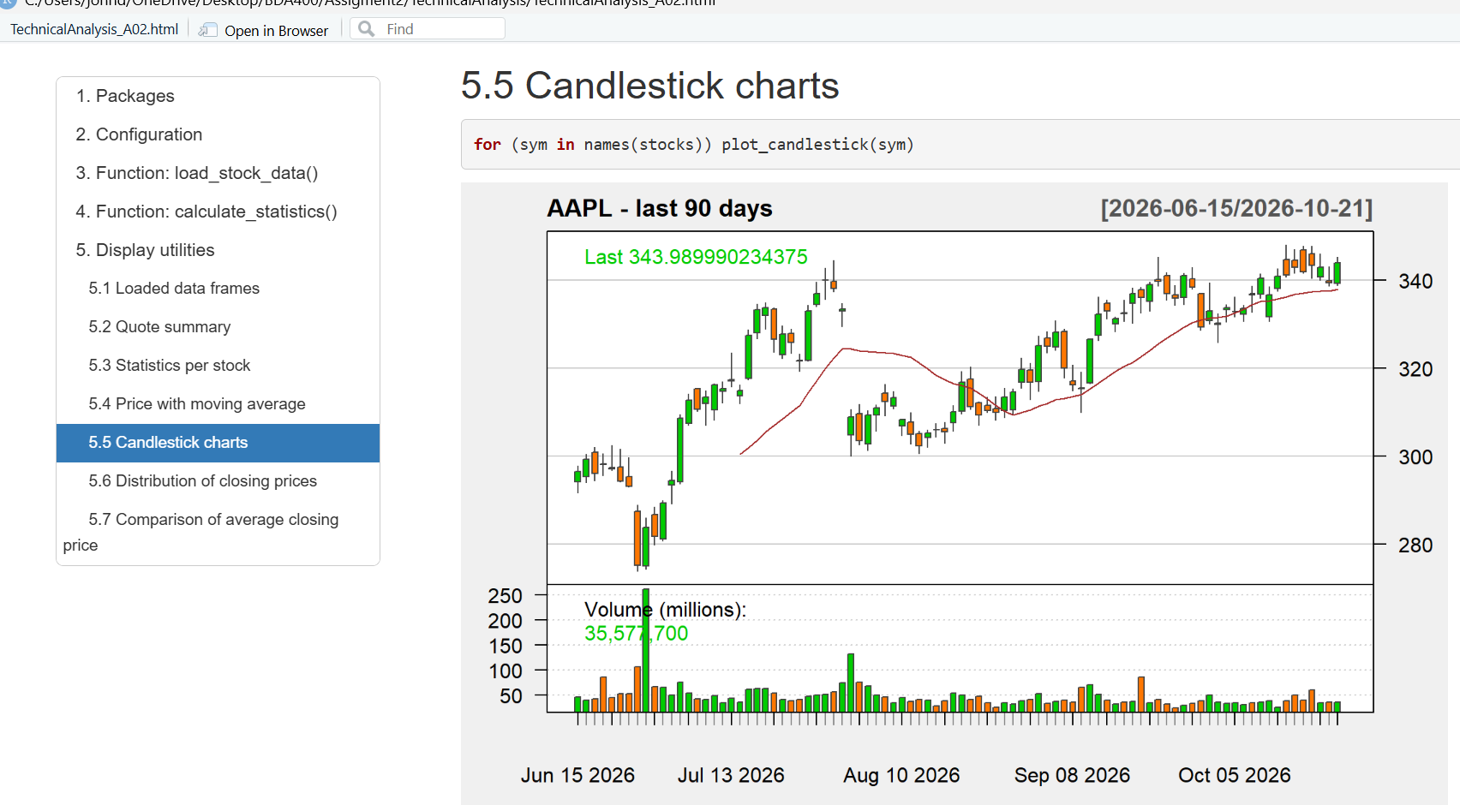
Figure 7.4a - AAPL

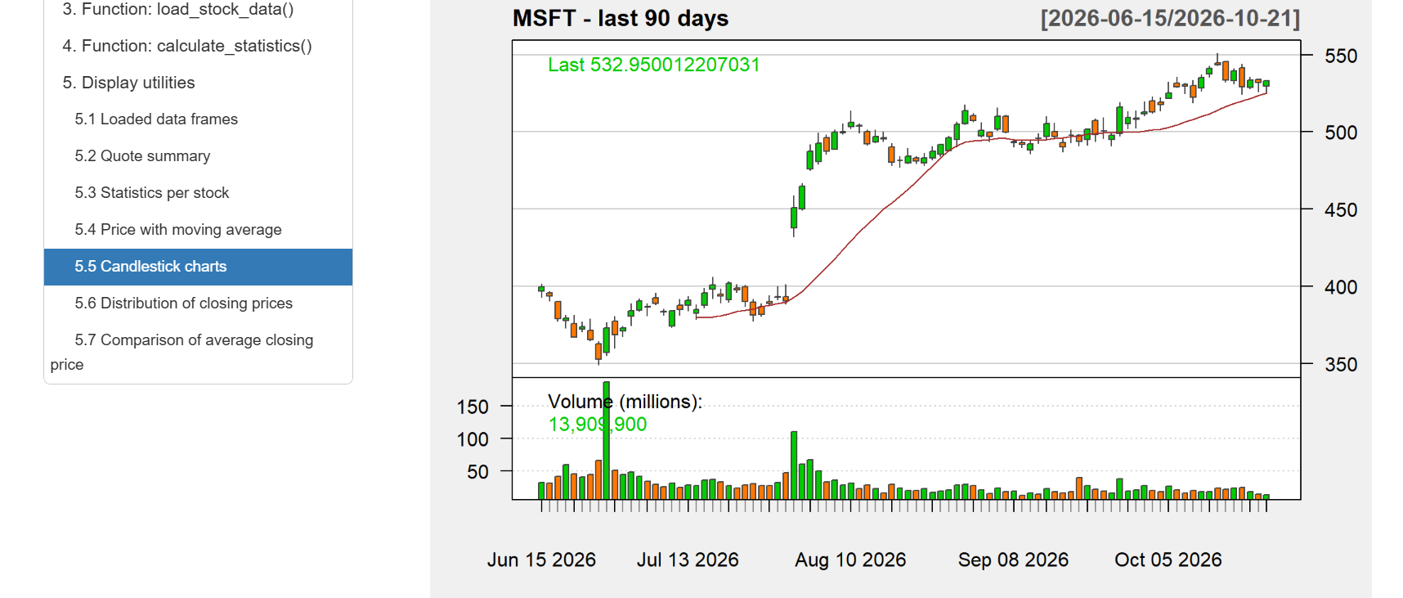
Figure 7.4b - MSFT

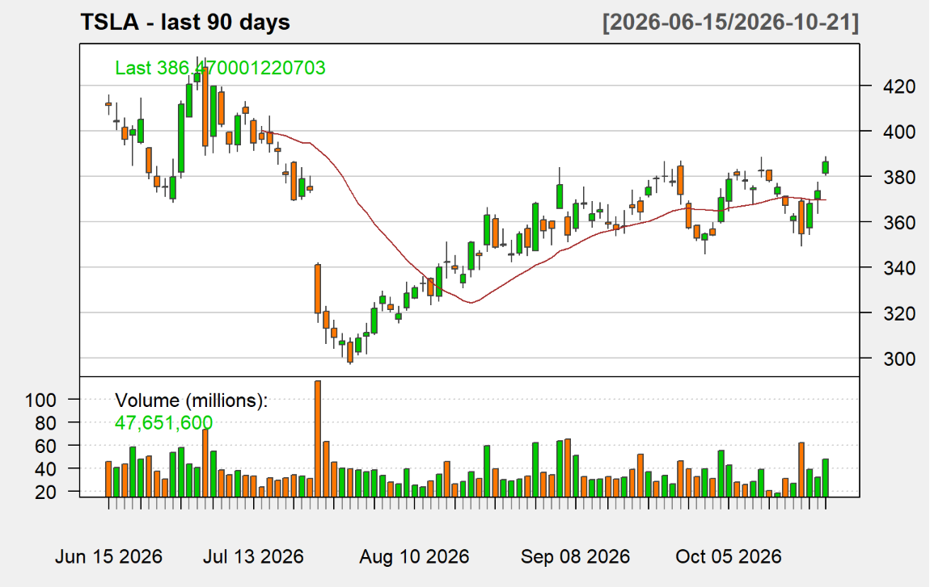
Figure 7.4c - TSLA

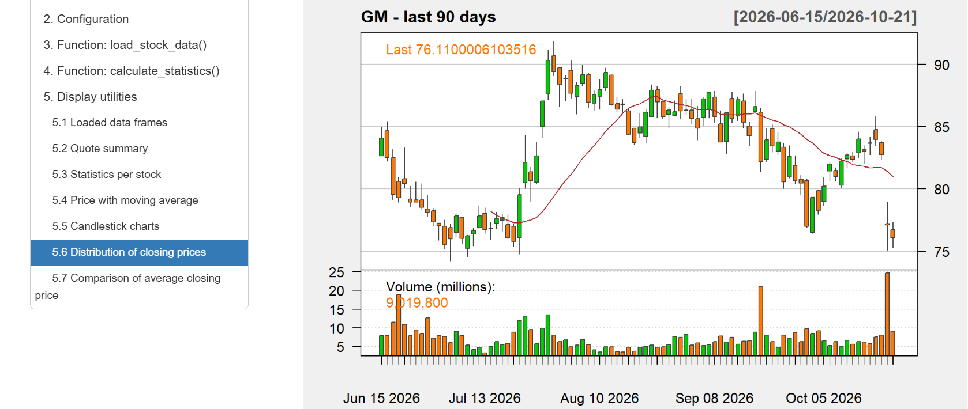
Figure 7.4d - GM

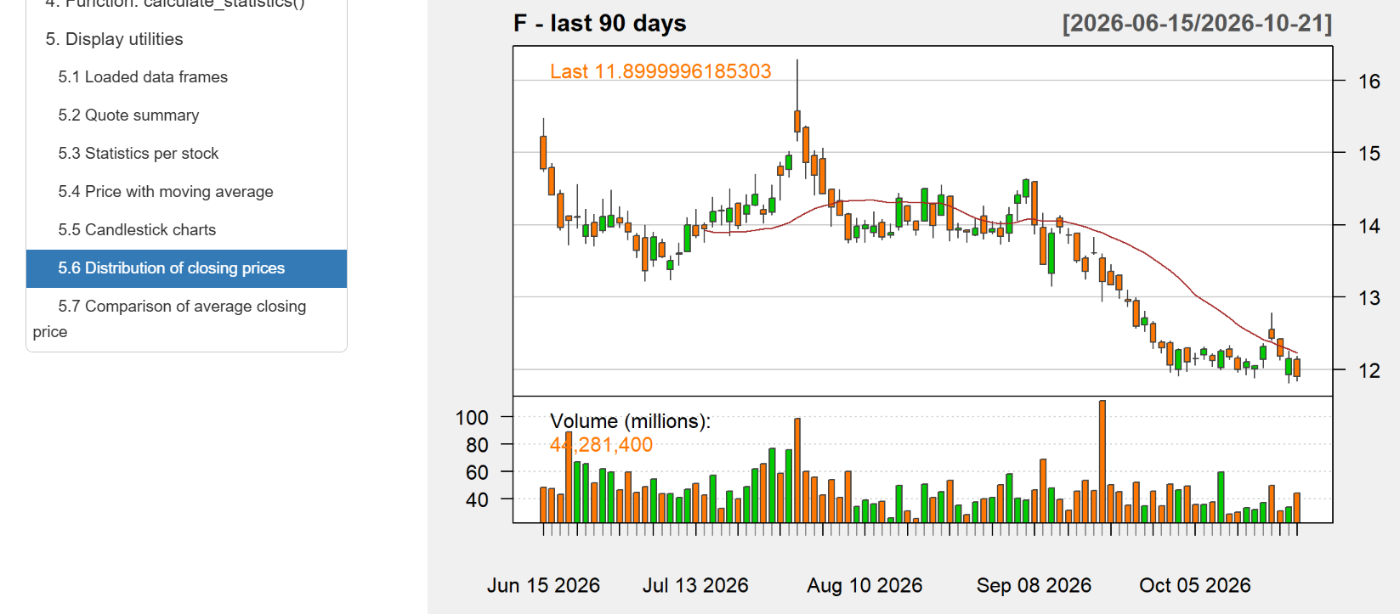
Figure 7.4e - F

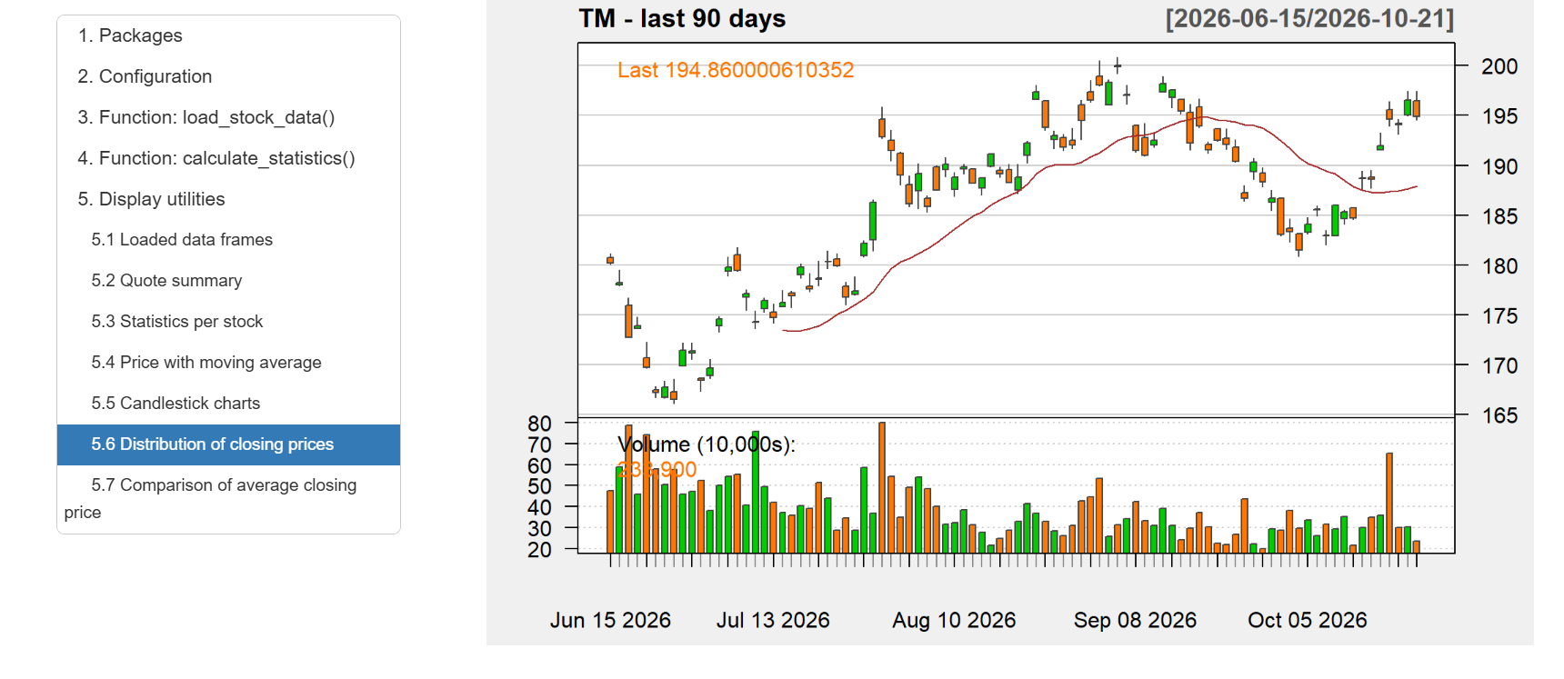
Figure 7.4f - TM

Distribution of closing prices
The red line marks the mean and the dashed blue line marks the median of each stock.
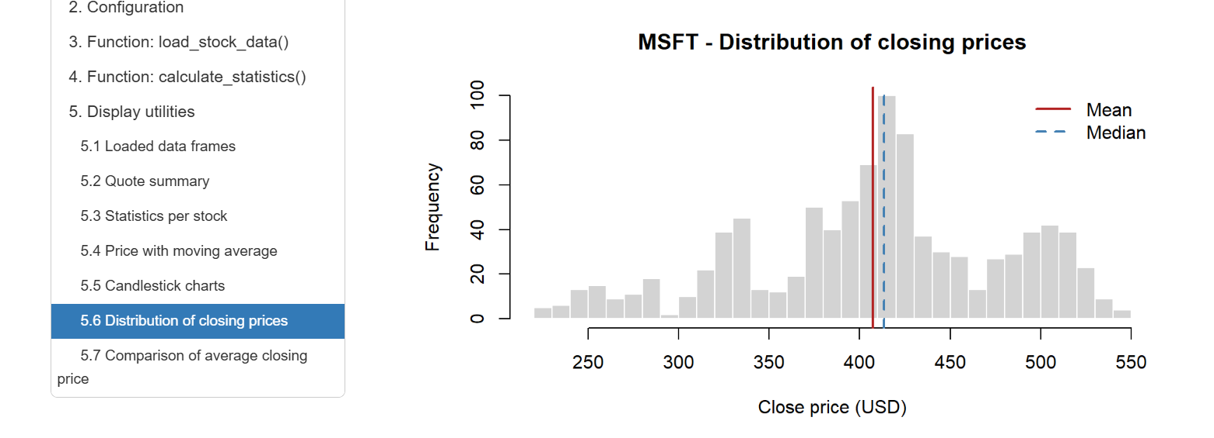
Figure 7.5a - MSFT

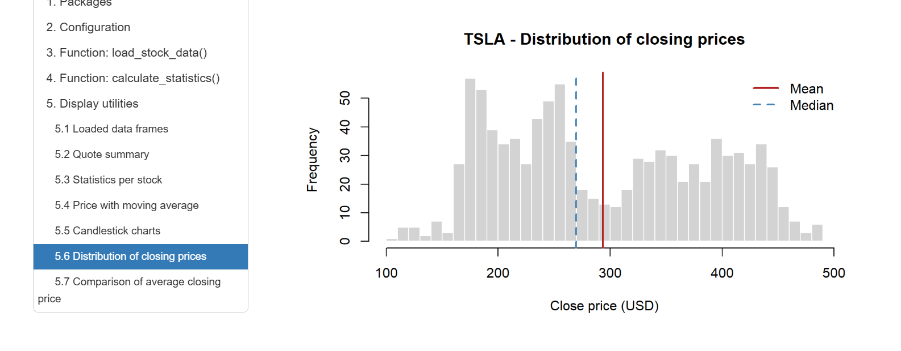
Figure 7.5b - TSLA

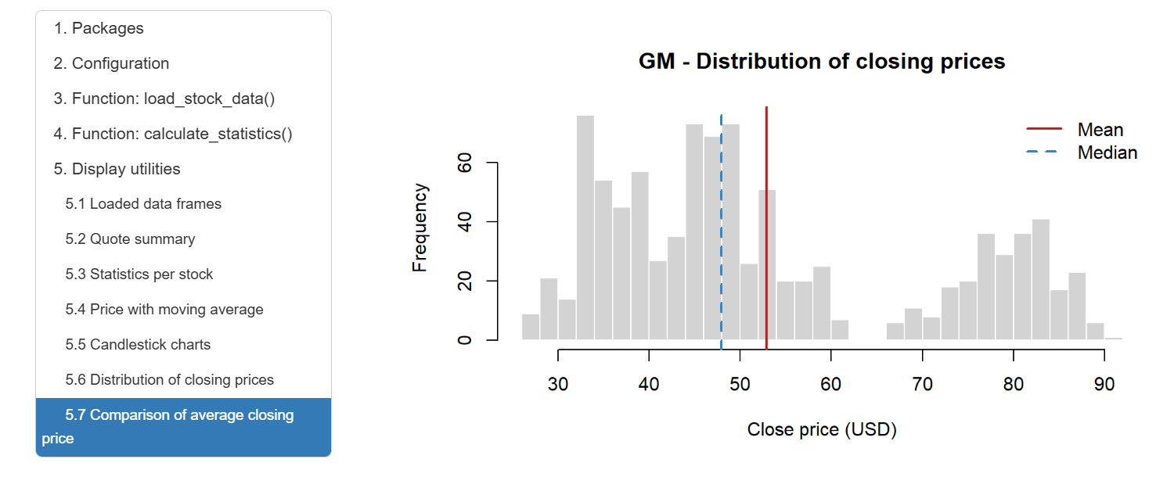
Figure 7.5c - GM

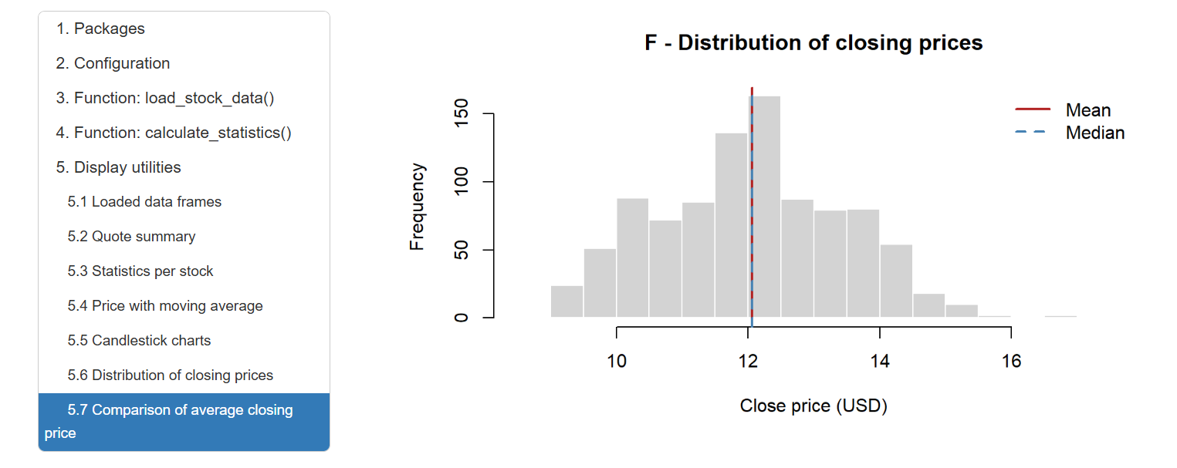
Figure 7.5d - F

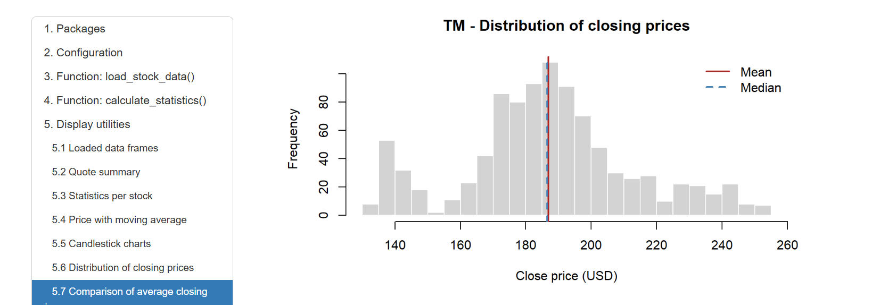
Figure 7.5e - TM

Comparison of average closing price
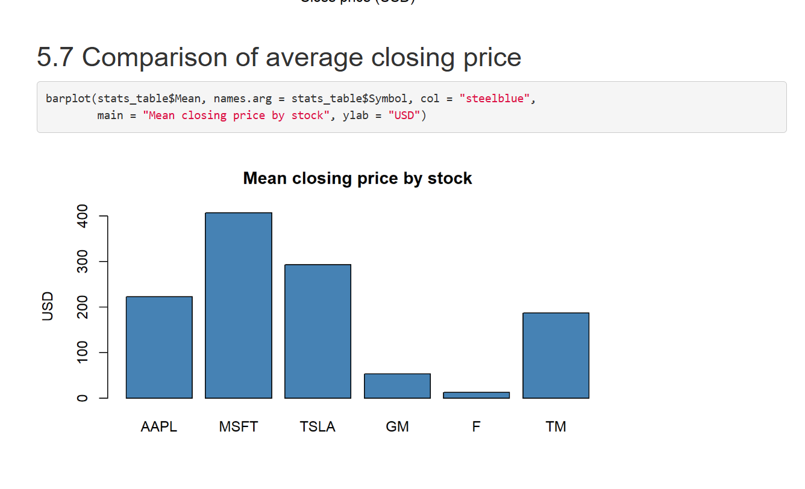
Figure 7.6 - Comparison of the mean closing price by stock (bar chart)

8. Documentation and Submission
- Knit TechnicalAnalysis_A02.Rmd to HTML to confirm that the whole script runs from start to finish.
- Upload this report, portfolio.txt and the .Rmd file to the Assignment2 folder of the TechnicalAnalysis repository.
- Submit the cover page with the repository link, using the file name JohnDiaz_BDA400_A02.

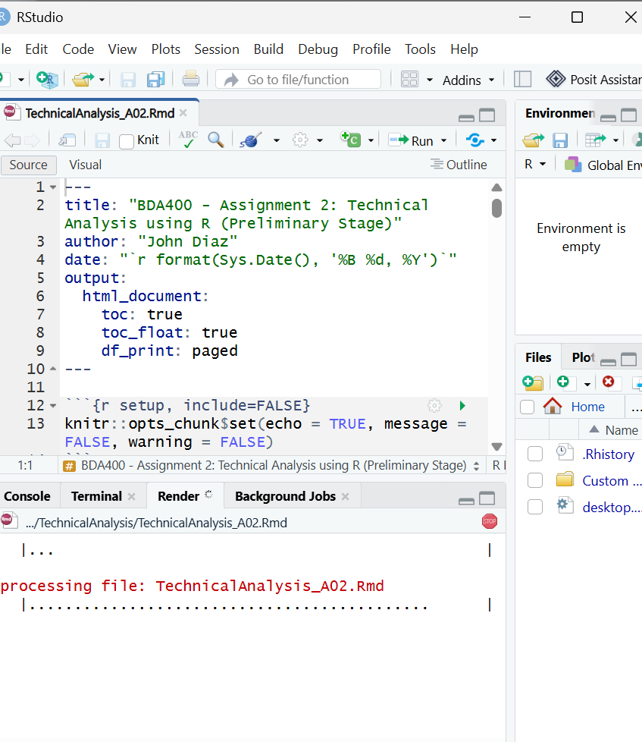
Figure 8.1 - Knitting TechnicalAnalysis_A02.Rmd in RStudio (Render tab running)

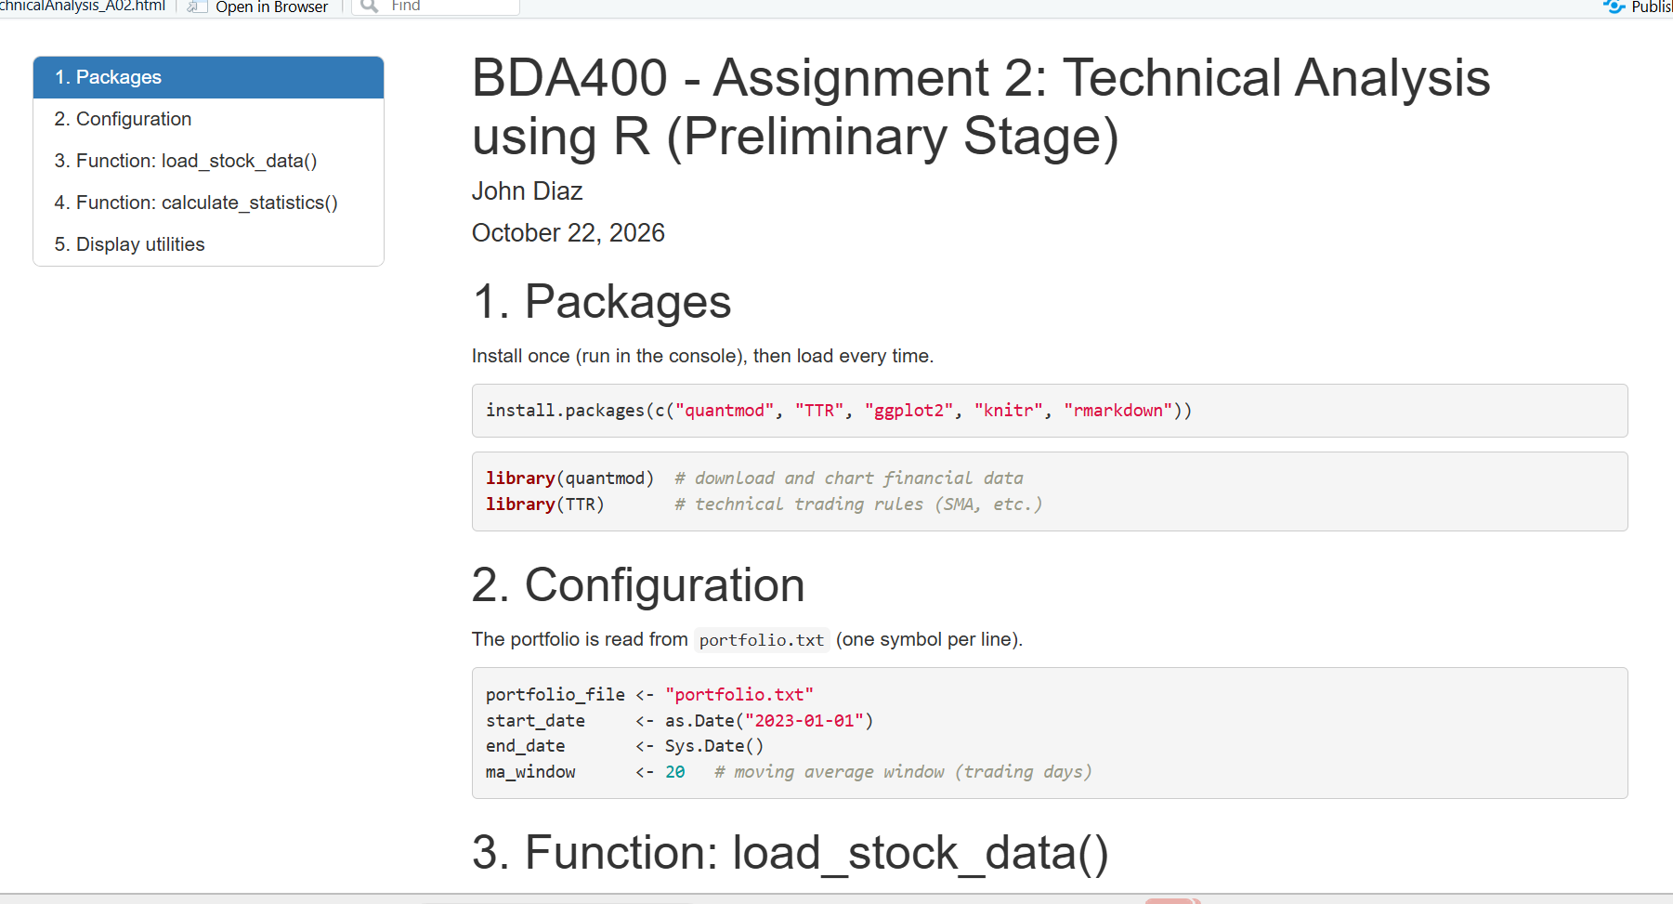
Figure 8.2 - Knit output (HTML) opened successfully

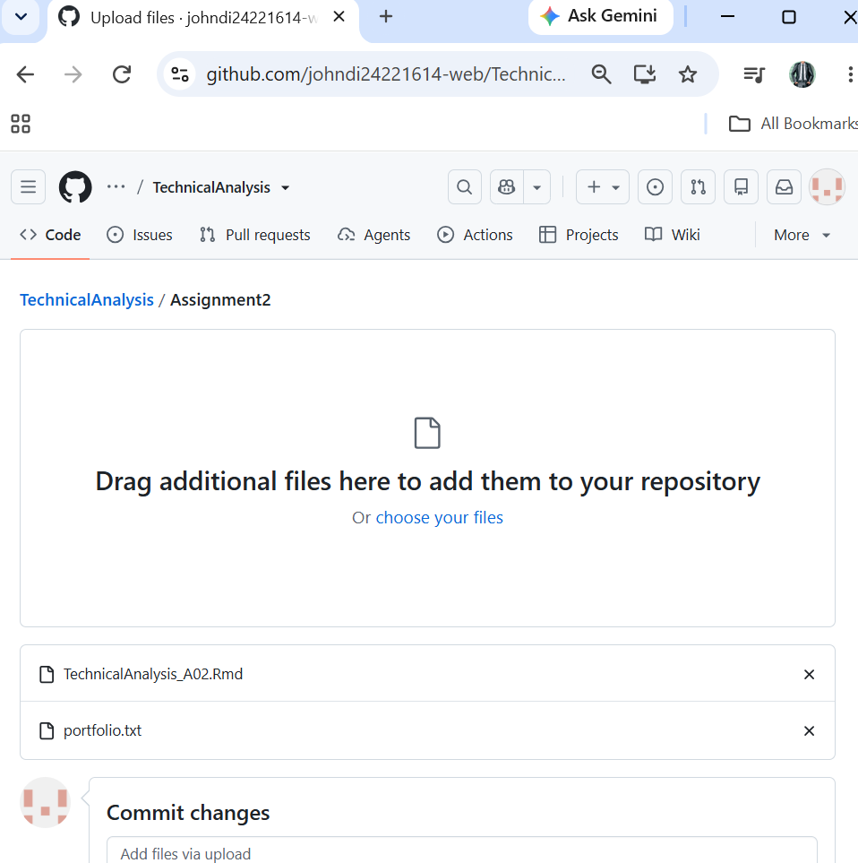
Figure 8.3a - Upload files page with portfolio.txt and TechnicalAnalysis_A02.Rmd ready to commit

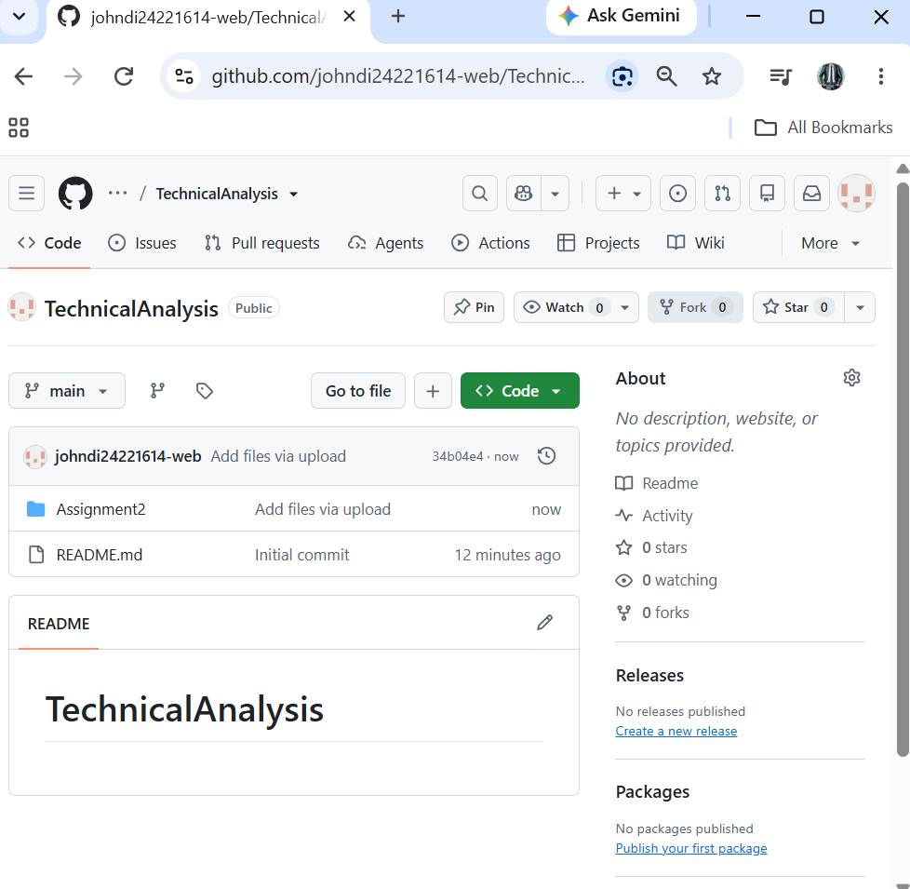
Figure 8.3b - Repository after the upload commit (Add files via upload)

SCREENSHOT
8.3c - Assignment2 folder with portfolio.txt, the .Rmd and the final Word report (final upload)

Conclusion
The environment (GitHub, Git, R, RStudio, quantmod and TTR) is now configured, and the base functions for loading data, computing statistics and displaying results are ready. They will be reused and extended in the next two stages of the technical analysis project.

