HARVIANA: A GIS-INTEGRATED DECISION SUPPORT SYSTEM FOR VISUALIZING VEGETABLE PRODUCTION TRENDS IN BENGUET

A Capstone Project Presented to the Faculty of the

College of Information Technology and Computer Sciences

University of the Cordilleras

In Partial Fulfillment

of the Requirements for the Degree

BACHELOR OF SCIENCE IN INFORMATION TECHNOLOGY

by

LORD ALFREY TONGNAWA BATERINA

JOHNDOE AMIEL ISIT DELA CRUZ

JOJEMAY MAGALSO TAGALOG

July 2026
APPROVAL SHEET

This project study entitled HARVIANA: A GIS-INTEGRATED DECISION SUPPORT SYSTEM FOR VISUALIZING VEGETABLE PRODUCTION TRENDS IN BENGUET prepared and submitted by LORD ALFREY T. BATERINA, JOHNDOE AMIEL I. DELA CRUZ, and JOJEMAY M. TAGALOG in partial fulfillment of the requirements for the degree BACHELOR OF SCIENCE IN INFORMATION TECHNOLOGY, has been examined and is recommended for acceptance and approval for oral examination.

ANNA RHODORA M. QUITALEG, MIT
Adviser

Project Study Committee

ANNA RHODORA M. QUITALEG, MIT RAZIELLE JEYNA MAE F. BERNALDEZ, BSCS
Member Member

GEM A. BALAY-ODAO, BSCS
Chairperson

PANEL OF EXAMINERS
APPROVED by the Committee on Oral Examination on __________________ with a grade of _____________.

GEM A. BALAY-ODAO, BSCS
Chairperson

ANNA RHODORA M. QUITALEG, MIT RAZIELLE JEYNA MAE F. BERNALDEZ, BSCS
Member Member

ACCEPTED AND APPROVED in partial fulfillment of the requirements for the degree BACHELOR OF SCIENCE IN INFORMATION TECHNOLOGY.

MELINDA A. BENINSIG, MIT JEFFREY S. INGOSAN, DIT
IT Program Chair Dean, College of
College of Information Technology Information Technology
and Computer Science and Computer Science

ABSTRACT
- Title: HARVIANA: A GIS-INTEGRATED DECISION SUPPORT
SYSTEM FOR VISUALIZING VEGETABLE PRODUCTION
TRENDS IN BENGUET

  - Total No. of Pages:
1.2. Text No. of Pages:

- Authors: BATERINA, LORD AFLREY T.
DELA CRUZ, JOHNDOE AMIEL I.
TAGALOG, JOJEMAY M.
- Type of Document: Capstone Project
- Type of Publication: Unpublished
- Accrediting Institution: University of the
Cordilleras, Gov. Pack Rd.
Baguio City

- Keywords: Harviana, Geographic Information System,
Agricultural Decision-Support, Vegetable
Production, Benguet

- Abstracts:
7.1 Rationale/Background of the Study
Vegetable production is essential to Benguet’s economy, agricultural livelihoods, and contribution to the regional food supply. However, crop plans, damage reports, and actual-harvest records can be difficult to consolidate when information is handled through separate or uncoordinated processes. Fragmented and delayed records may affect report validation, production monitoring, and the availability of timely information for municipal agricultural planning. These limitations also make it difficult to compare expected production with actual harvest outcomes and identify possible changes in vegetable supply. Farmers therefore need an organized way to manage crop activities and submit farm records, while agricultural offices require updated, validated, and location-based information for monitoring and decision-making. To address these needs, the researchers developed Harviana, a GIS-integrated decision-support system connecting Farmers, LGU Validators, and DA Administrators through submission, validation, monitoring, forecasting, and reporting.

7.2 Summary
This study aimed to design and develop Harviana: A GIS-Integrated Decision Support System for Visualizing Vegetable Production Trends in Benguet. Specifically, the researchers sought to:
- to identify the information requirements of proposed system;
- to determine the architectural framework of the proposed system;
- to identify the features of the proposed system; and
- to measure the extent of usability of Harviana among participating Farmers and DA Administrators.
The researchers used Scrum through five Sprints: Requirements Gathering and Planning, GIS Visualization Module Development, Core Feature Development, Machine-Learning Production Estimation and Supply Forecast Integration, and Testing and Evaluation. This process supported iterative development and refinement.

7.3 Findings
Based on the data gathered and analyzed in relation to the objectives of the study, the researchers identified the following findings:
- Harviana’s information requirements cover Farmer crop plans, damage reports, and harvest records; LGU validation data; DA monitoring and reporting information; and the minimum and recommended technical requirements.
- The “4+1” View Model described Harviana’s scenario, logical, process, development, and physical views, including its users, structure, workflows, software components, and Railway deployment with its machine-learning service and Railway PostgreSQL.
- Harviana provides role-based features for Farmers, LGU Validators, and DA Administrators. Farmers can plan crops, manage calendars, estimate production, receive recommendations, report damage, record harvests, and access maps and weather. LGUs review and validate reports, while DA administrators manage records, GIS data, forecasts, analytics, reports, and exports. Together, these features connect Farmer submissions, LGU validation, and DA monitoring.
- The 132 valid Farmer respondents obtained a mean SUS score of 71.55, interpreted as “OK to Good” and “Marginal to Acceptable.” The 18 DA Administrator respondents obtained an overall USE mean of 6.32, interpreted as “Strongly Agree.”

7.4. Conclusions
Based on the findings of the study, the researchers arrived at the following conclusions:
- The identified information requirements provide the records needed for crop monitoring, validation, forecasting, and reporting.
- The “4+1” View Model provides an organized framework for describing Harviana’s users, structure, processes, components, and deployment.
- Harviana’s role-based features establish an integrated workflow for crop planning, record submission, validation, GIS-based monitoring, supply forecasting, prediction analytics, and report generation. This workflow enables agricultural information to move from Farmers through LGU Validators to DA Administrators.
- Harviana was generally usable for the participating Farmers and DA Administrators, although the farmer-side interface may still be improved for first-time users.

7.5 Recommendations
Based on the conclusions of the study, the researchers recommend the following:
- Regularly review Harviana’s information and validation requirements with its user groups to maintain complete and relevant agricultural records.
- Maintain the database, machine-learning service, security controls, backups, and Railway deployment for reliable and secure operation.
- Expand crop coverage and validated datasets, improve user guidance, and support Farmers in areas with limited connectivity.
- Include LGU Validators and participants from other Benguet municipalities in future usability evaluations to improve the interface and validation workflow.
ACKNOWLEDGEMENT
The researchers would like to express their sincere gratitude to the individuals and organizations whose guidance, cooperation, and support contributed to the completion of this capstone project.
The researchers also extend their appreciation to Ms. Gem A. Balay-Odao, BSCS, Chairperson, and Ms. Razielle Jeyna Mae F. Bernaldez, BSCS, Committee Member, for sharing their time and expertise during the evaluation of the project. Their comments and recommendations helped the researchers address important concerns and improve both the system and the manuscript.
Sincere appreciation is extended to the faculty and staff of the College of Information Technology and Computer Sciences of the University of the Cordilleras for providing the knowledge, guidance, and academic environment needed to complete the study. The researchers also thank the Department of Agriculture–Cordillera Administrative Region, the participating DA Administrators, and the Farmers who shared their time, knowledge, and responses during the conduct and evaluation of the study. Their participation provided valuable information that contributed to the development and assessment of Harviana.
The researchers would also like to thank their families and friends for their patience, understanding, encouragement, and support throughout the completion of the capstone project. Their motivation helped the researchers continue despite the difficulties encountered during system development and manuscript preparation.
The researchers also acknowledge one another for the cooperation, commitment, and perseverance demonstrated throughout the project. Each member’s willingness to share responsibilities, exchange ideas, and work through challenges contributed greatly to the completion of Harviana.
Above all, the researchers give thanks to Almighty God for the wisdom, strength, guidance, and blessings that sustained them throughout this journey. To everyone who contributed directly or indirectly to the completion of this study, the researchers offer their heartfelt appreciation.
L.A.T.B
J.A.I.D.C
J.M.T

DEDICATION
This capstone project is lovingly dedicated to our families and loved ones, whose patience, understanding, encouragement, and sacrifices gave us the strength to continue throughout every stage of this journey.
To our adviser, teachers, and mentors, whose guidance and wisdom encouraged us to improve our ideas, overcome challenges, and complete this study with determination.
To the participating Farmers and DA personnel who shared their time, experiences, and insights, your contributions helped make Harviana relevant to agricultural monitoring and decision-making in Benguet.
To one another, for the cooperation, trust, patience, and perseverance that enabled us to face difficulties and complete this project as a team.
Above all, we dedicate this accomplishment to Almighty God, whose wisdom, guidance, and blessings sustained us throughout the completion of this study.
Alfrey
Johndoe
Jojemay

TABLE OF CONTENTS
Page
TITLE PAGE . . . . . . . . . . . . . . . . . . . . . . 1
APPROVAL SHEET . . . . . . . . . . . . . . . . . . . . 2
ABSTRACT . . . . . . . . . . . . . . . . . . . . . . . 3
ACKNOWLEDGEMENT . . . . . . . . . . . . . . . . . . . 6
DEDICATION . . . . . . . . . . . . . . . . . . . . . . 8
TABLE OF CONTENTS . . . . . . . . . . . . . . . . . . 9
LIST OF FIGURES . . . . . . . . . . . . . . . . . . . 11
LIST OF TABLES . . . . . . . . . . . . . . . . . . . . 13
CHAPTER
1 INTRODUCTION
Background of the Study . . . . . . . . . . 14
Importance of the Study . . . . . . . . . . 27
Objectives of the Study . . . . . . . . . . 30
Definition of Terms . . . . . . . . . . . . 31
2 METHODOLOGY
Software Development Methodology . . . . . 36
Design Thinking . . . . . . . . . . . . . . 43
Scope and Delimitation . . . . . . . . . . . 62
Data Gathering Techniques . . . . . . . . . 64
Sources of Data . . . . . . . . . . . . . . 66
Software Development Tools . . . . . . . . . 68
3 FINDINGS OF THE STUDY
Information Requirements for Harviana . . . 73
Architecture Framework of Harviana . . . . 77
Features of Harviana . . . . . . . . . . . . 90
Extent of the Usability of Harviana . . . . 101
4 CONCLUSIONS AND RECOMMENDATIONS
Conclusions . . . . . . . . . . . . . . . . 117
Recommendations . . . . . . . . . . . . . . 119
REFERENCES . . . . . . . . . . . . . . . . . . . . . 121
APPENDICES
A Communication Letter . . . . . . . . . . . . 128
B Endorsement Letter . . . . . . . . . . . . . 129
C Business Model Canvas . . . . . . . . . . . 130
D Invitation Letter . . . . . . . . . . . . . 132
E Documentation . . . . . . . . . . . . . . . 135
F Supporting Interfaces . . . . . . . . . . . 138
G Recommendation Processing . . . . . . . . 140
H ML Production Estimate . . . . . . . . . . . 141
I Agricultural Map Data . . . . . . . . . . . 142
J Crop Data Management . . . . . . . . . . . 143
K User Manual . . . . . . . . . . . 144

LIST OF FIGURES
Figure No. Figure Title Page
1 Scrum Development Process of Harviana . . . 37
2 Design Thinking . . . . . . . . . . . . . . . 43
3 Empathy Map . . . . . . . . . . . . . . . . . 45
4 The 5 Why Analysis . . . . . . . . . . . . . 47
5 Impact-Effort Matrix . . . . . . . . . . . . 49
6 Landing Page Overview Prototype . . . . . . 51
7 Login and Registration Prototype . . . . . . 52
8 Crop Planning and Farmer Calendar Prototype . 53
9 ML-Based Production Estimate Prototype . . . 54
10 Damage Report Submission Prototype . . . . . 55
11 Actual Harvest Recording Prototype . . . . . 56
12 LGU Report Validation Prototype . . . . . . 57
13 Interactive Map and Weather Prototype . . . 58
14 DA Dashboard and Supply
Forecast Prototype . . . . . . . . . . . . . 59
15 Reports and Export Prototype . . . . . . . . 60
16 The “4+1” View Model by Kruchten . . . . . . 78
17 Harviana Use Case Diagram . . . . . . . . . . 79
18 Harviana Class Diagram . . . . . . . . . . . 81
19 Harviana Login Sequence Diagram . . . . . . . 83
20 Harviana Crop Plan and Production Estimate Sequence Diagram . . . . . . . . . . . . . . 84
21 Harviana Farmer Report and LGU Validation
Sequence Diagram . . . . . . . . . . . . . . 85
22 Harviana Sequence Diagram for DA Administrator
Supply Forecast . . . . . . . . . . . . . . 86
23 Harviana Sequence Diagram for DA Report Generation and Report . . . . . . . . . . . . 87
24 Harviana Package Diagram . . . . . . . . . . 88
25 Harviana Deployment Diagram . . . . . . . . . 89
26 Farmer Dashboard . . . . . . . . . . . . . . . 92
27 Farmer Calendar and Crop Planning . . . . 93
28 ML-Based Production Estimate . . . . . . . . . 94
29 Damage Report Submission . . . . . . . . . . . 95
30 Actual Harvest Recording . . . . . . . . . . . 96
31 LGU Report Validation . . . . . . . . . . . . 97
32 Admin Dashboard and Supply Forecast . . . . 98
33 Crop Data Management . . . . . . . . . . . . . 99
34 Interactive Map and Weather . . . . . . . 100
35 Reports and Export Generation . . . . . . . . 101
36 Business Model Canvas . . . . . . . . . . . . 130

LIST OF TABLES
Table No. Table Title Page
1 Farmer Information . . . . . . . . . . . . . 76
2 LGU Validator Information . . . . . . . . . . 76
3 DA-Admin Information . . . . . . . . . . . . 76
4 System Requirements . . . . . . . . . . . . 77
5 SUS Score Interpretation Scale . . . . . . . 103
6 Farmers’ SUS Questionnaire Results . . . . . 104
7 Summary of Farmers’ SUS Score . . . . . . . . 106
8 Seven-Point USE Questionnaire
Interpretation Scale . . . . . . . . . . . . 108
9 Usefulness: Usability Testing Result for
DA Administrators . . . . . . . . . . . . . . 109
10 Ease of Use: Usability Testing Result for
DA Administrators . . . . . . . . . . . . . . 110
11 Ease of Learning: Usability Testing Result for
DA Administrators . . . . . . . . . . . . . . 112
12 Satisfaction: Usability Testing Result for
DA Administrators . . . . . . . . . . . . . . 113
13 Overall USE Questionnaire Result for
DA Administrators . . . . . . . . . . . . . 114
14 Overall Usability Summary of Harviana . . . . 115

Chapter 1
INTRODUCTION
Background of the Study
Agriculture remains a fundamental component of global food systems because it supports food production, livelihoods, employment, and economic activity. However, agricultural production is increasingly affected by climate variability, extreme weather events, environmental pressures, and disruptions in the movement and availability of food. The Intergovernmental Panel on Climate Change (IPCC, 2022) reported that climate-related extremes have already affected the productivity of agricultural, forestry, and fishery sectors, with consequences for food availability, prices, nutrition, and the livelihoods of affected communities. These conditions increase the need for timely and reliable agricultural information that can support production planning, risk monitoring, and coordinated responses to agricultural problems.
Food security also remains a significant global concern as agricultural producers attempt to meet increasing demand while responding to environmental and economic pressures. The Food and Agriculture Organization of the United Nations and its partner organizations reported that, despite recent progress, global hunger and food insecurity remain above pre-pandemic levels and the world is still far from achieving the targets of ending hunger and food insecurity by 2030 (FAO et al., 2025). The report also emphasized the importance of better data systems and sustained investments in resilient agrifood systems. This demonstrates that agricultural planning requires reliable information on production conditions, crop losses, market disruptions, and supply availability.
The continuing development of digital technologies has created opportunities to improve the collection, organization, and interpretation of agricultural information. The Food and Agriculture Organization of the United Nations (FAO, 2022) explained that digital technologies and agricultural automation can improve productivity, resource-use efficiency, environmental sustainability, and the resilience of agrifood systems when they are appropriately implemented. Geographic Information Systems, web-based applications, and machine learning technologies can also assist agricultural stakeholders in visualizing production patterns, estimating crop output, monitoring location-based conditions, and identifying changes in agricultural supply. The Digital Agriculture Roadmap Playbook further emphasizes the importance of connecting user-facing applications, agricultural databases, system integration components, and decision-support tools within an organized digital environment (World Bank, Gates Foundation, & Boston Consulting Group, 2025).
Despite the potential of digital agriculture, its benefits are not automatically available to all agricultural stakeholders. Small-scale producers and rural communities may experience limitations related to internet connectivity, digital literacy, access to appropriate devices, infrastructure, and the cost of adopting new technologies. FAO (2022) identified low digital literacy, inadequate connectivity, limited access to electricity, and financial constraints as barriers to the inclusive adoption of digital agricultural technologies. The E-Agriculture Strategy Guide also emphasized that digital agricultural initiatives require a clear vision, coordinated implementation, and monitoring mechanisms that respond to the conditions of their intended users (FAO & ITU, 2016). These issues highlight the need for agricultural information systems that are accessible, user-friendly, and capable of transforming fragmented records into validated and meaningful information for decision-making.
In the Philippine setting, the need for digital agricultural support is connected to the broader modernization of the country’s agricultural sector. The World Bank (2020) emphasized that transforming Philippine agriculture into a more dynamic, competitive, and diversified sector is important for food security and the welfare of rural communities. Achieving this transformation requires agricultural systems that can organize production data, improve the coordination of stakeholders, and provide information that supports farmers and government decision-makers.
The Philippine Development Plan 2023–2028 similarly promotes the modernization of agriculture and agribusiness. The National Economic and Development Authority (2023) considers agriculture part of a broader agrifood system that includes production, processing, marketing, consumption, and waste management. The plan emphasizes improving agricultural efficiency, strengthening value chains, and encouraging the adoption of appropriate technologies. These directions establish a need for digital systems that organize farm records and make agricultural information more useful for monitoring and planning.
The Department of Agriculture’s National Agriculture and Fisheries Modernization and Industrialization Plan 2021–2030 also supports coordinated and technology-assisted agricultural development. The plan provides a sector-wide direction for transforming the Philippine food system through collaboration among government institutions, private organizations, farmers, and other agricultural stakeholders (Department of Agriculture, 2022). A coordinated digital workflow can contribute to this direction by connecting farm-level records with local validation and administrative monitoring.
Digital agriculture has therefore become increasingly relevant in the Philippines. Briones et al. (2023) explained that digital technologies can contribute to agricultural productivity, market access, sustainability, and decision support. However, they also identified concerns involving the digital divide, rural connectivity, fragmented government information systems, and the need to harmonize agricultural data and advisory services. These findings indicate that agricultural platforms should not merely collect information but should organize it in a form that farmers and agricultural offices can understand and use.
Philippine agricultural stakeholders have also recognized the importance of preparing farmers and government institutions for technology-based agricultural systems. CGIAR (2024) reported that digital technologies are increasingly considered part of the future of Philippine agriculture, although limitations involving infrastructure, digital literacy, data security, and institutional coordination must still be addressed. Agricultural systems must therefore be designed around the responsibilities and capabilities of their users. Role-based interfaces can help ensure that farmers, validators, and administrators only access the information and system functions relevant to their assigned responsibilities.
The Cordillera Administrative Region, particularly Benguet, provides an important setting for applying these approaches because it is one of the country’s major sources of highland vegetables. According to the Philippine Statistics Authority RSSO-CAR (2025), the Cordillera Administrative Region produced 432,068.1 metric tons of vegetables in 2024. Benguet contributed 371,151.5 metric tons, representing 85.9 percent of the region’s total vegetable production. Because of Benguet’s significant contribution to the vegetable supply, planting schedules, production records, damage incidents, and actual-harvest information are important for monitoring agricultural conditions and anticipating possible changes in supply.
The importance of Benguet vegetables extends beyond the province because its agricultural products move through broader food value-chain networks. Aquino et al. (2025) examined the role of Benguet-sourced vegetables in household food access and supply movement. The study demonstrates how the condition of vegetable production in Benguet may affect traders, consumers, institutions, and communities that depend on vegetables produced in the province. This makes organized and timely agricultural production information valuable not only to farmers but also to government offices responsible for monitoring agricultural supply.
Despite Benguet’s contribution to vegetable production, farmers and agricultural offices may still experience difficulties in organizing crop activities, validating field reports, and converting farm-level information into usable administrative records. Farmers require an organized way to create crop plans, monitor scheduled activities, document crop damage, and record actual harvest results. LGU Validators need to review farmer-submitted reports before the information becomes part of the system’s validated records. DA Administrators, meanwhile, require consolidated information that can support production monitoring, map-based visualization, supply forecasting, and report generation. When these activities are conducted through separate or uncoordinated processes, agricultural information may become delayed, incomplete, inconsistent, or difficult to verify.
Agricultural extension and advisory services are also important in helping farmers and government offices use information effectively. The Philippine Agriculture and Fisheries Extension Strategic Plan 2023–2028 emphasizes the need to improve extension and advisory services as part of the transformation of the country’s food systems. The Agricultural Training Institute (2023) stated that the plan supports efficient agricultural production, competitiveness, stronger extension institutions, and the empowerment of farmers and fisherfolk. Digital platforms can support this direction by making crop plans, damage reports, harvest records, and monitoring information more accessible to farmers and agricultural personnel.
The Agricultural Training Institute’s e-Extension Program further demonstrates how digital platforms can support the delivery of agricultural information in the Philippines. The program serves as the Department of Agriculture’s digital strategy for providing farmers, fisherfolk, agricultural extension workers, and other stakeholders with access to online courses, technical information, and agricultural support services (Agricultural Training Institute, n.d.). Although Harviana does not replace agricultural extension services, it follows a related digital direction by organizing crop-related information and improving access to agricultural monitoring records.
Weather conditions must also be considered in crop planning and production monitoring. The Philippine Atmospheric, Geophysical and Astronomical Services Administration describes the Philippines as having a tropical and maritime climate characterized by relatively high temperatures, high humidity, and abundant rainfall (PAGASA, n.d.). These conditions make weather information relevant to planting schedules, farm activities, crop damage, and expected harvest dates. Providing weather information alongside location-based agricultural records can help farmers and administrators interpret production conditions more effectively.
Digital agriculture can also support adaptation to changing environmental conditions. Stephenson et al. (2021) explained that digital technologies can contribute to climate adaptation by making agricultural and spatial information available for crop suitability assessment, government planning, and the identification of agricultural priorities. This supports the use of maps and weather information in Harviana because these features allow users to view crop records in relation to farm locations and field conditions.
Geographic Information Systems and WebGIS technologies are especially relevant to agricultural monitoring because they allow records to be organized, displayed, and interpreted according to location. Raihan (2024) emphasized that GIS can support evidence-based agricultural decision-making by enabling the analysis of spatial information related to crop production, sustainability, and agricultural planning. Cui et al. (2022) demonstrated the use of an open-source WebGIS system for agricultural land management, while Patel et al. (2023) showed how a WebGIS-based decision-support system can assist agricultural monitoring and management. These studies support the development of Harviana as a GIS-integrated platform that presents vegetable production information through interactive map-based visualization.
Studies involving crop monitoring and forecasting also demonstrate the value of combining agricultural data with spatial and analytical technologies. Alemán-Montes et al. (2025) developed a near real-time spatial decision-support system that used a satellite mapping web browser to support crop monitoring. Wu et al. (2023) explained that reliable crop monitoring depends on the availability of timely and useful crop information. Ali et al. (2022) discussed the contribution of remote-sensing data to crop-yield prediction, while Jabed and Azmi Murad (2024) reviewed the application of machine learning and deep learning techniques in agricultural yield prediction. Collectively, these studies show how production records, spatial information, and forecasting techniques can provide agricultural stakeholders with more useful information for planning.
Local studies further establish the relevance of forecasting and decision-support systems to vegetable production in Benguet. Pilay and Werdenberg (2024) applied SARIMA-based forecasting to vegetable-production data from the province, demonstrating how historical production patterns can be analyzed to estimate possible future output. Quitaleg and Dumlao (2023) developed a decision-support system for predicting Benguet upland vegetable crops using machine learning techniques. These studies demonstrate that forecasting technologies are applicable to Benguet’s agricultural setting. However, Harviana expands this direction by combining crop planning, farmer-submitted records, validation, GIS visualization, production estimation, supply monitoring, and administrative reporting within one web-based platform.
In response to the identified global, national, and local concerns, this study developed Harviana, a GIS-integrated agricultural decision-support system intended for Farmers, LGU Validators, and DA Administrators. Farmers can use the system to create crop plans, organize agricultural activities through a calendar, view machine-learning-based production estimates, submit crop-damage reports, and record actual harvest results. The submitted damage and harvest records can be reviewed by LGU Validators before they are used as validated agricultural information. DA Administrators can access dashboards, monitor crop and harvest records, view interactive maps and weather information, examine municipal supply forecasts, and generate agricultural reports.
Harviana establishes a connected flow of information from Farmers to LGU Validators and DA Administrators. Through this workflow, farmer-submitted records can be reviewed and transformed into organized information for monitoring, forecasting, and reporting. The system does not replace the judgment of farmers or agricultural personnel. Instead, it provides a digital environment that assists them in organizing records, examining production conditions, and using agricultural information for more informed decisions.
The study is primarily aligned with Sustainable Development Goal 2: Zero Hunger, which promotes food security, sustainable agriculture, and support for small-scale food producers. Harviana contributes to this goal by supporting crop planning, agricultural record management, production monitoring, and access to validated information. The system also supports Sustainable Development Goal 12: Responsible Consumption and Production by documenting damage incidents, expected production, and actual harvest outcomes that can be considered in agricultural supply monitoring and efforts to reduce production-related losses.
Importance of the Study
This study is significant because it provides a digital approach to improving how agricultural information is collected, validated, monitored, and used for decision-making. Harviana supports the flow of crop-related data from farmers to LGU validators and DA administrators, allowing crop plans, damage reports, actual harvest records, and supply-related information to be organized in one system. Through this, the study contributes to the improvement of agricultural data management, crop monitoring, report generation, and decision-support processes.
To the Farmers. This study is beneficial to farmers because Harviana provides tools that help them manage crop planning and farm activity monitoring. Through the system, farmers can create crop plans, view scheduled crop activities through the farmer calendar, receive reminders, and check ML-based production estimates during the crop planning process. The system also allows farmers to submit crop damage reports and record actual harvest results, helping them document important farm events in a more organized way. With these features, farmers are supported in monitoring their production activities and maintaining clearer records of their crops.
To the LGU Validators. This study is significant to LGU validators because it provides a validation process for farmer-submitted reports. Through Harviana, LGU validators can view submitted damage reports, review report details and evidence, and decide whether a report should be approved or returned for correction. This process helps improve the reliability of agricultural information before it is used for DA monitoring and reporting. It also creates a checking layer between farmer submissions and administrative decision-making.
To the DA Administrators. This study is beneficial to DA administrators because Harviana provides features for monitoring crop records, viewing dashboards, accessing map and weather information, reviewing supply forecasts, and generating reports. These features help DA administrators organize validated agricultural data and use it for administrative monitoring and planning. The system also supports report export, allowing important crop and harvest information to be prepared for documentation, analysis, and decision-making.
To the Researchers. This study is significant to the researchers because it allows them to apply concepts in system development, database management, geographic information systems, machine learning, and usability testing to a real agricultural problem. Through the development of Harviana, the researchers are able to design a system that connects farmers, validators, and administrators in one digital workflow. The study also helps the researchers understand how technology can be used to support agricultural monitoring and decision-making.
To Future Researchers. This study may serve as a useful reference for future researchers interested in developing agricultural decision-support systems, crop-monitoring platforms, GIS-based applications, or other digital agriculture technologies. They may use the findings, system architecture, development process, and identified user requirements of Harviana as a foundation for designing similar systems for other crops, farming sectors, or geographic locations. Future studies may improve the machine-learning models, expand crop and municipal coverage, introduce mobile or offline capabilities, and integrate additional agricultural, environmental, or government data sources. Researchers may also conduct further evaluations involving a wider range of respondents, including LGU Validators, to assess system usability and operational effectiveness more comprehensively. Moreover, this study may guide future work concerning report validation, map-based production monitoring, municipal supply forecasting, data security, and agricultural report generation.
Objectives of the Study
The main objective of this study is to design and develop “Harviana: a GIS-integrated decision support system for visualizing vegetable production trends in Benguet”, a web-based agricultural decision-support system that supports crop planning, farmer calendar management, crop monitoring, LGU validation, DA administrative monitoring, and supply forecasting.
Specifically, this study aims to answer the following;
1. to identify the information requirements of the proposed system;
2. to determine the architectural framework of the proposed system;
3. to identify the features of the proposed system;
and
4. to measure the extent of usability of the proposed system.
Definition of Terms
To ensure clarity and consistency throughout this study, the following terms are defined based on how they are used in the development and discussion of Harviana.
Actual Harvest Record. This refers to the record submitted by a farmer after harvesting a crop. In this study, it includes the harvest amount, unit, harvest date, photo evidence, and notes. The system uses this record to compare expected production with the farmer-recorded harvest result.
Agricultural Decision-Support System. This refers to a digital system that helps users collect, organize, analyze, and present agricultural information for planning and decision-making. In this study, it refers to Harviana, which supports farmers, LGU validators, and DA administrators in crop planning, validation, monitoring, forecasting, and reporting.
Crop Damage Report. This refers to a report submitted by a farmer when a crop has been affected by damage. In this study, it includes the cause of damage, affected crop plan, damaged area, damage date, optional notes, and photo evidence. The report is reviewed by the LGU validator before being used for monitoring and report generation.
Crop Plan. This refers to the farmer’s planned crop production record. In this study, it includes details such as crop type, planting information, farm area, expected harvest schedule, and related crop activities. Crop plans are used in the farmer calendar, ML-based production estimate, and supply forecast features of Harviana.
DA Administrator. This refers to the system user responsible for administrative monitoring of crop records, forecasts, reports, users, and system data. In this study, the DA administrator can access dashboards, map and weather data, supply forecasting, and report generation features.
Farmer. This refers to the primary user of Harviana who creates crop plans, views calendar activities, receives production estimates, submits crop damage reports, and records actual harvest results.
Farmer Calendar. This refers to the calendar feature of Harviana that displays crop plans, farm activities, reminders, and schedules. In this study, it helps farmers monitor planting, maintenance, and harvest-related activities.
Geographic Information System. This refers to a system used to store, manage, and display location-based information. In this study, GIS-related features are represented through Harviana’s interactive map, which helps users view agricultural records and weather information based on location.
Harviana. This refers to the proposed web-based agricultural decision-support system developed in this study. It supports crop planning, farmer calendar management, ML-based production estimation, crop damage reporting, actual harvest recording, LGU validation, DA monitoring, map and weather viewing, supply forecasting, and report generation.
LGU Validator. This refers to the system user responsible for reviewing and validating farmer-submitted crop damage reports. In this study, the LGU validator can approve reports or return them for correction.
Machine Learning. This refers to the use of computational models that learn from data to provide predictions or estimates. In this study, machine learning is used to support production estimation during crop planning and supply forecasting.
ML-Based Production Estimate. This refers to the estimated crop production generated by the system during the crop planning process. In this study, it gives farmers an expected production value based on the information provided in the crop plan and the system’s prediction support.
Real-Time Supply Forecast. This refers to the DA feature that provides a forecast of crop supply using available crop plan, harvest, damage, and validation-related data. In this study, it helps DA administrators review possible supply conditions for monitoring and planning.
Report Generation. This refers to the process of organizing system records into report-focused views that can be used for documentation, analysis, and administrative decision-making. In this study, DA administrators can generate and export planting and harvest-related reports.
Role-Based Access Control. This refers to a system security approach that limits access based on the role assigned to each user. In this study, Harviana provides different access and functions for farmers, LGU validators, and DA administrators.
Usability. This refers to the extent to which users can use the system effectively, efficiently, and satisfactorily. In this study, usability is measured through usability testing conducted with farmers and DA administrators.
Web-Based System. This refers to a system that can be accessed through a web browser using an internet-connected device. In this study, Harviana is a web-based system designed for farmers, LGU validators, and DA administrators.

Chapter 2
METHODOLOGY
This chapter presents the methodology used in the development of Harviana. It discusses the software development methodology, design thinking process, scope and delimitation, data gathering techniques, sources of data, and software development tools used by the researchers. These methods served as the guide in identifying the needs of the users, designing the system features, developing the web-based platform, and evaluating the usability of Harviana.
Software Development Methodology
The researchers adopted the Scrum framework as the specific Agile software development methodology for Harviana. Scrum is a lightweight framework that supports the iterative and incremental development of complex products through short development cycles known as Sprints. It allows the development team to organize requirements, produce functional system increments, examine completed work, gather feedback, and make necessary adjustments throughout the development process (Schwaber & Sutherland, 2020).
Scrum was appropriate for Harviana because the system consists of interconnected modules for farmers, LGU Validators, and DA Administrators. These modules include crop planning, calendar-based farm activity monitoring, machine-learning-based production estimation, damage and actual-harvest reporting, LGU validation, GIS visualization, weather information, municipal supply forecasting, and administrative report generation. Through incremental development, the researchers were able to focus on related system components during each development cycle and ensure that completed features could operate with the existing parts of the platform.
The development of Harviana was divided into five project-specific Sprints: Requirements Gathering and Planning, GIS Visualization Module Development, Core Feature Development, Machine Learning Production Estimation and Supply Forecast Integration, and Testing and Evaluation. Each Sprint focused on a particular group of system requirements and produced a functional increment that contributed to the overall development of Harviana.
Figure 1 presents the five-Sprint Scrum development process followed by the researchers.

Figure 1
Scrum Development Process of Harviana
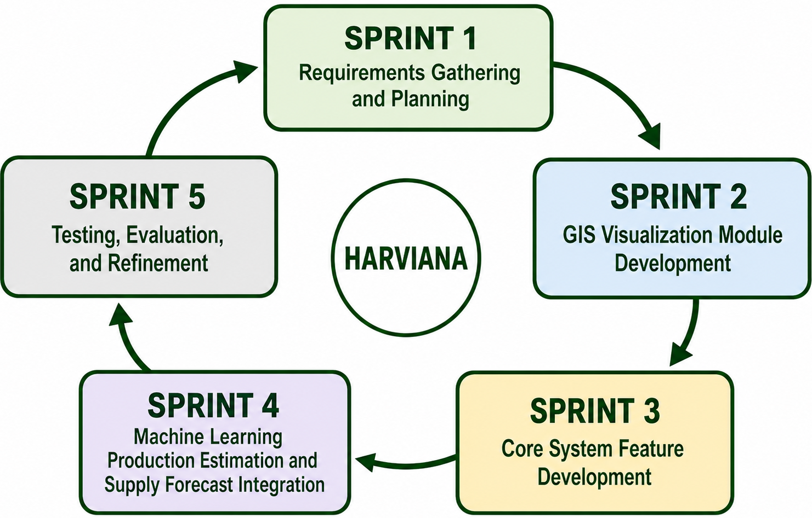
Requirements Gathering and Planning. The Requirements Gathering and Planning Sprint focused on identifying the problems, user needs, information requirements, and technical resources necessary for developing Harviana. Its purpose was to establish a clear understanding of what the system needed to accomplish before the major modules were implemented. The information gathered during this Sprint served as the basis for defining the system’s scope, user roles, functional requirements, data requirements, and initial development priorities.
During this Sprint, the researchers reviewed the agricultural decision-support components inherited from PASYA and determined which functions would be retained, modified, or developed specifically for Harviana. Information was gathered from farmers and DA Administrators concerning crop planning, agricultural record management, monitoring, and reporting. The LGU Validator role was also included in the planned workflow to provide a validation layer for farmer-submitted records. Based on the gathered information, the researchers prepared the Product Backlog, initial user workflows, database requirements, system diagrams, interface prototypes, and prioritized list of features for the succeeding Sprints.
GIS Visualization Module Development. The GIS Visualization Module Development Sprint focused on implementing the location-based monitoring components of Harviana. Its purpose was to provide farmers and DA Administrators with a visual representation of vegetable-production information across the municipalities of Benguet. Through this module, agricultural records could be viewed according to their geographic location, allowing users to understand the distribution of crop-related information more easily than through ordinary tabular records alone.
During this Sprint, the researchers developed the interactive agricultural map using Leaflet and OpenStreetMap. The map was connected to the agricultural records stored in PostgreSQL and provided filters for crop type, year, view type, farm type, and municipality. The researchers also integrated weather information so users could view temperature, weather conditions, rainfall probability, humidity, and wind speed for selected locations. The map interface, information panels, markers, filters, and municipal summaries were tested and refined to ensure that the displayed agricultural and weather information was understandable and accessible through different screen sizes.
Core Feature Development. The Core Feature Development Sprint focused on implementing the primary role-based workflows of Harviana. Its purpose was to create the functions required by Farmers, LGU Validators, and DA Administrators to enter, review, validate, monitor, and manage agricultural information. This Sprint established the main flow of data from farmer crop planning and report submission to LGU validation and DA administrative monitoring.
During this Sprint, the researchers developed account registration, login, Google authentication, role-based access, farmer onboarding, profile management, farmer dashboards, crop planning, and calendar-based farm activity monitoring. Features for submitting damage reports and recording actual harvests were also implemented. The LGU Validator module was developed to allow assigned validators to review evidence, approve reports, return submissions for correction, and provide validation notes. For DA Administrators, the researchers implemented administrative dashboards, user and crop-data management, report-focused views, and the generation and export of agricultural records.
Machine Learning Production Estimation and Supply Forecast Integration. The Machine Learning Production Estimation and Supply Forecast Integration Sprint focused on connecting Harviana with its machine-learning service and transforming farmer crop-plan data into decision-support information. Its purpose was to provide farmers with an estimated production value during crop planning and assist DA Administrators in monitoring the expected municipal vegetable supply. This Sprint connected the farmer’s planned agricultural activities with the forecasting and monitoring functions available on the administrative side of the system.
During this Sprint, the Laravel application was connected to the machine-learning service, which processed information such as municipality, farm type, selected crop, expected harvest period, and intended planting area. The returned production estimate and confidence value were stored with the farmer’s crop plan. Harviana then used the stored estimates together with LGU-approved damage reports and validated actual-harvest records to calculate adjusted municipal supply information. The resulting supply forecast was presented to DA Administrators through the administrative dashboard and interactive agricultural map.
Testing and Evaluation. The Testing and Evaluation Sprint focused on determining whether the completed Harviana modules functioned according to their intended requirements and whether the system’s inherited interaction design provided an acceptable usability foundation. Its purpose was to identify functional errors, verify the complete role-based workflow, examine the communication among connected services, and determine whether further improvements were required before the system was prepared for deployment and presentation.
During this Sprint, the researchers tested account authentication, role-based access, farmer onboarding, crop planning, calendar activities, production estimation, damage reporting, actual-harvest recording, LGU validation, administrative dashboards, GIS visualization, weather information, municipal supply forecasting, and report generation and export. The LGU Validator workflow was examined through functional testing, while the usability evaluation covered the farmer and DA Administrator respondent groups using the adviser-approved results originally gathered from PASYA. Identified errors and interface concerns were corrected and tested again. After the major functions were verified, Harviana was deployed on Railway and connected to Railway PostgreSQL and its machine-learning service.
Design Thinking
Design Thinking was used by the researchers to understand the needs, problems, and expectations of the target users of Harviana. This approach helped the researchers focus on the actual experiences of farmers, LGU validators, and DA administrators before finalizing the system features. Since Harviana is intended to support agricultural planning, validation, monitoring, and decision-making, the researchers used Design Thinking to ensure that the system was based on real user concerns rather than assumptions.
Design Thinking is a human-centered and iterative process that allows developers to study user needs, define problems, generate possible solutions, create prototypes, and test the proposed system. In this study, the researchers followed the five phases of Design Thinking: empathize, define, ideate, prototype, and test. These phases guided the researchers in identifying the problems in agricultural data collection and monitoring, designing possible solutions, and improving Harviana based on user needs and feedback. Figure 2 shows the Design Thinking process used in the development of Harviana.
Figure 2
Design Thinking

Empathize. The Empathize phase focused on understanding the experiences and challenges of the target users considered in the design of Harviana. The researchers gathered information from farmers and DA administrators to identify the difficulties they encounter in crop planning, record management, monitoring, reporting, and agricultural decision-making. The LGU Validator role was also considered in the system workflow because it serves as the validation layer between farmer-submitted records and DA administrative monitoring.
Based on the gathered information, farmers experienced challenges in organizing crop plans, monitoring farm activities, reporting crop damage, and keeping harvest records in a way that can be reviewed and used later. DA administrators needed consolidated and updated agricultural records that could support dashboards, map-based monitoring, supply forecasting, and report generation. Meanwhile, the LGU Validator role was identified as necessary for reviewing farmer-submitted reports and checking whether the information provided is acceptable before it becomes part of the system’s validated records. These findings helped the researchers identify the user needs that Harviana should address.
Figure 3 presents the empathy maps for Farmers and DA Administrators, illustrating their statements, thoughts, actions, and feelings concerning agricultural record management, monitoring, and decision-making. It emphasizes their need for organized methods to manage crop records, review validated information, monitor production, and prepare agricultural reports for planning and administrative use.
Figure 3
Empathy Map
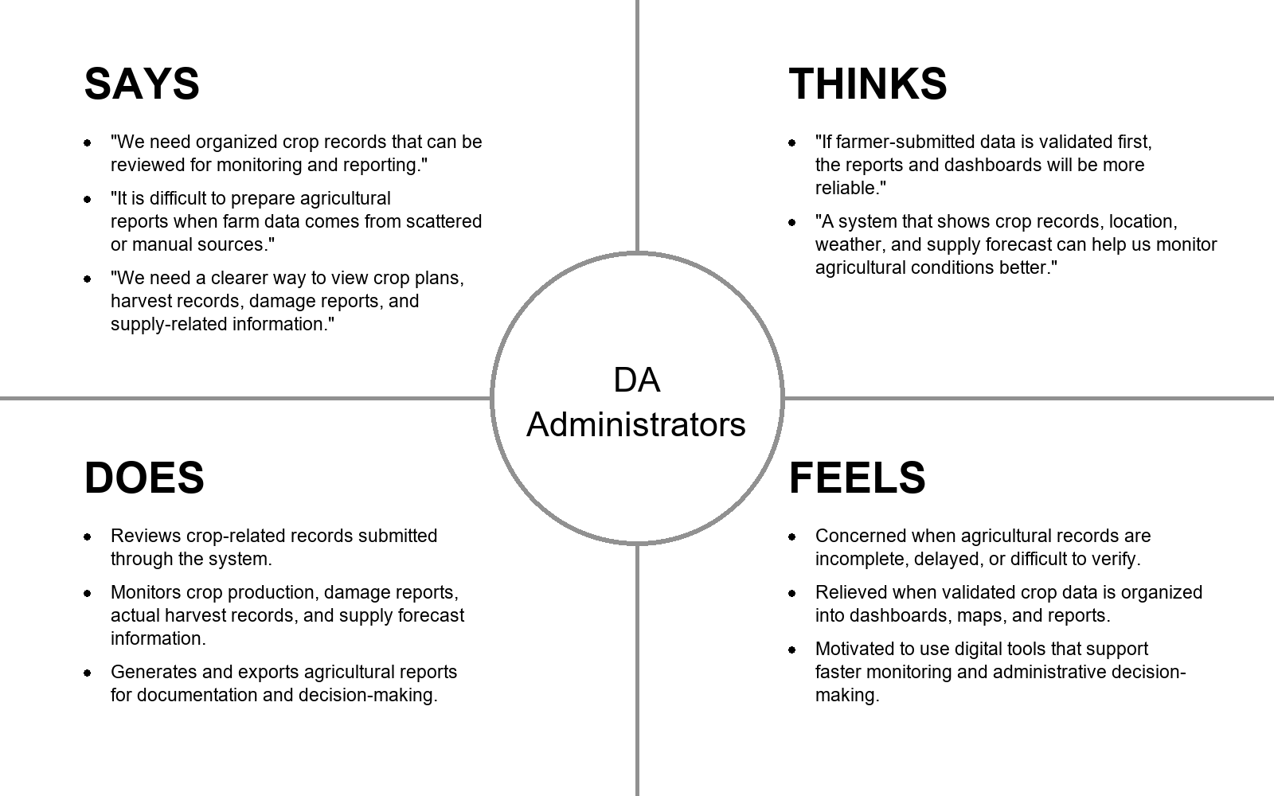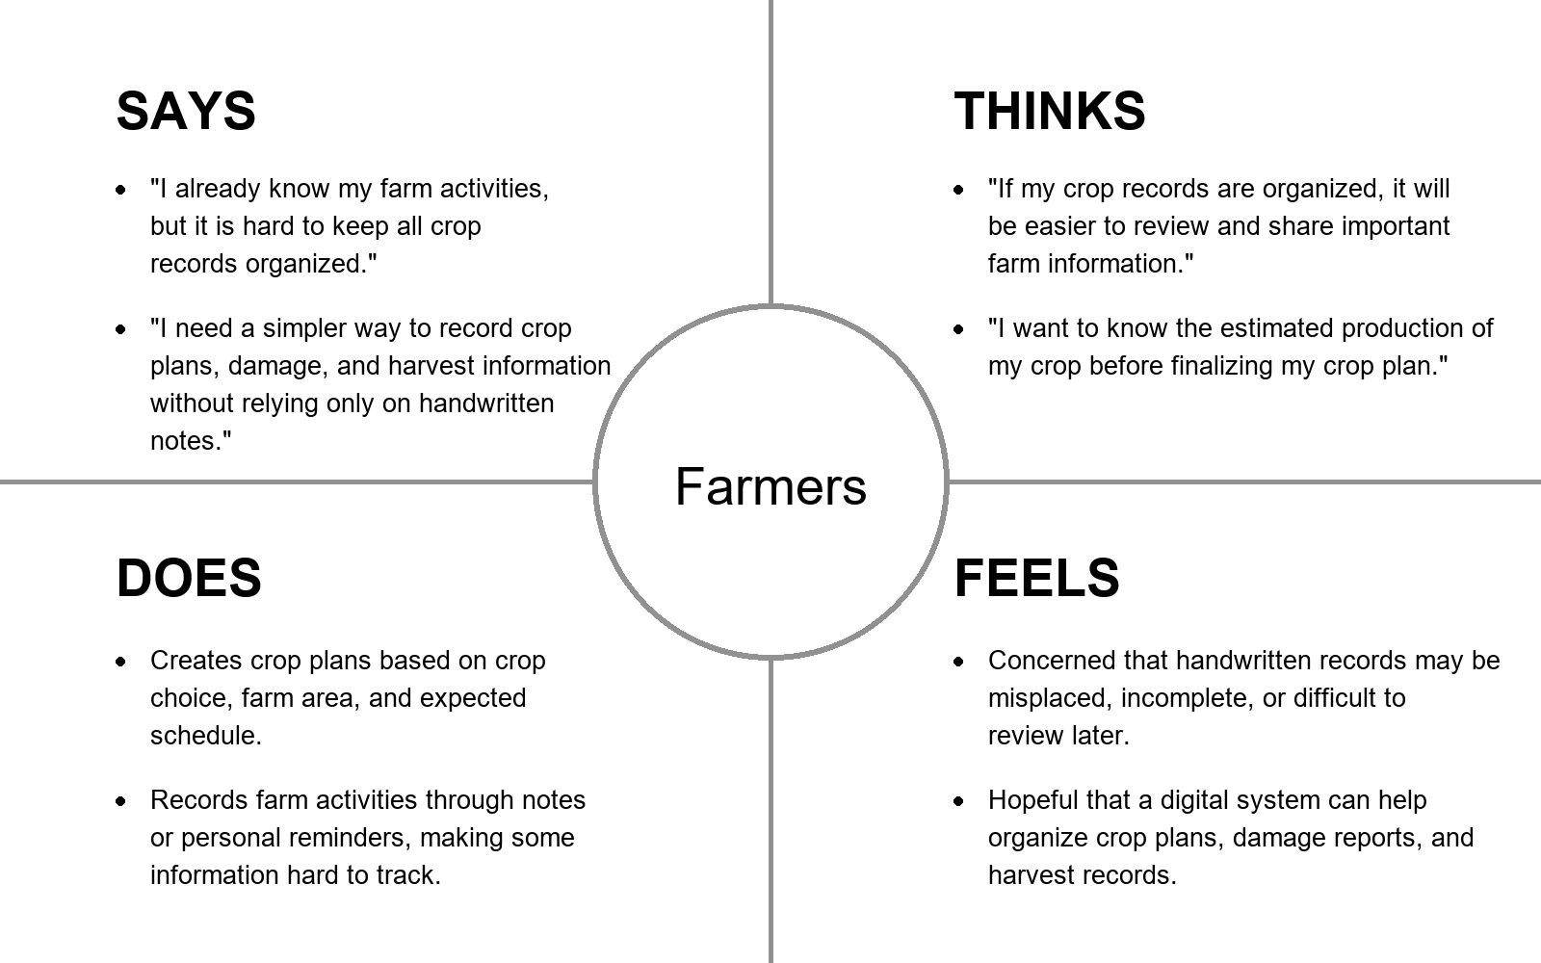
Define. The Define phase organized the information gathered during the Empathize phase into clear problem statements. The researchers identified that agricultural information is often recorded manually, stored separately, or difficult to validate and consolidate. Farmers need support in organizing crop plans, monitoring farm activities, submitting crop damage reports, and recording actual harvest results. DA administrators need reliable and updated agricultural data that can be used for dashboards, map-based monitoring, supply forecasting, and report generation.
Through this phase, the researchers defined the main problem as the lack of an integrated digital system that connects farmer-submitted agricultural records with validation and administrative monitoring. This problem affects the availability, reliability, and usability of crop-related information for planning and decision-making.
The researchers used the 5 Whys Analysis to identify the root causes of the problems encountered in agricultural record management and monitoring. This helped the researchers trace visible problems, such as scattered records, delayed reports, and difficulty in reviewing crop-related information, to deeper causes such as the lack of coordinated data flow, limited validation process, fragmented agricultural data, and absence of an integrated monitoring system.
Figure 4 presents the 5 Whys Analysis used to identify the root causes addressed by Harviana.
Figure 4
The 5 Why Analysis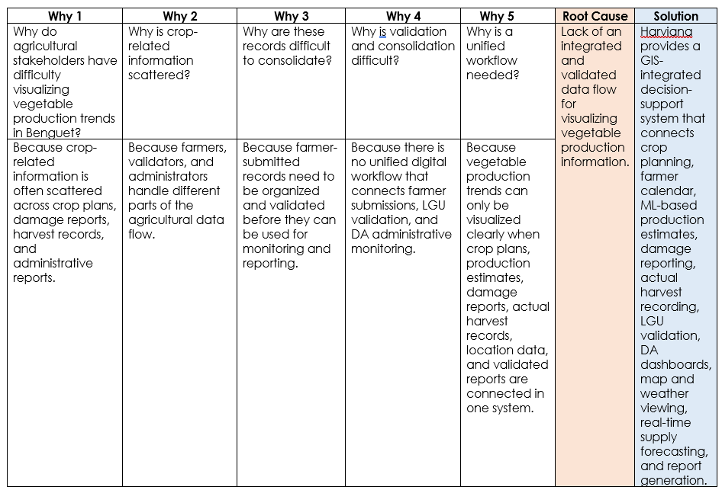
The 5 Whys Analysis shows that the main problem addressed by Harviana is not only the lack of production data, but the absence of an integrated and validated data flow that can transform scattered crop-related records into useful visual and administrative information. This root cause guided the development of Harviana as a GIS-integrated decision-support system that allows vegetable production information to be collected, validated, visualized, forecasted, and reported within one connected platform.
Ideate. Ideate is the stage where the researchers generate possible solutions based on the problem identified in the Define phase. In this phase, the researchers considered the root cause found in the 5 Whys Analysis, which showed the need for an integrated and validated data flow for visualizing vegetable production information in Benguet. Based on the root cause identified, the researchers proposed Harviana as a GIS-integrated decision-support system that connects farmer-submitted records, LGU validation, and DA administrative monitoring. The proposed features included crop planning, farmer calendar, ML-based production estimates, damage report submission, actual harvest recording, LGU report validation, DA dashboard, interactive map and weather viewing, real-time supply forecasting, and report generation.
To organize these ideas and determine which features should be prioritized, the researchers used an Impact-Effort Matrix. This tool helped the researchers evaluate each proposed feature based on its expected value to the users and the level of effort required for implementation. Features with high impact and manageable effort were prioritized because they directly support the main purpose of Harviana.
The matrix helped the researchers identify the core features needed for the system. Farmer-side features such as crop planning, farmer calendar, damage report submission, and actual harvest recording were prioritized because they serve as the source of agricultural data. The LGU validation feature was also included because it supports the reliability of submitted records. DA-side features such as dashboards, map and weather viewing, supply forecasting, and report generation were prioritized because they allow agricultural information to be visualized, monitored, and used for decision-making.
Figure 5 presents the Impact-Effort Matrix used to prioritize the features of Harviana.
Figure 5
Impact-Effort Matrix
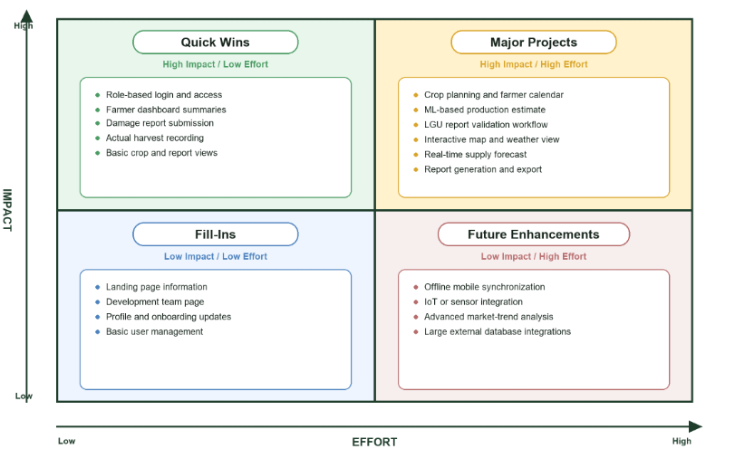
Prototype. Prototype is the stage where the ideas from the previous phase are transformed into a visual representation of the proposed system. Prototypes do not need to be fully functional at first, but they help the researchers present the layout, navigation, and expected user interaction of the system before final development. Through this phase, the researchers were able to show how the main features of Harviana would appear and function for its intended users.
In this stage, the researchers created low-fidelity prototypes to represent the basic interface of Harviana. The prototypes focused on the major features of the system, including the landing page, login and registration, farmer crop planning, calendar, ML-based production estimate, damage report submission, actual harvest recording, LGU report validation, interactive map and weather viewing, DA dashboard, supply forecast, and report generation.
The Landing Page serves as the first screen accessed by visitors. It introduces Harviana as a GIS-integrated decision-support system and provides access to general platform information, system features, development team details, login, and registration. This page helps users understand the purpose of the system before entering the role-based platform.
Figure 6 presents the Landing Page prototype of Harviana, which introduces the platform and provides navigation to important public pages and account access options.
Figure 6
Landing Page Overview Prototype
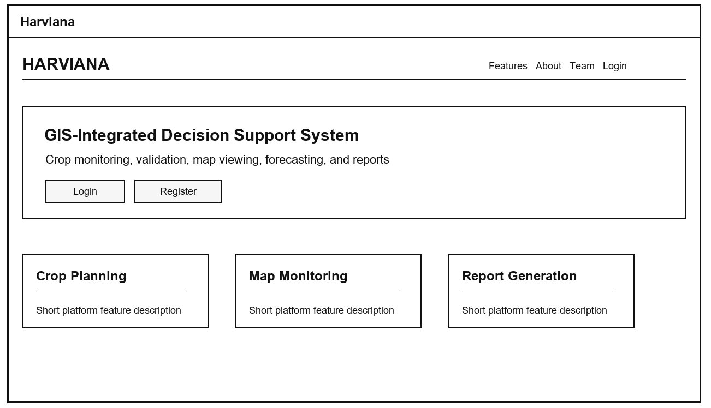
The Login and Registration feature allows users to access the system using their account credentials or create a new account. This feature supports role-based access by ensuring that users are directed to the correct interface depending on their assigned role, such as Farmer, LGU Validator, or DA Administrator.
Figure 7 presents the Login and Registration prototype, showing the basic account access screens used for signing in and creating a new user account.
Figure 7
Login and Registration Prototype
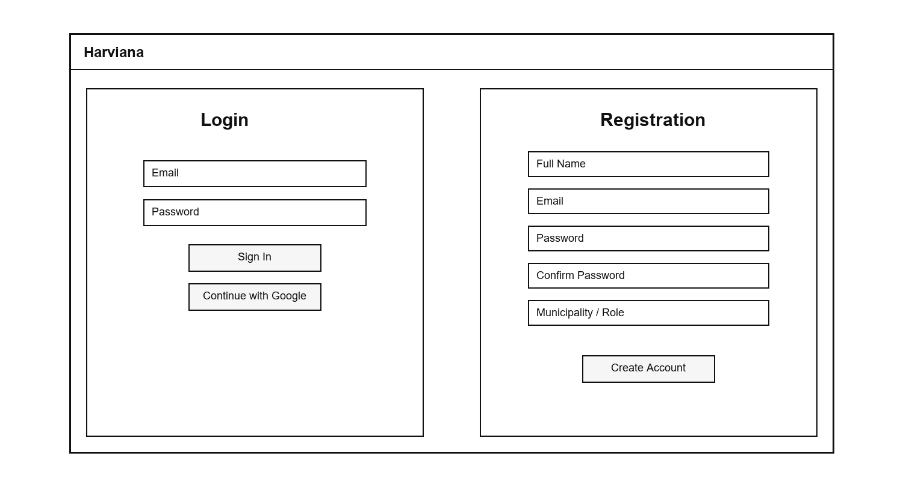
The Crop Planning and Farmer Calendar feature allows farmers to create crop plans and organize their farm activities according to the selected crop, intended planting area, water source, planting material, planting date, and expected harvest date. It provides farmers with a structured way to manage active crop plans and monitor important production activities throughout the cropping period. The calendar also displays scheduled tasks and reminders, helping farmers keep track of planting, crop maintenance, fertilizer application, and harvest-related activities.
Figure 8 presents the Crop Planning and Farmer Calendar prototype, demonstrating how farmers can create crop plans and view their scheduled activities through a single interface. The prototype illustrates how crop information, expected production schedules, reminders, and farm tasks are organized to support more convenient and systematic monitoring.
Figure 8
Crop Planning and Farmer Calendar Prototype
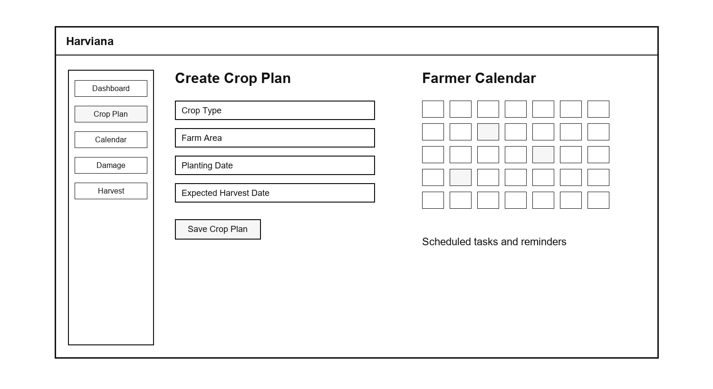
The ML-Based Production Estimate feature is included in the crop planning process to provide farmers with an estimated production value before finalizing a crop plan. The prototype shows how crop-related inputs may be entered and how the estimated output is displayed to the farmer. This feature supports crop planning by giving users an early reference regarding possible production based on the information provided. It does not replace the farmer’s decision, but it provides additional data that can help farmers review their crop plan more clearly.
Figure 9 presents the ML-Based Production Estimate prototype, showing how estimated production information is displayed as part of the crop planning process.
Figure 9
ML-Based Production Estimate Prototype
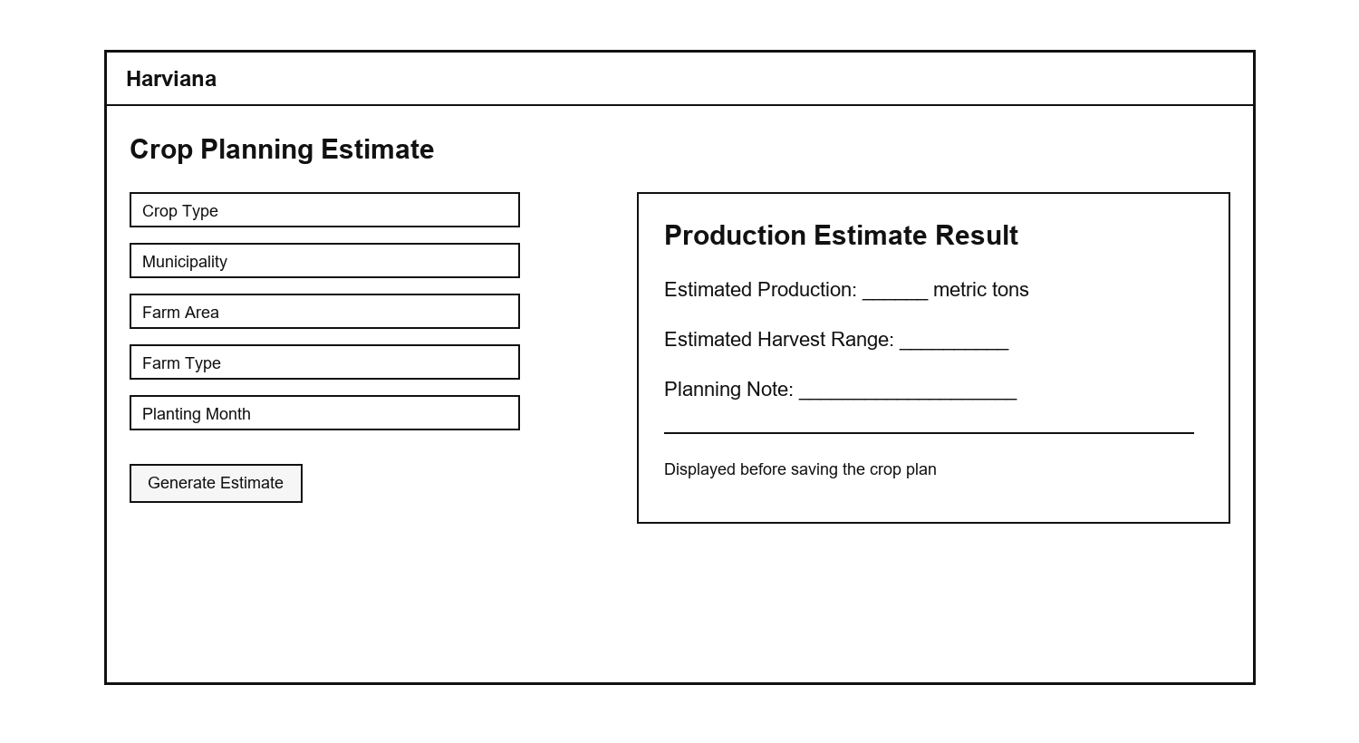
The Damage Report Submission feature allows farmers to document crop damage incidents in a structured and organized manner. The prototype includes fields for the cause of damage, affected crop plan, damaged area, date of occurrence, additional notes, and optional photographic evidence. It also connects each submitted report to the appropriate crop plan, helping the system maintain accurate and traceable damage records. The information is forwarded to the assigned LGU Validator, who can review the report and supporting evidence before approving it or returning it for correction. By providing a dedicated reporting form, Harviana helps farmers submit more complete damage information that can support validation, production monitoring, supply forecasting, and administrative report generation.
Figure 10 presents the Damage Report Submission prototype, showing the form used by farmers to submit crop damage details and supporting evidence.
Figure 10
Damage Report Submission Prototype
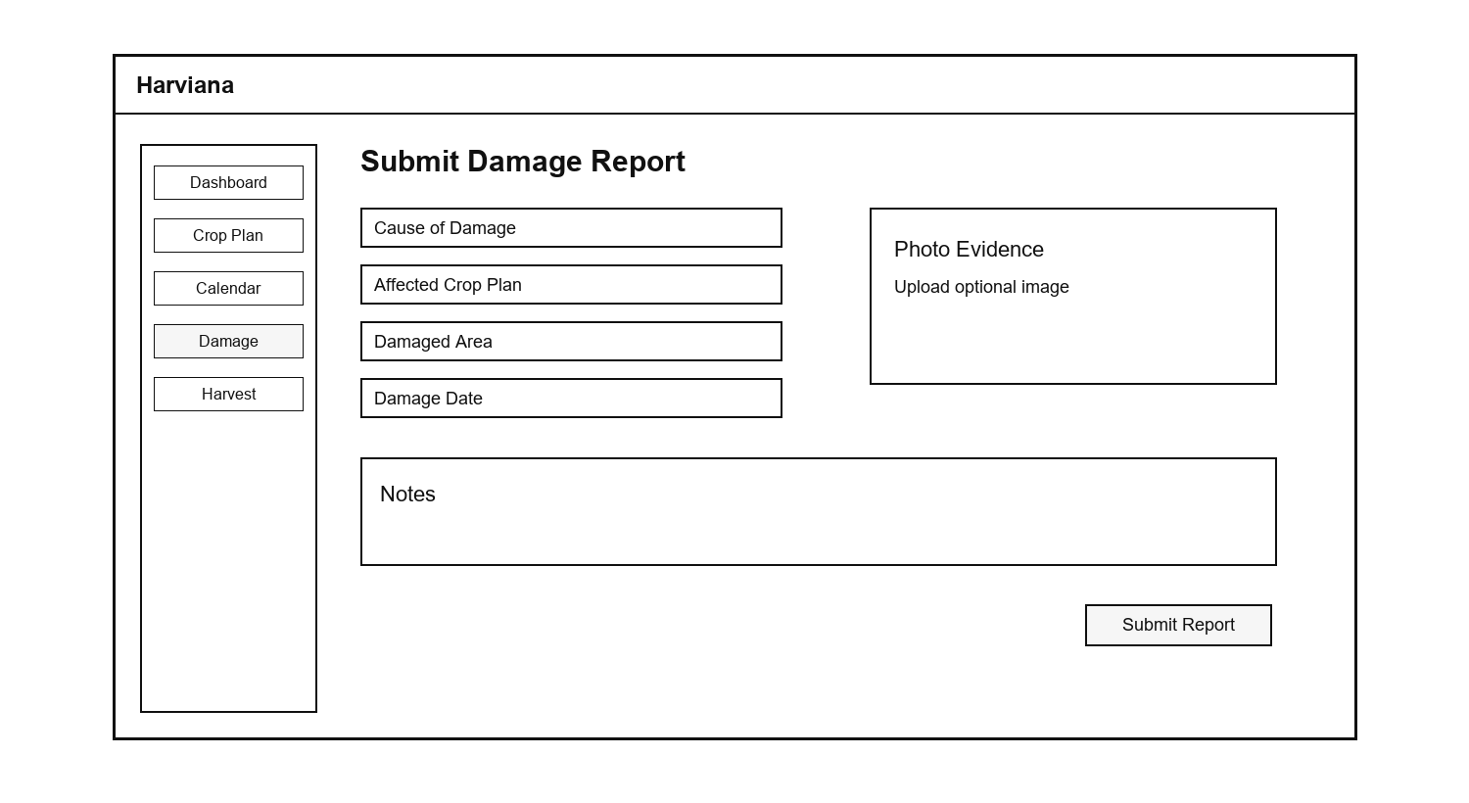
The Actual Harvest Recording feature allows farmers to submit the final harvest result of a crop plan. This includes the harvest amount, unit, harvest date, notes, and optional photo evidence. The system can also convert the submitted harvest amount into metric tons and compare it with the expected production from the crop plan. This feature helps improve production monitoring because it allows Harviana to compare estimated production with actual farmer-recorded harvest data.
Figure 11 presents the Actual Harvest Recording prototype, showing how farmers can submit harvest information and review the comparison between expected and actual production.
Figure 11
Actual Harvest Recording Prototype
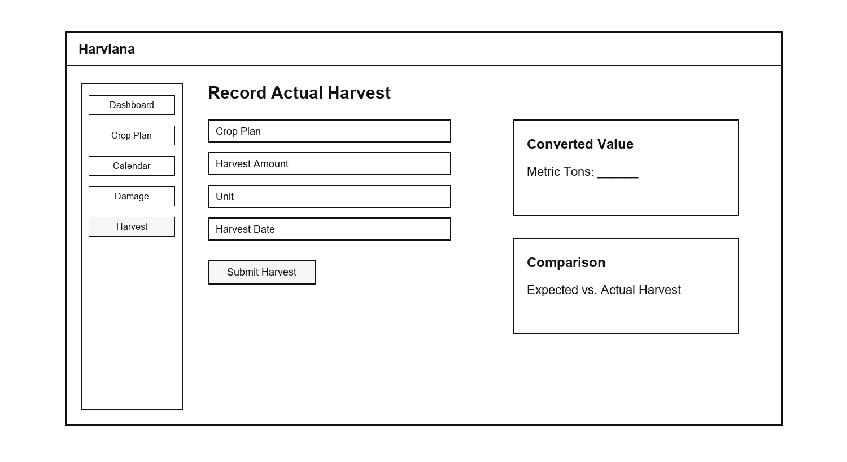
The LGU Report Validation feature serves as the checking layer between farmer-submitted records and DA administrative monitoring. Through this feature, LGU Validators can view submitted reports, review report details, check evidence, and decide whether a report should be approved or returned for correction. This process helps improve the reliability of the information stored in the system. It also ensures that reports used for DA dashboards, maps, forecasts, and generated reports have passed a validation step.
Figure 12 presents the LGU Report Validation prototype, showing the validation queue, report details, evidence section, and approval or return actions.
Figure 12
LGU Report Validation Prototype
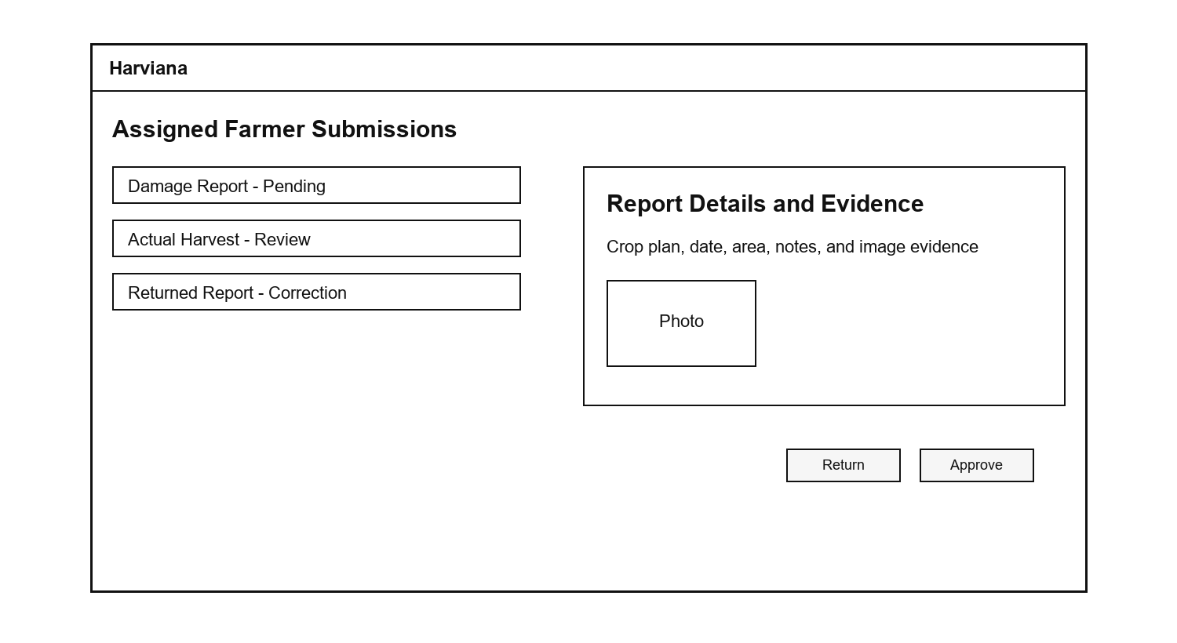
The Interactive Map and Weather feature allows users to view agricultural information according to location and selected filters. The prototype includes filters for crop type, year, view type, and farm type, allowing users to focus on specific records. It also includes a map area and weather information panel, which may show details such as temperature, rainfall probability, humidity, and wind speed. This feature supports spatial monitoring by helping users relate crop records with geographic and weather-related conditions.
Figure 13 presents the Interactive Map and Weather prototype, showing the map area, filter options, and weather information panel used for location-based agricultural monitoring.
Figure 13
Interactive Map and Weather Prototype
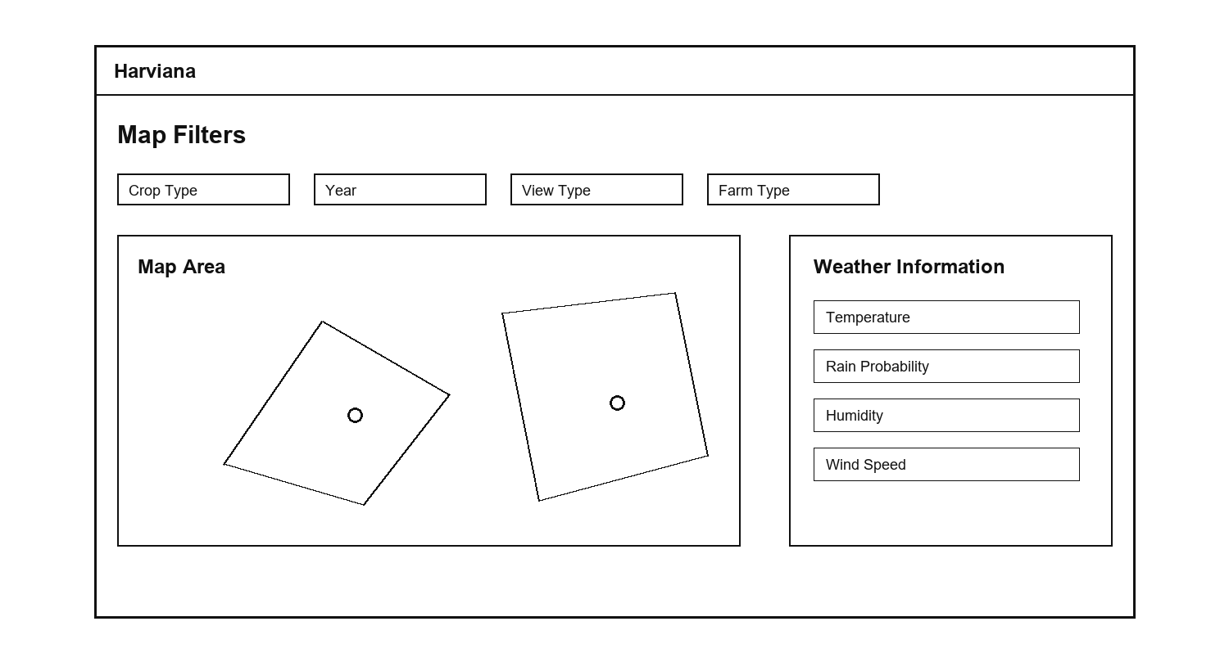
The DA Dashboard and Supply Forecast feature is designed to help DA Administrators monitor validated agricultural records in a summarized format. The dashboard presents important information such as harvest accuracy, crop production, damage records, and report categories. The supply forecast section provides support for reviewing expected supply conditions based on available crop and harvest-related data. This feature helps administrators quickly understand production-related trends before viewing more detailed records or generating reports.
Figure 14 presents the DA Dashboard and Supply Forecast prototype, showing the summarized monitoring cards, dashboard chart, and supply forecast section for DA Administrators.
Figure 14
DA Dashboard and Supply Forecast Prototype
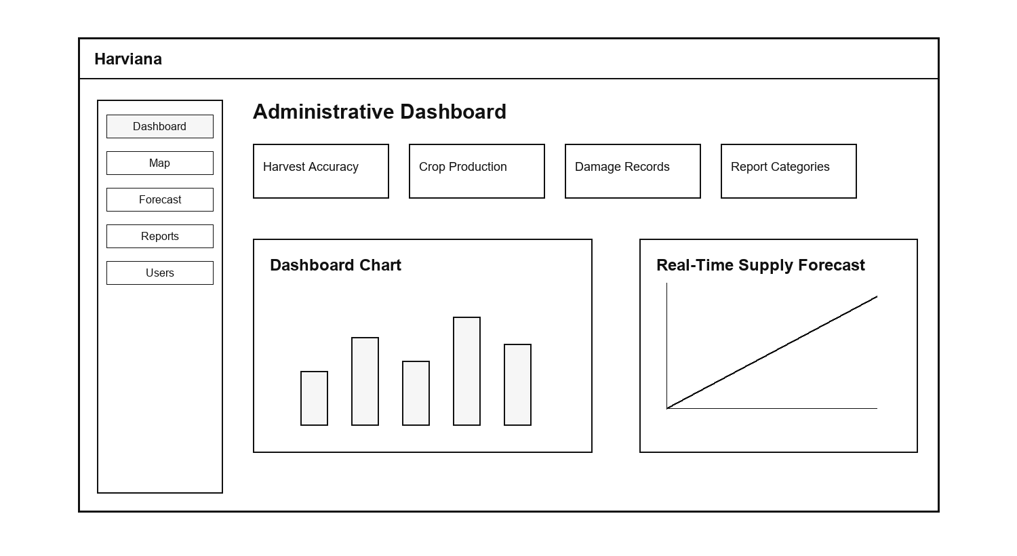
The Reports and Export feature allows DA Administrators to organize validated agricultural records into report form. The prototype includes sections for planting records, harvest records, damage records, and export options. This feature supports administrative documentation because it allows system data to be prepared for review, analysis, and decision-making. Through report generation and export, Harviana helps transform farmer-submitted and validated information into usable records for agricultural monitoring and planning.
Figure 15 presents the Reports and Export prototype, showing the report table and export options used by DA Administrators to prepare agricultural records.
Figure 15
Reports and Export Prototype
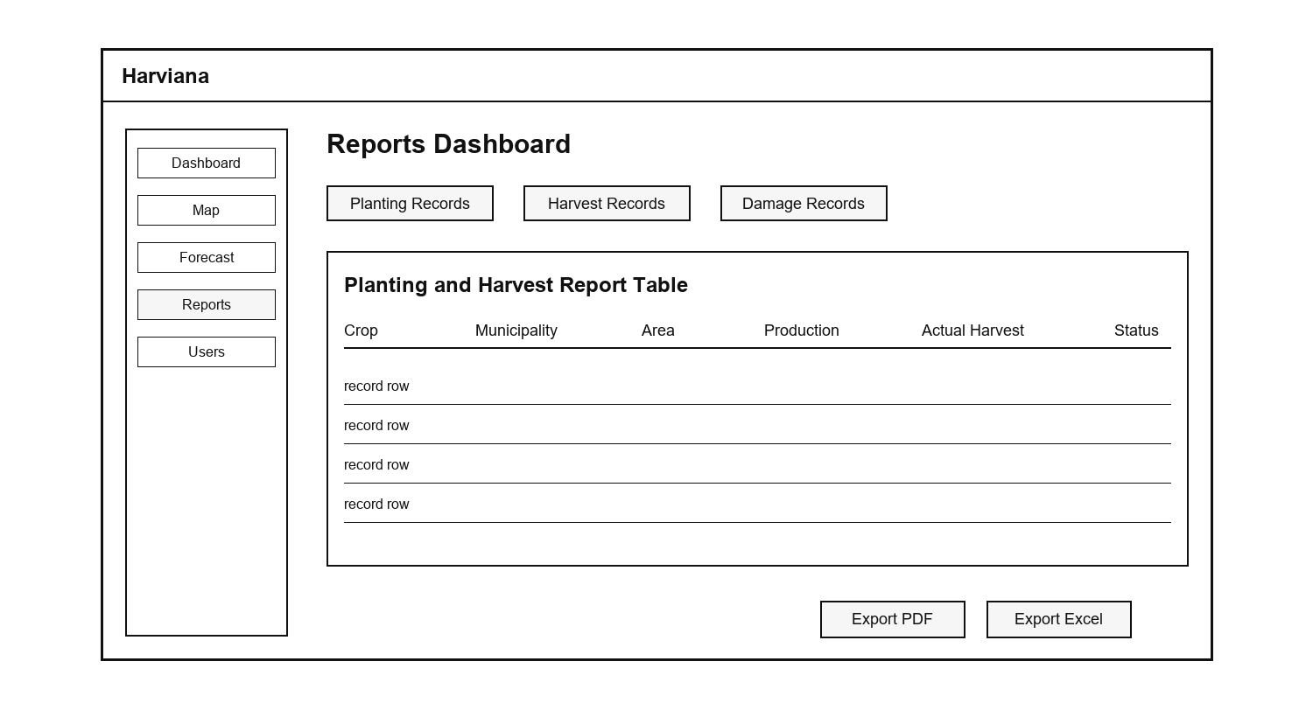
Test. The Test phase focused on evaluating whether the proposed system features were understandable, usable, and aligned with the needs of the target users. In this phase, the researchers conducted testing activities to check the main workflows of Harviana, including crop planning, farmer calendar use, ML-based production estimate viewing, damage report submission, actual harvest recording, LGU report validation, dashboard monitoring, interactive map and weather viewing, supply forecast review, and report generation.
The testing process involved participating farmers and DA administrators. Farmers tested the farmer-side features by performing tasks such as creating crop plans, viewing calendar reminders, submitting damage reports, and recording actual harvest results. These activities helped determine whether the farmer interface was understandable and useful for organizing farm-related records. DA administrators tested the administrative features by reviewing dashboards, viewing map and weather information, checking supply forecast data, and generating reports. This helped determine whether the system could support agricultural monitoring and decision-making.
Scope and Delimitation
The scope of this study covers the design and development of Harviana as a GIS-integrated decision-support system for monitoring vegetable production trends within the province of Benguet. Its geographic coverage is limited to the 13 municipalities of Benguet: Atok, Bakun, Bokod, Buguias, Itogon, Kabayan, Kapangan, Kibungan, La Trinidad, Mankayan, Sablan, Tuba, and Tublay. Agricultural records from other provinces and regions are outside the coverage of the study.
The agricultural coverage is limited to ten selected highland vegetable crops supported by the system: cabbage, broccoli, lettuce, cauliflower, Chinese cabbage, carrot, garden peas, white potato, snap beans, and sweet pepper. Historical production analysis is based on available records from 2015 to 2024. These records provide the basis for examining production patterns according to municipality, crop, year, planted area, production volume, productivity, and farm type. Crops and agricultural commodities not included in the available datasets are outside the analytical coverage of the study.
The study covers agricultural activities involving crop planning, farm-record submission, report validation, production monitoring, municipal supply forecasting, and administrative reporting. The records considered include crop plans, planting schedules, planted areas, damage incidents, actual-harvest results, validation decisions, and production totals. These activities follow a structured information flow from Farmers through LGU Validators to DA Administrators. Location and weather information are considered only as supporting information for interpreting agricultural conditions and production records within Benguet.
Harviana is limited to a web-based environment that requires an internet-connected device and a supported web browser. The production estimates, municipal supply forecasts, and map-based summaries generated by the system are intended only as decision-support information. They should not be treated as final, guaranteed, or official production values because their reliability depends on the completeness, accuracy, and timeliness of the historical and user-submitted data available to the system.
The study does not cover other agricultural sectors such as livestock, fisheries, forestry, or commodities outside the selected vegetable crops. It also excludes market-price prediction, automated farm monitoring through Internet of Things devices, offline data synchronization, community discussion services, and direct integration with all external government databases. The usability evaluation was limited to participating Farmers and DA Administrators. Although LGU Validators are included in the operational workflow, they were not included as respondents in the usability evaluation.
Data Gathering Techniques
The researchers utilized several data gathering techniques to collect the necessary information for the design, development, and evaluation of Harviana. These techniques helped the researchers understand the needs of the target users, identify the system requirements, determine the necessary features, and evaluate the usability of the system. The gathered information served as the basis for developing a GIS-integrated decision-support system that supports crop planning, validation, monitoring, forecasting, and report generation.
Interview. The researchers gathered information from farmers and DA Administrators to understand the current challenges encountered in crop planning, agricultural record management, monitoring, and reporting. The responses helped the researchers identify the difficulties experienced by farmers in organizing crop activities, submitting damage reports, and recording actual harvest results. The information gathered from DA Administrators also helped determine the need for organized dashboards, map-based monitoring, supply forecast information, and report generation features.
Survey Questionnaires. The researchers used survey questionnaires to evaluate the usability of Harviana among the participating users. Farmers evaluated the farmer-side features of the system using the System Usability Scale (SUS), while DA Administrators evaluated the administrative features using the USE questionnaire. The System Usability Scale introduced by Brooke (1996) was used because it provides a structured way to measure the perceived usability of a system. The USE questionnaire developed by Lund (2001) was used to evaluate the DA Administrator side of the system in terms of usefulness, ease of use, ease of learning, and satisfaction. The responses gathered from the questionnaires were used to measure the extent of usability of Harviana based on user experience, ease of use, usefulness, and satisfaction.
System Testing. The researchers also conducted system testing to check whether the major features of Harviana functioned according to their intended purpose. The testing covered crop planning, farmer calendar, ML-based production estimate, damage report submission, actual harvest recording, report validation, dashboard monitoring, interactive map and weather viewing, supply forecasting, and report generation. This helped ensure that the system workflows were functional before the usability results were analyzed.
Sources of Data
The researchers gathered data from individuals and references related to the agricultural sector to ensure that Harviana addressed the practical needs of its intended users. Primary data were gathered from participating farmers and DA Administrators. The farmers provided information about their experiences in crop planning, farm activity monitoring, damage reporting, and harvest recording. Their responses helped the researchers identify the farmer-side features needed in the system, such as crop planning, farmer calendar, ML-based production estimate, damage report submission, and actual harvest recording.
The researchers also gathered data from DA Administrators to understand the administrative side of agricultural monitoring and reporting. Their input helped the researchers determine the need for organized dashboards, map-based visualization, weather information, supply forecast viewing, and report generation. These data served as a basis for designing the administrative features of Harviana and ensuring that validated crop-related information could be presented in a more useful and organized manner.
Secondary data were gathered from related studies, government reports, agricultural references, and online sources relevant to digital agriculture, geographic information systems, decision-support systems, machine learning, crop monitoring, and vegetable production in Benguet. These sources helped establish the background of the study and supported the development of Harviana as a GIS-integrated decision-support system. The researchers also reviewed references related to usability evaluation to guide the use of the System Usability Scale (SUS) for farmers and the USE questionnaire for DA Administrators.
The data gathered from these sources were used to identify system requirements, determine the necessary features, design user workflows, and evaluate the usability of Harviana. Through these sources, the researchers were able to align the system with the needs of farmers and DA Administrators while supporting the overall goal of improving crop planning, validation, visualization, forecasting, and reporting.
Software Development Tools
The researchers utilized various software development tools and technologies in designing and developing Harviana. These tools supported the creation of the user interface, system modules, database management, map visualization, forecasting support, report generation, and deployment of the system.
Figma. Figma was used in designing the initial interface and layout of Harviana. It helped the researchers prepare the low-fidelity and high-fidelity prototypes of the system, including the landing page, login and registration pages, farmer dashboard, crop planning, calendar, map, validation, reports, and administrator modules. Through Figma, the researchers were able to visualize the structure of the system before proceeding to actual development.
Visual Studio Code. Visual Studio Code served as the main code editor used in developing the system. It was used for writing, editing, and organizing the source code of Harviana, including the backend files, frontend views, routes, controllers, models, and styling files. Its extensions and integrated terminal also helped the researchers manage the development process more efficiently.
PHP. PHP was used as the main server-side programming language of Harviana. It handled the backend logic of the system, including user authentication, crop plan processing, report submission, validation workflows, harvest records, and administrative report generation.
Laravel Framework. Laravel was used as the primary web development framework of Harviana. It provided the structure for implementing the system through routes, controllers, models, views, middleware, authentication, and database handling. Laravel also supported the role-based access of Farmers, LGU Validators, and DA Administrators, ensuring that each user group could access only the functions assigned to them.
Blade, Tailwind CSS, and Alpine.js. Laravel Blade was used to create the interface templates of the system, while Tailwind CSS was used for styling and responsive layout design. Alpine.js supported interactive frontend behavior such as dropdowns, modals, filters, dynamic forms, and other user interface actions. These tools helped improve the usability and appearance of Harviana across different system pages.
JavaScript and Chart.js. JavaScript was used to support interactive system functions such as map controls, form actions, dashboard updates, and dynamic page responses. Chart.js was used to present agricultural data in visual form, such as crop production charts, forecast charts, dashboard summaries, and report-related graphs. These tools helped transform system records into easier-to-understand visual information.
Vite, Node.js, and npm. Vite, Node.js, and npm were used to manage and build the frontend assets of the system. These tools supported the compilation of scripts and stylesheets, allowing the researchers to organize and optimize the frontend resources used by Harviana.
PostgreSQL. PostgreSQL was used as the database management system of Harviana. It stored the system records such as user accounts, crop plans, farm details, harvest records, damage reports, validation results, map-related data, and report information. The database served as the central storage for the agricultural records used in monitoring, forecasting, and report generation.
Leaflet and OpenStreetMap. Leaflet and OpenStreetMap were used to support the GIS-integrated map feature of Harviana. These tools allowed the system to display agricultural records through map-based visualization, helping users view crop-related information by location. Through this feature, Farmers and DA Administrators can better understand vegetable production trends in different areas of Benguet.
Google Weather API. The Google Weather API was used to provide weather-related information in the map feature of the system. It supported the display of field weather data such as temperature, rainfall probability, humidity, wind speed, and weather condition. This helped users relate agricultural records with environmental conditions that may affect crop production.
Python and Machine Learning API. Python was used for the machine learning component connected to Harviana. The machine learning service supported production estimation and forecasting functions by processing crop-related data and returning prediction results to the Laravel system. This allowed Harviana to provide data-driven support for crop planning and agricultural monitoring.
Laravel DomPDF and Maatwebsite Excel. Laravel DomPDF and Maatwebsite Excel were used to support report generation and export features. DomPDF allowed the system to generate printable PDF reports, while Maatwebsite Excel supported spreadsheet-based report export. These tools helped DA Administrators prepare agricultural records for documentation, analysis, and decision-making.
GitHub. GitHub was used for version control and project collaboration. It helped the researchers manage changes in the system source code, track development progress, and maintain a backup of the project files during development.
Railway. Railway was used to deploy Harviana and connect its web application, database, and machine-learning service for online testing and demonstration.
Chapter 3
FINDINGS OF THE STUDY
This chapter presents the findings of the study based on the development and evaluation of Harviana, a GIS-integrated decision-support system for visualizing vegetable production trends in Benguet. The findings are organized according to the objectives of the study, beginning with the identified information requirements, followed by the architectural framework, system features, and extent of usability of the system. This chapter also discusses how Harviana supports crop planning, report validation, map-based monitoring, supply forecasting, and report generation through its web-based platform. Lastly, it presents the usability evaluation results gathered from the participating farmers and DA Administrators.
Information Requirements for Harviana
This section presents the information requirements necessary for the operation of Harviana as a GIS-integrated decision support system for vegetable production in Benguet. These requirements consist of user account information, agricultural production records, farmer crop-planning data, and validation information. The system also requires technical resources that support its forecasting, mapping, monitoring, and reporting functions. Defining these requirements ensures that the information collected and processed by Harviana is accurate, organized, secure, and suitable for the needs of farmers, LGU validators, and Department of Agriculture administrators.
User Information. Harviana has three primary user groups: farmers, LGU validators, and DA administrators. Each user is required to provide specific account and location information according to their assigned role. These details allow the system to authenticate users, control access to features, personalize the information displayed, and associate agricultural records with the appropriate farmer and municipality.
Farmer information consists of the farmer’s full name, email address, password, preferred municipality, cooperative, and selected crops. During registration, farmers provide their name, email address, and password. After signing in, they complete the onboarding process by selecting their municipality and cooperative. This location information allows Harviana to display crop recommendations, municipal production information, weather conditions, and agricultural insights that are relevant to the farmer’s area.
Farmers also provide operational information through the crop-planning and farmer-calendar features. This information includes the selected crop, intended planting area, water source, planting material, planning date, estimated harvest date, and other details required to organize scheduled farm activities. During the production cycle, farmers may submit damage reports containing the affected crop plan, damaged area, cause and date of damage, supporting description, and optional photographic evidence. These reports are forwarded to the assigned LGU Validator for review, approval, or return for correction.
Once harvesting is completed, farmers may record the actual harvest date, harvested amount, measurement unit, additional notes, and optional photo evidence. Harviana converts the reported quantity into metric tons and compares the actual harvest with the production estimate associated with the crop plan. These records help the system maintain organized crop information, measure differences between estimated and actual production, and provide updated data for municipal supply monitoring and administrative reporting. Tables 1, 2, and 3 present the information required for Farmers, LGU Validators, and DA Administrators, together with the corresponding data types and storage formats, while Table 4 presents the minimum and recommended system requirements for operating Harviana.
Table 1
Farmer Information

Field Data Type | Length
USER_ID INTEGER FULL_NAME STRING  EMAIL_ADDRESS STRING  PASSWORD STRING  MUNICIPALITY STRING  COOPERATIVE STRING  ACCOUNT_STATUS BOOLEAN | Auto-generated  255  255  Encrypted  255  255  Active/Inactive
Table 2
LGU Validator Information

Field Data Type | Length
USER_ID INTEGER FULL_NAME STRING  EMAIL_ADDRESS STRING  PASSWORD STRING  LGU_MUNICIPALITY STRING  LGU_BARANGAY STRING  ACCOUNT_STATUS BOOLEAN  VALIDATION_NOTES Text | Auto-generated  255  255  Encrypted  255  255  Active/Inactive  Variable Length
Table 3
DA-Admin Information

Field Data Type | Length
USER_ID INTEGER FULL_NAME STRING  EMAIL_ADDRESS STRING  PASSWORD STRING  USER_ROLE STRING  ACCOUNT_STATUS BOOLEAN | Auto-generated  255  255  Encrypted  Administrator  Active/Inactive
System Requirements. Harviana is a responsive web-based application that can be accessed through smartphones, tablets, laptops, and desktop computers. Users must have a modern browser with JavaScript, cookies, and local browser storage enabled. A stable internet connection is required to retrieve map tiles, weather information, prediction results, and updated agricultural records. A stronger connection is recommended when uploading photographic evidence for damage and harvest reports. Table 4 presents the software and hardware requirements for the application.
Table 4
System Requirements

Requirement | Minimum System Requirement | Recommended
Device  Operating System  RAM  Connectivity | Smartphone, tablet, laptop, or desktop  Android 10+, iOS/iPadOS 17+, Windows 10+, or macOS 12 Monterey+  2GB  3G or Wi-Fi | Recent smartphone or computer  Android 12+, iOS/iPadOS 17+, Windows 11, or macOS 13+  4GB or higher  4G/LTE, 5G
Architecture Framework of Harviana
The architectural framework serves as the structural guide for the development and operation of Harviana. It presents how the system’s user interfaces, application modules, databases, and external services work together to support agricultural planning and monitoring. The framework also provides a common representation that helps researchers, developers, and stakeholders understand the system’s processes, responsibilities, and technical components. Through this structure, the design of Harviana is aligned with the requirements of farmers, LGU validators, and DA administrators.
Figure 16 presents Kruchten’s “4+1” View Model used as the architectural framework of Harviana.
Figure 16
The “4+1” View Model by Kruchten
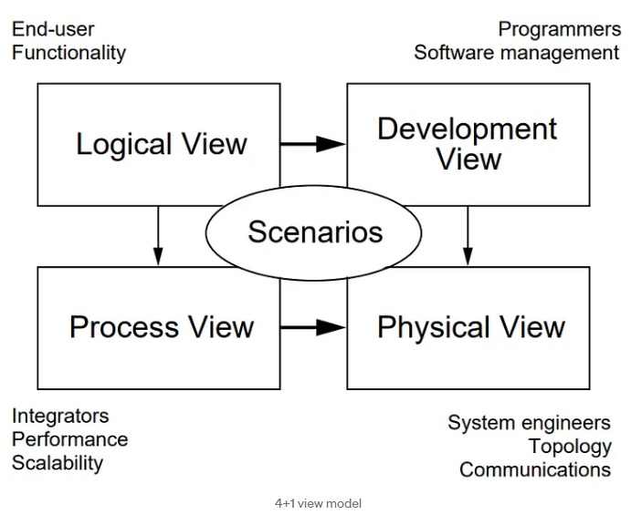
The researchers used Kruchten’s “4+1” View Model to describe the architecture of Harviana from different perspectives. The model consists of the Scenarios, Logical, Process, Development, and Physical views. These views may be represented using use case, class, sequence, package, and deployment diagrams. Together, they explain the system’s user interactions, functional structure, runtime processes, software organization, and deployment environment.
Scenarios. The scenario perspective describes Harviana according to the activities performed by its users during actual system operation. It presents the responsibilities, access privileges, and system interactions assigned to Farmers, LGU Validators, and DA Administrators. This view identifies how farmers submit crop plans, damage reports, and actual harvest records; how LGU validators review and verify these submissions; and how DA administrators use the consolidated information for monitoring, forecasting, and reporting. Through these role-based interactions, the scenario perspective demonstrates how agricultural information moves across the system and supports Harviana’s overall decision-support process.
Figure 17 maps the system’s principal activities across these three roles and clarifies how information moves from farmer submission to local validation and administrative use.
Figure 17
Harviana Use Case Diagram
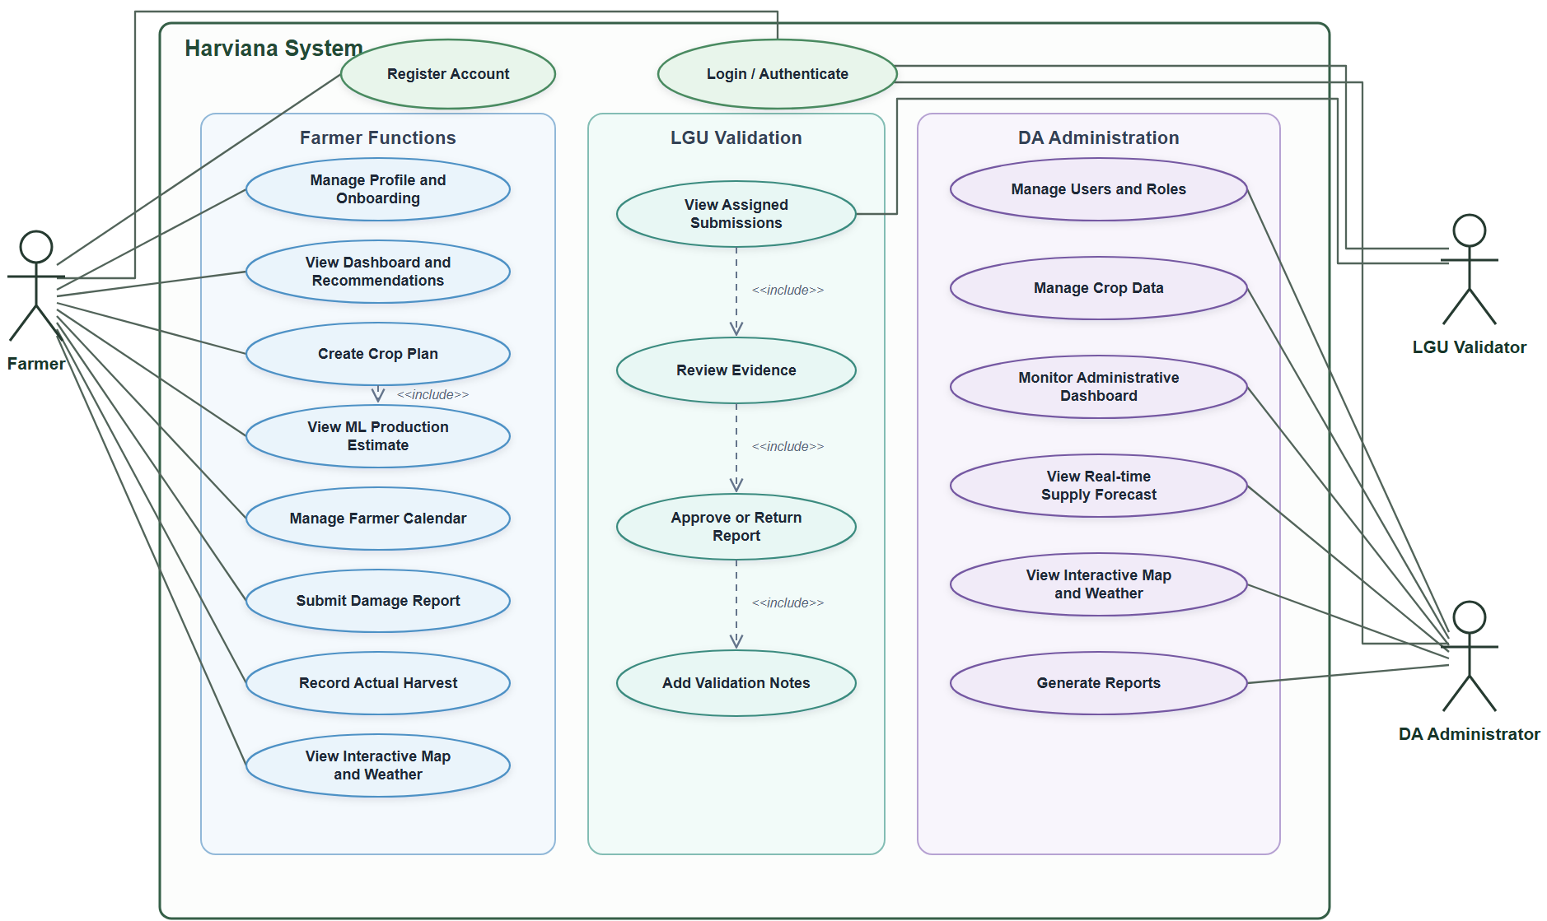
The use case diagram illustrates the core functions available to the three actors of Harviana. All actors must first complete the “Login/Authenticate” process before accessing their respective dashboards and system features. Farmers may register their accounts and complete the onboarding process by providing their municipality and cooperative information.
Once authenticated, farmers can manage their profiles, view personalized dashboards and crop recommendations, create crop plans, and receive machine-learning-based production estimates. They can also manage their farming calendar, submit damage reports, record actual harvest results, and access municipality-level maps and weather information. The “Create Crop Plan” use case includes the generation of a production estimate based on the crop, municipality, planting area, water source, and expected harvest period provided by the farmer.
LGU validators are responsible for reviewing damage reports and actual harvest records submitted by farmers within their assigned municipalities. They can view pending submissions, inspect the available evidence, approve valid records, or return submissions that require correction. Validators may also provide notes explaining their decision, while the system records the validation activity for monitoring purposes.
DA administrators have broader access to the system’s agricultural and administrative functions. They can manage user accounts and roles, maintain historical crop-production records, monitor the administrative dashboard, and access the real-time municipal supply forecast. They may also view the interactive map and weather information, generate reports, and examine prediction analytics for agricultural planning and system evaluation.
Logical View. The Logical View describes the internal organization of Harviana by presenting the data objects and service components responsible for its major functions. It focuses on how user accounts, agricultural records, crop plans, predictions, validation activities, and supply forecasts are represented within the application. A class diagram was developed to show the attributes, operations, and relationships of these components.
Figure 18 presents the principal classes and services that support Harviana’s role-based and agricultural decision-support functions.
Figure 18
Harviana Class Diagram
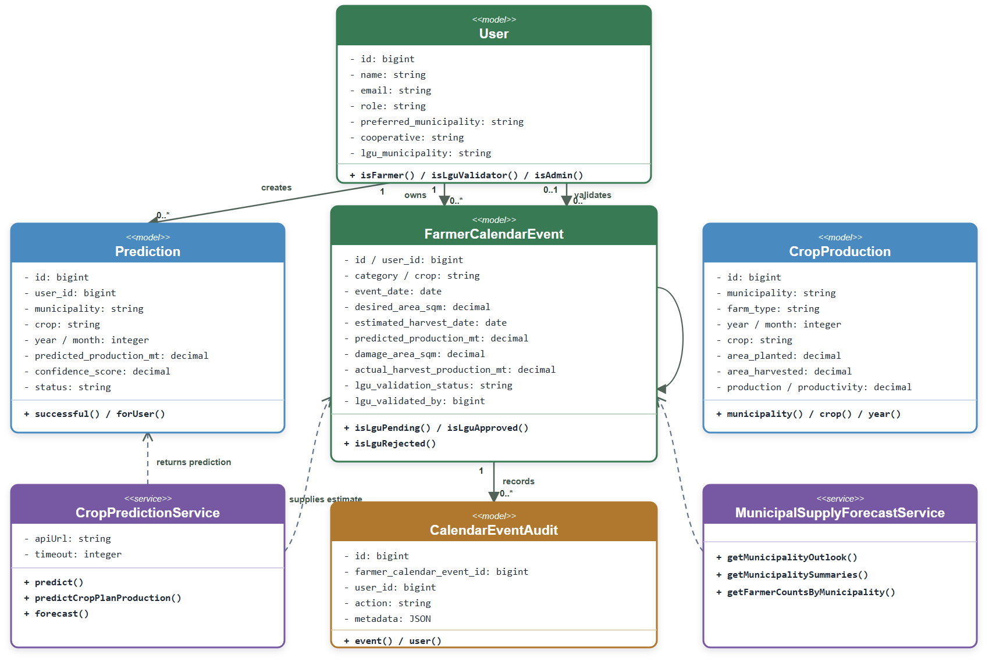
The class diagram represents the structure and primary components of Harviana. The User class manages the accounts and assigned roles of Farmers, LGU Validators, and DA Administrators. Farmers use the FarmerCalendarEvent class to create crop plans, organize planting and harvest schedules, submit damage reports, and record actual harvest results. LGU Validators review these submissions, provide validation notes, and approve or return records for correction, while the CalendarEventAudit class maintains a record of validation activities. The Prediction class stores production estimates generated for specific crops and municipalities. The CropProduction class maintains historical agricultural records used for dashboards, maps, reports, and forecasting. The CropPredictionService communicates with the machine-learning service to generate production estimates, while the MunicipalSupplyForecastService combines crop plans with approved damage and actual harvest information to calculate municipality-level supply forecasts for DA Administrators.
Process View. The process view describes how Harviana’s users and components interact during system operation. It presents requests and responses involving Farmers, LGU Validators, DA Administrators, controllers, services, the machine-learning service, and Railway PostgreSQL. It shows how inputs are processed, validated, stored, retrieved, and returned to the appropriate interface. The sequence diagrams cover authentication, crop-plan production estimation, LGU validation of farmer reports, municipal supply forecast retrieval, and DA report generation and export. These diagrams present the responsibilities of each user and component in the order the activities occur.
Figure 19 presents the authentication sequence diagram of Harviana, illustrating how user credentials are submitted, verified, and processed before the user is directed to the appropriate interface based on their assigned role.
Figure 19
Harviana Login Sequence Diagram
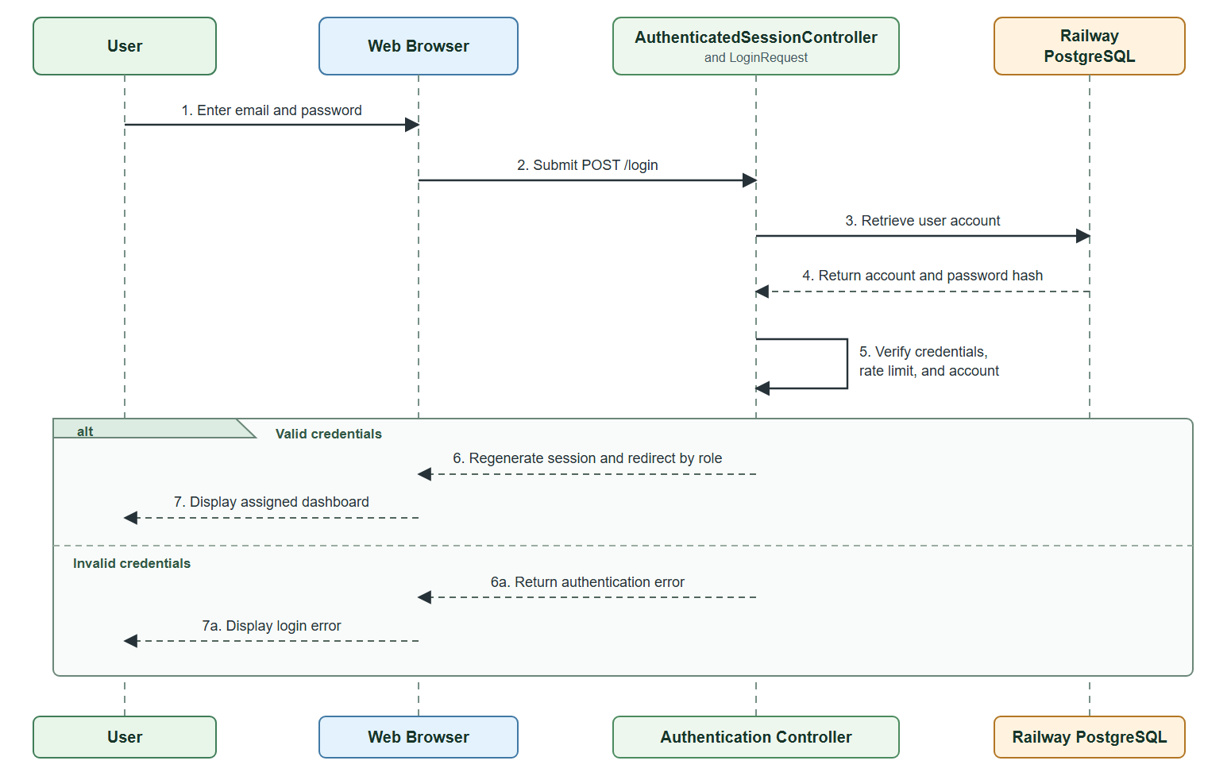
The sequence diagram illustrates how user enters an email address and password, which are submitted to the authentication controller. The system retrieves the corresponding account from Railway PostgreSQL and verifies the credentials. When authentication is successful, the session is regenerated, and the user is redirected to the appropriate dashboard based on their role as a Farmer, LGU Validator, or DA Administrator. If the credentials are invalid, the login page displays an authentication error.
Figure 20 presents the sequence diagram how Harviana generates a production estimate for a farmer’s crop plan.

Figure 20
Harviana Crop Plan and Production Estimate Sequence Diagram
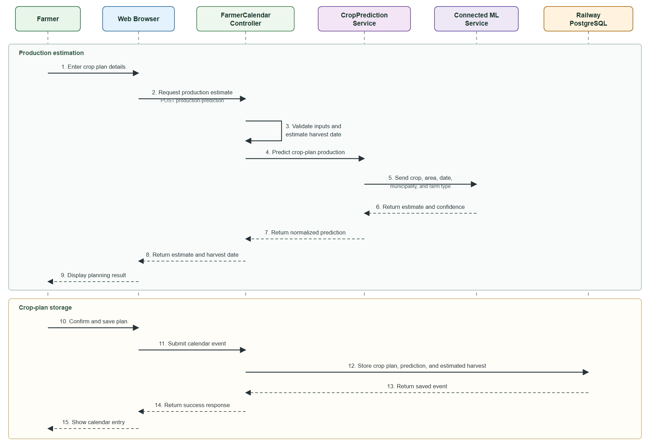
The diagram shows how the Farmer provides the crop, desired planting area, water source, planting material, and planning date. The Farmer Calendar Controller validates the information and calculates the estimated harvest date. The Crop Prediction Service sends the required data to the connected machine-learning service, which returns the predicted production and confidence value. After reviewing the result, the Farmer may save the crop plan, together with its prediction and estimated harvest date, in Railway PostgreSQL.
Figure 21 presents the submission and LGU validation of farmers’ damage and harvest reports.
Figure 21
Farmer Report and LGU Validation Sequence Diagram
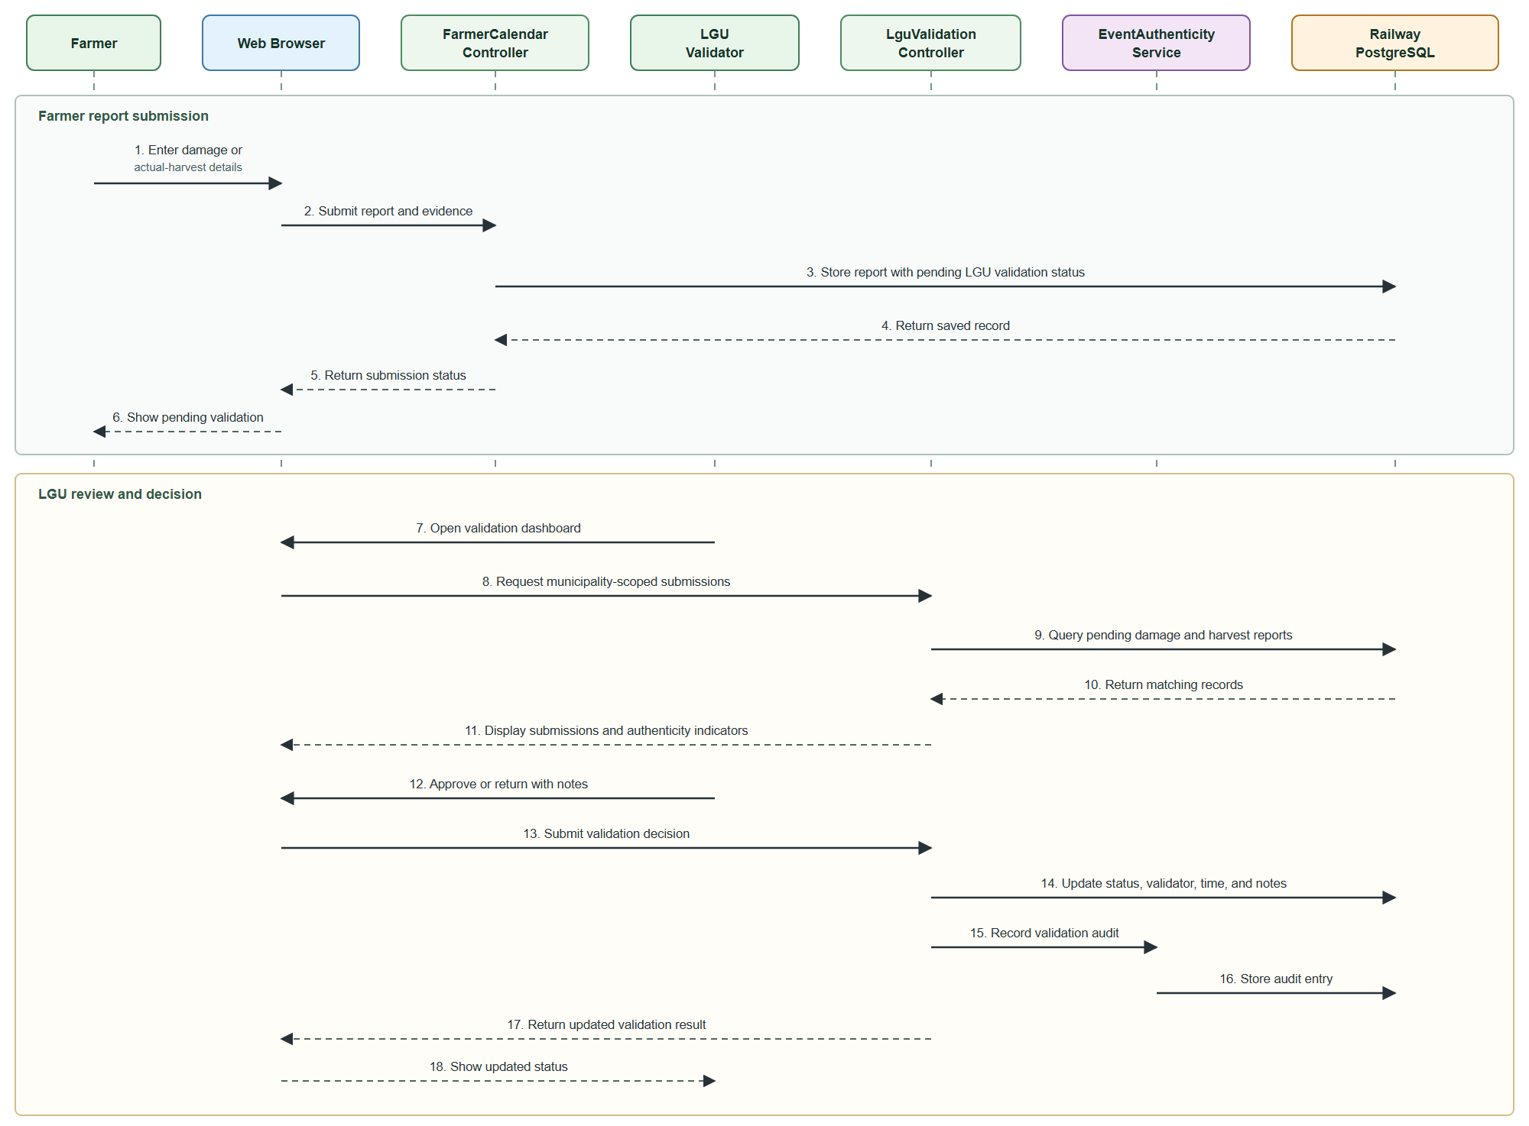
The sequence begins when the Farmer submits damage or actual-harvest information together with the required details and optional photographic evidence. Harviana stores the submitted report with a pending validation status and forwards it to the LGU Validator assigned to the farmer’s municipality. The LGU Validator reviews the report details and supporting evidence before approving the submission or returning it to the Farmer with correction notes. The system records the validation decision, validator information, date and time of validation, and corresponding audit entry. Once approved, the validated information becomes available for administrative reports and is included in the calculation of municipal supply forecasts accessible to the DA Administrator.
Figure 22 presents the DA Administrator’s process for viewing municipal supply forecasts.
Figure 22
Harviana Sequence Diagram for DA Administrator Supply Forecast
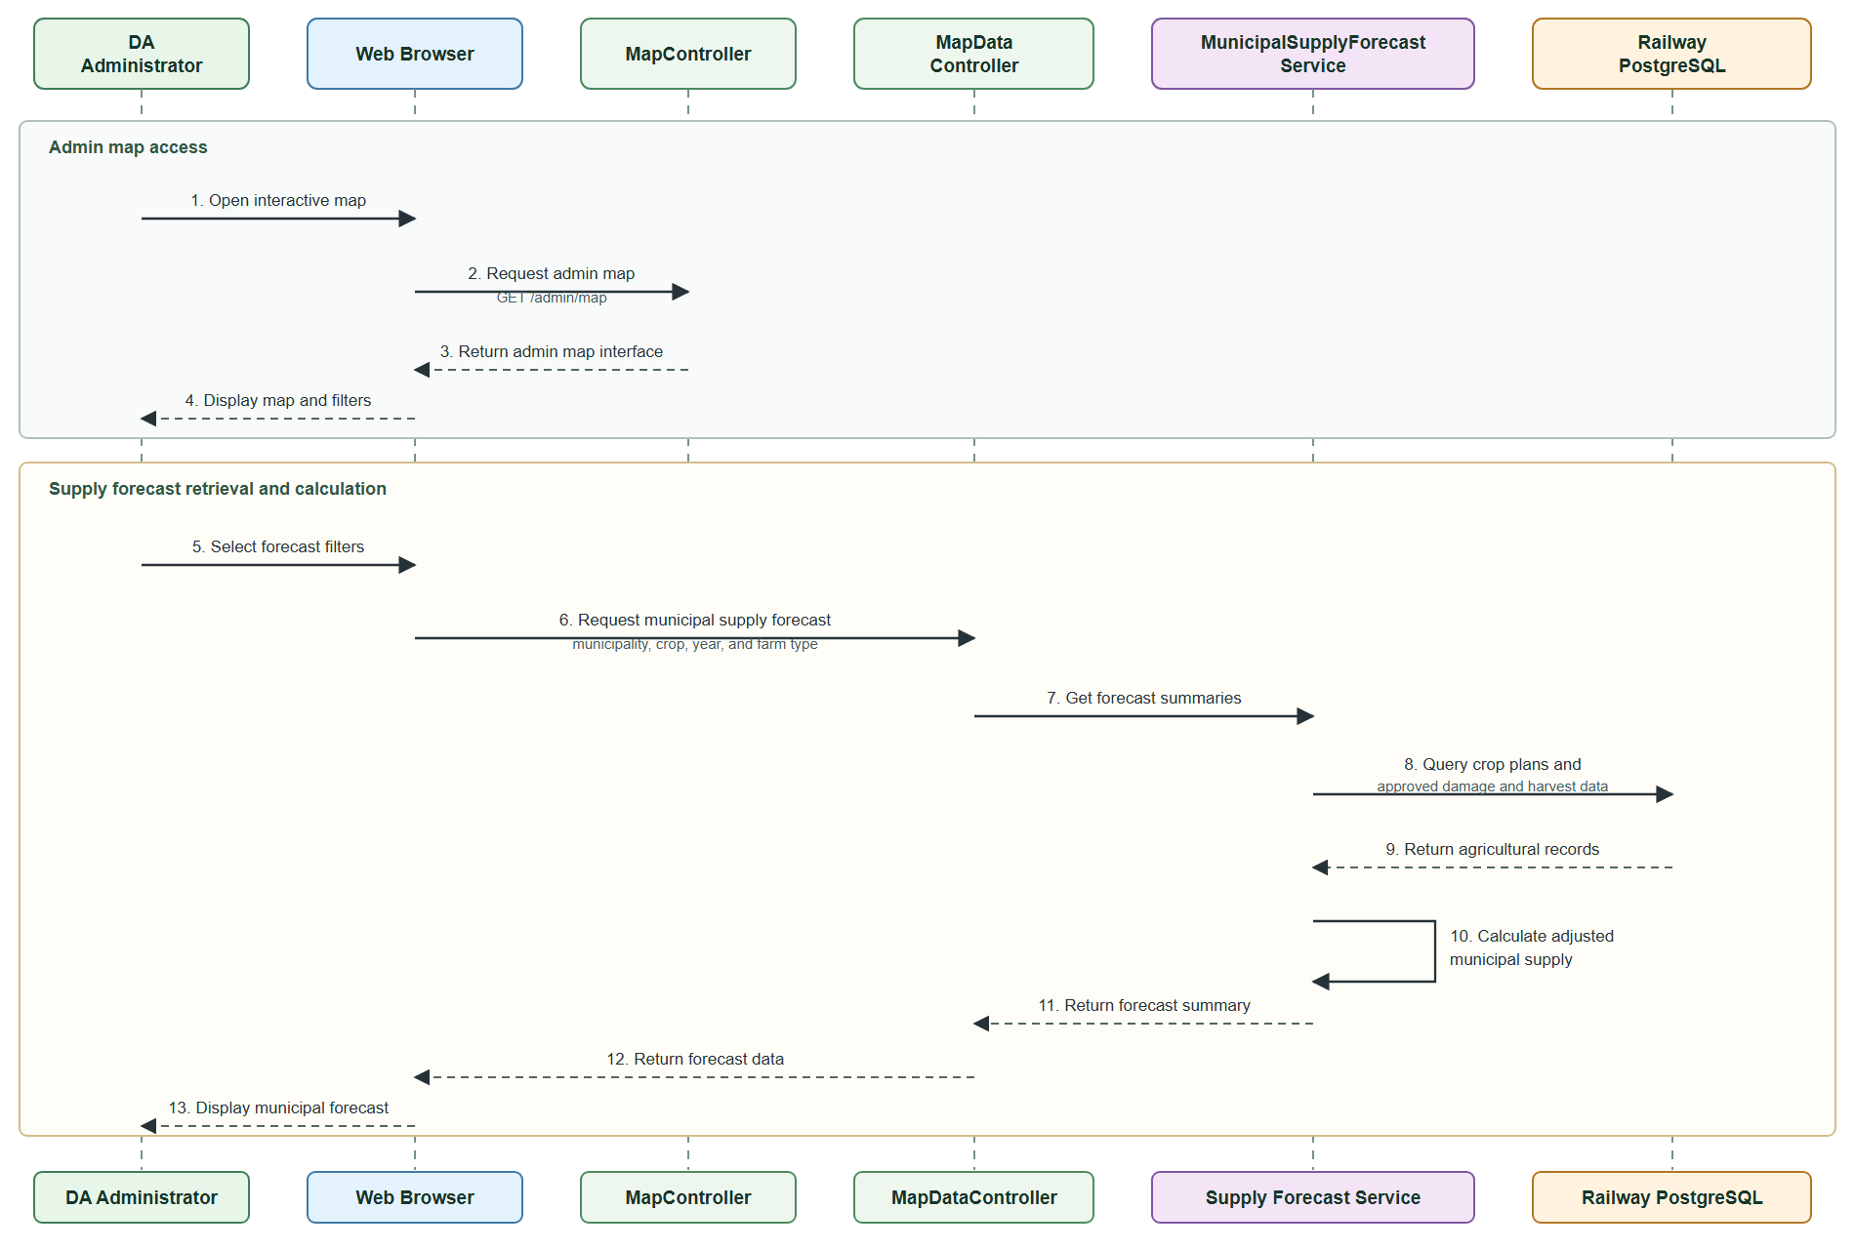
The sequence diagram shows how the DA Administrator accesses the interactive map and applies forecast filters. The Municipal Supply Forecast Service retrieves farmer crop plans, stored production predictions, and LGU-approved damage and actual-harvest records from Railway PostgreSQL. It calculates the adjusted municipal supply and returns the results for display on the administrator’s map.
Figure 23 presents the report generation and export process available to the DA Administrator.

Figure 23
Harviana Sequence Diagram for DA Report Generation and Export
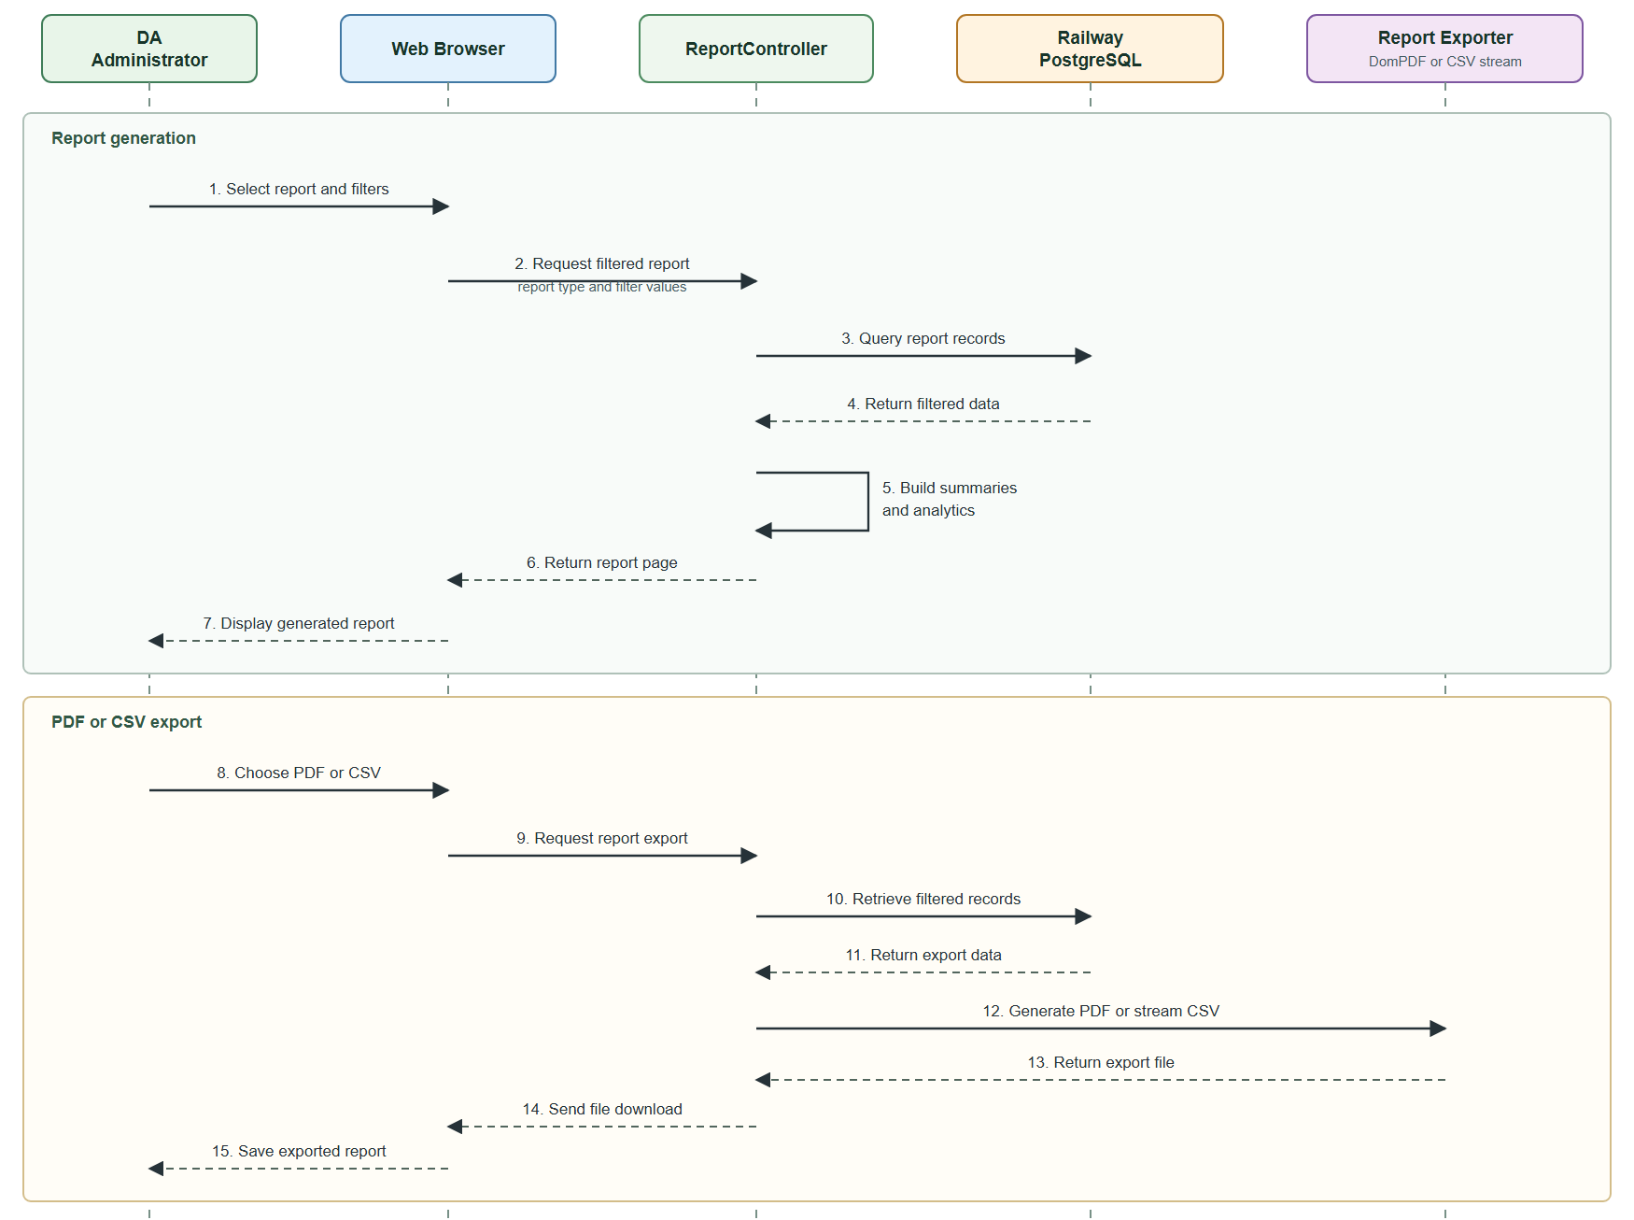
The sequence diagram shows how the DA Administrator selects a report and applies the necessary filters. The Report Controller retrieves the required records from Railway PostgreSQL and processes them into summaries and analytics for display. The administrator can then export the generated report as a PDF or CSV file. The system prepares the selected format and sends the completed report to the browser for download.
Development View. The development view presents Harviana’s software organization from the developers’ perspective. It shows how the application is divided into packages and how these packages depend on one another. A package diagram is used to represent the presentation layer, routing and access control, controllers, domain services, data models, external services, and database.
Figure 24 presents the package diagram of Harviana and the dependencies among its software modules.
Figure 24
Harviana Package Diagram
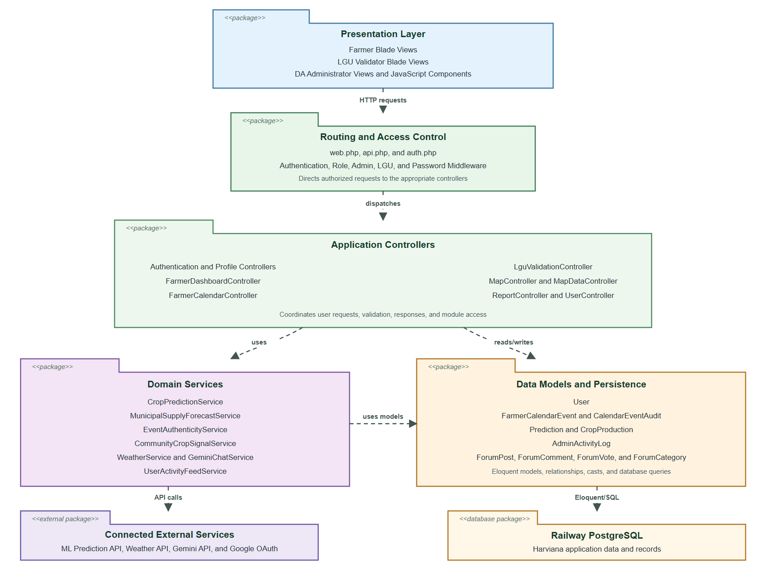
The package diagram shows how requests from the Farmer, LGU Validator, and DA Administrator interfaces pass through the routing and access-control package before reaching the appropriate controllers. The controllers use domain services for production prediction, supply forecasting, report validation, weather information, and other system operations. These services access the system’s data models and connected external services. The data models manage Harviana’s records stored in Railway PostgreSQL. This structure separates the interface, processing, service, and data-access responsibilities.
Physical View. The physical view presents the hardware, cloud services, and external systems used to operate Harviana. It shows where the application is deployed and how user devices, the web application, database, machine-learning service, and third-party APIs communicate. A deployment diagram is used to represent these physical and cloud-based connections. This view clarifies how the Railway environment supports online access, data storage, and system processing for agricultural monitoring and administrative decision-making activities.
Figure 25 presents the deployment structure of Harviana, illustrating how users access the web application deployed on Railway and how it connects to its machine-learning service and Railway PostgreSQL database to support its online agricultural monitoring and decision-support functions.
Figure 25
Harviana Deployment Diagram
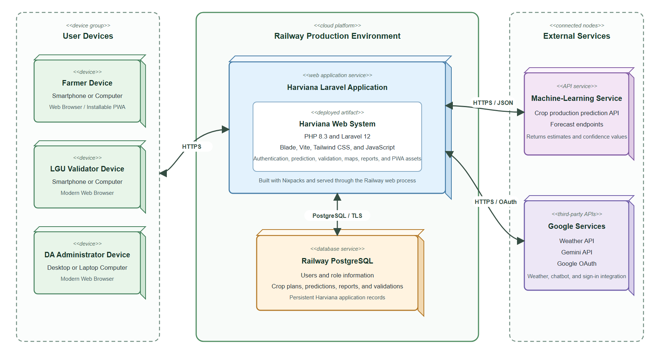
The deployment diagram shows Farmers, LGU Validators, and DA Administrators accessing Harviana through web browsers or the installable PWA over HTTPS. The Laravel application is deployed on Railway and communicates with Railway PostgreSQL to manage user accounts, crop plans, predictions, validation records, and reports. Production-estimation requests are sent to the connected machine-learning service. Harviana also communicates with Google services for weather information, chatbot responses, and OAuth authentication.
Features of Harviana
Harviana provides role-based functions for three intended user groups: Farmers, LGU Validators, and DA Administrators. For Farmers, the system provides the Farmer Dashboard and Crop Recommendations, Crop Planning and Farmer Calendar, ML-Based Production Estimate, Damage Report Submission, Actual Harvest Recording, and access to Interactive Agricultural Map and Weather information. For LGU Validators, Harviana provides assigned report queues, evidence review, validation notes, and approval or return of farmer-submitted damage and harvest records. For DA Administrators, the system provides the Administrative Dashboard and Municipal Supply Forecast, Crop Data Management, User and Role Management, Interactive Agricultural Map and Weather, and Reports and Export Generation. The following discussion presents these core features according to the responsibilities of each user group. Supporting interfaces, including the landing page and login and registration pages, are presented in Appendix F.
Farmer Features. The Farmer side of Harviana provides tools for reviewing crop information, organizing crop plans and schedules, obtaining production estimates, reporting crop damage, recording actual harvests, and accessing map and weather information.
Farmer Dashboard and Crop Recommendations. The dashboard is the Farmer’s main workspace after login. It summarizes active crop plans, reminders, harvest progress, nearby crop information, and recommendations based on available agricultural records. Quick links also provide access to the calendar and other commonly used Farmer functions.
Figure 26 presents the Farmer Dashboard and Crop Recommendations feature, which summarizes crop records, reminders, and recommended actions for Farmers.
Figure 26
Farmer Dashboard and Crop Recommendations
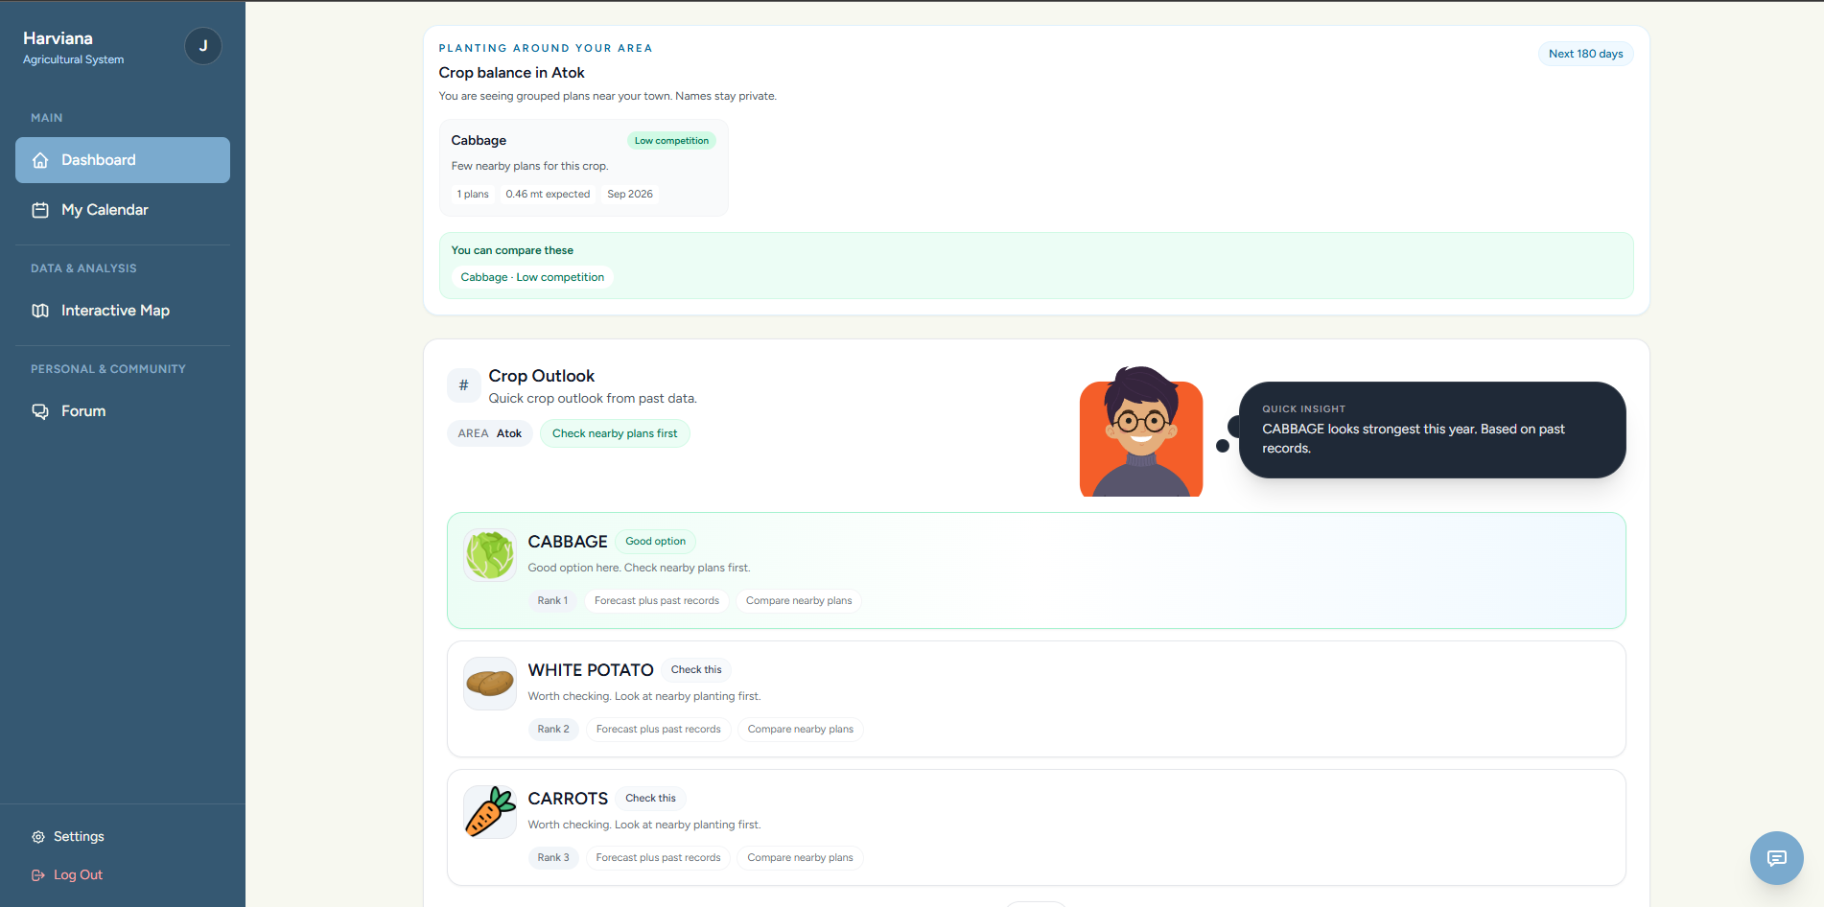
Crop Planning and Farmer Calendar. Farmers can create crop plans by providing the selected crop, intended planting area, water source, planting material, planting date, and expected harvest date. After a plan is created, its activities and important dates appear on the calendar. The page also shows active crops, upcoming reminders, and scheduled tasks such as planting, fertilizer application, crop maintenance, and harvesting. Arranging these records according to date gives Farmers a more organized way to monitor the production cycle.
Figure 27 presents the Crop Planning and Farmer Calendar feature, where Farmers create crop plans and review scheduled agricultural activities.
Figure 27
Crop Planning and Farmer Calendar
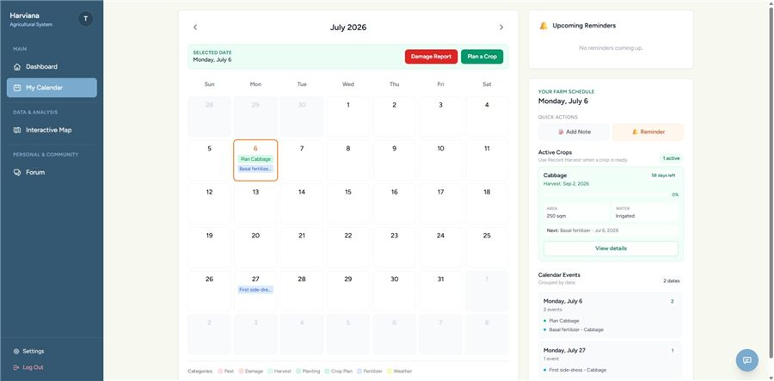
ML-Based Production Estimate. During crop planning, Harviana generates an estimated production value using the information entered by the Farmer and the agricultural records processed by the machine-learning service. The estimate serves as a planning reference for the possible output of the selected crop and planted area. It is not treated as a guaranteed harvest because actual production may still be affected by weather, crop damage, farm practices, and other field conditions. The estimated value can later be compared with the actual harvest recorded for the crop plan.
Figure 28 presents the ML-Based Production Estimate displayed after the Farmer provides the required crop-plan details.
Figure 28
ML-Based Production Estimate
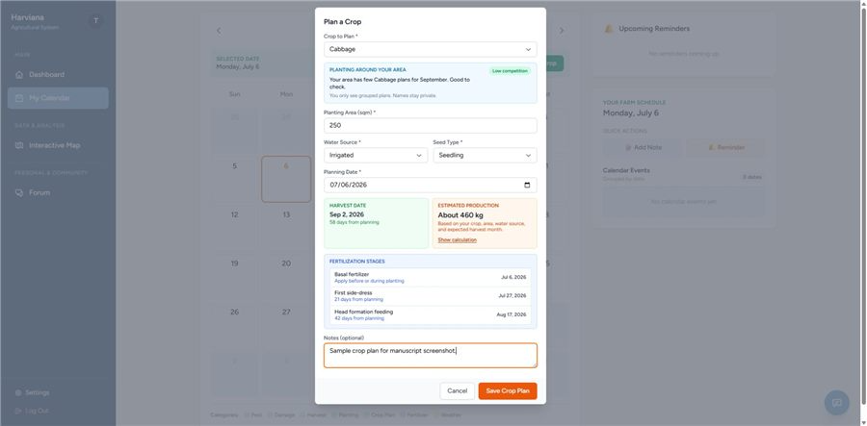
Damage Report Submission. Farmers use this page to document crop damage that occurs during the production period. The form records the affected crop plan, cause of damage, damaged area, date of occurrence, and additional notes describing the incident. Photographic evidence may also be attached to support the submitted information and provide the LGU Validator with a clearer view of the reported damage. Once submitted, the report receives a pending validation status and becomes available to the assigned LGU Validator for review. The validator may approve the report or return it to the Farmer when corrections or additional information are required. Using a standardized form helps ensure that crop-damage information is recorded consistently, reviewed properly, and prepared for agricultural monitoring and reporting.
Figure 29 presents the Damage Report Submission feature, where Farmers record crop damage and attach supporting evidence.
Figure 29
Damage Report Submission
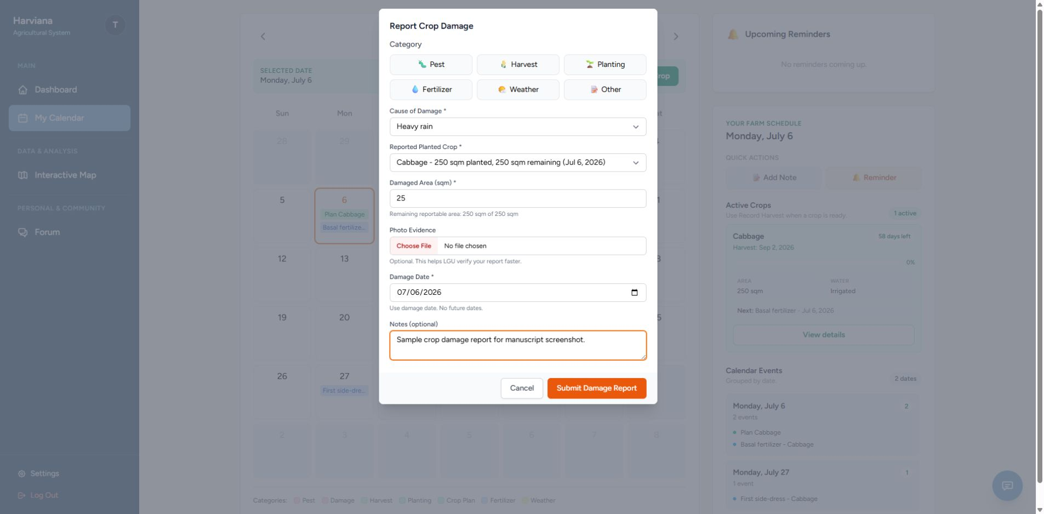
Actual Harvest Recording. After the crop-production period, Farmers can enter the actual harvest amount, unit of measurement, harvest date, optional photographic evidence, and additional notes. Harviana converts the submitted quantity into metric tons and compares it with the production estimate from the corresponding crop plan. The comparison shows the difference between the expected output and the Farmer’s recorded harvest. After validation, these records contribute to production monitoring and municipal supply information.
Figure 30 presents the Actual Harvest Recording feature, where Farmers submit the production outcome of a completed crop plan.
Figure 30
Actual Harvest Recording
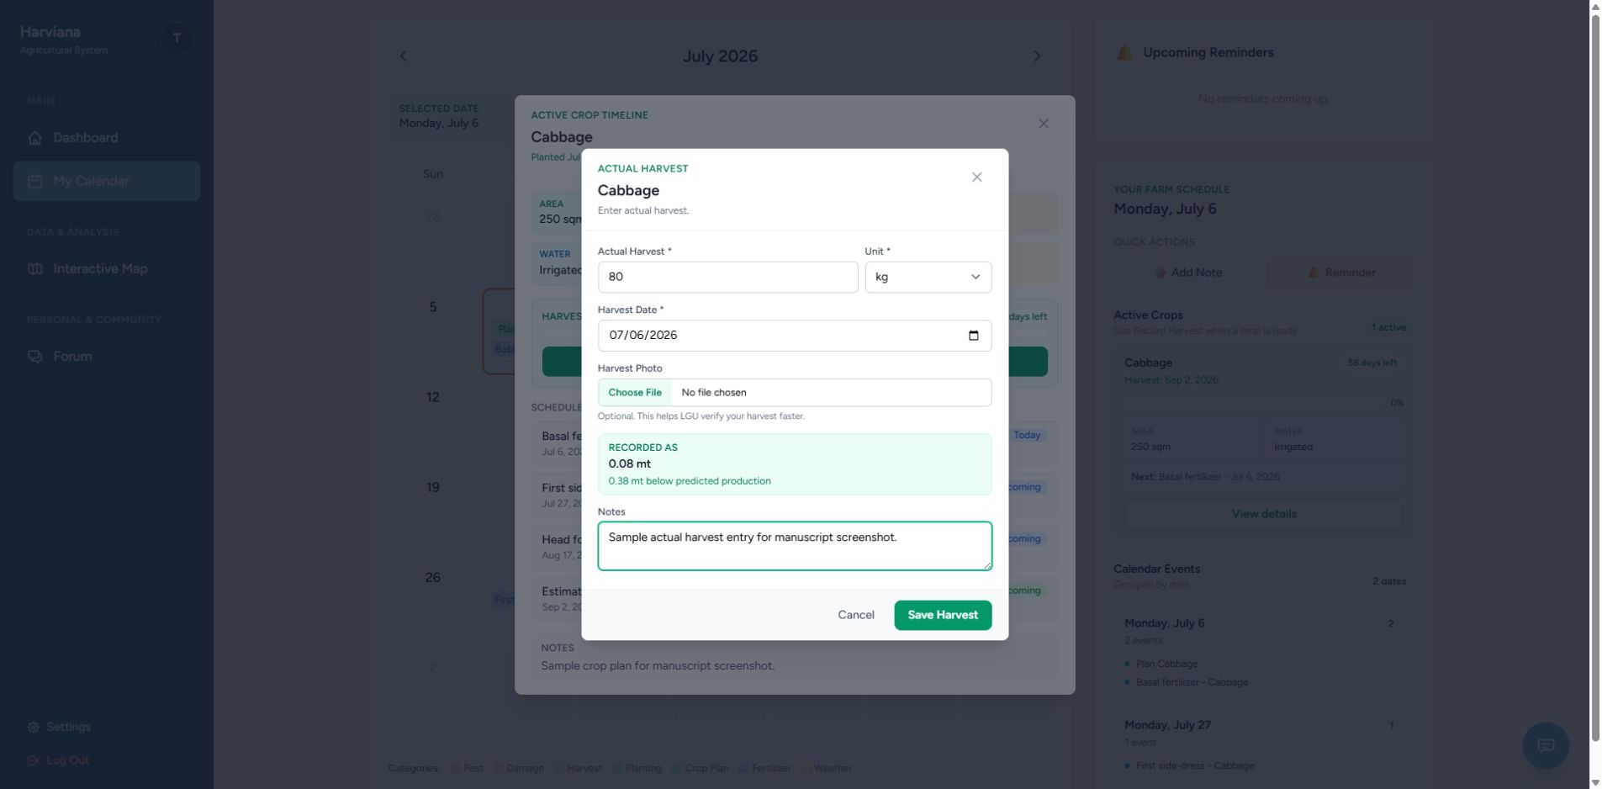
LGU Validator Features. The LGU Validator side provides tools for reviewing Farmer-submitted damage and harvest records, examining supporting evidence, adding validation notes, and approving or returning reports.
LGU Report Validation. LGU Validators can filter assigned reports, examine damage or harvest details and supporting evidence, and approve submissions or return them for correction. Harviana records the validator, decision, validation date and time, and notes as part of the report history.
Figure 31 presents the LGU Report Validation feature, including its report queue, evidence review, and approval or return actions.
Figure 31
LGU Report Validation
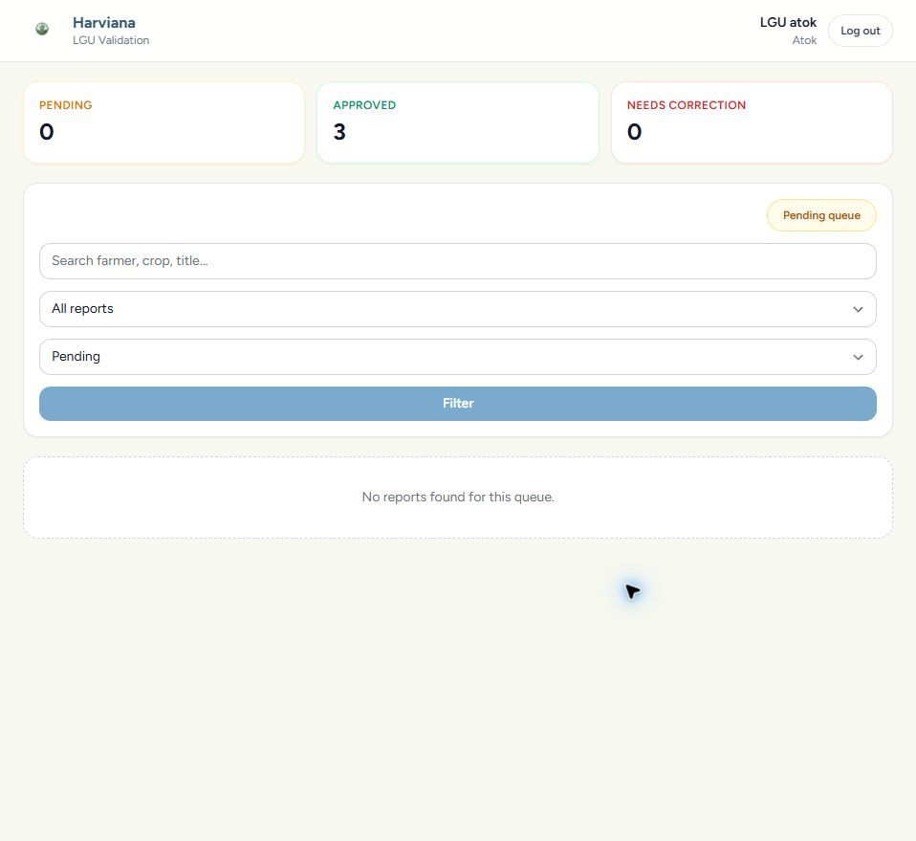
DA Administrator Features. The DA Administrator side provides tools for monitoring validated records and municipal supply, managing crop data and user accounts, viewing map-based information, and preparing administrative reports.
Administrative Dashboard and Municipal Supply Forecast. The administrative dashboard summarizes crop records, municipalities, production, actual harvests, damage, and recent system activity. Its municipal supply values help DA Administrators review the estimated availability of selected vegetables by location and production period.
Figure 32 presents the Administrative Dashboard and Municipal Supply Forecast, which consolidate crop and supply information for DA Administrators.
Figure 32
Administrative Dashboard and Municipal Supply Forecast
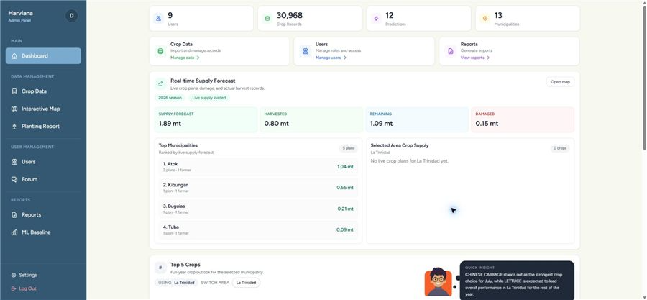
Crop Data Management. DA Administrators can import, add, update, archive, search, and filter agricultural production records by municipality, crop, year, and other stored categories. These records support Harviana’s maps, production estimates, municipal supply forecasts, and administrative reports.
Figure 33 presents the Crop Data Management feature, which allows DA Administrators to maintain the agricultural production records used by Harviana.

Figure 33
Crop Data Management
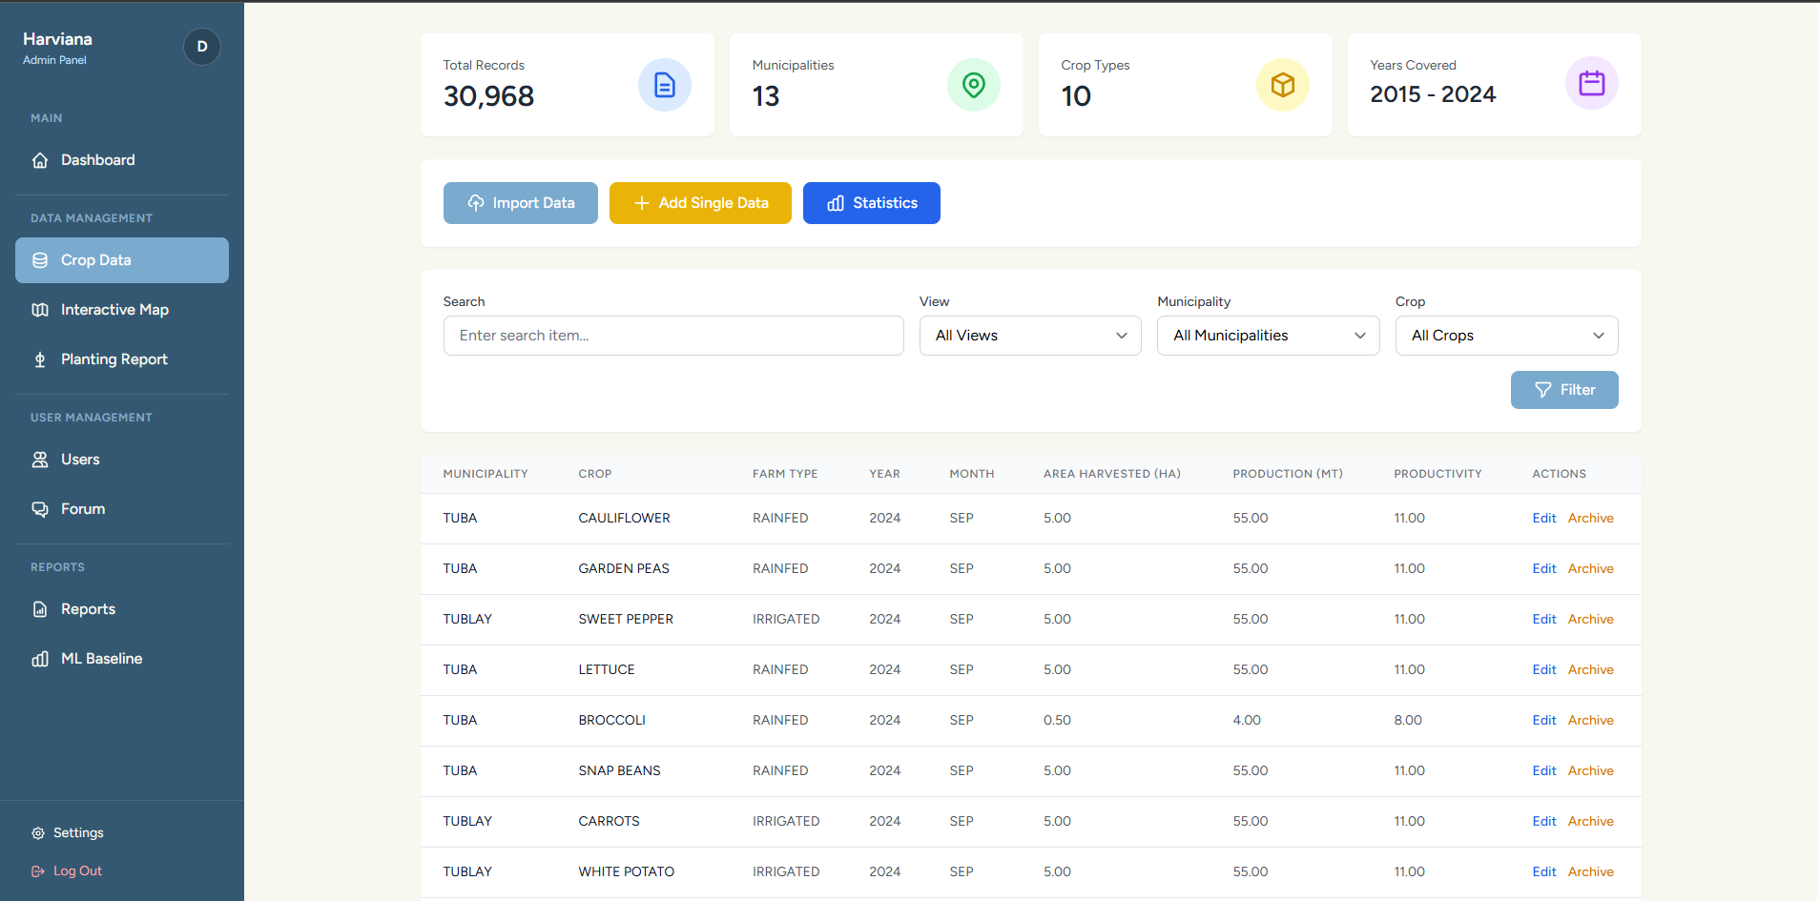
Interactive Agricultural Map and Weather. The interactive map displays agricultural information according to the geographic location of available crop records. Farmers and DA Administrators can filter the displayed information according to crop type, year, view type, and farm type to focus on selected production records or locations. Weather information for a selected area includes temperature, current weather condition, probability of rainfall, humidity, and wind speed. Presenting agricultural records together with location and weather information helps users examine the distribution of vegetable production across the municipalities of Benguet.
Figure 34 presents the Interactive Agricultural Map and Weather feature, which provides Farmers and DA Administrators with a location-based view of agricultural records and current weather information.
Figure 34
Interactive Agricultural Map and Weather
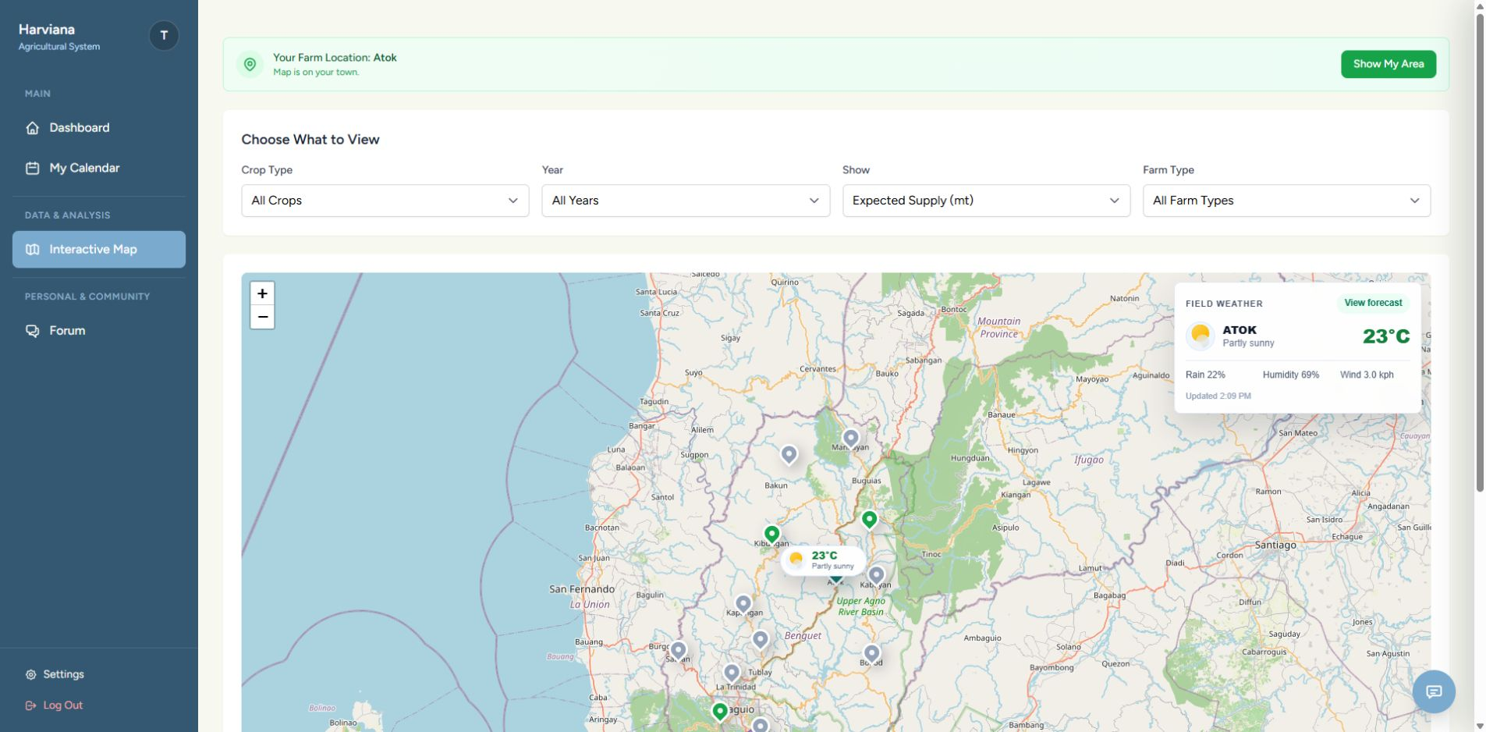
Reports and Export Generation. The Reports Dashboard organizes harvest accuracy, crop production, damage records, planting records, planted areas, production values, and actual-harvest information into report-focused views. DA Administrators can filter the available records according to crop, municipality, production period, and report category. The Planting Report and Export page provides a detailed view of planting and harvest-related records and allows the information to be exported for documentation and further analysis. This feature transforms validated agricultural records into organized reports that can support administrative monitoring, planning, and decision-making.
Figure 35 presents the Reports and Export Generation feature, which combines agricultural summaries, planting information, actual-harvest records, and export functions for DA Administrators.
Figure 35
Reports and Export Generation
Extent of the Usability of Harviana
The extent of usability of Harviana was evaluated to determine how the system was perceived by its intended users after interacting with its major features. The evaluation focused on two user groups: farmers and DA Administrators. The farmer-side evaluation measured the usability of features such as crop planning, farmer calendar monitoring, damage report submission, and actual harvest recording. The DA Administrator-side evaluation measured the usability of features such as dashboard monitoring, interactive map and weather viewing, supply forecast review, report generation, and export of agricultural records.
The researchers used two usability instruments to evaluate the system. The System Usability Scale (SUS) was used for the farmer respondents, while the USE questionnaire was used for the DA Administrator respondents. A total of 132 valid responses were used for the farmer-side SUS evaluation, while 18 valid responses were used for the DA Administrator-side USE evaluation. These responses were analyzed according to the scoring procedures and interpretation scales of the selected usability instruments.
For the farmer evaluation, the System Usability Scale (SUS) developed by Brooke (1996) was used to measure the perceived usability of the farmer-side features of Harviana. The SUS is composed of ten statements rated using a five-point scale. For the computation, the odd-numbered items were scored by subtracting one from the participant’s response, while the even-numbered items were scored by subtracting the participant’s response from five. The adjusted scores were added together and multiplied by 2.5 to convert the result into a score ranging from 0 to 100. The interpretation of SUS scores was adapted from Bangor, Kortum, and Miller (2009).
Table 5 presents the SUS score interpretation scale used in analyzing the farmer usability results

Table 5
SUS Score Interpretation Scale
Grade | SUS Score Range | Adjective Range | Acceptability Range
A- to A+  B- to B+  C- to C+  D  F | 78.9–100  72.6–78.8  62.7–72.5  51.7–62.6  0.0–51.6 | Excellent – Best Imaginable  Good to Excellent  OK to Good  OK  Worst Imaginable - Poor | Acceptable  Acceptable  Marginal - Acceptable  Marginal  Not Acceptable
Table 5 served as the basis for interpreting the overall SUS score of Harviana from the farmer perspective. Higher SUS scores indicate a more positive usability evaluation. Scores within the higher ranges suggest that users can understand and operate the system with less difficulty, while lower scores indicate that the system may require further improvement to support user interaction.
Table 6 presents the farmers’ responses to the SUS questionnaire. The values under columns 1 to 5 show the number of farmers who selected each response option. The item contribution mean shows the average score contribution of each item after applying the SUS scoring procedure.

Table 6
Farmers’ SUS Questionnaire Results
No. | Statement | 1 | 2 | 3 | 4 | 5 | Item Contribution Mean
1  2  3  4  5  6  7  8  9  10 | I think that I would like to use frequently.  I found the system  Unnecessarily complex.  I thought the system was easy to use.  I think that I would need assistance to use the system.  I found the various features of the system were well integrated.  I thought there was too much inconsistency in the system.  I would imagine that most users would learn to use the system very quickly.  I found the system very difficult to use.  I felt very confident using the system.  I needed to learn many things before I could get started with the system. | 3  44  2  34  2  50  3  45  4  32 | 4  39  3  37  6  33  8  38  10  37 | 15  25  24  31  18  31  22  34  33  30 | 46  13  53  20  52  14  48  13  42  18 | 64  11  50  10  54  4  51  2  43  15 | 3.24  2.70  3.11  2.49  3.14  2.84  3.03  2.84  2.83  2.40
As shown in Table 6, the farmer respondents generally gave favorable responses to the positive statements and lower responses to the negatively worded statements. For the positive items, many respondents selected 4 and 5, showing agreement with statements related to frequent use, ease of use, feature integration, learnability, and confidence in using Harviana. For the negative items, many respondents selected 1 and 2, showing disagreement with statements suggesting that the system was complex, inconsistent, difficult to use, or required too much learning before use.
The pattern of responses indicates that the farmers were generally able to understand and interact with the farmer-side features of Harviana. The results suggest that the crop planning, calendar, damage report, and actual harvest recording features were usable for the participating farmers. However, the presence of varied responses also suggests that some users may still need guidance or interface improvements, especially for first-time use.
After computing the SUS scores of the 132 valid farmer responses, the total SUS score obtained was 9,445. The average SUS score was computed as follows:
Average SUS Score = Σ SUS Scores / n
Average SUS Score = 9,445 / 132
Average SUS Score = 71.55 or approximately 71.6
Table 7 presents the summary of the farmers’ SUS score, including the number of valid respondents, total computed SUS score, mean score, median score, standard deviation, minimum score, maximum score, and overall interpretation. This table provides an overview of the usability result obtained from the farmer respondents after their individual SUS scores were computed and summarized.
Table 7
Summary of Farmers’ SUS Score
Measure | Result
Number of Valid Respondents  Total SUS Score  Mean SUS Score  Median SUS Score  Standard Deviation  Minimum Score  Maximum Score  Overall Interpretation | 132  9,445  71.55  75.00  15.21  32.50  97.50  OK to Good / Marginal to Acceptable
As presented in Table 7, the farmers obtained a mean SUS score of 71.55. Based on the interpretation scale, this falls within the C- to C+ range, with an adjective rating of OK to Good and an acceptability range of Marginal to Acceptable. This means that the farmer-side features of Harviana were generally usable, but there are still areas that may be improved to make the system easier and more comfortable for all farmer users.
The result shows that Harviana can support farmers in performing important crop-related tasks such as creating crop plans, viewing scheduled farm activities, submitting crop damage reports, and recording actual harvest results. Since the score is close to the acceptable range, the findings suggest that the farmer-side interface has a positive usability foundation. However, refinements in user guidance, interface clarity, and ease of first-time navigation may further improve the farmer experience.
For the DA Administrator evaluation, the USE questionnaire developed by Lund (2001) was used to evaluate the usability of the administrative side of Harviana. The questionnaire measured four dimensions: usefulness, ease of use, ease of learning, and satisfaction. These dimensions were appropriate for evaluating the DA Administrator side of the system because the administrative features are intended to support monitoring, map-based visualization, supply forecast review, and report generation.
The DA Administrators rated each statement using a seven-point scale. Higher ratings indicate stronger agreement with the usability statement and a more positive evaluation of the system. The verbal interpretation ranges were computed by the researchers based on the seven-point response scale.
Table 8 presents the seven-point USE questionnaire interpretation scale used to analyze the responses of the DA Administrators. It shows the point values, corresponding mean ranges, and verbal interpretations used to determine the level of agreement for each usability dimension. This table served as the basis for interpreting the computed weighted means for usefulness, ease of use, ease of learning, and satisfaction.

Table 8
Seven-Point USE Questionnaire Interpretation Scale
Point | Mean Range | Verbal Interpretation
1  2  3  4  5  6  7 | 1.00–1.86  1.87–2.72  2.73–3.58  3.59–4.44  4.45–5.30  5.31–6.16  6.17–7.00 | Strongly Disagree  Disagree  Somewhat Disagree  Neutral  Somewhat Agree  Agree  Strongly Agree
Table 8 was used to interpret the weighted means obtained from the DA Administrator responses. Mean values closer to 7 indicate stronger agreement and more favorable usability perception. This scale allowed the researchers to determine the usability level of Harviana’s administrative features in each USE dimension.
Table 9 presents the usability testing result for the Usefulness dimension of the USE questionnaire. It shows the responses of the DA Administrators for each usefulness-related statement, including the frequency of ratings from 1 to 7 and the computed weighted mean for each item. This table was used to determine how useful Harviana was in helping DA Administrators perform monitoring, forecasting, map viewing, and report generation tasks.

Table 9
Usefulness: Usability Testing Result for DA Administrators
No. | Statement | 1 | 2 | 3 | 4 | 5 | 6 | 7 | Weighted Mean
1  2  3  4  5  6  7  8 | It helps me be more effective.  It helps me be more productive.  It is useful.  It gives me more control over the activities in my work.  It makes the things I want to accomplish easier to get done.  It saves me time when I use it.  It meets my needs.  It does everything I would expect it to do | 0  0  0  0  0  0  0  0 | 0  0  0  0  0  0  0  0 | 0  0  0  0  0  0  0  0 | 1  1  0  2  0  0  1  2 | 4  4  1  4  1  1  2  3 | 7  6  6  7  11  10  10  9 | 6  7  11  5  6  7  5  4 | 6.00  6.06  6.56  5.83  6.28  6.33  6.06  5.83
 | Mean |  |  |  |  |  |  |  | 6.12
As shown in Table 9, the Usefulness dimension obtained a mean of 6.12, which is interpreted as Agree. This indicates that the DA Administrators generally found Harviana useful in supporting their administrative tasks. The highest-rated item was “It is useful,” with a weighted mean of 6.56, showing that the respondents recognized the value of the system in their work. The results suggest that Harviana can help DA Administrators review agricultural records, monitor crop-related information, and use system-generated data for planning and decision-making.
Table 10 presents the usability testing results for the Ease of Use dimension of the USE questionnaire. It shows the DA Administrators’ responses to each statement, including the frequency of ratings from 1 to 7 and the corresponding weighted mean. The results were used to determine how easily the respondents could navigate Harviana, understand its interface, complete administrative tasks, and recover from errors while using the system.
Table 10
Ease of Use: Usability Testing Result for DA Administrators
No. | Statement | 1 | 2 | 3 | 4 | 5 | 6 | 7 | Weighted Mean
9  10  11  12  13  14  15  16  17  18  19 | It is easy to use.  It is simple to use.  It is user-friendly.  It requires the fewest steps possible to accomplish what I want to do with it.  It is flexible.  Using it is effortless.  I can use it without instructions.  I do not notice inconsistencies as I use it.  Both occasional and regular users would like it.  I can recover from mistakes quickly and easily.  I can use it successfully every time. | 0  0  0  0  0  0  0  0  0  0  0 | 0  0  0  0  0  0  0  0  0  0  0 | 0  0  0  0  0  0  0  0  0  0  0 | 0  0  0  0  0  1  1  1  0  0  0 | 1  1  0  1  1  2  0  4  3  3  1 | 9  7  9  11  6  9  11  9  9  10  11 | 8  10  9  6  11  6  6  4  6  5  6 | 6.39  6.50  6.50  6.28  6.56  6.11  6.22  5.89  6.17  6.11  6.28
 | Mean |  |  |  |  |  |  |  | 6.27
The Ease of Use dimension obtained a mean of 6.27, which is interpreted as Strongly Agree. This result indicates that the DA Administrators found the administrative side of Harviana easy to operate. The highest-rated item was “It is flexible,” with a weighted mean of 6.56, while “It is simple to use” and “It is user-friendly” both received weighted means of 6.50. These results suggest that the administrative dashboard, map, forecast, and reporting features were generally easy to navigate and use.
The lowest-rated item under this dimension was “I do not notice inconsistencies as I use it,” with a weighted mean of 5.89. Although this still falls within the Agree range, it suggests that some minor inconsistencies or areas for interface improvement may still be present. Overall, the results show that Harviana’s administrative interface provides a positive user experience in terms of ease of use.
Table 11 presents the usability testing result for the Ease of Learning dimension.
Table 11
Ease of Learning: Usability Testing Result for DA Administrators
No. | Statement | 1 | 2 | 3 | 4 | 5 | 6 | 7 | Weighted Mean
20  21  22  23 | I learned to use it quickly.  I easily remember how to use it.  It is easy to learn to use it.  I quickly became skillful with it. | 0  0  0  0 | 0  0  0  0 | 0  0  0  0 | 0  0  0  0 | 0  0  0  0 | 7  7  5  8 | 11  11  13  9 | 6.61  6.61  6.72  6.39
 | Mean |  |  |  |  |  |  |  | 6.58
As presented in Table 11, the Ease of Learning dimension obtained a mean of 6.58, interpreted as Strongly Agree. This was the highest among the four USE dimensions. The result indicates that DA Administrators were able to understand and learn the administrative features of Harviana quickly. The highest-rated item was “It is easy to learn to use it,” with a weighted mean of 6.72.
This finding suggests that the system’s administrative interface was understandable even for users who may be using the platform for the first time. The dashboard layout, map filters, forecast display, and report functions appear to be structured in a way that allows users to learn the system with minimal difficulty. This is important because DA Administrators need to access and interpret agricultural information efficiently.
Table 12 presents the usability testing result for the Satisfaction dimension.
Table 12
Satisfaction: Usability Testing Result for DA Administrators
No. | Statement | 1 | 2 | 3 | 4 | 5 | 6 | 7 | Weighted Mean
24  25  26  27  28  29  30 | I am satisfied with it.  I would recommend it to a colleague.  It is pleasant to use.  It works the way I want it to work.  It is wonderful.  I feel I need to have it.  It meets my needs. | 0  0  0  0  0  0  0 | 0  0  0  0  0  0  0 | 0  0  0  0  0  0  0 | 0  1  0  0  0  0  0 | 2  1  2  3  1  4  2 | 9  7  9  9  8  6  8 | 7  9  7  6  9  8  8 | 6.28  6.33  6.28  6.17  6.44  6.22  6.33
 | Mean |  |  |  |  |  |  |  | 6.29
As shown in Table 12, the Satisfaction dimension obtained a mean of 6.29, interpreted as Strongly Agree. This indicates that the DA Administrators were highly satisfied with the administrative features of Harviana. The highest-rated item was “It is wonderful,” with a weighted mean of 6.44, while the lowest-rated item was “It works the way I want it to work,” with a weighted mean of 6.17. Since even the lowest-rated item still falls within the Strongly Agree range, the results show a consistently positive satisfaction level.
The satisfaction results suggest that the DA Administrators found Harviana beneficial and acceptable for their work. The system’s ability to present dashboards, map-based agricultural information, supply forecasts, and exportable reports contributed to a positive administrative user experience. These findings support the system’s purpose of helping DA Administrators access and review agricultural records in a more organized and useful manner.
Table 13 presents the overall USE questionnaire result for DA Administrators.
Table 13
Overall USE Questionnaire Result for DA Administrators
Use Dimension | Mean | Verbal Interpretation
Usefulness  Ease of Use  Ease of Learning  Satisfaction | 6.12  6.27  6.58  6.29 | Agree  Strongly Agree  Strongly Agree  Strongly Agree
Overall Result | 6.32 | Strongly Agree
Table 13 shows that the DA Administrator side of Harviana obtained an overall USE result of 6.32, interpreted as Strongly Agree. The overall result was computed from the mean scores of the four USE dimensions. The highest dimension was Ease of Learning, followed by Satisfaction, Ease of Use, and Usefulness. These findings indicate that the administrative side of Harviana was positively evaluated by the DA Administrator respondents.
The results show that Harviana was perceived as useful for administrative monitoring and reporting, easy to use when navigating system features, easy to learn for users interacting with the platform, and satisfactory in supporting administrative tasks. This confirms that the DA Administrator-side features of Harviana were able to support agricultural monitoring, map-based visualization, supply forecast review, and report generation in a usable manner.
Table 14 presents the overall usability summary of Harviana based on the two user groups.
Table 14
Overall Usability Summary of Harviana
User Group | Usability | Valid Respondents | Overall Result | Interpretation
Farmers  DA Administrators | System Usability Scale (SUS)  USE Questionnaire | 132  18 | 71.55/100  6.32/7 | OK to Good / Marginal to Acceptable  Strongly Agree
As presented in Table 14, Harviana received positive usability results from both participating user groups. The farmer-side features obtained a SUS score of 71.55, interpreted as OK to Good and Marginal to Acceptable. This means that the farmer-side features were generally usable, but may still be improved to provide a smoother experience for all farmer users. The result suggests that farmers can use Harviana for crop planning, farmer calendar monitoring, damage report submission, and actual harvest recording.
The DA Administrator-side features obtained an overall USE result of 6.32, interpreted as Strongly Agree. This indicates that DA Administrators found the system useful, easy to use, easy to learn, and satisfactory. The result supports the role of Harviana as a decision-support system that helps DA Administrators monitor agricultural data, view map-based information, review supply forecasts, and generate reports.
Overall, the usability findings show that Harviana was able to meet the usability needs of its evaluated users. The farmer-side features demonstrated a usable and acceptable foundation, while the DA Administrator-side features received a strong positive evaluation. These results suggest that Harviana can support agricultural data collection, validation-based reporting, map-based visualization, supply forecasting, and administrative decision-making through a usable web-based platform.

Chapter 4
CONCLUSIONS AND RECOMMENDATIONS
This chapter presents the conclusions drawn from the findings of the study and shows how the objectives of Harviana were addressed. It also provides recommendations that may guide the improvement of the system and the development of similar agricultural decision-support platforms.
Based on the findings of the study, the researchers arrived at the following conclusions:
1. The information requirements of Harviana were identified for Farmers, LGU Validators, and DA Administrators. Farmers provide crop plans, farm activities, damage reports, and actual-harvest records. LGU Validators review submitted reports and record their validation decisions, while DA Administrators access consolidated agricultural information for monitoring, forecasting, and report generation. The minimum and recommended system requirements were also identified to support the operation of the platform.
2. The “4+1” View Model served as the architectural framework of Harviana. The use case, class, sequence, package, and deployment diagrams presented the system’s user interactions, structure, processes, software components, and deployment environment. Harviana is deployed on Railway and connected to its machine-learning service and Railway PostgreSQL.
3. The study identified and developed the major features of Harviana according to the responsibilities of its intended users. Farmers were provided with tools for crop planning, calendar-based activity monitoring, production estimation, crop recommendations, damage reporting, actual-harvest recording, and location-based agricultural information. LGU Validators were provided with features for reviewing farmer-submitted reports, recording validation decisions, returning reports for correction, and maintaining validation audit entries. DA Administrators were provided with dashboard monitoring, GIS-based visualization, agricultural-record management, municipal supply forecasting, prediction analytics, and report generation and export functions. The integration of these features established a structured workflow for collecting, validating, visualizing, monitoring, forecasting, and reporting vegetable-production information in Benguet.
4. The usability evaluation showed that the farmer-side features obtained a mean SUS score of 71.55 from 132 valid respondents. This result falls within the C- to C+ range and is interpreted as “OK to Good” and “Marginal to Acceptable.” The DA Administrator evaluation obtained an overall USE weighted mean of 6.32 from 18 respondents, interpreted as “Strongly Agree.” These results show that Harviana was generally usable, although the farmer interface may still be improved to make first-time use easier.
Recommendations
Based on the conclusions of the study, the researchers recommend the following:
1. The information requirements and validation procedures of Harviana should be reviewed regularly with Farmers, LGU Validators, and DA Administrators. This will help ensure that the agricultural records collected by the system remain complete, relevant, and useful for monitoring and reporting.
2. The system’s database, machine-learning service, access controls, and deployment environment should be maintained and monitored regularly. Database backups and system testing should also be conducted to protect agricultural records and maintain reliable access to the platform.
3. Future development may include support for additional crops, more validated production and harvest data, clearer user instructions, and improved access for Farmers in areas with limited internet connectivity. These improvements may help strengthen the production-estimation and municipal supply-forecasting functions of Harviana.
4. Further usability testing should include LGU Validators and respondents from additional municipalities in Benguet. The results may be used to improve the interface, simplify commonly performed tasks, and make Harviana more accessible to its intended users.

REFERENCES
Agricultural Training Institute. (2023). Philippine Agriculture and Fisheries Extension Strategic Plan 2023-2028. Agricultural Training Institute. https://ati2.da.gov.ph/ati-main/content/sites/default/files/2023-08/AFE%20Strat%20Plan%202023-2028.pdf
Agricultural Training Institute. (n.d.). e-Extension Program for Agriculture and Fisheries. Retrieved July 8, 2026, from https://www.e-extension.gov.ph/
Alemán-Montes, B., Serra, P., Zabala, A., Masó, J., & Pons, X. (2025). A near real-time spatial decision support system for improving sugarcane monitoring through a satellite mapping web browser. Smart Agricultural Technology, Article 101084. https://doi.org/10.1016/j.atech.2025.101084
Ali, A. M., Abouelghar, M., Belal, A. A., Saleh, N., Yones, M., Selim, A. I., Amin, M. E. S., Elwesemy, A., Kucher, D. E., Maginan, S., & Savin, I. (2022). Crop yield prediction using multi sensors remote sensing: Review article. The Egyptian Journal of Remote Sensing and Space Science, 25(3), 711–716. https://doi.org/10.1016/j.ejrs.2022.04.006
Aquino, L. L. M., Delos Reyes, J. A., & Catelo, M. A. O. (2025). Mapping and understanding food value chain networks of Benguet-sourced vegetables: The lens of the households. University of the Philippines Center for Integrative and Development Studies. https://cids.up.edu.ph/wp-content/uploads/2025/03/Mapping-and-Understanding-Food-Value-Chain-Networks-of-Benguet-Sourced-Vegetables.pdf
Bangor, A., Kortum, P., & Miller, J. (2009). Determining what
individual SUS scores mean: Adding an adjective rating scale. Journal of Usability Studies, 4(3), 114–123. https://dl.acm.org/doi/10.5555/2835587.2835589
Briones, R. M., Galang, I. M. R., & Latigar, J. S. (2023). Transforming Philippine agri-food systems with digital technology: Extent, prospects, and inclusiveness (PIDS Discussion Paper Series No. 2023-29). Philippine Institute for Development Studies. https://doi.org/10.62986/dp2023.29
Brooke, J. (1996). SUS: A quick and dirty usability scale. In P. W. Jordan, B. Thomas, B. A. Weerdmeester, & I. L. McClelland (Eds.), Usability evaluation in industry. Taylor & Francis. https://doi.org/10.1201/9781498710411-35
CGIAR. (2024). In the Philippines, stakeholders are charting the future of digital agriculture. https://www.cgiar.org/news-events/news/in-the-philippines-stakeholders-are-charting-the-future-of-digital-agriculture
Cui, L., Li, W., Wang, X., & Niu, X. (2022). Design and implementation of open-source WebGIS system for orchard land management. Advances in Computer, Signals and Systems, 6, 26–34. https://doi.org/10.23977/acss.2022.060304
Department of Agriculture. (2022). National Agriculture and Fisheries Modernization and Industrialization Plan 2021-2030: Transforming the Philippine food system together. Department of Agriculture. https://www.bswm.da.gov.ph/download/national-agriculture-and-fisheries-modernization-and-industrialization-plan-2021-2030/
Food and Agriculture Organization of the United Nations. (2022). The State of Food and Agriculture 2022: Leveraging automation in agriculture for transforming agrifood systems. FAO. https://doi.org/10.4060/cb9479en
Food and Agriculture Organization of the United Nations, & International Telecommunication Union. (2016). E-agriculture strategy guide: Piloted in Asia-Pacific countries. FAO and ITU. https://www.itu.int/dms_pub/itu-d/opb/str/D-STR-E_AGRICULT.01-2016-PDF-E.pdf
Food and Agriculture Organization of the United Nations, International Fund for Agricultural Development, United Nations Children’s Fund, World Food Programme, & World Health Organization. (2025). The state of food security and nutrition in the world 2025: Addressing high food price inflation for food security and nutrition. FAO. https://doi.org/10.4060/cd6008en
Intergovernmental Panel on Climate Change. (2022). Climate change 2022: Impacts, adaptation and vulnerability. Cambridge University Press. https://doi.org/10.1017/9781009325844
Jabed, M. A., & Azmi Murad, M. A. (2024). Crop yield prediction in agriculture: A comprehensive review of machine learning and deep learning approaches, with insights for future research and sustainability. Heliyon, 10, Article e40836. https://doi.org/10.1016/j.heliyon.2024.e40836
Lund, A. M. (2001). Measuring usability with the USE questionnaire. Usability Interface, 8(2), 3–6. https://garyperlman.com/quest/quest.cgi?form=USE
National Economic and Development Authority. (2023). Philippine Development Plan 2023-2028. https://pdp.depdev.gov.ph/philippine-development-plan-2023-2028/
PAGASA. (n.d.). Climate of the Philippines. Retrieved July 8, 2026, from https://www.pagasa.dost.gov.ph/information/climate-philippines
Patel, S., Kaur, B., Verma, S., Sood, A., Litoria, P. K., & Pateriya, B. (2023). Web GIS based decision support system for agriculture monitoring and management. Geoinformatics & Geostatistics: An Overview, 11(1). https://www.scitechnol.com/peer-review/web-gis-based-decision-support-system-for-agriculture-monitoring-and-management-3yKT.php?article_id=21228
Philippine Statistics Authority RSSO-CAR. (2025, March 27). CY 2024 Cordillera vegetables situationer (Reference No. SSR 2025-12). https://rssocar.psa.gov.ph/content/cy-2024-cordillera-vegetables-situationer
Pilay, J. G., & Werdenberg, A. J. M. (2024). Forecasting vegetable production in Benguet, Philippines using SARIMA process with mathematical transformations. AIP Conference Proceedings, 3016(1), Article 070009. https://doi.org/10.1063/5.0192466
Quitaleg, A. R., & Dumlao, M. (2023). A decision support system for Benguet’s upland vegetable crop prediction using machine learning techniques. European Chemical Bulletin, 12(Special Issue 6). https://doi.org/10.48047/ecb/2023.12.si6.655
Raihan, A. (2024). A systematic review of Geographic Information Systems (GIS) in agriculture for evidence-based decision making and sustainability. Global Sustainability Research, 3(1), 1–24. https://doi.org/10.56556/gssr.v3i1.636
Schwaber, K., & Sutherland, J. (2020). The Scrum Guide: The definitive guide to Scrum—The rules of the game. https://scrumguides.org/docs/scrumguide/v2020/2020-Scrum-Guide-US.pdf
Stephenson, J., Chellew, T., von Köckritz, L., Rose, A., & Dinesh, D. (2021). Digital agriculture to enable adaptation: A supplement to the UNFCCC NAP Technical Guidelines (CCAFS Working Paper No. 372). CGIAR Research Program on Climate Change, Agriculture and Food Security. https://unfccc.int/sites/default/files/resource/CCAFS_NAP_Agriculture_Supplement.pdf
World Bank. (2020). Transforming Philippine agriculture: During COVID-19 and beyond. World Bank. https://doi.org/10.1596/34012
World Bank, Gates Foundation, & Boston Consulting Group. (2025). Digital Agriculture Roadmap Playbook. World Bank. https://documents1.worldbank.org/curated/en/099053025063021993/pdf/P508004-f943a09b-c45f-4c93-b554-9dd1decd1e7c.pdf
Wu, B., Zhang, M., Zeng, H., Tian, F., Potgieter, A. B., Qin, X., Yan, N., Chang, S., Zhao, Y., Dong, Q., Boken, V., Plotnikov, D., Guo, H., Wu, F., Zhao, H., Deronde, B., Tits, L., & Loupian, E. (2023). Challenges and opportunities in remote sensing-based crop monitoring: A review. National Science Review, 10(4), Article nwac290. https://doi.org/10.1093/nsr/nwac290

APPENDICES
Appendix A
Communication Letter
Appendix B
Endorsement Letter
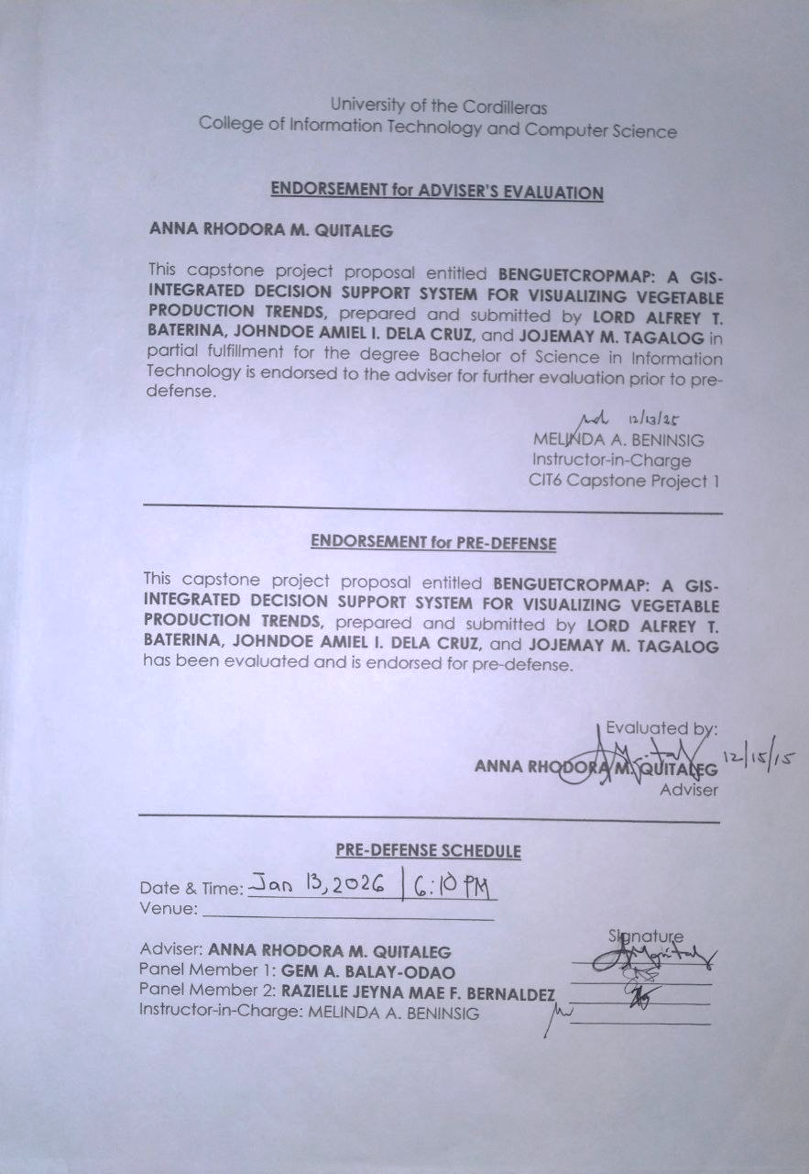

Appendix C
Business Model Canvas
Figure 36
Business Model Canvas
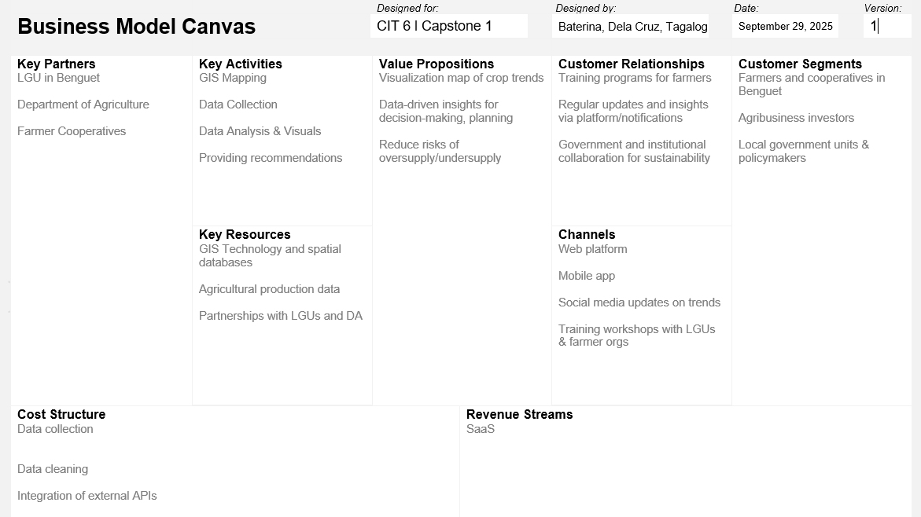
Figure 36, showing the Business Model Canvas for the Harviana system, identifies Customer Segments as the Farmers and DA Administrators/Agricultural Officers as part of a Multi-sided Platform. The primary Value Propositions include an accessible, user-friendly visual map and a decision support system that provides long-term forecasting (2025 to 2030), helping administrators design targeted actions to reduce waste and loss. The system is deployed via Channels that include browsers and a Progressive Web App using open-source web-mapping tools to maximize
accessibility. Customer Relationships are built and maintained through features like the Historical Analysis validation mode, which helps establish user trust by comparing predictions against known historical yields. Revenue Streams are projected to come from Subscription Fees, Licensing, Usage fees, and Grants, following a Value-Driven pricing strategy. Key Resources include the human development team, intellectual property, and physical infrastructure, while Key Activities focus on Production (development), Problem Solving (insights/forecasting), and maintaining the platform. Key Partners are sought to acquire necessary resources and activities, specifically the DA for historical production data.

Appendix D
Invitation Letter (Adviser)
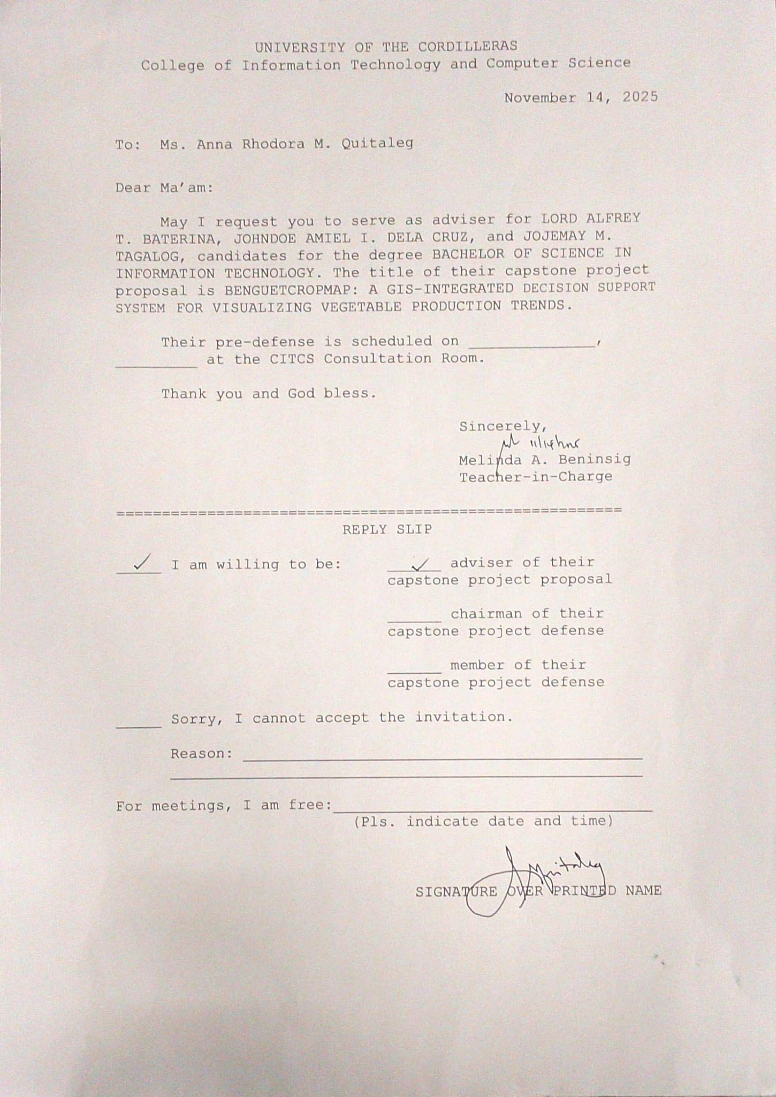
Appendix D
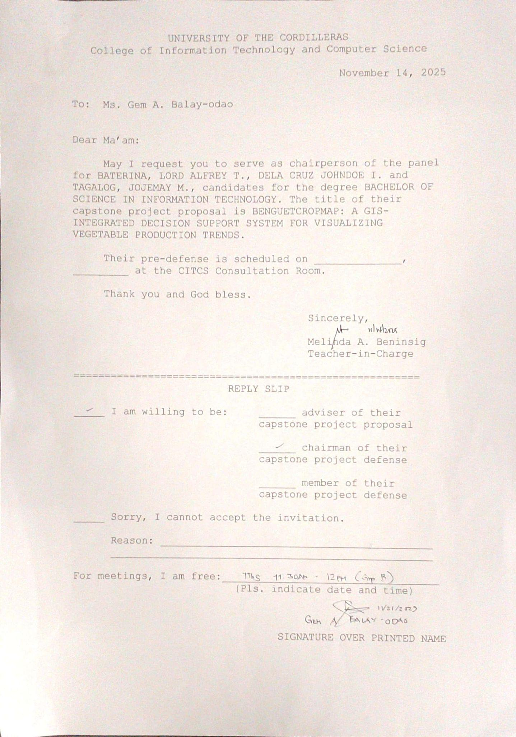
Invitation Letter (Chairperson)
Appendix D
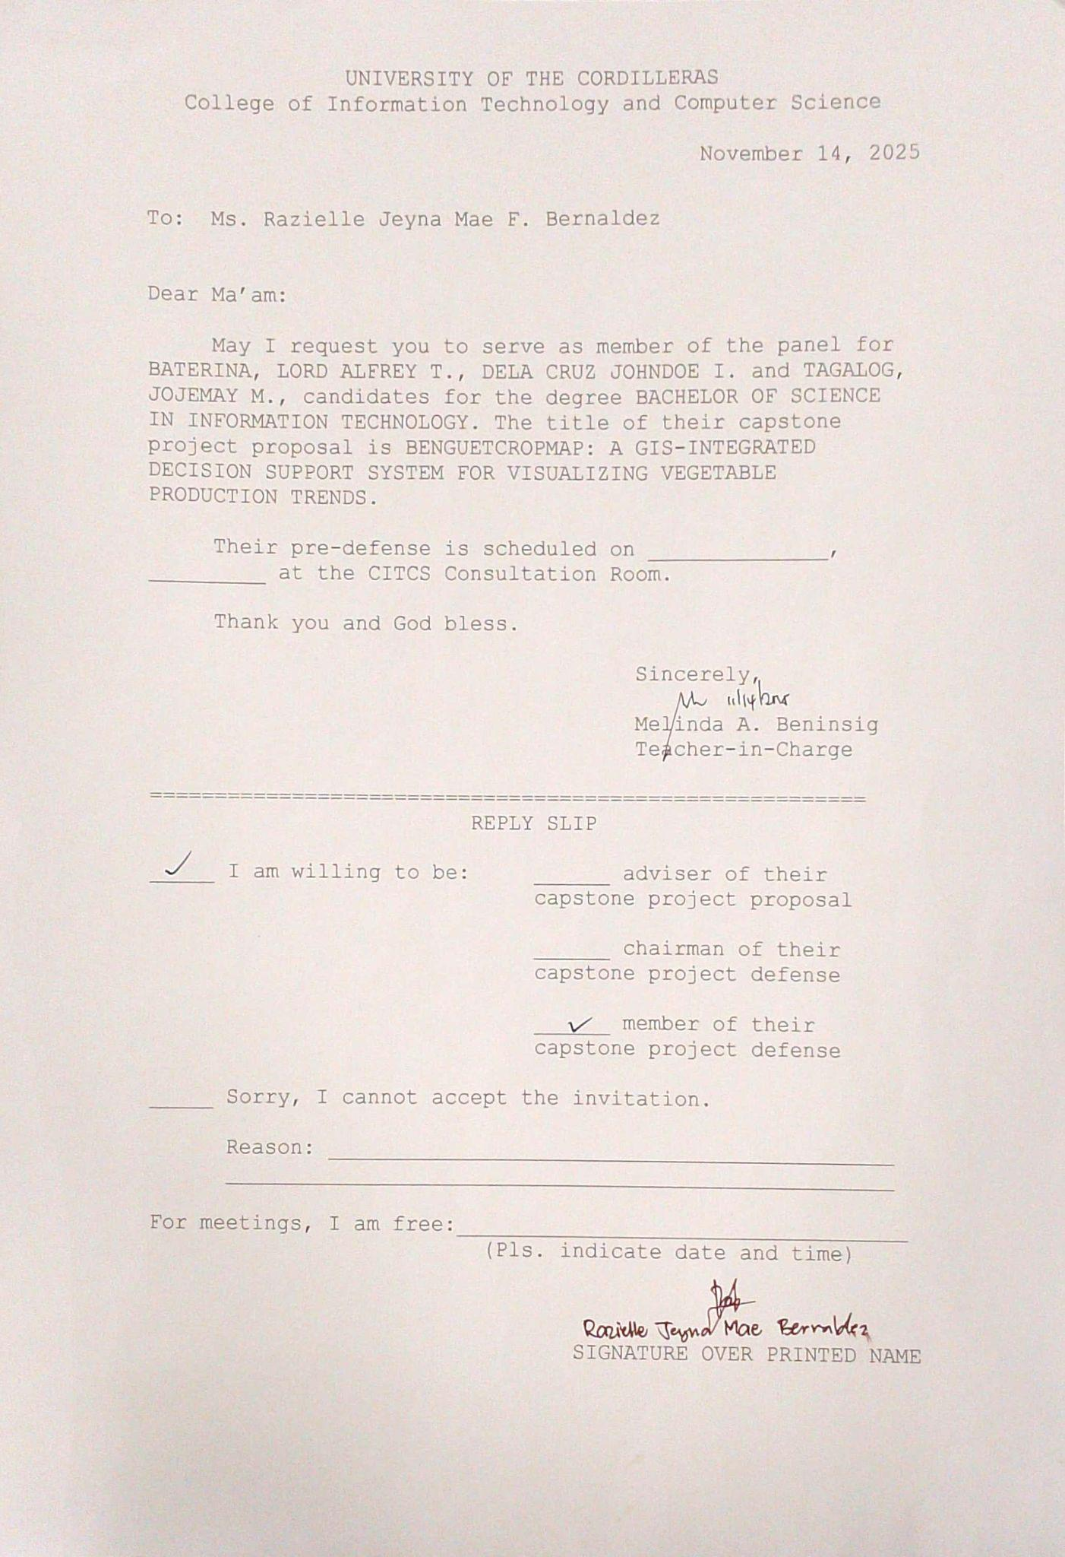
Invitation Letter (Member)

Appendix E
Sample Usability Test Survey
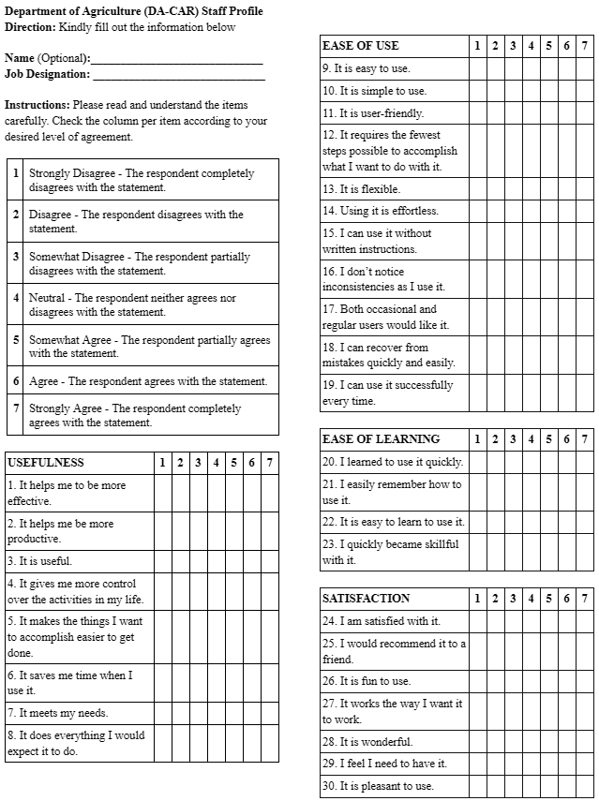
Appendix E
Technology Brief
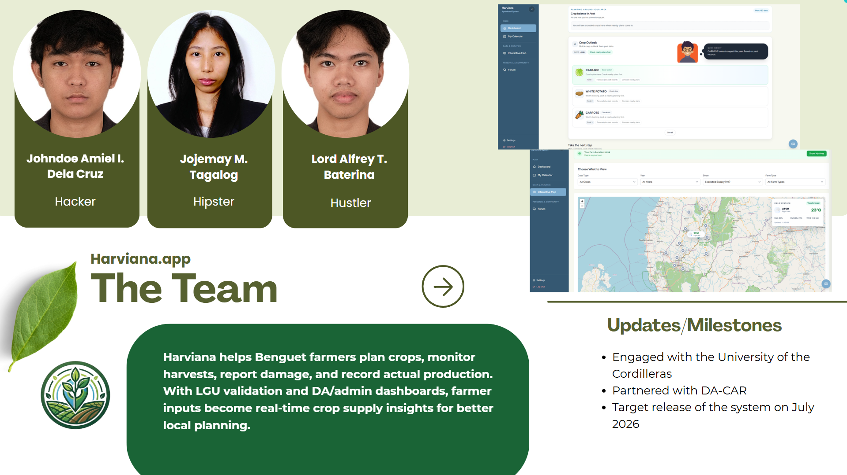
Appendix E
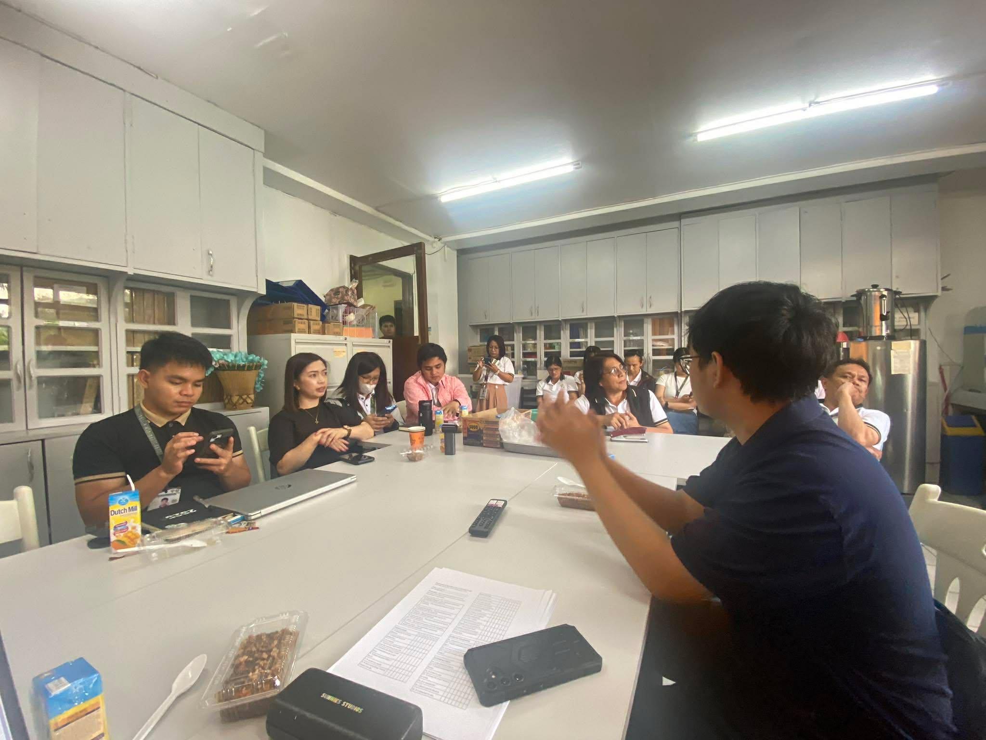
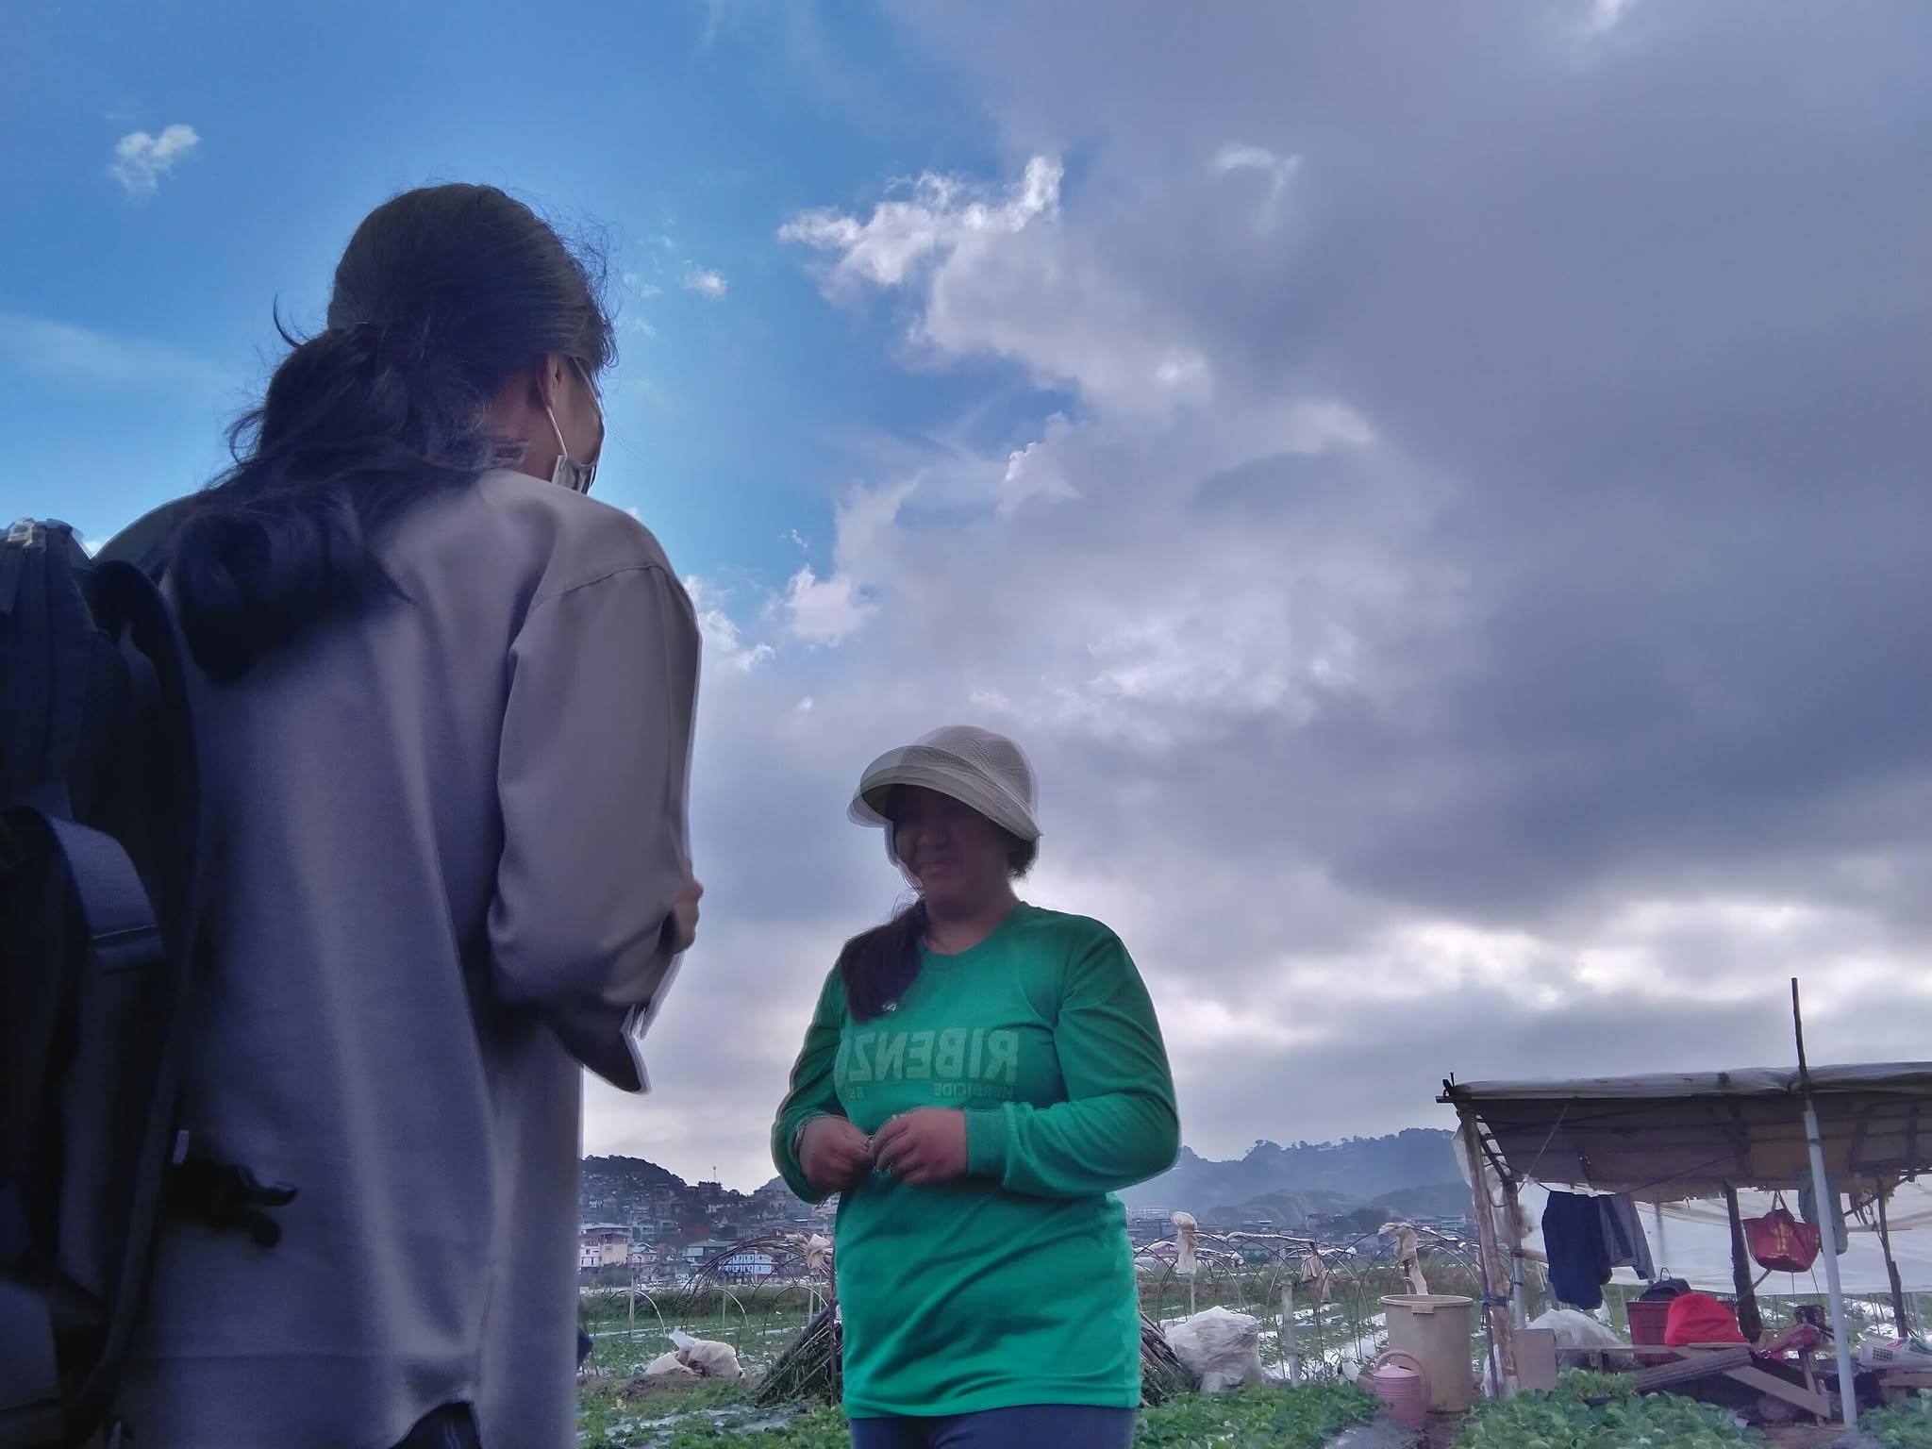
Documentation

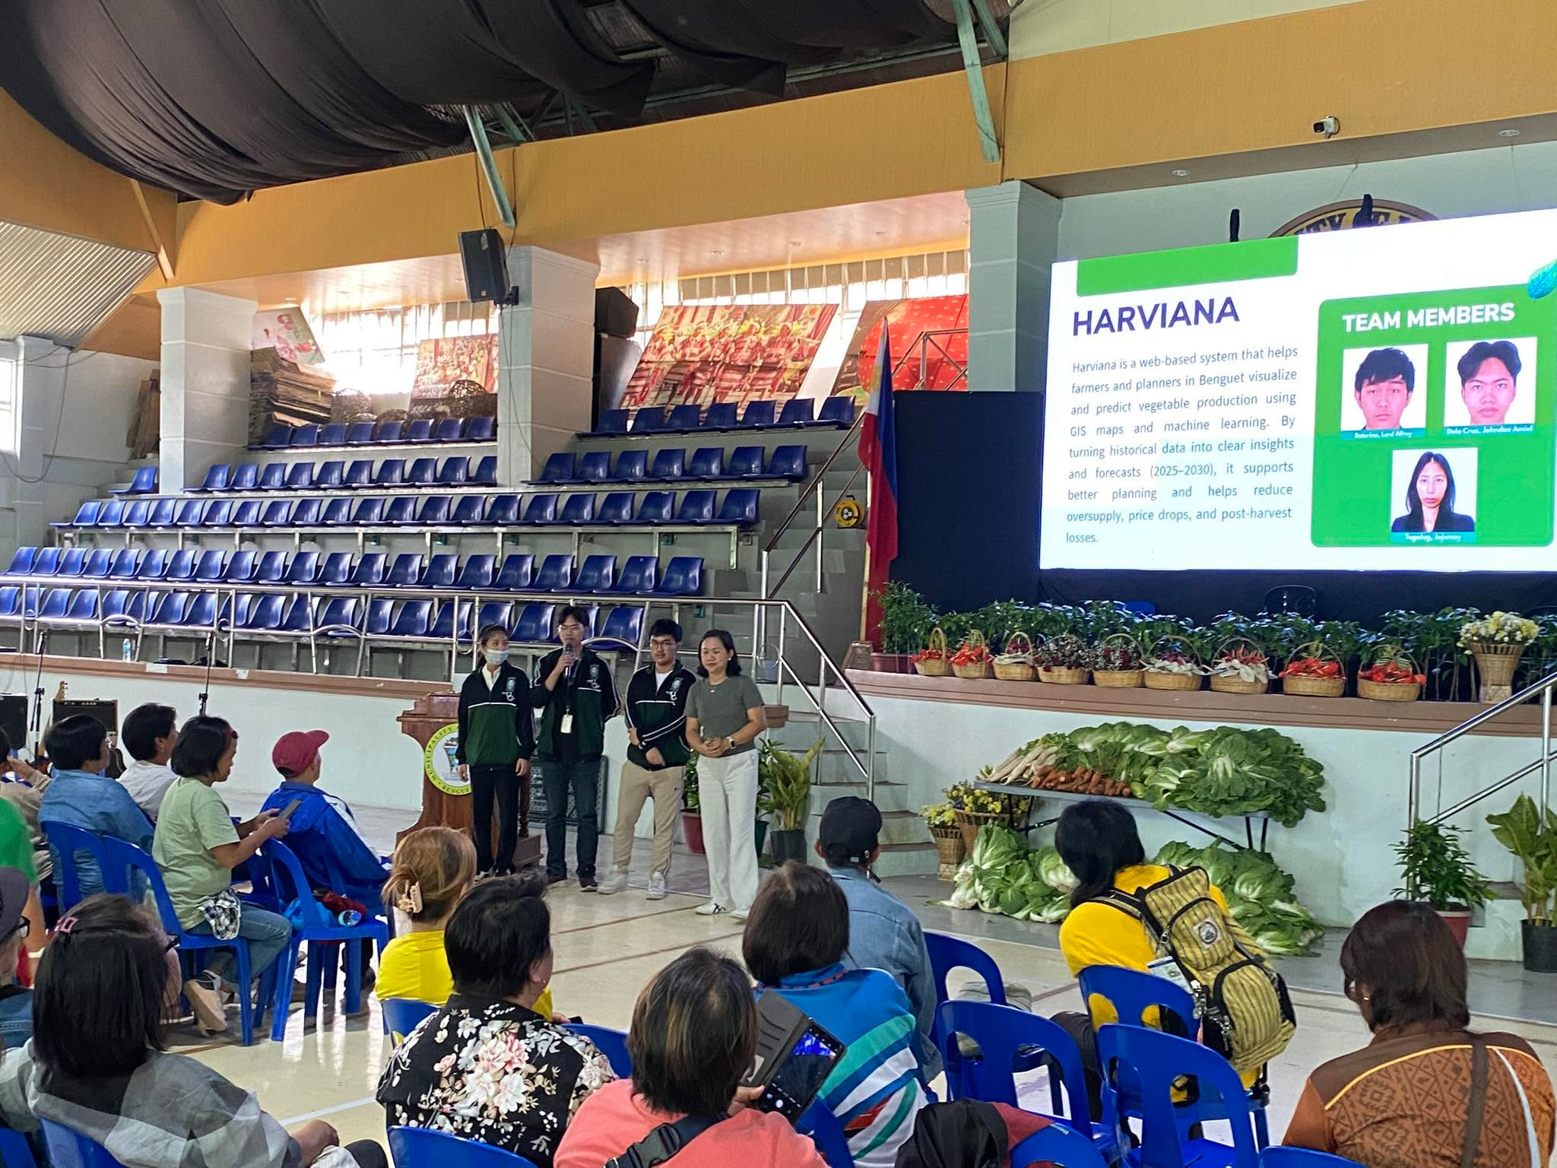
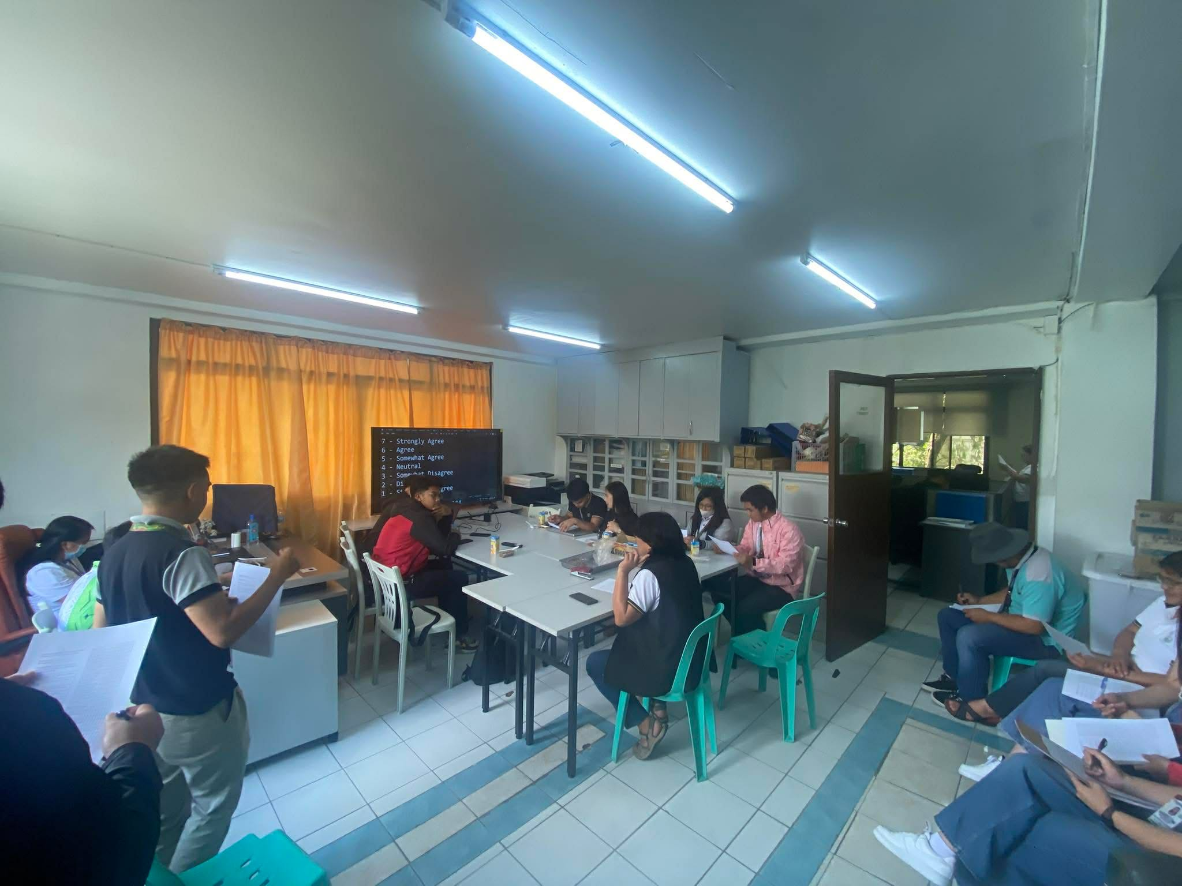
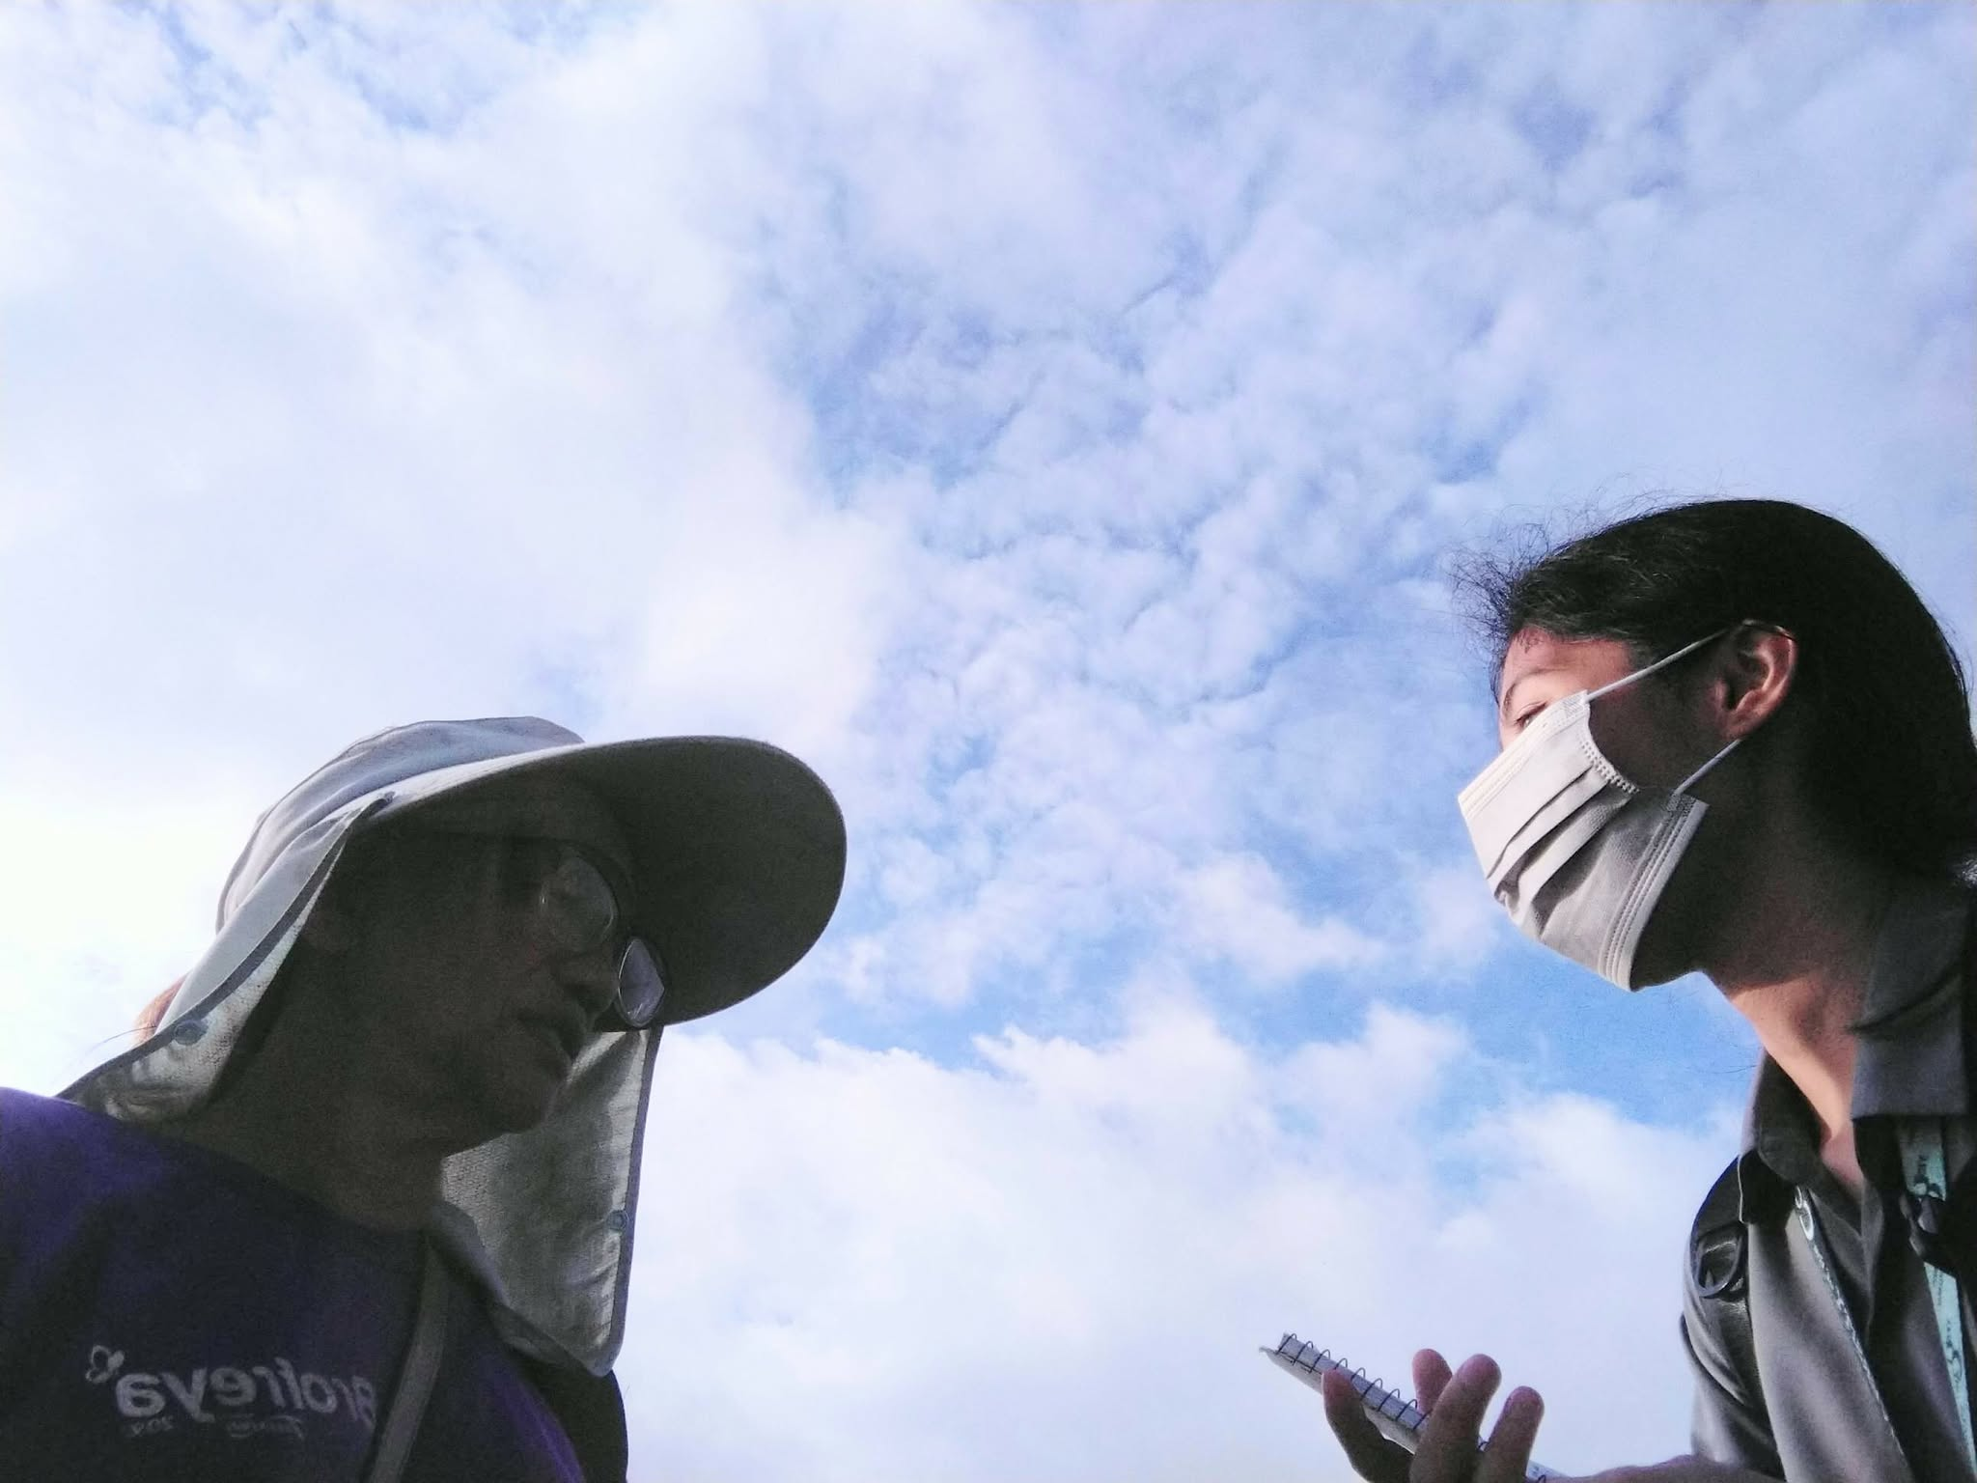

Appendix F
Supporting Interfaces of Harviana
This appendix presents Harviana's public landing, login, and registration interfaces. These pages introduce the platform and support account access before Farmers, LGU Validators, and DA Administrators proceed to their assigned system functions.
Landing Page. The Landing Page introduces Harviana as a GIS-integrated decision-support system and provides access to platform information, features, the development team, login, and registration.
Figure 37 presents the Harviana Landing Page, which introduces the platform and provides navigation to general information and account-access options.
Figure 37
Harviana Landing Page
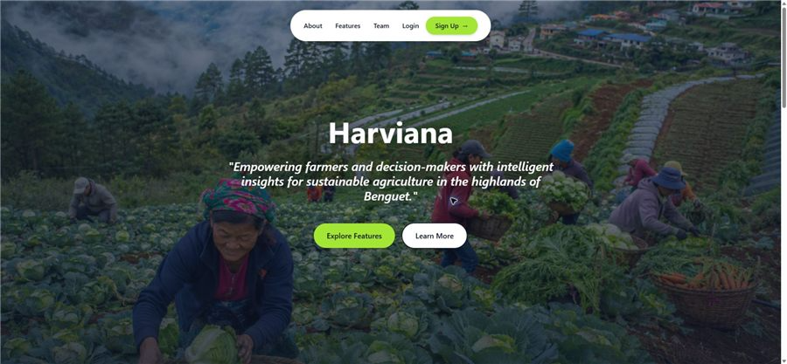
User Login and Registration. The login page allows registered users to sign in through their credentials or Google, while the registration page allows new users to create an account. Harviana then directs users to the appropriate interface based on their assigned role.
Figure 37 presents the Harviana login and registration pages used for account authentication and account creation.
Figure 37
Harviana User Login and Registration Pages
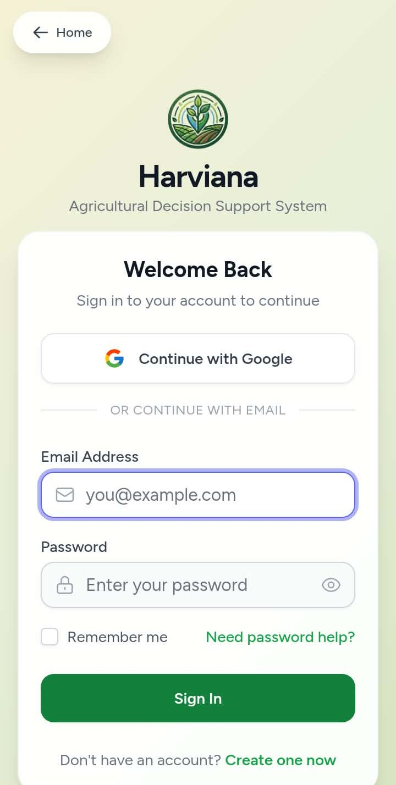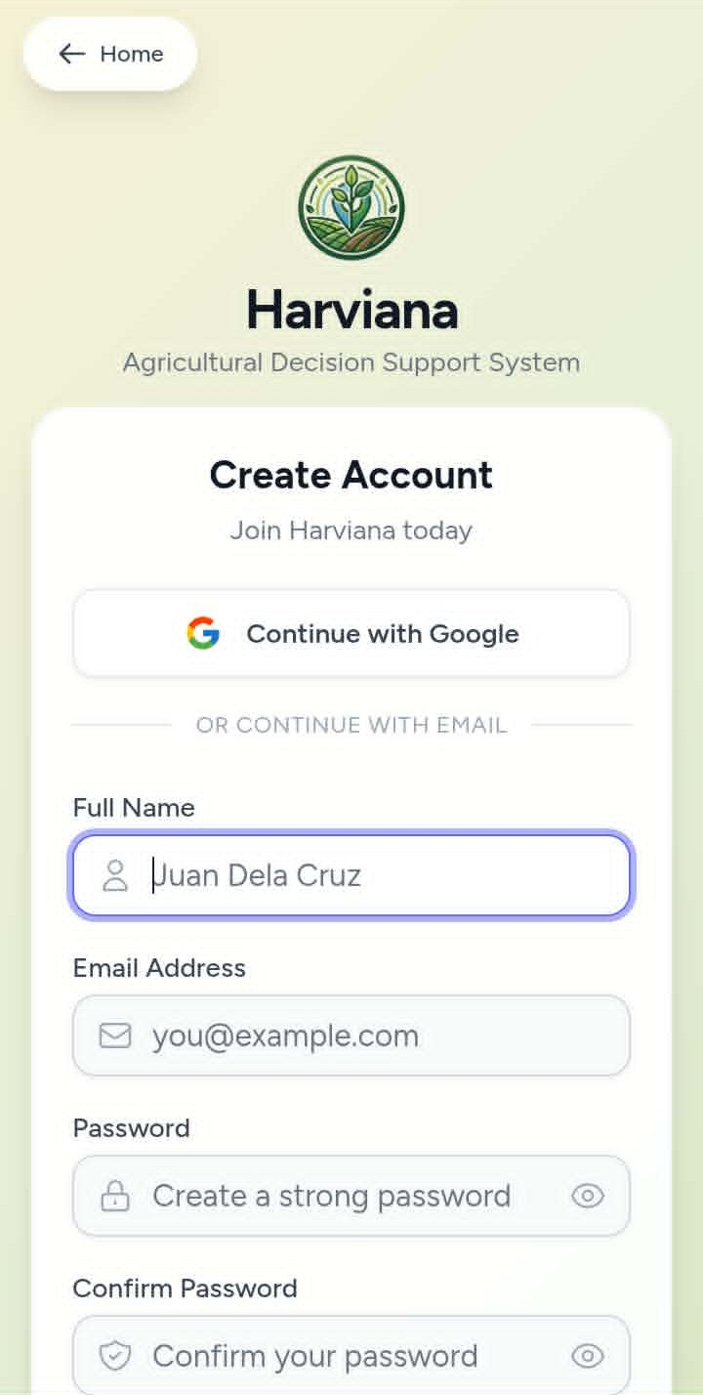

Appendix G
Code Snippet for Shared Recommendation Processing
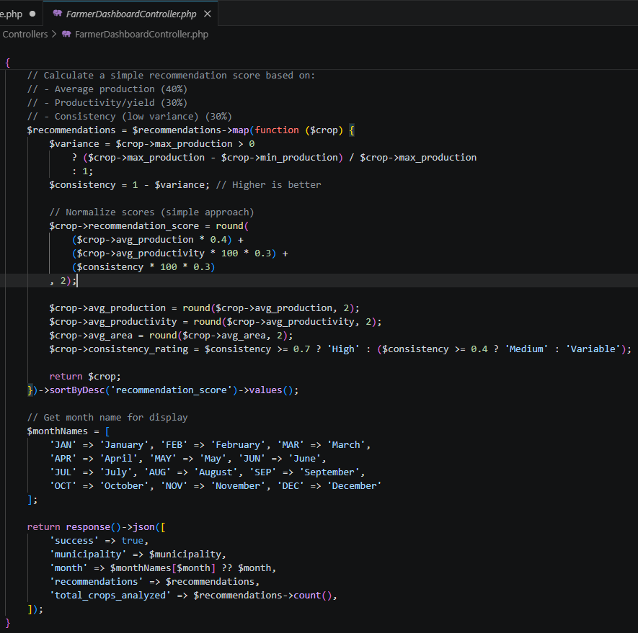
This code snippet calculates crop recommendation scores using historical average production, productivity, and production consistency. It then arranges the results from the highest to the lowest score, allowing the Farmer and DA Administrator interfaces to identify the crops with stronger historical production performance for the selected municipality and month.
Appendix H
Code Snippet for ML-Based Production
Estimate Processing
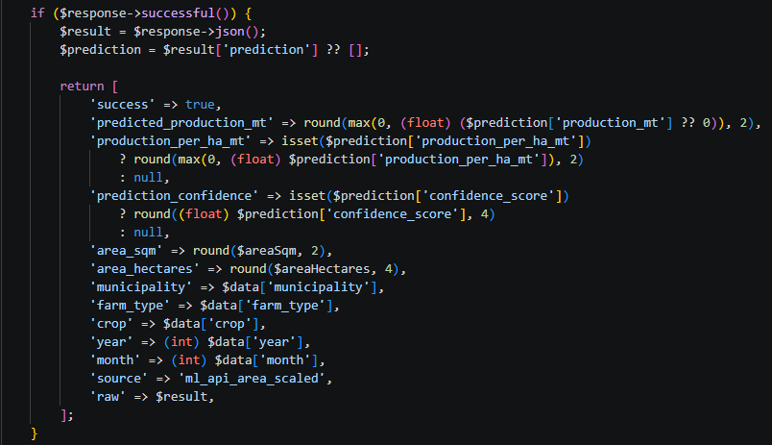
This code snippet processes the response returned by Harviana’s area-scaled machine-learning service. It extracts and normalizes the predicted production, production per hectare, confidence score, and crop-plan information for presentation during crop planning.

Appendix I
Code Snippet for Interactive Agricultural
Map Data Processing
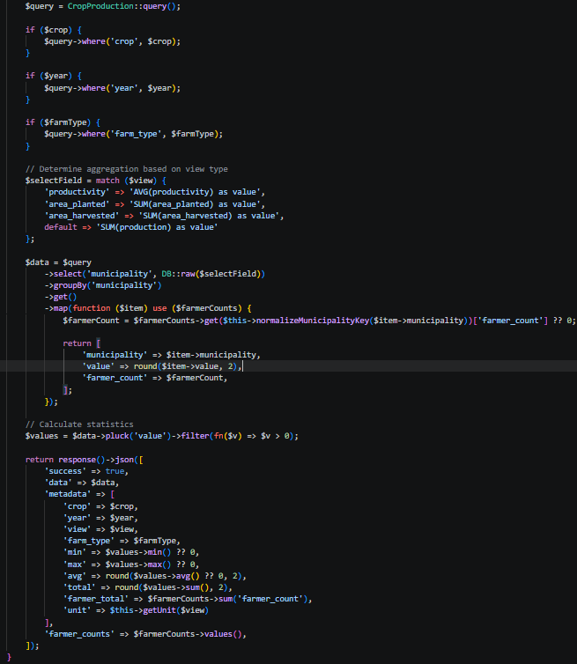
This code snippet filters agricultural data according to crop, year, farm type, and selected map view. The information is grouped by municipality and returned with summarized statistics for presentation on the interactive map.
Appendix J
Code Snippet for Crop Data Management
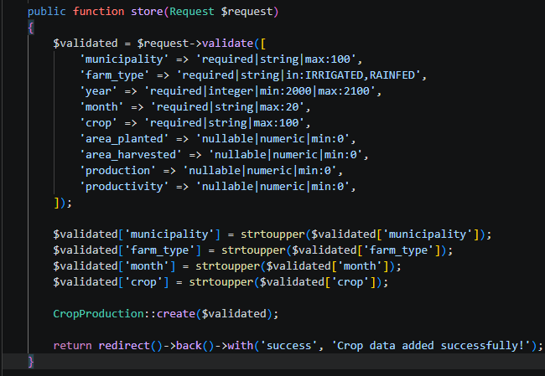
This code snippet validates and stores an agricultural production record entered by the DA Administrator. Selected values are standardized before the record is saved.

Appendix K
User Manual 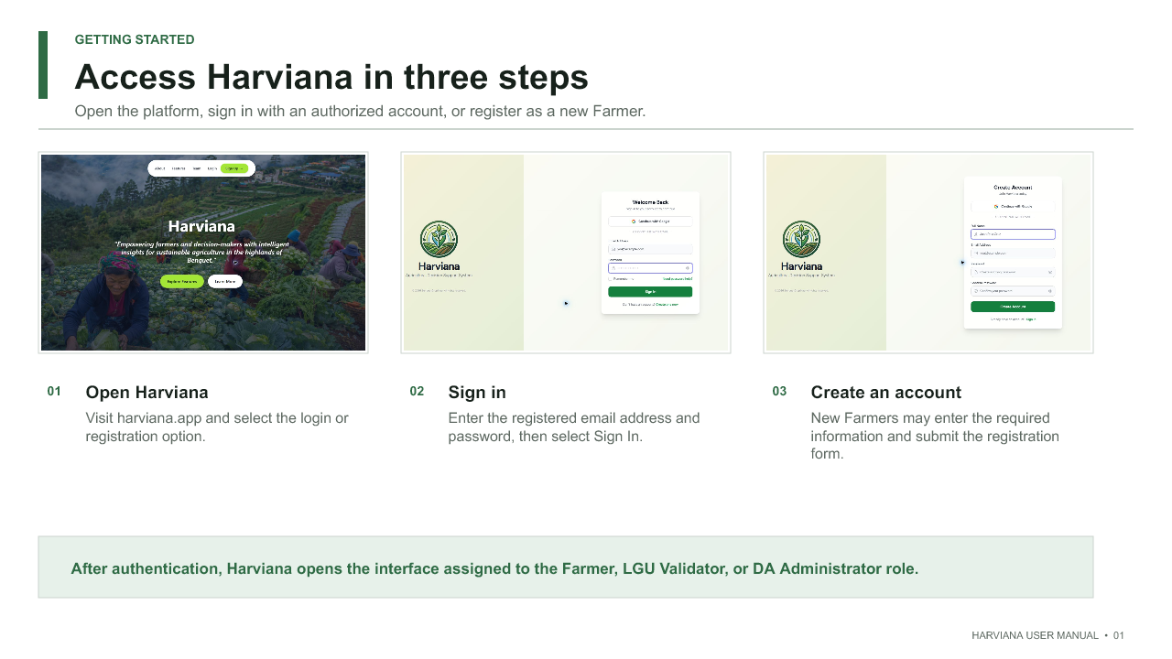 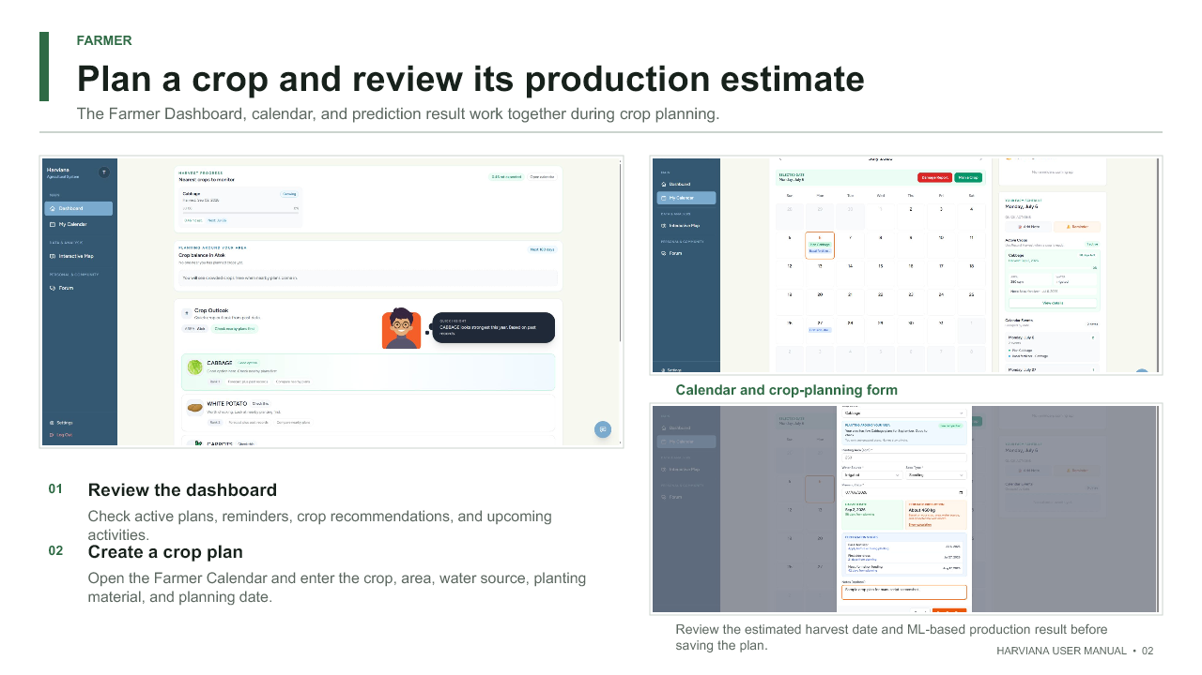
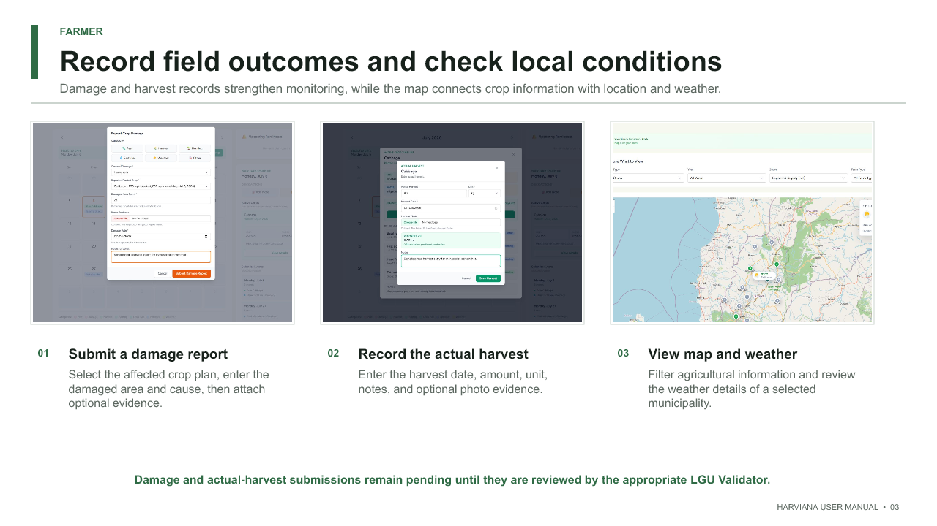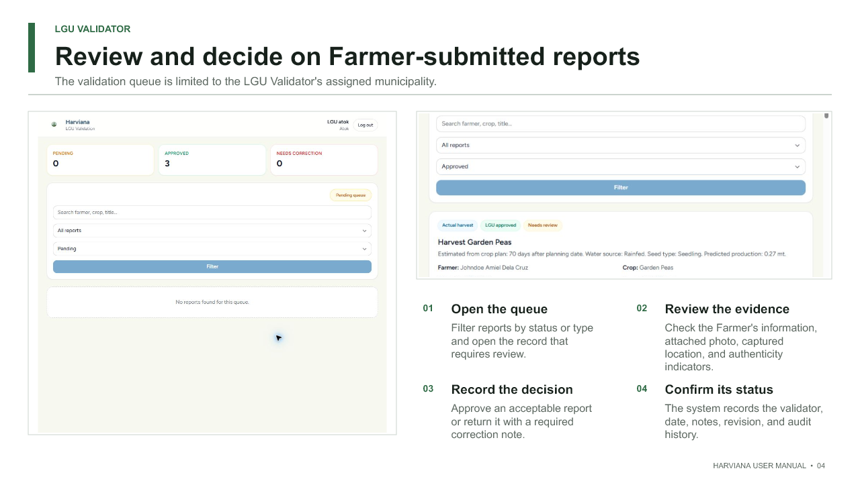

  - Available upon request
CURRICULUM VITAE  JOHNDOE AMIEL I. DELA CRUZ  #96 Camp 8, Baguio City  +63.977.076.5709  johndoedelacruz29@gmail.com |  |  | 
EDUCATIONAL ATTAINMENT
Tertiary | : Bachelor of Science in Information Technology  : Web Technology Track  : University of the Cordilleras  : Gov. Pack Rd., Baguio City  : Expected Date of Graduation: 2026
Secondary | : Umingan National High Scool  : Umingan, Pangasinan  : July 2022  : With Honors
Primary | : Marymount Montesorri Academy  : Umingan, Pangasinan  : April 2016  : With Honors
SKILLS AND QUALIFICATIONS
- Knowledgeable in Computer Hardware Installation, Assembly, and Troubleshooting
- Knowledgeable in Technical Support Fundamentals
- Experienced in Git version control
- Basic Web Development skills with HTML, CSS, JavaScript, PHP, Laravel, and Tailwind CSS
- Skilled in Microsoft 365 productivity tools including Word, Excel, PowerPoint, and Outlook
- Committed and hardworking, with a willingness to learn and improve
- Clear and confident in written and spoken communication
- Certified in Responsive Web Design (freeCodeCamp)
SEMINARS and TRAININGS ATTENDED
- Google Technical Support Fundamentals
May 8, 2025
Coursera Online Training
- Resposive Web Design Training
December 11, 2023
FreeCodeCamp Online Training
- ADSE SAP Analytics Cloud workshop
May 31, 2025
University of the Cordilleras
PERSONAL INFORMATION
Date of Birth |  | : January 29, 2004
Age |  | : 21 years old
Height |  | : 5’4”
Weight |  | : 60 kgs.
CHARACTER REFERENCES
  - Available upon request

LORD ALFREY T. BATERINA  #69 Purok 8, Irisan, Baguio City  +63.992.024.9564  baterinalordalfrey8@gmail.com |  |  | 
EDUCATIONAL ATTAINMENT
Tertiary | : Bachelor of Science in Information Technology  : Web Technology Track  : University of the Cordilleras  : Gov. Pack Rd., Baguio City  : Expected Date of Graduation: 2026
Secondary | : Kalinga State University  : Bulanao, Tabuk City, Kalinga  : June 2022
Primary | : Bulanao Central School  : Bulanao, Tabuk City, Kalinga  : May 2016
SKILLS AND QUALIFICATIONS
- Applied HTML, CSS, JavaScript, and PHP to build responsive web pages, troubleshoot code, and implement dynamic features.
- Collaborated on team projects using Git for version control, ensuring clean code and cross-browser compatibility Experienced in Git version control
- Basic understanding of the Laravel Framework.
- Utilized Excel to input and format data, create simple spreadsheets, and apply basic formulas.
- Drafted and formatted documents in Word, such as letters, meeting minutes, and basic reports, with attention to formatting consistency.
- Assisted in designing straightforward PowerPoint slides for class projects or team updates, incorporating text, images, and charts.
- Intermediate understanding of Computer hardware and basic troubleshooting.
- Completed the freeCodeCamp Responsive Web Design certification, which covered mobile-first design concepts, HTML, and CSS.
- Enthusiastic team player who adapts easily to any situation.

SEMINARS and TRAININGS ATTENDED
- No seminars or formal trainings attended yet; actively seeking opportunities to expand professional development.

PERSONAL INFORMATION
Date of Birth |  | : September 26, 2004
Age |  | : 21 years old
Height |  | : 5’7”
Weight |  | : 70 kgs.
CHARACTER REFERENCES
  - Available upon request

