HARVIANA: A GIS-INTEGRATED DECISION SUPPORT SYSTEM FOR VISUALIZING VEGETABLE PRODUCTION TRENDS

A Capstone Project Presented to the Faculty of the

College of Information Technology and Computer Sciences

University of the Cordilleras

In Partial Fulfillment

of the Requirements for the Degree

BACHELOR OF SCIENCE IN INFORMATION TECHNOLOGY

by

LORD ALFREY TONGNAWA BATERINA

JOHNDOE AMIEL ISIT DELA CRUZ

JOJEMAY MAGALSO TAGALOG

February 2026
APPROVAL SHEET

This capstone project proposal entitled HARVIANA: A GIS-INTEGRATED DECISION SUPPORT SYSTEM FOR VISUALIZING VEGETABLE PRODUCTION TRENDS, prepared and submitted by LORD ALFREY T. BATERINA, JOHNDOE AMIEL I. DELA CRUZ, and JOJEMAY M. TAGALOG in partial fulfillment of the requirements for the degree BACHELOR OF SCIENCE IN INFORMATION TECHNOLOGY, has been examined and is recommended for acceptance and approval for oral examination

ANNA RHODORA M. QUITALEG, MIT
Adviser

CAPSTONE PROJECT COMMITTEE

ANNA RHODORA M. QUITALEG, MIT RAZIELLE JEYNA MAE F. BERNALDEZ, BSCS
Member Member

GEM A. BALAY-ODAO, BSCS
Chairperson
TABLE OF CONTENTS
Page
TITLE PAGE . . . . . . . . . . . . . . . . . . . . . . 1
APPROVAL SHEET . . . . . . . . . . . . . . . . . . . . 2
TABLE OF CONTENTS . . . . . . . . . . . . . . . . . . 3 CHAPTER
1 INTRODUCTION
Rationale . . . . . . . . . . . . . . . . . 4
Project Objectives . . . . . . . . . . . . . 11
Proposed Solutions . . . . . . . . . . . . . 12
2 DESIGN THINKING
Empathize . . . . . . . . . . . . . . . . . 16
Define . . . . . . . . . . . . . . . . . . . 21
Ideate . . . . . . . . . . . . . . . . . . . 27
Prototype . . . . . . . . . . . . . . . . . 29
Test . . . . . . . . . . . . . . . . . . . . 41
REFERENCES . . . . . . . . . . . . . . . . . . . . . 44
APPENDICES
A Communication Letter . . . . . . . . . . . . 48
B Endorsement Letter . . . . . . . . . . . . . 49
C Business Model Canvas . . . . . . . . . . . 50
D Invitation Letter . . . . . . . . . . . . . 52
E Documentation . . . . . . . . . . . . . . . 55
Chapter 1
INTRODUCTION
Background of the Study
Agriculture plays an important role in food supply, livelihood, and local economic activity. In agricultural communities, farmers and decision-makers rely on timely and organized information to support crop planning, production monitoring, and response to crop-related problems. However, agricultural information is often recorded separately by farmers, local offices, and administrative agencies, which can make it difficult to produce updated and reliable data for planning. This problem becomes more significant in vegetable-producing areas where crops are seasonal, affected by weather conditions, and sensitive to delays in planting, harvesting, and distribution.
The need for digital support in agriculture is connected to the broader modernization of the Philippine agricultural sector. The World Bank (2020) emphasized that transforming Philippine agriculture into a more dynamic and diversified sector is important not only for food security but also for improving the welfare of rural communities. This supports the need for agricultural systems that can help organize production data, improve monitoring, and provide useful information for both farmers and government decision-makers.
The Philippine Development Plan 2023-2028 also emphasizes the modernization of agriculture and agribusiness. The plan views agriculture as part of a larger agri-food system that includes production, processing, marketing, consumption, and waste management. It also highlights the need to improve agricultural efficiency, strengthen value chains, and support the adoption of improved technologies. This relates to Harviana because the system contributes to agricultural modernization by organizing crop records, improving monitoring, and supporting data-based decision-making among farmers, LGU validators, and DA administrators.
The Department of Agriculture’s National Agriculture and Fisheries Modernization and Industrialization Plan 2021-2030 further supports the need for coordinated and technology-assisted agricultural development. The Agricultural Training Institute (2022) described NAFMIP as a whole-of-nation plan that guides sector-wide growth and encourages public and private stakeholders to work toward a shared agricultural vision. This is connected to Harviana because the system provides a digital workflow that links farm-level records with validation and administrative monitoring, allowing agricultural information to move in a more organized and coordinated manner.
In the Philippines, the use of digital technology in agriculture has become increasingly important. Briones, Galang, and Latigar (2023) discussed that digital agriculture can support productivity, market access, sustainability, and decision-support systems. However, they also noted that digital agriculture must address issues such as the digital divide, rural connectivity, and the need to harmonize government data and advisory services. This shows that digital tools should not only collect data but should also organize information in a way that can be used by farmers and agricultural offices.
The Food and Agriculture Organization (2022) also emphasized that automation and digital technologies can contribute to more resilient and productive agrifood systems. The report explained that agricultural automation can improve productivity, resource-use efficiency, and sustainability when properly adopted. However, it also recognized that small-scale producers may face barriers in accessing and using these technologies. This supports the need for agricultural systems that are practical and accessible to local users. Harviana responds to this concern by providing a web-based system that focuses on organized crop planning, reporting, validation, and administrative monitoring rather than requiring complex equipment from farmers.
The use of information and communication technologies in agriculture is also supported by the E-Agriculture Strategy Guide developed by the Food and Agriculture Organization and the International Telecommunication Union. FAO and ITU (2016) explained that e-agriculture strategies help countries use ICT in a more organized way by establishing a vision, action plan, and monitoring framework. This supports the need for systems like Harviana, which apply digital tools to improve agricultural data collection, monitoring, reporting, and decision support.
At the policy level, digital technologies can also improve how agricultural programs are planned and implemented. The Organisation for Economic Co-operation and Development (2019) explained that digital innovations can help agricultural policies by reducing information gaps, lowering transaction costs, and improving the way different actors work together. This is relevant to Harviana because the system connects farmers, LGU validators, and DA administrators in one workflow. Through this structure, the information submitted by farmers can be reviewed, organized, and used by administrators for reports and supply-related monitoring.
At the system level, digital agriculture becomes more useful when data, users, and decision-making tools are connected in one organized structure. The World Bank, Gates Foundation, and Boston Consulting Group (2025) described a Digital Agriculture Roadmap as a strategy and implementation plan that guides the transformation of agriculture through digital technologies. The report also emphasized that digital agriculture involves user-facing applications, data systems, integration layers, and decision-support tools. This is related to Harviana because the system connects farmer-submitted crop plans, harvest records, damage reports, LGU validation, and DA administrative monitoring into a single digital workflow.
The growing discussion on digital agriculture in the Philippines also shows the importance of preparing farmers and agricultural offices for technology-based systems. The International Rice Research Institute and CGIAR (2024) reported that Philippine stakeholders have recognized digital technologies as an important part of the future of agriculture, while also noting challenges such as digital literacy, infrastructure limitations, and data security. These concerns are important in developing agricultural systems because technology must be usable, secure, and meaningful to its target users. Harviana addresses this by providing role-based access for farmers, LGU validators, and DA administrators, allowing each user group to access only the functions related to their responsibilities.
The Cordillera Administrative Region, particularly Benguet, is one of the country’s major sources of highland vegetables. According to the Philippine Statistics Authority RSSO-CAR (2025), CAR produced 432,068.1 metric tons of vegetables in 2024, with Benguet contributing 371,151.5 metric tons or 85.9 percent of the region’s total vegetable production. Because of Benguet’s major role in vegetable supply, crop production records, damage reports, harvest information, and planting schedules are important for monitoring agricultural conditions. Aquino, Delos Reyes, and Catelo (2025) also emphasized the importance of Benguet-sourced vegetables in food value chain networks, showing how vegetable production in the province contributes to household food access and wider supply movement.
Despite this importance, farmers and agricultural offices may still experience difficulties in monitoring crop activities, validating field reports, and converting submitted farm information into useful administrative records. Farmers need a system that can help them plan crops, monitor farm activities, report damages, and record actual harvest results. Local government validators need a way to review submitted information before it is used for decision-making. DA administrators, on the other hand, need consolidated records that can support monitoring, reporting, and forecasting. Without an organized system, agricultural information may become delayed, incomplete, or difficult to verify.
Agricultural extension and advisory services also play an important role in helping farmers and agricultural offices use information for better decisions. The Philippine Agriculture and Fisheries Extension Strategic Plan 2023-2028 emphasizes the need to reframe extension and advisory services for food systems transformation. The Agricultural Training Institute (2023) stated that the plan supports efficient production, competitiveness, stronger extension institutions, and empowered farmers and fisherfolk. Harviana supports this direction by providing farmers and agricultural administrators with a platform where crop plans, damage reports, harvest records, and validation results can be accessed and used for monitoring.
The Agricultural Training Institute’s e-Extension Program also shows how digital systems can support agricultural information delivery in the Philippines. ATI describes e-Extension as the digital strategy of the Department of Agriculture for delivering agricultural extension services. It provides farmers, fisherfolk, agricultural extension workers, and other stakeholders with access to agriculture and fisheries-related information, online courses, and technical support. This strengthens the relevance of Harviana because the system also uses a digital platform to support farmers and agricultural offices, particularly in organizing crop-related records and making information easier to access.
Weather conditions also affect agricultural production. PAGASA describes the Philippines as having a tropical and maritime climate characterized by relatively high temperature, high humidity, and abundant rainfall. These conditions make weather-related monitoring important for crop planning and farm activity scheduling. For farmers, access to crop calendars and weather information can help them become more aware of possible risks. For administrators, weather and location-based information can support better interpretation of crop conditions and production records.
Digital agriculture is also useful in addressing agricultural risks related to changing environmental conditions. Stephenson et al. (2021) explained that digital agriculture can support climate adaptation and that spatial information can help inform government priorities and decisions related to crop suitability and agricultural planning. This supports Harviana’s use of map-based monitoring and weather information, since these features help users relate crop records with location and field conditions without requiring manual consolidation of data.
GIS and WebGIS technologies have become important in agricultural monitoring because they allow production records to be viewed and analyzed according to location. Raihan (2024) emphasized that Geographic Information Systems can support evidence-based agricultural decision-making by helping users analyze spatial information related to crop production, sustainability, and planning. Similarly, Cui et al. (2022) demonstrated the use of open-source WebGIS tools in managing agricultural land information, while Patel et al. (2023) showed how Web GIS-based decision-support systems can assist in agricultural monitoring and management. These studies support the development of Harviana as a GIS-integrated system that visualizes vegetable production records through map-based monitoring.
Recent studies also show the value of combining agricultural data, forecasting, and spatial monitoring for better production-related decisions. Alemán-Montes et al. (2025) presented a near real-time spatial decision-support system that used a satellite mapping web browser to support crop monitoring. Wu et al. (2023) also emphasized that reliable crop monitoring requires timely and useful crop information that can support food security decisions. In relation to crop forecasting, Ali et al. (2022) discussed the role of multi-sensor remote sensing in crop yield prediction, while Jabed and Azmi Murad (2024) reviewed how machine learning and deep learning approaches can support crop yield prediction. These studies support Harviana’s use of map visualization, production estimation, and forecasting as decision-support features.
Local studies further strengthen the relevance of Harviana to vegetable production in Benguet. Pilay and Werdenberg (2024) applied SARIMA-based forecasting to vegetable production in Benguet, showing the importance of analyzing production trends to understand possible future outputs. Quitaleg and Dumlao (2023) also developed a decision-support system for Benguet upland vegetable crop prediction using machine learning techniques. These studies show that forecasting and decision-support systems are relevant to Benguet’s vegetable production context. Harviana builds on this direction by combining crop planning, farmer-submitted records, LGU validation, GIS visualization, supply forecasting, and DA report generation in one web-based platform.
In response to these needs, this study proposes Harviana, a web-based agricultural decision-support system designed to assist farmers, LGU validators, and DA administrators. Harviana allows farmers to create crop plans, view calendar-based farm activities, receive ML-based production estimates, submit crop damage reports, and record actual harvest results. Submitted reports can be reviewed by LGU validators to improve the reliability of information before it is used for administrative monitoring. DA administrators can view dashboards, monitor crop records, access interactive map and weather information, generate reports, and review real-time supply forecasts.
Harviana is designed to create a connected flow of agricultural information from farmers to LGU validators and DA administrators. Through this structure, the system helps transform farmer-submitted data into validated and organized records that can support crop monitoring, report generation, and supply-related decision-making. The system supports the goals of digital agriculture by improving the collection, validation, visualization, and use of agricultural data.
The study is also aligned with Sustainable Development Goal 2: Zero Hunger, which promotes sustainable agriculture, improved food security, and support for small-scale farmers. Harviana contributes to this goal by helping improve crop planning, harvest monitoring, and agricultural reporting. It also supports Sustainable Development Goal 12, particularly the reduction of food losses along production and supply chains, by allowing the system to record damage reports, actual harvests, and production-related information that can support better agricultural monitoring.
Importance of the Study
This study is significant because it provides a digital approach to improving how agricultural information is collected, validated, monitored, and used for decision-making. Harviana supports the flow of crop-related data from farmers to LGU validators and DA administrators, allowing crop plans, damage reports, actual harvest records, and supply-related information to be organized in one system. Through this, the study contributes to the improvement of agricultural data management, crop monitoring, report generation, and decision-support processes.
To the Farmers. This study is beneficial to farmers because Harviana provides tools that help them manage crop planning and farm activity monitoring. Through the system, farmers can create crop plans, view scheduled crop activities through the farmer calendar, receive reminders, and check ML-based production estimates during the crop planning process. The system also allows farmers to submit crop damage reports and record actual harvest results, helping them document important farm events in a more organized way. With these features, farmers are supported in monitoring their production activities and maintaining clearer records of their crops.
To the LGU Validators. This study is significant to LGU validators because it provides a validation process for farmer-submitted reports. Through Harviana, LGU validators can view submitted damage reports, review report details and evidence, and decide whether a report should be approved or returned for correction. This process helps improve the reliability of agricultural information before it is used for DA monitoring and reporting. It also creates a checking layer between farmer submissions and administrative decision-making.
To the DA Administrators. This study is beneficial to DA administrators because Harviana provides features for monitoring crop records, viewing dashboards, accessing map and weather information, reviewing supply forecasts, and generating reports. These features help DA administrators organize validated agricultural data and use it for administrative monitoring and planning. The system also supports report export, allowing important crop and harvest information to be prepared for documentation, analysis, and decision-making.
To the Researchers. This study is significant to the researchers because it allows them to apply concepts in system development, database management, geographic information systems, machine learning, and usability testing to a real agricultural problem. Through the development of Harviana, the researchers are able to design a system that connects farmers, validators, and administrators in one digital workflow. The study also helps the researchers understand how technology can be used to support agricultural monitoring and decision-making.
To Future Researchers. This study may serve as a reference for future researchers who are interested in developing agricultural decision-support systems, crop monitoring platforms, or digital agriculture applications. Future researchers may use this study as a basis for improving prediction models, expanding crop coverage, adding mobile or offline features, or integrating additional agricultural data sources. The study may also guide future work related to usability, validation processes, map-based monitoring, and agricultural report generation.
Objectives of the Study
The main objective of this study is to design and develop “Harviana: a GIS-integrated decision support system for visualizing vegetable production trends in Benguet”, a web-based agricultural decision-support system that supports crop planning, farmer calendar management, crop monitoring, LGU validation, DA administrative monitoring, and supply forecasting.
Specifically, this study aims to answer the following:
- to identify the information requirements of the proposed system;
- to determine the architectural framework of the proposed system;
- to identify the features of the proposed system; and
- to measure the extent of usability of the proposed system among participating farmers and DA administrators.
Definition of Terms
To ensure clarity and consistency throughout this study, the following terms are defined based on how they are used in the development and discussion of Harviana.
Actual Harvest Record. This refers to the record submitted by a farmer after harvesting a crop. In this study, it includes the harvest amount, unit, harvest date, photo evidence, and notes. The system uses this record to compare expected production with the farmer-recorded harvest result.
Agricultural Decision-Support System. This refers to a digital system that helps users collect, organize, analyze, and present agricultural information for planning and decision-making. In this study, it refers to Harviana, which supports farmers, LGU validators, and DA administrators in crop planning, validation, monitoring, forecasting, and reporting.
Crop Damage Report. This refers to a report submitted by a farmer when a crop has been affected by damage. In this study, it includes the cause of damage, affected crop plan, damaged area, damage date, optional notes, and photo evidence. The report is reviewed by the LGU validator before being used for monitoring and report generation.
Crop Plan. This refers to the farmer’s planned crop production record. In this study, it includes details such as crop type, planting information, farm area, expected harvest schedule, and related crop activities. Crop plans are used in the farmer calendar, ML-based production estimate, and supply forecast features of Harviana.
DA Administrator. This refers to the system user responsible for administrative monitoring of crop records, forecasts, reports, users, and system data. In this study, the DA administrator can access dashboards, map and weather data, supply forecasting, and report generation features.
Farmer. This refers to the primary user of Harviana who creates crop plans, views calendar activities, receives production estimates, submits crop damage reports, and records actual harvest results.
Farmer Calendar. This refers to the calendar feature of Harviana that displays crop plans, farm activities, reminders, and schedules. In this study, it helps farmers monitor planting, maintenance, and harvest-related activities.
Geographic Information System. This refers to a system used to store, manage, and display location-based information. In this study, GIS-related features are represented through Harviana’s interactive map, which helps users view agricultural records and weather information based on location.
Harviana. This refers to the proposed web-based agricultural decision-support system developed in this study. It supports crop planning, farmer calendar management, ML-based production estimation, crop damage reporting, actual harvest recording, LGU validation, DA monitoring, map and weather viewing, supply forecasting, and report generation.
LGU Validator. This refers to the system user responsible for reviewing and validating farmer-submitted crop damage reports. In this study, the LGU validator can approve reports or return them for correction.
Machine Learning. This refers to the use of computational models that learn from data to provide predictions or estimates. In this study, machine learning is used to support production estimation during crop planning and supply forecasting.
ML-Based Production Estimate. This refers to the estimated crop production generated by the system during the crop planning process. In this study, it gives farmers an expected production value based on the information provided in the crop plan and the system’s prediction support.
Real-Time Supply Forecast. This refers to the DA feature that provides a forecast of crop supply using available crop plan, harvest, damage, and validation-related data. In this study, it helps DA administrators review possible supply conditions for monitoring and planning.
Report Generation. This refers to the process of organizing system records into report-focused views that can be used for documentation, analysis, and administrative decision-making. In this study, DA administrators can generate and export planting and harvest-related reports.
Role-Based Access Control. This refers to a system security approach that limits access based on the role assigned to each user. In this study, Harviana provides different access and functions for farmers, LGU validators, and DA administrators.
Usability. This refers to the extent to which users can use the system effectively, efficiently, and satisfactorily. In this study, usability is measured through usability testing conducted with farmers and DA administrators.
Web-Based System. This refers to a system that can be accessed through a web browser using an internet-connected device. In this study, Harviana is a web-based system designed for farmers, LGU validators, and DA administrators.

Chapter 2
METHODOLOGY
This chapter presents the methodology used in the development of Harviana. It discusses the software development methodology, design thinking process, scope and delimitation, data gathering techniques, sources of data, and software development tools used by the researchers. These methods served as the guide in identifying the needs of the users, designing the system features, developing the web-based platform, and evaluating the usability of Harviana.
Software Development Methodology
The researchers used the Agile Software Development Methodology in developing Harviana. Agile is an iterative approach to software development that allows the system to be built, tested, reviewed, and improved in repeated cycles. This methodology was selected because Harviana required continuous refinement based on the needs of different user groups, including farmers, LGU validators, and DA administrators.
Agile was suitable for the development of Harviana because the system includes several connected features such as crop planning, farmer calendar management, ML-based production estimation, crop damage reporting, actual harvest recording, LGU validation, DA monitoring, map and weather viewing, supply forecasting, and report generation. Through Agile, the researchers were able to develop these features in stages, test them, and improve them based on feedback and system requirements.
The development of Harviana followed the main phases of Agile methodology: requirements gathering, design, development, testing, deployment, and review. These phases helped the researchers organize the development process and ensure that each part of the system supported the overall goal of providing an agricultural decision-support system. Figure 1 shows the Agile Software Development Methodology used in the development of Harviana.
Figure 1
Agile Software Development Methodology
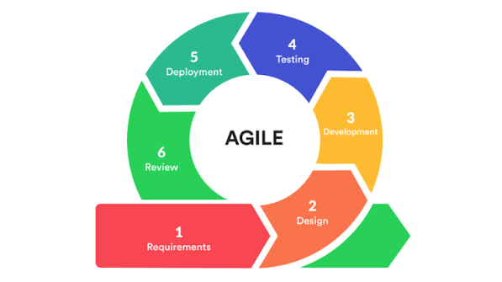

Requirements Gathering. In this phase, the researchers identified the needs and concerns of the target users. The researchers focused on understanding the problems experienced by farmers in crop planning and farm monitoring, the need of LGU validators to review submitted reports, and the need of DA administrators to access organized agricultural data for monitoring and decision-making. The information gathered during this phase served as the basis for identifying the system requirements and core features of Harviana.
Design. In this phase, the researchers prepared the structure and interface design of the system. The design process included planning the user roles, system flow, database structure, and main interfaces for farmers, LGU validators, and DA administrators. The researchers also created visual representations such as diagrams, wireframes, and prototypes to guide the development of the system. This phase helped ensure that the system would be understandable, role-based, and aligned with the needs of its users.
Development. In this phase, the researchers implemented the features of Harviana based on the approved design and system requirements. The system was developed as a web-based application with separate interfaces for farmers, LGU validators, and DA administrators. Features such as crop planning, farmer calendar, production estimate, damage reporting, actual harvest recording, validation, dashboards, interactive map, weather viewing, supply forecasting, and report generation were developed and connected to the system database.
Testing. In this phase, the researchers tested the system to identify errors, check feature functionality, and determine whether the system met the intended requirements. The researchers tested the different user workflows, including farmer crop planning, report submission, LGU validation, DA dashboard monitoring, map viewing, and report generation. Testing helped the researchers identify issues that needed correction and ensured that the system functions worked properly before deployment and usability evaluation.
Deployment. In this phase, Harviana was prepared and deployed so that users could access the system through a web browser. The deployment phase allowed the researchers to test the system in a more realistic environment and confirm whether the system could support its intended users. This phase also helped ensure that the system database, machine learning support, and main web features were connected and accessible.
Review. In this phase, the researchers reviewed the system based on testing results, user feedback, and usability evaluation. The review phase allowed the researchers to identify areas for improvement and refine the system features. Through this process, Harviana was improved to better support crop planning, agricultural monitoring, report validation, and decision-making.
Design Thinking
Design Thinking was used by the researchers to understand the needs, problems, and expectations of the target users of Harviana. This approach helped the researchers focus on the actual experiences of farmers, LGU validators, and DA administrators before finalizing the system features. Since Harviana is intended to support agricultural planning, validation, monitoring, and decision-making, the researchers used Design Thinking to ensure that the system was based on real user concerns rather than assumptions.
Design Thinking is a human-centered and iterative process that allows developers to study user needs, define problems, generate possible solutions, create prototypes, and test the proposed system. In this study, the researchers followed the five phases of Design Thinking: empathize, define, ideate, prototype, and test. These phases guided the researchers in identifying the problems in agricultural data collection and monitoring, designing possible solutions, and improving Harviana based on user needs and feedback. Figure 2 shows the Design Thinking process used in the development of Harviana.
Figure 2
Design Thinking
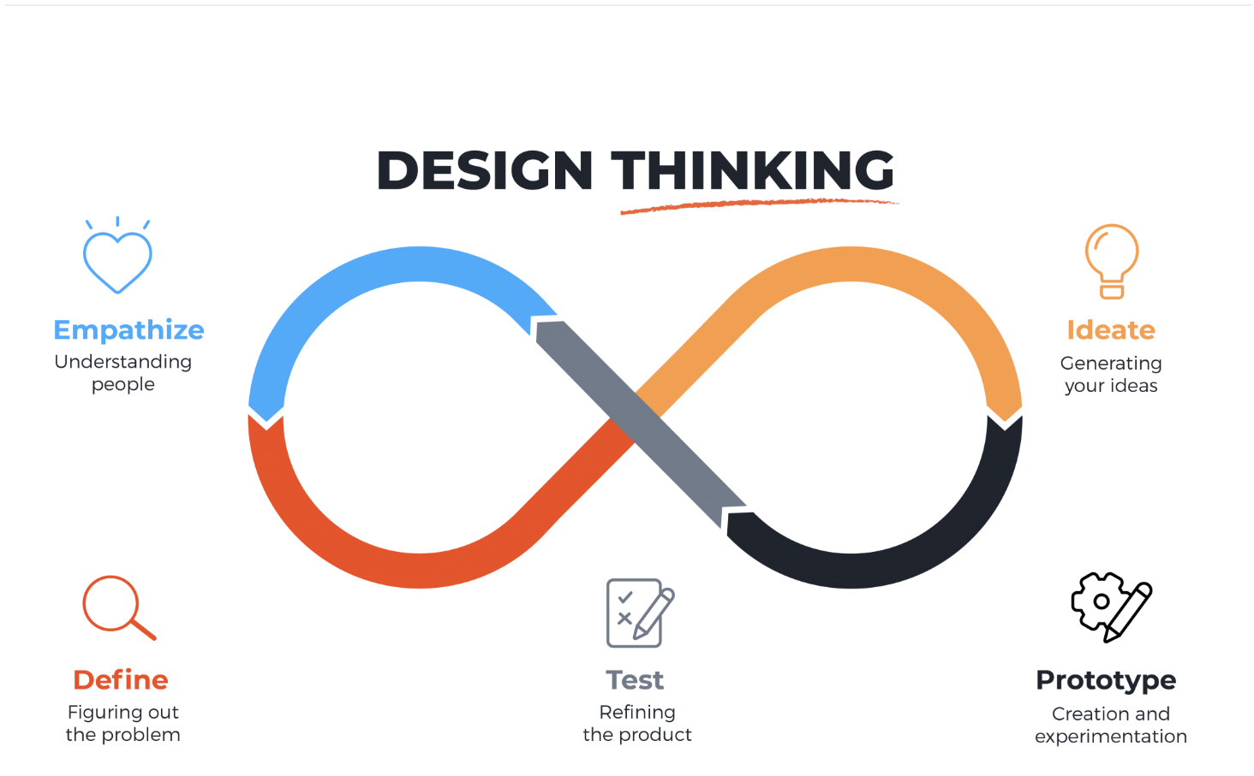
Empathize. The Empathize phase focused on understanding the experiences and challenges of the target users considered in the design of Harviana. The researchers gathered information from farmers and DA administrators to identify the difficulties they encounter in crop planning, record management, monitoring, reporting, and agricultural decision-making. The LGU Validator role was also considered in the system workflow because it serves as the validation layer between farmer-submitted records and DA administrative monitoring.
Based on the gathered information, farmers experienced challenges in organizing crop plans, monitoring farm activities, reporting crop damage, and keeping harvest records in a way that can be reviewed and used later. DA administrators needed consolidated and updated agricultural records that could support dashboards, map-based monitoring, supply forecasting, and report generation. Meanwhile, the LGU Validator role was identified as necessary for reviewing farmer-submitted reports and checking whether the information provided is acceptable before it becomes part of the system’s validated records. These findings helped the researchers identify the user needs that Harviana should address.
Figure 3 presents the empathy map for farmers, showing their need for a simpler way to organize crop plans, damage reports, and harvest records.

Figure 3
Empathy Map
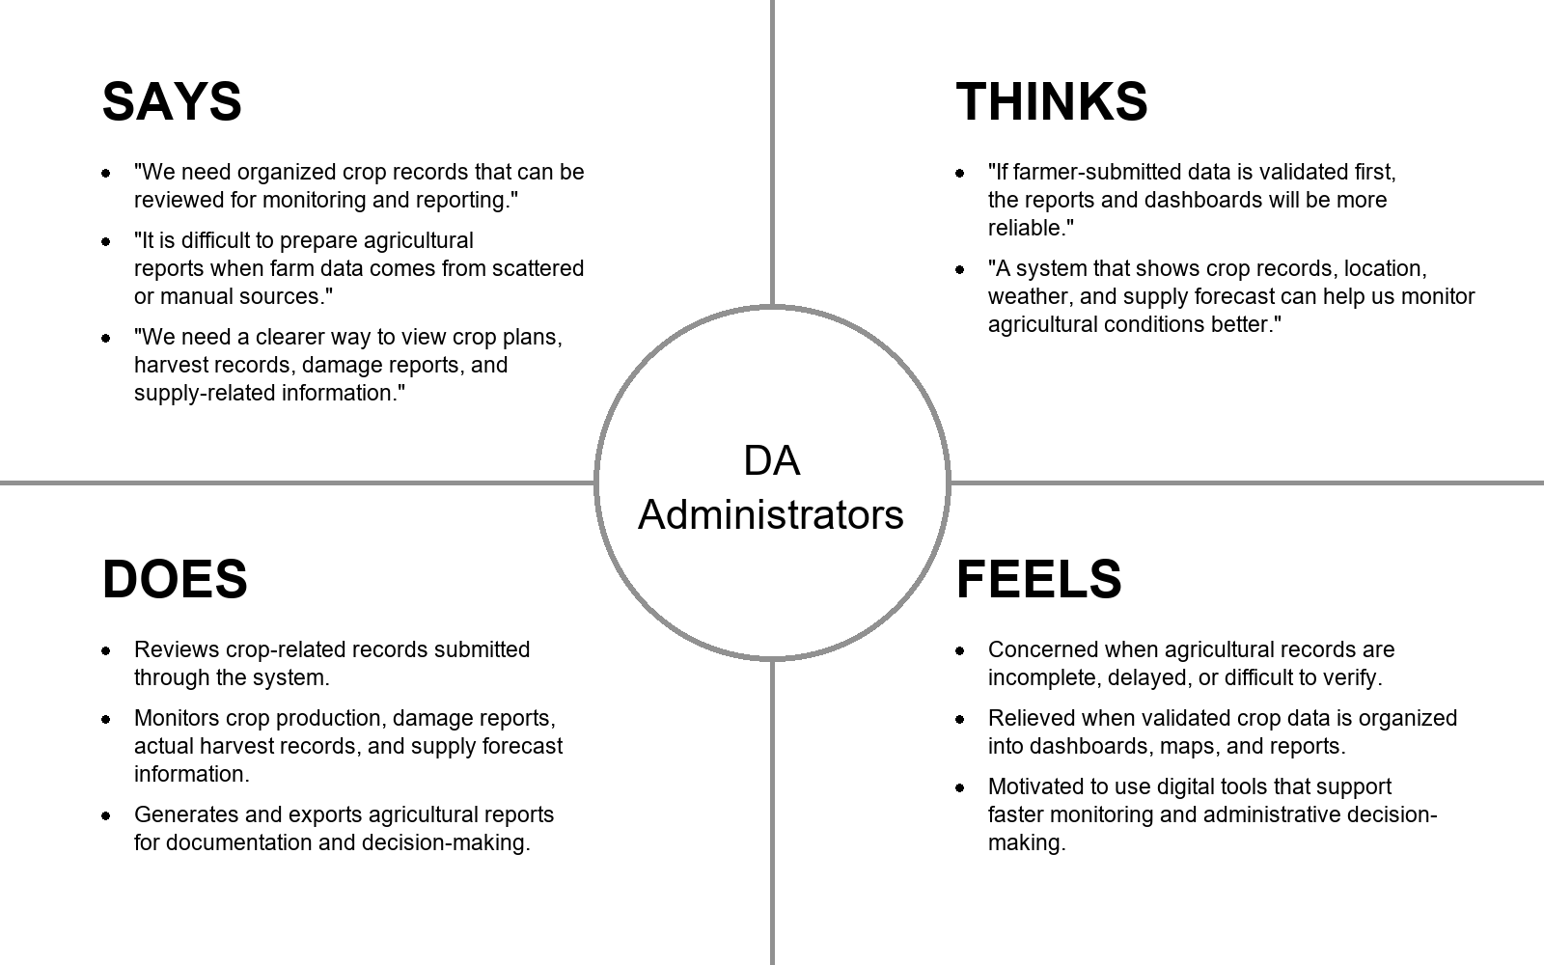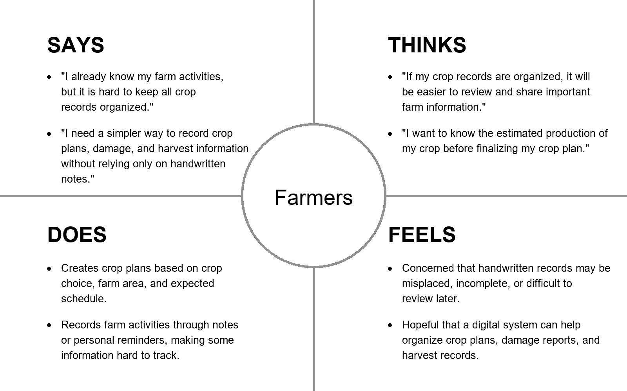
Define. The Define phase organized the information gathered during the Empathize phase into clear problem statements. The researchers identified that agricultural information is often recorded manually, stored separately, or difficult to validate and consolidate. Farmers need support in organizing crop plans, monitoring farm activities, submitting crop damage reports, and recording actual harvest results. DA administrators need reliable and updated agricultural data that can be used for dashboards, map-based monitoring, supply forecasting, and report generation.
Through this phase, the researchers defined the main problem as the lack of an integrated digital system that connects farmer-submitted agricultural records with validation and administrative monitoring. This problem affects the availability, reliability, and usability of crop-related information for planning and decision-making.
The researchers used the 5 Whys Analysis to identify the root causes of the problems encountered in agricultural record management and monitoring. This helped the researchers trace visible problems, such as scattered records, delayed reports, and difficulty in reviewing crop-related information, to deeper causes such as the lack of coordinated data flow, limited validation process, fragmented agricultural data, and absence of an integrated monitoring system.
Figure 4 presents the 5 Whys Analysis used to identify the root causes addressed by Harviana.
Figure 4
The 5 Why Analysis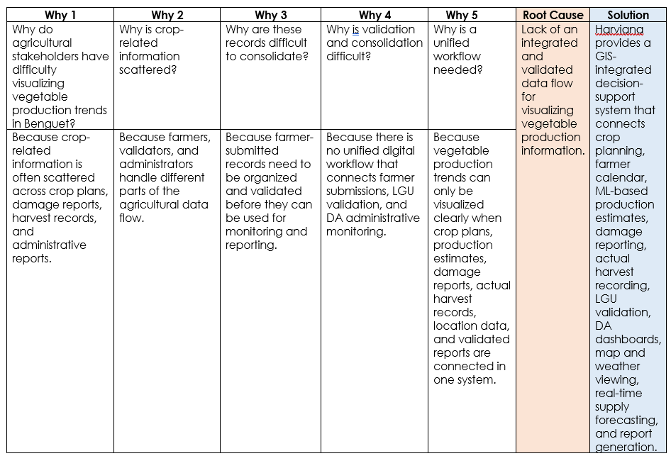
The 5 Whys Analysis shows that the main problem addressed by Harviana is not only the lack of production data, but the absence of an integrated and validated data flow that can transform scattered crop-related records into useful visual and administrative information. This root cause guided the development of Harviana as a GIS-integrated decision-support system that allows vegetable production information to be collected, validated, visualized, forecasted, and reported within one connected platform.
Ideate. Ideate is the stage where the researchers generate possible solutions based on the problem identified in the Define phase. In this phase, the researchers considered the root cause found in the 5 Whys Analysis, which showed the need for an integrated and validated data flow for visualizing vegetable production information in Benguet. Based on the root cause identified, the researchers proposed Harviana as a GIS-integrated decision-support system that connects farmer-submitted records, LGU validation, and DA administrative monitoring. The proposed features included crop planning, farmer calendar, ML-based production estimates, damage report submission, actual harvest recording, LGU report validation, DA dashboard, interactive map and weather viewing, real-time supply forecasting, and report generation.
To organize these ideas and determine which features should be prioritized, the researchers used an Impact-Effort Matrix. This tool helped the researchers evaluate each proposed feature based on its expected value to the users and the level of effort required for implementation. Features with high impact and manageable effort were prioritized because they directly support the main purpose of Harviana.
The matrix helped the researchers identify the core features needed for the system. Farmer-side features such as crop planning, farmer calendar, damage report submission, and actual harvest recording were prioritized because they serve as the source of agricultural data. The LGU validation feature was also included because it supports the reliability of submitted records. DA-side features such as dashboards, map and weather viewing, supply forecasting, and report generation were prioritized because they allow agricultural information to be visualized, monitored, and used for decision-making.
Figure 5 presents the Impact-Effort Matrix used to prioritize the features of Harviana.
Figure 5
Impact-Effort Matrix
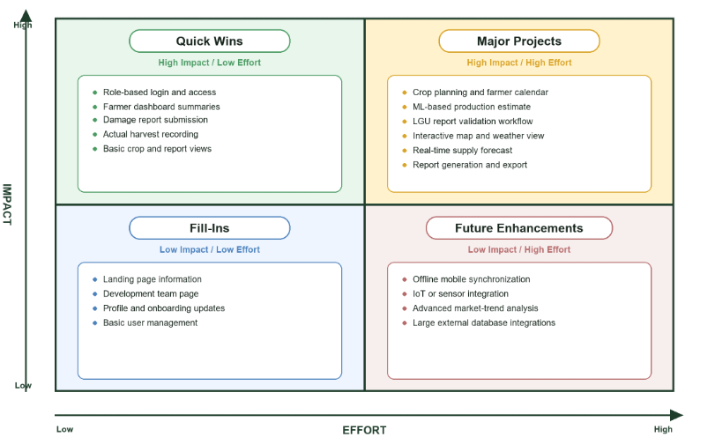
Prototype. Prototype is the stage where the ideas from the previous phase are transformed into a visual representation of the proposed system. Prototypes do not need to be fully functional at first, but they help the researchers present the layout, navigation, and expected user interaction of the system before final development. Through this phase, the researchers were able to show how the main features of Harviana would appear and function for its intended users.
In this stage, the researchers created low-fidelity prototypes to represent the basic interface of Harviana. The prototypes focused on the major features of the system, including the landing page, login and registration, farmer crop planning, calendar, ML-based production estimate, damage report submission, actual harvest recording, LGU report validation, interactive map and weather viewing, DA dashboard, supply forecast, and report generation.
The Landing Page serves as the first screen accessed by visitors. It introduces Harviana as a GIS-integrated decision-support system and provides access to general platform information, system features, development team details, login, and registration. This page helps users understand the purpose of the system before entering the role-based platform.
Figure 6 presents the Landing Page prototype of Harviana, which introduces the platform and provides navigation to important public pages and account access options.
Figure 6
Harviana Landing Page Overview
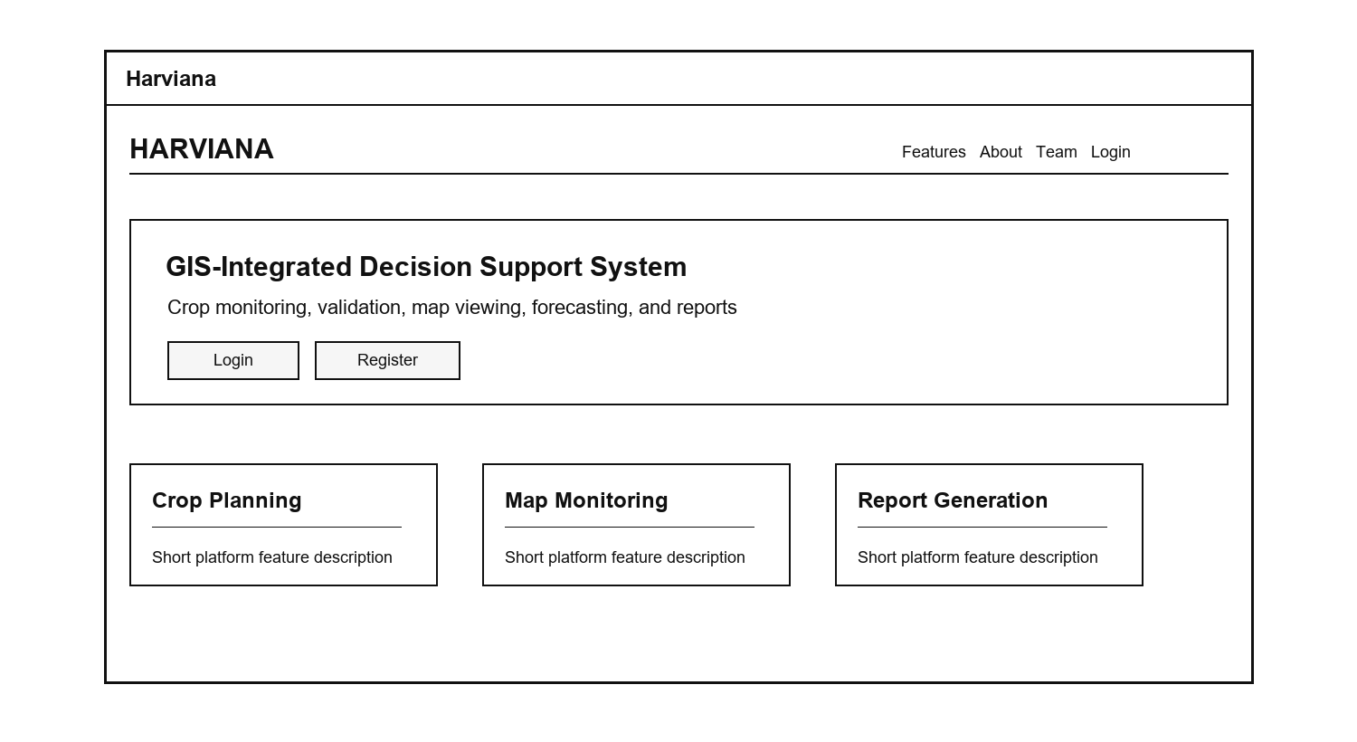
The Login and Registration feature allows users to access the system using their account credentials or create a new account. This feature supports role-based access by ensuring that users are directed to the correct interface depending on their assigned role, such as Farmer, LGU Validator, or DA Administrator.
Figure 7 presents the Login and Registration prototype, showing the basic account access screens used for signing in and creating a new user account.
Figure 7
Login and Registration
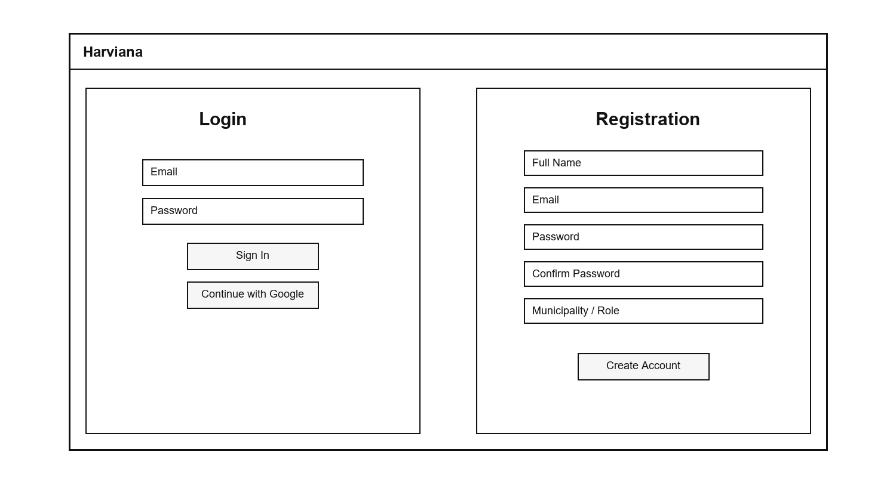
The Crop Planning and Farmer Calendar feature allows farmers to create crop plans and organize farm activities based on crop type, farm area, planting date, and expected harvest date. The calendar section helps farmers view scheduled activities and reminders, making it easier to monitor planting, maintenance, and harvest-related tasks.
Figure 8 presents the Crop Planning and Farmer Calendar prototype, showing how farmers can create crop plans and view scheduled farm activities in one interface.
Figure 8
Crop Planning and Farmer Calendar Prototype
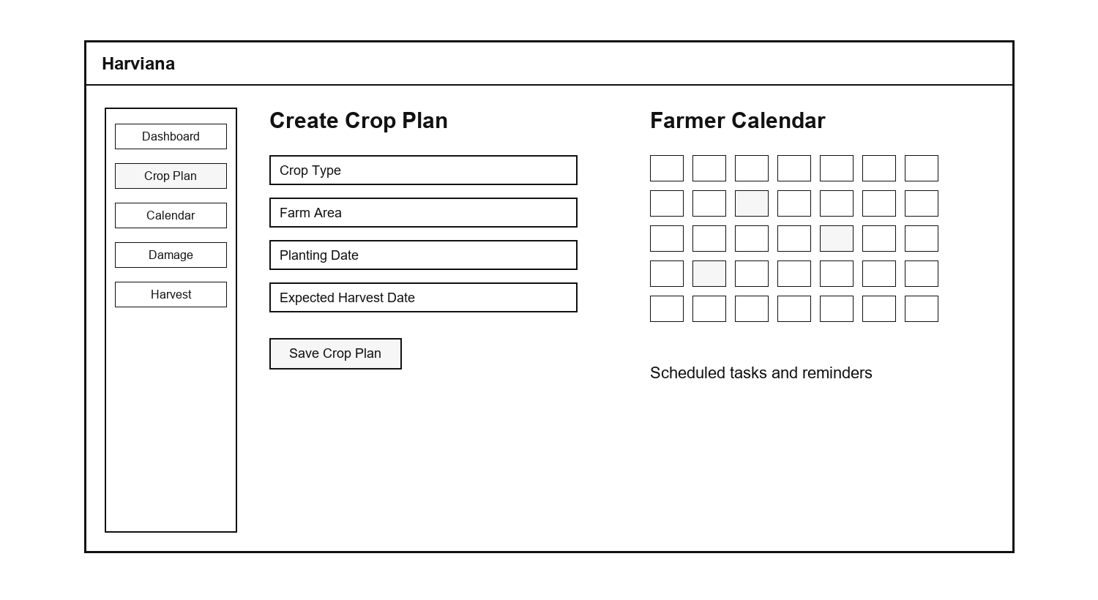
The ML-Based Production Estimate feature is included in the crop planning process to provide farmers with an estimated production value before finalizing a crop plan. The prototype shows how crop-related inputs may be entered and how the estimated output is displayed to the farmer. This feature supports crop planning by giving users an early reference regarding possible production based on the information provided. It does not replace the farmer’s decision, but it provides additional data that can help farmers review their crop plan more clearly.
Figure 9 presents the ML-Based Production Estimate prototype, showing how estimated production information is displayed as part of the crop planning process.
Figure 9
ML-Based Production Estimate Prototype
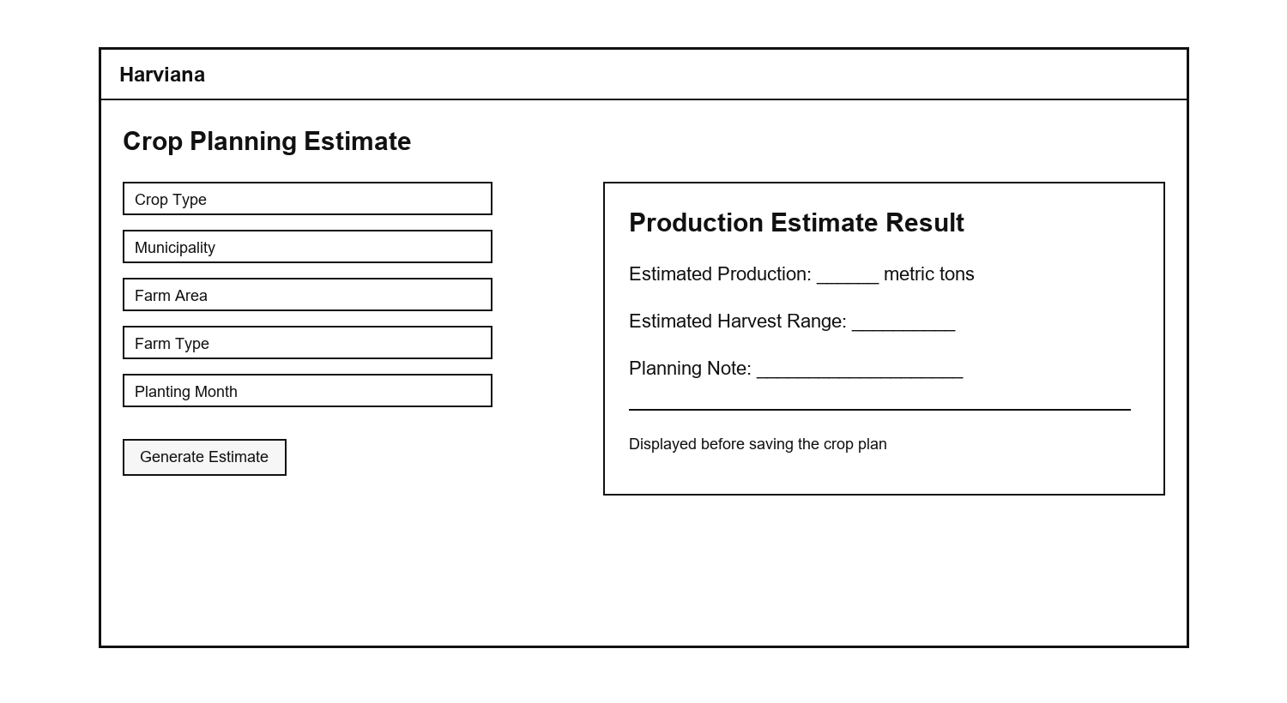
The Damage Report Submission feature allows farmers to document crop damage incidents in a structured way. The prototype includes fields for the cause of damage, affected crop plan, damaged area, damage date, notes, and optional photo evidence. This feature is important because damage information must be recorded clearly before it can be reviewed by the LGU Validator. By providing a dedicated report form, Harviana helps farmers submit crop damage records that are easier to organize, review, and use for monitoring.
Figure 10 presents the Damage Report Submission prototype, showing the form used by farmers to submit crop damage details and supporting evidence.
Figure 10
Damage Report Submission
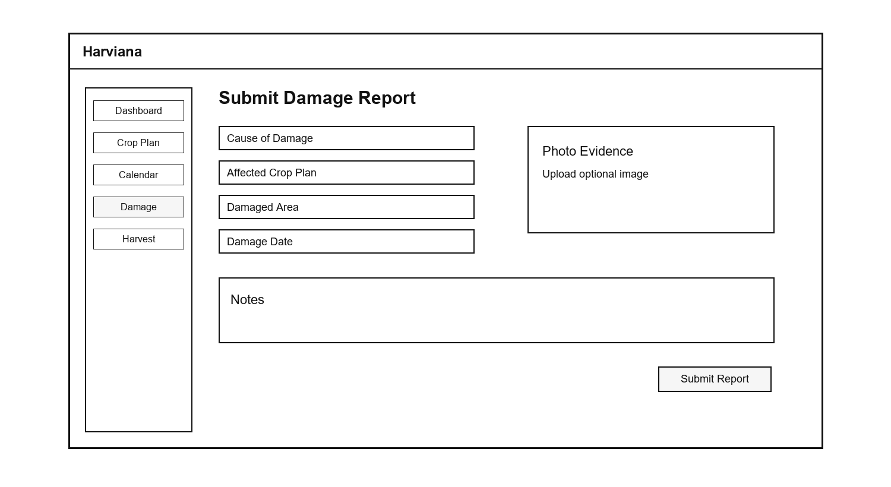
The Actual Harvest Recording feature allows farmers to submit the final harvest result of a crop plan. This includes the harvest amount, unit, harvest date, notes, and optional photo evidence. The system can also convert the submitted harvest amount into metric tons and compare it with the expected production from the crop plan. This feature helps improve production monitoring because it allows Harviana to compare estimated production with actual farmer-recorded harvest data.
Figure 11 presents the Actual Harvest Recording prototype, showing how farmers can submit harvest information and review the comparison between expected and actual production.
Figure 11
Actual Harvest Recording
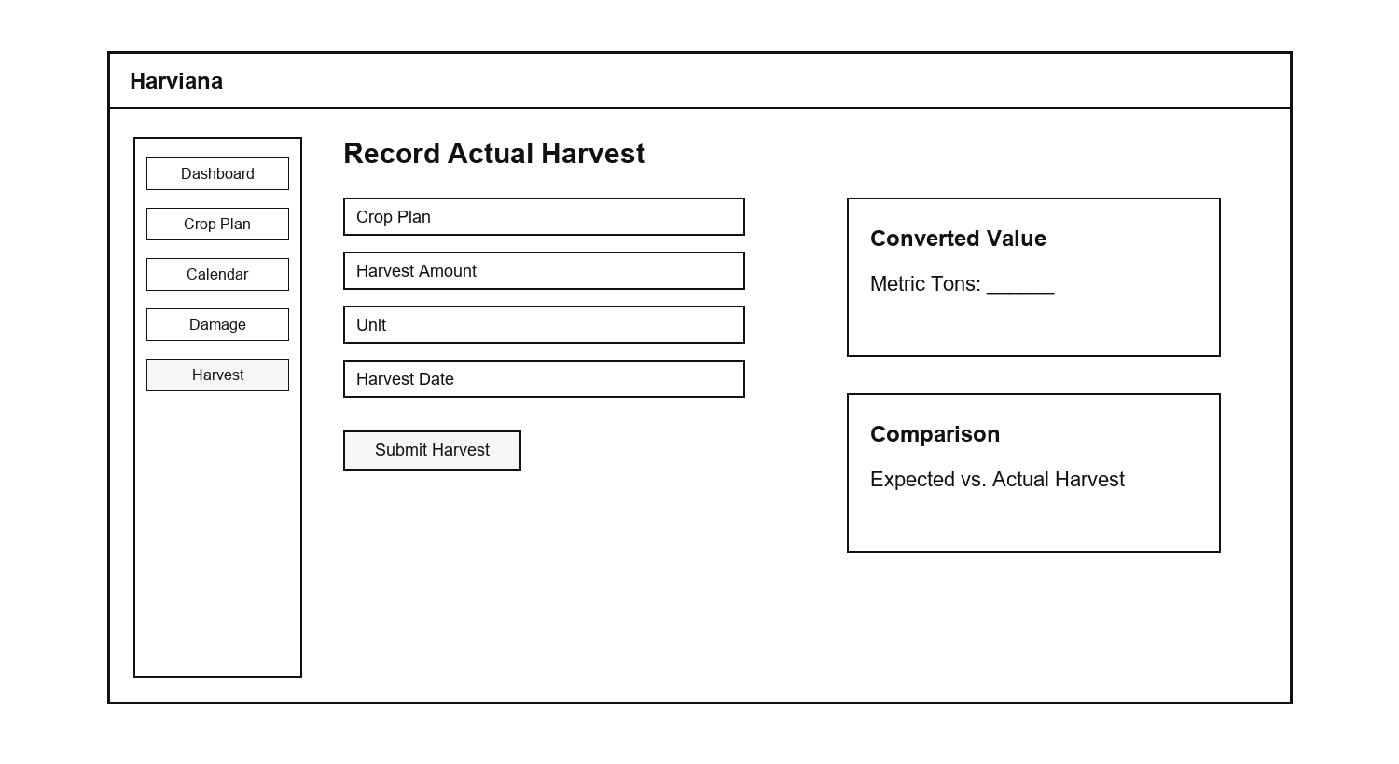
The LGU Report Validation feature serves as the checking layer between farmer-submitted records and DA administrative monitoring. Through this feature, LGU Validators can view submitted reports, review report details, check evidence, and decide whether a report should be approved or returned for correction. This process helps improve the reliability of the information stored in the system. It also ensures that reports used for DA dashboards, maps, forecasts, and generated reports have passed a validation step.
Figure 12 presents the LGU Report Validation prototype, showing the validation queue, report details, evidence section, and approval or return actions.
Figure 12
LGU Report Validation
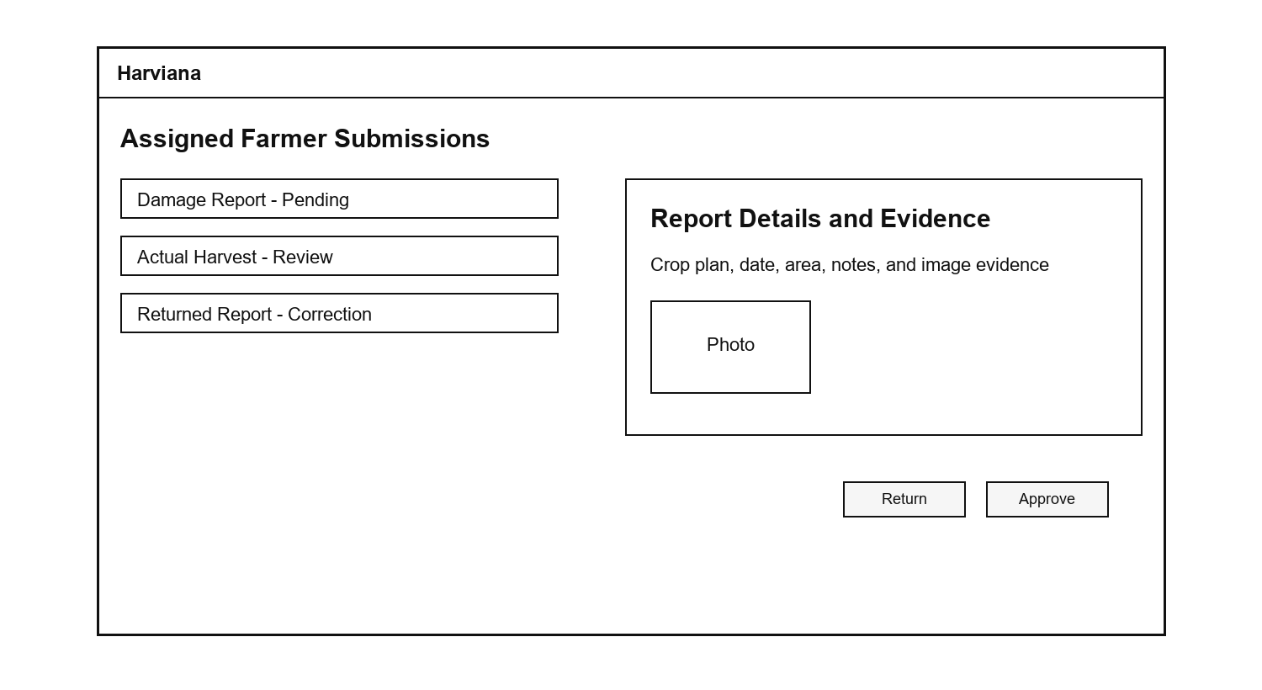
The Interactive Map and Weather feature allows users to view agricultural information according to location and selected filters. The prototype includes filters for crop type, year, view type, and farm type, allowing users to focus on specific records. It also includes a map area and weather information panel, which may show details such as temperature, rainfall probability, humidity, and wind speed. This feature supports spatial monitoring by helping users relate crop records with geographic and weather-related conditions.
Figure 13 presents the Interactive Map and Weather prototype, showing the map area, filter options, and weather information panel used for location-based agricultural monitoring.
Figure 13
Interactive Map and Weather Prototype
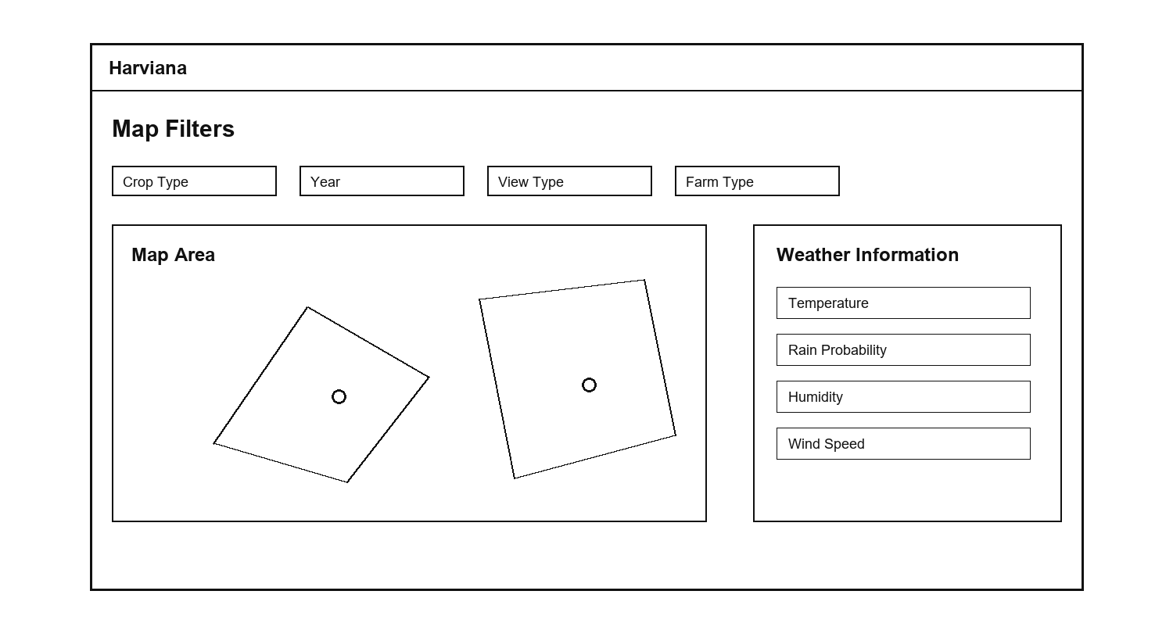
The DA Dashboard and Supply Forecast feature is designed to help DA Administrators monitor validated agricultural records in a summarized format. The dashboard presents important information such as harvest accuracy, crop production, damage records, and report categories. The supply forecast section provides support for reviewing expected supply conditions based on available crop and harvest-related data. This feature helps administrators quickly understand production-related trends before viewing more detailed records or generating reports.
Figure 14 presents the DA Dashboard and Supply Forecast prototype, showing the summarized monitoring cards, dashboard chart, and supply forecast section for DA Administrators.
Figure 14
DA Dashboard and Supply Forecast
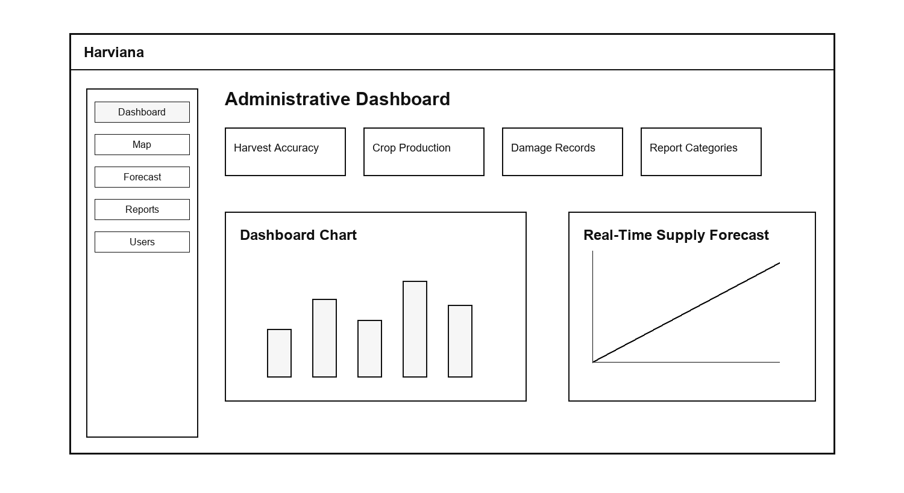
The Reports and Export feature allows DA Administrators to organize validated agricultural records into report form. The prototype includes sections for planting records, harvest records, damage records, and export options. This feature supports administrative documentation because it allows system data to be prepared for review, analysis, and decision-making. Through report generation and export, Harviana helps transform farmer-submitted and validated information into usable records for agricultural monitoring and planning.
Figure 15 presents the Reports and Export prototype, showing the report table and export options used by DA Administrators to prepare agricultural records.
Figure 15
Reports and Export
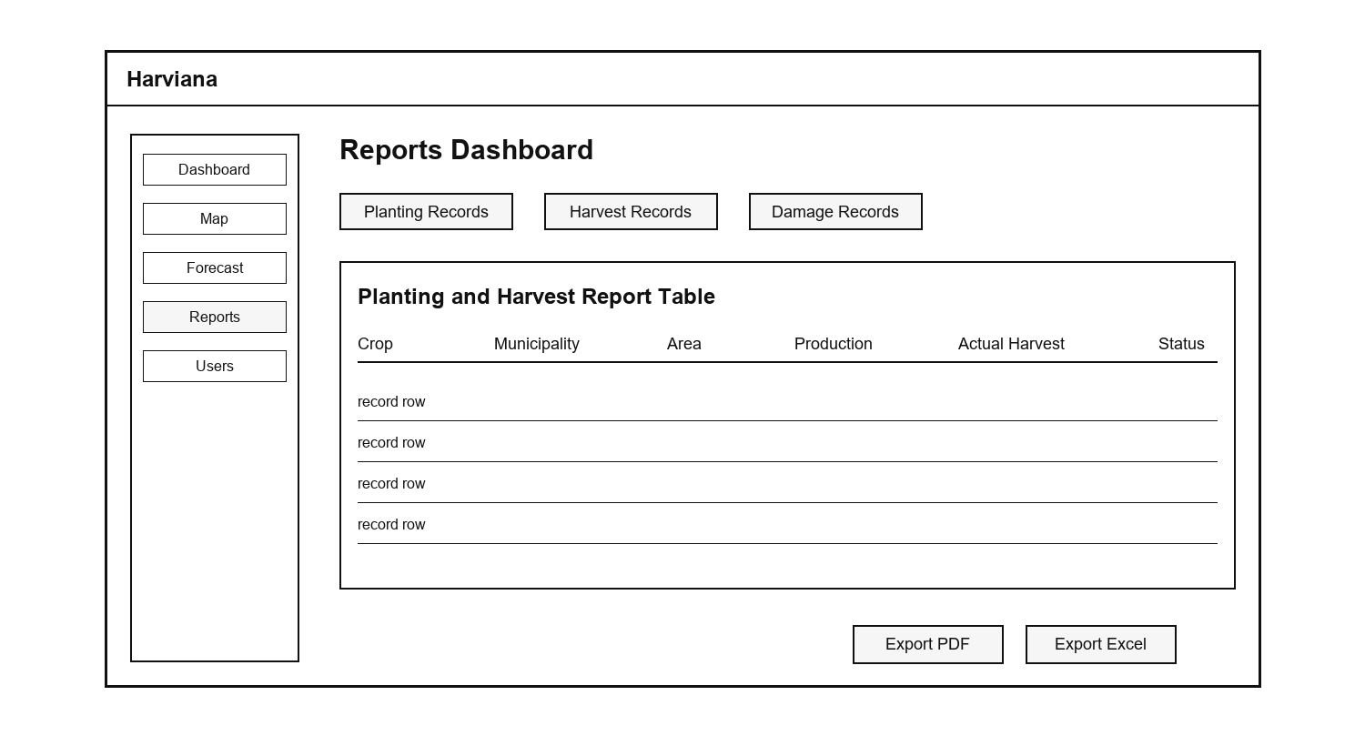
Test. The Test phase focused on evaluating whether the proposed system features were understandable, usable, and aligned with the needs of the target users. In this phase, the researchers conducted testing activities to check the main workflows of Harviana, including crop planning, farmer calendar use, ML-based production estimate viewing, damage report submission, actual harvest recording, LGU report validation, dashboard monitoring, interactive map and weather viewing, supply forecast review, and report generation.
The testing process involved participating farmers and DA administrators. Farmers tested the farmer-side features by performing tasks such as creating crop plans, viewing calendar reminders, submitting damage reports, and recording actual harvest results. These activities helped determine whether the farmer interface was understandable and useful for organizing farm-related records. DA administrators tested the administrative features by reviewing dashboards, viewing map and weather information, checking supply forecast data, and generating reports. This helped determine whether the system could support agricultural monitoring and decision-making.

Scope and Delimitation
The scope of this study focuses on the design and development of Harviana, a GIS-integrated decision-support system for visualizing vegetable production trends in Benguet. The system is designed to support vegetable production-related monitoring activities by organizing crop plans, farmer-submitted reports, harvest records, validation results, map-based information, supply forecasts, and generated reports.
Harviana is intended for three main user groups: farmers, LGU Validators, and DA Administrators. Farmers are provided with features for account registration, login, crop planning, farmer calendar viewing, ML-based production estimate viewing, damage report submission, and actual harvest recording. These features allow farmers to organize crop activities and submit crop-related information through a web-based platform.
The system also includes an LGU validation feature, which allows submitted farmer reports to be reviewed, approved, or returned for correction. This validation process serves as a checking layer before farmer-submitted information becomes part of the validated records used for administrative monitoring.
For DA Administrators, Harviana provides features for dashboard monitoring, crop data viewing, interactive map and weather viewing, real-time supply forecast review, report generation, and export of agricultural records. These features are designed to support the monitoring of validated crop information and the preparation of agricultural reports for documentation and decision-making.
The study is delimited to vegetable production-related records within Benguet. The system does not cover agricultural records from other provinces or farming sectors outside the identified scope of the study. The production estimates and supply forecasts generated by Harviana are intended to serve as decision-support information and should not be treated as final or absolute production values. The reliability of these outputs depends on the completeness and accuracy of the data available in the system.
Harviana is developed as a web-based system that can be accessed through a browser using an internet-connected device. The system does not include full market price prediction, community forum functions, IoT-based farm monitoring, offline mobile synchronization, or direct integration with all external government databases. It also does not replace the decision-making authority of farmers, LGU personnel, or DA Administrators. Instead, it provides digital support for crop planning, validation, visualization, forecasting, and reporting.
For the usability evaluation, the study involved participating farmers and DA Administrators. Farmers evaluated the farmer-side features of the system, while DA Administrators evaluated the administrative monitoring and reporting features. Although the LGU Validator module is included in the system workflow, LGU Validators were not included as usability respondents due to the study’s respondent availability and scope limitations.
Data Gathering Techniques
The researchers utilized several data gathering techniques to collect the necessary information for the design, development, and evaluation of Harviana. These techniques helped the researchers understand the needs of the target users, identify the system requirements, determine the necessary features, and evaluate the usability of the system. The gathered information served as the basis for developing a GIS-integrated decision-support system that supports crop planning, validation, monitoring, forecasting, and report generation.
Interview. The researchers gathered information from farmers and DA Administrators to understand the current challenges encountered in crop planning, agricultural record management, monitoring, and reporting. The responses helped the researchers identify the difficulties experienced by farmers in organizing crop activities, submitting damage reports, and recording actual harvest results. The information gathered from DA Administrators also helped determine the need for organized dashboards, map-based monitoring, supply forecast information, and report generation features.
Survey Questionnaires. The researchers used survey questionnaires to evaluate the usability of Harviana among the participating users. Farmers evaluated the farmer-side features of the system using the System Usability Scale (SUS), while DA Administrators evaluated the administrative features using the USE questionnaire. The System Usability Scale introduced by Brooke (1996) was used because it provides a structured way to measure the perceived usability of a system. The USE questionnaire developed by Lund (2001) was used to evaluate the DA Administrator side of the system in terms of usefulness, ease of use, ease of learning, and satisfaction. The responses gathered from the questionnaires were used to measure the extent of usability of Harviana based on user experience, ease of use, usefulness, and satisfaction.
System Testing. The researchers also conducted system testing to check whether the major features of Harviana functioned according to their intended purpose. The testing covered crop planning, farmer calendar, ML-based production estimate, damage report submission, actual harvest recording, report validation, dashboard monitoring, interactive map and weather viewing, supply forecasting, and report generation. This helped ensure that the system workflows were functional before the usability results were analyzed.
Sources of Data
The researchers gathered data from individuals and references related to the agricultural sector to ensure that Harviana addressed the practical needs of its intended users. Primary data were gathered from participating farmers and DA Administrators. The farmers provided information about their experiences in crop planning, farm activity monitoring, damage reporting, and harvest recording. Their responses helped the researchers identify the farmer-side features needed in the system, such as crop planning, farmer calendar, ML-based production estimate, damage report submission, and actual harvest recording.
The researchers also gathered data from DA Administrators to understand the administrative side of agricultural monitoring and reporting. Their input helped the researchers determine the need for organized dashboards, map-based visualization, weather information, supply forecast viewing, and report generation. These data served as a basis for designing the administrative features of Harviana and ensuring that validated crop-related information could be presented in a more useful and organized manner.
Secondary data were gathered from related studies, government reports, agricultural references, and online sources relevant to digital agriculture, geographic information systems, decision-support systems, machine learning, crop monitoring, and vegetable production in Benguet. These sources helped establish the background of the study and supported the development of Harviana as a GIS-integrated decision-support system. The researchers also reviewed references related to usability evaluation to guide the use of the System Usability Scale (SUS) for farmers and the USE questionnaire for DA Administrators.
The data gathered from these sources were used to identify system requirements, determine the necessary features, design user workflows, and evaluate the usability of Harviana. Through these sources, the researchers were able to align the system with the needs of farmers and DA Administrators while supporting the overall goal of improving crop planning, validation, visualization, forecasting, and reporting.
Software Development Tools
The researchers utilized various software development tools and technologies in designing and developing Harviana. These tools supported the creation of the user interface, system modules, database management, map visualization, forecasting support, report generation, and deployment of the system.
Figma. Figma was used in designing the initial interface and layout of Harviana. It helped the researchers prepare the low-fidelity and high-fidelity prototypes of the system, including the landing page, login and registration pages, farmer dashboard, crop planning, calendar, map, validation, reports, and administrator modules. Through Figma, the researchers were able to visualize the structure of the system before proceeding to actual development.
Visual Studio Code. Visual Studio Code served as the main code editor used in developing the system. It was used for writing, editing, and organizing the source code of Harviana, including the backend files, frontend views, routes, controllers, models, and styling files. Its extensions and integrated terminal also helped the researchers manage the development process more efficiently.
PHP. PHP was used as the main server-side programming language of Harviana. It handled the backend logic of the system, including user authentication, crop plan processing, report submission, validation workflows, harvest records, and administrative report generation.
Laravel Framework. Laravel was used as the primary web development framework of Harviana. It provided the structure for implementing the system through routes, controllers, models, views, middleware, authentication, and database handling. Laravel also supported the role-based access of Farmers, LGU Validators, and DA Administrators, ensuring that each user group could access only the functions assigned to them.
Blade, Tailwind CSS, and Alpine.js. Laravel Blade was used to create the interface templates of the system, while Tailwind CSS was used for styling and responsive layout design. Alpine.js supported interactive frontend behavior such as dropdowns, modals, filters, dynamic forms, and other user interface actions. These tools helped improve the usability and appearance of Harviana across different system pages.
JavaScript and Chart.js. JavaScript was used to support interactive system functions such as map controls, form actions, dashboard updates, and dynamic page responses. Chart.js was used to present agricultural data in visual form, such as crop production charts, forecast charts, dashboard summaries, and report-related graphs. These tools helped transform system records into easier-to-understand visual information.
Vite, Node.js, and npm. Vite, Node.js, and npm were used to manage and build the frontend assets of the system. These tools supported the compilation of scripts and stylesheets, allowing the researchers to organize and optimize the frontend resources used by Harviana.
PostgreSQL. PostgreSQL was used as the database management system of Harviana. It stored the system records such as user accounts, crop plans, farm details, harvest records, damage reports, validation results, map-related data, and report information. The database served as the central storage for the agricultural records used in monitoring, forecasting, and report generation.
Leaflet and OpenStreetMap. Leaflet and OpenStreetMap were used to support the GIS-integrated map feature of Harviana. These tools allowed the system to display agricultural records through map-based visualization, helping users view crop-related information by location. Through this feature, Farmers and DA Administrators can better understand vegetable production trends in different areas of Benguet.
Google Weather API. The Google Weather API was used to provide weather-related information in the map feature of the system. It supported the display of field weather data such as temperature, rainfall probability, humidity, wind speed, and weather condition. This helped users relate agricultural records with environmental conditions that may affect crop production.
Python and Machine Learning API. Python was used for the machine learning component connected to Harviana. The machine learning service supported production estimation and forecasting functions by processing crop-related data and returning prediction results to the Laravel system. This allowed Harviana to provide data-driven support for crop planning and agricultural monitoring.
Laravel DomPDF and Maatwebsite Excel. Laravel DomPDF and Maatwebsite Excel were used to support report generation and export features. DomPDF allowed the system to generate printable PDF reports, while Maatwebsite Excel supported spreadsheet-based report export. These tools helped DA Administrators prepare agricultural records for documentation, analysis, and decision-making.
GitHub. GitHub was used for version control and project collaboration. It helped the researchers manage changes in the system source code, track development progress, and maintain a backup of the project files during development.
Railway. Railway was used as the deployment platform for Harviana. It allowed the researchers to deploy the web application and connect it with its database and machine learning service. Through Railway, the system became accessible online for testing and demonstration.

Chapter 3
FINDINGS OF THE STUDY
This chapter presents the findings of the study based on the development and evaluation of Harviana, a GIS-integrated decision-support system for visualizing vegetable production trends in Benguet. The findings are organized according to the objectives of the study, beginning with the identified information requirements, followed by the architectural framework, system features, and extent of usability of the system. This chapter also discusses how Harviana supports crop planning, report validation, map-based monitoring, supply forecasting, and report generation through its web-based platform. Lastly, it presents the usability evaluation results gathered from the participating farmers and DA Administrators.
Information Requirements for Harviana
This section presents the information requirements necessary for the operation of Harviana as a GIS-integrated decision support system for vegetable production in Benguet. These requirements consist of user account information, agricultural production records, farmer crop-planning data, and validation information. The system also requires technical resources that support its forecasting, mapping, monitoring, and reporting functions. Defining these requirements ensures that the information collected and processed by Harviana is accurate, organized, secure, and suitable for the needs of farmers, LGU validators, and Department of Agriculture administrators.
User Information. Harviana has three primary user groups: farmers, LGU validators, and DA administrators. Each user is required to provide specific account and location information according to their assigned role. These details allow the system to authenticate users, control access to features, personalize the information displayed, and associate agricultural records with the appropriate farmer and municipality.
Farmer information consists of the farmer’s full name, email address, password, preferred municipality, cooperative, and selected crops. During registration, farmers provide their name, email address, and password. After signing in, they complete the onboarding process by selecting their municipality and cooperative. This location information allows Harviana to display crop recommendations, municipal production information, weather conditions, and agricultural insights that are relevant to the farmer’s area.
Farmers also provide operational information through the crop-planning and calendar features. This includes the selected crop, intended planting area, water source, planting material, planning date, and estimated harvest date. During the production cycle, farmers may submit damage reports containing the affected crop, damaged area, cause of damage, supporting description, and photographic evidence. Once harvesting is completed, they may record the actual harvest date, harvested amount, measurement unit, and additional notes. These records allow the system to compare estimated production with actual harvest outcomes and provide updated information for municipal supply monitoring. Tables 1, 2, and 3 present the information required for farmers, LGU validators, and DA administrators, together with their corresponding storage data types and formats, while Table 4 presents the minimum and recommended system requirements for operating Harviana.

Table 1
Farmer Information
Field Data Type | Length
USER_ID INTEGER FULL_NAME STRING  EMAIL_ADDRESS STRING  PASSWORD STRING  MUNICIPALITY STRING  COOPERATIVE STRING  ACCOUNT_STATUS BOOLEAN | Auto-generated  255  255  Encrypted  255  255  Active/Inactive
Table 2
LGU Validator Information
Field Data Type | Length
USER_ID INTEGER FULL_NAME STRING  EMAIL_ADDRESS STRING  PASSWORD STRING  LGU_MUNICIPALITY STRING  LGU_BARANGAY STRING  ACCOUNT_STATUS BOOLEAN  VALIDATION_NOTES Text | Auto-generated  255  255  Encrypted  255  255  Active/Inactive  Variable Length
Table 3
DA-Admin Information
Field Data Type | Length
USER_ID INTEGER FULL_NAME STRING  EMAIL_ADDRESS STRING  PASSWORD STRING  USER_ROLE STRING  ACCOUNT_STATUS BOOLEAN | Auto-generated  255  255  Encrypted  Administrator  Active/Inactive

System Requirements. Harviana is a responsive web-based application that can be accessed through smartphones, tablets, laptops, and desktop computers. Users must have a modern browser with JavaScript, cookies, and local browser storage enabled. A stable internet connection is required to retrieve map tiles, weather information, prediction results, and updated agricultural records. A stronger connection is recommended when uploading photographic evidence for damage and harvest reports. Table 4 presents the software and hardware requirements for the application.
Table 4
System Requirements
Requirement | Minimum System Requirement | Recomended
Device  Operating System  RAM  Connectivity | Smartphone, tablet, laptop, or desktop  Android 10+, iOS/iPadOS 17+, Windows 10+, or macOS 12 Monterey+  2GB  3G or Wi-Fi | Recent smartphone or computer  Android 12+, iOS/iPadOS 17+, Windows 11, or macOS 13+  4GB or higher  4G/LTE, 5G

Architecture Framework of Harviana
The architectural framework serves as the structural guide for the development and operation of Harviana. It presents how the system’s user interfaces, application modules, databases, and external services work together to support agricultural planning and monitoring. The framework also provides a common representation that helps researchers, developers, and stakeholders understand the system’s processes, responsibilities, and technical components. Through this structure, the design of Harviana is aligned with the requirements of farmers, LGU validators, and DA administrators.
Figure 16 presents Kruchten’s “4+1” View Model used as the architectural framework of Harviana.
Figure 16
The “4+1” View Model of Harviana
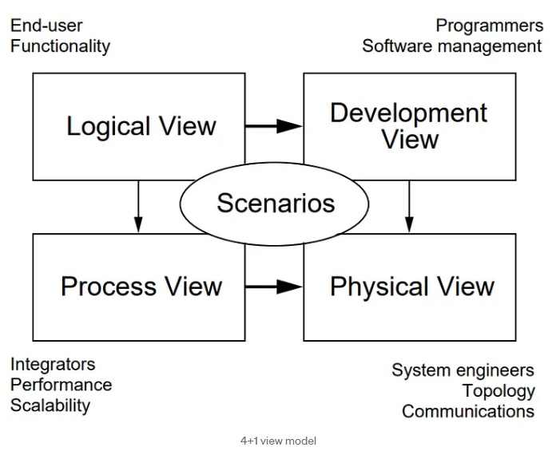
The researchers used Kruchten’s “4+1” View Model to describe the architecture of Harviana from different perspectives. The model consists of the Scenarios, Logical, Process, Development, and Physical views. These views may be represented using use case, class, sequence, package, and deployment diagrams. Together, they explain the system’s user interactions, functional structure, runtime processes, software organization, and deployment environment.
Scenarios. The scenario perspective describes Harviana according to the activities performed by its users during actual system operation. It presents the responsibilities, access privileges, and system interactions assigned to Farmers, LGU Validators, and DA Administrators. This view identifies how farmers submit crop plans, damage reports, and actual harvest records; how LGU validators review and verify these submissions; and how DA administrators use the consolidated information for monitoring, forecasting, and reporting. Through these role-based interactions, the scenario perspective demonstrates how agricultural information moves across the system and supports Harviana’s overall decision-support process.
Figure 17 maps the system’s principal activities across these three roles and clarifies how information moves from farmer submission to local validation and administrative use.
Figure 17
Harviana Use Case Diagram
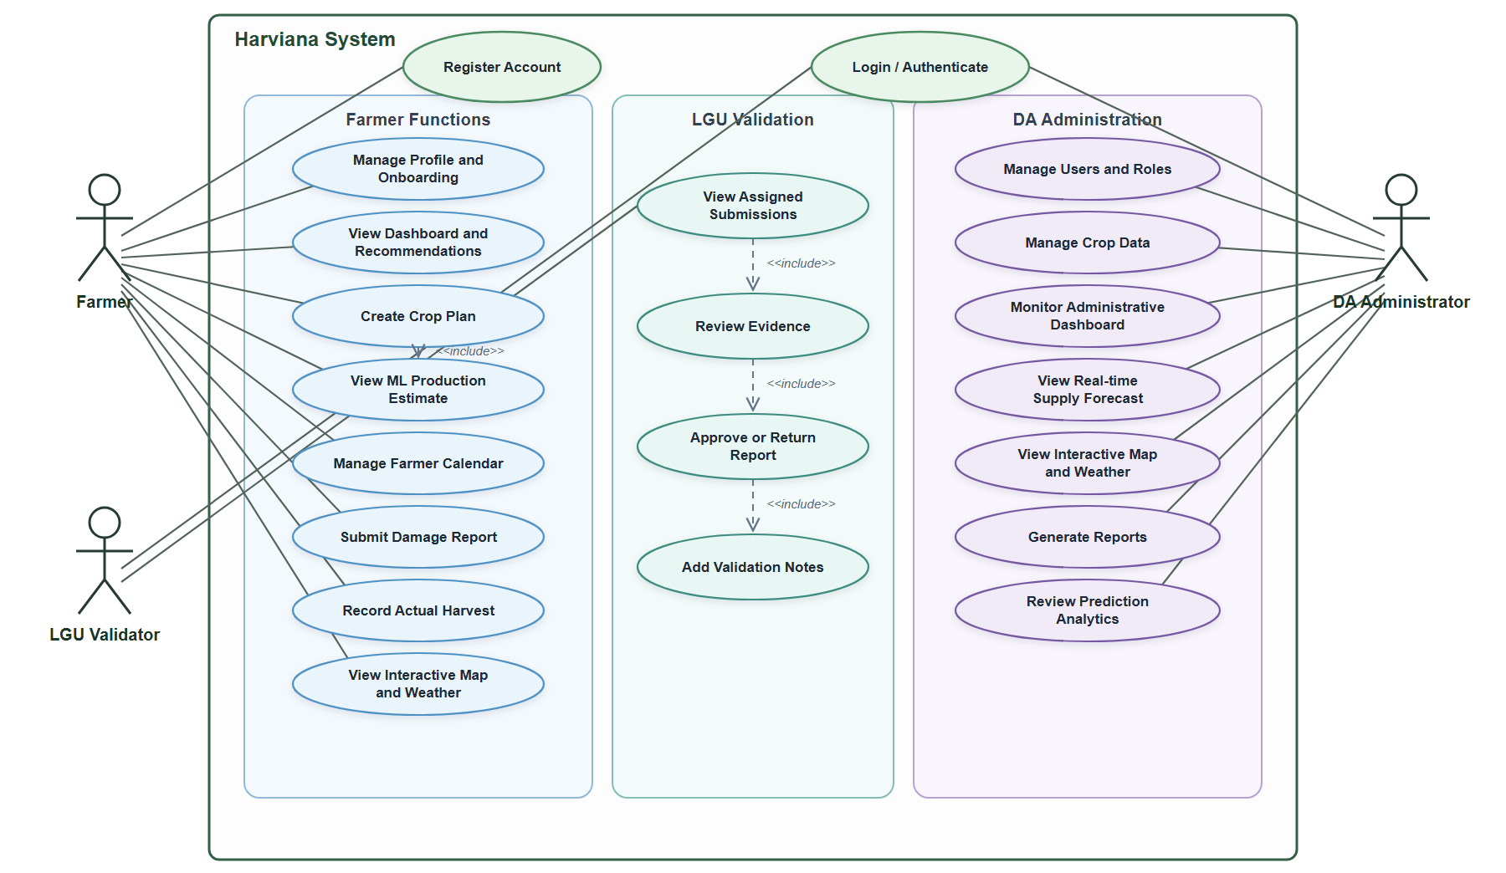
The use case diagram illustrates the core functions available to the three actors of Harviana. All actors must first complete the “Login/Authenticate” process before accessing their respective dashboards and system features. Farmers may register their accounts and complete the onboarding process by providing their municipality and cooperative information.
Once authenticated, farmers can manage their profiles, view personalized dashboards and crop recommendations, create crop plans, and receive machine-learning-based production estimates. They can also manage their farming calendar, submit damage reports, record actual harvest results, and access municipality-level maps and weather information. The “Create Crop Plan” use case includes the generation of a production estimate based on the crop, municipality, planting area, water source, and expected harvest period provided by the farmer.
LGU validators are responsible for reviewing damage reports and actual harvest records submitted by farmers within their assigned municipalities. They can view pending submissions, inspect the available evidence, approve valid records, or return submissions that require correction. Validators may also provide notes explaining their decision, while the system records the validation activity for monitoring purposes.
DA administrators have broader access to the system’s agricultural and administrative functions. They can manage user accounts and roles, maintain historical crop-production records, monitor the administrative dashboard, and access the real-time municipal supply forecast. They may also view the interactive map and weather information, generate reports, and examine prediction analytics for agricultural planning and system evaluation.
Logical View. The Logical View describes the internal organization of Harviana by presenting the data objects and service components responsible for its major functions. It focuses on how user accounts, agricultural records, crop plans, predictions, validation activities, and supply forecasts are represented within the application. A class diagram was developed to show the attributes, operations, and relationships of these components.
Figure 18 presents the principal classes and services that support Harviana’s role-based and agricultural decision-support functions.
Figure 18
Harviana Class Diagram
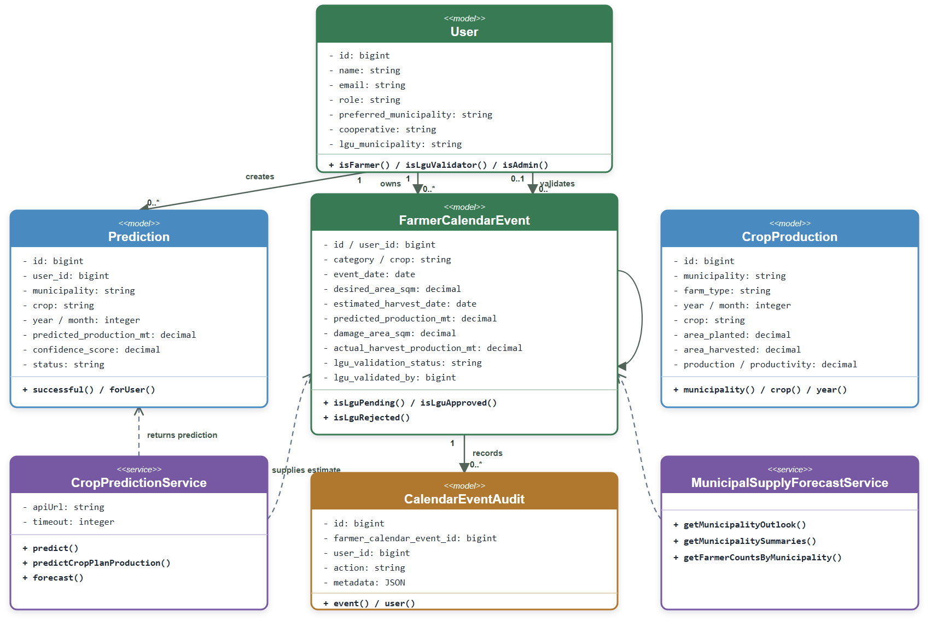
The class diagram represents the structure and primary components of Harviana. The User class manages the accounts and assigned roles of Farmers, LGU Validators, and DA Administrators. Farmers use the FarmerCalendarEvent class to create crop plans, organize planting and harvest schedules, submit damage reports, and record actual harvest results. LGU Validators review these submissions, provide validation notes, and approve or return records for correction, while the CalendarEventAudit class maintains a record of validation activities. The Prediction class stores production estimates generated for specific crops and municipalities. The CropProduction class maintains historical agricultural records used for dashboards, maps, reports, and forecasting. The CropPredictionService communicates with the machine-learning service to generate production estimates, while the MunicipalSupplyForecastService combines crop plans with approved damage and actual harvest information to calculate municipality-level supply forecasts for DA Administrators.
Process View. The process view describes how Harviana’s users and system components interact during runtime. It presents the sequence of requests and responses involving Farmers, LGU Validators, DA Administrators, controllers, services, the connected machine-learning service, and Railway PostgreSQL. The following sequence diagrams cover user authentication, crop-plan production estimation, and LGU validation of farmer reports.
Figure 19 presents the sequence diagram authentication process of Harviana.

Figure 19
Harviana Login Sequence Diagram
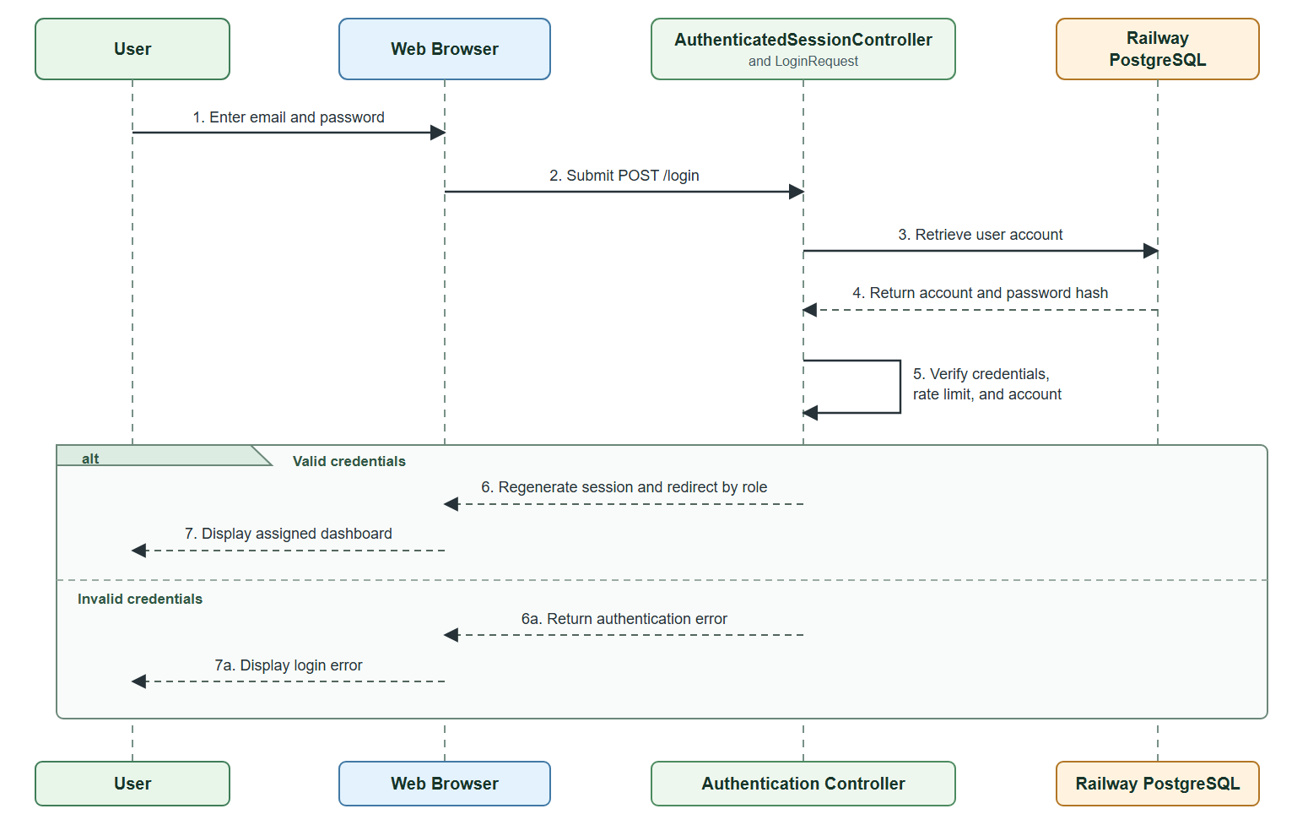
The sequence diagram illustrates how user enters an email address and password, which are submitted to the authentication controller. The system retrieves the corresponding account from Railway PostgreSQL and verifies the credentials. When authentication is successful, the session is regenerated, and the user is redirected to the appropriate dashboard based on their role as a Farmer, LGU Validator, or DA Administrator. If the credentials are invalid, the login page displays an authentication error.
Figure 20 presents the sequence diagram how Harviana generates a production estimate for a farmer’s crop plan.
Figure 20
Harviana Crop Plan and Production Estimate Sequence Diagram
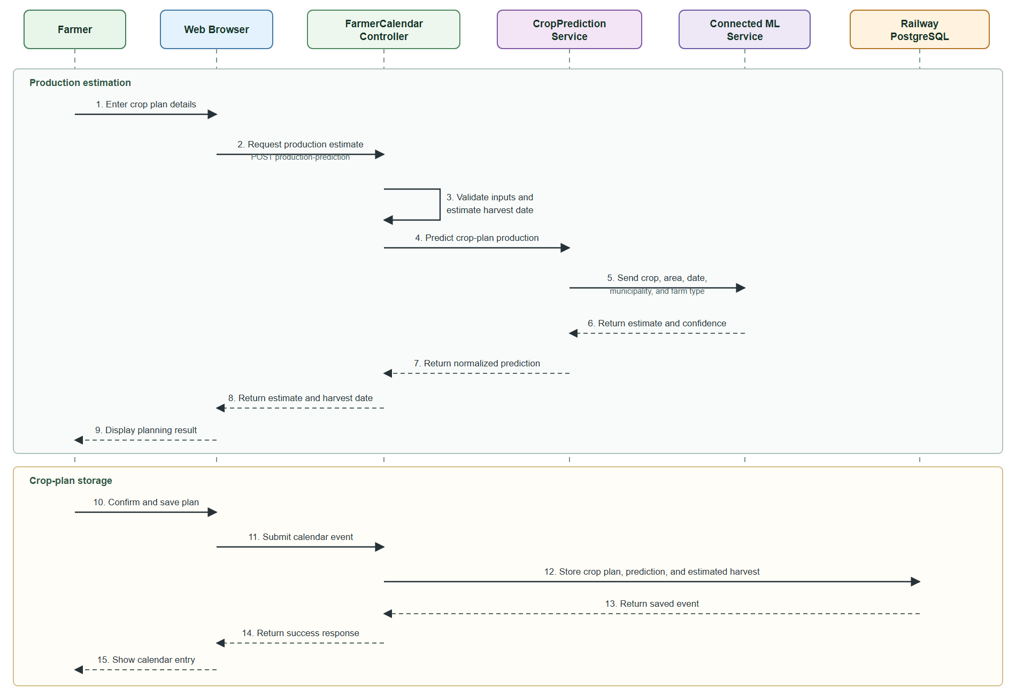
The diagram shows how the Farmer provides the crop, desired planting area, water source, planting material, and planning date. The Farmer Calendar Controller validates the information and calculates the estimated harvest date. The Crop Prediction Service sends the required data to the connected machine-learning service, which returns the predicted production and confidence value. After reviewing the result, the Farmer may save the crop plan, together with its prediction and estimated harvest date, in Railway PostgreSQL.
Figure 21 presents the submission and LGU validation of farmers’ damage and harvest reports.
Figure 21
Farmer Report and LGU Validation Sequence Diagram
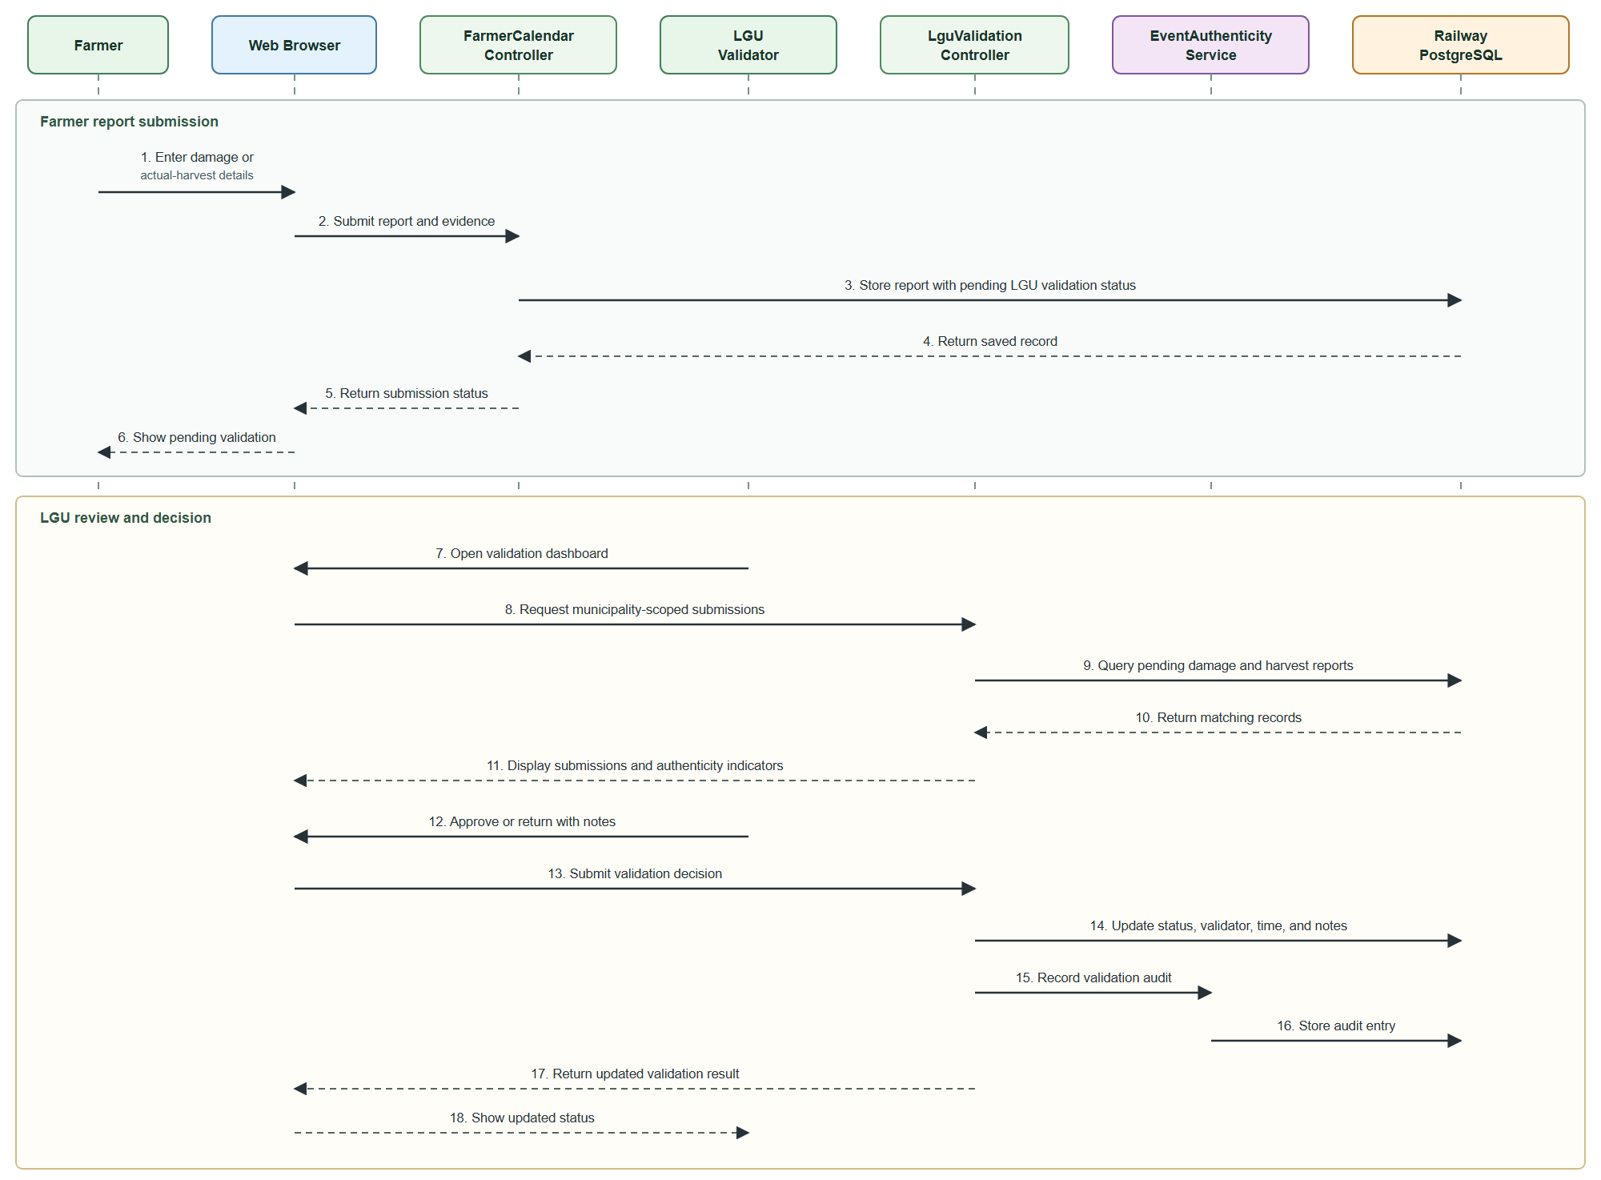
The Farmer submits damage or actual-harvest information together with supporting evidence. Harviana stores the report with a pending validation status. The assigned LGU Validator reviews the report and either approves it or returns it with correction notes. The decision, validator details, validation time, and audit entry are recorded. Approved information supports the reports and municipal supply forecasts available to the DA Administrator.
Figure 22 presents the DA Administrator’s process for viewing municipal supply forecasts.
Figure 22
Harviana Sequence Diagram for DA Administrator Supply Forecast
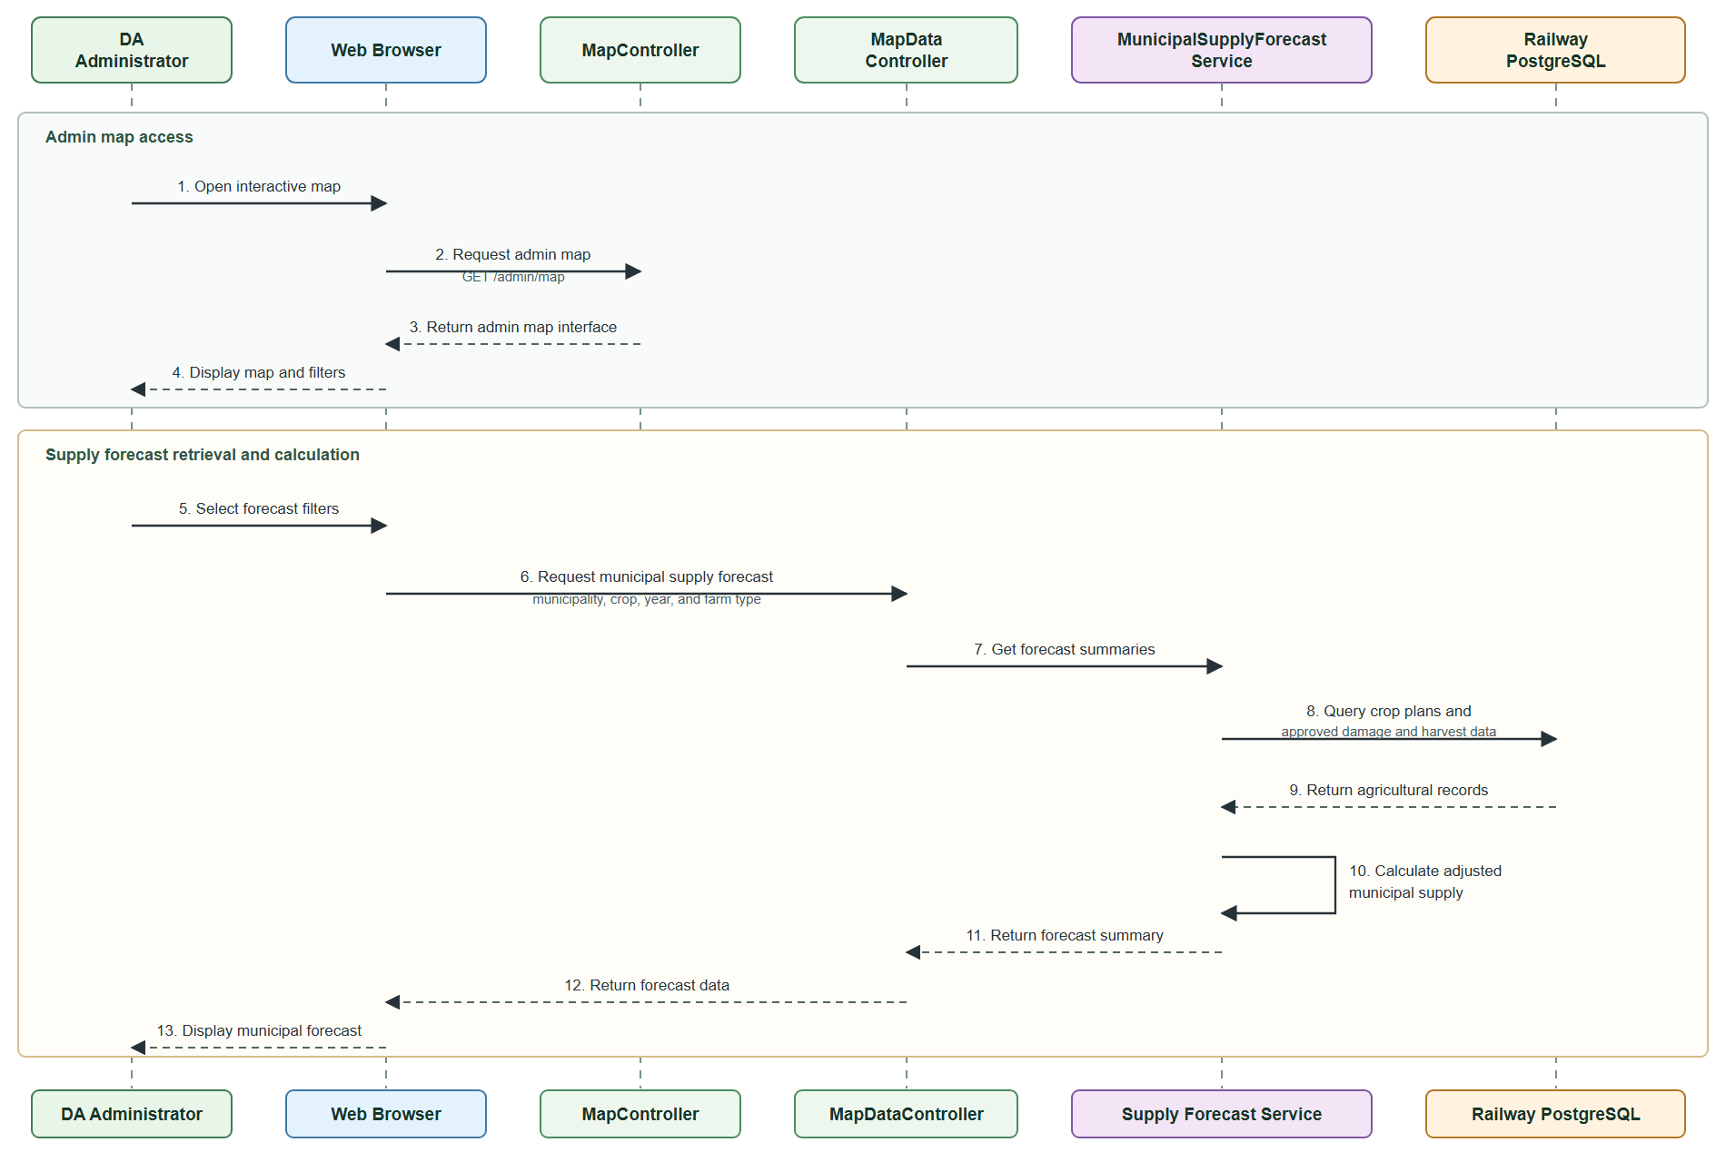
The sequence diagram shows how the DA Administrator accesses the interactive map and applies forecast filters. The Municipal Supply Forecast Service retrieves farmer crop plans, stored production predictions, and LGU-approved damage and actual-harvest records from Railway PostgreSQL. It calculates the adjusted municipal supply and returns the results for display on the administrator’s map.
Figure 23 presents the report generation and export process available to the DA Administrator.
Figure 23
Harviana Sequence Diagram for DA Report Generation and Export
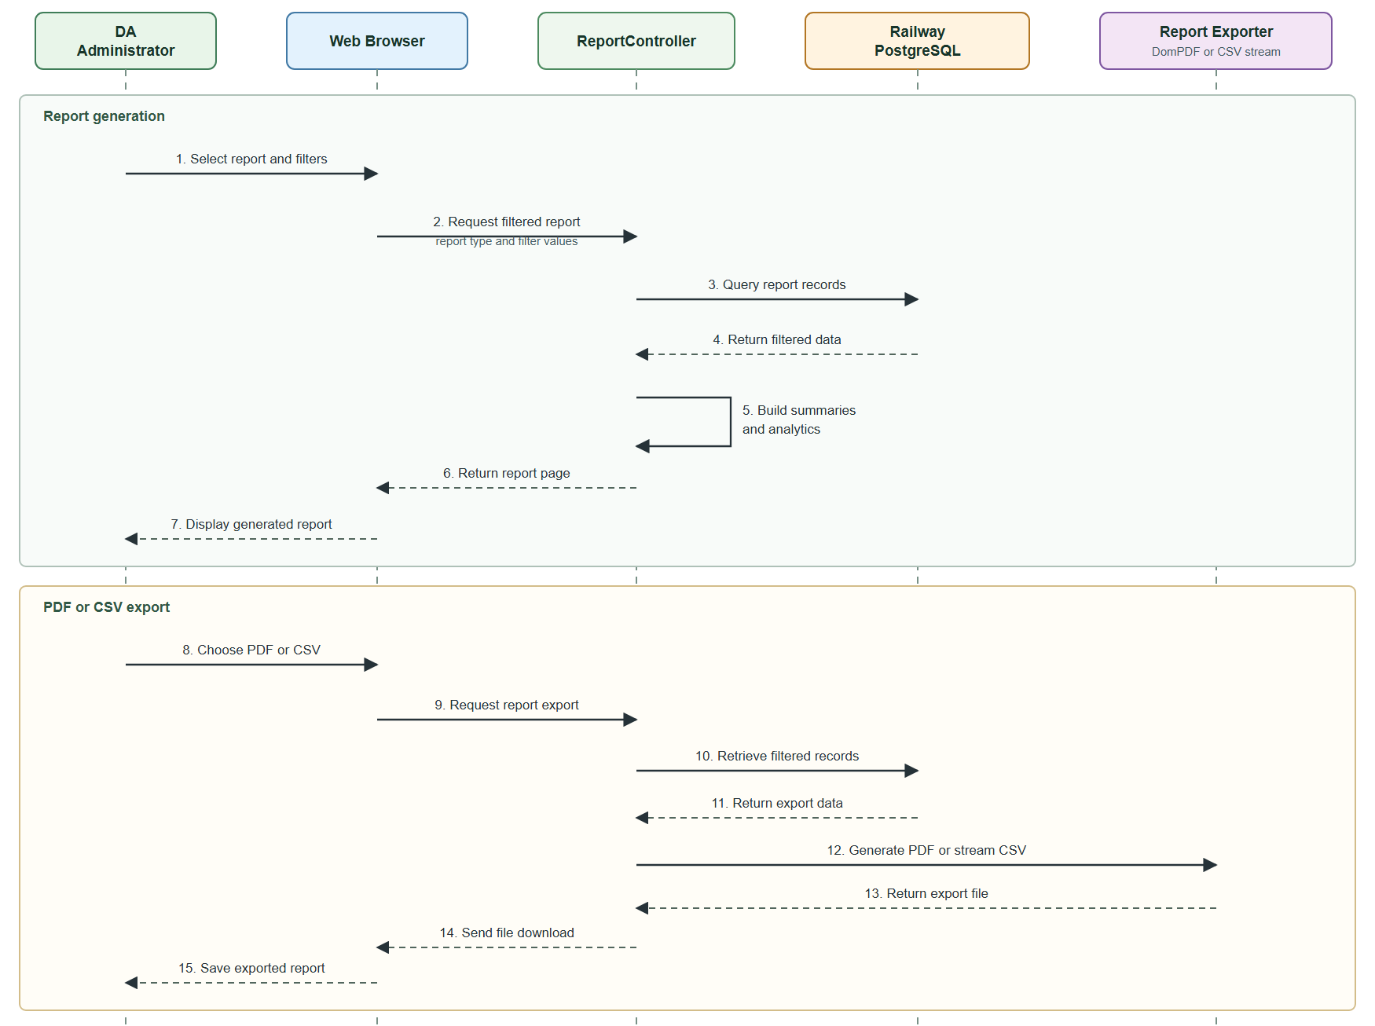
The sequence diagram shows how the DA Administrator selects a report and applies the necessary filters. The Report Controller retrieves the required records from Railway PostgreSQL and processes them into summaries and analytics for display. The administrator can then export the generated report as a PDF or CSV file. The system prepares the selected format and sends the completed report to the browser for download.
Development View. The development view presents Harviana’s software organization from the developers’ perspective. It shows how the application is divided into packages and how these packages depend on one another. A package diagram is used to represent the presentation layer, routing and access control, controllers, domain services, data models, external services, and database.
Figure 24 presents the package diagram of Harviana and the dependencies among its software modules.
Figure 24
Harviana Package Diagram
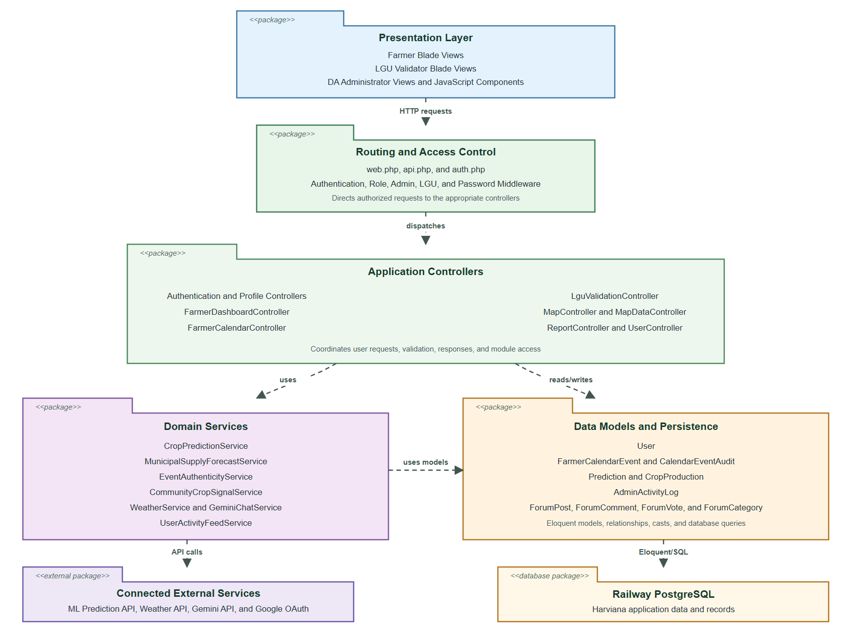
The package diagram shows how requests from the Farmer, LGU Validator, and DA Administrator interfaces pass through the routing and access-control package before reaching the appropriate controllers. The controllers use domain services for production prediction, supply forecasting, report validation, weather information, and other system operations. These services access the system’s data models and connected external services. The data models manage Harviana’s records stored in Railway PostgreSQL.
Physical View. The physical view presents the hardware, cloud services, and external systems used to operate Harviana. It shows where the application is deployed and how user devices, the web application, database, machine-learning service, and third-party APIs communicate. A deployment diagram is used to represent these physical and cloud-based connections.
Figure 25 presents the deployment structure of Harviana and its connected services.

Figure 25
Harviana Deployment Diagram
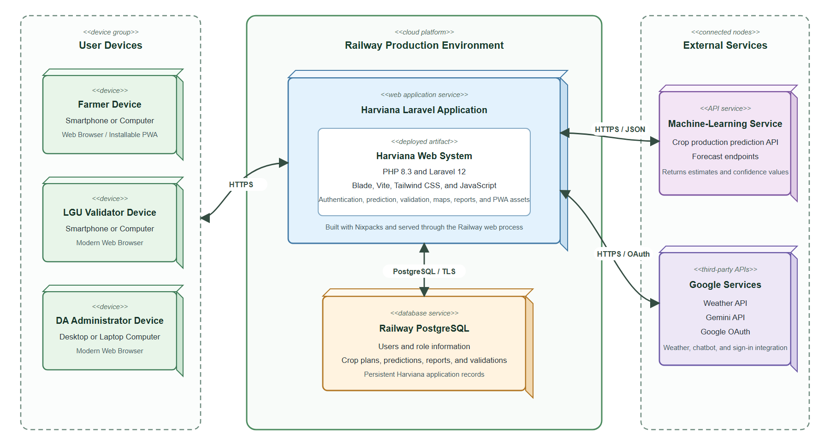
The deployment diagram shows Farmers, LGU Validators, and DA Administrators accessing Harviana through web browsers or the installable PWA over HTTPS. The Laravel application is deployed on Railway and communicates with Railway PostgreSQL to manage user accounts, crop plans, predictions, validation records, and reports. Production-estimation requests are sent to the connected machine-learning service. Harviana also communicates with Google services for weather information, chatbot responses, and OAuth authentication.

Features of Harviana
This section presents the major features available in Harviana. The system provides secure role-based access, farmer crop-planning tools, machine-learning production estimates, LGU validation, municipal supply forecasting, and administrative reports. These features establish a connected flow in which farmer-submitted information is reviewed by LGU Validators and transformed into decision-support information for DA Administrators.
Harviana landing page. It serves as the first page accessed by visitors and introduces the purpose of the platform. Through this page, users can view general information about the system, explore its features, learn about the development team, and proceed to the login or account registration page. The landing page also gives users an initial understanding of how Harviana supports agricultural activities through digital crop monitoring, data collection, and forecasting support. It presents Harviana as an agricultural decision-support system designed to assist farmers and decision-makers in managing crop-related information more efficiently.
Figure 26 presents the public landing page that introduces Harviana as an agricultural decision-support system.

Figure 26
Harviana landing page
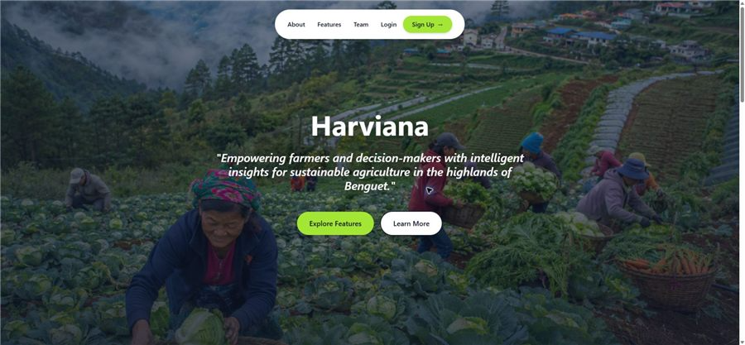
User Login and Registration. These pages allow registered users to sign in using their account credentials or Google authentication, while new users can create an account by entering the required registration details. After successful login, the system identifies the user’s assigned role and directs them to the appropriate interface, such as the Farmer dashboard, LGU Validator workspace, or DA Administrator dashboard. This role-based access helps organize the system functions according to the responsibilities of each user group. Through this process, Harviana ensures that users can access only the features, records, and information related to their role within the system, improving both usability and data security.
Figure 27 presents the login and registration pages of Harviana, which provide the main access points for users of the system.
Figure 27
User Login and Registration
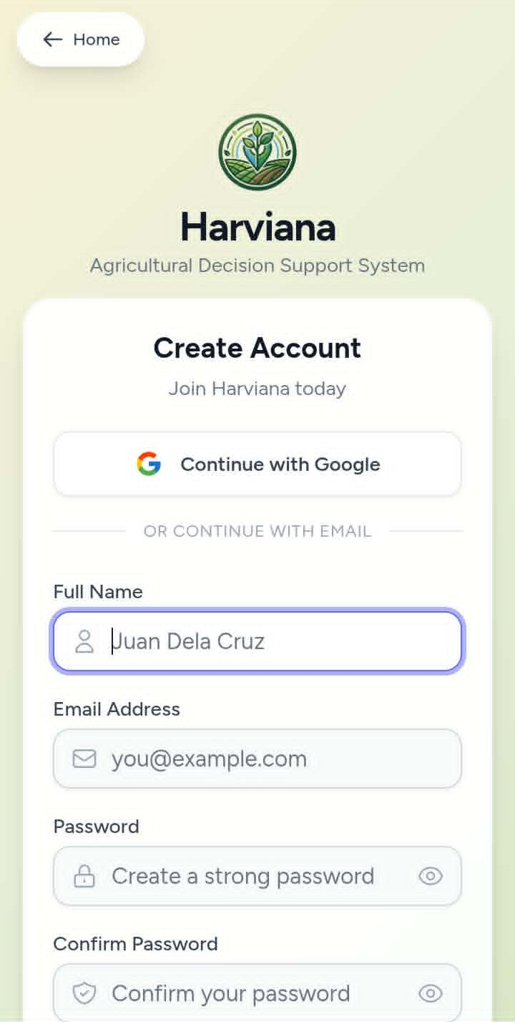
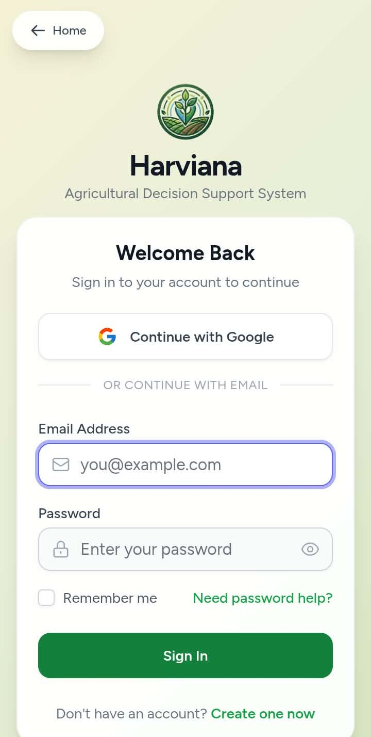
Farmer Dashboard. This page provides farmers with an overview of their crop-related activities, nearby crop monitoring, crop outlook, harvest progress, and quick access to the farmer calendar. Through this feature, farmers can immediately review useful agricultural information in one place before proceeding to planning, monitoring, or reporting activities. The dashboard helps farmers track their current farm records and understand the status of their crop activities more conveniently.
Figure 28 presents the Farmer Dashboard of Harviana, which serves as the main workspace for farmer accounts after login.

Figure 28
Farmer Dashboard
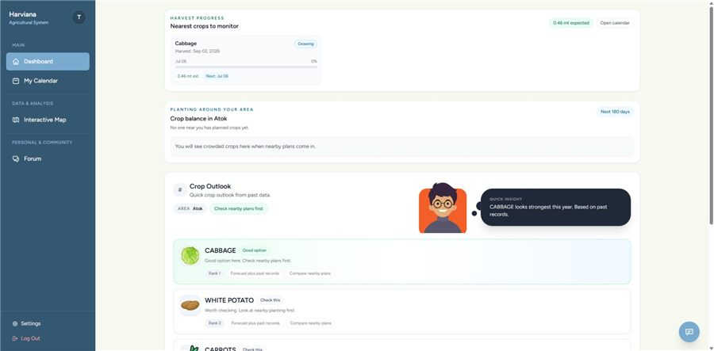
Farmer Calendar and Crop Planning. Through this feature, farmers can create crop plans, view active crops, check upcoming reminders, and see scheduled crop activities such as planting, fertilizer application, and other crop management tasks. The calendar also helps farmers follow the expected timeline of their crop production activities from the planning stage up to the harvest period. By placing crop plans and farm tasks in a calendar format, the system allows farmers to monitor important dates more easily and avoid overlooking scheduled activities. This supports more organized monitoring of planting, maintenance, and harvest-related activities.
Figure 29 presents the Farmer Calendar and Crop Planning feature of Harviana, which allows farmers to organize crop activities based on dates and planned farm operations.
Figure 29
Farmer Calendar and Crop Planning
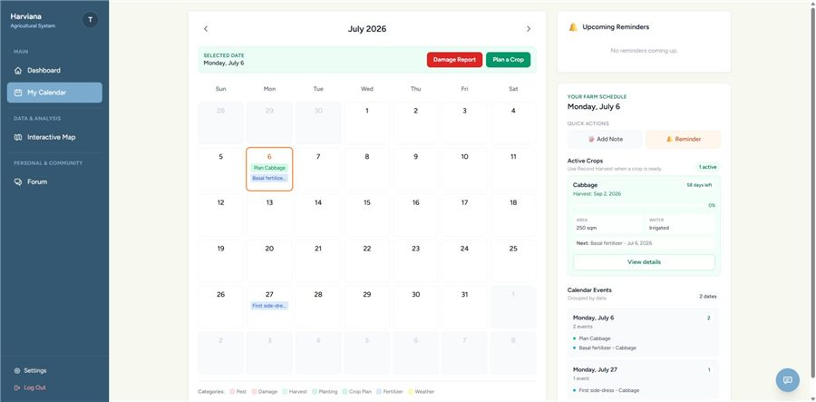
ML-Based Production Estimate. This feature provides an estimated production value after the farmer enters important crop plan details, including crop type, planting area, water source, seed type, and planning date. The system also displays an estimated harvest date and crop activity stages to guide the farmer throughout the production cycle. This helps farmers understand the possible output of a planned crop before the harvest period and gives them additional information for planning their farm activities.
Figure 30 presents the ML-Based Production Estimate feature of Harviana, which is displayed during the crop planning process after the farmer provides the required crop plan details. This feature shows the estimated production output generated by the system to help farmers preview the possible result of their planned crop before the actual harvest period.
Figure 30
ML-Based Production Estimate
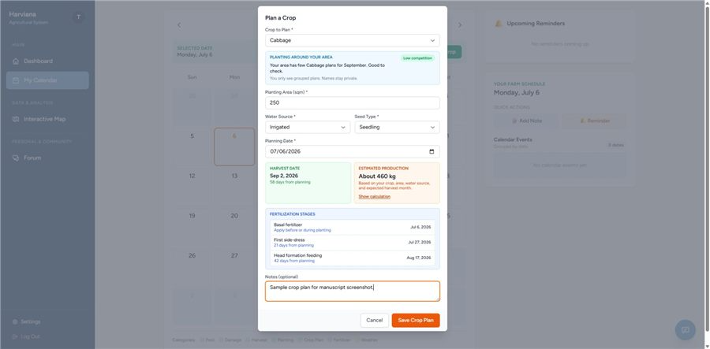
Damage Report Submission. In this feature, farmers can select the cause of damage, affected crop plan, damaged area, damage date, and optional notes or photo evidence to support their report. The submitted information can later be reviewed by the LGU Validator before it is included in monitoring records and report generation. This process helps ensure that crop losses are properly documented, validated, and connected to the correct crop plan. It also allows the system to keep more reliable damage records for agricultural monitoring and decision-making.
Figure 31 presents the Damage Report Submission feature of Harviana, which allows farmers to document crop damage that occurs during the production period.

Figure 31
Damage Report Submission
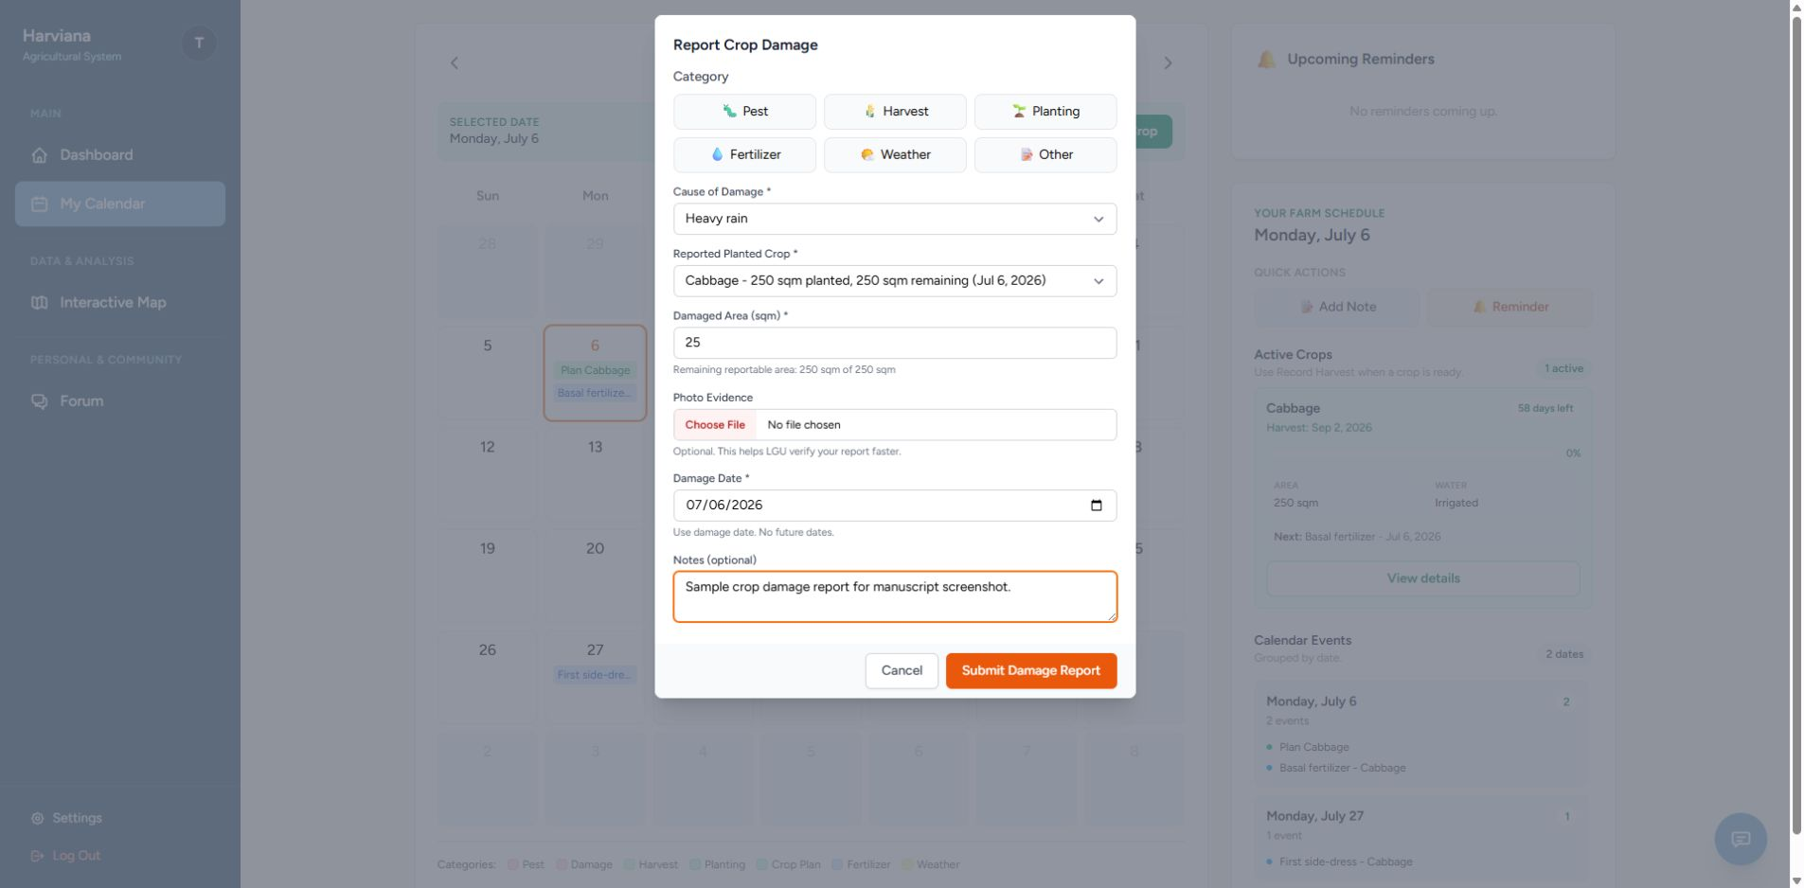
Actual Harvest Recording. This feature allows farmers to record the actual harvest amount, unit of measurement, harvest date, optional photo evidence, and notes after the crop has been harvested. The system also converts the submitted amount into metric tons and compares it with the expected production generated from the crop plan. Through this comparison, the system can show the difference between the predicted output and the actual harvest submitted by the farmer. This helps improve production monitoring and provides more useful data for evaluating crop performance.
Figure 32 presents the Actual Harvest Recording feature of Harviana, which enables farmers to submit their harvest results after the crop production period.

Figure 32
Actual Harvest Recording
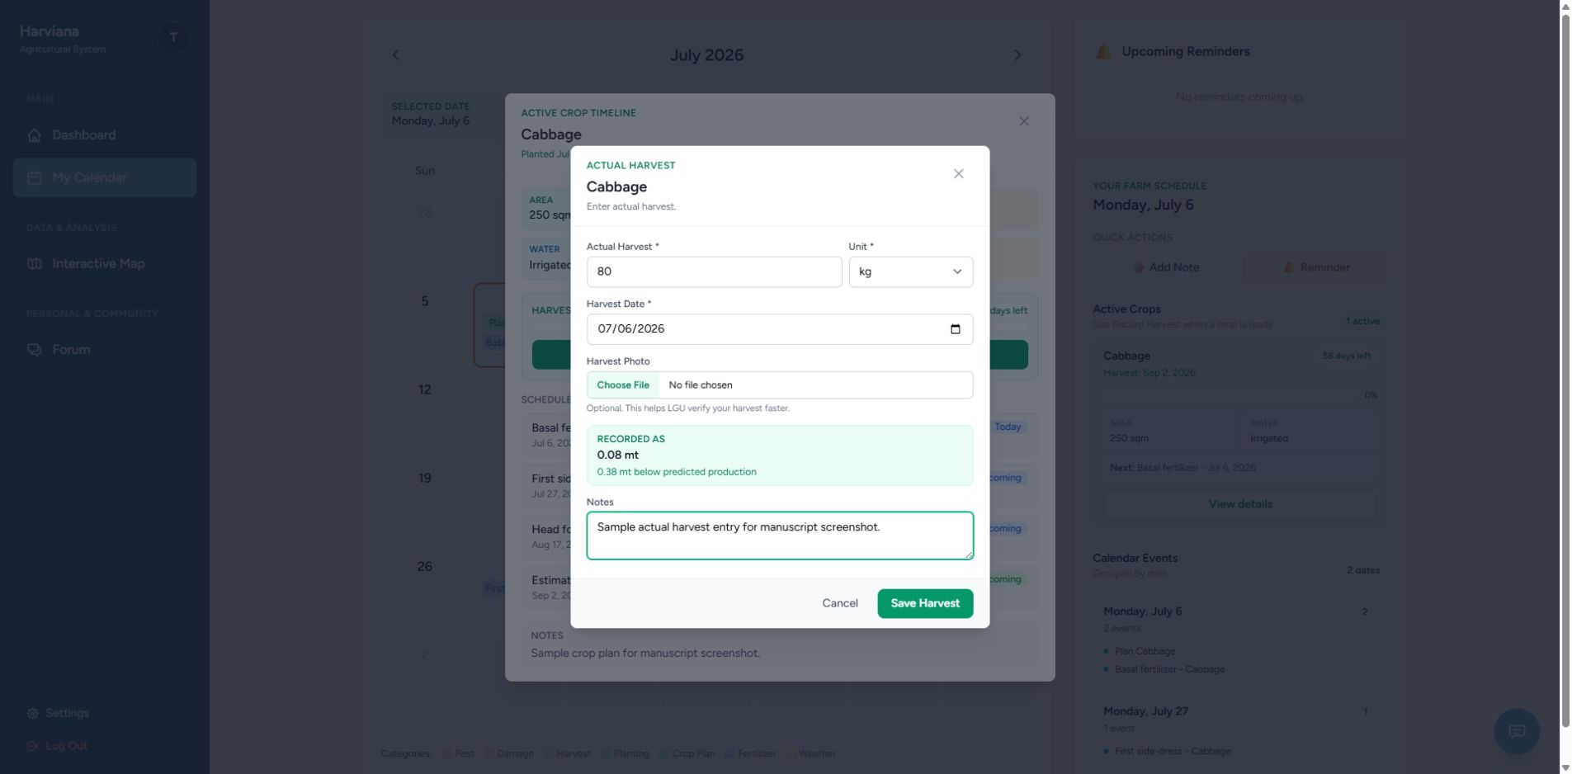
LGU Report Validation. Through this feature, LGU Validators can view report queues, filter submissions, check report status, review report details, and determine whether a report can be approved or returned for correction. The validation process allows LGU Validators to examine farmer-submitted data before it becomes part of the system’s official monitoring records. This helps improve the reliability and accuracy of agricultural information used by the system. It also creates a checking layer between farmer submissions and DA administrative monitoring, ensuring that reports are reviewed before they are used for forecasting, analysis, and decision-making.
Figure 33 presents the LGU Report Validation feature of Harviana, which supports the review of farmer-submitted reports before they are used in higher-level monitoring.

Figure 33
LGU Report Validation
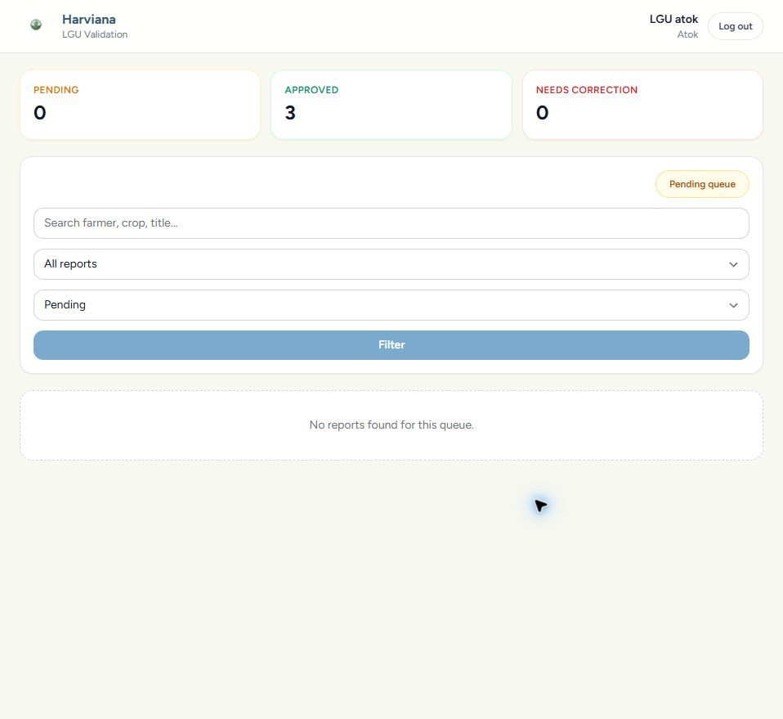
Administrator Dashboard and Supply Forecast. This feature displays a summary of system records, crop records, predictions, municipalities, and current supply information. The dashboard includes supply forecast values, harvested crop data, remaining supply, reported damage, and top municipality summaries. Through this feature, the DA Administrator can monitor agricultural conditions and use updated information for planning, coordination, and decision-making.
Figure 34 presents the DA Administrator Dashboard and Real-Time Supply Forecast feature of Harviana, which provides DA administrators with a centralized view of crop and supply-related records.
Figure 34
Administrator Dashboard and Supply Forecast
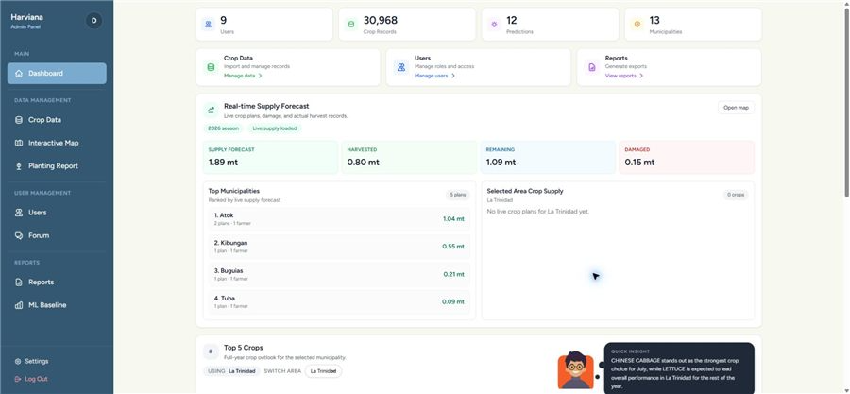
Interactive Agricultural Map and Weather. Users can filter map information according to crop type, year, view type, and farm type to focus on specific crop or area records. The map also displays field weather information such as temperature, weather condition, rainfall probability, humidity, and wind speed, allowing users to view agricultural data together with relevant environmental conditions. Through this feature, users can better understand how crop records are distributed across different municipalities. This supports spatial monitoring by helping users relate agricultural records with location and weather conditions for more informed planning and decision-making.
Figure 35 presents the Interactive Agricultural Map and Weather feature of Harviana, which provides a location-based view of agricultural information across municipalities.
Figure 35
Interactive Agricultural Map and Weather
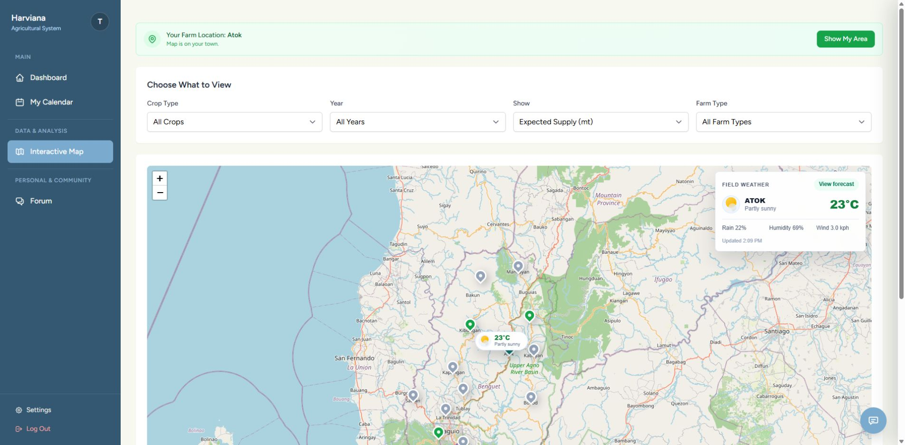
Reports and Export Generation. This feature summarizes harvest accuracy, crop production, damage records, report categories, planting records, planted areas, crop types, production values, and actual harvest information. It helps DA Administrators review the condition of crop records, compare forecasted data with farmer-recorded harvest information, and identify important report trends. The feature also supports report generation and export, allowing validated system data to be prepared for documentation, analysis, and administrative decision-making.
Figure 36 presents the Reports and Export Generation feature of Harviana, which organizes agricultural information into a report-focused view for DA Administrators.
Figure 36
Reports and Export Generation
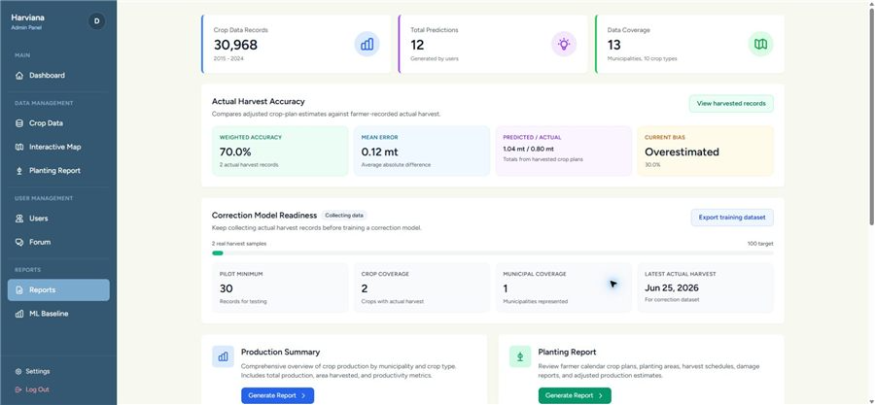
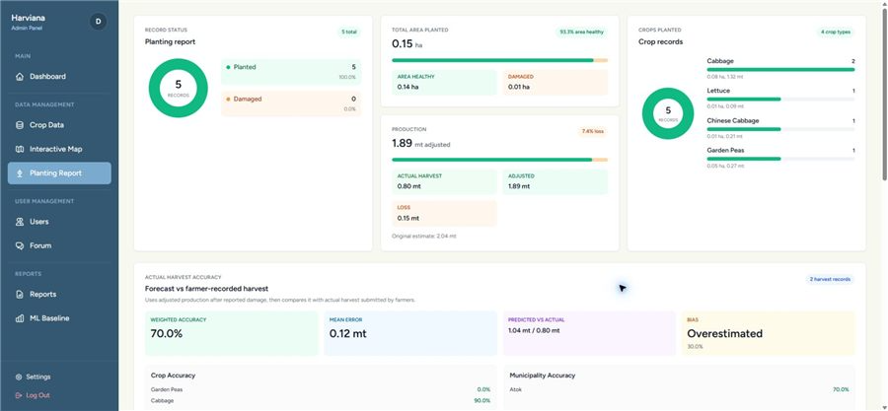
Extent of the Usability of Harviana
The extent of usability of Harviana was evaluated to determine how the system was perceived by its intended users after interacting with its major features. The evaluation focused on two user groups: farmers and DA Administrators. The farmer-side evaluation measured the usability of features such as crop planning, farmer calendar monitoring, damage report submission, and actual harvest recording. The DA Administrator-side evaluation measured the usability of features such as dashboard monitoring, interactive map and weather viewing, supply forecast review, report generation, and export of agricultural records.
The researchers used two usability instruments to evaluate the system. The System Usability Scale (SUS) was used for the farmer respondents, while the USE questionnaire was used for the DA Administrator respondents. A total of 132 valid responses were used for the farmer-side SUS evaluation, while 18 valid responses were used for the DA Administrator-side USE evaluation. These responses were analyzed according to the scoring procedures and interpretation scales of the selected usability instruments.
For the farmer evaluation, the System Usability Scale (SUS) developed by Brooke (1996) was used to measure the perceived usability of the farmer-side features of Harviana. The SUS is composed of ten statements rated using a five-point scale. For the computation, the odd-numbered items were scored by subtracting one from the participant’s response, while the even-numbered items were scored by subtracting the participant’s response from five. The adjusted scores were added together and multiplied by 2.5 to convert the result into a score ranging from 0 to 100. The interpretation of SUS scores was adapted from Bangor, Kortum, and Miller (2009).
Table 5 presents the SUS score interpretation scale used in analyzing the farmer usability results
Table 5
SUS Score Interpretation Scale
Grade | SUS Score Range | Adjective Range | Length
A- to A+  B- to B+  C- to C+  D  F | 78.9–100  72.6–78.8  62.7–72.5  51.7–62.6  0.0–51.6 | Excellent – Best Imaginable  Good to Excellent  OK to Good  OK  Worst Imaginable - Poor | Acceptable  Acceptable  Marginal - Acceptable  Marginal  Not Acceptable
Table 5 served as the basis for interpreting the overall SUS score of Harviana from the farmer perspective. Higher SUS scores indicate a more positive usability evaluation. Scores within the higher ranges suggest that users can understand and operate the system with less difficulty, while lower scores indicate that the system may require further improvement to support user interaction.
Table 6 presents the farmers’ responses to the SUS questionnaire. The values under columns 1 to 5 show the number of farmers who selected each response option. The item contribution mean shows the average score contribution of each item after applying the SUS scoring procedure.

Table 6
Farmers’ SUS Questionnaire Results
No. | Statement | 1 | 2 | 3 | 4 | 5 | Item Contribution Mean
1  2  3  4  5  6  7  8  9  10 | I think that I would like to use frequently.  I found the system  Unnecessarily complex.  I thought the system was easy to use.  I think that I would need assistance to use the system.  I found the various features of the system were well integrated.  I thought there was too much inconsistency in the system.  I would imagine that most users would learn to use the system very quickly.  I found the system very difficult to use.  I felt very confident using the system.  I needed to learn many things before I could get started with the system. | 3  44  2  34  2  50  3  45  4  32 | 4  39  3  37  6  33  8  38  10  37 | 15  25  24  31  18  31  22  34  33  30 | 46  13  53  20  52  14  48  13  42  18 | 64  11  50  10  54  4  51  2  43  15 | 3.24  2.70  3.11  2.49  3.14  2.84  3.03  2.84  2.83  2.40
As shown in Table 6, the farmer respondents generally gave favorable responses to the positive statements and lower responses to the negatively worded statements. For the positive items, many respondents selected 4 and 5, showing agreement with statements related to frequent use, ease of use, feature integration, learnability, and confidence in using Harviana. For the negative items, many respondents selected 1 and 2, showing disagreement with statements suggesting that the system was complex, inconsistent, difficult to use, or required too much learning before use.
The pattern of responses indicates that the farmers were generally able to understand and interact with the farmer-side features of Harviana. The results suggest that the crop planning, calendar, damage report, and actual harvest recording features were usable for the participating farmers. However, the presence of varied responses also suggests that some users may still need guidance or interface improvements, especially for first-time use.
After computing the SUS scores of the 132 valid farmer responses, the total SUS score obtained was 9,445. The average SUS score was computed as follows:
Average SUS Score = Σ SUS Scores / n
Average SUS Score = 9,445 / 132
Average SUS Score = 71.55 or approximately 71.6
Table 7 presents the summary of the farmers’ SUS score, including the number of valid respondents, total computed SUS score, mean score, median score, standard deviation, minimum score, maximum score, and overall interpretation. This table provides an overview of the usability result obtained from the farmer respondents after their individual SUS scores were computed and summarized.
Table 7
Summary of Farmers’ SUS Score
Measure | Result
Number of Valid Respondents  Total SUS Score  Mean SUS Score  Median SUS Score  Standard Deviation  Minimum Score  Maximum Score  Overall Interpretation | 132  9,445  71.55  75.00  15.21  32.50  97.50  OK to Good / Marginal to Acceptable
As presented in Table 7, the farmers obtained a mean SUS score of 71.55. Based on the interpretation scale, this falls within the C- to C+ range, with an adjective rating of OK to Good and an acceptability range of Marginal to Acceptable. This means that the farmer-side features of Harviana were generally usable, but there are still areas that may be improved to make the system easier and more comfortable for all farmer users.
The result shows that Harviana can support farmers in performing important crop-related tasks such as creating crop plans, viewing scheduled farm activities, submitting crop damage reports, and recording actual harvest results. Since the score is close to the acceptable range, the findings suggest that the farmer-side interface has a positive usability foundation. However, refinements in user guidance, interface clarity, and ease of first-time navigation may further improve the farmer experience.
For the DA Administrator evaluation, the USE questionnaire developed by Lund (2001) was used to evaluate the usability of the administrative side of Harviana. The questionnaire measured four dimensions: usefulness, ease of use, ease of learning, and satisfaction. These dimensions were appropriate for evaluating the DA Administrator side of the system because the administrative features are intended to support monitoring, map-based visualization, supply forecast review, and report generation.
The DA Administrators rated each statement using a seven-point scale. Higher ratings indicate stronger agreement with the usability statement and a more positive evaluation of the system. The verbal interpretation ranges were computed by the researchers based on the seven-point response scale.
Table 8 presents the seven-point USE questionnaire interpretation scale used to analyze the responses of the DA Administrators. It shows the point values, corresponding mean ranges, and verbal interpretations used to determine the level of agreement for each usability dimension. This table served as the basis for interpreting the computed weighted means for usefulness, ease of use, ease of learning, and satisfaction.

Table 8
Seven-Point USE Questionnaire Interpretation Scale
Point | Mean Range | Verbal Interpretation
1  2  3  4  5  6  7 | 1.00–1.86  1.87–2.72  2.73–3.58  3.59–4.44  4.45–5.30  5.31–6.16  6.17–7.00 | Strongly Disagree  Disagree  Somewhat Disagree  Neutral  Somewhat Agree  Agree  Strongly Agree
Table 8 was used to interpret the weighted means obtained from the DA Administrator responses. Mean values closer to 7 indicate stronger agreement and more favorable usability perception. This scale allowed the researchers to determine the usability level of Harviana’s administrative features in each USE dimension.
Table 9 presents the usability testing result for the Usefulness dimension of the USE questionnaire. It shows the responses of the DA Administrators for each usefulness-related statement, including the frequency of ratings from 1 to 7 and the computed weighted mean for each item. This table was used to determine how useful Harviana was in helping DA Administrators perform monitoring, forecasting, map viewing, and report generation tasks.

Table 9
Usefulness: Usability Testing Result for DA Administrators
No. | Statement | 1 | 2 | 3 | 4 | 5 | 6 | 7 | Weighted Mean
1  2  3  4  5  6  7  8 | It helps me be more effective.  It helps me be more productive.  It is useful.  It gives me more control over the activities in my work.  It makes the things I want to accomplish easier to get done.  It saves me time when I use it.  It meets my needs.  It does everything I would expect it to do | 0  0  0  0  0  0  0  0 | 0  0  0  0  0  0  0  0 | 0  0  0  0  0  0  0  0 | 1  1  0  2  0  0  1  2 | 4  4  1  4  1  1  2  3 | 7  6  6  7  11  10  10  9 | 6  7  11  5  6  7  5  4 | 6.00  6.06  6.56  5.83  6.28  6.33  6.06  5.83
 | Mean |  |  |  |  |  |  |  | 6.12
As shown in Table 9, the Usefulness dimension obtained a mean of 6.12, which is interpreted as Agree. This indicates that the DA Administrators generally found Harviana useful in supporting their administrative tasks. The highest-rated item was “It is useful,” with a weighted mean of 6.56, showing that the respondents recognized the value of the system in their work. The results suggest that Harviana can help DA Administrators review agricultural records, monitor crop-related information, and use system-generated data for planning and decision-making.
Table 10 presents the usability testing results for the Ease of Use dimension of the USE questionnaire. It shows the DA Administrators’ responses to each statement, including the frequency of ratings from 1 to 7 and the corresponding weighted mean. The results were used to determine how easily the respondents could navigate Harviana, understand its interface, complete administrative tasks, and recover from errors while using the system.
Table 10
Ease of Use: Usability Testing Result for DA Administrators
No. | Statement | 1 | 2 | 3 | 4 | 5 | 6 | 7 | Weighted Mean
9  10  11  12  13  14  15  16  17  18  19 | It is easy to use.  It is simple to use.  It is user-friendly.  It requires the fewest steps possible to accomplish what I want to do with it.  It is flexible.  Using it is effortless.  I can use it without instructions.  I do not notice inconsistencies as I use it.  Both occasional and regular users would like it.  I can recover from mistakes quickly and easily.  I can use it successfully every time. | 0  0  0  0  0  0  0  0  0  0  0 | 0  0  0  0  0  0  0  0  0  0  0 | 0  0  0  0  0  0  0  0  0  0  0 | 0  0  0  0  0  1  1  1  0  0  0 | 1  1  0  1  1  2  0  4  3  3  1 | 9  7  9  11  6  9  11  9  9  10  11 | 8  10  9  6  11  6  6  4  6  5  6 | 6.39  6.50  6.50  6.28  6.56  6.11  6.22  5.89  6.17  6.11  6.28
 | Mean |  |  |  |  |  |  |  | 6.27
The Ease of Use dimension obtained a mean of 6.27, which is interpreted as Strongly Agree. This result indicates that the DA Administrators found the administrative side of Harviana easy to operate. The highest-rated item was “It is flexible,” with a weighted mean of 6.56, while “It is simple to use” and “It is user-friendly” both received weighted means of 6.50. These results suggest that the administrative dashboard, map, forecast, and reporting features were generally easy to navigate and use.
The lowest-rated item under this dimension was “I do not notice inconsistencies as I use it,” with a weighted mean of 5.89. Although this still falls within the Agree range, it suggests that some minor inconsistencies or areas for interface improvement may still be present. Overall, the results show that Harviana’s administrative interface provides a positive user experience in terms of ease of use.
Table 11 presents the usability testing result for the Ease of Learning dimension.
Table 11
Ease of Learning: Usability Testing Result for DA Administrators
No. | Statement | 1 | 2 | 3 | 4 | 5 | 6 | 7 | Weighted Mean
20  21  22  23 | I learned to use it quickly.  I easily remember how to use it.  It is easy to learn to use it.  I quickly became skillful with it. | 0  0  0  0 | 0  0  0  0 | 0  0  0  0 | 0  0  0  0 | 0  0  0  0 | 7  7  5  8 | 11  11  13  9 | 6.61  6.61  6.72  6.39
 | Mean |  |  |  |  |  |  |  | 6.58
As presented in Table 11, the Ease of Learning dimension obtained a mean of 6.58, interpreted as Strongly Agree. This was the highest among the four USE dimensions. The result indicates that DA Administrators were able to understand and learn the administrative features of Harviana quickly. The highest-rated item was “It is easy to learn to use it,” with a weighted mean of 6.72.
This finding suggests that the system’s administrative interface was understandable even for users who may be using the platform for the first time. The dashboard layout, map filters, forecast display, and report functions appear to be structured in a way that allows users to learn the system with minimal difficulty. This is important because DA Administrators need to access and interpret agricultural information efficiently.
Table 12 presents the usability testing result for the Satisfaction dimension.
Table 12
Satisfaction: Usability Testing Result for DA Administrators
No. | Statement | 1 | 2 | 3 | 4 | 5 | 6 | 7 | Weighted Mean
24  25  26  27  28  29  30 | I am satisfied with it.  I would recommend it to a colleague.  It is pleasant to use.  It works the way I want it to work.  It is wonderful.  I feel I need to have it.  It meets my needs. | 0  0  0  0  0  0  0 | 0  0  0  0  0  0  0 | 0  0  0  0  0  0  0 | 0  1  0  0  0  0  0 | 2  1  2  3  1  4  2 | 9  7  9  9  8  6  8 | 7  9  7  6  9  8  8 | 6.28  6.33  6.28  6.17  6.44  6.22  6.33
 | Mean |  |  |  |  |  |  |  | 6.29
As shown in Table 12, the Satisfaction dimension obtained a mean of 6.29, interpreted as Strongly Agree. This indicates that the DA Administrators were highly satisfied with the administrative features of Harviana. The highest-rated item was “It is wonderful,” with a weighted mean of 6.44, while the lowest-rated item was “It works the way I want it to work,” with a weighted mean of 6.17. Since even the lowest-rated item still falls within the Strongly Agree range, the results show a consistently positive satisfaction level.
The satisfaction results suggest that the DA Administrators found Harviana beneficial and acceptable for their work. The system’s ability to present dashboards, map-based agricultural information, supply forecasts, and exportable reports contributed to a positive administrative user experience. These findings support the system’s purpose of helping DA Administrators access and review agricultural records in a more organized and useful manner.
Table 13 presents the overall USE questionnaire result for DA Administrators.
Table 13
Overall USE Questionnaire Result for DA Administrators
Use Dimension | Mean | Verbal Interpretation
Usefulness  Ease of Use  Ease of Learning  Satisfaction | 6.12  6.27  6.58  6.29 | Agree  Strongly Agree  Strongly Agree  Strongly Agree
Overall Result | 6.32 | Strongly Agree
Table 13 shows that the DA Administrator side of Harviana obtained an overall USE result of 6.32, interpreted as Strongly Agree. The overall result was computed from the mean scores of the four USE dimensions. The highest dimension was Ease of Learning, followed by Satisfaction, Ease of Use, and Usefulness. These findings indicate that the administrative side of Harviana was positively evaluated by the DA Administrator respondents.
The results show that Harviana was perceived as useful for administrative monitoring and reporting, easy to use when navigating system features, easy to learn for users interacting with the platform, and satisfactory in supporting administrative tasks. This confirms that the DA Administrator-side features of Harviana were able to support agricultural monitoring, map-based visualization, supply forecast review, and report generation in a usable manner.
Table 14 presents the overall usability summary of Harviana based on the two user groups.
Table 14
Overall Usability Summary of Harviana
User Group | Usability | Valid Respondents | Overall Result | Interpretation
Farmers  DA Administrators | System Usability Scale (SUS)  USE Questionnaire | 132  18 | 71.55/100  6.32/7 | OK to Good / Marginal to Acceptable  Strongly Agree
As presented in Table 14, Harviana received positive usability results from both participating user groups. The farmer-side features obtained a SUS score of 71.55, interpreted as OK to Good and Marginal to Acceptable. This means that the farmer-side features were generally usable, but may still be improved to provide a smoother experience for all farmer users. The result suggests that farmers can use Harviana for crop planning, farmer calendar monitoring, damage report submission, and actual harvest recording.
The DA Administrator-side features obtained an overall USE result of 6.32, interpreted as Strongly Agree. This indicates that DA Administrators found the system useful, easy to use, easy to learn, and satisfactory. The result supports the role of Harviana as a decision-support system that helps DA Administrators monitor agricultural data, view map-based information, review supply forecasts, and generate reports.
Overall, the usability findings show that Harviana was able to meet the usability needs of its evaluated users. The farmer-side features demonstrated a usable and acceptable foundation, while the DA Administrator-side features received a strong positive evaluation. These results suggest that Harviana can support agricultural data collection, validation-based reporting, map-based visualization, supply forecasting, and administrative decision-making through a usable web-based platform.

REFERENCES
Agricultural Training Institute. (2023). Philippine Agriculture and Fisheries Extension Strategic Plan 2023-2028. Agricultural Training Institute. https://ati2.da.gov.ph/ati-main/content/sites/default/files/2023-08/AFE%20Strat%20Plan%202023-2028.pdf
Agricultural Training Institute. (n.d.). e-Extension Program for Agriculture and Fisheries. Retrieved July 8, 2026, from https://www.e-extension.gov.ph/
Alemán-Montes, B., Serra, P., Zabala, A., Masó, J., & Pons, X. (2025). A near real-time spatial decision support system for improving sugarcane monitoring through a satellite mapping web browser. Smart Agricultural Technology, Article 101084. https://doi.org/10.1016/j.atech.2025.101084
Ali, A. M., Abouelghar, M., Belal, A. A., Saleh, N., Yones, M., Selim, A. I., Amin, M. E. S., Elwesemy, A., Kucher, D. E., Maginan, S., & Savin, I. (2022). Crop yield prediction using multi sensors remote sensing: Review article. The Egyptian Journal of Remote Sensing and Space Science, 25(3), 711–716. https://doi.org/10.1016/j.ejrs.2022.04.006
Aquino, L. L. M., Delos Reyes, J. A., & Catelo, M. A. O. (2025). Mapping and understanding food value chain networks of Benguet-sourced vegetables: The lens of the households. University of the Philippines Center for Integrative and Development Studies. https://cids.up.edu.ph/wp-content/uploads/2025/03/Mapping-and-Understanding-Food-Value-Chain-Networks-of-Benguet-Sourced-Vegetables.pdf
Briones, R. M., Galang, I. M. R., & Latigar, J. S. (2023). Transforming Philippine agri-food systems with digital technology: Extent, prospects, and inclusiveness (PIDS Discussion Paper Series No. 2023-29). Philippine Institute for Development Studies. https://doi.org/10.62986/dp2023.29
Brooke, J. (1996). SUS: A quick and dirty usability scale. In P. W. Jordan, B. Thomas, B. A. Weerdmeester, & I. L. McClelland (Eds.), Usability evaluation in industry. Taylor & Francis. https://doi.org/10.1201/9781498710411-35
CGIAR. (2024). In the Philippines, stakeholders are charting the future of digital agriculture. https://www.cgiar.org/news-events/news/in-the-philippines-stakeholders-are-charting-the-future-of-digital-agriculture
Cui, L., Li, W., Wang, X., & Niu, X. (2022). Design and implementation of open-source WebGIS system for orchard land management. Advances in Computer, Signals and Systems, 6, 26–34. https://doi.org/10.23977/acss.2022.060304
Department of Agriculture. (2022). National Agriculture and Fisheries Modernization and Industrialization Plan 2021-2030: Transforming the Philippine food system together. Department of Agriculture. https://www.bswm.da.gov.ph/download/national-agriculture-and-fisheries-modernization-and-industrialization-plan-2021-2030/
Food and Agriculture Organization of the United Nations. (2022). The State of Food and Agriculture 2022: Leveraging automation in agriculture for transforming agrifood systems. FAO. https://doi.org/10.4060/cb9479en
Food and Agriculture Organization of the United Nations, & International Telecommunication Union. (2016). E-agriculture strategy guide: Piloted in Asia-Pacific countries. FAO and ITU. https://www.itu.int/dms_pub/itu-d/opb/str/D-STR-E_AGRICULT.01-2016-PDF-E.pdf
Jabed, M. A., & Azmi Murad, M. A. (2024). Crop yield prediction in agriculture: A comprehensive review of machine learning and deep learning approaches, with insights for future research and sustainability. Heliyon, 10, Article e40836. https://doi.org/10.1016/j.heliyon.2024.e40836
Lund, A. M. (2001). Measuring usability with the USE questionnaire. Usability Interface, 8(2), 3–6. https://garyperlman.com/quest/quest.cgi?form=USE
National Economic and Development Authority. (2023). Philippine Development Plan 2023-2028. https://pdp.depdev.gov.ph/philippine-development-plan-2023-2028/
Organisation for Economic Co-operation and Development. (2019). Digital opportunities for better agricultural policies. OECD Publishing. https://doi.org/10.1787/571a0812-en
PAGASA. (n.d.). Climate of the Philippines. Retrieved July 8, 2026, from https://www.pagasa.dost.gov.ph/information/climate-philippines
Patel, S., Kaur, B., Verma, S., Sood, A., Litoria, P. K., & Pateriya, B. (2023). Web GIS based decision support system for agriculture monitoring and management. Geoinformatics & Geostatistics: An Overview, 11(1). https://www.scitechnol.com/peer-review/web-gis-based-decision-support-system-for-agriculture-monitoring-and-management-3yKT.php?article_id=21228
Philippine Statistics Authority RSSO-CAR. (2025, March 27). CY 2024 Cordillera vegetables situationer (Reference No. SSR 2025-12). https://rssocar.psa.gov.ph/content/cy-2024-cordillera-vegetables-situationer
Pilay, J. G., & Werdenberg, A. J. M. (2024). Forecasting vegetable production in Benguet, Philippines using SARIMA process with mathematical transformations. AIP Conference Proceedings, 3016(1), Article 070009. https://doi.org/10.1063/5.0192466
Quitaleg, A. R., & Dumlao, M. (2023). A decision support system for Benguet’s upland vegetable crop prediction using machine learning techniques. European Chemical Bulletin, 12(Special Issue 6). https://doi.org/10.48047/ecb/2023.12.si6.655
Raihan, A. (2024). A systematic review of Geographic Information Systems (GIS) in agriculture for evidence-based decision making and sustainability. Global Sustainability Research, 3(1), 1–24. https://doi.org/10.56556/gssr.v3i1.636
Stephenson, J., Chellew, T., von Köckritz, L., Rose, A., & Dinesh, D. (2021). Digital agriculture to enable adaptation: A supplement to the UNFCCC NAP Technical Guidelines (CCAFS Working Paper No. 372). CGIAR Research Program on Climate Change, Agriculture and Food Security. https://unfccc.int/sites/default/files/resource/CCAFS_NAP_Agriculture_Supplement.pdf
World Bank. (2020). Transforming Philippine agriculture: During COVID-19 and beyond. World Bank. https://doi.org/10.1596/34012
World Bank, Gates Foundation, & Boston Consulting Group. (2025). Digital Agriculture Roadmap Playbook. World Bank. https://documents1.worldbank.org/curated/en/099053025063021993/pdf/P508004-f943a09b-c45f-4c93-b554-9dd1decd1e7c.pdf
Wu, B., Zhang, M., Zeng, H., Tian, F., Potgieter, A. B., Qin, X., Yan, N., Chang, S., Zhao, Y., Dong, Q., Boken, V., Plotnikov, D., Guo, H., Wu, F., Zhao, H., Deronde, B., Tits, L., & Loupian, E. (2023). Challenges and opportunities in remote sensing-based crop monitoring: A review. National Science Review, 10(4), Article nwac290. https://doi.org/10.1093/nsr/nwac290
Bangor, A., Kortum, P., & Miller, J. (2009). Determining what individual SUS scores mean: Adding an adjective rating scale. Journal of Usability Studies, 4(3), 114–123. https://dl.acm.org/doi/10.5555/2835587.2835589

APPENDICES
Appendix A
Communication Letter
Appendix B
Endorsement Letter
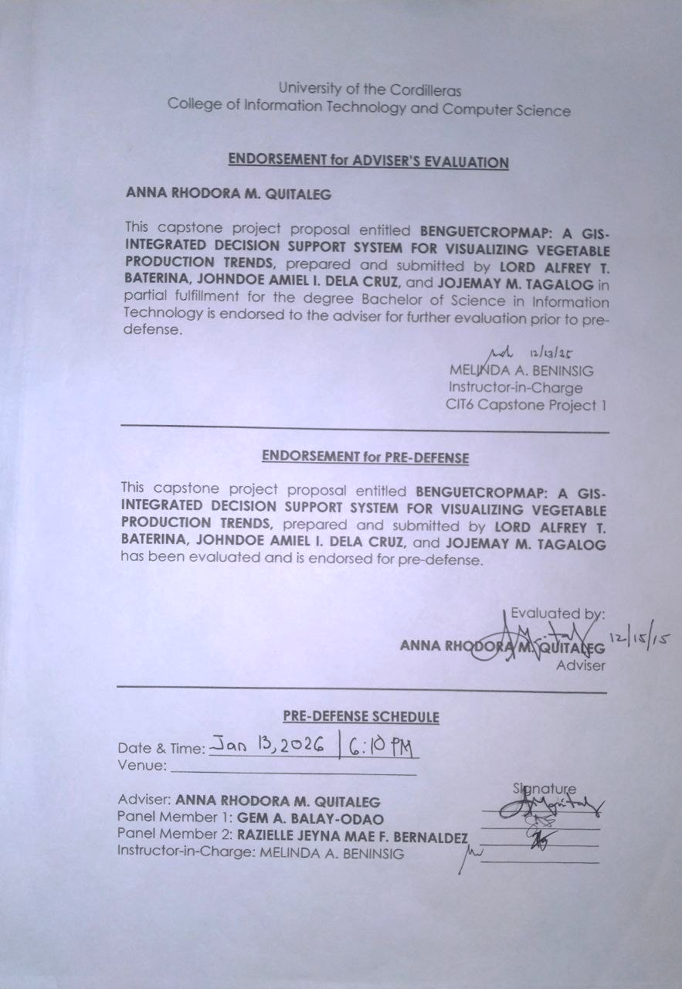

Appendix C
Business Model Canvas
Figure 20
Business Model Canvas
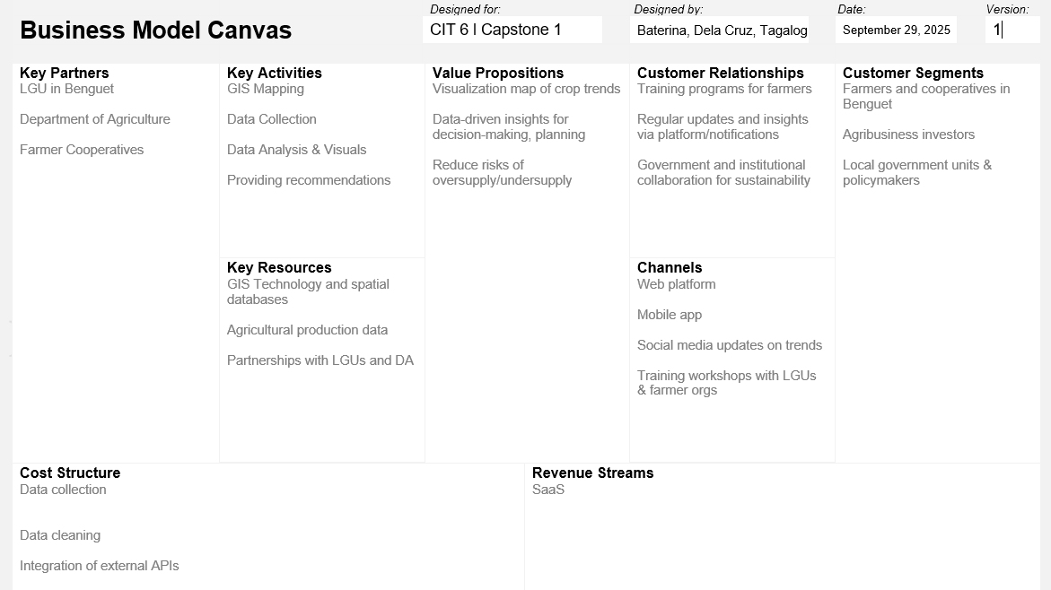
Figure 20, showing the Business Model Canvas for the Harviana system, identifies Customer Segments as the Farmers and DA Administrators/Agricultural Officers as part of a Multi-sided Platform. The primary Value Propositions include an accessible, user-friendly visual map and a decision support system that provides long-term forecasting (2025 to 2030), helping administrators design targeted actions to reduce waste and loss. The system is deployed via Channels that include browsers and a Progressive Web App using open-source web-mapping tools to maximize
accessibility. Customer Relationships are built and maintained through features like the Historical Analysis validation mode, which helps establish user trust by comparing predictions against known historical yields. Revenue Streams are projected to come from Subscription Fees, Licensing, Usage fees, and Grants, following a Value-Driven pricing strategy. Key Resources include the human development team, intellectual property, and physical infrastructure, while Key Activities focus on Production (development), Problem Solving (insights/forecasting), and maintaining the platform. Key Partners are sought to acquire necessary resources and activities, specifically the DA for historical production data.
Appendix D
Invitation Letter
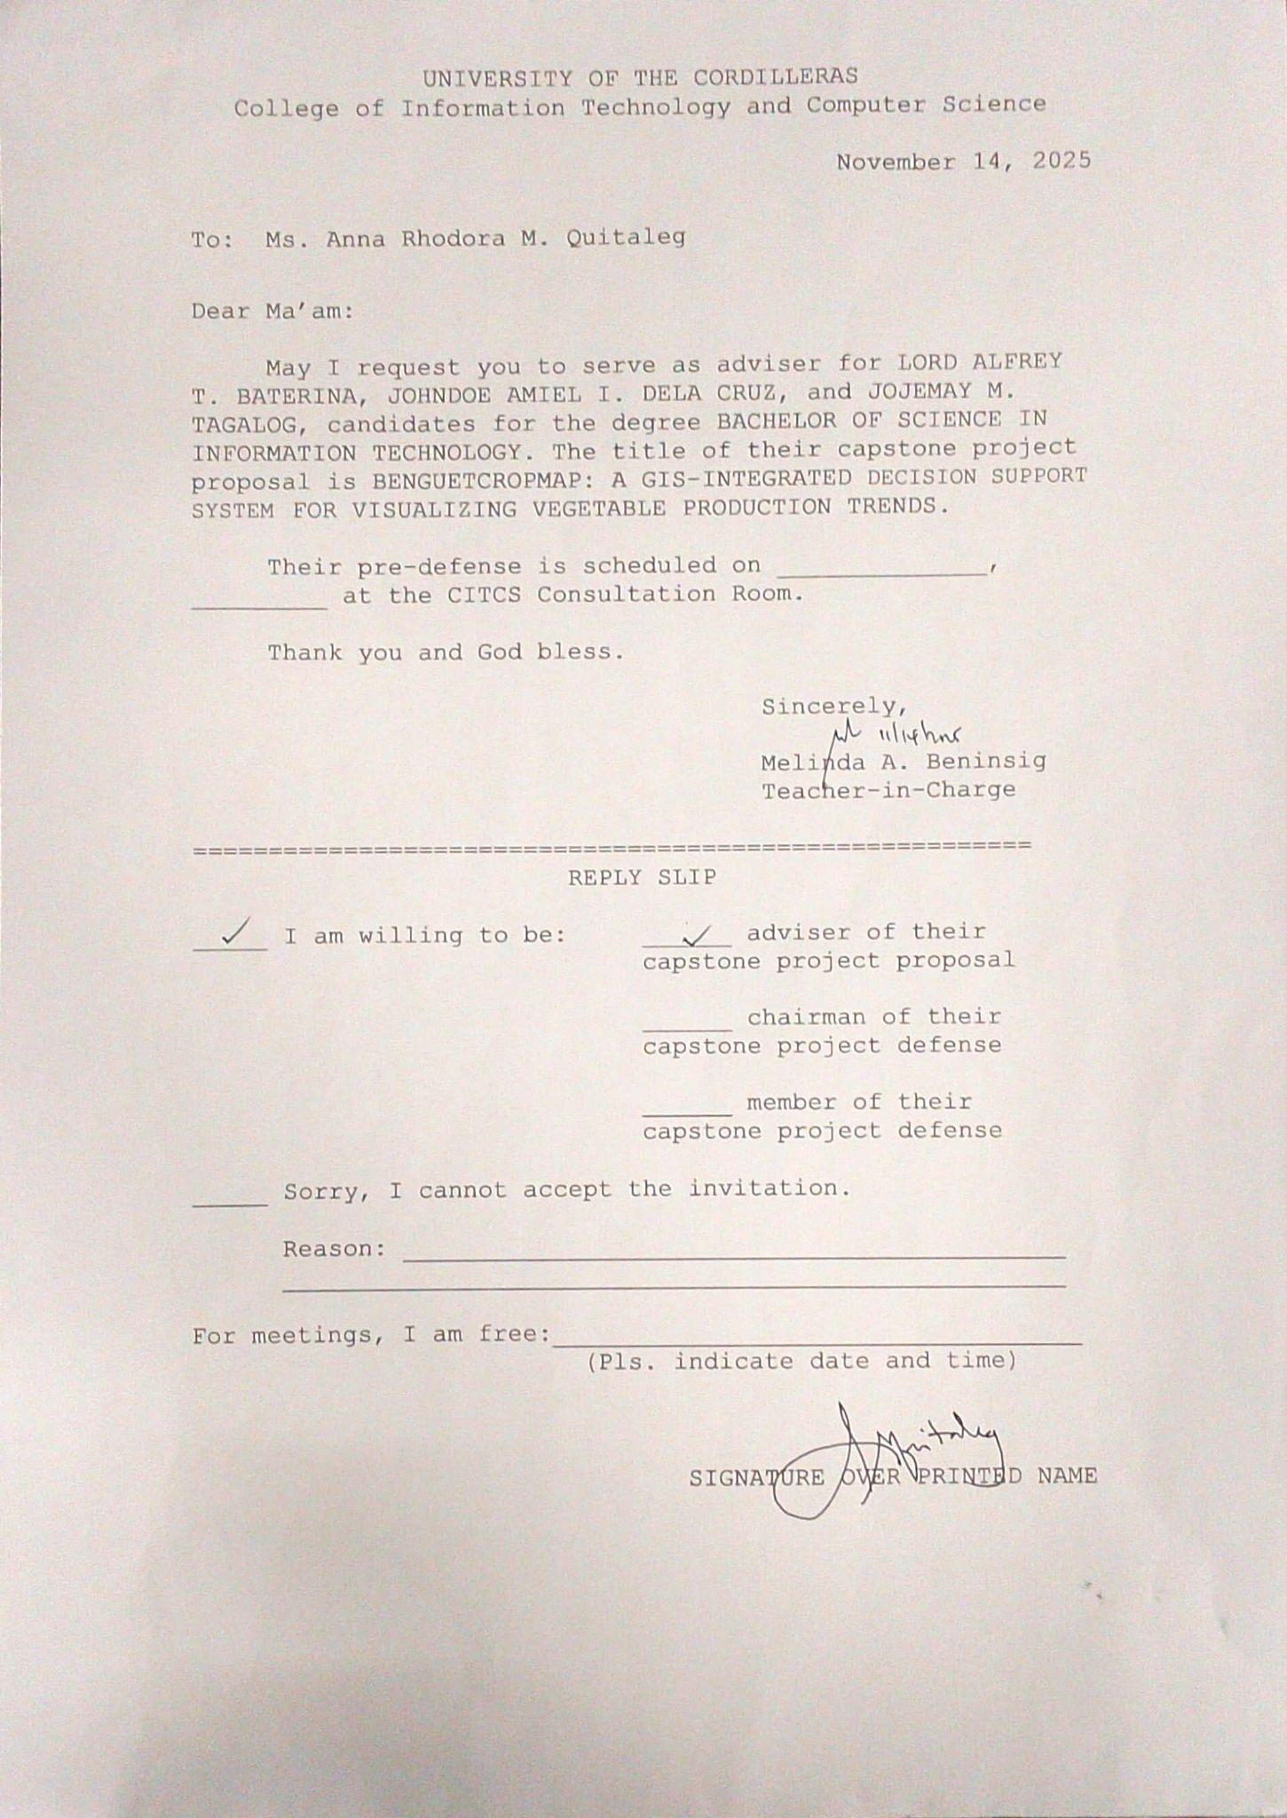
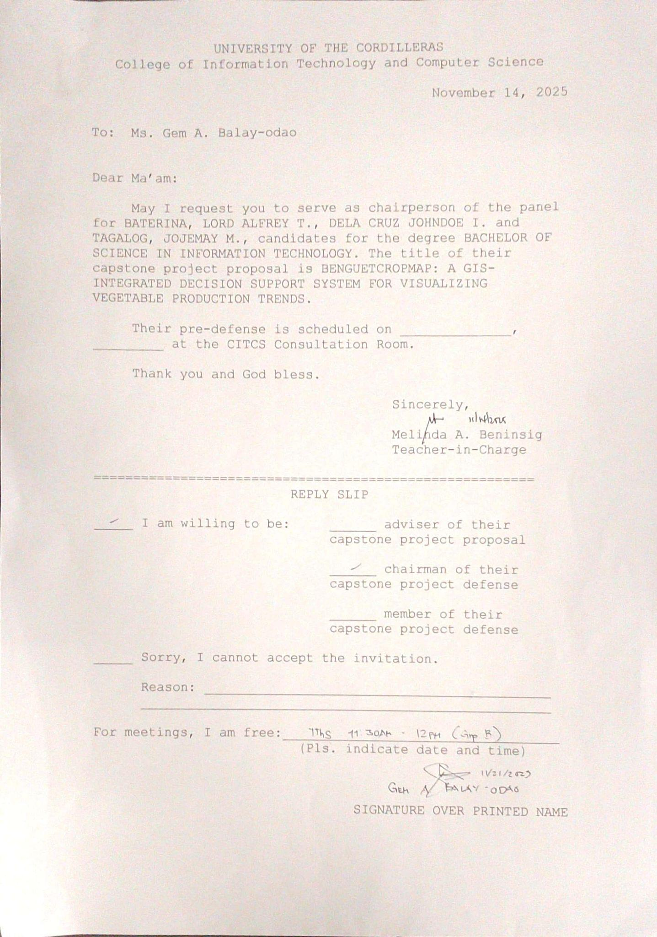
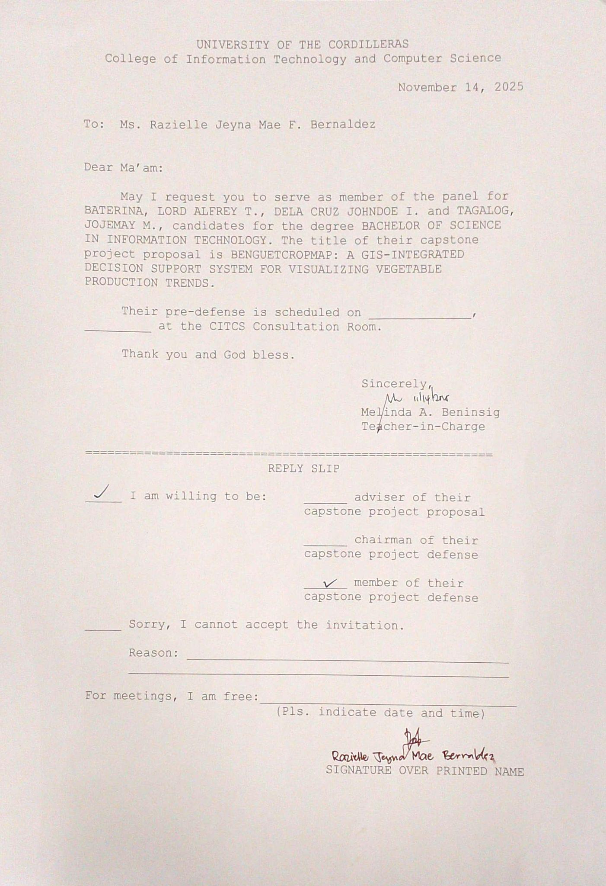
Appendix E
Documentation
