1. A. This can’t occur. Since each VC number is two bits and there are 4 links carrying 2 VCs each it is impossible to assign a number to the new virtual circuit as there aren’t any numbers available for it to use. So a new VC with all the links can’t be established properly with only 2 bit numbers.

B. There are 4 total links and each link has two VCs. Each individual link has four possible combinations and there are four links, so there are two to the fourth possible combinations which is 16.

C. 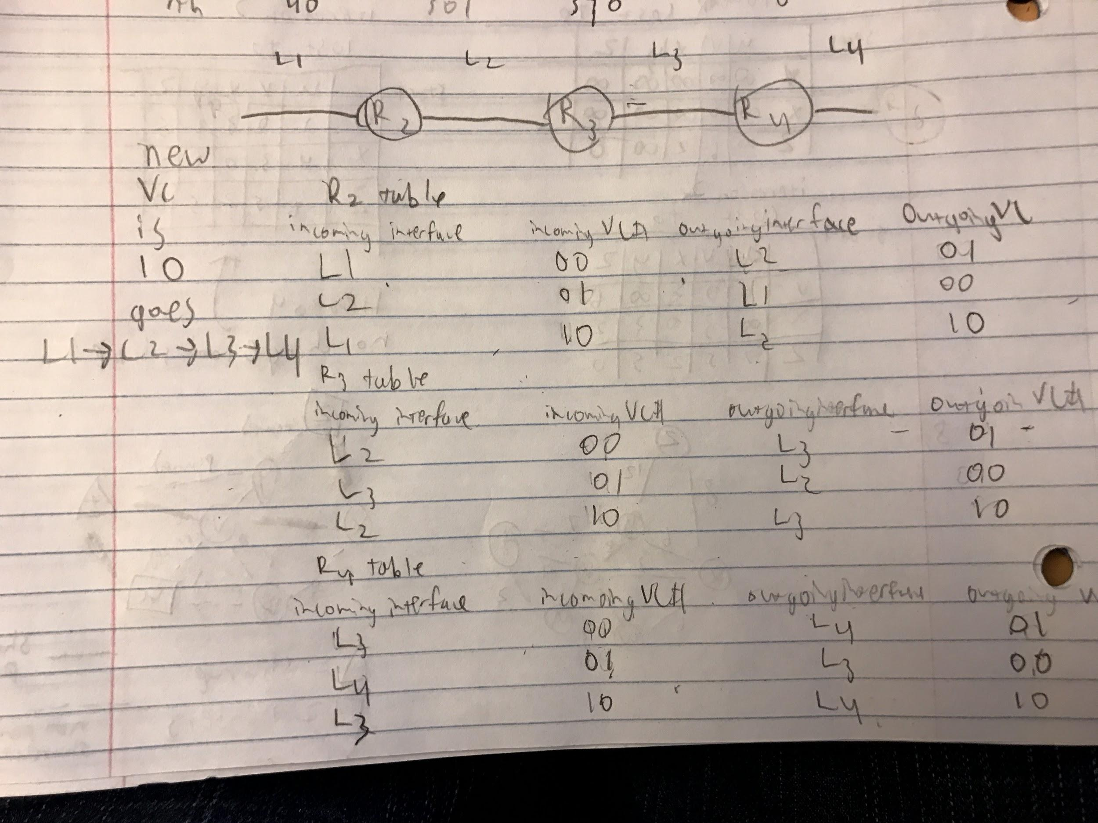

1. A.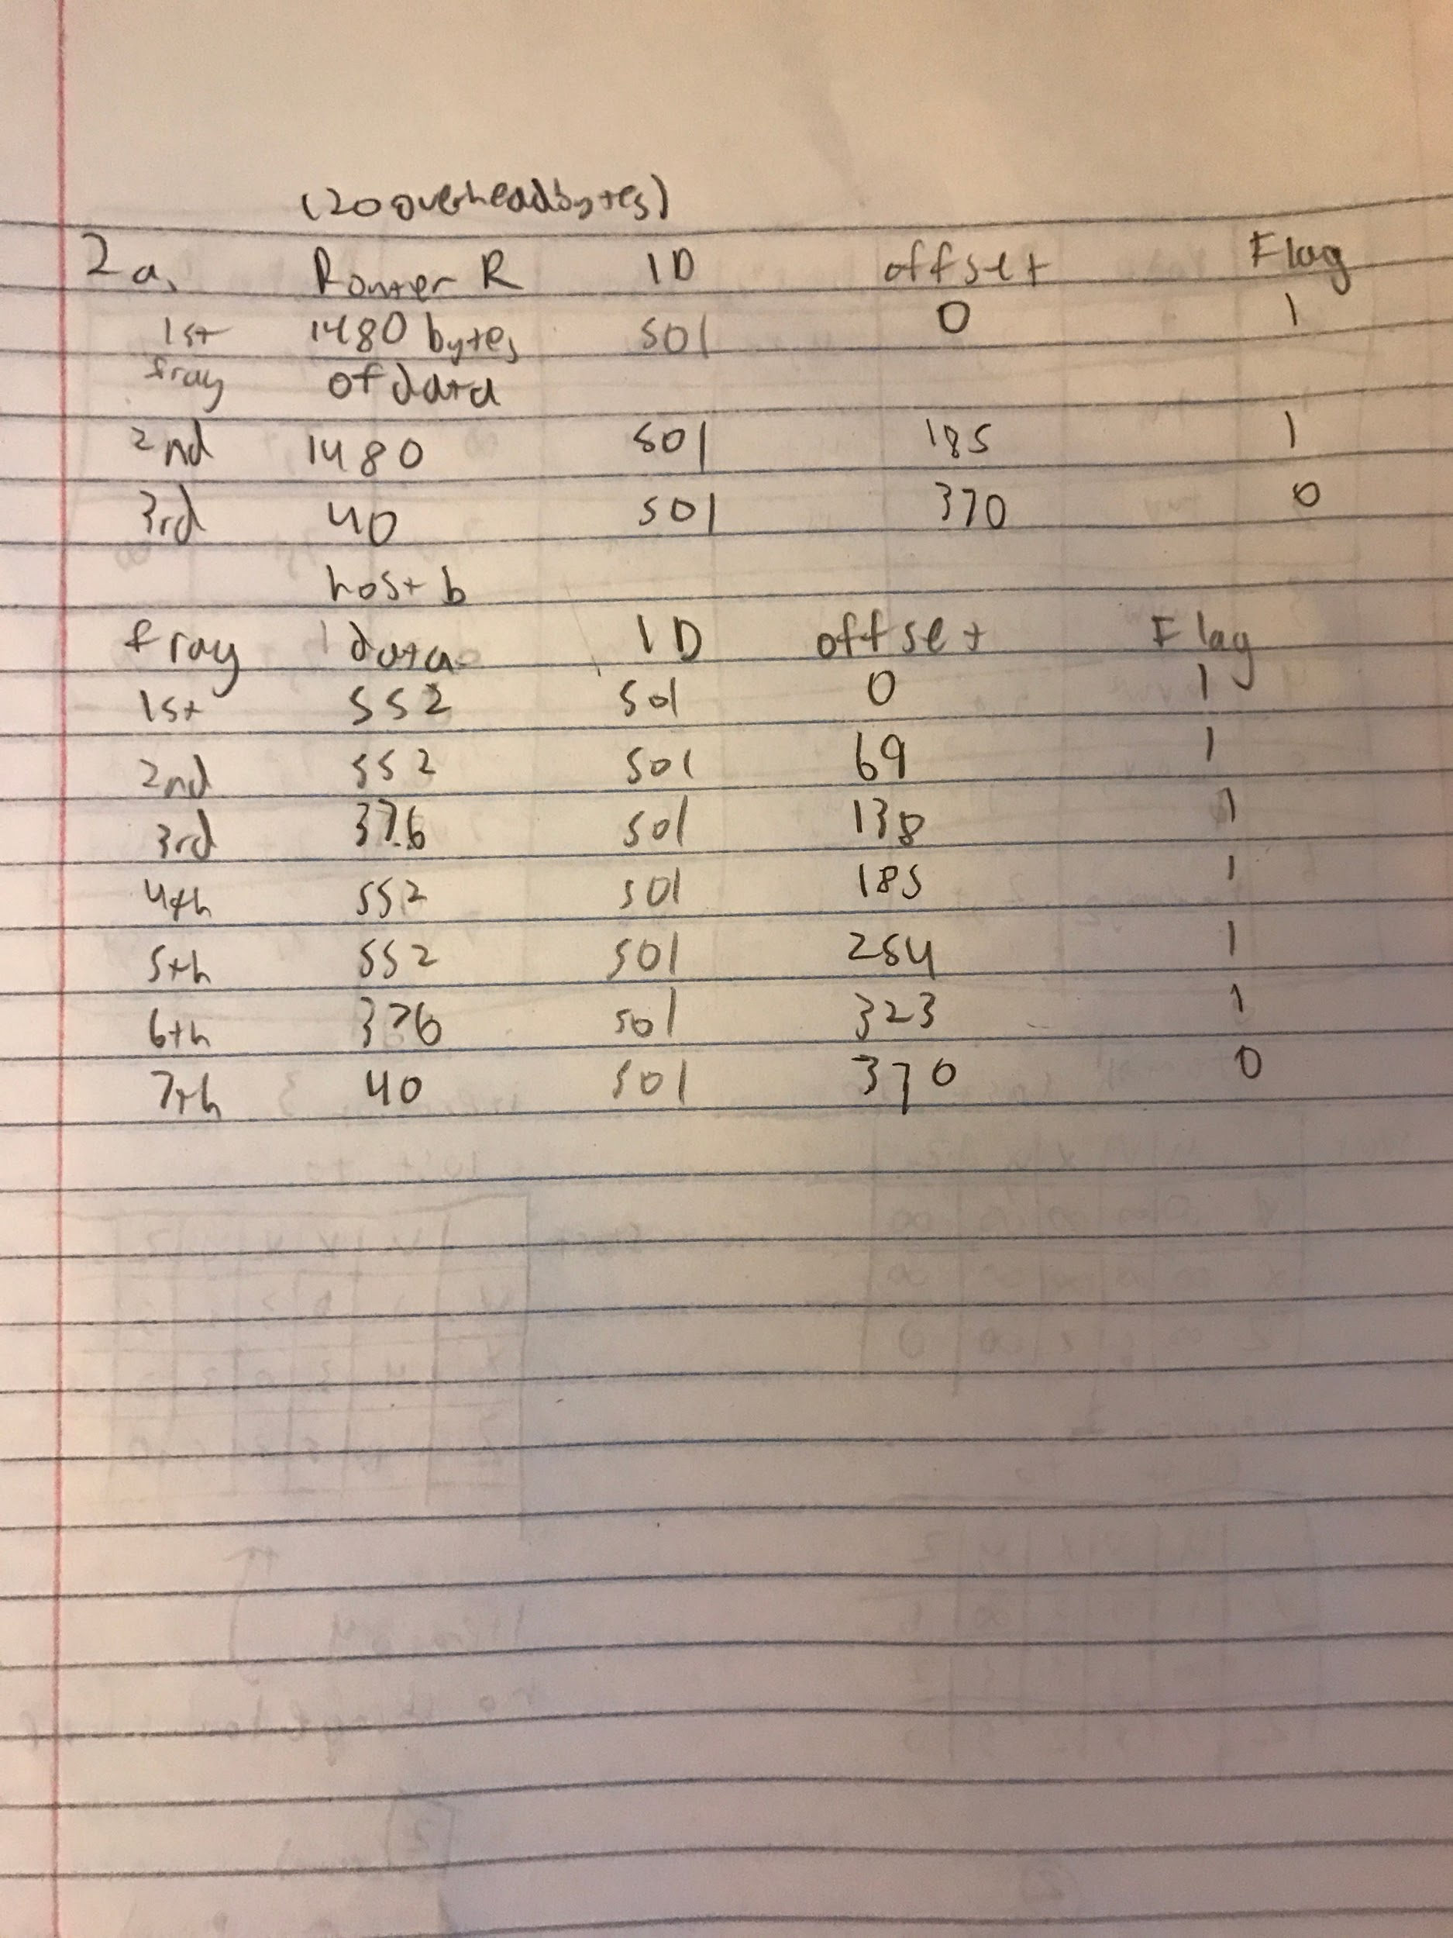

B. The main problem with increasing the chunk size is that if the MTU is say 40, and the chuck size of the offset is 32 bytes you wouldn’t even be able to transmit any data. Keeping it small at 8 with an overhead of 20 bytes helps avoid this problem. A smaller potential inefficiency would be it is less common for numbers to divide by 32 as opposed to 8, so instead of transmitting say 552 bits you could only transmit 544 bits in that fragment. This problem would get worse the larger the offset chunk size.

C. First a 480 byte fragment would arrive from R1 to R3 B. After that a 1000 byte fragment (or smaller if not needed) would arrive from R2 to R3 to B. This would continue. So basically each fragment from Host A will be split into 2 at R0 with R1 transmitting the first part and R2 transmitting the rest. Unless of course R1 can transmit the whole thing.

1. A. 154.16.52.16/20 (20 bits of masking)

B. 154.16.48.0 - 154.16.63.255 is the range of addresses possible on the subnet

C. There are 20 mask bits so 2^20 = 1048576

1. # of addresses for link interface 0 = 64

# of addresses for link interface 1 = 32

# of addresses for link interface 2 = 32 for 011 and 64 for 10 for 96 total

# of addresses for link interface 3 = 64

1. See pic
2. See Pic
3. The table for D will not change. D currently has information from B saying it can get to z in 7 hops, so A providing that it can do it in 10 is not faster, so the data will not be updated in D’s table. If it was less than 7 than it would be.
4. 