**Report Individual Project**

**Name: Rohit Kumar Malik**

**UFID: 94711368**

**Steps to run the script:**

1. install the following packages.

caret, datasets, rpart, klaR, RWeka, MASS, e1071, ggplot2, tree, party, oblique.tree, partykit

1. put the life_expectancy.csv file in along with the script file.
2. to install all the packages please uncomment all the install.packages statement
3. launch and run the project1.R script to produce the results.

**Note: I have removed the functions as I was facing issues in reproducing the results. All the classifications are separated by comments**

**Results:**

**Iris Dataset Analysis:**

**Desion Tree: RIPPER**

**Prediction setosa versicolor virginica**

setosa 10 0 0

versicolor 0 8 0

virginica 0 2 10

Accuracy : 0.9333

Recall 1.0000 0.8000 1.0000

Precision 1.0000 1.0000 0.8333

F-Measure 1.0000 .89 .907

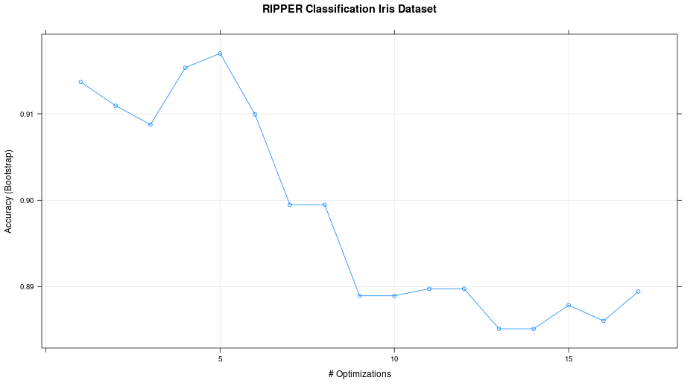

**C4.5: Confusion Matrix**

**Prediction setosa versicolor virginica**

setosa 10 0 0

versicolor 0 9 0

virginica 0 1 10

Accuracy : 0.9667

Recall: 1.0000 0.9000 1.0000

Precision: 1.0000 1.0000 0.9091

F-Measure: 1.0000 .95 .952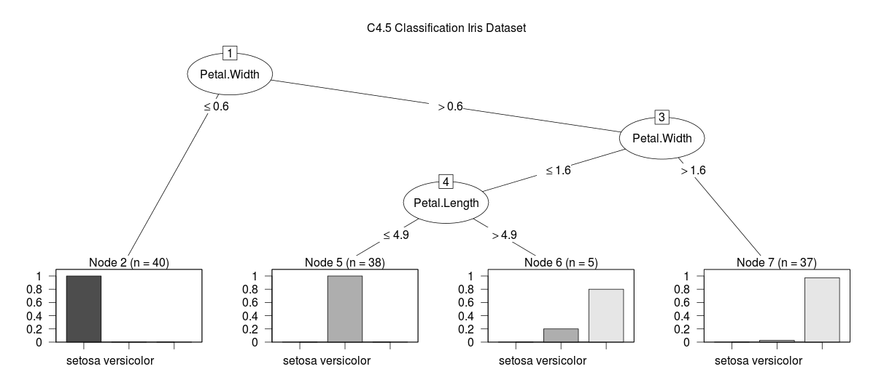

**ObliqueTree:Confusion Matrix**

setosa versicolor virginica

setosa 10 0 0

versicolor 0 9 0

virginica 0 1 10

Accuracy : 0.9667

Recall: 1.0000 0.9000 1.0000

Precision: 1.0000 1.0000 0.9091

F-Measure: 1.0000 .95 .952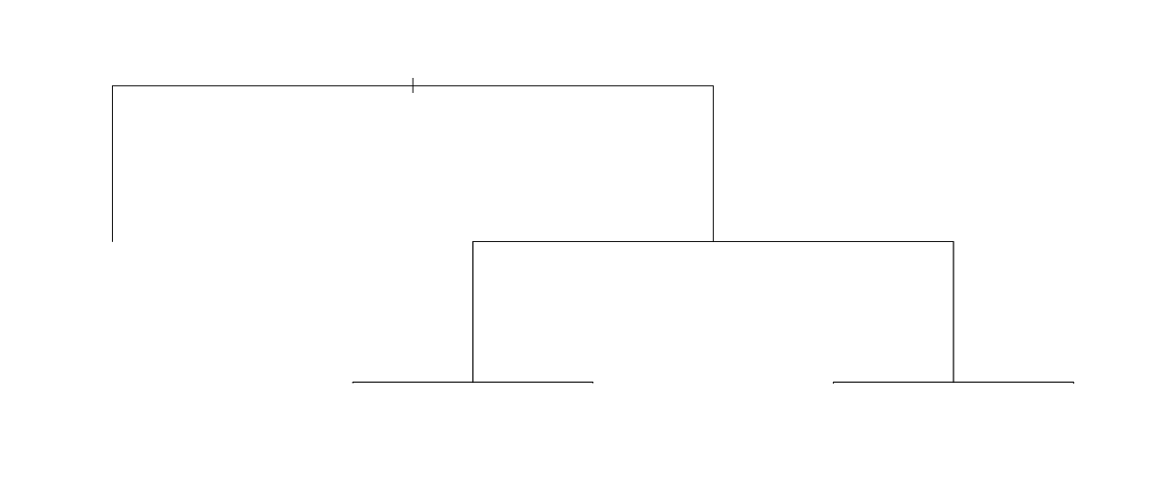

**NaiveBase: Confusion Matrix**

setosa versicolor virginica

setosa 10 0 0

versicolor 0 10 0

virginica 0 0 10

Accuracy: 1

Recall 1.0000 1.0000 1.0000

Precision 1.0000 1.0000 1.0000

F-Measure 1.0000 1.0000 1.0000

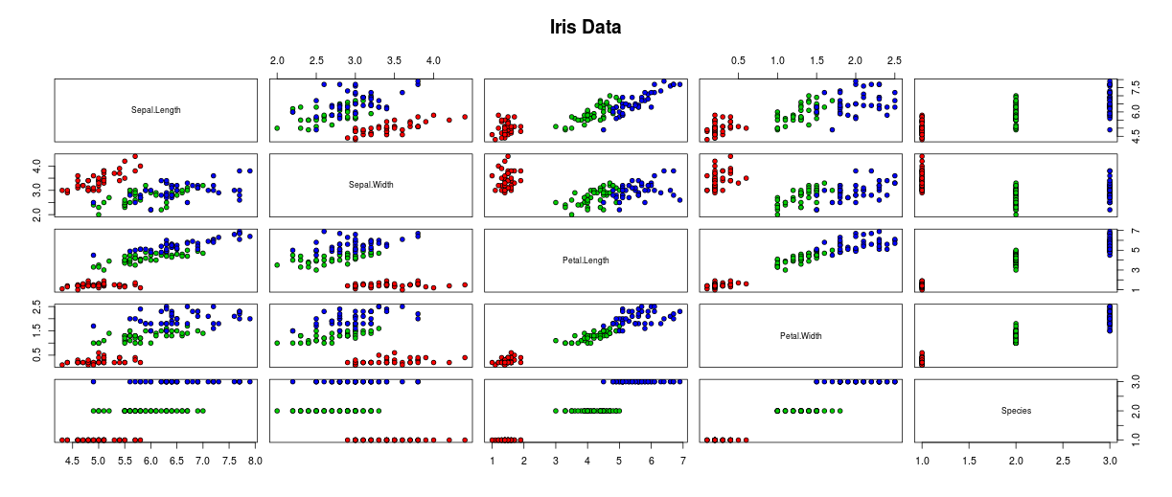

**KNN: Confusion Matrix** setosa versicolor virginica

setosa 10 0 0

versicolor 0 9 1

virginica 0 1 9

Accuracy : 0.9333

Recall 1.0000 0.9000 0.9000

Precision 1.0000 0.9000 0.9000

F-Measure 1.0000 0.9 .9

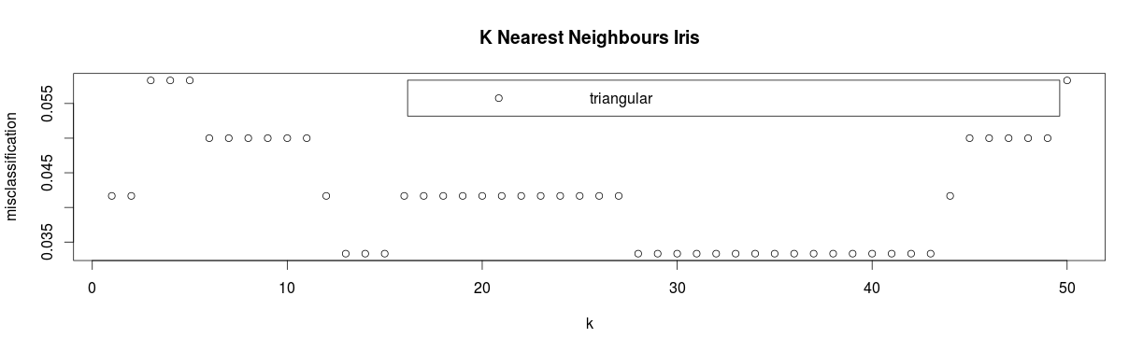

**LifeExpectancy Dataset**

**Desion Tree: (RIPPER)**

**Confusion Matrix:**

Prediction Africa Asia Europe North America South America

Africa 6 1 0 1 0

Asia 4 9 4 3 1

Europe 0 2 4 0 1

North America 0 0 0 0 0

South America 0 0 0 0 0

Accuracy : 0.5278

Recall 0.6000 0.7500 0.5000 0.0000 0.00000

Precision 0.7500 0.4286 0.5714 NaN NaN

F-Measure 0.67 0.545 0.533 NaN NaN

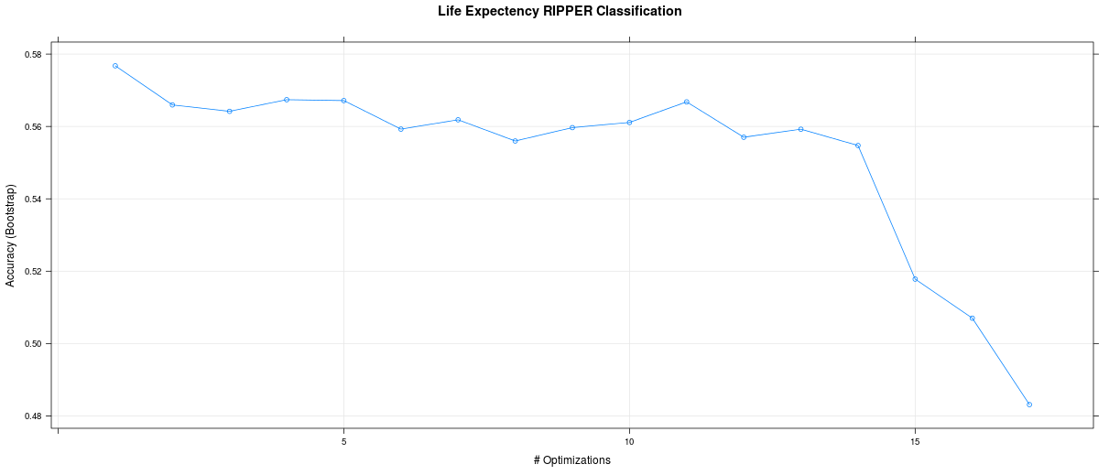

**C4.5:**

**Confusion Matrix**

Prediction Africa Asia Europe North America South America

Africa 7 1 0 1 0

Asia 3 6 2 2 0

Europe 0 3 3 0 1

North America 0 2 2 1 1

South America 0 0 1 0 0

Accuracy : 0.4722

Recall 0.7000 0.5000 0.37500 0.25000 0.00000

Precision 0.7778 0.4615 0.42857 0.16667 0.00000

F-Measure 0.74 0.48 0..4 0.20 .000000

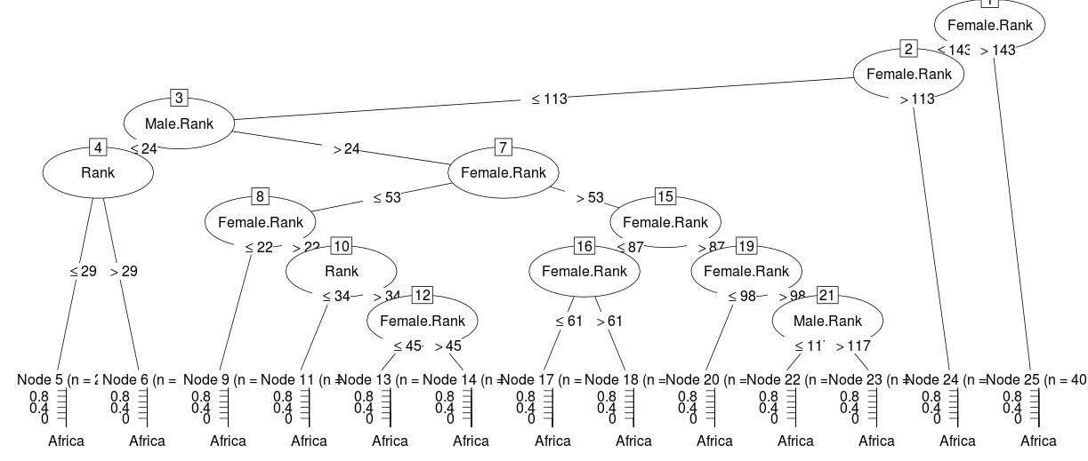

**ObliqueTree:**

Prediction Africa Asia Europe North America South America

Africa 6 0 0 1 0

Asia 4 6 1 2 1

Europe 0 2 6 0 1

North America 0 4 1 1 0

South America 0 0 0 0 0

Accuracy : 0.5278

Recall 0.6000 0.5000 0.7500 0.25000 0.00000

Precision 0.8571 0.4286 0.6667 0.16667 NaN

F-Measure 0.705 0.461 0.705 0.20 NaN

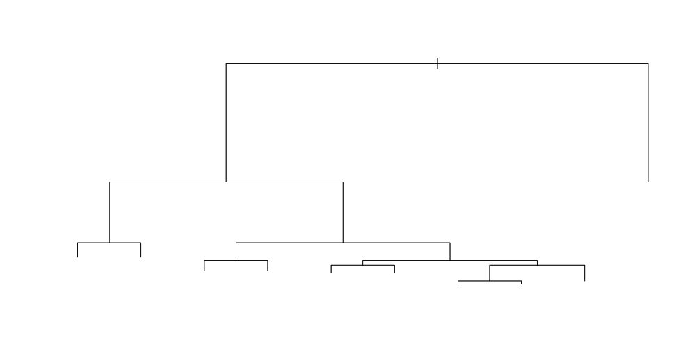

**NaiveBase:** Confusion Matrix

Prediction Africa Asia Europe North America South America

Africa 9 2 0 0 0

Asia 0 4 1 1 0

Europe 0 3 5 1 1

North America 1 3 2 2 1

South America 0 0 0 0 0

Accuracy : 0.5556

Recall 0.9000 0.3333 0.6250 0.50000 0.00000

Precision 0.8182 0.6667 0.5000 0.22222 NaN

F-Measure 0.857 0.4444 0.5555 0.3076 NaN

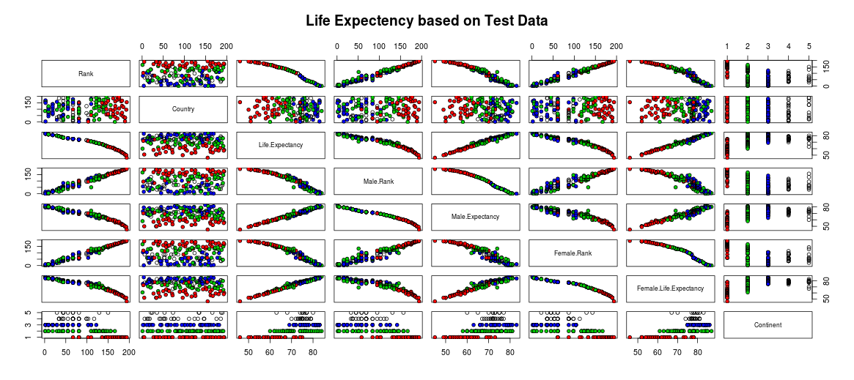

**K Nearest Neighbours:**Prediction Africa Asia Europe North America South America

Africa 8 1 0 2 0

Asia 2 3 0 0 1

Europe 0 4 8 2 1

North America 0 4 0 0 0

South America 0 0 0 0 0

Accuracy : 0.5278

Recall 0.8000 0.25000 1.0000 0.0000 0.00000

Precision 0.7273 0.50000 0.5333 0.0000 NaN

F-Measure 0.762 0.33 0.695 0.0000 NaN

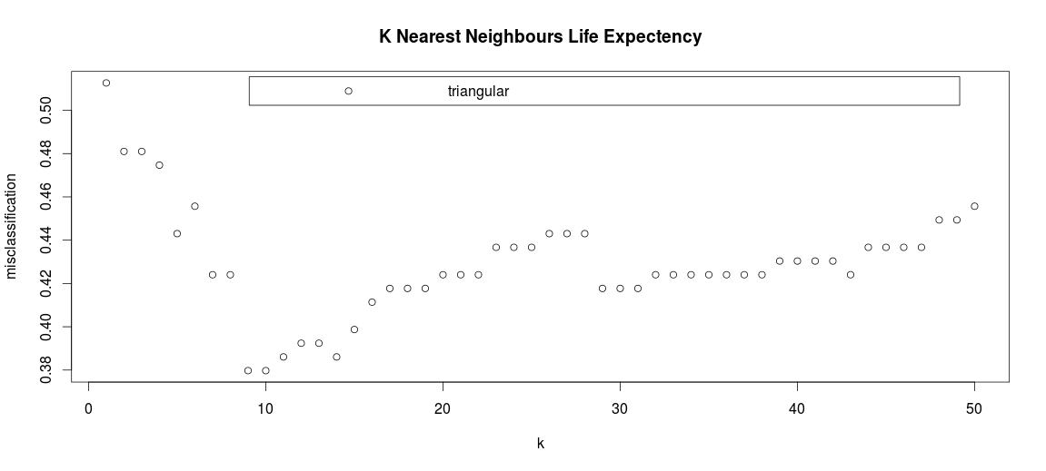

**Conclusion:**

In case of the Iris data set Naive Bayes method is having the Highest accuracy.

RIPPER Method Accuracy : 0.9333

C4.5 Method Accuracy : 0.9667

Oblique Tree Method Accuracy : 0.9667

Naive Bayes Accuracy : 1

KNN Method Accuracy : 0.9333

In case of the live data (Life Expectancy Dataset) again Naive Bayes is having the highest accuracy.

RIPPER Method Accuracy : 0.5278

C4.5 Method Accuracy : 0.4722

Oblique Tree Method Accuracy : 0.5278

Naive Bayes Accuracy : 0.5556

KNN Method Accuracy : 0.5278

The Iris data set is having close to perfect accuracy considering all the methods.