Reconstruct image from sparsely sampled pixels using fully convolutional neural network (FCN)

Take image in which only small fraction of the pixels are known and reconstruct the full image

Using fully convolutional neural net (tensorflow implementation).

*Original Image, Sparsely sampled image Image reconstruct(upsampled)*

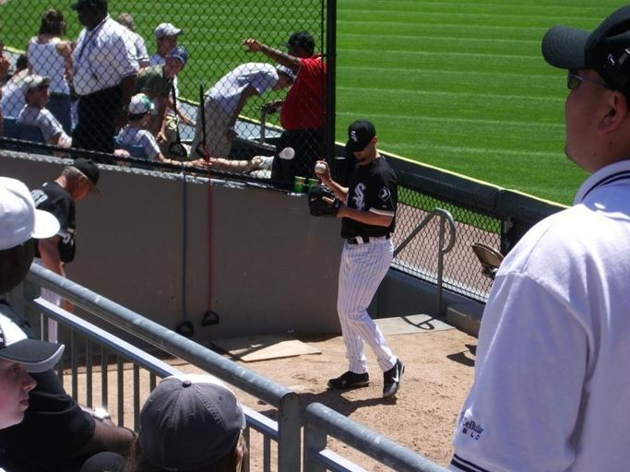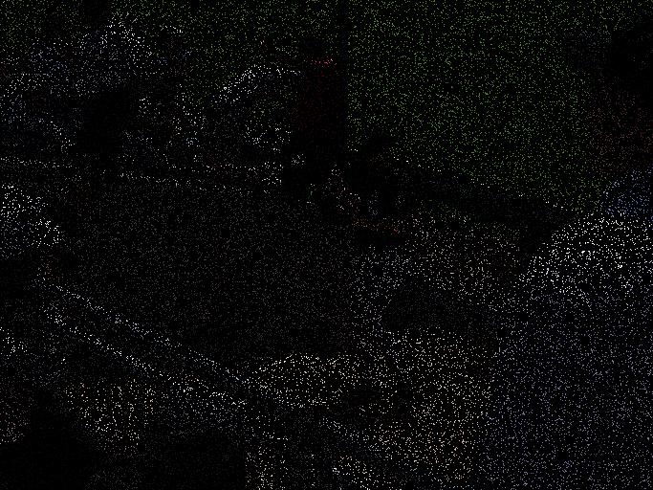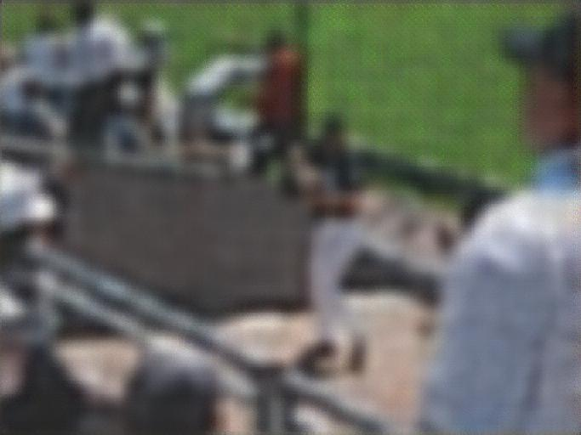

**Training:**

In **train.py:**

1. Set folder with images in: Train_Image_Dir
2. Set Images size in: Im_Width and Im_Hight
3. Set Sampling rate (hence fraction of pixels) sampled from each image in: SamplingRate
4. Run Script the trained net will appear in the log_dir

**Using trained net to reconstruct sparsely sample image:**

In: **RunPrediction.py**

1. *Assume that you already have trained model in log_dir, if you dont have trained model see training section*
2. *Set folder with images in: Image_Dir*
3. *Set Sampling rate (hence fraction of pixels) sampled from each image in: SamplingRate, If the images are already sampled (hence most pixels are zero) set SamplingRate value to 1*
4. *Set the directory in which you want the output image to appear to: OUTPUT_Dir*

*The code was run on python 2.7 using tensorflow 1.1*

*This code is based on Fully convolutional neural nets code:* [*https://github.com/shekkizh/FCN.tensorflow*](https://github.com/shekkizh/FCN.tensorflow)

*published by:****Sarath Shekkizhar***

# 