**John Duriman**

**CPE 403**

**Lab 4**

**5002373995**

**Task 00: Execute the provided code, no submission is required.**

**------------------------------------------------------------------------------------**

**Task 01: Change the toggle of the GPIO at 10 Hz using Timer0 with 43% duty cycle and verify the waveform generated.**

Youtube Link: https://youtu.be/yasprspzCJ8

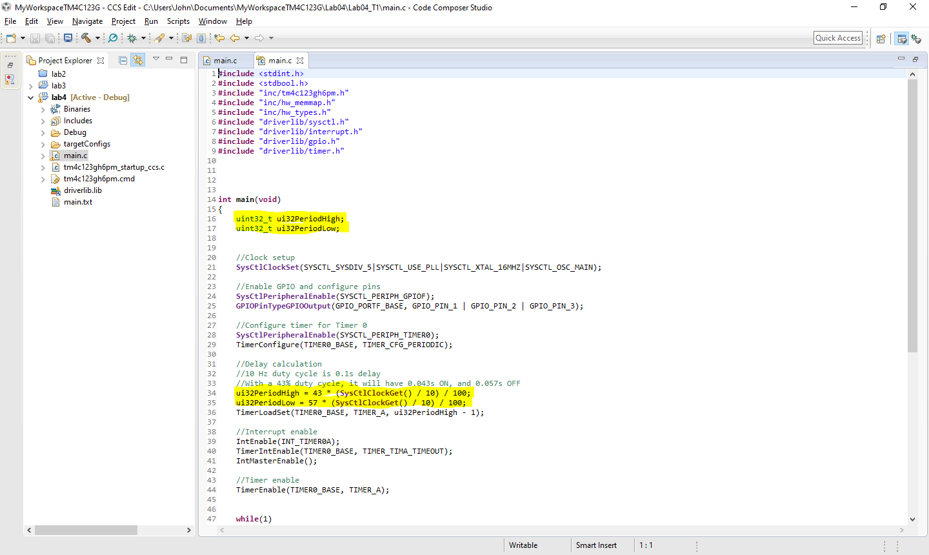**Modified Code:**

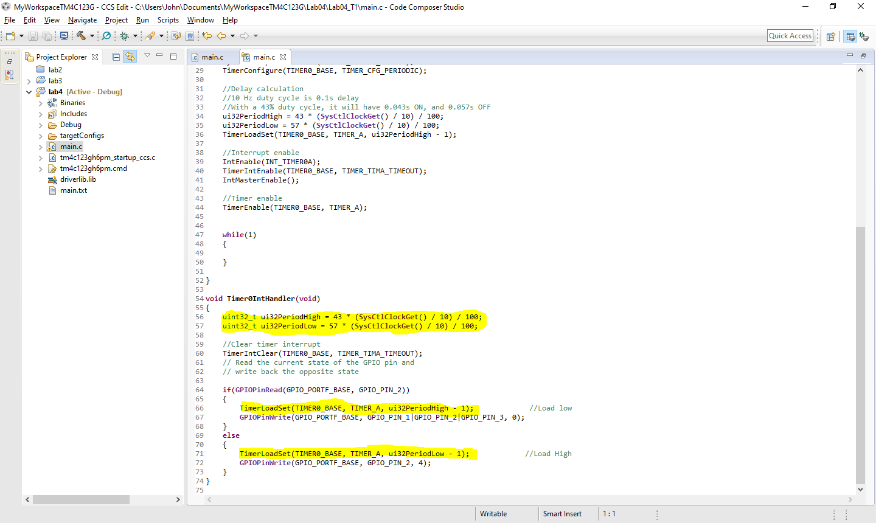

**--------------------------------------------------------------------------------------------------------------------------------------------------------**

**Task 02: Include a GPIO Interrupt to Task 01 from switch SW2 to turn ON and the LED for 1 sec. Use a Timer1 to calculate the 1 sec delay. The toggle of the GPIO is suspended when executing the interrupt.**

Youtube Link: https://youtu.be/yasprspzCJ8

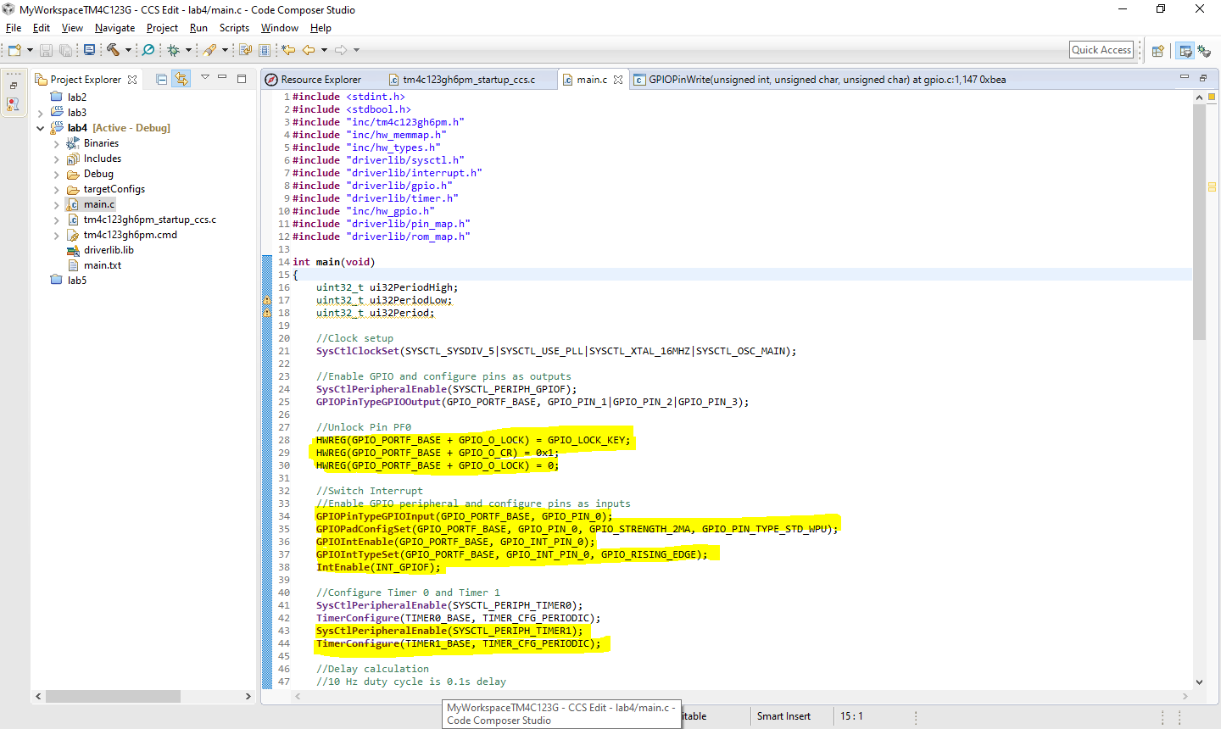**Modified Code:**

