**John Duriman**

**CPE 403**

**Lab 5**

**5002373995**

**Task 00: Execute the provided code, no submission is required.**

**------------------------------------------------------------------------------------**

**Task 01: Change the ADC Sequencer to SS2. Turn on the LED at PF2 if the temperature is greater than 75 degF, else PF1 is ON. Use internal temperature sensor for all SS2 sequence**

Youtube Link: https://youtu.be/HhIpT49eDQI

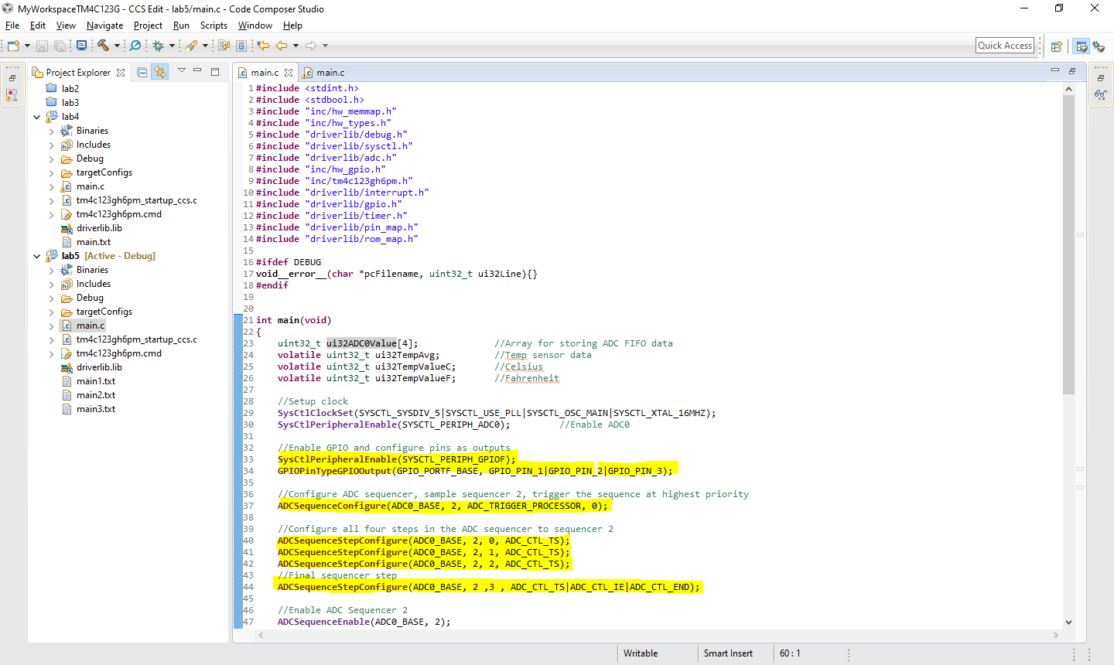**Modified Code:**

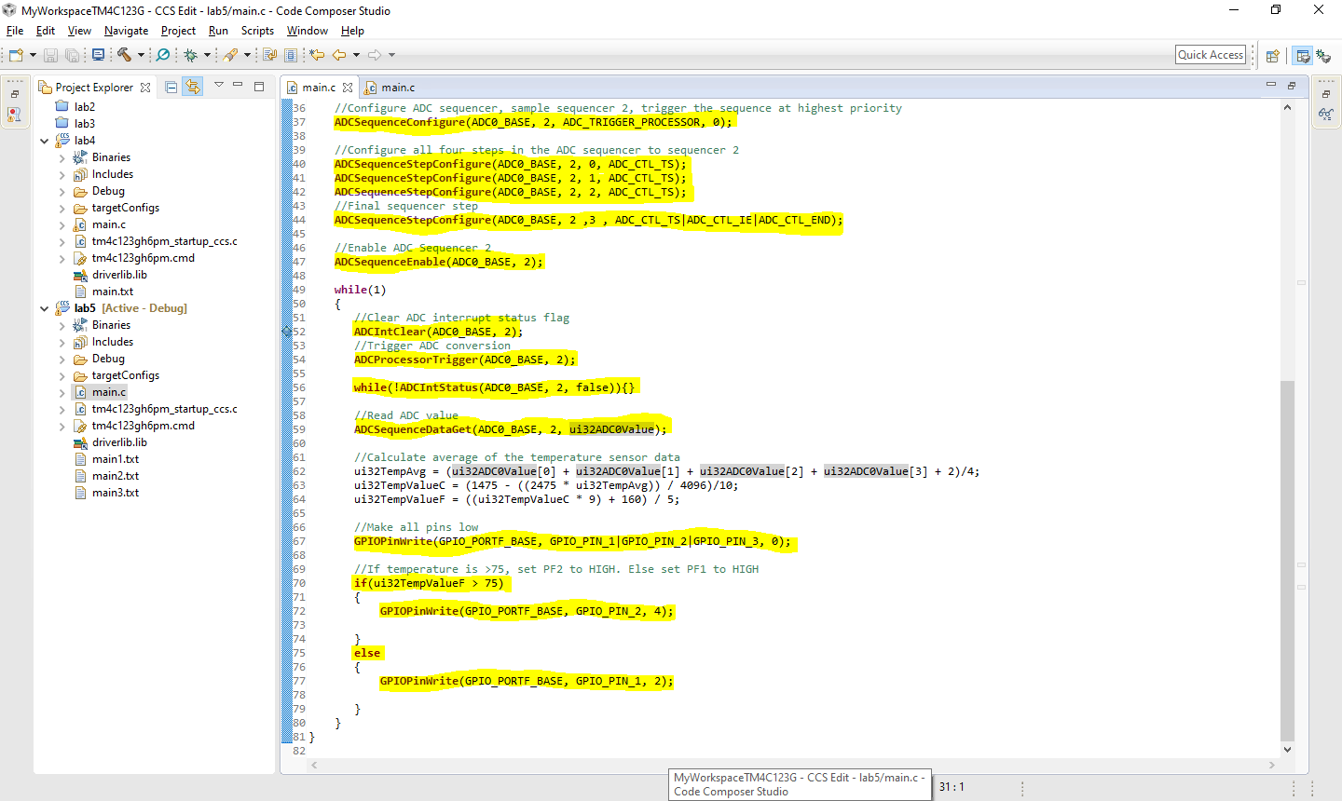

**------------------------------------------------------------------------------------**

**Task 02: Introduce hardware averaging to 32. Using the timer TIMER1A conduct an ADC conversion on overflow every 0.5 sec. Use the Timer1A interrupt.**

Youtube Link: https://youtu.be/HhIpT49eDQI

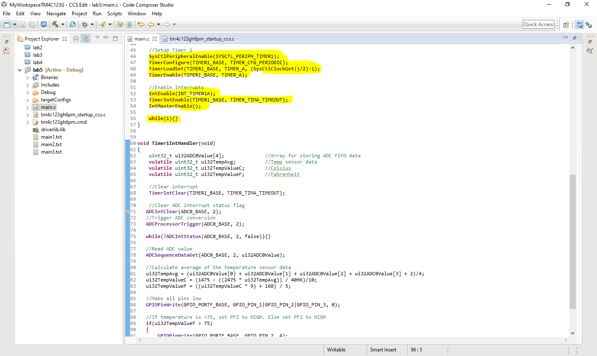**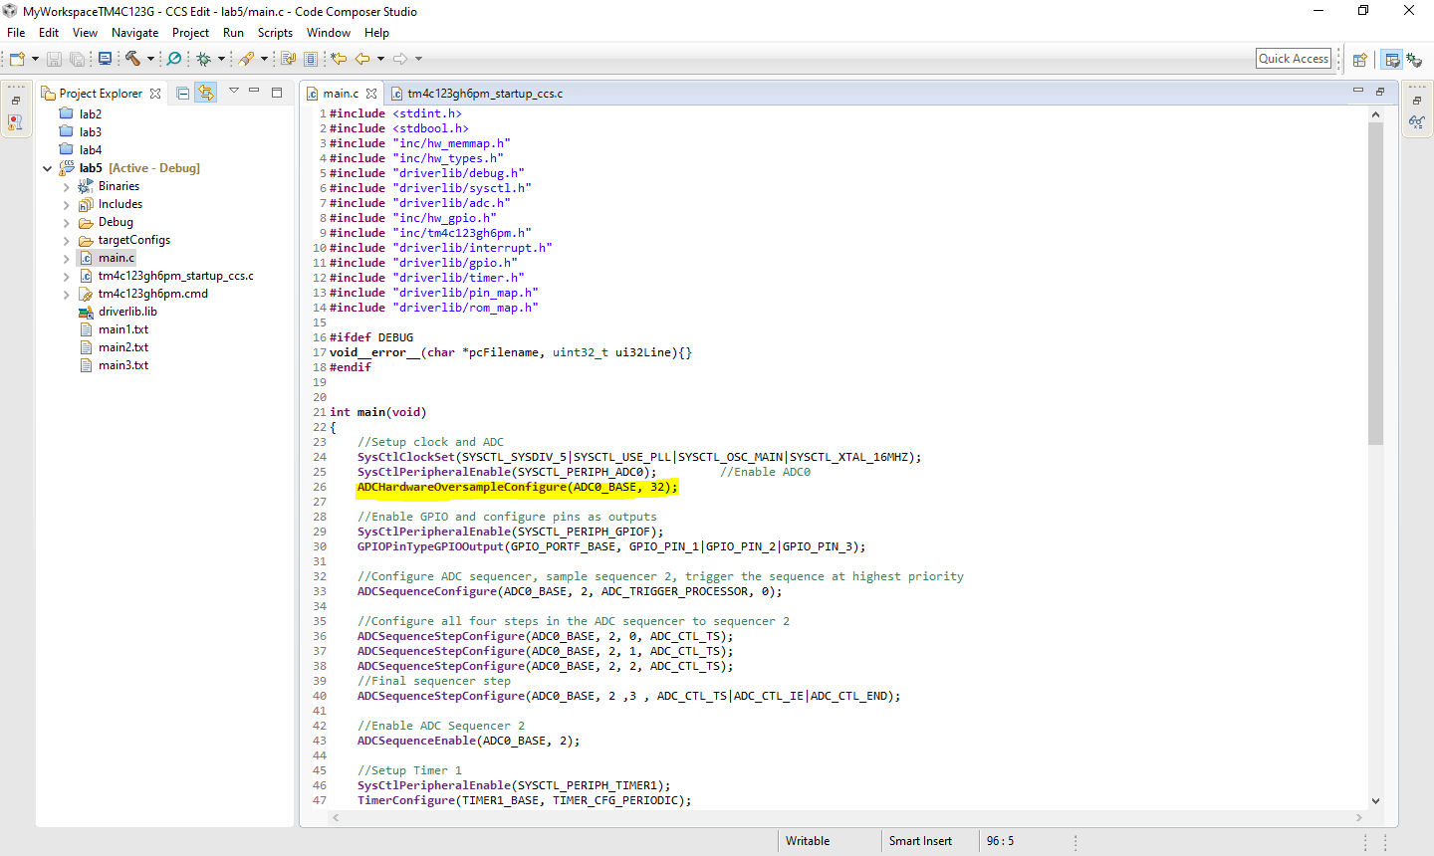Modified Code:**

