**John Duriman**

**CPE 403**

**Lab 7**

**5002373995**

**Task 00: Execute the provided code, display the temperatures in the built-in Graph Tool**

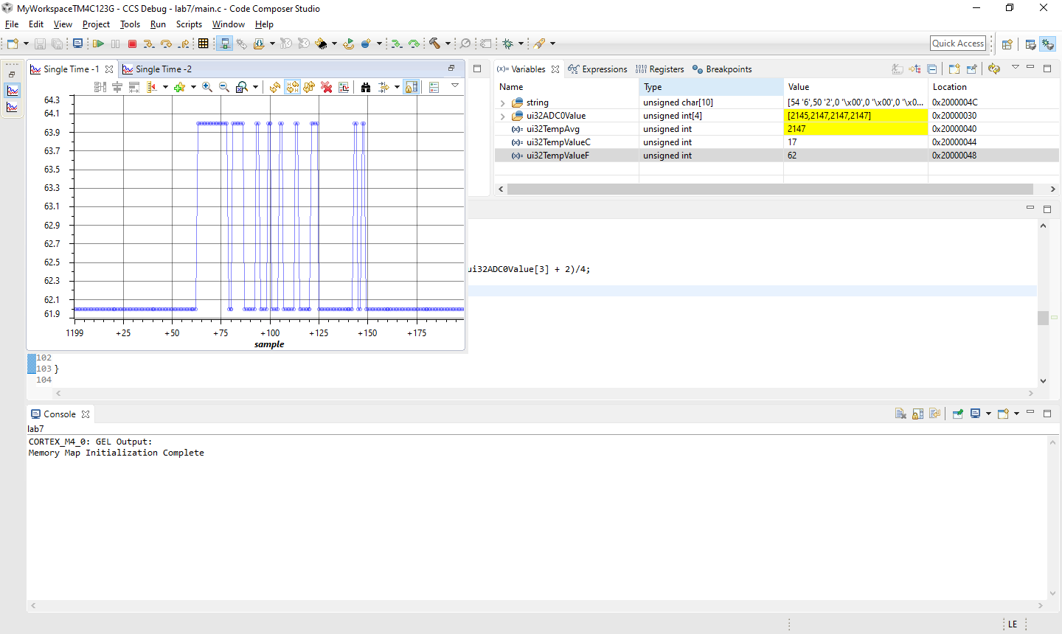**Youtube Link: https://youtu.be/n2tKQkZZTzM**

**Task 01: Continuously display the temperature of the device (internal temperature sensor) on the a) hyperterminal, and b) GUI Composer (Temp Sensor) using a timer interrupt every 0.5 secs.**

****Youtube Link: https://youtu.be/n2tKQkZZTzM

**Modified Code:**

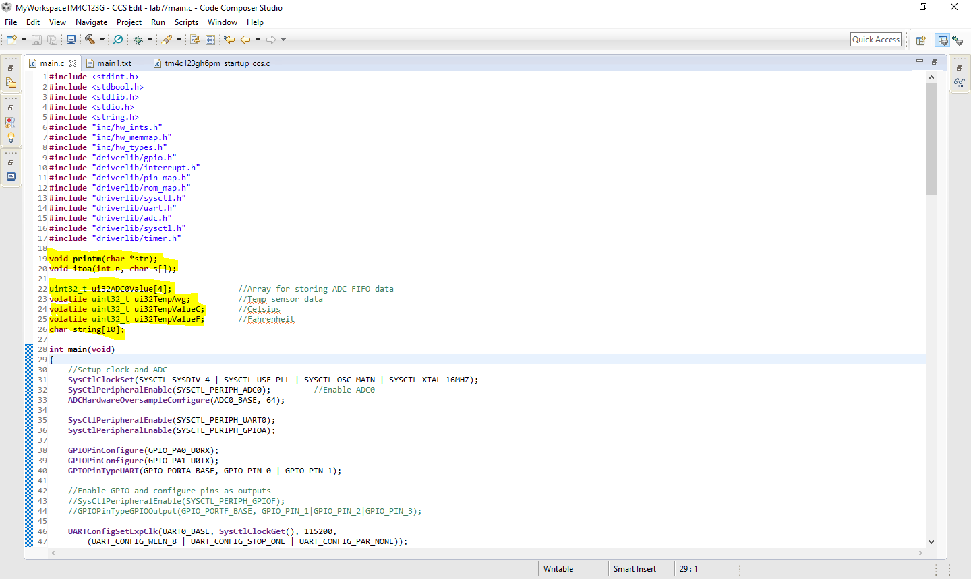**I made the variables global, so both main and Timer1IntHandler can access the values.**

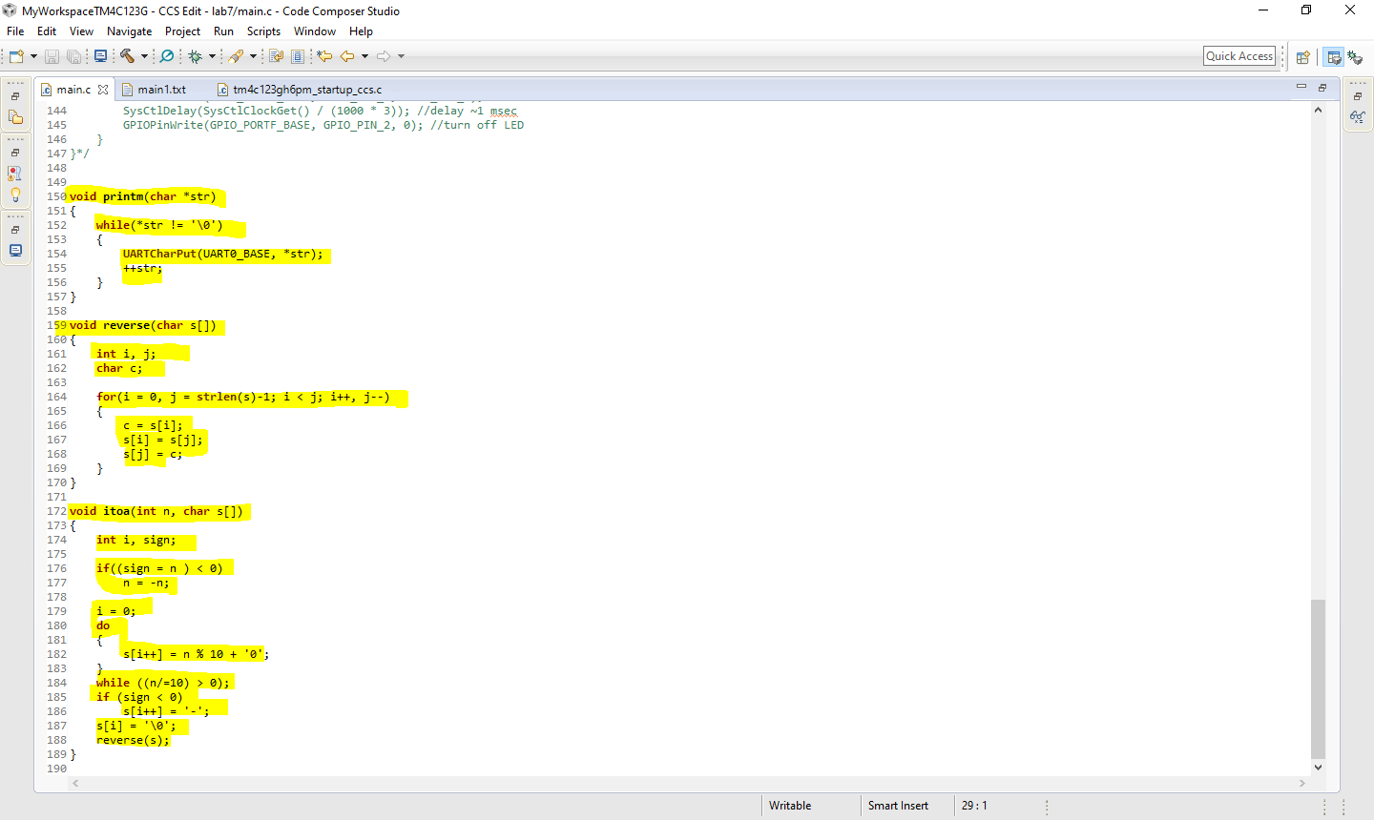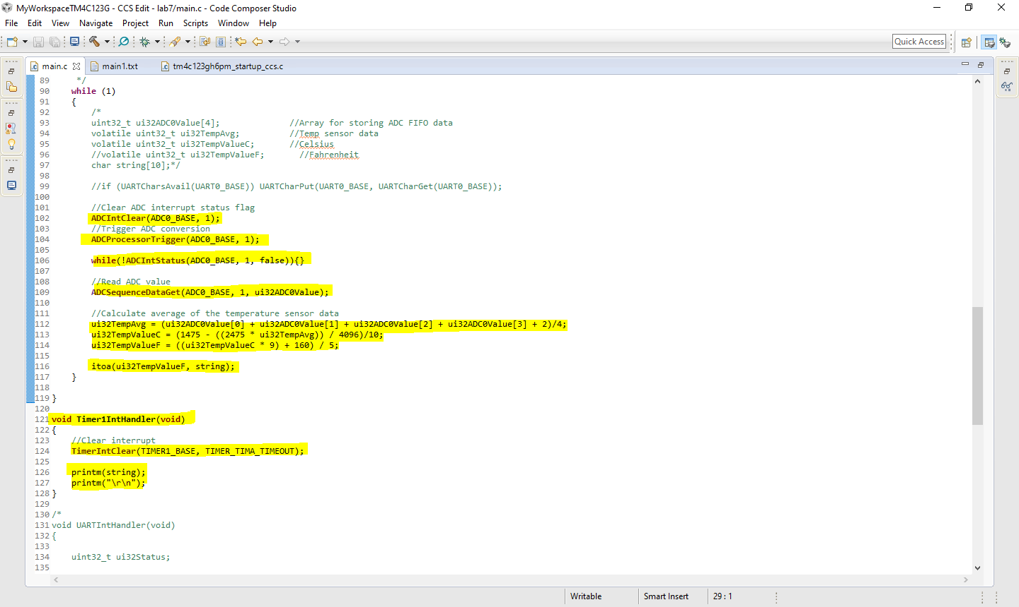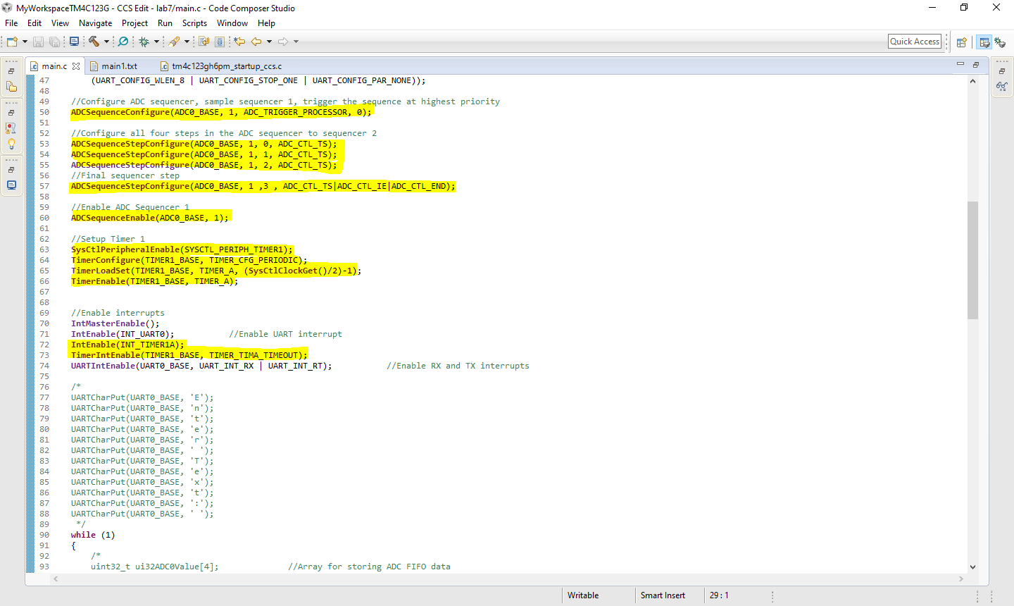

**------------------------------------------------------------------------------------**

**Task 02: Interaction/User Interface: Develop a user interface using UART to perform the following:**

**Enter the cmd: R: RED LED, G: Green LED, B: Blue LED, T: Temperature:**

**Based on the command (cmd) the program should turn ON Red LED when R is entered in the terminal, etc. Command of ‘r’ will turn off the Red LED.**

Youtube Link: https://youtu.be/n2tKQkZZTzM

**Modified Code:**

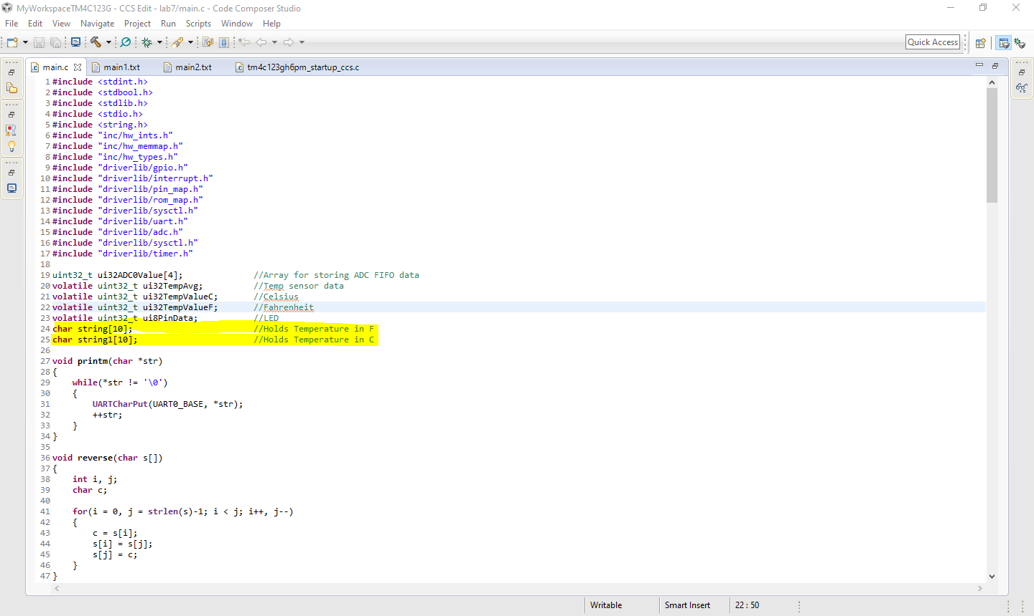**Added two variables that hold an array of characters for each temperature to put for the function itoa()**

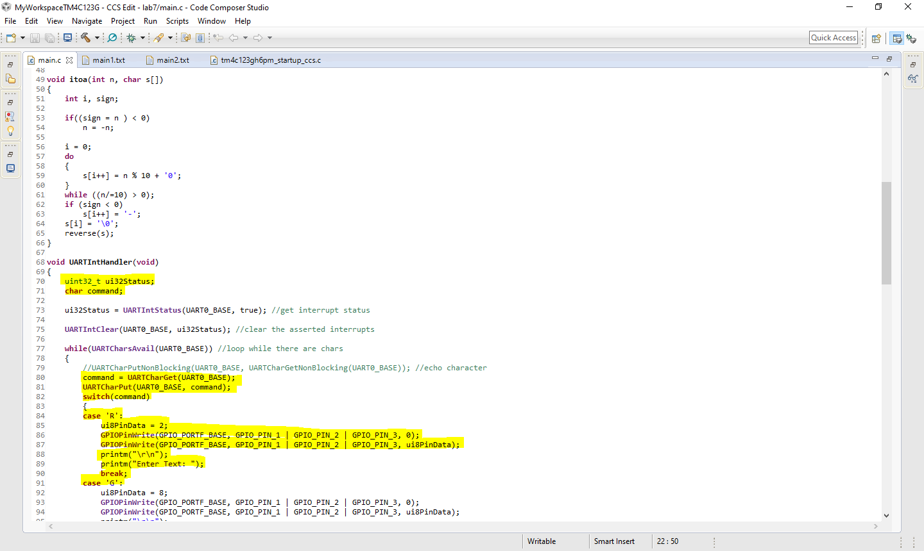Variable command is a character that is taken from the UART which is then compared to values in the switch case. ‘R’ will turn on the RED LED light and then print an extra line as well as the prompt for the next command etc.

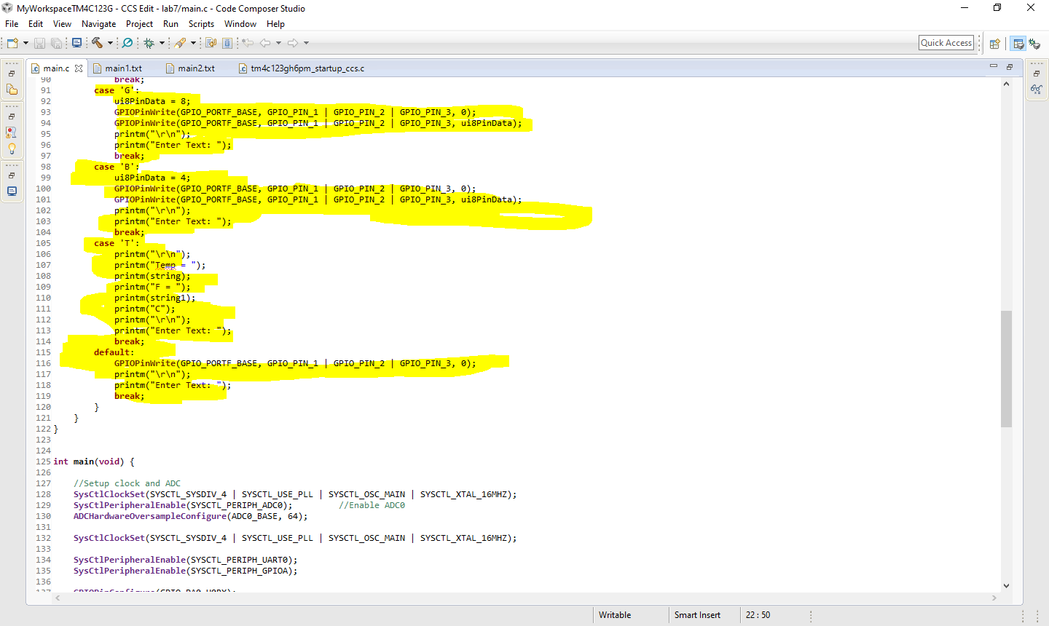**Command ‘T’ just prints out both temperature values pulled from the ADC**

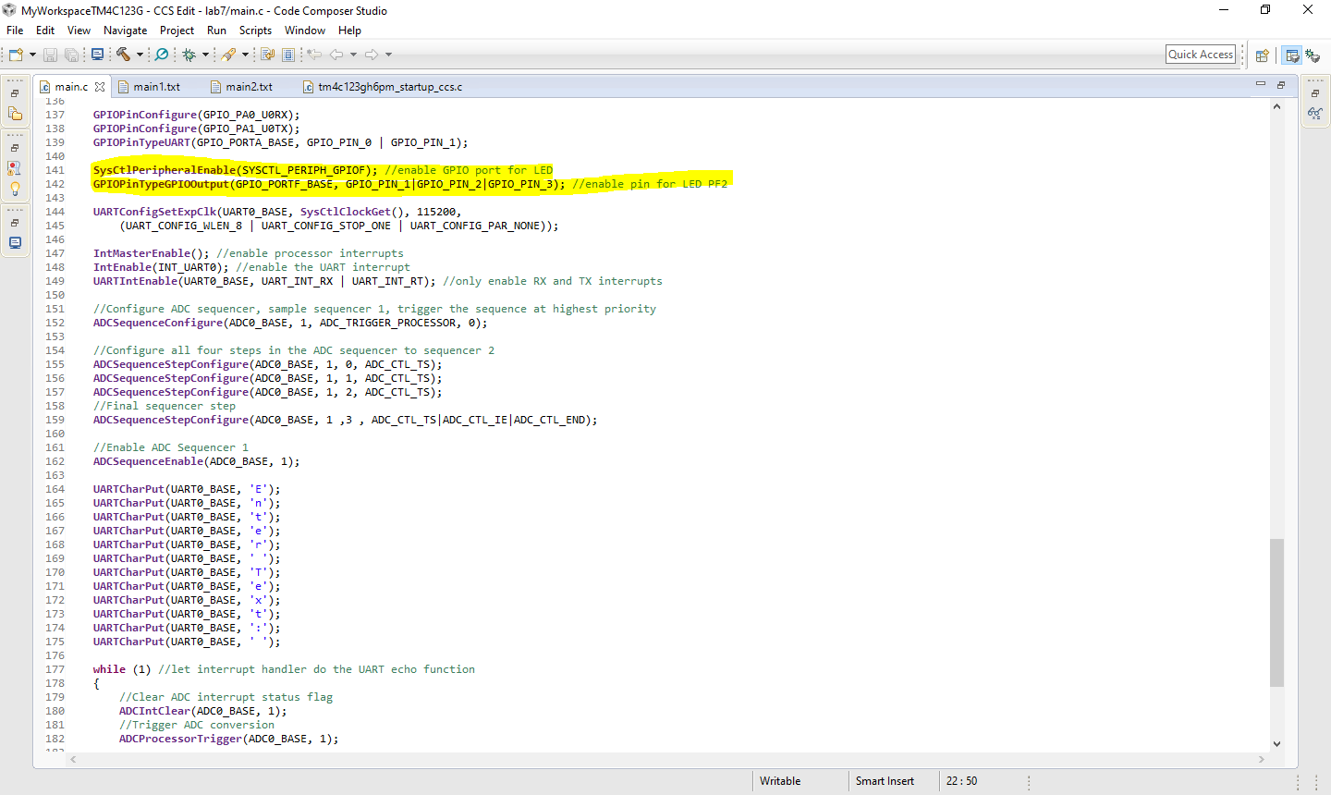**Added GPIO output settings for LED lights**

**ADC logic is done in the while loop to keep the temperature consistent and because I was having trouble getting itoa() to work outside of int main(). Itoa is run twice: one for Fahrenheit and the other for Celsius**

