**John Duriman**

**CPE 403**

**Lab 9**

**5002373995**

**Task 00: Submit a comprehensive commented file of the original code**

Youtube Link: https://youtu.be/Nox3Qsi5Vs8

**Modified Code:**

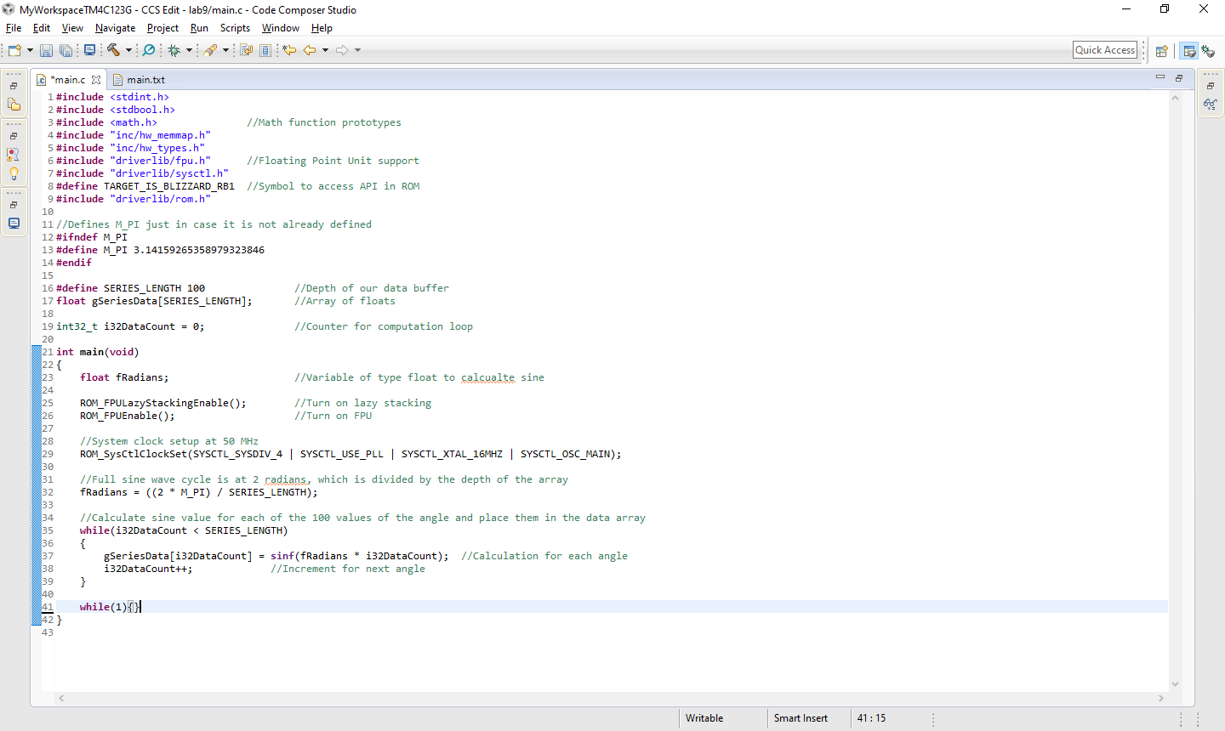

**Task 01: Modify the code to implement the below equation to generate a frequency of 5Hz. Display the equation for 1 second.**

Youtube Link: https://youtu.be/Nox3Qsi5Vs8

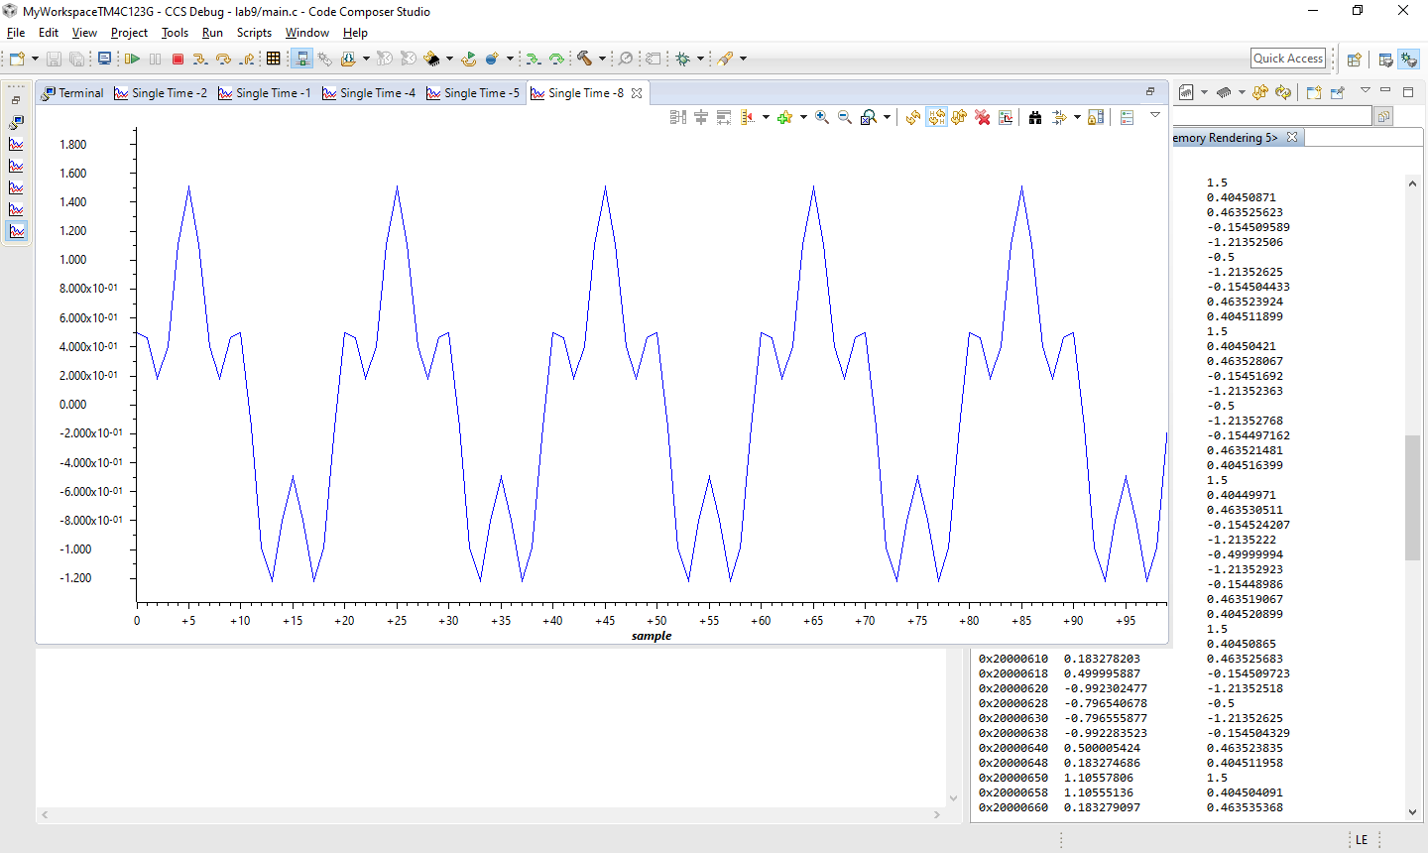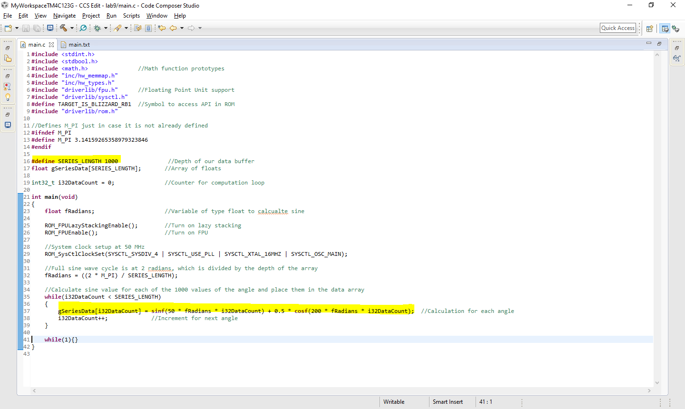**Modified Code:**