1. Laurent Saved Locations PU
   1. Go to this link: <https://7936937-sb1.app.netsuite.com/app/common/scripting/script.nl?id=843>
   2. Click Edit and Copy the Code
   3. 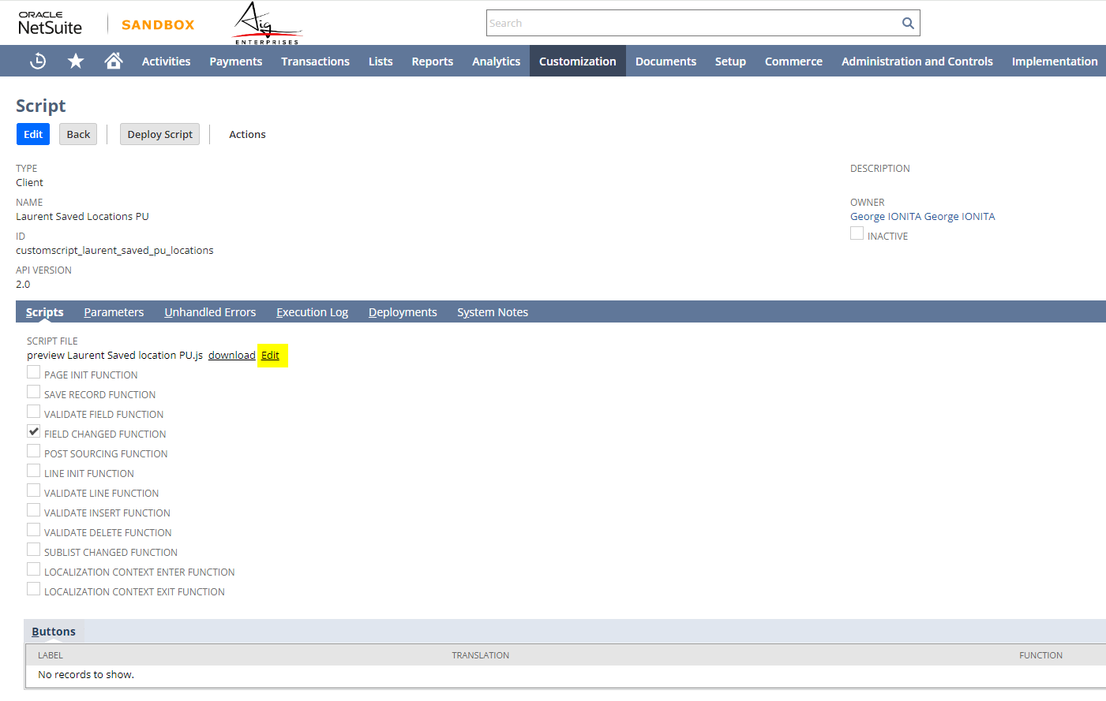
   4. Go To Production and Find the script and update the code
   5. Test if Working as Expected
   6. See Next Page for Laurent Drop Saved Locations
2. Laurent Drop Saved Locations
   1. Go to this link: <https://7936937-sb1.app.netsuite.com/app/common/scripting/script.nl?id=844>
   2. Click Edit and Copy the Code
   3. 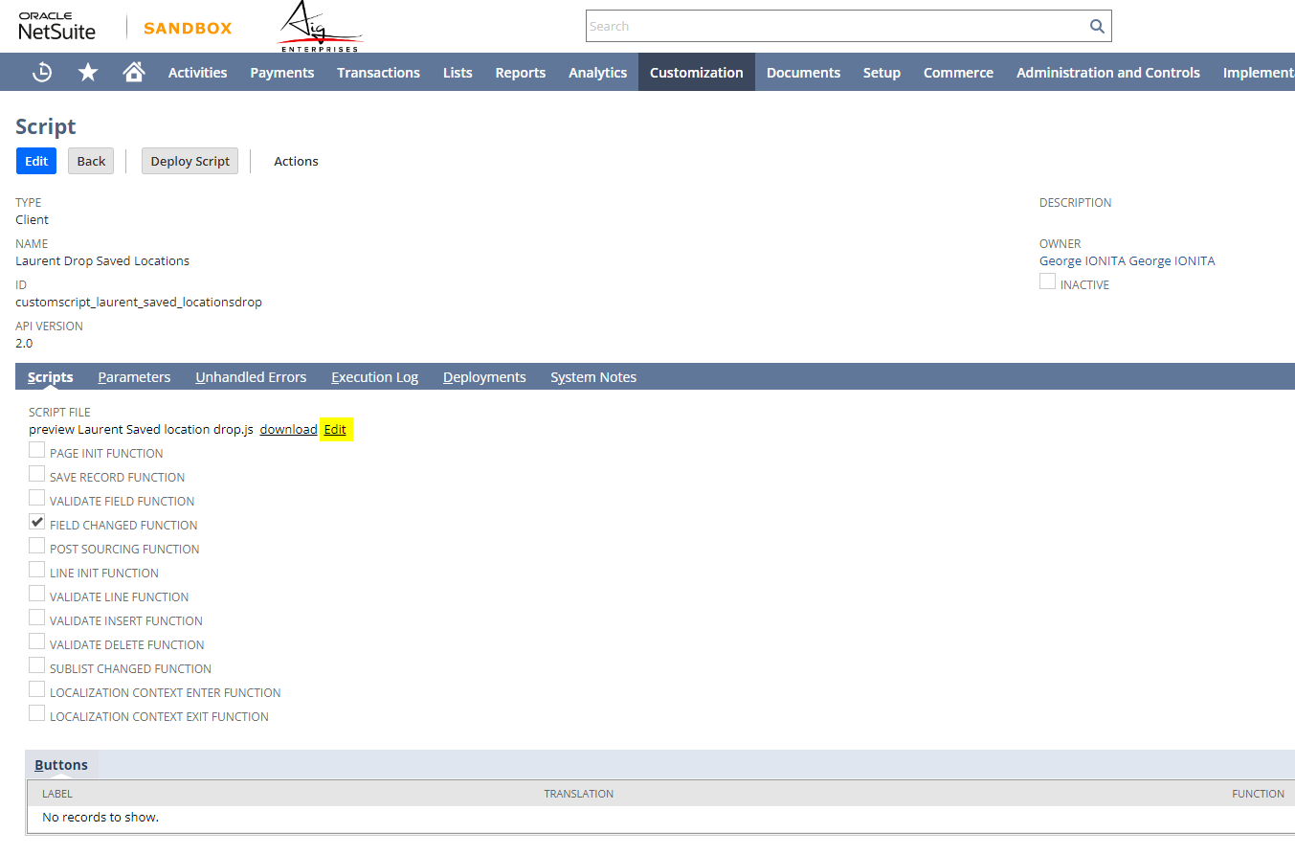
   4. Go To Production and Find the script and update the code
   5. Test if Working as Expected