1. Set to inactive
   1. Name: Laurent Order Form Set
   2. Script Type: User Event
   3. Inactive: Checked
2. Create Client Script
   1. Download the script
      1. <https://7936937-sb1.app.netsuite.com/app/common/scripting/script.nl?id=876>
      2. 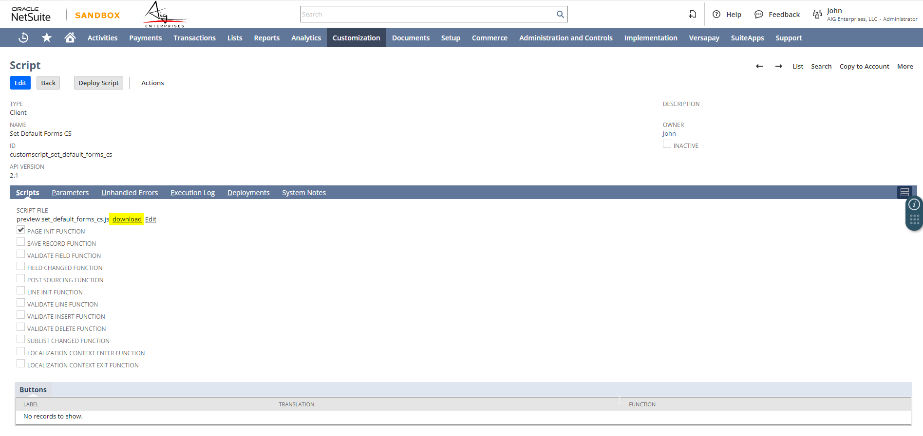
   2. Create New Client Script
      1. 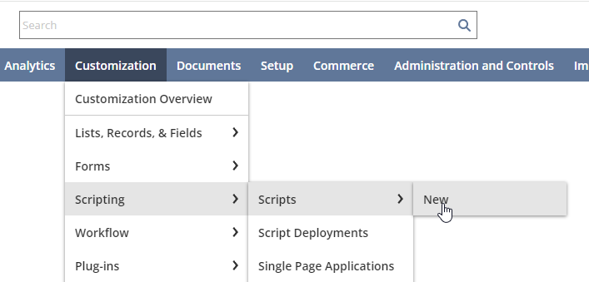
   3. Fill in the following information
      1. 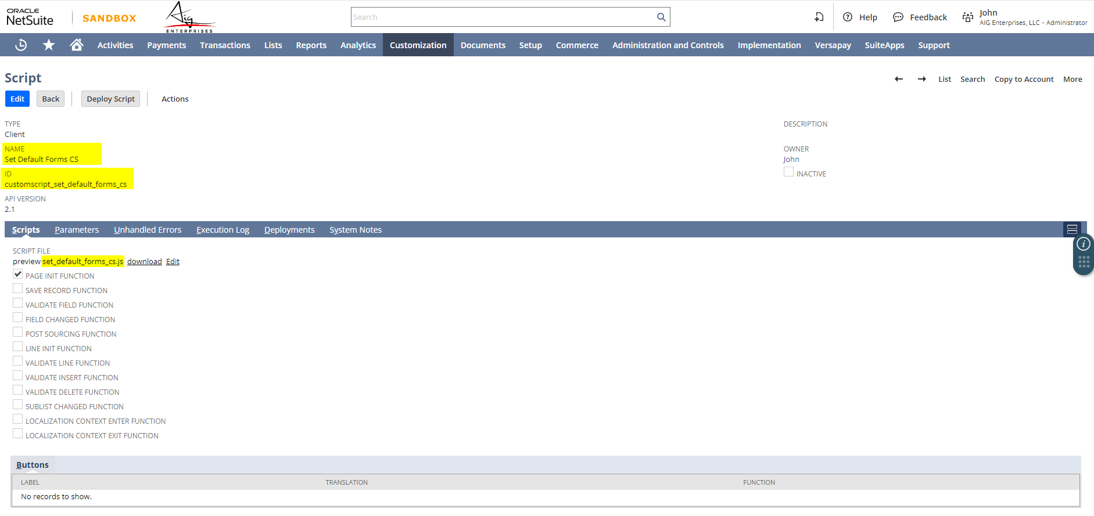
      2. 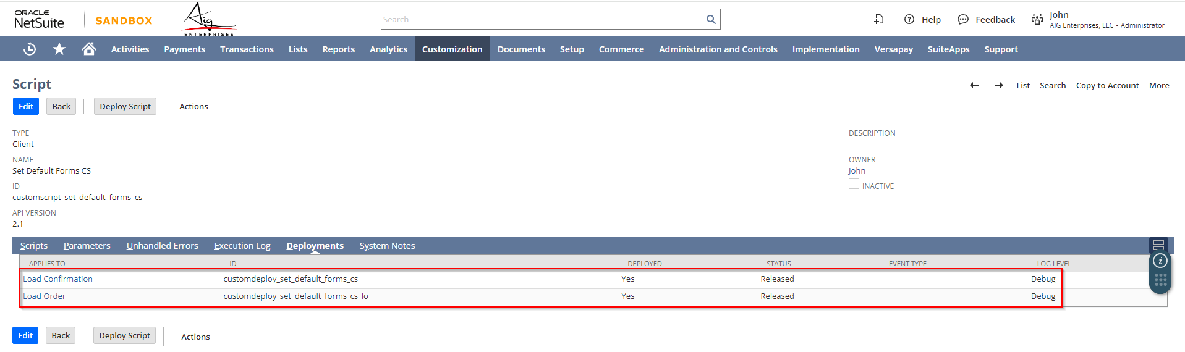
      3. 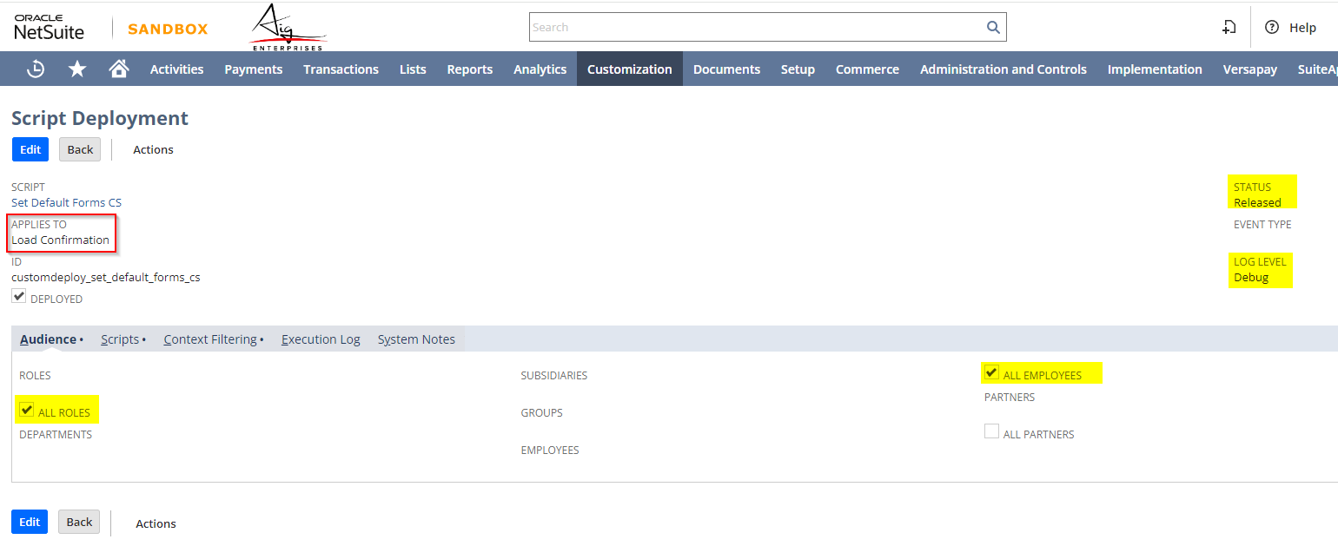
      4. 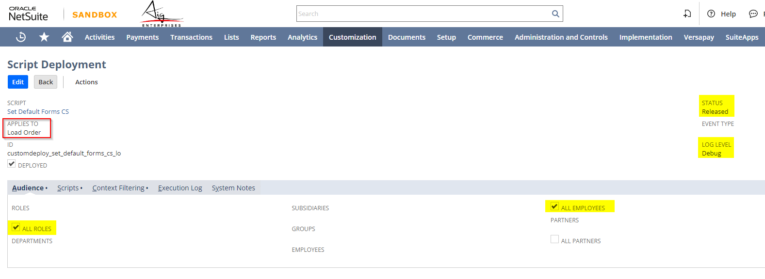
3. Update the code google_autocomplete_client.js
   1. Go to this link
      1. <https://7936937-sb1.app.netsuite.com/app/common/scripting/script.nl?id=837>
      2. Click Edit and Copy the code
      3. 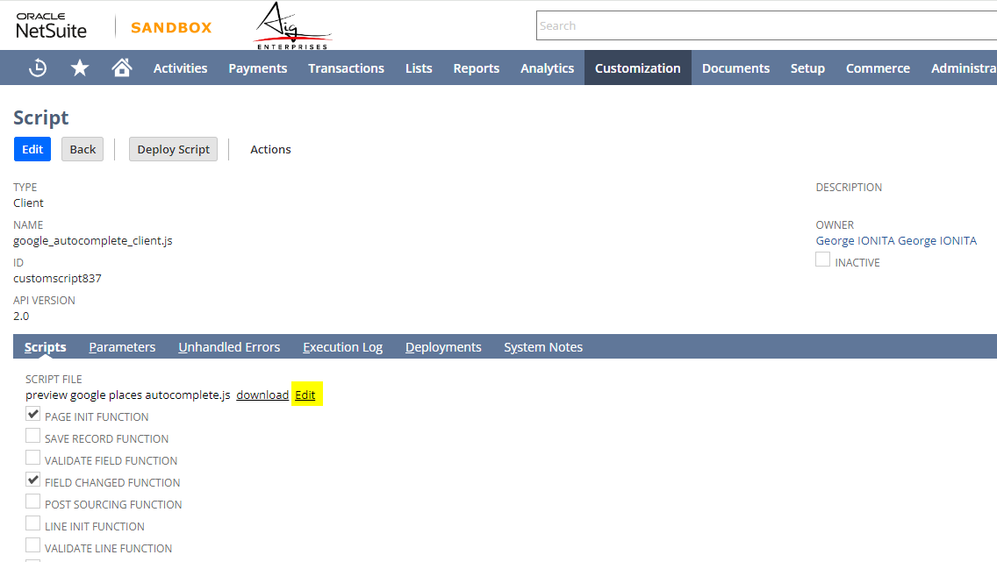
      4. Paste it into same script in Production
4. Undeploy CS Prompt Payment Discount on Load Order
   1. Navigate to the following Scripting > Scripted Records
      1. 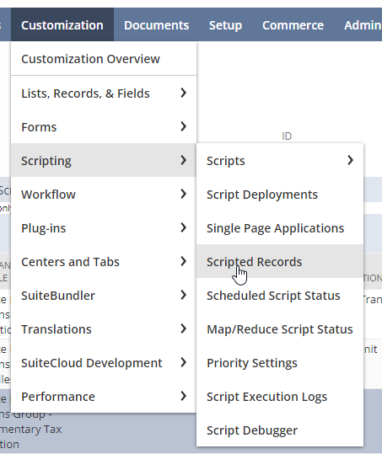
      2. Find Load Order and Click Edit
      3. 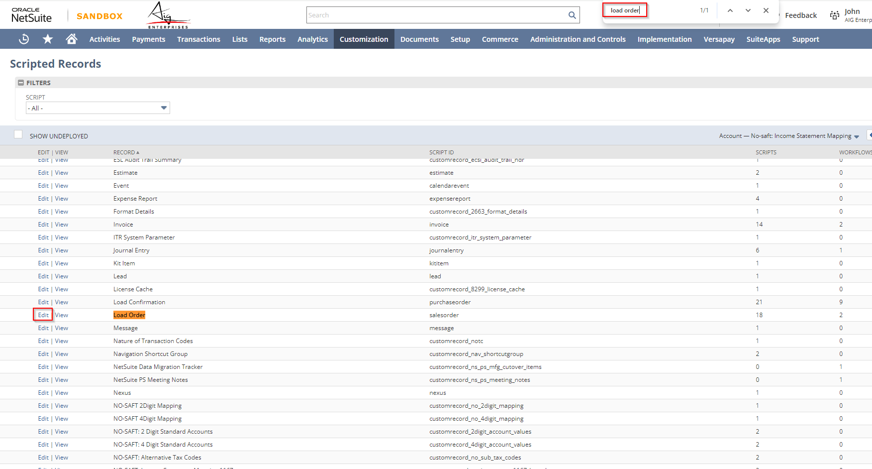
      4. Click on Client Scripts Tab and find the CS Prompt Payment Discount
      5. 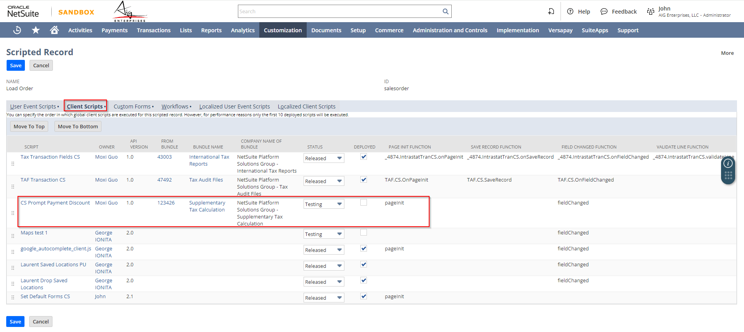
      6. Set the following
         1. Status: Testing
         2. Deployed: Unchecked
5. Test if working as expected