1. Create User Event Script
   1. Download the script
      1. <https://7936937-sb1.app.netsuite.com/app/common/scripting/script.nl?id=877>
      2. 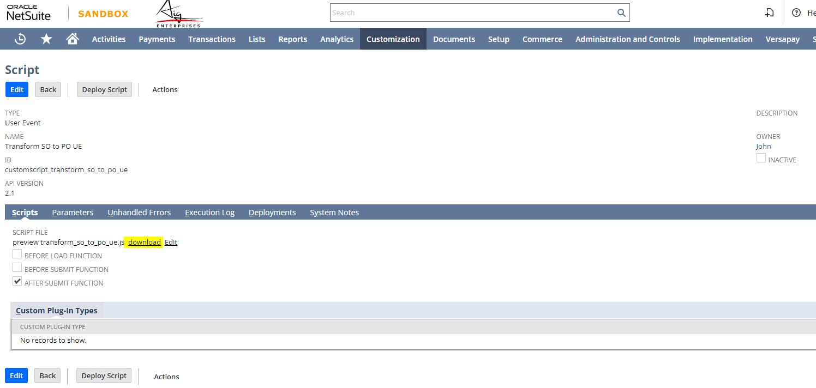
   2. Create New User Event Script
      1. 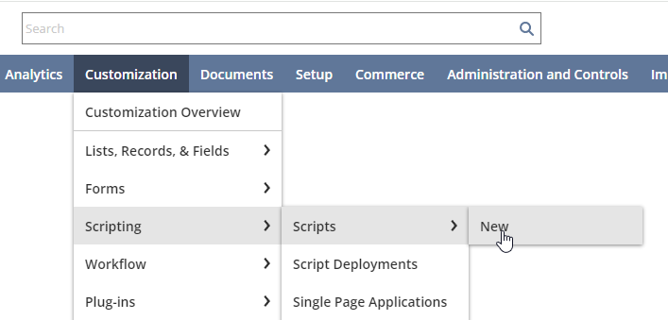
   3. Fill in the following information
      1. 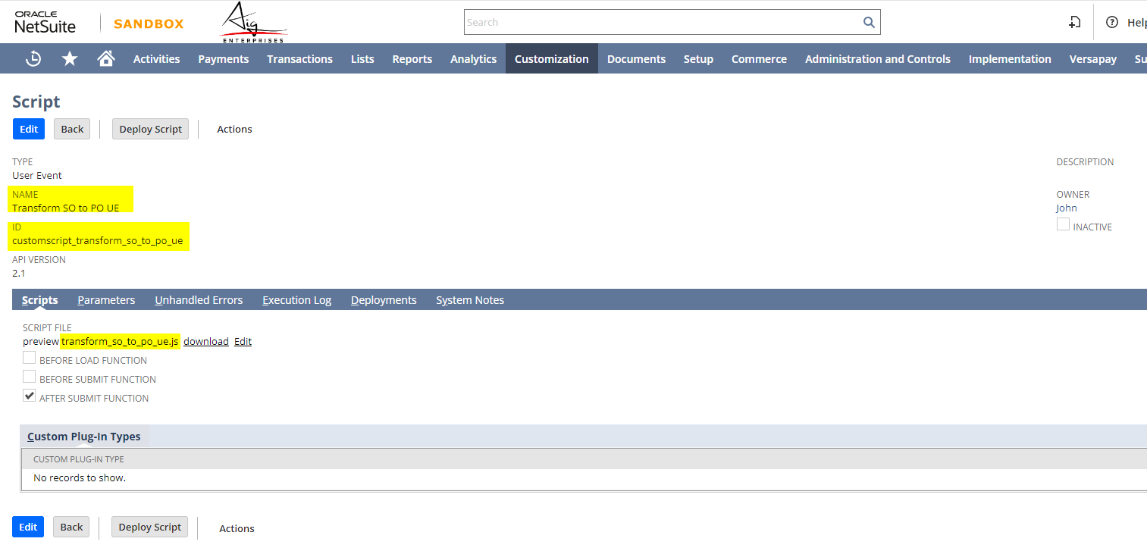
      2. 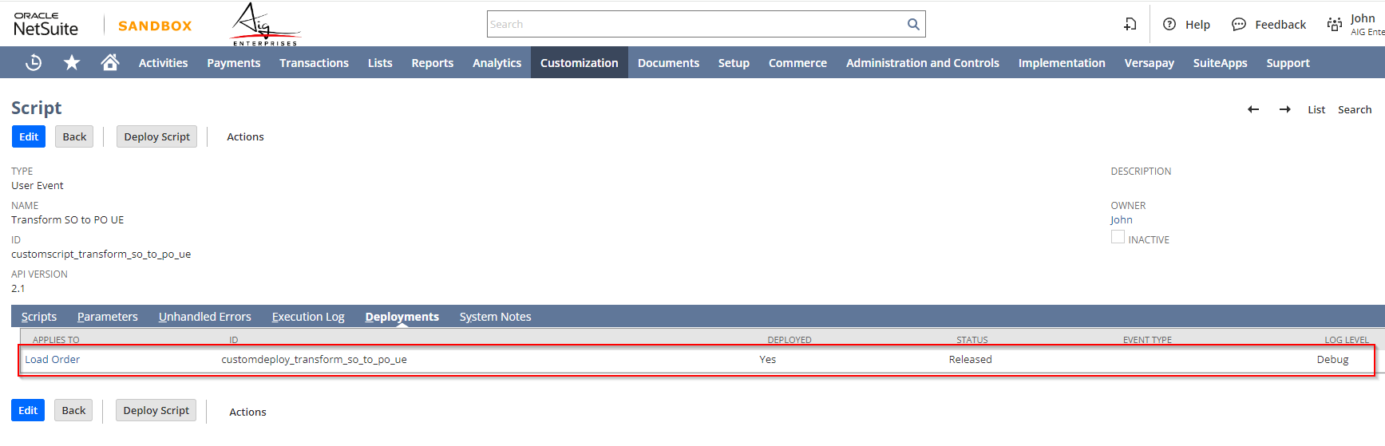
      3. 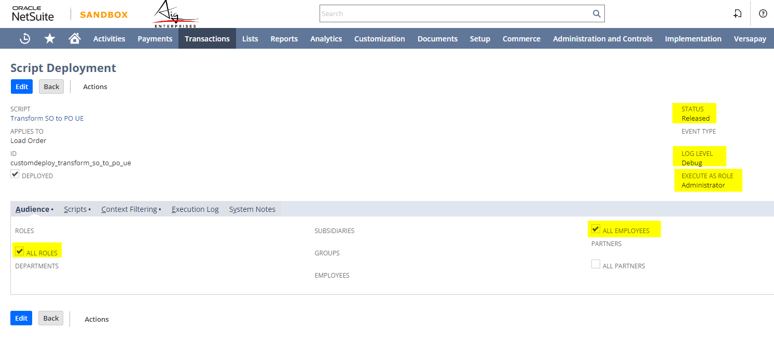
      4. Just be reminded that this script will only work if the current user is Laurent and John
2. Removed the required line field
   1. Dimensions
      1. 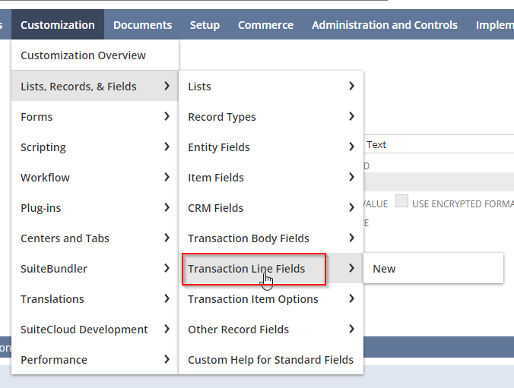Go to the following
      2. 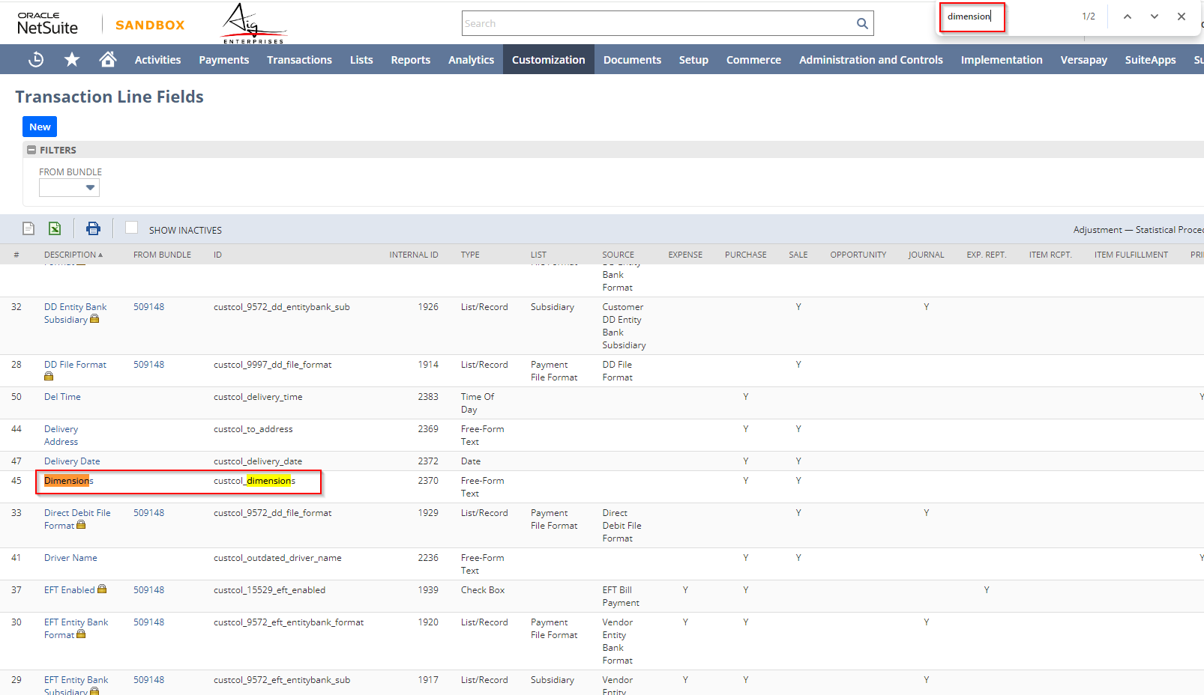Find Click the Dimensions
      3. 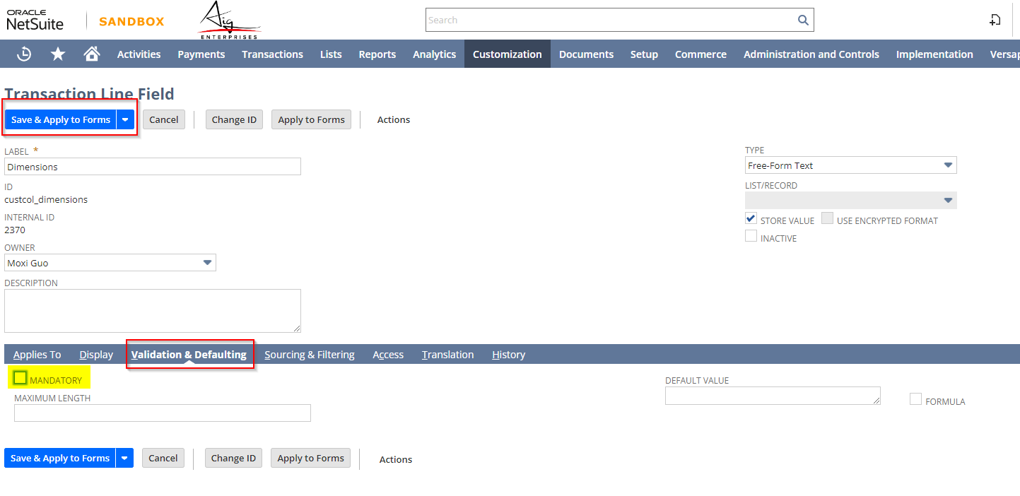Go to Validation & Defaulting Tab
      4. Untick the Mandatory Checkbox
      5. Press Save and Apply to Forms
3. Test if working as expected