**Deploying & Monitoring a Golang Application**

**TOOLS**

1. **Source Code Management : Git/GitHub**
2. **CI/CD Pipeline : Jenkins**
3. **Target to host the app: Docker/Docker hub**
4. **Provisioning using: Terraform**
5. **Configuration Management; Ansible**
6. **Deploying docker container/image: Kubernetes**
7. **Monitoring tools: Elk + Metric beat**
8. **Software package: Golang**

**WORKFLOW**

1. **Develop the Application**
2. **Commit & push the code to GitHub**
3. **Create Jenkins jobs**
   1. **Job 1 – uses Terraform to spin an EC2 instance**
   2. **Job 2 – uses Ansible to install Minikube & kubectl**
   3. **Job 3 – uses create & push the image to Docker Hub, deploy the application to Test Kubernetes**
   4. **Job 4 – uses create & push the image to Docker Hub, deploy the application to Production Kubernetes**
4. **Use a browser to view the App**
5. **Use Elkstack and metric beat to collect data**

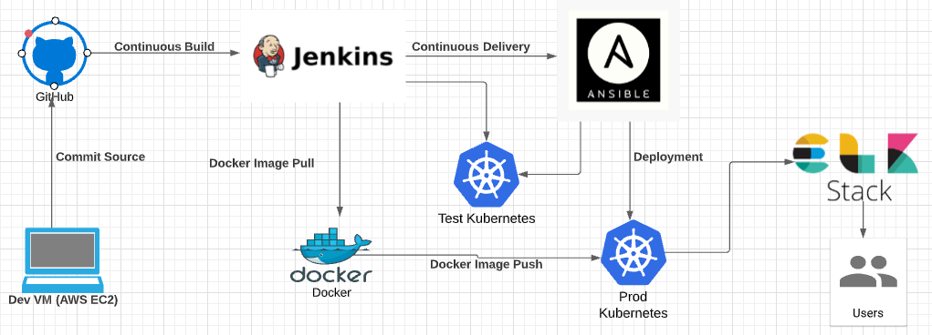

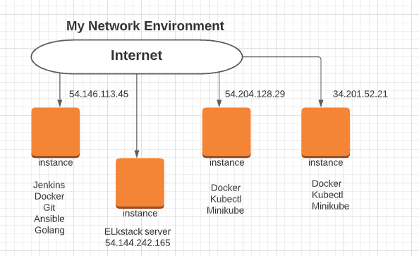

**The Dockerfile**

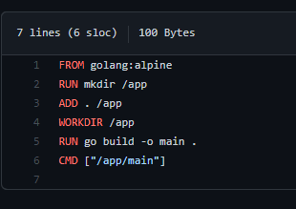

**The Golang script**

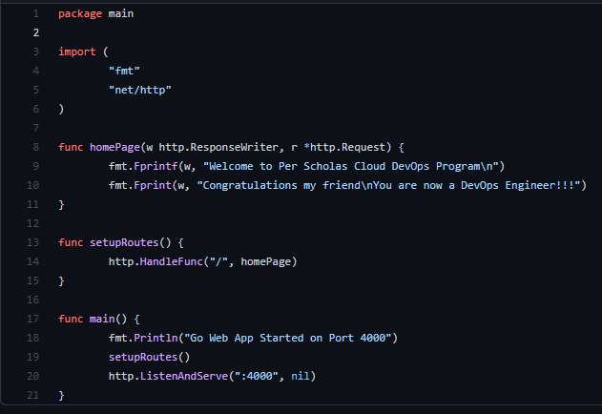

**Job 1 – Using terraform to spin a new EC2 instance that will be used a Test Kubernetes**

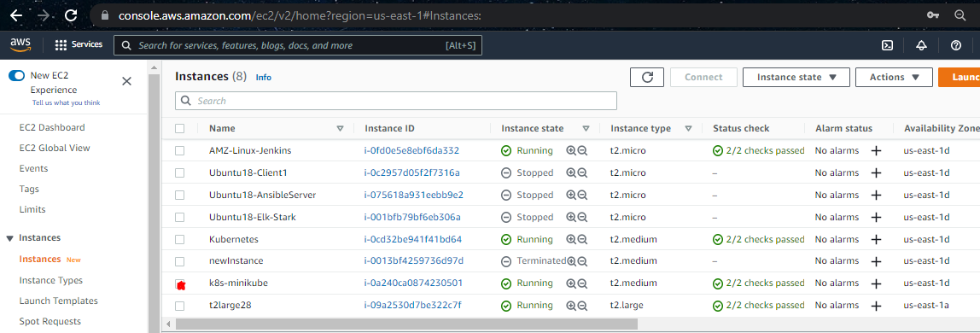

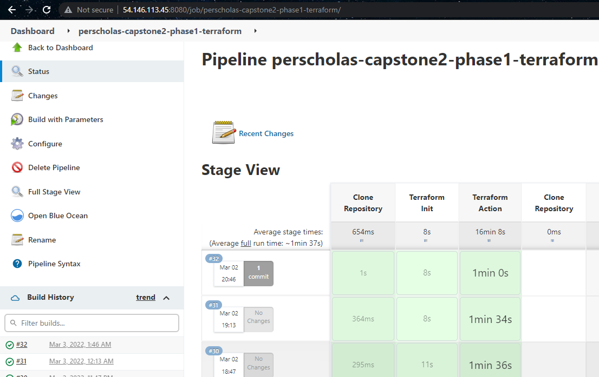

**Job 2 -- Running Ansible to install Minikube**

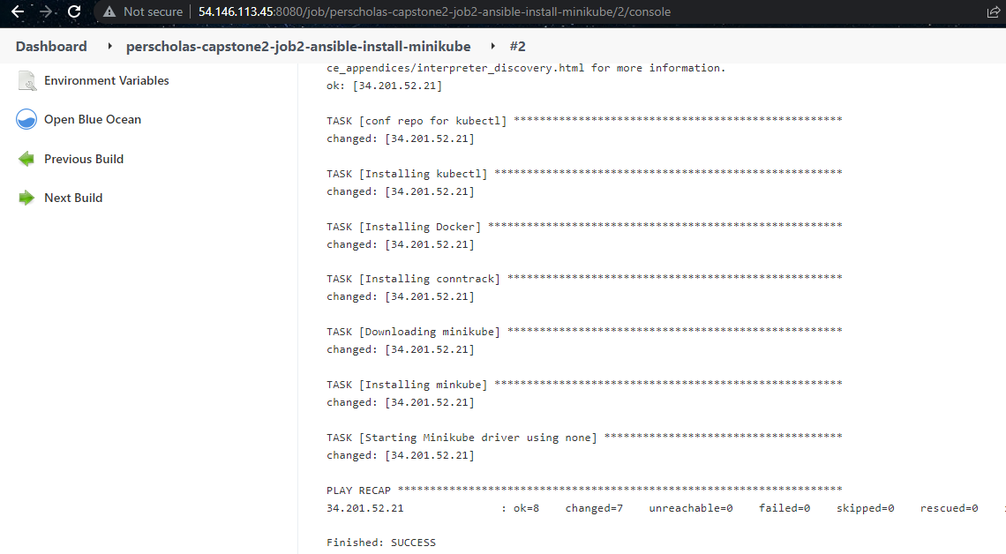

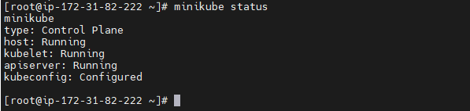

**Job 3 -- Deploying the application to Test Kubernetes**

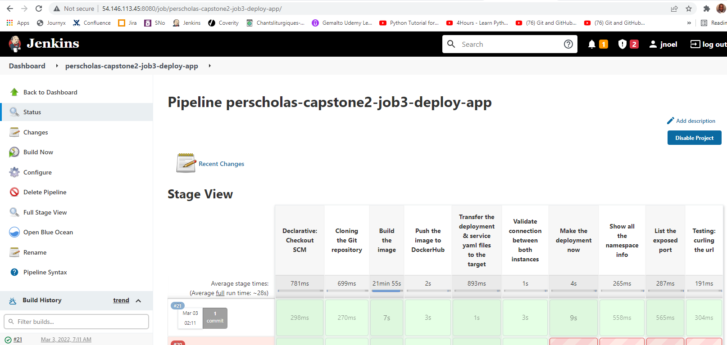

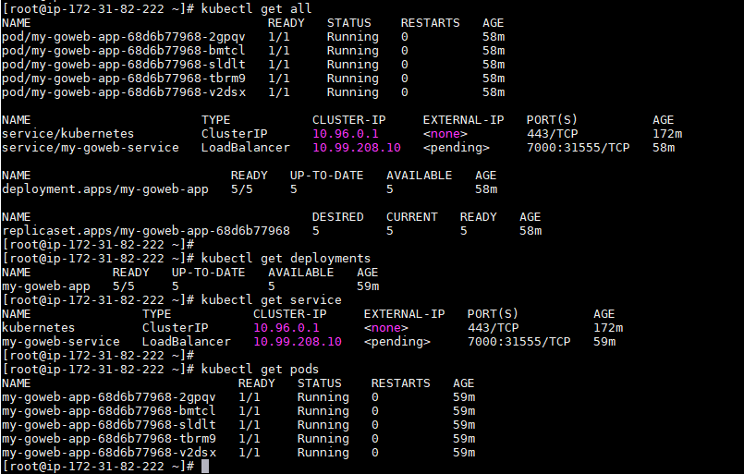

Verify the app is running

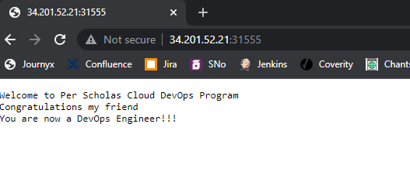

Job 4 -- **Deploying the application to Production Kubernetes (54.204.128.29)**

