John Enrick Plenos

plenosjohn@yahoo.com

Abstract

This document contains the instructions on using the system during the national convention

NFJPIA Registration system

User’s Manual

Table of Contents

Overview 2

Module 1 : Online registration 2

User Registration 2

Registration confirmation 2

Module 2 : Registration Information system 3

Attendance, penalty and information confirmation 4

User Management (VP of Finance only) 4

# Overview

The Registration System was made in order to ease up the registration process of the delegates for the Annual National Convention of NFJPIA. The system has two modules, the online registration module referred as Module 1 and Registration Information System referred as Module 2.

# Module 1 : Online registration

Module 1 can be access by visiting ncjpia.initiativesolution.com using any web browser but we recommend on using Google chrome for optimal user experience.

## User Registration

There are two steps that a registrant must follow, Step 1: Submit Registration Form and Step 2: Send a copy of payment receipt or deposit slip.

## Registration confirmation

A list of registrant can be viewed by visiting ncjpia.initiativesolution.com/portal. The assigned officer must use the log in credentials given by the Vice President of Finance. Figure 1 shows the list of the registrant that submitted their registration form.

The panel on the left side shows the summary panel labelled as 1, and Filter Table labelled as 2. The summary panel shows the number of registrants, the number of registrant who paid the registration fee and the number of registration who submitted their copy of deposit slip but have not been approved yet. The Filter Table will filter the result of the table on the right side with the given parameters.

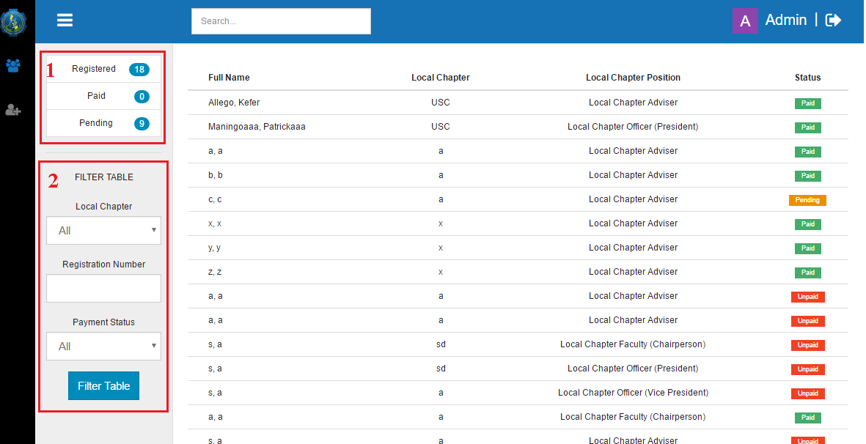

Figure 1 Registrant List

To view the details of a registrant, just click it row in the table. It will show all information about the registrant as shown in Figure 2. The image labelled as 2 is the copy of deposit slip submitted by the registrant. To confirm the payment of the registrant, just click the button labelled as 1.

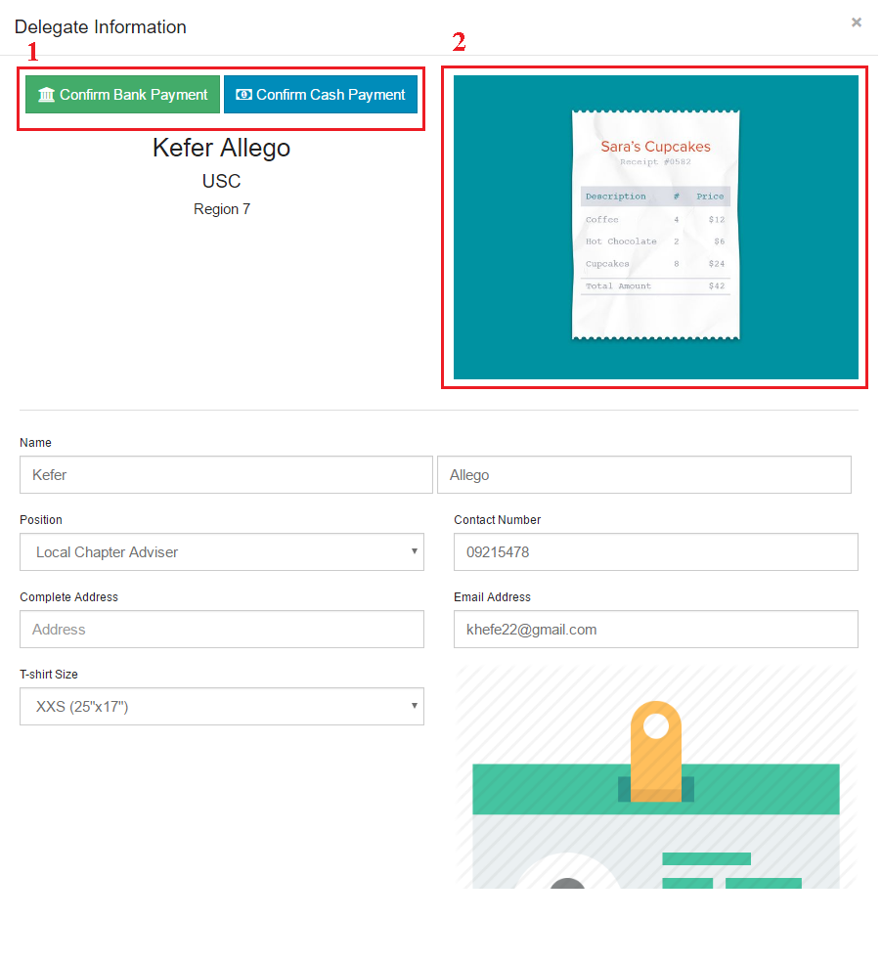

Figure 2 Delegate Details

# Module 2 : Registration Information system

Module 2 allows different users to view or modify the details of the registrants during the national convention. Access module 2 is the same as Module 1 Registration Confirmation Section.

## Attendance, penalty and information confirmation

By clicking a row in the list of registrant, the information of the registrant will be shown together with the option of confirming the attendance, correcting some information, and inputting the amount of penalty.

To confirm the attendance, just click the button labelled as 1 in Figure 3. To give penalty, just enter the amount of penalty then click the button labelled as 2. In order to make correction, just change the fields such as name, position, etc. then click the save changes button at the bottom.

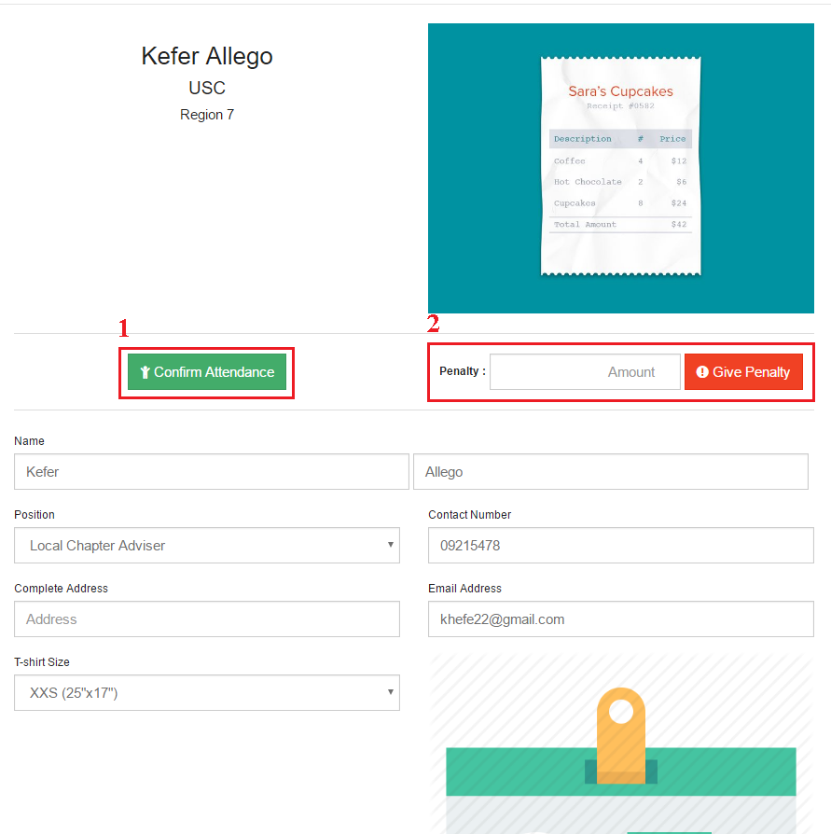

Figure 3 Attendance, Penalty, and Modification

## User Management (VP of Finance only)

To create or modify the user of the system just click the link labelled as 1 in Figure 4. It will list all the users. It has also Filter Table.

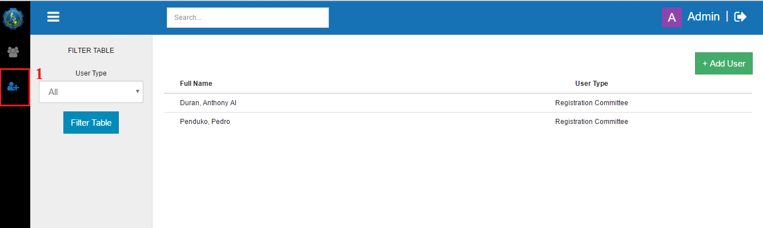

Figure 4 User

# Installation

# Maintenance

## Cleaning Database

Visit localhost/phpMyAdmin using a browser. Select ncjpia database by click the name labelled as 2 in figure 5.

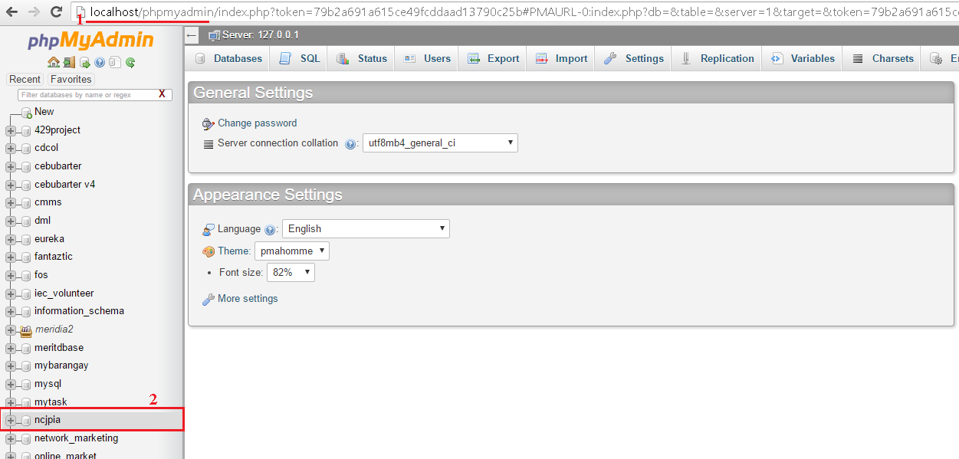

Figure 5 Database Step 1

Select all the tables in database by clicking the check box labelled as 1 in Figure 6. Then delete the selected table by selecting drop which is labelled as 2 in Figure 6. Click yes when ask for confirmation.

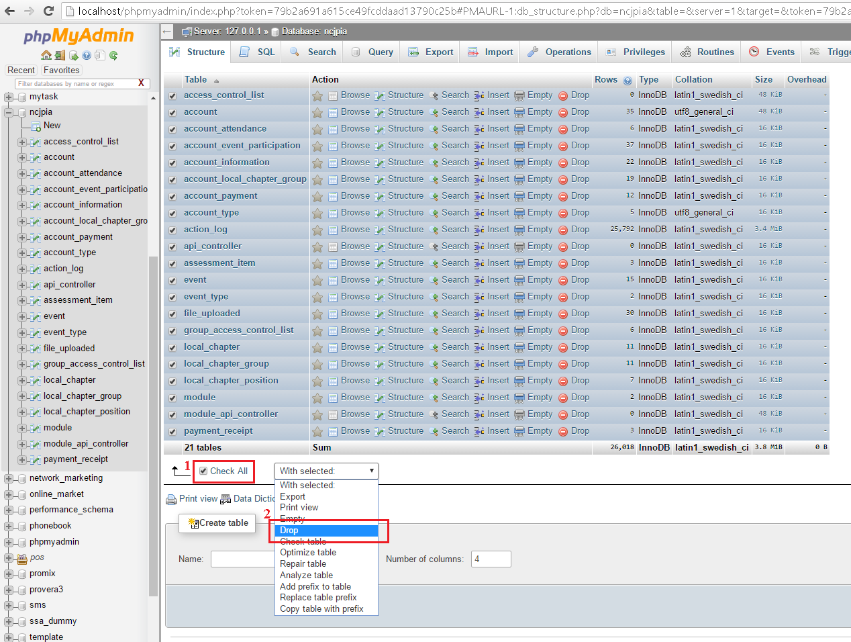

Figure 6 Deleting tables

After deleting the tables, import the database by clicking the import labelled as 1 in Figure 7. Then choose file, select the located in C:/xampp/htdocs/ncjpia/initiati_ncjpia.sql. Then press the Go button.