John Fanara

Prof. Alrajab

CSC229

2/13/23

1.

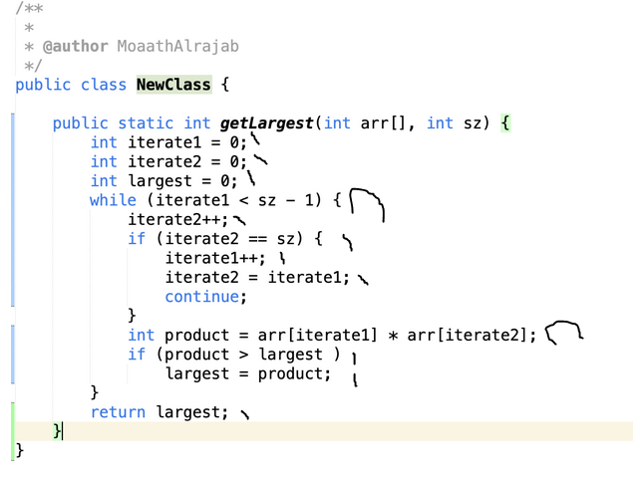

2n + 10 => O(n)

2. You can take one piece from each of the bags and place them on the scale one by one until the 1.1 gram piece is added. Once you have the 1.1 gram piece added you have your bag.