C2000 PM Motor Drive
Author: John Figie
Date 11/03/2022

Introduction
The intent of this document is to provide a technical description of the C2000-PM_Motor_Drive as well as operating instructions. The initial version of this project is a dual PM DC motor drive that operates in torque mode (current mode). The input reference signal is provided by an analog input. In the future this project may include a sserial (smart serial interface) like that on the https://github.com/rene-dev/stmbl project. Another variation may be a triple axis PM DC motor drive that runs in velocity mode with the velocity reference as an analog input as well as the feedback velocity (either taken from a tachometer or generated digitally from position feedback)

Technical Description

Block Diagram
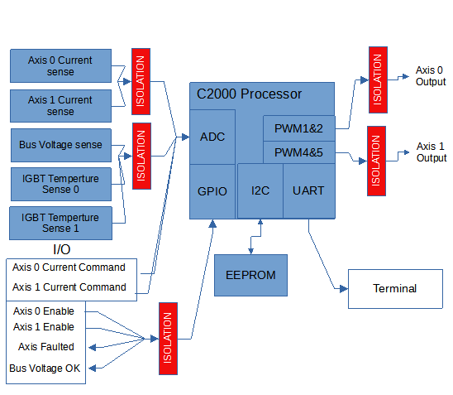

PMWs
PWM is used to control the voltage to the motor. The C2000-PM_Motor Drive uses center aligned uni-polar PWMS. Each motor is controlled using 2 PWMs controlling 4 power switching devices used to switch 3 different voltages levels of Vbus, -Vbus and 0Volts to the motor. This is a very common arraignment for PWM control of DC and AC motors and is selected because of improved efficiency over the more simple bipolar PWM. The power switching devices are arranged in a bridge configuration shown for a DC motor in Figure1 below. Note that the switch shown in the figure are actually implemented with some type of solid state devices such as a MOSFET or IGBT. In either case of of solid state device an intrinsic body diode is also realized as shown in parallel with the switch.
According to Figure1 each pair of switches are controlled by a PWM output. PWM 1 controls S1 and S2 and PWM 2 controls S3 and S4. When PWM 1 is ON S1 is closed and S2 is OPEN and when PWM 1 is OFF S1 is OFF and S2 is ON. Similarly PWM 2 controls S3 and S4 in a the same way. Each PWM has 2 separate outputs output A and B which control the pair of switches and inserts a small dead time when the PWM changes state. This dead time ensures that both switches in the pair are off for a brief time before a switch turns on to prevent a momentary shoot through or short circuit of the Bus power supply. Neglecting the dead time, there are 4 states for the pair of PWM outputs resulting in 3 different voltages applied to the motor terminals. For 3 phase AC motor control an additional pair of switches are used so that an AC motor with 3 terminals may be connected to each switch pair.
Figure 1: PWM Controlled Power Switching Devices in a Bridge Configuration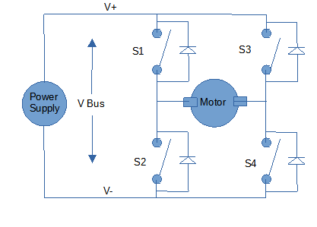
Table 1: Motor Terminal Voltages According to PWM States
PWM 1 | PWM 2 | S1 | S2 | S3 | S4 | Voltage  Applied to Motor
OFF | OFF | OFF | ON | OFF | ON | 0
OFF | ON | OFF | ON | ON | OFF | - VBus
ON | OFF | ON | OFF | OFF | ON | 0
ON | ON | ON | OFF | ON | OFF | + VBus

When dead time occurs, then both switches in a pair are off for a brief period of time. During the dead time the motor current will continue to flow due to the motor inductance. The intrinsic diodes will conduct the motor current as needed and prevent destructive over-voltage spikes that would otherwise result from opening the inductive motor circuit.

PMW Modulation
The PWMs used are know as center aligned PWMs. These PWMs use a triangle wave carrier shown in Figure 2 Below. The PWM output is generated by comparing the Compare level to the Carrier. In the figure the compare level is show at ½ the PMW Max Count, producing a 50% duty output. The duty of the PWM output is changed by increasing or decreasing the compare level. The compare level is expressed in terms of the modulation signal. A modulation signal of 0 corresponds to ½ the PMW Max Count, shown in Figure 2 Below. A modulation signal of +1 corresponds to a compare level of PWM Max Count. A modulation signal of -1 corresponds to a compare level of 0 counts. As described in
each PMW controls a pair of power switching devices, so in the case of a DC motor controlled by 2 pairs of switching devices, 2 PMWs are used. The PWM carriers are synchronized. For DC motor control the modulation signal used for PWM2 is the negative of PWM1. An illustration of 2 PMWs used to control 2 pairs of switches is shown in Figure 3 below. In the figure different combinations of PWM states produce different voltages of Vbus, 0V or -Vbus shown previously in Table 1. Note that using 2 PWMs in the manner shown in Figure 3 the PWM action applied to the motor results in 3 different voltage levels and a PWM frequency that is double the PWM carrier frequency.
Figure 2: Center Aligned PWM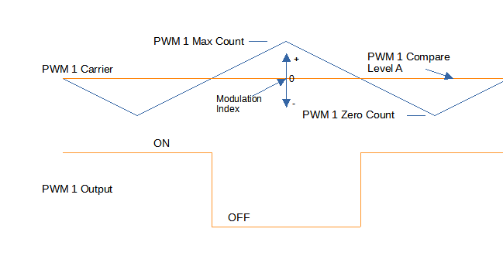
Figure 3: 2 Center Aligned PWMs for DC Motor Control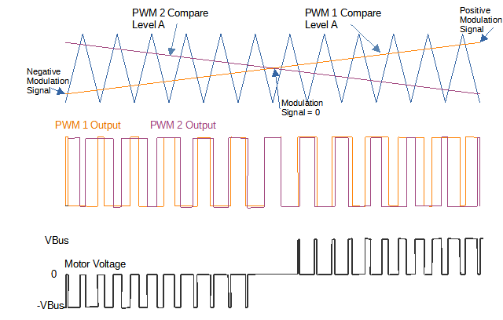

PMW Dead Time
Actual switching devices cannot turn on and off with infinite slope and zero delay. Dead time is used to ensure both switches in the pair controlled by a PMW output are OFF before either switch can turn on. The C2000 PWMs have a feature for dead time creation. To use the dead time feature a PWM has 2 actual outputs A and B for each PWM so that each switching device is controlled separately. Further details on the operation are found in https://www.ti.com/lit/pdf/sprui10
In the C2000-PM_Motor_Drive dead time for each PWM is set using the Dead-Band Generation sub module of the PWM.

Motor Current Measurement
Motor current is measured by a current sensor in series with one of the motor terminals. The motor current sensor is isolated from the C2000 processor using an isolation amp. Current is measured using one of the C2000 12 bit ADC input channels. Current measurements are requested at the peak and valley of the PWM carrier waveform. Sampling at the peak and valleys ensure that no power devices will be switching at that time. The peak and vally sampling of current also provides a better estimate of the average current over the PWM period. Note that the motor inductance keeps the current from changing too rapidly and the sample is centered around the peak and valley of the current waveform as shown in figure 4 below.

PWM Isolation Circuit
Figure 4: Motor Current Sampling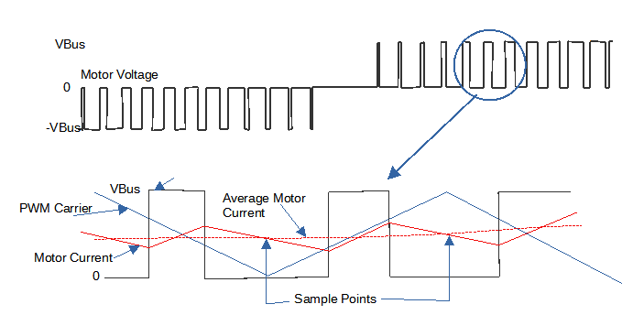
The PWM signals are isolated and coupled to the IGBT or MOSFET gates as shown in figure 5 below. According to the figure in order for a power switching device to close the PWM outputs from the C2000 processor must be in opposite states. This coupling technique ensures that only one of the switches in a pair can be closed at a time. As shown in the figure it can be seen that when PWM1A output is Low and PWM1B output is high then S1 will close. This logic is used to set up the C2000 PWM outputs and dead band generation.
Figure 5: PWM Isolation Circuit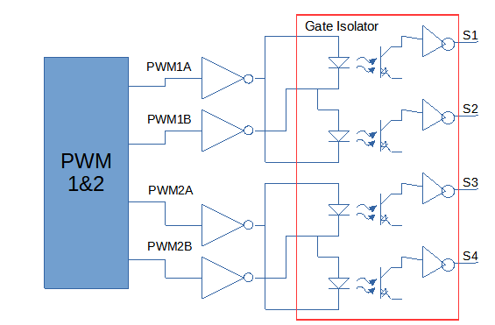

OPERATION

Operating Modes
The drive can operate in Voltage Mode or in Current mode. Current mode is the typical use with a velocity or position control as outer feedback loops as part of a control system with a motion planner such as LinuxCNC
Voltage mode allows open loop operation of each axis using an internally set voltage command. The PWM value is set according to the voltage command. Feedback is not used in Voltage Mode by the drive axis.

Command Line Interface (CLI)
A command line interface is provided to set up the drive and each axis of the drive. The command line interface will also report some status of the drive when a change occurs. To use the command line interface a serial communications interface with the following setting is used:
BAUD 9600
PuTTy may be used as the terminal for the interface and versions are available for Windows and Linux
The CLI is by design simple and does not make use of certain C library function such as printf() because of the code size expense.
Unless otherwise noted all arguments and return values that represent numeric values are given in Decimal format
s_pwm <axis> <PWM value>
r_adc <channel>
p_pwm <axis> <PWM value> <duration>
pwm_off <axis>
pwm_on <axis.
Eewrite <address> <value>
eeread <address>
p_cref <axis> <value>
r_axis <axis> <item>
w_axis <axis> <item> <value.
adc_cal <channel>

Control Variables
A structure of control variables is initiated for each axis at power on of the drive. Some variables are initiated from EEPROM and others have fixed values. The axis control variables are defined in PMDC_drive.h

Firmware Operation and Timing
Currently there are 3 interrupt routines used in the drive. These interrupts are:
- ADCINT1_ISR which results from the End of Conversion for SOC5
- ADCINT2_ISR which results from the End of Conversion for SOC14
- EPWM1_INT_ISR Which is used in special test modes invoked via the CLI
The Main routine initializes the drive and control variables and starts the PWMs but waits until axis are enabled before turning on the PWM outputs. In the background the main routine runs receiving commands over the UART input and reporting status over the same UART interface. When a CLI command is received, the command is executed as part of the background task.

SOCs
SOC are Start of Conversion requests. Please refer to https://www.ti.com/lit/pdf/sprui10 for more details. For the C2000-PM_Motor_Drive The SOCs are set up to run at the peak and valley of the PWM Carrirer.
The 16 SOCs are used in the round robin configuration. At the peak of PWM1 a series of SOCs are initiated with the first request being the axis current for Axis0 and Axis1 followed by the command input for each axis. After the last SOC is complete then the ADCINT1_ISR is entered and the current control loop is executed for each axis(if the mode is enabled) and the PWMs are updated. Simillarly at the valley of PWM2 another series of SOCs are initiated again requesting ADC conversion of the Axis0 and Axis1 current followed by the current command inputs. After the last SOC of the second series is complete ADCINT2_ISR is entered and the control loops are executed again. By running the 2 ISRs in this way the control loops are updated at 2 times the PWM carrier frequency.

PID control with LinuxCNC
Typically the C2000-PM_Motor_Drive will be operating in Torque Mode when used with LinuxCNC. The drive will receive a reference current as the input to a PI control in the drive. The output of the PI control is voltage. As typically found in many servo motor position control systems cascaded PI loops may be used. The cascaded loops are referred to as torque, velocity and position. The velocity and position loops may be configured and controlled by LinuxCNC while the torque loop is within the drive.

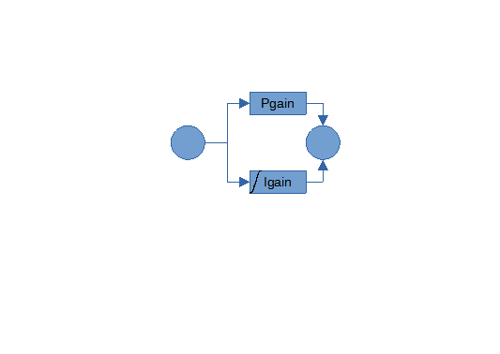

Timing

Reference to PWM methods for motor control

