P0
John Filippone
johnpfilippone@yahoo.com

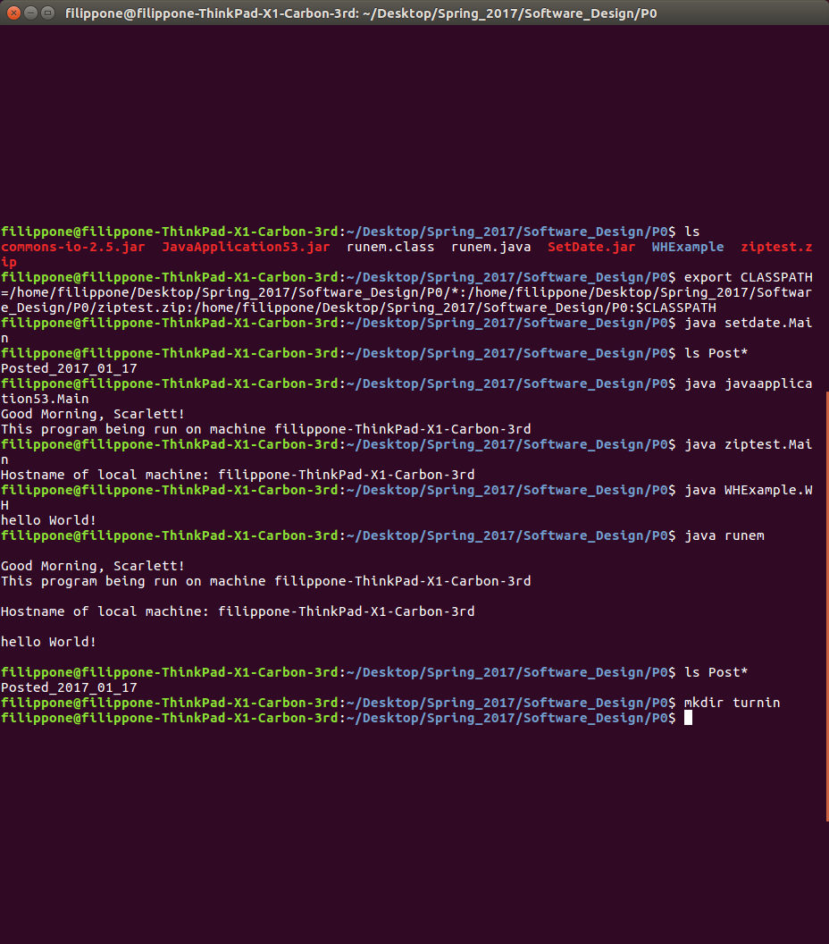

Proof of work

First I show my directory contents to show that it does not contain the files created by setdate.Main.

Then I set my class path. For the jar files I use the wild card: P0/*, for the zip file I use an absolute path, and for the class file I put the file inside of a directory named WHExample and added the P0 directory (the directory that contains WHExample) to the classpath.

Finally I run each of the commands described in the project web page one at a time and show the outputs.

