Practice Challenges: Worked Word Output
Check-your-work artifacts for the two challenges that produce Word output.

Challenge 3: Revenue by region (report-ready table)
Region | Revenue | Share
North | $535,879 | 24.9%
West | $489,393 | 22.7%
East | $422,289 | 19.6%
South | $379,930 | 17.6%
Central | $327,447 | 15.2%
TOTAL | $2,154,938 | 100.0%

Challenge 4: Regions by order count, and the bottom line
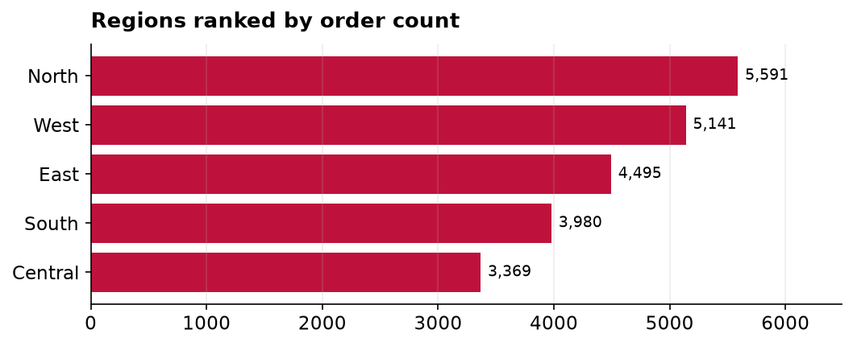
Bottom line: North leads not just in revenue but in sheer order volume, so it is our busiest market as well as our biggest, and the natural place to protect first.

