Quarterly Sales Performance, 2024
Prepared for the leadership team | Confidential

Bottom line
Revenue reached $2.15M in 2024, up 12% from the first quarter to the fourth. Growth was broad but uneven: North is now a third larger than Central. We recommend shifting a share of Q1 marketing spend toward Central and South to close the regional gap.

The numbers at a glance
Metric | Value
Total revenue | $2,154,938
Orders | 22,576
Average order value | $95.45
Q4 vs Q1 growth | +12%
Top region | North

Revenue trend and regional split
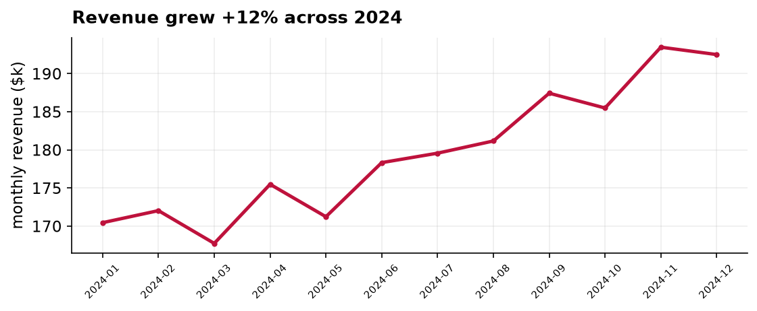
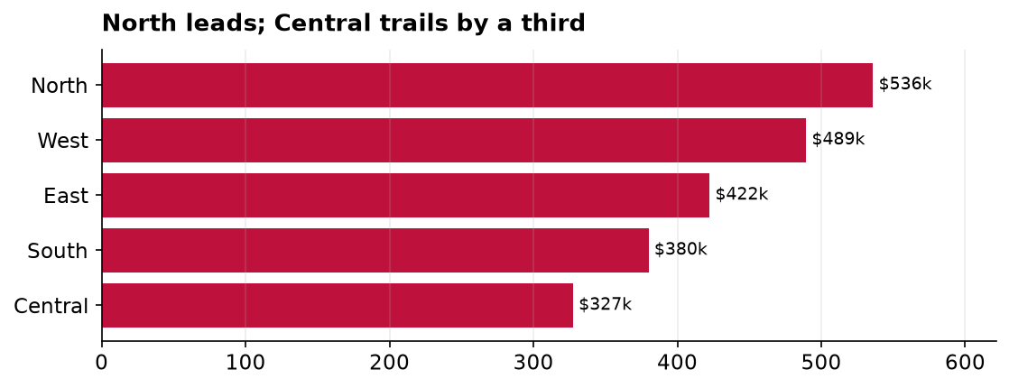

What we found
- Revenue rose every quarter, from $510k in Q1 to $571k in Q4.
- North ($536k) and West ($489k) drove over 45% of revenue.
- Central ($327k) remains the clear laggard and the biggest upside.

Recommendation
Rebalance a portion of marketing investment toward the underperforming Central and South regions in Q1 2025, and set a target of narrowing the North-to-Central revenue gap from 39% to under 25%.

