A/B Test Readout: New Checkout Flow
Experiment ran 2 weeks | Owner: Growth team

Decision
SHIP the new checkout.
The new checkout lifted conversion from 8.1% to 9.4%, a 16% relative gain. The result is statistically significant (p = 0.012) and the plausible effect stays positive.

Method
Visitors were randomly split between the current checkout (A) and a redesigned flow (B), 6,000 per arm. Success is a completed purchase. We compare conversion rates with a two-proportion z-test and report a 95% confidence interval on the difference.

Results
Group | Visitors | Conversions | Rate
A (control) | 6,000 | 486 | 8.1%
B (new checkout) | 6,000 | 564 | 9.4%
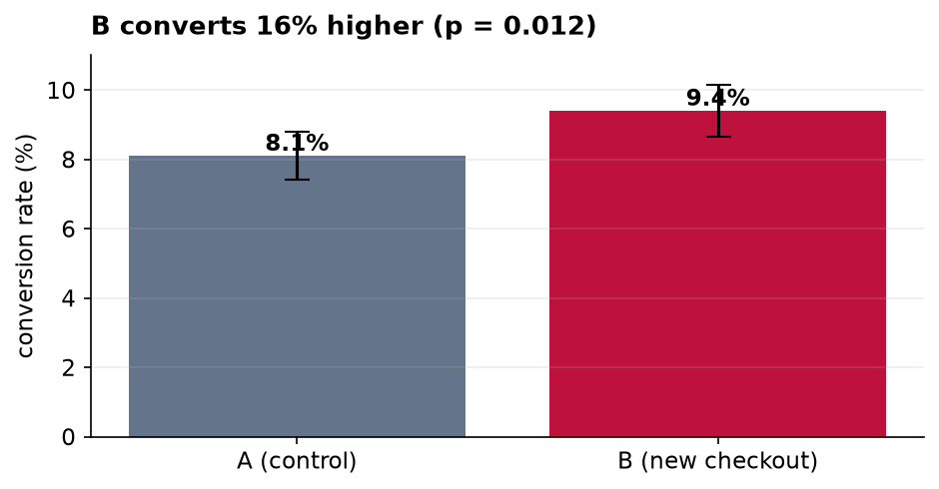
Relative lift +16%. Two-proportion z = 2.52, p = 0.012. 95% confidence interval on the absolute difference: [+0.29%, +2.31%].

Caveats
- The test ran for two weeks; a longer window would confirm the effect holds beyond a novelty bump.
- Conversion is the only metric here; monitor refunds and support tickets after rollout.
- The interval is comfortably above zero, but the lower bound is modest, so treat the point estimate as optimistic.

