Drivers of Customer Satisfaction
Analytics team | Survey of 320 customers

Summary
Across 320 respondents, four service factors explain 84% of the variation in satisfaction. The strongest lever is ease of use (each 1-point gain adds 3.8 points of satisfaction), followed by support quality. Long wait times are the only factor that lowers it. Investment in ease of use offers the largest expected return.

Data and method
Respondents rated overall satisfaction from 0 to 100 and four drivers from 1 to 10. We fit an ordinary least squares regression of satisfaction on all four drivers simultaneously, so each coefficient is the effect of that driver holding the others constant.

Results
Driver | Coefficient | Std. error | p-value
Intercept | +28.03 | 1.33 | 0.000
ease of use | +3.82 | 0.12 | 0.000
support quality | +2.37 | 0.11 | 0.000
price fairness | +1.51 | 0.11 | 0.000
wait time | -0.90 | 0.11 | 0.000
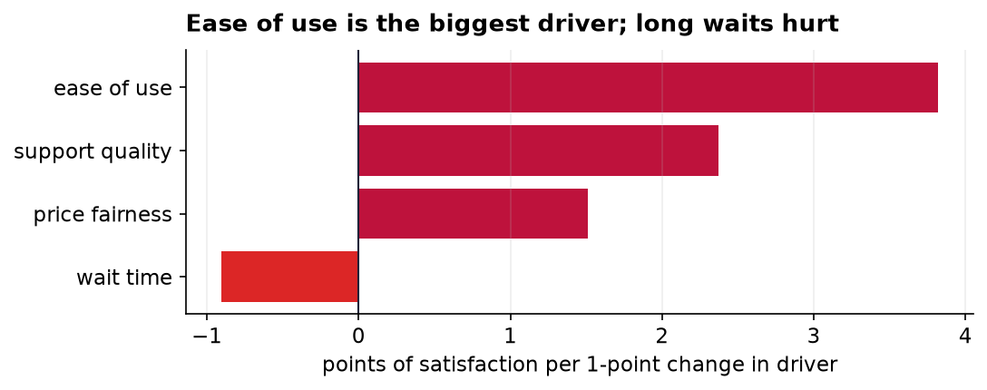
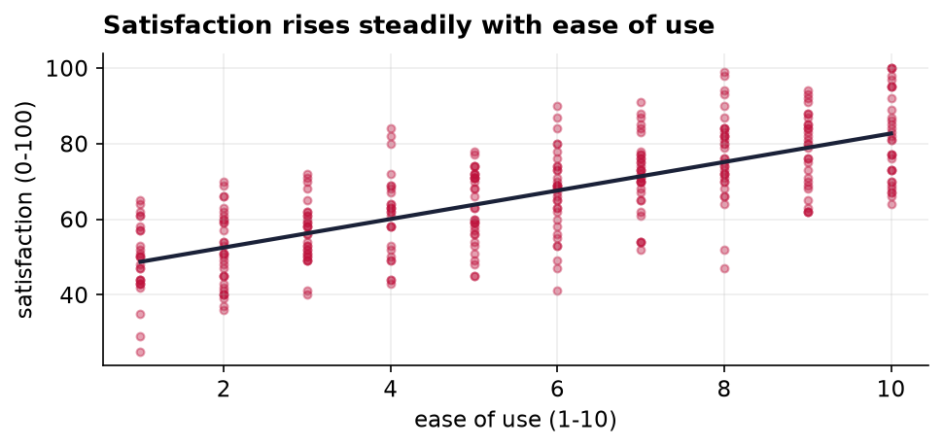

Interpretation
- Ease of use and support quality together account for most of the explained variation.
- Price fairness matters but less; wait time is the one factor to reduce, not increase.
- The model explains 84% of variation (R-squared = 0.84), a strong fit for survey data.

Limitations
- The data is observational, so these are associations, not proven causes.
- Drivers are self-reported and may correlate with an overall halo effect.
- A single survey wave cannot capture how these relationships shift over time.

