Fill-Weight Audit: The Line Is Running Slightly Heavy
Quality Analytics memo | To: Plant Manager, Packaging | Re: 340 g whole-bean bags, one-day QC sample

Recommendation
Lower the fill target from its current setting to about 340.5 grams. Our sample shows bags are averaging a little over a gram above the 340 g label. That is money left on the table at volume, and trimming the target recovers most of it while keeping every bag safely above the printed weight. Do not aim straight at 340 g: that would put roughly half of bags under the label, which the net-content rules do not allow.

What we found
We weighed a sample of 70 bags pulled across one production day. The average fill was 341.2 grams against a 340 gram label, an overfill of about 1.2 grams per bag. This is not a fluke of which bags we happened to grab: the numbers are far too consistent for that. We are 95 percent confident the true average sits between 340.7 and 341.7 grams, a range that stays entirely above the label. In plain terms, we can say with confidence the line runs heavy, and by about a gram.
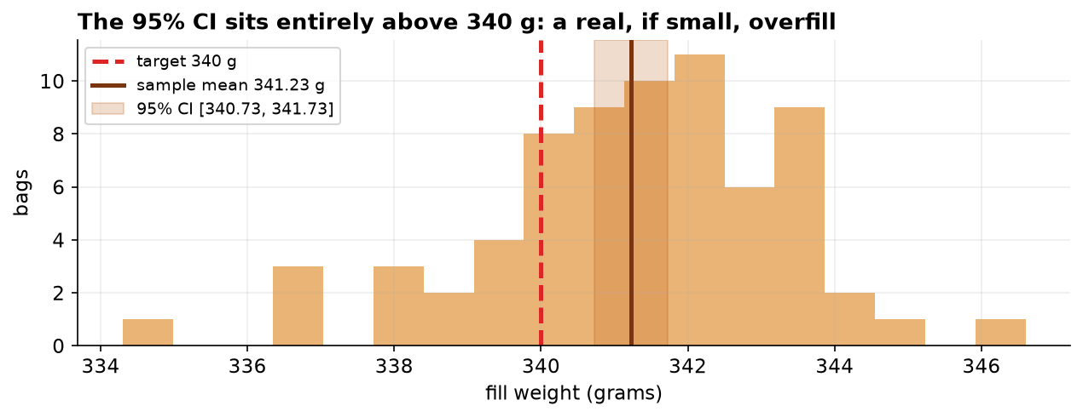
Every bag we weighed, with the 340 g label (dashed red) and the range where the true average lives (gold band). The band sits completely to the right of the label, which is the picture of a real, if small, overfill.

How much it matters
Per bag, a gram of coffee is nothing. Across a million-bag run it is roughly 1,200 kilograms of product given away, which for a commodity like coffee is a real cost. So the finding is worth acting on, but it is not an emergency: no customer is being shorted, and the fix is a small setpoint change, not a line rebuild.

Why the numbers can be trusted
The raw QC export was messy, and we cleaned it before drawing any conclusion. Three duplicate log entries, three blank readings, and three impossible values (a 0-gram empty pan, a mistyped 34.1, and a fat-finger 3410) were removed, taking 78 rows down to 70 genuine measurements. We also confirmed the weights follow the normal bell shape a t-test expects, so the standard test applies, and a second, assumption-free test agreed with it. In short, the result is not an artifact of bad data or the wrong method.
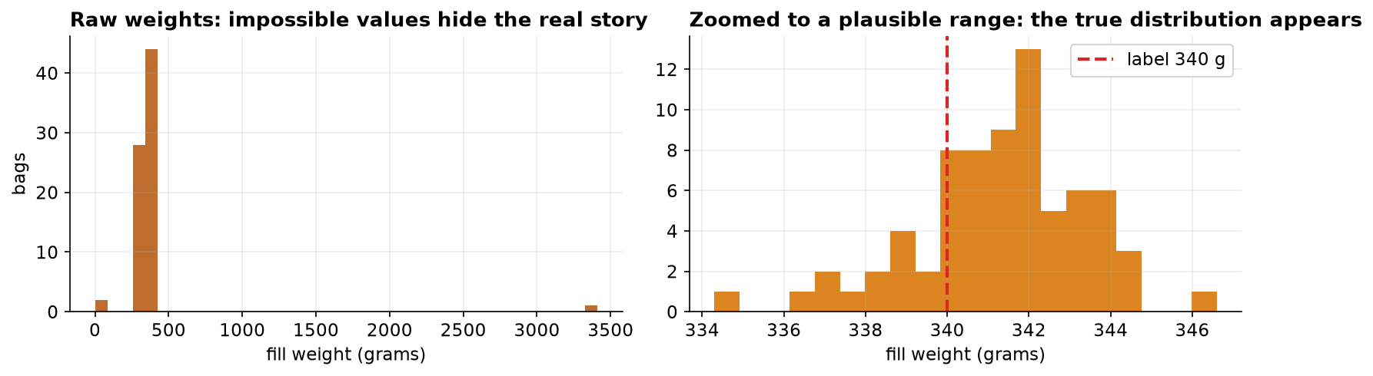
Before and after cleaning. A few impossible entries (left) hid the real distribution; once removed, a clean bell centered just above 340 g appears (right).

Before you change the setpoint
Two cautions. First, this is one day on two lines; weigh a few more days before treating the overfill as a permanent number. Second, the whole finding rests on the scale, so verify it against a certified reference weight, a scale reading half a gram high would create an overfill that is not really there. With those two checks done, trimming the target toward 340.5 g is the safe, money-saving move.

