A Redesigned Onboarding Program and Time to Productivity:
A Two-Sample Analysis under Unequal Variances
Capstone Technical Report · Statistics, Data Science and AI: A Visual Handbook · John Fisher
Abstract. Objective. To evaluate whether a redesigned onboarding program reduces new-hire time to productivity relative to the incumbent program. Methods. Time to productivity (business days) was compared between an independent New cohort (n = 55) and a Standard cohort (n = 52). Group normality was assessed by Shapiro-Wilk, and homogeneity of variance by Levene's and Bartlett's tests; because variances differed, Welch's unequal-variance t-test was the primary procedure, with the Mann-Whitney U test as a distribution-free check. Cohen's d and a 95% confidence interval for the mean difference were reported. Results. The New cohort reached productivity a mean of 4.68 days sooner (19.9 vs 24.6 days). Both groups were approximately normal, but variances were unequal (Levene p = 0.002; Bartlett p = 0.0002), the New cohort being substantially more dispersed (SD 7.6 vs 4.4). Welch's test was significant, t(87.8) = 3.92, p < 0.001, 95% CI [2.31, 7.05] days, Cohen's d = 0.75; Mann-Whitney concurred (p < 0.001). Conclusions. The redesign yields a meaningful mean acceleration of roughly 5 days, but its greater variance implies less predictable ramp times, a trade-off that belongs in any deployment decision.
Keywords: two-sample t-test; Welch's correction; homogeneity of variance; Levene's test; effect size; onboarding.
1. Introduction
Comparing a treatment condition to a control on a continuous outcome is the archetypal two-group inference problem. Here the treatment is a redesigned onboarding program and the outcome is time to productivity in business days, lower being better. The hypotheses for the population mean difference are H0: mean(New) = mean(Standard) versus H1: the means differ, two-sided at alpha = 0.05. A frequently overlooked subtlety, and the methodological focus of this report, is that the textbook pooled t-test assumes equal group variances; when that assumption fails, Welch's unequal-variance formulation is required.
2. Data
The dataset comprises 115 hire records with a program label, department, and time to productivity. The program label had been recorded with inconsistent casing and whitespace and was standardized prior to analysis; duplicates, missing outcomes, and out-of-range values were then removed (Table 1). The analysis sample was n = 107 (52 Standard, 55 New).
Table 1. Data-cleaning provenance. Removed out-of-range values: {-4, 0, 999}.
Step | Rule | Removed | Remaining
Raw export | — | — | 115
Standardize label | trim/case-fold cohort | 0 | 115
De-duplication | drop duplicate rows | 2 | 113
Missing outcome | drop blank days_to_productive | 3 | 110
Range filter | retain 1–120 business days | 3 | 107
3. Methods
Normality within each group was assessed by the Shapiro-Wilk test and Q-Q plots. Homogeneity of variance was tested by Levene's test (median-centered, robust to non-normality) and Bartlett's test. Because both indicated unequal variances, Welch's t-test with Satterthwaite degrees of freedom was adopted as the primary test; the pooled t-test is reported only for contrast. The Mann-Whitney U test provided a rank-based sensitivity analysis. Effect size was Cohen's d using the simple pooled standard deviation, and precision a 95% CI for the mean difference. Computations used SciPy and statsmodels in Python 3; figures used Matplotlib.
4. Results
Table 2. Descriptive statistics by cohort.
Group | n | Mean (days) | SD | Median | Min | Max
Standard | 52 | 24.56 | 4.43 | 24.9 | 13.7 | 34.0
New | 55 | 19.88 | 7.59 | 18.8 | 6.5 | 41.1
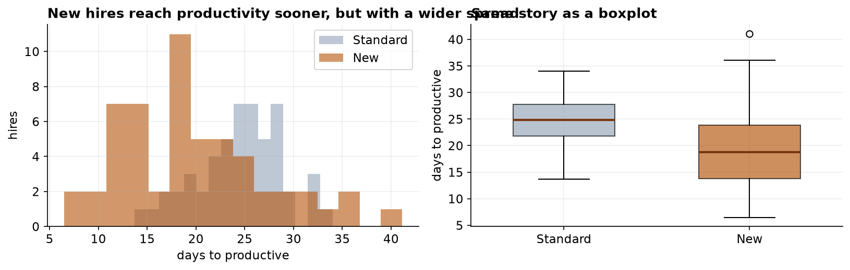
Figure 1. Distributions (left) and boxplots (right) of time to productivity by cohort. The New cohort is shifted lower but is visibly more dispersed.
Both cohorts were consistent with normality (Shapiro-Wilk: Standard W = 0.985, p = 0.745; New W = 0.966, p = 0.115), but the equal-variance assumption was rejected by both tests (Table 3), the New cohort's standard deviation being 1.71 times the Standard cohort's. Welch's test is therefore the appropriate procedure.
Table 3. Assumption diagnostics.
Diagnostic | Statistic | p-value | Conclusion
Shapiro-Wilk (Standard) | W = 0.985 | 0.745 | normal
Shapiro-Wilk (New) | W = 0.966 | 0.115 | normal
Levene (median-centered) | W = 10.21 | 0.0018 | variances differ
Bartlett | chi-sq = 14.28 | 0.0002 | variances differ
Table 4. Two-sample test results for H0: equal means.
Test | Statistic | df | p-value | Effect / interval
Welch t (primary) | t = 3.920 | 87.8 | 1.75e-04 | d = 0.75; 95% CI [2.31, 7.05] d
Pooled t (for contrast) | t = 3.866 | 105 | 1.92e-04 | assumes equal variance; not valid here
Mann-Whitney U | U = 2063 | — | 8.06e-05 | distribution-free confirmation
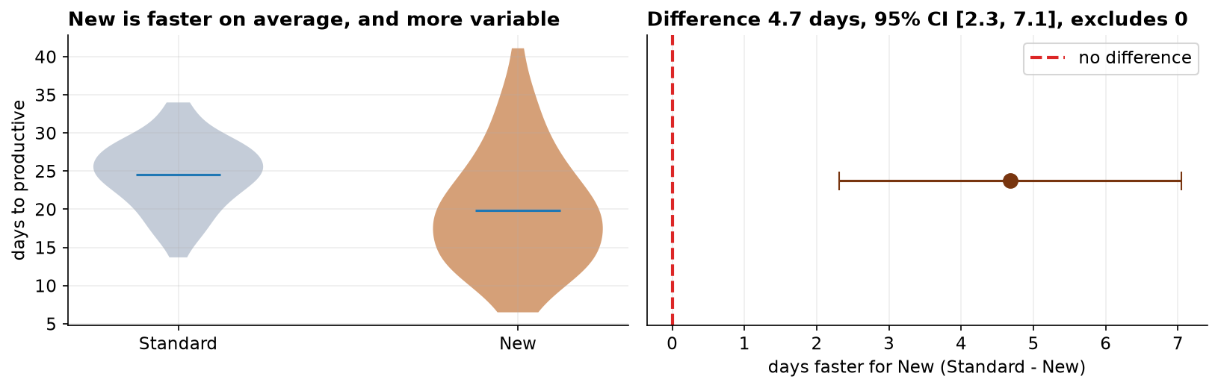
Figure 2. Group distributions (left) and the estimated mean difference with its 95% CI (right); the interval excludes zero.
The New program reduced mean time to productivity by 4.68 days (95% CI [2.31, 7.05]), a medium-to-large standardized effect. With near-equal group sizes the pooled and Welch statistics happen to nearly coincide (t = 3.87 vs 3.92); this coincidence is not general, and under unequal group sizes ignoring heteroscedasticity can bias the p-value in either direction, which is why Welch is the appropriate default.
5. Discussion
The redesign delivers a real mean acceleration. The more consequential finding is the marked increase in variance: the New cohort is faster on average yet less predictable, with a right tail of slow starters comparable to the incumbent program. A decision framed only on the mean would misrepresent the operational reality, where variance in ramp time carries staffing and planning cost. Reporting the dispersion alongside the mean difference is therefore not optional.
Threats to validity. The comparison is causal only under comparable assignment; if the New program was allocated by department, manager, or start window rather than at random, the estimated effect confounds the program with those factors, and comparability on covariates should be verified. The outcome also depends on a consistently applied productivity criterion; differential application across cohorts would contribute measurement, not learning-speed, differences. Finally, this is a single-organization pilot, supporting staged rollout with monitoring rather than broad generalization.
6. Conclusion
New-hire onboarding time was significantly shorter under the redesigned program (Welch t(87.8) = 3.92, p < 0.001; mean difference 4.7 days, 95% CI [2.31, 7.05]; d = 0.75), a result robust to a distribution-free check. The accompanying increase in variance qualifies the recommendation and should be managed in deployment.
References
Student (1908). The probable error of a mean. Biometrika, 6(1), 1–25.
Welch, B. L. (1947). The generalization of Student's problem when several different population variances are involved. Biometrika, 34(1–2), 28–35.
Levene, H. (1960). Robust tests for equality of variances. In Contributions to Probability and Statistics (pp. 278–292). Stanford University Press.
Bartlett, M. S. (1937). Properties of sufficiency and statistical tests. Proc. R. Soc. Lond. A, 160(901), 268–282.
Mann, H. B., & Whitney, D. R. (1947). On a test of whether one of two random variables is stochastically larger than the other. Ann. Math. Statist., 18(1), 50–60.
Shapiro, S. S., & Wilk, M. B. (1965). An analysis of variance test for normality. Biometrika, 52(3–4), 591–611.
Cohen, J. (1988). Statistical Power Analysis for the Behavioral Sciences (2nd ed.). Lawrence Erlbaum.
Reproducibility
The dataset (capstone-onboarding-productivity.xlsx) and an executable notebook reproducing every statistic, table, and figure accompany the chapter. Analyses use NumPy, pandas, SciPy, statsmodels, and Matplotlib.

