Effect of an Eight-Week Program on Systolic Blood Pressure:
A Paired-Samples Analysis, with a Note on Uncontrolled Designs
Capstone Technical Report · Statistics, Data Science and AI: A Visual Handbook · John Fisher
Abstract. Objective. To test whether systolic blood pressure (SBP) changed after an eight-week lifestyle-and-medication program, and to delimit what a single-arm pre-post design can and cannot establish. Methods. SBP was measured before and after the program in the same patients (n = 55 complete pairs). The paired differences were tested for normality (Shapiro-Wilk) and analyzed by a two-sided paired t-test, with the Wilcoxon signed-rank test as a distribution-free check. Cohen's d_z and a 95% CI for the mean change were reported; an independent-samples analysis is shown to quantify the efficiency gained from pairing. Results. SBP fell by a mean of 7.27 mmHg (146.7 to 139.5); the differences were normal (W = 0.989, p = 0.89). The reduction was highly significant, t(54) = -7.37, p < 0.001, 95% CI [-9.25, -5.29] mmHg, d_z = 0.99, and confirmed by Wilcoxon (p < 0.001). Pre-post correlation was high (r = 0.85), so pairing reduced the standard error roughly 2.5-fold relative to an independent-groups analysis. Conclusions. SBP decreased by a clinically meaningful margin, but in the absence of a control arm the change cannot be attributed to the program; regression to the mean and secular effects are unadjusted competing explanations.
Keywords: paired t-test; within-subject design; regression to the mean; single-arm study; Wilcoxon signed-rank; effect size.
1. Introduction
When the same units are measured under two conditions, the paired (within-subject) design removes between-unit variation and is markedly more efficient than an independent-groups comparison. Here systolic blood pressure is measured before and after an eight-week program in a cohort of hypertensive patients. The hypotheses concern the mean of the within-patient change delta = after - before: H0: mean(delta) = 0 versus H1: mean(delta) != 0, two-sided at alpha = 0.05. A second, equally important aim is inferential hygiene: to state precisely what a single-arm pre-post design licenses.
2. Data
Each record contains a patient identifier, age, and SBP before and after the program. A paired analysis requires both measurements, so patients lacking a follow-up (dropouts) are not analyzable. After removing duplicates, dropouts, and physiologically impossible values (Table 1), n = 55 complete pairs remained.
Table 1. Data-cleaning provenance. Removed impossible readings: {0, 29, 300} mmHg.
Step | Rule | Removed | Remaining
Raw export | — | — | 64
De-duplication | drop duplicate rows | 2 | 62
Complete pairs | drop rows missing either reading | 4 | 58
Range filter | retain 70–250 mmHg both readings | 3 | 55
3. Methods
The paired t-test is a one-sample t-test on the differences and assumes those differences are approximately normal; this was assessed by Shapiro-Wilk and a Q-Q plot of the differences (not of the raw readings). The Wilcoxon signed-rank test served as a distribution-free sensitivity analysis. Effect size was Cohen's d_z = mean(delta)/SD(delta), the standardization appropriate to a within-subject contrast. To quantify the value of the design, an (inappropriate) independent-samples t-test on the same data is reported alongside, comparing standard errors. Analyses used SciPy in Python 3.
4. Results
Table 2. Descriptive statistics. Pre-post correlation r = 0.85.
Quantity | Before | After | Change (after − before)
Mean (mmHg) | 146.7 | 139.5 | -7.27
SD (mmHg) | 11.7 | 13.9 | 7.32
n (pairs) | 55 | 55 | 55
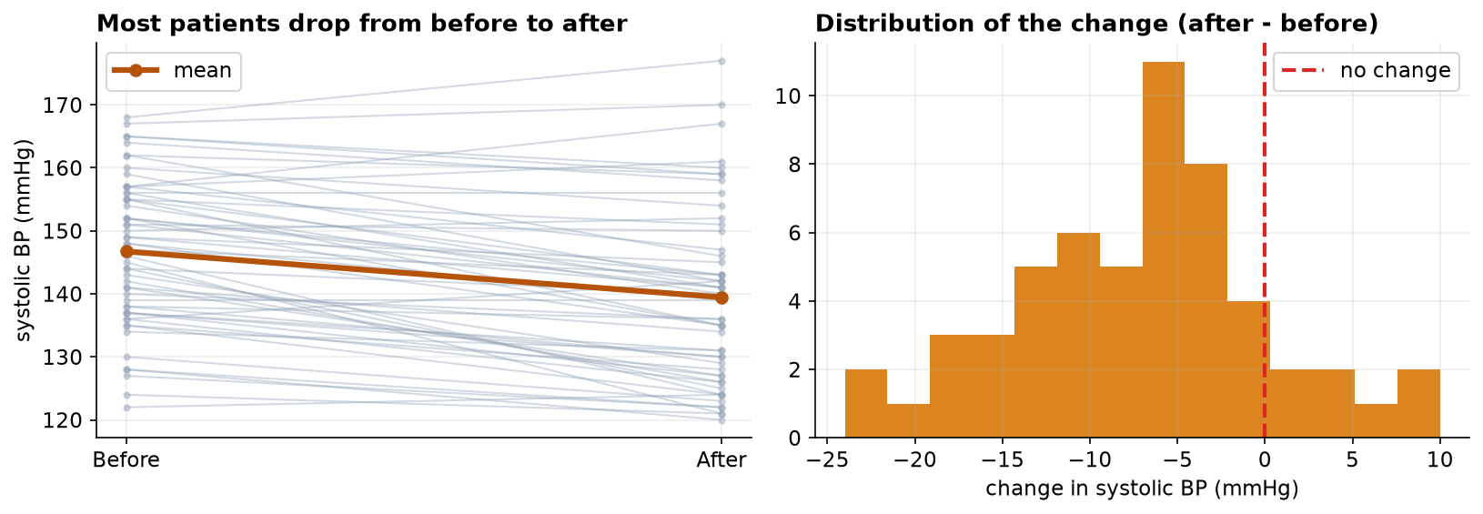
Figure 1. Paired plot (left): one line per patient from before to after, with the group mean in bold. Distribution of within-patient change (right).
The within-patient differences were consistent with normality (W = 0.989, p = 0.89; Figure 2), validating the paired t-test. The mean change of -7.27 mmHg was highly significant (Table 3), with a 95% CI of [-9.25, -5.29] mmHg lying entirely below zero and a large within-subject effect (d_z = 0.99). The Wilcoxon test agreed. The high pre-post correlation (r = 0.85) is what makes the paired design efficient: the paired standard error (0.99 mmHg) is about 2.5 times smaller than the independent-groups standard error (2.44 mmHg), turning an independent-samples t of -2.98 into a paired t of -7.37 on identical data.
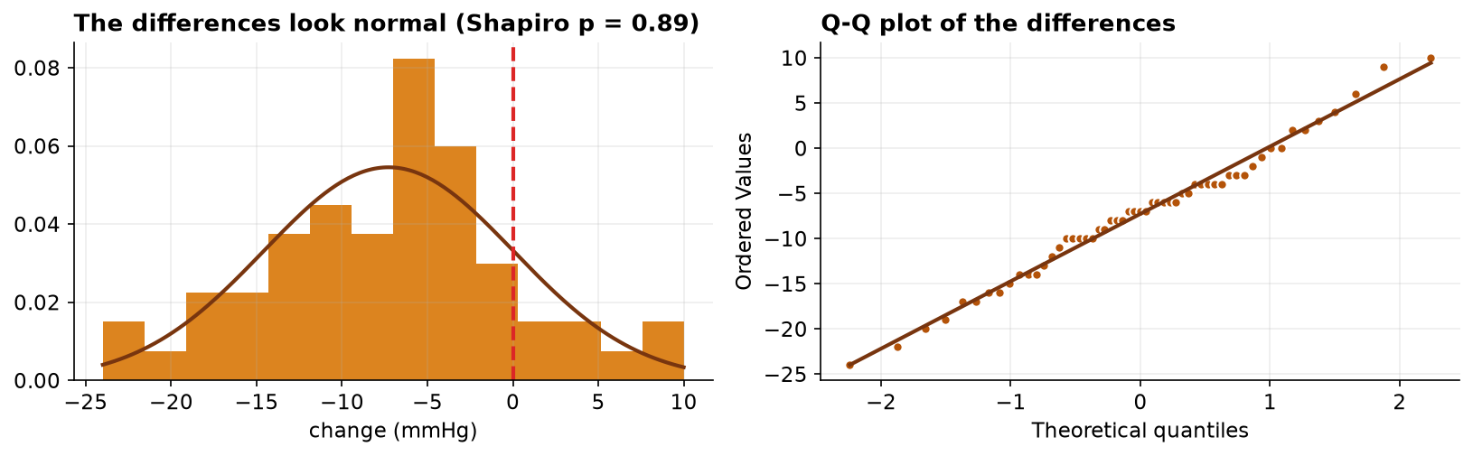
Figure 2. Normality of the within-patient differences: histogram with fitted normal (left) and Q-Q plot (right).
Table 3. Paired analysis and the efficiency contrast against an independent-samples test.
Test | Statistic | df | p-value | Effect / interval
Paired t (primary) | t = -7.372 | 54 | 1.03e-09 | d_z = 0.99; 95% CI [-9.25, -5.29] mmHg
Wilcoxon signed-rank | W = 110.0 | — | 8.13e-08 | distribution-free confirmation
Independent t (for contrast) | t = -2.98 | 108 | 3.60e-03 | ignores pairing; far less efficient
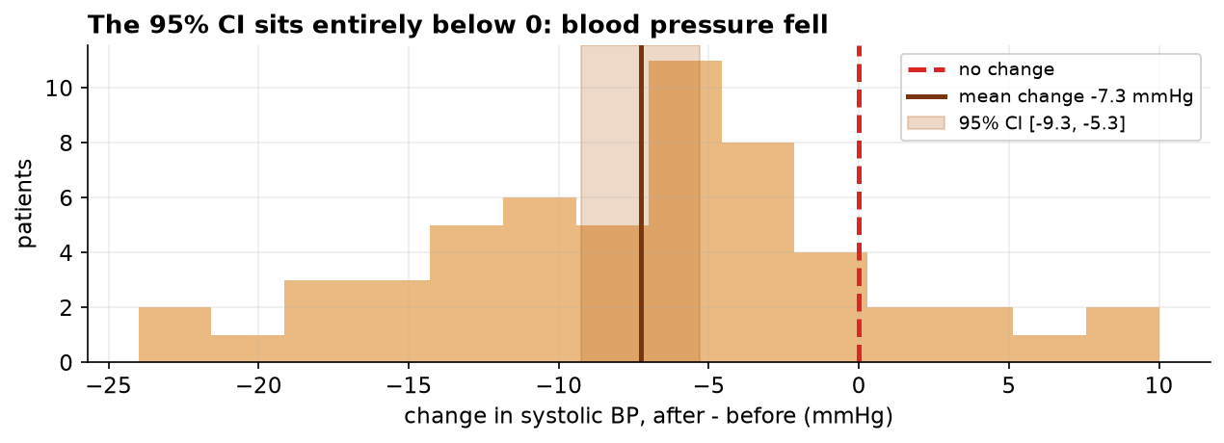
Figure 3. Distribution of within-patient change with the mean and its 95% CI (shaded) relative to zero (dashed). The interval lies entirely below zero.
5. Discussion
Systolic blood pressure declined by approximately 7 mmHg, a change that is both statistically decisive and, clinically, of a magnitude associated with reduced cardiovascular risk. The paired design is the correct and efficient analysis for the question 'did SBP change'.
It is the causal question that requires caution, and this is the methodological crux. The study is single-arm: there is no concurrent control group. Consequently the observed decline conflates any program effect with (i) regression to the mean, which is expected because patients were enrolled on the basis of elevated readings and extreme values tend to move toward the mean on remeasurement; (ii) secular and seasonal trends and lifestyle changes coincident with enrollment; and (iii) measurement effects such as the white-coat response attenuating at the second visit. None of these is estimable without a comparison arm measured identically but not exposed to the program. A randomized controlled design, or at minimum a contemporaneous control, is required before attributing the reduction to the intervention. The paired t-test answers 'did it change'; it is structurally silent on 'did the program cause it'.
6. Conclusion
Systolic blood pressure fell significantly over the program (paired t(54) = -7.37, p < 0.001; mean change -7.3 mmHg, 95% CI [-9.25, -5.29]; d_z = 0.99), robustly across parametric and rank-based tests. Absent a control arm, the decline is not attributable to the program, and a controlled follow-up is the appropriate next step.
References
Student (1908). The probable error of a mean. Biometrika, 6(1), 1–25.
Shapiro, S. S., & Wilk, M. B. (1965). An analysis of variance test for normality. Biometrika, 52(3–4), 591–611.
Wilcoxon, F. (1945). Individual comparisons by ranking methods. Biometrics Bulletin, 1(6), 80–83.
Barnett, A. G., van der Pols, J. C., & Dobson, A. J. (2005). Regression to the mean: what it is and how to deal with it. International Journal of Epidemiology, 34(1), 215–220.
Vickers, A. J., & Altman, D. G. (2001). Analysing controlled trials with baseline and follow-up measurements. BMJ, 323(7321), 1123–1124.
Cohen, J. (1988). Statistical Power Analysis for the Behavioral Sciences (2nd ed.). Lawrence Erlbaum.
Reproducibility
The dataset (capstone-blood-pressure-before-after.xlsx) and an executable notebook reproducing every statistic, table, and figure accompany the chapter. Analyses use NumPy, pandas, SciPy, and Matplotlib.

