Screening Seven Clinical Markers for Association with Heart Disease:
Effect Sizes under Multiple-Comparison Control
Capstone Technical Report · Statistics, Data Science and AI: A Visual Handbook · John Fisher
Abstract. Objective. To identify which of seven routine clinical markers differ between patients with and without diagnosed heart disease, while controlling the family-wise error rate incurred by testing several markers simultaneously. Methods. In an observational cohort (n = 575; 242 disease, 333 healthy), each marker was compared between groups by Welch's t-test; the seven p-values were corrected by the Bonferroni and Holm procedures. Effect sizes (Cohen's d; point-biserial correlation) were reported. Results. Uncorrected, three markers reached p < 0.05; after correction only two survived: Age (d = 1.34, r_pb = 0.55) and Cholesterol (d = 0.95, r_pb = 0.42), both p < 0.001. Systolic blood pressure was nominally significant (p = 0.021) but had a negligible effect size (d = 0.20) and did not survive correction, an expected false positive given a family-wise error probability of about 30% across seven tests. Conclusions. Only age and cholesterol are defensibly associated with disease status in this cohort. Because the data are observational and age is a plausible confounder of the other markers, a covariate-adjusted model is the appropriate next step; the marginal screen is hypothesis-generating, not confirmatory.
Keywords: multiple comparisons; family-wise error rate; Bonferroni; Holm; effect size; confounding; observational study.
1. Introduction
Screening a panel of markers against a single outcome is efficient but statistically hazardous: each test carries its own type-I error probability, so the chance that at least one null marker is declared significant grows rapidly with the number of tests. For k independent tests at level alpha, the family-wise error rate (FWER) is 1 - (1 - alpha)^k, which for alpha = 0.05 and k = 7 equals about 30%. This report screens seven markers for association with heart-disease status and applies multiplicity control so that the reported discoveries are credible rather than artifacts of volume.
2. Data
The observational cohort records seven continuous markers and a binary heart-disease diagnosis per patient. After removing duplicate records and values outside clinically plausible ranges, and dropping records with missing markers, n = 575 patients remained (242 with disease, 333 healthy). Marker ranges used for cleaning were: Age 18–100; BMI 12–70; Systolic_BP 70–250; Diastolic_BP 40–150; Cholesterol 80–450; Glucose 50–400; Heart_Rate 35–200.
Table 1. Data-cleaning provenance.
Step | Rule | Removed | Remaining
Raw export | — | — | 603
De-duplication | drop duplicate rows | 3 | 600
Range + missing | plausible ranges; complete markers | 25 | 575
3. Methods
For each marker, the two groups (disease vs healthy) were compared by Welch's unequal-variance t-test; at several hundred observations per group the Central Limit Theorem renders this robust. Effect sizes were Cohen's d (pooled) and the point-biserial correlation between the binary outcome and each marker, which is algebraically equivalent to the t-based comparison and quantifies association on the correlation scale. The seven resulting p-values were adjusted for multiplicity by the Bonferroni procedure (reject if p < alpha/k) and by Holm's step-down procedure, which controls the FWER with greater power. Analyses used SciPy and statsmodels in Python 3.
4. Results
The clinical dashboard (Figure 1) previews the result: only age and cholesterol visibly separate the groups, and in the correlation matrix the Disease row shows Age at 0.55 and Cholesterol at 0.42 against near-zero values elsewhere. Table 2 gives the formal screen, ranked by effect size.
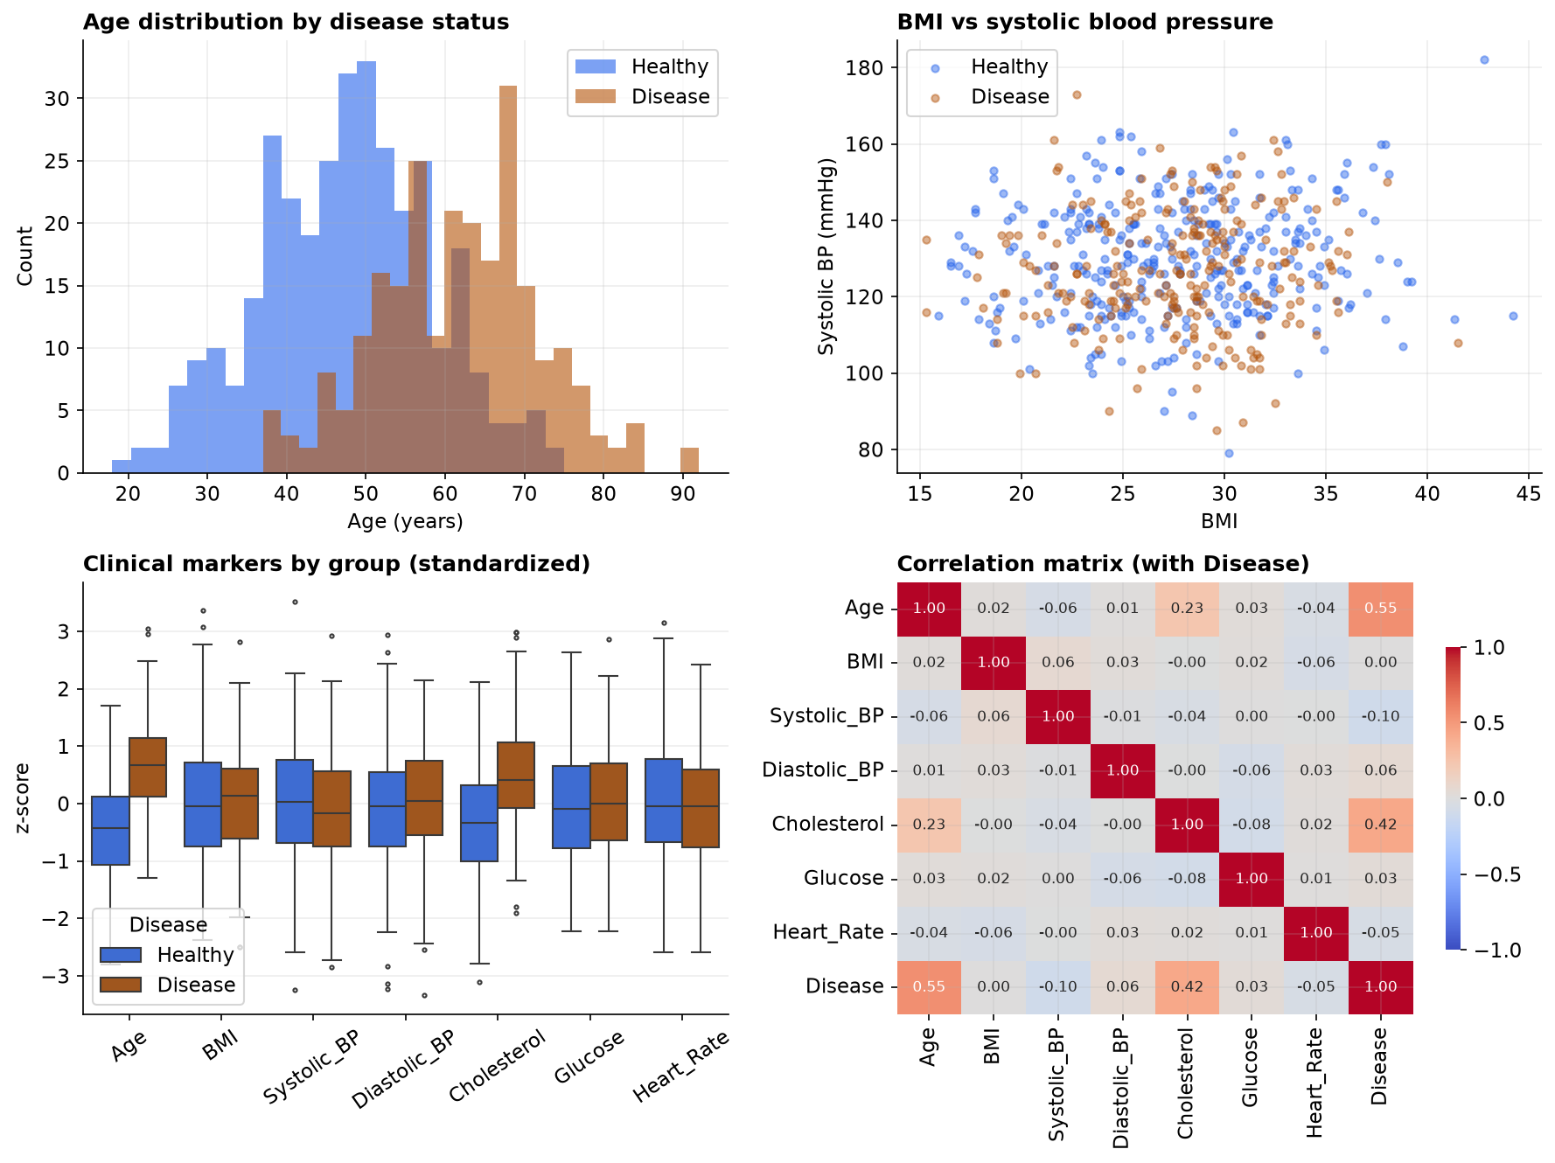
Figure 1. Clinical dashboard: age by disease status, BMI vs systolic BP, standardized marker boxplots by group, and the correlation matrix (including the Disease label).
Table 2. Two-group screen for all seven markers, ranked by effect size. Bonferroni threshold = 0.05/7 = 0.0071.
Marker | Healthy | Disease | Cohen's d | r_pb | p (raw) | Verdict
Age | 47.5 | 61.7 | 1.34 | 0.55 | <0.001 | survives (Holm & Bonferroni)
Cholesterol | 197.8 | 234.6 | 0.95 | 0.42 | <0.001 | survives (Holm & Bonferroni)
Systolic_BP | 129.7 | 126.7 | 0.20 | -0.10 | 0.021 | raw-significant; rejected by correction
Diastolic_BP | 82.0 | 83.2 | 0.11 | 0.06 | 0.174 | not significant
Heart_Rate | 74.9 | 73.8 | 0.11 | -0.05 | 0.208 | not significant
Glucose | 97.4 | 98.8 | 0.06 | 0.03 | 0.443 | not significant
BMI | 27.6 | 27.6 | 0.01 | 0.00 | 0.919 | not significant
Two markers, Age and Cholesterol, are associated with disease by any standard: both have large effect sizes and p-values many orders of magnitude below even the Bonferroni threshold. Systolic blood pressure is the instructive case: its raw p-value (0.021) falls under 0.05, but its effect size is negligible (d = 0.20) and it does not survive either correction. It is the false positive anticipated by the 30% family-wise error rate, and it is a clinically seductive one, since blood pressure is a marker an investigator expects to matter. The remaining four markers are not significant even before correction. Figure 2 summarizes the outcome on the effect-size scale.
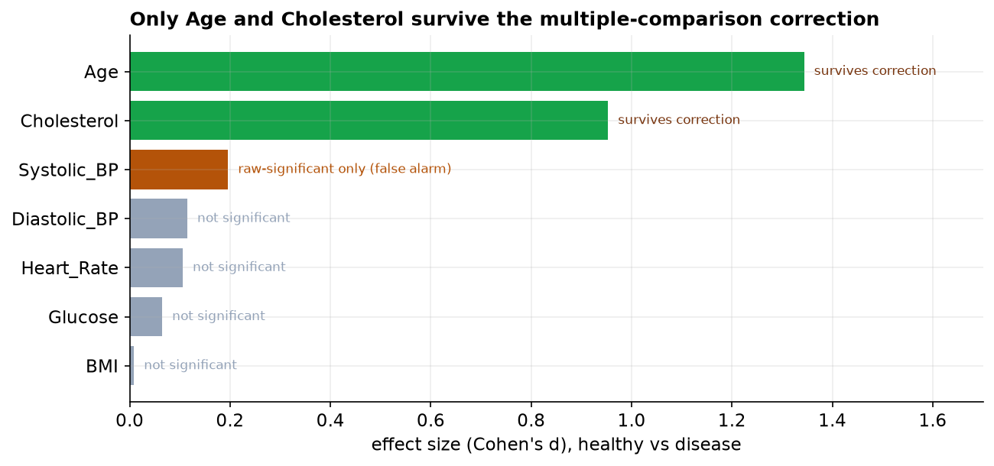
Figure 2. Effect size per marker. Markers surviving multiplicity correction (green) are distinguished from a raw-only false positive (gold) and non-significant markers (grey).
5. Discussion
The analysis makes two methodological points concrete. First, multiplicity control is not a formality: without it, this seven-marker screen would have reported blood pressure as a finding, a false positive with a trivial effect size. Reporting the effect size alongside the corrected p-value provides a second, independent guard against over-interpretation. Second, and more fundamentally, this is an observational cohort, so the surviving associations are not causal. Age is a canonical confounder here: it is associated with disease and with several markers (notably cholesterol), so a marginal association between cholesterol and disease may be partly or wholly attributable to age. Disentangling a marker's independent contribution requires a multivariable model that adjusts for age (e.g., logistic regression), not a battery of univariate tests. The marginal screen is properly read as hypothesis-generating.
When the number of tests is large, FWER control by Bonferroni becomes conservative and power suffers; in such settings the false discovery rate (Benjamini-Hochberg) is the standard alternative, bounding the expected proportion of false discoveries rather than the probability of any. With only 7 tests the FWER approach adopted here is appropriate and transparent.
6. Conclusion
Of seven markers screened against heart-disease status, only Age (d = 1.34) and Cholesterol (d = 0.95) are defensibly associated after controlling the family-wise error rate; systolic blood pressure was a correction-rejected false positive. Given the observational design and the confounding role of age, a covariate-adjusted model is the appropriate confirmatory step.
References
Welch, B. L. (1947). The generalization of Student's problem when several different population variances are involved. Biometrika, 34(1–2), 28–35.
Bonferroni, C. E. (1936). Teoria statistica delle classi e calcolo delle probabilita. Pubbl. R. Ist. Sup. Sci. Econ. Comm. Firenze, 8, 3–62.
Holm, S. (1979). A simple sequentially rejective multiple test procedure. Scandinavian Journal of Statistics, 6(2), 65–70.
Benjamini, Y., & Hochberg, Y. (1995). Controlling the false discovery rate. Journal of the Royal Statistical Society B, 57(1), 289–300.
Cohen, J. (1988). Statistical Power Analysis for the Behavioral Sciences (2nd ed.). Lawrence Erlbaum.
Rothman, K. J. (1990). No adjustments are needed for multiple comparisons. Epidemiology, 1(1), 43–46.
Reproducibility
The dataset (capstone-heart-disease-markers.xlsx) and an executable notebook reproducing every statistic, table, and figure accompany the chapter. Analyses use NumPy, pandas, SciPy, statsmodels, seaborn, and Matplotlib.

