AI CONTROL PLANE ASSESSMENT TOOLKIT
Assessment templates T1 to T13
Part 1: the blank templates. Part 2: the templates filled in for reference use case 1, engagement launch at a global audit, tax and advisory firm (illustrative).
John Fisher
2026
A companion to the guide Assessing an AI Control Plane Project
https://johnfisher-ai.github.io/ai-control-plane-handbook/toolkit/
© 2026 John Fisher. Licensed under CC BY-NC-ND 4.0, with additional permissions to fill in and adapt the templates; see the notices at the end. John Fisher works for Salesforce; the views here are his own and drawn from public information, and this toolkit is not affiliated with or endorsed by Salesforce.

About this document
This document holds the thirteen templates of the AI control plane assessment, T1 to T13, ready to copy and fill in. Part 1 has the blank templates, each with its note on how to use it. Part 2 has the same templates filled in for reference use case 1, engagement launch at a global audit, tax and advisory firm, each with a note on why it is filled that way.
The method behind the templates, the workshops and the readout are in the guide Assessing an AI Control Plane Project on the website: https://johnfisher-ai.github.io/ai-control-plane-handbook/toolkit/. Section, figure and appendix numbers in the template notes refer to that guide, or to the handbook where the note says so, and each one links to its page.
Conventions. Text in grey italic brackets, such as [Name, title], is a prompt to replace. Add rows as needed, and keep an owner and a date against anything the client has confirmed. Superscript numbers refer to the sources listed at the end, numbered as in the handbook’s endnotes. The firm in Part 2 and all its figures are illustrative.
License. © 2026 John Fisher, licensed under CC BY-NC-ND 4.0, with two additional permissions: you may fill in and adapt these templates to run assessments, and you may adapt them for other work of your own, inside your organization or for clients, including in paid work, if each completed report, readout or adapted version carries the credit line given in the notices at the end. Neither permission covers selling the templates or publishing changed versions of them.

Contents
About this document
Part 1. Blank templates
T1. Use case at a glance
T2. Business case and value hypothesis
T3. Asset inventory
T4. Requirements register
T5. Security and compliance requirements
T6. KPIs and scorecard
T7. North-star architecture (vendor-neutral)
T8. A day in the life
T9. How the components work together
T10. Realizing the use case with MuleSoft Agent Fabric and Informatica
T11. Phased implementation: ROI and business value at every milestone
T12. Decisions, risks and next steps
T13. Operating model and adoption plan
Part 2. Templates filled in for use case 1
T1 filled: use case at a glance
T2 filled: business case and value hypothesis
T3 filled: asset inventory
T4 filled: requirements register
T5 filled: security and compliance requirements
T6 filled: KPIs and scorecard
T7 filled: north-star architecture (vendor-neutral)
T8 filled: a day in the life
T9 filled: how the components work together
T10 filled: realizing the use case with MuleSoft Agent Fabric and Informatica
T11 filled: phased implementation with ROI and business value
T12 filled: decisions, risks and next steps
T13 filled: operating model and adoption plan
Sources
Notices and disclosures
About John Fisher

Part 1. Blank templates
Each template starts with a note on how to use it: its purpose, when to fill it, who owns it, how to fill it and what it feeds. The client-facing report template on the website has the same structure, so the filled templates carry straight into the report.
Fill the templates in the order of the six steps. Replace every bracketed prompt, add rows as needed, and keep an owner and a date against anything the client has confirmed.
Template | Name | Step | Owner | Feeds
T1 | Use case at a glance | Frame | Engagement lead and the business owner | Deck: The use case, At a glance  Report: sections 1–2
T2 | Business case and value hypothesis | Frame | Engagement lead and finance | Deck: The value at stake. Report: section 4
T3 | Asset inventory (T3a to T3h) | Discover | Lead architect with the owners | Deck: Discovery, Asset inventory  Report: section 3 and appendix
T4 | Requirements register | Define | Lead architect with the business owner | Deck: Requirements. Report: section 5 and appendix
T5 | Security and compliance requirements | Define | Lead architect with the CISO | Deck: Security. Report: section 6
T6 | KPIs and scorecard | Discover and phase | Engagement lead and lead architect with finance | Deck: KPIs at every milestone. Report: sections 4 and 11
T7 | North-star architecture (vendor-neutral) | Design | Lead architect with the enterprise architect | Deck: Vendor-neutral architecture. Report: section 7
T8 | A day in the life | Design | Lead architect with a user | Deck: A day in the life. Report: section 8
T9 | How the components work together | Design | Lead architect | Deck: Component interaction. Report: section 8
T10 | Realizing the use case with MuleSoft Agent Fabric and Informatica | Design | Lead architect with specialists | Deck: Realized, Mapping, Coexistence  Report: section 9
T11 | Phased implementation: ROI and business value at every milestone | Phase | Engagement lead and lead architect with finance | Deck: Phased plan, Value  Report: sections 10–11
T12 | Decisions, risks and next steps | Decide | Engagement lead | Deck: Decisions. Report: section 12
T13 | Operating model and adoption plan | Phase and decide | Engagement lead, the sponsor and HR | Deck: Operating model. Report: sections 10 and 12

T1. Use case at a glance
How to use T1
Purpose. Describe the use case on one page, in the client’s words, so everyone agrees what is in and out of scope.
When. Step 1 (frame), updated after discovery.
Who. The engagement lead drafts it with the business owner, and the lead architect adds the stages and systems.
How to fill it
- Name the use case after its business outcome, for example “Engagement launch: from verbal win to ready-to-charge.”
- Write the problem today and the target state in two or three sentences each.
- Fill the trigger, end state, users, systems of record and out-of-scope rows.
- List five to seven stages. For each, record the human step, the work mode (human-led, AI-assisted or AI-led) and why, the agent and its tier, and the system of record.
- Write three to five business goals and the control-plane goals, each with the KPI that measures it.
- Score the use case against the seven selection criteria, with evidence.
Tips
- Keep it to one page and leave the detail to the other templates.
- If you cannot name the end state, the scope is not ready.
- Ask could AI and should AI of every stage (Section 2). A human-led step needs a reason the risk team would accept.
Feeds. Client deck: The use case; At a glance. Client report: sections 1 and 2.

Use case | [Name, after its business outcome]
Client and business unit | [Client, business unit]
Executive sponsor | [Name, title]
Business owner | [Name, title]
Problem today | [The chain of manual, risk-sensitive steps and what the delays and errors cost]
Target state | [What agents do, what people keep, which systems are involved]
Trigger | [Event that starts the process]
End state | [What is true when it is done]
Users | [User groups]
Systems of record | [Systems the process runs on]
Out of scope | [What the first phase excludes]

Stages
Stage | Human step | Work mode | Agent and tier | System of record
[Stage name] | [Decision or none] | [Human-led, AI-assisted or AI-led; why] | [Agent (Tier n, mode)] | [System]

Goals
Goal | Type | Measured by
[Goal] | [Business or control plane] | [KPI]

Selection scores
Criterion | Score (1–5) | Evidence
Value at stake
Visible pain
Reachable systems
Data readiness
Safe first step
Measurable in 90 days
Sponsor and owner
Total (out of 35)

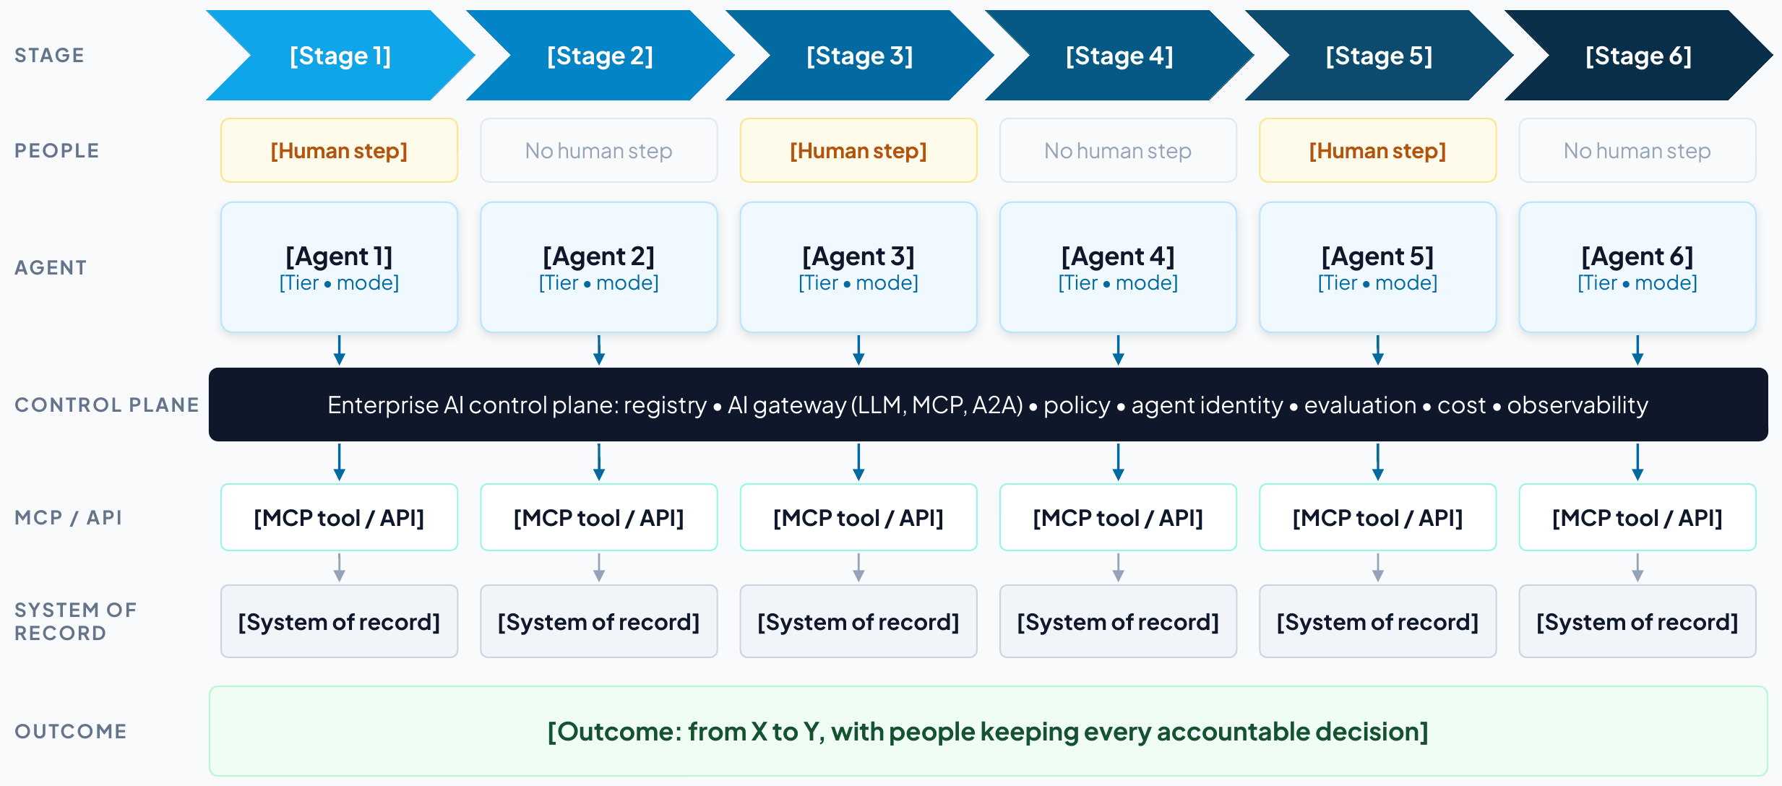
Figure 5. Template: the use case at a glance, as it appears in Part 2 of the client deck. Amber boxes are human decisions, and blue boxes are agents and their tiers.

T2. Business case and value hypothesis
How to use T2
Purpose. State the value at stake as a few levers with formulas that the business owner and finance can check.
When. Step 1 (frame) as a hypothesis, then step 5 (phase) with measured baselines.
Who. The engagement lead, with the business owner and the finance partner.
How to fill it
- Pick the levers that apply: capacity, revenue, utilization, cost avoided, risk avoided.
- For each, write how the solution delivers it and the formula with its inputs.
- Take inputs from the client (volumes, rates, loaded costs) and record their source.
- Mark each lever’s confidence (high, medium, low) and what would raise it.
- Total the run rate at full scale, before platform, model and change costs.
- Record every assumption and who agreed it.
- Set the total against the published payback benchmarks (Section 6), with separate horizons for generative and agentic slices.
Tips
- Prefer a conservative, checkable figure to a large, vague one.
- Describe risk avoided in words and evidence unless the client has its own number.
Feeds. Client deck: The value at stake, Value arrives at every milestone. Client report: section 4.

Value lever | How the solution delivers it | Formula and inputs | Annual value (illustrative) | Confidence
Capacity released | [How] | [Volume × unit × value] | [$] | [H, M or L]
Revenue protected or accelerated | [How] | [Volume × unit × value] | [$] | [H, M or L]
Utilization and throughput | [How] | [Volume × unit × value] | [$] | [H, M or L]
Cost avoided | [How] | [Volume × unit × value] | [$] | [H, M or L]
Risk avoided | [How] | [Volume × unit × value] | [$] | [H, M or L]

Assumption | Value | Source | Agreed by
[Volume, rate or cost] | [Value] | [System or person] | [Name, date]

Run rate at full scale | [About $X a year released or protected, before platform, model and change costs]
Costs | [From the project team’s estimate: platform, implementation, model usage, change]
Expected business outcomes | [Three to five outcomes in the sponsor’s words]
Payback benchmark | Typical AI payback is two to four years, against seven to 12 months for other technology investments⁸²
Horizons | [Which slices are judged in months (read-only, drafting) and which on a longer horizon (agents acting in systems of record)]

T3. Asset inventory
How to use T3
Purpose. Record every asset the use case touches, who owns it, how it is controlled today and when the plan needs it.
When. Step 2 (discover), updated through design.
Who. The lead architect, confirmed row by row with each owner.
How to fill it
- Start from the data request and the process walkthrough, and add one row per asset.
- Fill T3a to T3h in turn: systems, data, tools, agents, models, identities, policies, infrastructure.
- For every agent, record an owner, a sponsor, a tier and a status (live, pilot, planned or shadow), its lifecycle stage and next recertification, and any native control plane that already governs it.
- For every tool and system, record read or write access and whether it exists today or must be built.
- Add the phase in which each asset is needed.
- Turn every unknown into an open question in T12.
Tips
- Run Agent Scanners where the client allows. It finds agents and MCP servers people forget.
- “Not enforced today” is a valuable entry, because that is where the control plane adds value first.
Feeds. Client deck: Discovery; Asset inventory. Client report: section 3 and the appendix.

T3a. Applications and systems of record
System | Owner | Role in the use case | Interfaces | Agent access | Phase
[System] | [Team] | [What it does in the process] | [API, event, file] | [Read or write] | [1–4]

T3b. Data assets and master data
Data asset | System of record | Golden record today? | Quality and risk notes | Sensitivity | Owner or steward
[Domain or data set] | [System] | [Yes, partly, no] | [Issues] | [Class] | [Name or team]

T3c. Integrations, APIs, events and MCP tools
Tool or interface | System | Operation | Scope | Exists or to build | Used by
[tool_name] | [System] | [What it does] | [Read or write] | [Exists or to build] | [Agent]

T3d. Agents and copilots
Agent | Responsibility | Tier | Human role | Owner | Status and phase
[Agent] | [What it does] | [Tier, mode] | [Who decides] | [Team] | [Live, pilot, planned, shadow; phase]

Agent | Sponsor | Lifecycle stage | Next recertification | Retirement criteria | Native control plane
[Agent] | [Name] | [Propose to retire] | [Date] | [When it is retired] | [Agent 365, AgentCore or none]

T3e. Models
Model | Provider and hosting | Tasks | Data rules | Fallback
[Model] | [Provider; SaaS, VPC or on premises] | [Tasks] | [Retention, regions, masking] | [Fallback]

T3f. Identities, users and channels
Actor | Channel | Authentication | Authority and approvals
[User group or agent] | [Channel] | [SSO, MFA, step-up] | [What they may approve]

T3g. Policies and controls
Policy or control | Type | Enforced today | Target enforcement | Owner
[Rule] | [Gate, data, limit, regulatory] | [Where, or not enforced] | [Where it will be enforced] | [Team]

T3h. Infrastructure, runtime and observability
Component | Notes
[Environment, network zone, keys, logging, residency] | [Constraint or decision]

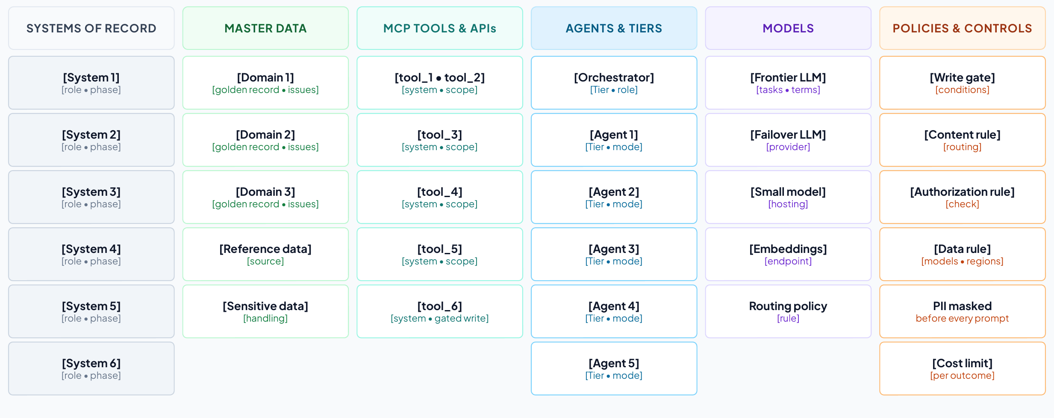
Figure 6. Template: the asset inventory by layer, as it appears in Part 2 of the client deck.

T4. Requirements register
How to use T4
Purpose. Record what the solution must do and the conditions it must meet, each traceable to a KPI and a phase.
When. Step 3 (define), refined in design.
Who. The lead architect, accepted by the business owner and the relevant client owners.
How to fill it
- Use the prefixes BR, FR, DR, IR, NFR, SR, CR and OR (Section 4).
- Write each requirement with a measurable acceptance test.
- Set a priority (Must, Should, Could, Won’t) and the phase in which it must be met.
- Link each requirement to the KPI it moves or protects.
- Name an owner who can accept it.
- Include the operational requirements the control plane needs: evaluation before promotion and on sampled production traces, cost attribution by owner and use case, and a takeover runbook for any agent at tier 3 or above (Section 4).
Tips
- A short register the client owns is more useful than a long one nobody reads. For one use case, 20 to 30 rows is typical.
- Write identity requirements to the vendor-neutral checklist in Section 4: a unique identity per agent, authority that narrows at each hop, no static keys and real-time revocation.
- Fill the control-ID column only when compliance asks for it, from the crosswalk in Section 4 (ISO/IEC 42001, NIST AI RMF, EU AI Act).
Feeds. Client deck: Requirements. Client report: section 5 and the appendix.

ID | Type | Requirement and acceptance test | Priority | KPI | Phase | Owner | Control ID
[BR-01] | [Type] | [Requirement; how it will be tested] | [Must] | [KPI] | [1–4] | [Owner] | [If asked]

T5. Security and compliance requirements
How to use T5
Purpose. Set the controls for every layer, the autonomy tier for every agent and the evidence each obligation requires.
When. Step 3 (define), with the requirements and security workshop.
Who. The lead architect with the client’s CISO or security architect and risk and compliance.
How to fill it
- For each of the nine layers, write the controls the use case needs (Section 4 lists the questions to ask).
- Record what enforces each control in the realization, and in which phase.
- Give every agent a tier, a human role, the approvals bound to its actions and its limits.
- List each regulatory or professional obligation with the evidence it requires and where that evidence is produced.
- Map the design to the OWASP agentic risks (ASI01 to ASI10) and name an owner for every gap (Section 4).
- For every agent above tier 1, record the evidence it needs for promotion and the events that demote it automatically.
- For every agent at tier 3 or above, write the takeover runbook: who takes over, with what information, and how the process continues.
- If compliance asks, add control IDs from ISO/IEC 42001, the NIST AI RMF or the EU AI Act.
Tips
- Only a few agents should ever write to a system of record, and those writes need bound, time-limited approvals and a drilled kill switch.
- Turn the 2026 protocol changes into controls: the registry verifies signed agent cards (A2A 1.0), and the gateway applies policy on MCP’s standard request headers and joins every call to its trace.^{26,27}
Feeds. Client deck: Security. Client report: section 6.

Layer | Requirement (controls) | Enforced by | Control IDs | Phase | Owner
Users
Agents
A2A
MCP
APIs
Models
Data at rest
Data in motion
Audit

Autonomy by agent
Agent | Tier | Human role | Approval bound to | Limits and kill switch
[Agent] | [Tier] | [Who decides] | [Action and validity] | [Limits]

Promotion and demotion
Agent | Current tier | Evidence to promote | Demotion triggers
[Agent] | [Tier] | [Evaluations, red-team findings, impact assessment, sign-off] | [Security event, failed binding check, stale data, lost sponsor]

Human takeover
Agent | Who takes over | Information handed over | Degraded mode and service level | Last drill
[Agent at tier 3 or above] | [Named team] | [Trace, pending actions and approvals, data touched] | [Manual or deterministic; service level] | [Date]

Threat coverage
OWASP agentic risk | Controls in this design | Residual gap and owner
ASI01 Agent Goal Hijack
ASI02 Tool Misuse
ASI03 Identity & Privilege Abuse
ASI04 Agentic Supply Chain Vulnerabilities
ASI05 Unexpected Code Execution
ASI06 Memory & Context Poisoning
ASI07 Insecure Inter-Agent Communication
ASI08 Cascading Failures
ASI09 Human-Agent Trust Exploitation
ASI10 Rogue Agents

Compliance and evidence
Obligation | Control ID | Evidence required | Where it is produced | Owner
[Regulation or standard] | [Clause or control] | [Evidence] | [System or log] | [Team]

T6. KPIs and scorecard
How to use T6
Purpose. Define how success is measured: a baseline and a target at every milestone for each KPI, with its source and owner.
When. Step 2 (discover) for baselines and step 5 (phase) for milestone targets.
Who. The engagement lead and the lead architect, with the business owner and finance.
How to fill it
- Define each KPI precisely: what is counted, from which event to which, in which scope.
- Record the data source and the owner who reports it.
- Measure the baseline in the phase 1 scope, and write “not measured” where there is no data yet.
- Set a target for months 3, 8, 12 and 24 in line with the phasing (T11).
- Keep the control-plane KPIs: agent quality, governed AI traffic, AI cost per outcome and AI cost visibility.
- Give each scorecard metric a leading indicator from the library below, defined so that every team computes it the same way, and measure value instead of adoption.
Tips
- Month 3 targets apply to the first slice only. Say “in scope” so no one reads them as enterprise-wide.
Feeds. Client deck: The value at stake, KPIs at every milestone. Client report: sections 4 and 11.

KPI | Definition | Data source | Owner
[KPI] | [What is counted, from when to when] | [System] | [Owner]
Agent quality | Evaluation pass rate for the agents’ key outputs | [Evaluation tool] | [Owner]
Governed AI traffic | Share of model and tool calls through the AI gateway | AI Gateway | [Owner]
AI cost per [outcome] | Model and platform cost per outcome | LLM Governance  Finance | [Owner]
AI cost visibility | Share of model and tool spend attributed to an owner and a use case within a day | AI Gateway  LLM Governance  Billing data | [Owner]

KPI | Baseline | Month 3 | Month 8 | Month 12 | Month 24
[KPI] | [Baseline] | [In scope] | [Target] | [Target] | [Target]
Agent quality | Not measured | Baseline set | [Track] | [Target] | [Target]
Governed AI traffic | Not measured | 100% in scope | 100% in scope | 100% | 100%
AI cost per [outcome] | Not measured | Baseline set | Within target | Within target | Within target
AI cost visibility | Not measured | 100% in scope | 100% in scope | 100% | 100%

Control-plane scorecard
Metric | Definition | Direction | Data source
Agent coverage | Share of known agents registered with an owner and a risk tier | Up | Agent Registry and Scanners
Governed traffic | Share of LLM and MCP calls routed through the AI gateway | Up | AI Gateway
Cost per outcome | Model spend per resolved task, by use case | Down | LLM Governance  Business systems
AI cost visibility | Share of model and tool spend attributed to an owner and a use case within a day, and share of agents under a token-based rate limit | Up | AI Gateway and LLM Governance  Billing data in FOCUS format
Value realized | Run-rate value of live use-case slices against their business cases, agreed with finance | Up | Business-case tracking  Use-case KPIs
Policy enforcement | Violations blocked before impact versus found afterward | Up | AI Gateway policy events
Time to contain | Minutes from alert to kill switch or credential revocation, and to open work handed to a named person | Down | Agent Kill Switch  Identity logs  Takeover drill records
Evaluation pass rate | Agents meeting quality thresholds before promotion | Up | Evaluation runs (any evaluation tool)
Oversight coverage | Share of tier 3–4 high-risk actions with approval or audit | Up | Trusted Agent Identity  Audit logs
Oversight effectiveness | Share of high-risk actions executed exactly as approved and within the approval’s validity window, with drills showing people can stop an agent in time | Up | Gateway approval-binding events  Kill Switch drill records
Crypto readiness | Share of the asymmetric-crypto inventory with a migration plan | Up | Cryptographic inventory

Leading indicators (KPI library)
Scorecard metric | Leading indicator | How to measure it
Agent coverage | Unregistered agents found | Agents found by scanners but not yet registered, and days from discovery to registration
Governed traffic | New agents launched behind the gateway | Share of newly promoted agents whose first production call went through the gateway
Cost per outcome | Cost per successful task | Model and tool spend divided by tasks that passed their success check, by use case⁶⁰
AI cost visibility | Spend attributed within a day | Share of the previous day’s model and tool spend tagged to an owner and a use case
Value realized | Acceptance rate | Share of agent outputs accepted without significant edits, with undo and revert counted as rejections⁶⁰
Policy enforcement | Near misses | Calls blocked per 1,000, by policy, and their trend
Time to contain | Drill time | Minutes to stop an agent and hand its open work to a named person in the latest drill
Evaluation pass rate | Trajectory quality | Tool-selection accuracy and plan adherence on sampled production traces⁶⁰
Oversight coverage | Verification latency | Time from an agent completing a task to a person approving it.⁶⁰ Very short times can mean approval without review.
Oversight effectiveness | Takeover rate | How often a person has to step in and take over a task the agent started⁶⁰
Crypto readiness | Algorithm agility | Share of gateways and service meshes that can change algorithms by configuration

T7. North-star architecture (vendor-neutral)
How to use T7
Purpose. Show what good looks like for this use case, layer by layer, before any product is named.
When. Step 4 (design), in the architecture workshop.
Who. The lead architect with the client’s enterprise architect.
How to fill it
- Start from the north star in Figure 2 (handbook Figure 4) and the asset inventory (T3).
- Fill each layer with the use case’s channels, agents and tiers, orchestration, models, tools, data governance and systems of record.
- Record the design decisions and their rationale.
- Check the design rule: every agent-to-model and agent-to-tool call passes the control plane.
- Name only the systems of record and keep everything else vendor-neutral.
- Run the design-review checklist with the enterprise architect, against the framework the client already uses (Section 5).
Feeds. Client deck: Vendor-neutral architecture. Client report: section 7.

Layer | What goes here | This use case
Users and channels | Who uses the solution, through which channel, with which authentication
Agents and tiers | Each agent with its tier and mode (read-only, drafts, proposes, gated writes)
Orchestration | The pattern (embedded, dedicated or hybrid/federated), the orchestrator, the deterministic gates and the triggers
Control plane | Registry, AI gateway (LLM, MCP, A2A), policy decision point, identity and delegation, evaluation and cost, kill switch
Models | Frontier, private and embedding models, and the routing policy
MCP servers and APIs | The capabilities exposed as governed tools, with read or write scopes
Data governance | Golden records, semantic layer and data contracts, catalog and lineage, quality, access policies
Systems of record | The named systems the process runs on
Across every layer | Security controls  Governance and observability

Design decisions
Decision | Options | Choice and rationale
Orchestration pattern | Embedded  Dedicated orchestration tier  Hybrid/federated
Model hosting and routing | Provider SaaS under enterprise terms  Private models in the client’s VPC  Regions
Where gateways and MCP servers run | CloudHub (MuleSoft-managed) or customer-managed Runtime Fabric
Data residency and sovereignty | Regions, private links, customer-managed keys
Human approvals and tiers | Which actions need a person, and how approvals are bound and expire
Observability and audit | OpenTelemetry traces, SIEM, retention

Design review checklist
Check | Framework | Yes, partly or no | Evidence
Every agent has an owner, a sponsor, a risk tier and an identity of its own | Cloud Adoption Framework  20 questions
Each agent’s tool access is least-privilege and allow-listed | Well-Architected Agentic AI Lens
Human oversight matches the risk and reversibility of each action | Well-Architected Agentic AI Lens
Agents’ data access is aligned with their users’ access | 20 questions
Only trusted, registered MCP and A2A servers are reachable | Cloud Adoption Framework
New policies start in audit mode, then enforce | Cloud Adoption Framework
Agent reasoning, tool calls and hand-offs are traced end to end | Well-Architected Agentic AI Lens  20 questions
Agent costs are tagged to cost centers, with alerts as spend nears budget | Cloud Adoption Framework  Well-Architected Agentic AI Lens
Adversarial testing runs before release and on a schedule | Cloud Adoption Framework
There is a tested way to disable a misbehaving agent and hand over its work | Cloud Adoption Framework

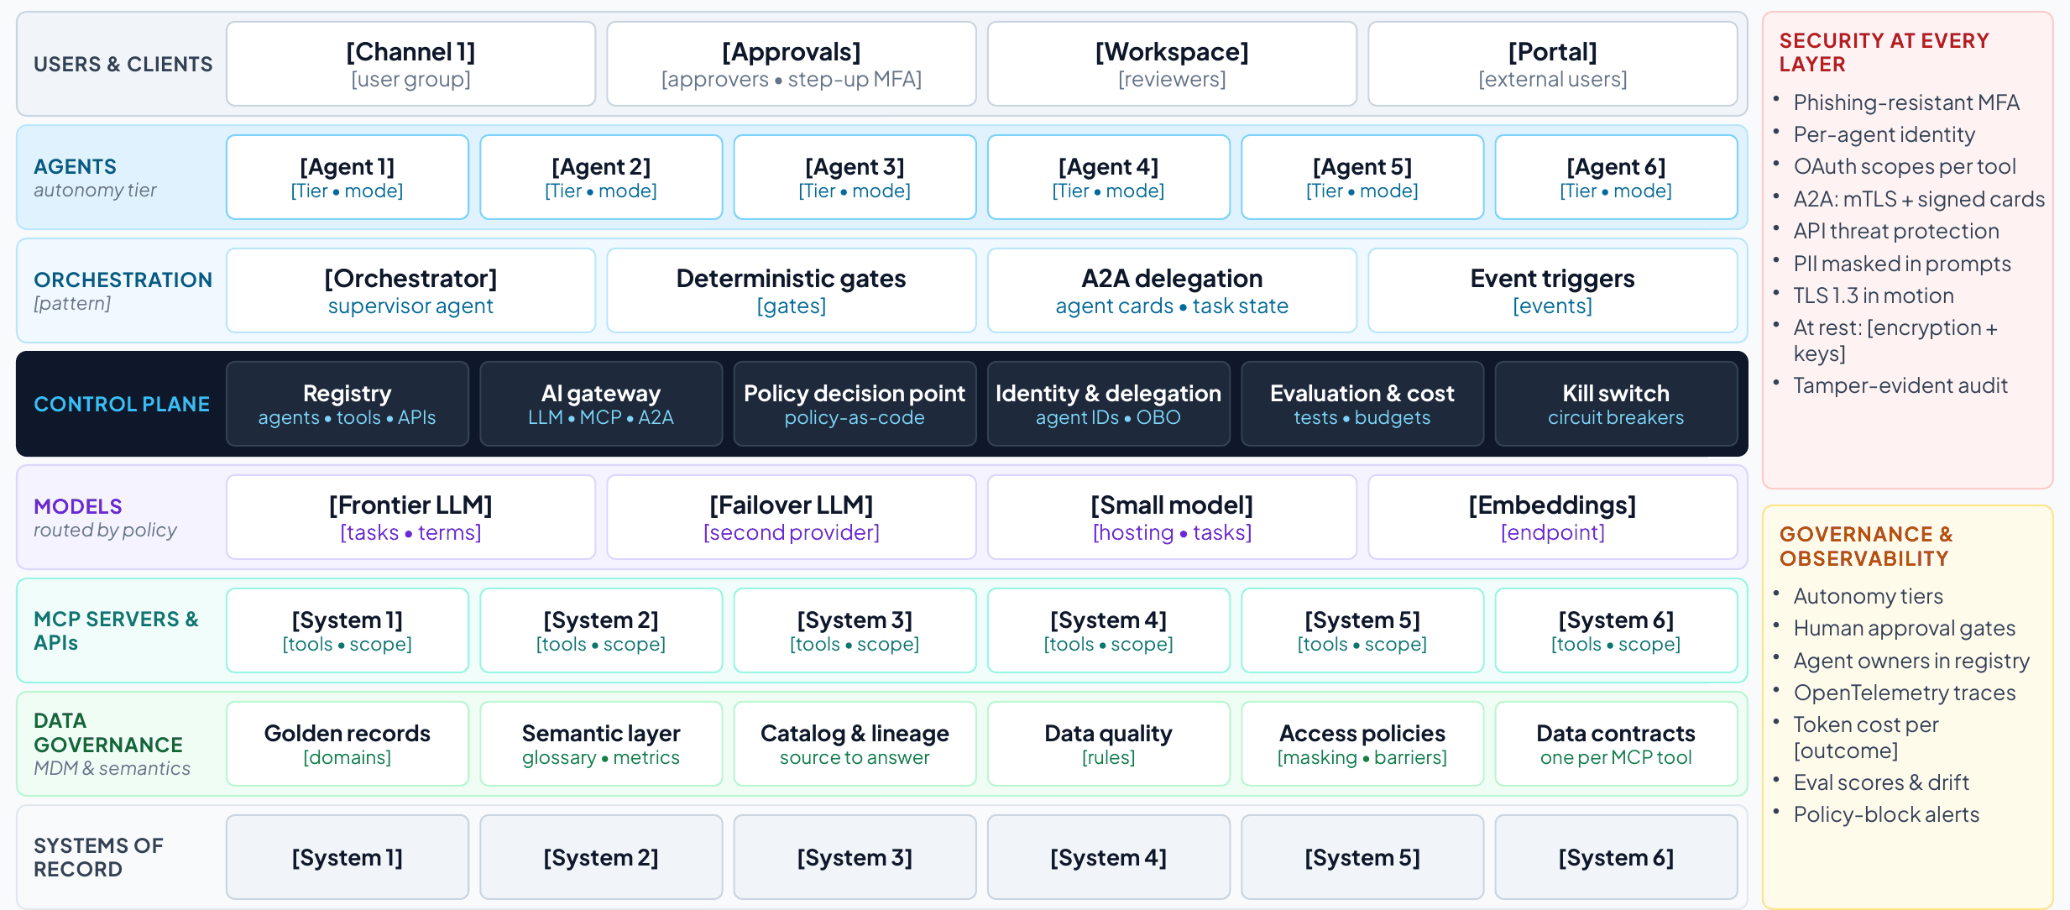
Figure 7. Template: the vendor-neutral solution architecture, as it appears in Part 2 of the client deck.

T8. A day in the life
How to use T8
Purpose. Make the architecture human: one persona, one realistic case, from trigger to end state.
When. Step 4 (design).
Who. The lead architect, checked with a real user.
How to fill it
- Choose a persona and a realistic case in the first phase’s scope.
- Write six to eight timestamped moments from the trigger to the end state.
- Show every human decision, and one moment where a control changes the outcome.
- End with the result in business terms.
Feeds. Client deck: A day in the life. Client report: section 8.

Persona | [Name, role, team]
The case | [What happens and why it matters]

Time | Moment | What happens | Who decides
[hh:mm] | [Moment] | [What happens] | [Person or none]

T9. How the components work together
How to use T9
Purpose. Trace the day in the life through the architecture: which components act, over which protocol, under which controls.
When. Step 4 (design).
Who. The lead architect.
How to fill it
- Use the same moments as T8.
- For each, name the components and protocols (A2A between agents, MCP from agents to tools, APIs to systems of record).
- Name the controls that apply, including every policy check before a write.
- For every hand-off between agents, check the four delegation rules: a verifiable unit of work, a right-sized model, permissions narrowed at the hop, and escalation to a person when the request is ambiguous (Section 4).
Feeds. Client deck: Component interaction. Client report: section 8.

Time | What happens | Components and protocols | Controls applied
[hh:mm] | [Moment] | [Components; A2A, MCP or API] | [Controls]

Delegation check
Hand-off | Unit of work and its check | Model | Permissions passed on | When it stops and asks
[Agent to agent] | [Task; how its result is checked] | [Model or none] | [Scopes, narrowed] | [Condition; to whom]

T10. Realizing the use case with MuleSoft Agent Fabric and Informatica
How to use T10
Purpose. Map every reference component to the MuleSoft Agent Fabric, MuleSoft or Informatica capability that realizes it.
When. Step 4 (design), after T7.
Who. The lead architect, with MuleSoft and Informatica specialists as needed.
How to fill it
- Keep the rows the use case needs and delete the others.
- Write the role each capability plays in this use case.
- List what stays the client’s choice.
- Agree how the control plane coexists with any native agent control planes the client runs, and which is authoritative for what.
Tips
- Custom Omni Gateway policies, built with the Policy Development Kit, are not MuleSoft products. Name who builds, tests and supports them.
- Confirm MuleSoft connector coverage for each of the client’s systems, and map each data need to an Informatica MCP server or an API.
- Name the evaluation tool the client will use (any evaluation tool works), and record its results in the registry.
Feeds. Client deck: Realized; Mapping to the AI control plane; Coexistence. Client report: section 9.

Reference component | MuleSoft or Informatica capability | Role in this use case
Registry | Agent Registry and Agent Scanners (MuleSoft Agent Fabric)
Orchestration | Agent Broker with guided determinism (MuleSoft Agent Fabric)
AI gateway | AI Gateway for LLM and MCP traffic, and Omni Gateway policies for APIs and A2A (MuleSoft)
Agent identity | Trusted Agent Identity with mobile approval (MuleSoft Agent Fabric)
Approvals bound to execution  Exposure limits | Custom Omni Gateway policies built with the Policy Development Kit (Approval-to-Execution Binding and Cross-Session Aggregate-Risk Gate)
Operate and control | Agent Kill Switch, Agent Visualizer and AI cost controls for token-based rate limits and spend attribution (MuleSoft Agent Fabric)
MCP servers and APIs | MCP Bridge  System and Process APIs with MuleSoft connectors
Master data | Multidomain MDM (Informatica)
Semantics, catalog, lineage | Data Governance and Catalog, with the CDGC Metadata Search MCP server (Informatica)
Data quality | Data quality rules, with the Address Verification MCP server (Informatica)
Deployment | CloudHub or customer-managed Runtime Fabric (MuleSoft)

What stays the client’s choice
Component | Client’s choice | Notes
Channels and collaboration tools
Agent platforms and frameworks
Models and providers
Systems of record
Identity provider
Security operations (SIEM)

Coexisting control planes
Estate | Native agent control plane | Usually authoritative for | MuleSoft Agent Fabric’s role
Microsoft 365 and Azure | Agent 365 and Microsoft Entra Agent ID¹² | Identities and inventory of Microsoft agents  Access to Microsoft 365 data | Registers Copilot Studio and Foundry agents and applies common policy to their calls into enterprise systems
AWS | Amazon Bedrock AgentCore⁶² | Runtime, memory and identity for agents built on AWS | Registers Bedrock and AgentCore agents and governs their access to enterprise APIs and MCP tools
Google Cloud | Gemini Enterprise Agent Platform: Agent Registry, Agent Gateway, Agent Identity⁴⁷ | Agents built on Google Cloud | Registers them and applies the same policy as for every other estate
Salesforce | Agentforce | Agents working in Salesforce data and processes | Registers and governs Agentforce agents
Across estates | No single native plane | Cross-vendor inventory  Policy on every call into enterprise capabilities and data  Cross-vendor orchestration  Cost and audit | The vendor-neutral control plane²¹
[Client estate] | [Plane] | [What it is authoritative for] | [Agreed role]

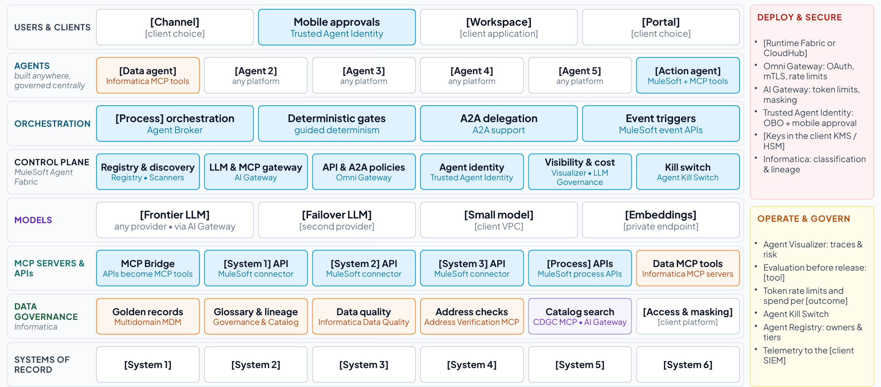
Figure 8. Template: the architecture realized with MuleSoft Agent Fabric and Informatica, as it appears in Part 2 of the client deck. Blue boxes are MuleSoft, orange Informatica, violet both, and white the client’s choice.

T11. Phased implementation: ROI and business value at every milestone
How to use T11
Purpose. Show what goes live at each milestone, the KPIs it moves and the value it delivers, quick wins first.
When. Step 5 (phase), in the value and phasing workshop.
Who. The engagement lead and the lead architect, with the business owner and finance.
How to fill it
- Align the use case’s milestones (months 3, 8, 12 and 24) with the four platform phases.
- For each milestone, write what goes live, the KPIs at that milestone and the run-rate value with its formula.
- Record the foundations each milestone leaves behind for the next use case.
- Test the month-3 slice against the quick-win test and shrink it until it passes.
- Add the cumulative value and, with the project team, the costs. Then show net value and payback.
- Set the plan against the payback benchmarks (Section 6), and judge generative and agentic slices on separate horizons.
Tips
- Agents act in systems of record only from phase 3, under bound approvals and limits that hold across sessions.
- Never add values across use cases from different businesses.
Feeds. Client deck: Phased plan, Phased delivery, Value arrives at every milestone. Client report: sections 10 and 11.

Milestone | What goes live | KPIs at the milestone | Value (illustrative) | Formula | Foundations left behind
Month 3 (phase 1) | [First slice: one scope, read-only or propose-only] | [KPIs in scope] | [$ a year] | [Formula] | [Registry, gateway, first MCP tools, golden record]
Month 8 (phase 2) | [Wider scope; drafts and proposals] | [KPIs] | [$ a year] | [Formula] | [Reusable APIs and MCP tools; routing and token-based rate limits]
Month 12 (phase 3) | [Every case; gated writes under bound approvals] | [All KPI targets met] | [$ a year] | [Formula] | [Agent identities; bound approvals; drills; evaluation]
Month 24 (phase 4): all goals met | [Run rate sustained; adjacent processes] | [All KPIs held] | [$ cumulative] | [Sum] | [Federated control plane]

Quick-win test for the month-3 slice
Test | Yes or no | Evidence
Shows measurable value within 90 days in one scope (one service line, market, region or site).
Runs read-only or propose-only (tiers 1 and 2): no writes to systems of record yet.
Uses systems and data that are reachable now, or with one connector.
Saves time or money that the users and the sponsor can see.
Leaves a reusable foundation behind: a registered agent, a governed MCP tool, a golden record or the gateway itself.
Has a baseline taken before it starts, so the movement can be proved.

Cumulative value and ROI
Period | Run rate | Months in force | Value | Costs | Net
Months 3–8 |  | 5
Months 8–12 |  | 4
Months 12–24 |  | 12
Total by month 24

Payback benchmark | Typical AI payback is two to four years, against seven to 12 months for other technology investments, and 67% of CEOs expect AI returns within one to three years^{82,83}
This plan | [The payback month once costs are estimated, and how the read-only first slice beats the benchmark]
Horizons | [Read-only and drafting slices judged in months; slices that act in systems of record on a longer horizon]
Cost data | [Billing data attributed to this use case, in the FOCUS format where available; not list prices]

T12. Decisions, risks and next steps
How to use T12
Purpose. Record the decisions you will ask for, the risks and open questions, and the first 90 days.
When. Throughout the engagement, finalized for step 6 (decide).
Who. The engagement lead, with the lead architect for technical risks.
How to fill it
- Start from the four standard decisions and adapt them to the client.
- Log every risk, assumption, issue and dependency with an owner and an action.
- Write the 90-day plan in four steps with exit criteria.
Tips
- Before any agent reaches tier 3, add a decision to approve its takeover runbook and drill (T5).
- Present the operating model with the decisions: who owns what once the agents are live (T13).
Feeds. Client deck: Decisions. Client report: section 12.

Decision | What it covers | Owner | By when
Name an owner | One accountable executive and an AI governance council covering agents, models and AI spend, with a sponsor for every agent | [Sponsor] | [Date]
Fund phase 1 | [The first slice, in one scope; every model and tool call through AI Gateway] | [Sponsor] | [Date]
Adopt the standards | API-led connectivity, MCP and A2A as enterprise policy  Every agent registered and routed through the control plane | [Enterprise architect] | [Date]
Agree how value is reported | Baseline the KPIs with finance now and report value at every milestone review | [Finance partner] | [Date]

Risks, assumptions, issues and dependencies
Type | Description | Impact | Mitigation or action | Owner
[Risk] | [Description] | [Impact] | [Action] | [Owner]

The first 90 days
Weeks | Step | Activities | Exit criteria
1–2 | Pick the scope and baseline | [Scope; KPI baselines with finance] | [Baseline signed off]
3–6 | Govern the traffic | [Agent Scanners; Registry; AI Gateway; first golden record] | [Agents registered; traffic governed]
7–10 | Start read-only | [First agents at tiers 1–2 in assist mode] | [Users working with the agents]
11–13 | Prove and decide | [KPIs, run-rate value, AI cost] | [Decision on phase 2]

T13. Operating model and adoption plan
How to use T13
Purpose. Name who owns what once the agents are live, the decisions each role can take, the skills people need, and how adoption and value will be measured.
When. Step 5 (phase), in the value and phasing workshop, then confirmed in step 6 (decide).
Who. The engagement lead, working with the sponsor, the business owner and HR or the change lead. The lead architect covers the platform roles.
How to fill it
- Name a person or team for each role, starting with the accountable executive and the AI governance council.
- Give every agent in T3d a sponsor.
- Agree the RACI for the control-plane activities below, adapting the defaults to the client.
- Plan training for each audience before the slice it affects goes live.
- Choose the adoption measures and their targets, and measure value and acceptance instead of usage.
Tips
- Technology is the smaller part of the work: BCG estimates that becoming AI-first “involves 30% technology and 70% people and organization.”⁸⁵
- Agree which work stays human (T1) before any decision on roles.
Feeds. Client deck: Operating model. Client report: sections 10 and 12.

Roles and decision rights
Role | Named person or team | Owns | Decides
Accountable executive | [Name or team] | The program, its funding and its business cases | Which phases and use cases proceed
AI governance council (architecture, security, risk, data, finance and the business) | [Name or team] | Policy, autonomy tiers, standards and no-go zones | Promotions of high-risk agents  Exceptions
Business owner, per use case | [Name or team] | Value, KPIs and the process agents work in | Which steps stay human-led, AI-assisted or AI-led  Acceptance of results
Agent sponsor, per agent | [Name or team] | One agent from registration to retirement | Recertification and retirement  The first call in an incident
Platform team (the control plane’s product owner) | [Name or team] | Registry, gateway, identity, evaluation and observability services | Platform plan, shared policies and onboarding standards
Security and risk | [Name or team] | Threat model, red-teaming and incident response | Blocking a release  Demoting or stopping an agent
Finance | [Name or team] | Cost attribution and value tracking | How value per milestone is reported  Budget thresholds

RACI for the control plane
Activity | Accountable | Responsible | Consulted | Informed
Register a new agent with its owner, sponsor, tier and system card | Agent sponsor | Platform team | Security and risk | AI governance council
Promote an agent to a higher tier | AI governance council | Agent sponsor | Security and risk  Business owner | Platform team
Recertify or retire an agent | Agent sponsor | Platform team | Business owner | AI governance council
Change a shared policy, or approve a new MCP server or model provider | AI governance council | Platform team | Security and risk  Enterprise architect | Agent sponsors
Stop an agent and run the takeover | Security and risk | Agent sponsor  The named takeover team | Platform team | Business owner  Accountable executive
Report value and AI cost at each milestone | Business owner | Finance | Platform team | Accountable executive

Training plan
Audience | What they need to learn | When | Owner
Approvers | What they approve and the facts behind it  How bound approvals expire  How to stop an agent | Before their first approval | [Owner]
Agent sponsors | The agent lifecycle: registration, evaluation, promotion, recertification, retirement and the takeover runbook | Before they register their first agent | [Owner]
Business teams | Working alongside agents: reviewing drafts, handling exceptions and taking over when an agent is stopped | Before each slice goes live | [Owner]
Platform team | Running the control plane as a product: registry, gateway, identity, evaluation, cost and observability | Phase 1 | [Owner]
Security and risk | Threat mapping, red-teaming agents, incident response and takeover drills | Phases 1 to 3 | [Owner]

Adoption measures
Measure | Definition | Baseline | Target
Acceptance rate | Share of agent outputs accepted without significant edits, with undo and revert counted as rejections⁶⁰ | [Baseline] | [Target]
Takeover rate | How often a person has to step in and take over a task the agent started⁶⁰ | [Baseline] | [Target]
Verification latency | Time from an agent completing a task to a person approving it. Very short times can mean approval without review.⁶⁰ | [Baseline] | [Target]
Trained before go-live | Share of approvers, sponsors and users trained before their slice goes live | [Baseline] | [Target]
Value per milestone | Run-rate value delivered against the business case, not the number of users or prompts⁸⁸ | [Baseline] | [Target]

Part 2. Templates filled in for use case 1
Part 2 fills every template for reference use case 1 from the handbook (Section 11): engagement launch at a global audit, tax and advisory firm. The firm and all its figures are illustrative. Product descriptions come from public information. Each template is followed by a short note on why it is filled the way it is, which is the judgment to carry into your own assessments.
Client | A global audit, tax and advisory firm (illustrative)
Use case | Engagement launch: from verbal win to ready-to-charge
Assessment | Five weeks, eight workshops (Appendix B) and a readout to the managing partner for operations and the leadership team (illustrative)
Volumes and rates | 10,000 engagement launches a year, $120 an hour loaded cost, $200 an hour average rate and 5,000 client-facing staff working 1,800 hours a year (illustrative)

T1 filled: use case at a glance
Use case | Engagement launch: from verbal win to ready-to-charge
Problem today | Between a verbal win and the first chargeable hour sits a chain of manual, risk-sensitive steps: resolving the legal entity, checking conflicts and auditor independence, drafting the letter, pricing, staffing, and creating the SAP project and billing plan. Each step lives in a different system and is owned by a different function, so the chain takes days to weeks. People wait on the bench, early work goes unbilled, and a missed affiliate can become an independence breach.⁸⁹
Target state | An Engagement Launch Orchestrator coordinates six specialist agents across the CRM, the independence system, document management, Workday, SAP S/4HANA and Snowflake. People keep every judgment that carries professional or regulatory accountability. Agents assemble, check, draft and update, and the control plane makes every step governed, observable and auditable.
Trigger | An opportunity reaches verbal win in the CRM
End state | Independence cleared and documented, engagement letter signed, team soft-booked, and the SAP project, WBS, billing plan and charge codes active
Users | Engagement managers and partners, Risk & Quality (independence reviewers), resource management and finance
Systems of record | CRM  Independence and conflicts system  Document management and e-signature  Workday HCM  SAP S/4HANA  Snowflake
Out of scope | Delivery of the engagement itself and invoicing after launch

Stages
Stage | Human step | Work mode | Agent and tier | System of record
Verbal win | Manager sees the launch plan | AI-led: planning and tracking | Launch Orchestrator (Tier 2) | CRM
Accept client | None | AI-led, read-only: matching to the golden record | Entity Resolution (Tier 2, read-only) | Client master (MDM)
Risk clearance | Risk decides | Human-led: independence is a regulated professional judgment | Conflicts & Independence (Tier 1) | Independence system
Scope and price | Manager edits the letter | AI-assisted: agents draft, and the manager edits and accepts | Scoping & Letter and Pricing & Budget (Tiers 1–2) | DMS  SAP S/4HANA  Snowflake
Staff team | Manager confirms | AI-assisted: the agent proposes and the manager confirms | Staffing (Tier 2) | Workday HCM
Approve and set up | Partner approves  Client signs | Human-led approval, then AI-led setup under the bound approval | Engagement Setup (Tier 3, gated) | SAP S/4HANA

Goals
Goal | Type | Measured by
Faster time to revenue: verbal win to ready-to-charge in about two business days | Business | Win-to-ready-to-charge
Lower cost to launch: Risk, resourcing and finance work exceptions instead of re-keying data | Business | Manual effort per launch
No known independence exceptions at engagement start, with a complete evidence trail for inspections | Business | Independence cleared before start  Post-start exceptions
A better client experience (engagement letter the same day) and staff experience (clear assignments, fewer chasers) | Business | Staffing within 48 hours
Every model and tool call governed by one control plane, with AI cost per launch within its target | Control plane | Governed AI traffic  AI cost per launch  Agent quality

Selection scores
Criterion | Score (1–5) | Evidence
Value at stake | 5 | 10,000 launches a year, with about $30M a year at stake (T2)
Visible pain | 5 | Partners and managers chase status, and early hours go unbilled
Reachable systems | 4 | SAP, Workday, Snowflake and the CRM have APIs, but the independence system needs a search API
Data readiness | 3 | Client hierarchy spread across three systems, with stewardship needed first
Safe first step | 5 | Entity resolution and independence can start read-only, with Risk deciding
Measurable in 90 days | 4 | Cycle time and effort can be measured in one service line
Sponsor and owner | 4 | Managing partner for operations sponsors  Head of practice operations owns
Total (out of 35) | 30 | Strong first use case

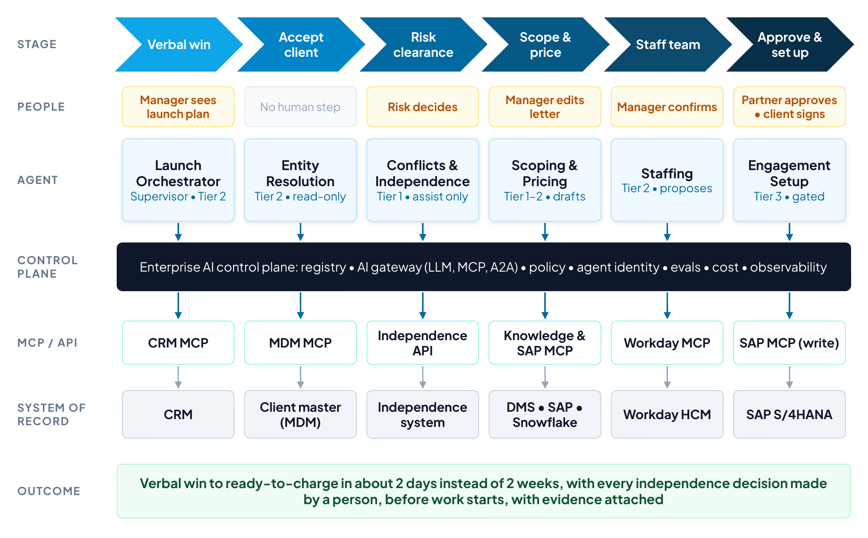
Figure 9. Use case 1 at a glance: the launch stages, the agent and human step in each, and the governed path to each system of record (handbook Figure 8).
Why it is filled this way
The use case is named after its business outcome, from verbal win to ready-to-charge, so the sponsor recognizes the value in the title.
The out-of-scope row excludes delivering the engagement and invoicing afterwards, which keeps the first phase to the launch alone.
Every stage shows who keeps the decision. The use case is safe to start because independence, engagement terms and partner approval stay with people while agents assemble, check, draft and update.
Each stage has a work mode and, where it is human-led, the reason. Risk clearance stays human-led because independence is a regulated professional judgment: the should-AI answer is no, whatever a model could do.
Data readiness scores 3 out of 5 because the client hierarchy is spread across three systems. That gap puts the golden record into phase 1 without stopping the use case.

T2 filled: business case and value hypothesis
Value lever | How the solution delivers it | Formula and inputs | Annual value (illustrative) | Confidence
Capacity released | Manual assembly, checking and data entry falls from about 14 to 5 hours per launch across managers, Risk, resourcing and finance | 10,000 launches × 9 hours × $120 loaded cost | About $10.8M a year | Medium
Revenue protected | Charge codes exist when work starts, so early hours are billed instead of written off | 2,500 affected launches × 20 hours × $200 average rate | About $10.0M a year | Medium
Utilization | Teams are confirmed within days instead of weeks, reducing bench time | 0.5 point × 5,000 client-facing staff × 1,800 hours × $200 | About $9.0M a year | Low
Risk avoided | Every independence decision is made by a person before work starts, with evidence and lineage attached | Avoided remediation, regulatory and reputational cost | Not quantified | Not applicable

Assumption | Value | Source | Agreed by
Engagement launches a year | 10,000 | CRM (illustrative) | Business owner
Loaded cost per hour | $120 | Finance (illustrative) | Finance partner
Average rate per hour | $200 | Finance (illustrative) | Finance partner
Launches starting before charge codes exist | About 2,500 a year, about 20 hours each | SAP and time records (illustrative) | Finance partner
Client-facing staff and hours | 5,000 staff  1,800 hours a year | Workday (illustrative) | Talent

Run rate at full scale | About $30 million a year released or protected, before platform, model and change costs
Costs | To be estimated with the project team: platform, implementation, model usage and change
Expected business outcomes | Verbal win to ready-to-charge in about two business days  Lower cost to launch  No known independence exceptions at engagement start, with a complete evidence trail  The engagement letter the same day
Payback benchmark | Typical AI payback is two to four years.⁸² This plan releases value from month 3 and reaches the full run rate at month 12, so the payback month depends on the costs the project team will estimate.
Horizons | The read-only first slice is judged in months. The gated SAP setup, which acts in a system of record, is judged on the 12-month horizon.

Why it is filled this way
Each lever has a formula that finance can check line by line. The inputs are labeled illustrative until the firm’s own baseline replaces them.
Utilization carries low confidence because it depends on how quickly freed time is re-staffed, which the firm will measure in phase 2.
Risk avoided is described without a price. The firm may have its own estimate of remediation and regulatory cost, and until that estimate is available, evidence and lineage are the value.
The benchmark row sets the case beside what finance will compare it with: the two to four years a typical AI use case takes to pay back.

T3 filled: asset inventory
The inventory below is illustrative. For each tool, the table shows whether it exists today or must be built, and the phase column shows when the plan needs it.
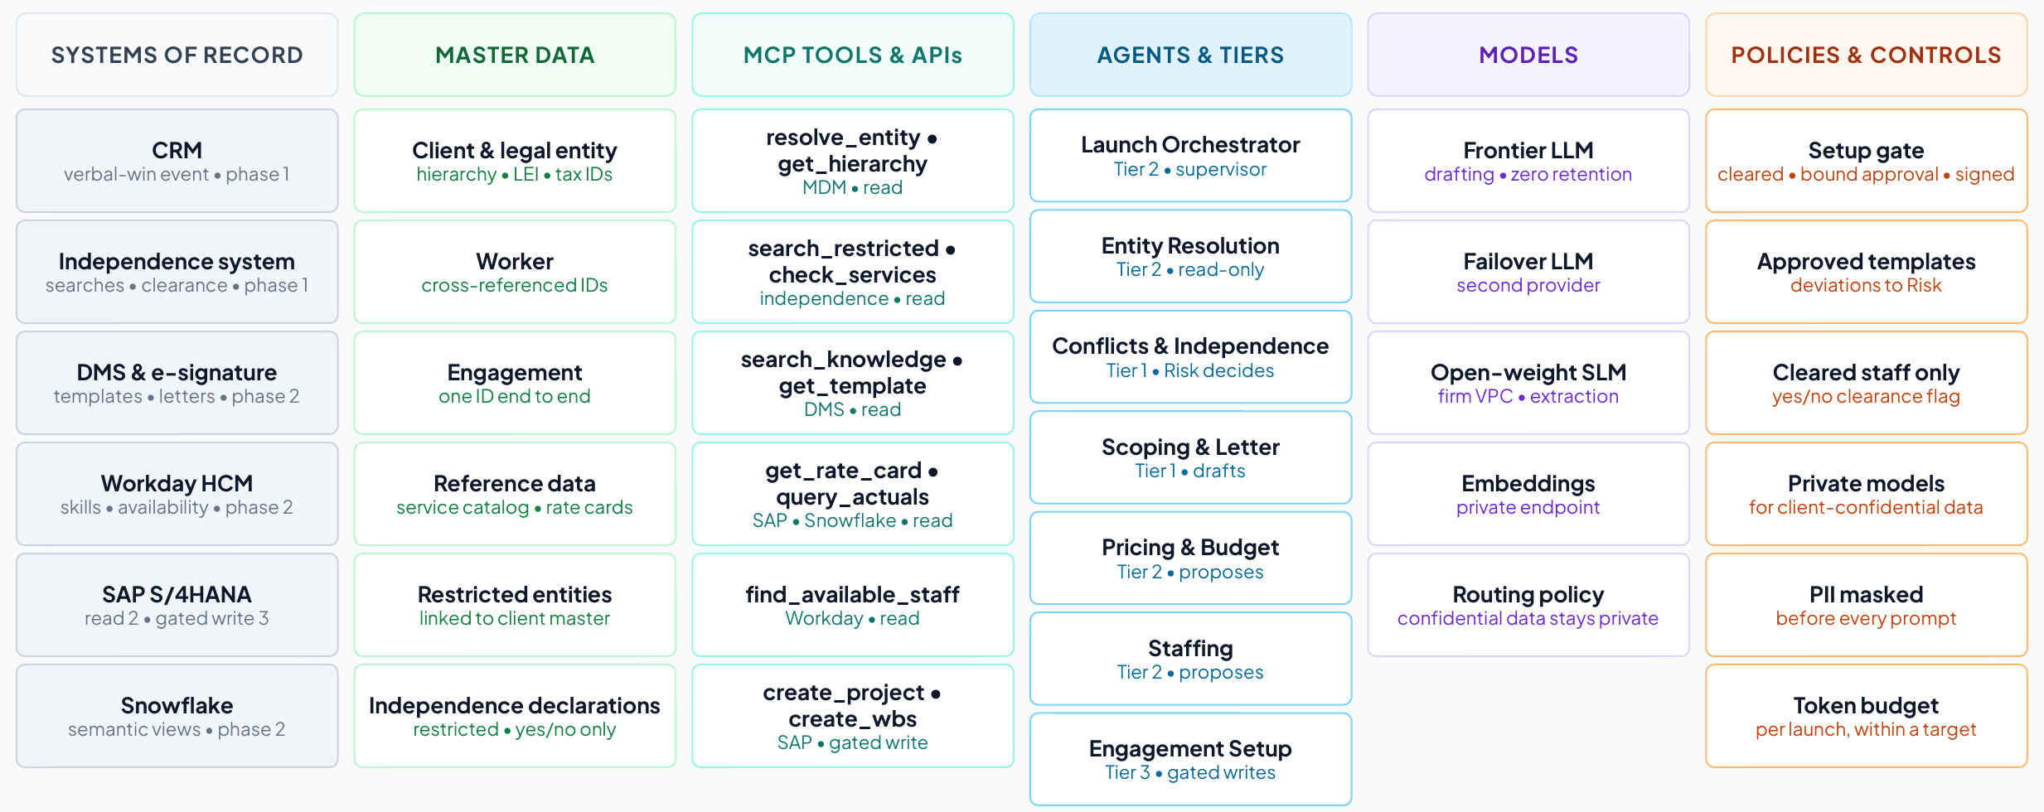
Figure 10. Use case 1 assets by layer, from the asset inventory (client deck, Part 1).

T3a. Applications and systems of record
System | Owner | Role in the use case | Interfaces | Agent access | Phase
CRM | Sales operations | Opportunity and account  The verbal-win event starts the launch | Event  Opportunity and account API | Read | 1
Independence and conflicts system | Risk & Quality | Conflict and independence searches, restricted-entity list, clearance flag | Search API  Clearance-flag API | Read (a person decides) | 1
Master data hub | Data governance | Client, worker and engagement golden records with hierarchies | MDM API  MCP tools (resolve_entity, get_hierarchy) | Read | 1
Document management and e-signature | Risk & Quality  Practice operations | Templates, clause library, precedent  Engagement letters  Client signature | Search and document APIs  Signature event | Read  Create drafts | 2
Workday HCM | Talent | Skills, certifications, availability | Workday API | Read | 2
SAP S/4HANA | Finance | Rate cards  Project, WBS, billing plan and charge codes | SAP APIs | Read (phase 2)  Write, policy-gated (phase 3) | 2–3
Snowflake | Finance and data platform | Historical engagement economics through governed semantic views | Semantic views | Read | 2
Collaboration tool (chat copilot) | IT | The engagement manager’s entry point, in Slack or Teams | Chat app | Channel only | 1

T3b. Data assets and master data
Data asset | System of record | Golden record today? | Quality and risk notes | Sensitivity | Owner or steward
Client and legal-entity master | Master data hub, fed by the CRM, SAP and the independence system | To extend | A missed subsidiary is a missed conflict: hierarchy freshness, duplicate entities, missing LEI or tax IDs | Confidential | Risk & Quality data steward
Restricted-entity list | Independence system | Yes | Must link to the client master | Restricted | Risk & Quality
Worker master | Workday (system of record), cross-referenced in MDM | Partly | Worker IDs differ across the CRM, SAP and the independence system | Confidential (personal data) | Talent
Engagement master | Master data hub | New | One engagement ID for the opportunity, the independence case, the letter and the SAP project | Confidential | Finance
Reference data: service catalog, rate cards | SAP S/4HANA  Service catalog | Partly | Effective dates must be respected | Internal | Finance
Independence declarations | Independence system | Yes | Personal financial interests: field-level encryption or tokenization  Others see a yes or no clearance only | Restricted | Risk & Quality
Templates, clauses and precedent | Document management and knowledge base | Not applicable | Approved templates only  Information barriers between engagements | Confidential | Risk & Quality
Historical engagement economics | Snowflake semantic views | Not applicable | Shared metric definitions (realization, utilization) | Confidential | Finance

T3c. Integrations, APIs, events and MCP tools
Tool or interface | System | Operation | Scope | Exists or to build | Used by
Verbal-win event | CRM | Start the launch | Event | Exists | Launch Orchestrator
resolve_entity  get_hierarchy | Master data hub | Match the client and return hierarchy and identifiers | Read | New MCP tools | Entity Resolution
search_restricted  check_services  get_relationships | Independence system | Conflict and independence searches | Read | To build | Conflicts & Independence
search_knowledge  get_template | Document management and knowledge base | Precedent and approved templates | Read | To build | Scoping & Letter
create_document | Document management | Create the draft letter | Write (drafts only) | To build | Scoping & Letter
get_rate_card | SAP S/4HANA | Rate cards | Read | To build | Pricing & Budget
query_actuals | Snowflake | Historical actuals through a semantic view | Read | To build | Pricing & Budget
find_available_staff | Workday HCM | Skills, availability and location | Read | To build | Staffing
get_clearance_flag | Independence system | Yes or no clearance for a person and client | Read (yes or no only) | To build | Staffing
create_project  create_wbs  create_billing_plan | SAP S/4HANA | Project, WBS, billing plan and charge codes | Write, policy-gated | To build (phase 3) | Engagement Setup
Signature event | E-signature | Client signed | Event | Exists | Launch Orchestrator

T3d. Agents
Agent | Responsibility | Tier | Human role | Owner | Phase
Launch Orchestrator | Plans and tracks the launch, delegates tasks over A2A and enforces the regulated sequence | Tier 2 | Sees plan and status | Practice operations (proposed) | 1
Entity Resolution | Matches the client to its MDM golden record and returns hierarchy and identifiers | Tier 2, read-only | None | Data governance (proposed) | 1
Conflicts & Independence | Runs conflict and independence searches and assembles findings and precedent | Tier 1 | Risk decides | Risk & Quality | 1
Scoping & Letter | Drafts scope and engagement letter from approved templates and clauses | Tier 1 | Manager edits  Partner approves | Risk & Quality (templates) | 2
Pricing & Budget | Builds the budget from rate cards and historical actuals and checks margin | Tier 2 | Manager accepts | Finance (proposed) | 2
Staffing | Proposes a team by skills, availability, location and independence clearance | Tier 2 | Manager confirms | Talent | 2
Engagement Setup | Creates project, WBS, billing plan and charge codes | Tier 3, policy-gated | None (gated by policy) | Finance | 3

Agent | Sponsor | Lifecycle stage | Next recertification | Retirement criteria
Launch Orchestrator | Head of practice operations | Register and onboard (phase 1) | Every six months | The launch process changes or a successor replaces it
Entity Resolution | Head of data governance | Register and onboard (phase 1) | Every six months | Precision below threshold for a quarter, or matching moves into MDM
Conflicts & Independence | Risk & Quality leader | Register and onboard (phase 1) | Quarterly (regulated work) | Independence rules change beyond its evaluation suite
Scoping & Letter | Risk & Quality leader (templates) | Propose (phase 2) | Quarterly | The clause library is replaced, or accuracy falls below threshold
Pricing & Budget | Finance partner | Propose (phase 2) | Every six months | The rate-card system is replaced
Staffing | Talent leader | Propose (phase 2) | Every six months | Workday matching covers the need
Engagement Setup | Finance partner | Propose (phase 3) | Quarterly (writes to SAP) | SAP setup is automated another way, or a failed binding check goes unexplained

T3e. Models
Model | Provider and hosting | Tasks | Data rules | Fallback
Frontier model (primary) | Provider under enterprise terms with zero data retention | Drafts engagement letters and summarizes complex findings | Personal data masked  Approved regions  No training on firm data | Second frontier provider
Frontier model (failover) | Second provider, same terms | Failover for drafting and summaries | As above | Not applicable
Open-weight small language model | Self-hosted in the firm’s VPC | Entity extraction, classification and personal-data detection | Client-confidential text never leaves the firm for routine tasks | Not applicable
Embedding model | Private endpoint | Indexes credentials, prior proposals and templates for retrieval | Indexes partitioned by client and engagement (information barriers) | Not applicable

Routing policy. Client-confidential payloads go only to private models or approved regions. Drafting goes to the frontier model with personal data masked, and token budgets are set per launch.

T3f. Identities, users and channels
Actor | Channel | Authentication | Authority and approvals
Engagement managers | Chat copilot | Single sign-on with phishing-resistant MFA | Edit letters, accept budgets, confirm teams
Partners | Mobile approval | Step-up authentication | Approve letter and budget  Approve the SAP setup request (bound to that request, expires at the end of the business day)
Risk & Quality reviewers | Case workspace | Single sign-on with MFA | Decide independence (Tier 1)
Resource management and finance | Existing tools | Single sign-on with MFA | Work exceptions
Client signatories | E-signature portal | Portal authentication | Sign the engagement letter
Agents (seven) | None (machine actors) | A unique workload identity per agent instance⁹¹ | Least-privilege scopes  On-behalf-of tokens with narrowed scopes⁹²  No agent approves its own output

T3g. Policies and controls
Policy or control | Type | Enforced today | Target enforcement | Owner
Engagement setup in SAP requires independence status CLEARED, the partner’s approval bound to the exact setup request (expiring at the end of the business day) and a signed letter | Approval and gate | Manual checks | Policy decision point  A custom Omni Gateway policy, built with the Policy Development Kit, for approval binding | Finance  Risk & Quality
Engagement letters use approved templates, and any clause deviation routes to Risk & Quality | Content | Manual review | Template and clause checks in the Scoping & Letter agent | Risk & Quality
Staffing proposals include only people with independence clearance for the client and the required credentials | Authorization | Manual | Clearance flag (yes or no) checked by the Staffing agent | Talent  Risk & Quality
Client-confidential data is processed only by private models in approved regions | Data and routing | Not enforced | AI Gateway routing policy | CISO
Personal data is masked before prompts | Data | Not enforced | AI Gateway masking and PII detection | Privacy officer
Token budget per launch  AI cost per launch within its target | Cost limit | Not measured | AI Gateway token-based rate limits  Spend attribution in LLM Governance | Finance  Platform owner
Information barriers between engagements | Data access | Partly (document permissions) | Retrieval filtering  Partitioned indexes  Snowflake row-access policies | Risk & Quality
Autonomy tiers and new agents approved by the AI governance council  Evaluation before promotion | Governance | None | Agent Registry tiers  Evaluation suites (any evaluation tool) | AI governance council
Auditor-independence rules⁸⁹ | Regulatory | Manual evidence | Evidence and lineage attached to every decision | Risk & Quality

T3h. Infrastructure, runtime and observability
Component | Notes
Firm virtual private cloud | Gateways, MCP servers and the self-hosted model run inside the firm’s VPC where confidentiality requires
Private connectivity | Private links to SAP, Workday and Snowflake, with no public endpoints for systems of record
Keys and secrets | Customer-managed keys in a KMS or HSM  AES-256 at rest
Transport | TLS 1.3 everywhere  mTLS between services  Hybrid post-quantum key exchange at gateways as vendors support it
Observability | OpenTelemetry traces for every hop, tied to one engagement correlation ID, feeding the firm’s SIEM and an operations dashboard⁹⁴

Why it is filled this way
The inventory counts six systems of record, seven agents, four models, fifteen MCP tools, four master data domains and nine policies. Those counts become the discovery slide, and every row has an owner.
The master data hub appears as a system even though the golden record is “to extend”: a missed subsidiary is a missed conflict, so the client master is on the critical path from phase 1.
Most policies are “manual” or “not enforced” today. That column makes the case for the control plane, which enforces the same rules at runtime in the gateway path.
Owners marked “proposed” are the lead architect’s suggestion for the firm to confirm. The handbook names Risk & Quality, Finance and Talent as owners of their agents.
Every agent also has a named sponsor and a recertification date. The independence and setup agents are recertified quarterly, because one supports regulated work and the other writes to SAP.

T4 filled: requirements register
ID | Type | Requirement | Priority | KPI | Phase | Owner
BR-01 | Business | Cut verbal-win-to-ready-to-charge from 10 to 2 business days | Must | Win-to-ready-to-charge | 3 | Business owner
BR-02 | Business | Cut manual effort per launch from 14 to 5 hours | Must | Manual effort per launch | 1–3 | Business owner
BR-03 | Business | Every independence decision is made by a person before work starts, with evidence and lineage | Must | Independence cleared before start | 1 | Risk & Quality
FR-01 | Functional | On verbal win, create a launch plan with a correlation ID and show it to the engagement manager within a minute | Must | Win-to-ready-to-charge | 1 | Practice operations
FR-02 | Functional | Resolve the client to its golden record with the full hierarchy (ultimate parent, affiliates, subsidiaries) and identifiers | Must | Post-start exceptions | 1 | Data governance
FR-03 | Functional | Run conflict and independence searches and assemble findings and precedent for a reviewer to decide (Tier 1) | Must | Independence cleared before start | 1 | Risk & Quality
FR-04 | Functional | Draft the engagement letter from approved templates and clauses, and route any deviation to Risk & Quality | Must | Manual effort per launch | 2 | Risk & Quality
FR-05 | Functional | Build the budget from rate cards and historical actuals and check the margin against target | Should | Manual effort per launch | 2 | Finance
FR-06 | Functional | Propose a team by skills, availability, location and independence clearance | Must | Staffing within 48 hours | 2 | Talent
FR-07 | Functional | Create the SAP project, WBS, billing plan and charge codes only when independence is cleared, the partner has approved that exact request and the letter is signed | Must | First-time-right setup | 3 | Finance
DR-01 | Data | Maintain one golden record per legal entity with hierarchy, LEI and tax IDs, linked to the restricted-entity list, and monitor freshness and duplicates | Must | Post-start exceptions | 1 | Data governance
DR-02 | Data | Share one engagement ID across the opportunity, the independence case, the letter and the SAP project | Must | First-time-right setup | 1–3 | Finance
DR-03 | Data | Publish a glossary, shared metric definitions and a data contract for each MCP tool, and capture lineage from source to agent output | Should | Agent quality | 2 | Data governance
IR-01 | Integration | Expose each system of record as governed APIs and MCP tools with explicit read or write scopes | Must | Governed AI traffic | 1–3 | Enterprise architect
NFR-01 | Non-functional | Fail over the primary model to a second provider, and make every SAP write idempotent | Must | First-time-right setup | 2–3 | Platform owner
NFR-02 | Non-functional | Set a token budget per launch, keep AI cost per launch within its target, and attribute every model and tool call to the engagement and its cost center within a day | Must | AI cost per launch | 1–2 | Finance
SR-01 | Security | Give every agent instance its own workload identity with short-lived credentials and no static API keys  Use on-behalf-of tokens with narrowed scopes  No agent approves its own output | Must | Oversight coverage | 1 | CISO
SR-02 | Security | Process client-confidential data only on private models in approved regions, and mask personal data before prompts | Must | Governed AI traffic | 1 | CISO
SR-03 | Security | Bind the partner’s approval to the exact setup request and expire it at the end of the business day | Must | Oversight effectiveness | 3 | CISO  Finance
CR-01 | Compliance | Keep the evidence behind every independence decision for inspections, with retention aligned to professional-standards documentation requirements | Must | Independence cleared before start | 1 | Risk & Quality
OR-01 | Operational | Trace every hop with OpenTelemetry under one engagement correlation ID, and show cycle time, policy blocks, token cost and evaluation drift on one dashboard | Must | Governed AI traffic | 1 | Platform owner
OR-02 | Operational | Pass evaluation suites before promotion (letter-clause accuracy, independence-finding recall, entity-resolution precision), then score sampled production traces continuously | Must | Agent quality | 2 | AI governance council
OR-03 | Operational | Before the setup agent reaches tier 3, write and drill a takeover runbook: open launches move to the finance setup queue with their trace, pending approvals and data touched | Must | Time to contain | 3 | Finance

Why it is filled this way
Every requirement names the KPI it moves and the phase in which it must be met, so phase 1 stays small: the gated SAP write (FR-07) and the bound approval (SR-03) are phase 3.
The data requirements (DR-01, DR-02) are Must and phase 1 because entity resolution and independence depend on them from the first slice.
The operational requirements treat evaluation as a lifecycle (OR-02) and make the takeover runbook a condition of tier 3 (OR-03). NFR-02 makes every model and tool call attributable to the engagement that caused it.
The register stops at 23 rows. It covers what shapes the architecture and the plan and leaves detailed user stories to delivery.

T5 filled: security and compliance requirements
Security follows zero-trust principles:⁹⁰ every actor is authenticated, every call is authorized for the specific task, and nothing is trusted because of where it sits on the network.
Layer | Requirement (controls) | Enforced by | Phase
Users | Single sign-on with phishing-resistant MFA  Step-up authentication for partner approval  Role- and attribute-based access | Firm identity provider  Trusted Agent Identity mobile approval | 1
Agents | A unique workload identity per agent instance⁹¹  Short-lived credentials and no static API keys⁴⁶  Least-privilege scopes  Autonomy tiers  Kill switch  No agent approves its own output | Agent Registry (owner and tier)  Trusted Agent Identity  Agent Kill Switch | 1
A2A | Registered, signed agent cards, verified by the registry (A2A version 1.0)  Mutual TLS plus OAuth tokens on every call²⁷  Delegation carried through on-behalf-of token exchange with narrowed scopes⁹²  Only registered agents may call each other | Agent Registry  Agent Broker A2A support  Omni Gateway policies | 1–2
MCP | MCP servers behind the gateway as OAuth-protected resources, audience-bound tokens with no pass-through, per-tool scopes, input and output schema validation, and policy on MCP’s standard request headers, with every call joined to its trace²⁶  As firm practice: allow-lists per agent, only registered and version-pinned servers, and separate read and write tools | AI Gateway MCP policies  MCP Bridge | 1
APIs | OAuth 2.0 client credentials or signed JWTs  mTLS to backends  Rate limits, payload and injection threat protection  Private connectivity to SAP, Workday and Snowflake | Omni Gateway policies⁷⁸ | 1
Models | Access only through the gateway, enterprise terms with zero data retention and no training on firm data, prompt-injection and jailbreak screening, personal data masked before prompts, and output validation⁹³ | AI Gateway routing, masking and token-based rate limits | 1
Data at rest | AES-256 with customer-managed keys in a KMS or HSM  Field-level encryption or tokenization for personal financial interests  Snowflake row-access and masking policies  Vector indexes partitioned by client and engagement | Firm KMS or HSM  Snowflake policies  Informatica classification | 1
Data in motion | TLS 1.3 everywhere  mTLS between services  Private links to SaaS  Hybrid post-quantum key exchange at gateways as vendors support it | Gateways  Private links | 1
Audit | Tamper-evident logs linking user, agent, tool call and record  Retention aligned to professional-standards documentation requirements | Agent Visualizer  OpenTelemetry traces to the firm SIEM | 1

Autonomy by agent
Agent | Tier | Human role | Approval bound to | Limits and kill switch
Launch Orchestrator | Tier 2 | Sees plan and status | Not applicable | Token budget per launch  Kill switch
Entity Resolution | Tier 2, read-only | None | Not applicable | Read-only scopes
Conflicts & Independence | Tier 1 | Risk decides | The reviewer’s decision, signed and logged | Read-only  No agent decides
Scoping & Letter | Tier 1 | Manager edits  Partner approves | The partner’s approval of the letter | Approved templates only  Drafts only
Pricing & Budget | Tier 2 | Manager accepts | Not applicable | Read-only
Staffing | Tier 2 | Manager confirms | Not applicable | Clearance returned as yes or no only
Engagement Setup | Tier 3, policy-gated | None (gated by policy) | The partner’s approval of that exact setup request, expiring at the end of the business day | Idempotent writes  Kill switch drilled before go-live

Promotion and demotion
Agent | Current tier | Evidence to promote | Demotion triggers
Engagement Setup | Tier 3, gated, from month 12 | At month 8 it proposes setups that match the partners’ approvals for a full quarter  Red-team findings closed  Impact assessment updated  Finance and Risk & Quality agree | An approval fails its binding check  Independence status changes after approval  Stale hierarchy data  Any security event
Scoping & Letter | Tier 1, drafts only | Stays at tier 1: the partner approves every letter. Standard letters could move to tier 2 only after clause accuracy holds for two quarters and Risk & Quality agrees | Clause accuracy below threshold  A template change not yet evaluated
Conflicts & Independence | Tier 1 by design | Not promoted: independence stays a human-led decision | Finding recall below threshold  The restricted-entity list out of date
Staffing | Tier 2, proposes | Stays at tier 2: managers confirm every team | The clearance-flag check fails  Stale Workday data

Human takeover
Agent | Who takes over | Information handed over | Degraded mode and service level | Drills
Engagement Setup | Finance project-setup team | The launch trace, the partner’s bound approval, the setup request and any SAP objects already created | Manual SAP setup as today, within one business day | Before tier 3 goes live, then quarterly
Launch Orchestrator | Practice operations | The launch plan and status of every launch in flight | Managers follow the launch checklist by hand | Before phase 2, then twice a year
Staffing | Resource management | Proposed teams and their clearance flags (yes or no only) | Manual staffing as today | Twice a year

Threat coverage
OWASP agentic risk | What it looks like here | Controls in this design
ASI01 Agent Goal Hijack | Hidden instructions in client documents or precedent redirect a letter or a finding | Input and tool-result screening at AI Gateway  Template and clause checks  The partner approves the exact letter
ASI02 Tool Misuse | The setup agent creates the wrong SAP objects | Separate read and write tools  Schema validation  Idempotent writes  Per-launch limits
ASI03 Identity & Privilege Abuse | An agent acts beyond the authority of the person it acts for | One identity per agent  On-behalf-of tokens with narrowed scopes  The approval bound to the exact setup request
ASI04 Agentic Supply Chain Vulnerabilities | A poisoned or changed MCP server enters the launch path | Only registered, version-pinned MCP servers  Reviewed tool definitions  Gap: the platform team owns what enters the registry
ASI05 Unexpected Code Execution | A drafting request triggers code or commands | No code or shell tools for any launch agent
ASI06 Memory & Context Poisoning | Wrong entity data leads to a missed conflict | Context only from the golden record, the catalog and lineage  Quality rules on the client hierarchy
ASI07 Insecure Inter-Agent Communication | A spoofed agent asks the orchestrator for independence findings | Signed agent cards  mTLS plus OAuth on every A2A call  Only registered agents may call each other
ASI08 Cascading Failures | A bad hierarchy update spreads to every launch that day | Propose-only on stale master data  Per-launch limits  The kill switch
ASI09 Human-Agent Trust Exploitation | A polished summary leads a reviewer or partner to approve without reading | Findings shown with evidence and lineage  Approver training  Verification latency watched  Gap: Risk & Quality owns what reviewers are shown
ASI10 Rogue Agents | An unregistered agent calls SAP or the independence system | Agent Scanners and the registry  Decoy tools  Gateway-only access to systems of record

Compliance and evidence
Obligation | Evidence required | Where it is produced | Owner
Auditor-independence rules⁸⁹ | Independence cleared before work starts, with the findings and the reviewer’s decision | Independence system  Decision log with lineage | Risk & Quality
Professional-standards documentation | Retained evidence for inspections | Tamper-evident audit logs  Document management | Risk & Quality
Data protection | Personal data masked  Personal financial interests protected | AI Gateway masking  Tokenization in the independence system | Privacy officer
AI governance standards the firm reports against (ISO/IEC 42001; NIST AI RMF)^{72,73} | Inventory, risk tiers, impact assessments, evaluation and monitoring records | Agent Registry, evaluation records and audit logs (handbook Appendix C maps the controls) | AI governance council

Why it is filled this way
Only one agent writes to a system of record, and only under three conditions: independence cleared, the partner’s bound approval and a signed letter. Every other agent reads, drafts or proposes.
Under data minimization, the staffing agent sees a yes or no clearance flag and never the personal financial interests behind it, which keeps sensitive data where it belongs.
Most controls are phase 1 because security starts on day one, while autonomy is phased in later.
The setup agent earns tier 3 on evidence: a quarter of proposed setups that match the partners’ approvals. It drops back automatically if a binding check fails or independence status changes, and finance can take over its open launches within a business day.
The threat table shows coverage and the two gaps that need named owners: what enters the registry (the platform team) and what reviewers are shown (Risk & Quality).

T6 filled: KPIs and scorecard
KPI | Definition | Data source | Owner
Win-to-ready-to-charge | Business days from verbal win to active charge codes | CRM and SAP timestamps | Business owner
Manual effort per launch | Hours across all roles to launch one engagement | Time study  Activity logs | Business owner
Independence cleared before start | Share of engagements cleared before any work begins | Independence system  SAP | Risk & Quality
Post-start independence exceptions | Exceptions found after work begins, per 1,000 engagements | Independence system | Risk & Quality
First-time-right setup | SAP projects created without later correction | SAP change logs | Finance
Staffing within 48 hours | Roles confirmed within 48 hours of verbal win | Workday  CRM | Talent
Agent quality | Evaluation pass rate for letters and independence summaries | Evaluation suites | AI governance council
Governed AI traffic | Share of model and tool calls through the AI gateway | AI Gateway | Platform owner
AI cost per launch | Model and platform cost per engagement launched | LLM Governance  Finance | Finance
AI cost visibility | Share of AI spend for launches attributed to an engagement and its cost center within a day | AI Gateway  LLM Governance | Finance

KPI | Baseline | Month 3 | Month 8 | Month 12 | Month 24
Win-to-ready-to-charge | 10 days | Measure in scope | Measure | 2 days | 2 days
Manual effort per launch | 14 hours | About 10 hours in scope | About 8 hours | 5 hours | 5 hours
Independence cleared before start | 92% | Measure in scope | Measure | 100% | 100%
Post-start independence exceptions | 4 | Measure in scope | Measure | Below 0.5 | Below 0.5
First-time-right setup | 80% | Manual, as today | Manual, as today | 97% | 97%
Staffing within 48 hours | 55% | Measure | Toward 70% | 85% | 85%
Agent quality | Not measured | Baseline set | Track | 95% or higher | 95% or higher
Governed AI traffic | Not measured | 100% in scope | 100% in scope | 100% | 100%
AI cost per launch | Not measured | Baseline set | Within target | Within target | Within target
AI cost visibility | Not measured | 100% in scope | 100% in scope | 100% | 100%

Control-plane scorecard for the use case
Metric | What it shows for this use case | Leading indicator | Data source
Agent coverage | Every launch agent registered with an owner, a sponsor and a tier | Launch agents found by scanners but not yet registered | Agent Registry and Scanners
Governed traffic | Every model and tool call in scope through AI Gateway | New launch agents whose first production call went through the gateway | AI Gateway
Cost per outcome | AI cost per launch against its target | Cost per successful task: letters and budgets that passed their checks | LLM Governance
AI cost visibility | AI spend for launches attributed to an engagement within a day | Share of the previous day’s spend tagged to an engagement | AI Gateway  LLM Governance
Value realized | Run rate of the live slice against the business case: about $0.5M, $8M, then $30M a year | Acceptance rate of letters and budgets without significant edits | Business-case tracking
Oversight effectiveness | SAP setups executed exactly as the partner approved, within the approval’s validity | Takeover rate: how often a manager or reviewer takes over a task an agent started | Gateway approval-binding events
Time to contain | Kill-switch and takeover drill passed before tier 3 goes live | Drill time: minutes to stop the setup agent and hand its open launches to finance | Agent Kill Switch  Takeover drill records

Why it is filled this way
Baselines are illustrative. Three are “not measured” because the firm has no gateway today, and measuring them is itself a phase 1 outcome.
Month 3 targets apply to one service line in one region, and say so. All targets are met by month 12, and month 24 shows them sustained.
The scorecard ties the use case to the platform: agent coverage, governed traffic and cost per outcome are the evidence the control plane is working.
Every scorecard metric has a leading indicator that moves within weeks, and AI cost visibility is measured from phase 1, when every call in scope is tagged to its engagement.

T7 filled: north-star architecture (vendor-neutral)
Layer | This use case
Users and clients | Chat copilot (engagement managers)  Mobile approvals with step-up MFA (partners)  Risk workspace (independence reviewers)  E-signature portal (client signatories)
Agents and tiers | Entity Resolution (Tier 2, read-only)  Conflicts & Independence (Tier 1, Risk decides)  Scoping & Letter (Tier 1, drafts only)  Pricing & Budget (Tier 2, proposes)  Staffing (Tier 2, proposes)  Engagement Setup (Tier 3, gated writes)
Orchestration | Hybrid/federated  Launch Orchestrator as supervisor  Deterministic gates for independence, approvals and signature  A2A delegation²⁷  CRM and e-signature event triggers
Control plane | Registry of agents, tools and APIs  AI gateway for LLM, MCP and A2A traffic  Policy decision point (policy as code)  Identity and delegation  Evaluation and cost  Kill switch
Models | Frontier model for drafting (zero retention)  Second frontier provider for failover  Self-hosted open-weight SLM for extraction  Embeddings on a private endpoint
MCP servers and APIs | CRM, independence system, knowledge and document management, Workday, SAP S/4HANA and Snowflake, each with explicit read or write scopes²⁶
Data governance | Golden records for client, worker and engagement  Semantic layer and data contracts  Catalog and lineage  Data quality  Access policies and information barriers
Systems of record | CRM  Independence system  Document management and e-signature  Workday HCM  SAP S/4HANA  Snowflake
Across every layer | Security: MFA, per-agent identity, OAuth scopes per tool, mTLS, masking, encryption, tamper-evident audit. Governance: autonomy tiers, human approval gates, agent owners, OpenTelemetry traces, token cost per launch, evaluation scores

Design decisions
Decision | Choice and rationale
Orchestration pattern | Hybrid/federated: the control plane governs identity, policy, cost and audit centrally, while each function owns its agents (Risk & Quality, Finance, Talent). Within a launch, a supervisor pattern applies.
Model hosting and routing | A frontier model under enterprise terms with zero data retention for drafting, a second provider for failover, and a self-hosted open-weight model for extraction so client-confidential text stays in the firm.
Where gateways and MCP servers run | Inside the firm’s VPC where confidentiality requires (customer-managed Runtime Fabric in the realization).
Data residency | Client-confidential payloads only to private models or approved regions  Private links to SaaS  Customer-managed keys
Human approvals and tiers | Independence, engagement terms and partner approval stay human. The setup write is gated, and the partner’s approval is bound to the exact request and expires at the end of the business day.
Observability and audit | OpenTelemetry traces for every hop under one engagement correlation ID, feeding the firm’s SIEM and an operations dashboard.⁹⁴

Design review against the firm’s framework
Check | Result | Evidence
Every agent has an owner, a sponsor, a risk tier and an identity of its own | Yes | Seven launch agents, each with an owner, a sponsor, a tier and its own workload identity (T3d, T5)
Each agent’s tool access is least-privilege and allow-listed | Yes | Allow-lists per agent and separate read and write tools (T5)
Human oversight matches the risk and reversibility of each action | Yes | Tier 1 for independence and letters, and the SAP write gated by a bound approval (T5)
Agents’ data access is aligned with their users’ access | Yes | On-behalf-of tokens carry the manager’s or partner’s narrowed scopes (T5)
Only trusted, registered MCP and A2A servers are reachable | Partly | Registry and gateway from phase 1, with version pinning for MCP servers to be set up in phase 1
New policies start in audit mode, then enforce | Yes | Routing and masking policies start in audit mode in the phase 1 scope, then enforce
Agent reasoning, tool calls and hand-offs are traced end to end | Yes | One engagement correlation ID across every hop (OR-01)
Agent costs are tagged to cost centers, with alerts as spend nears budget | Yes | Token budget per launch and spend attributed to each engagement (NFR-02)
Adversarial testing runs before release and on a schedule | Partly | Evaluation suites before promotion (OR-02)  The red-team schedule is to be agreed with the CISO
There is a tested way to disable a misbehaving agent and hand over its work | Yes | Kill switch and takeover runbook drilled before tier 3 (T5, OR-03)

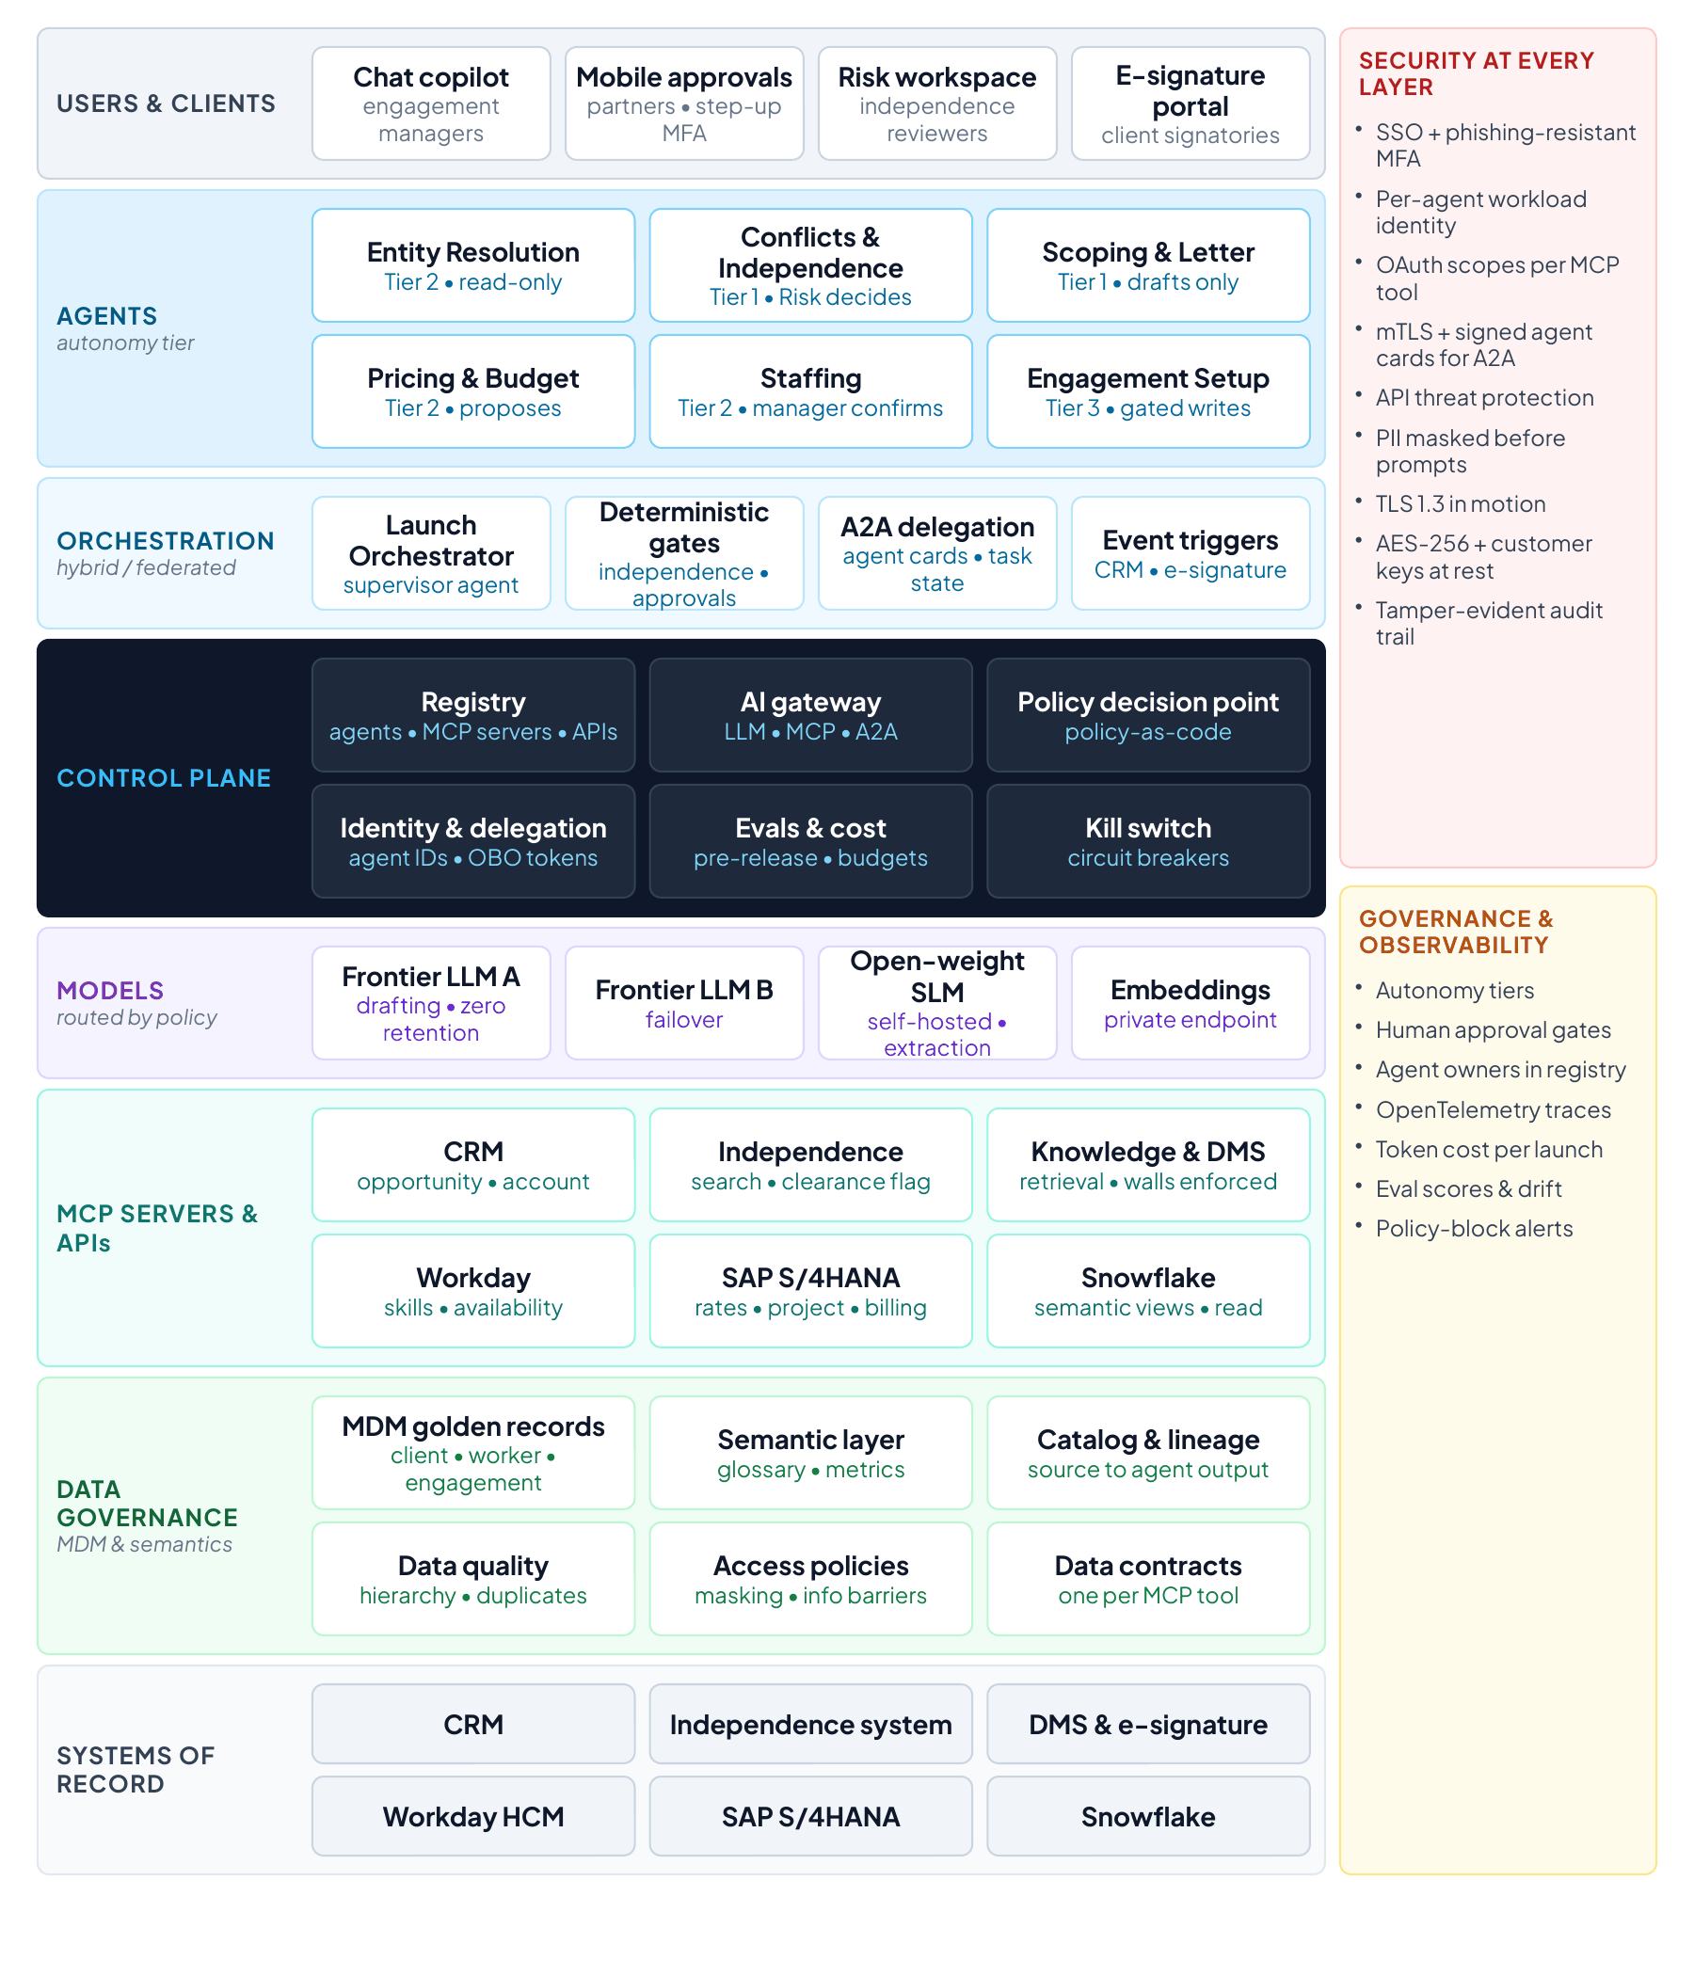
Figure 11. Use case 1 vendor-neutral solution architecture. Only the systems of record are named products (handbook Figure 9).
Why it is filled this way
The regulated sequence is deterministic and is not left to model reasoning. There is no letter before independence is cleared, and nothing is written to SAP before the partner and the client have approved. Models reason inside steps and never skip a gate.
Data governance is a layer of its own because independence checks are only as good as the entity data behind them.
Only systems of record are named. Everything else stays vendor-neutral until T10.
The design review found two gaps to close in phase 1: version pinning for MCP servers and an agreed red-team schedule.

T8 filled: a day in the life
Persona | Maya Chen, engagement manager in the advisory practice, launching Project Atlas for a new client
The case | Project Atlas, a new client that turns out to be a subsidiary of a group whose parent is an audit client (illustrative)

Time | Moment | What happens | Who decides
08:05 | Verbal win | The CRM opportunity for Project Atlas moves to verbal win. Within a minute Maya’s chat copilot shows a launch plan targeting ready-to-charge in two days. | No
08:12 | Client resolved | The entity-resolution agent matches the client to its golden record and finds that it is a subsidiary of a group whose parent is an audit client. An enhanced independence review starts automatically. | No
09:40 | Independence cleared | A reviewer in Risk & Quality approves the engagement with one condition: no work on financial-reporting systems. | Yes: Risk decides
10:30 | Letter drafted | The scoping agent drafts the engagement letter with the carve-out, and Maya rewrites two paragraphs. | Yes: Maya edits
11:20 | Budget ready | The pricing agent’s budget arrives with a 31% margin against a 30% target. | Yes: Maya accepts
13:05 | Team proposed | The staffing agent proposes a team of five, having already replaced a consultant who is not independence-cleared for this client. Maya sees only that a substitution was required, not why. | Yes: Maya confirms
14:30 | Partner approves | The partner approves the letter and budget on mobile with step-up authentication, and the letter goes to the client for signature. | Yes: partner approves
16:10 | Ready to charge | Once the client signs, the setup agent creates the SAP project, WBS and billing plan, and the team receives charge codes. What used to take two weeks finished the same day. | Client signs  Setup gated by policy

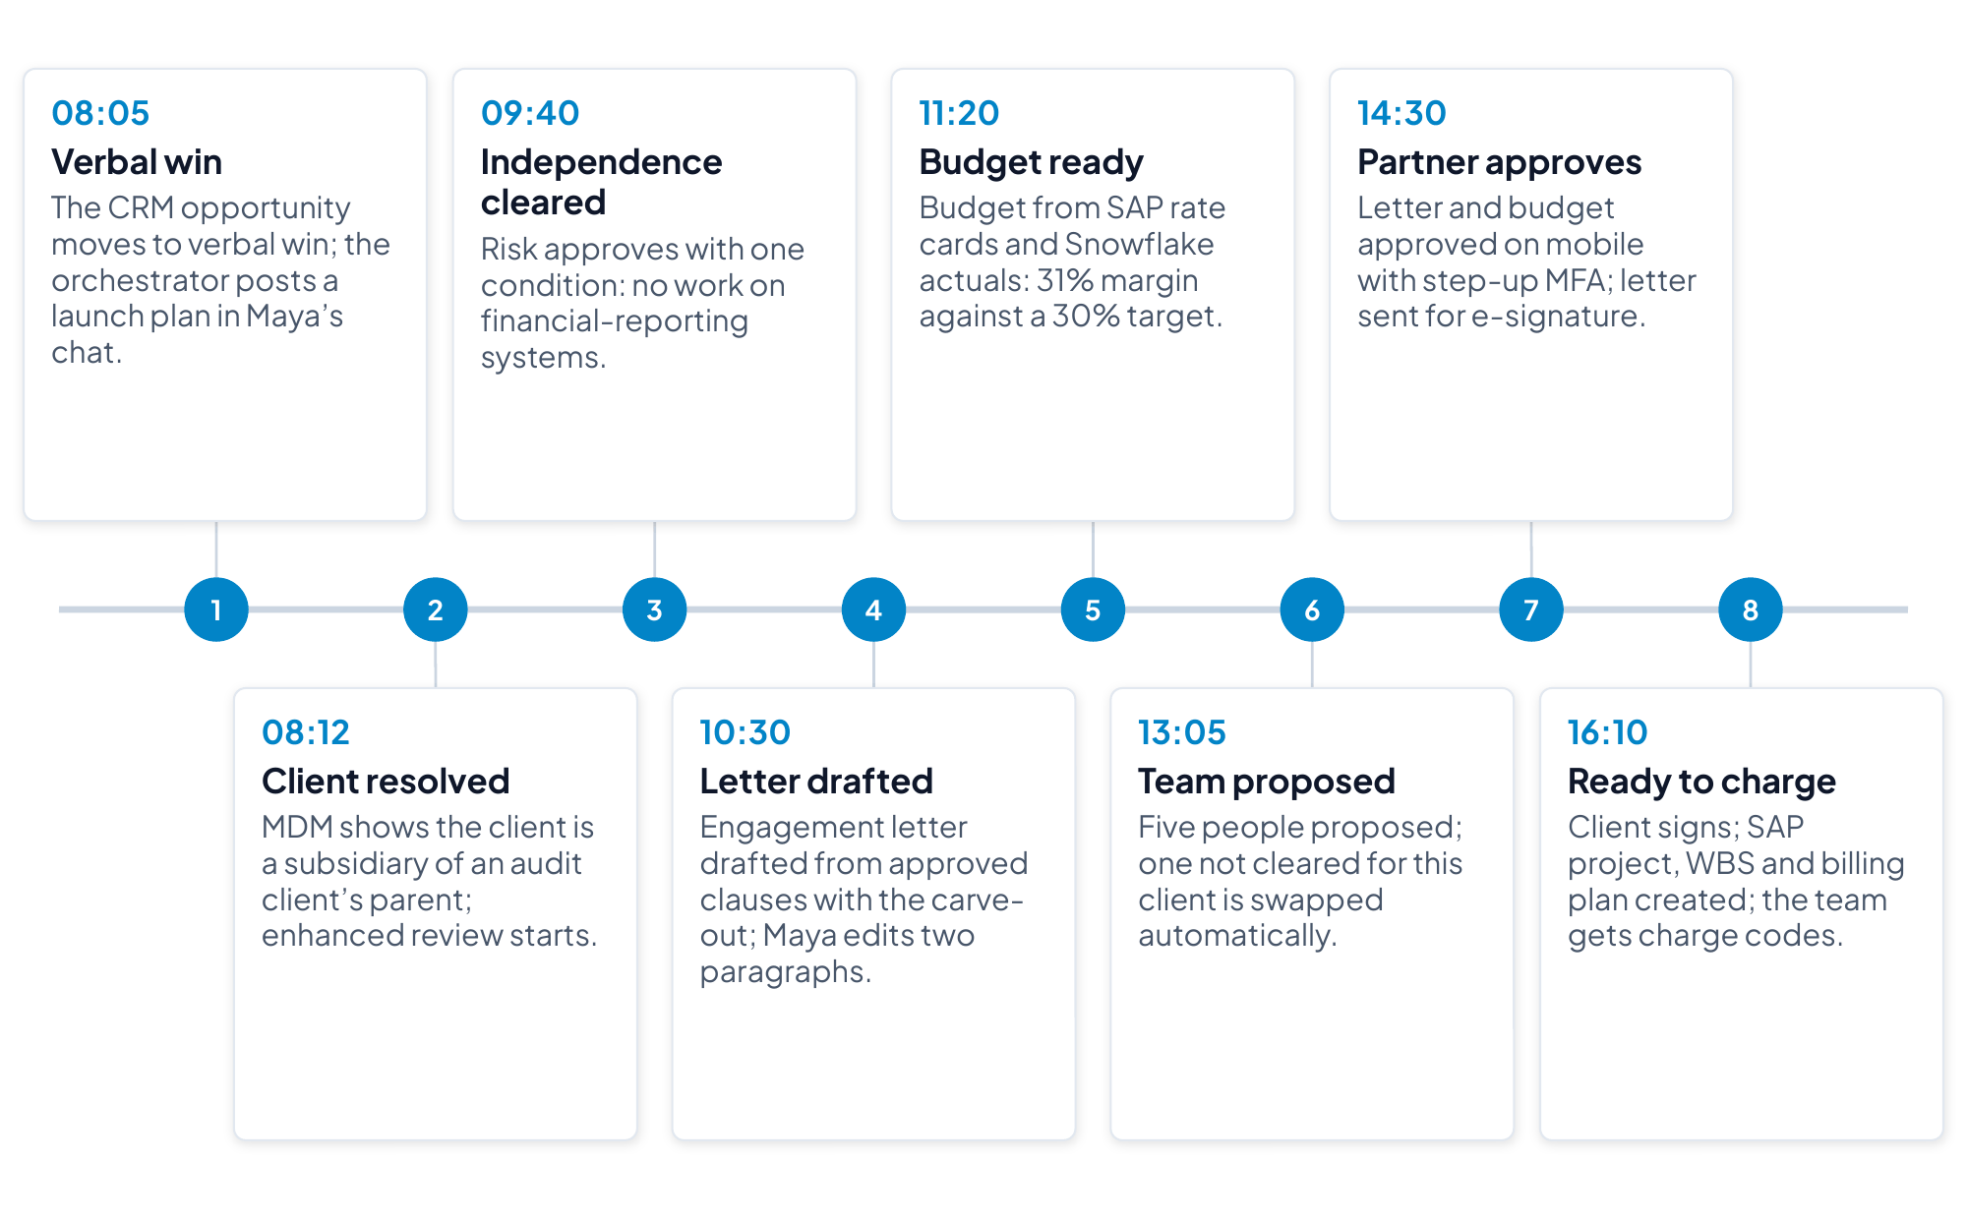
Figure 12. A day in the life of an engagement manager launching Project Atlas (illustrative; handbook Figure 10).
Why it is filled this way
The story includes one moment where a control changes the outcome, and it is the moment a CTO remembers: the entity-resolution agent finds the audit-client parent, which starts an enhanced review.
Maya sees only that a substitution was required, so the story shows data minimization without a lecture.
The day ends in business terms: what used to take two weeks finished the same day.

T9 filled: how the components work together
Time | What happens | Components and protocols | Controls applied
08:05 | Verbal win starts the launch | CRM event triggers the Launch Orchestrator, which registers the plan with a correlation ID | Orchestrator workload identity  Trace starts
08:12 | Client resolved to its golden record | Orchestrator delegates to Entity Resolution over A2A  Agent calls MCP tools on the master data hub (resolve_entity, get_hierarchy) | Read-only scopes  Gateway authorization  Lineage captured
09:40 | Independence decision | Conflicts & Independence agent calls independence-system tools  Private SLM summarizes  Review task goes to Risk | Tier 1: a person decides  Decision signed and logged
10:30 | Letter drafted | Scoping agent retrieves precedent through the knowledge MCP, then drafts with the frontier model via the AI gateway | Retrieval filtered by information barriers  Personal data masked  Template and clause checks
11:20 | Budget built | Pricing agent reads SAP rate cards and a Snowflake semantic view through MCP (read) | Row-access policies  Metric definitions from the semantic layer
13:05 | Team proposed | Staffing agent calls Workday MCP tools and the clearance-flag API | Data minimization: clearance returns yes or no only  Manager confirms
14:30 | Partner approval | Mobile approval with step-up MFA, recorded against the engagement ID | Non-repudiation  Separation of duties
16:10 | Engagement set up | Setup agent calls SAP MCP write tools after the policy decision point allows | Gate: cleared, approved and signed  Idempotent writes  Kill switch available

Delegation check
Hand-off | Unit of work and its check | Model | Permissions passed on | When it stops and asks
Orchestrator to Entity Resolution | Resolve one client to its golden record, checked against the hierarchy and identifiers returned | Self-hosted small model | Read-only MDM scopes, on behalf of the manager | An ambiguous match goes to a data steward, not to the next step
Orchestrator to Conflicts & Independence | Assemble the findings for one launch, checked by the Risk reviewer | Self-hosted small model for summaries | Read-only independence scopes with no decision rights | Always: a person decides
Orchestrator to Scoping & Letter | Draft one letter from approved templates, checked by template and clause rules | Frontier model through AI Gateway | Drafts only, in document management | Any clause deviation goes to Risk & Quality
Orchestrator to Engagement Setup | Create one SAP project, WBS and billing plan, checked against the approved request | None needed for the write | Write scopes for this launch only, after the gate allows | Any mismatch with the approval stops the write

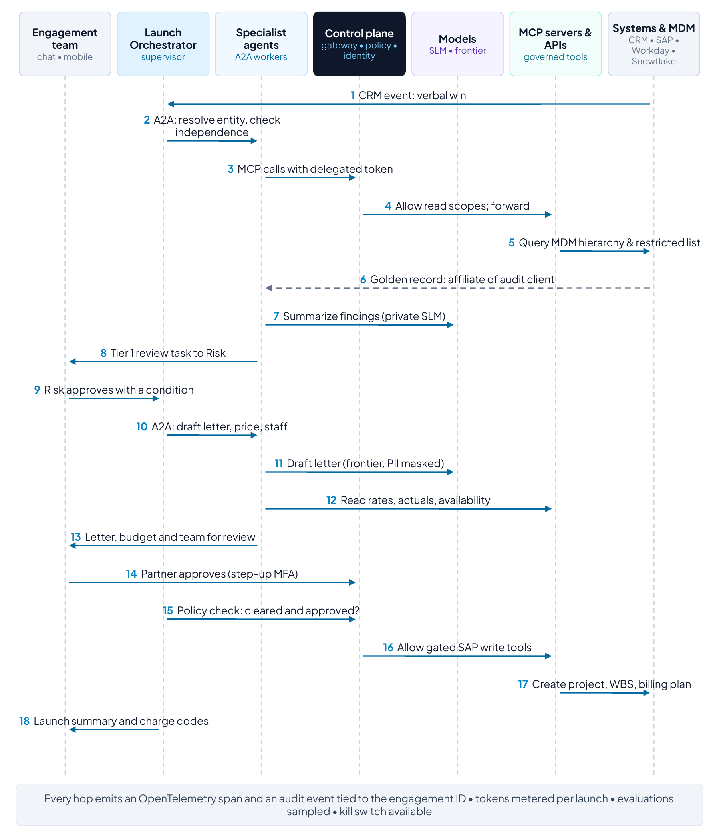
Figure 13. Component interaction for the Project Atlas launch. Numbered steps follow the day in the life (handbook Figure 11).
Why it is filled this way
Each moment names the protocol: A2A between the orchestrator and specialist agents, MCP from agents to tools, APIs to systems of record.
The last row shows the policy decision point allowing the SAP write only when the three conditions are met. Every write in every use case needs a row like it.
Every hand-off narrows authority: the setup agent receives write scopes for one launch only, after the gate allows, and any mismatch with the approval stops the write.

T10 filled: realizing the use case with MuleSoft Agent Fabric and Informatica
Reference component | MuleSoft or Informatica capability | Role in this use case
Registry | Agent Registry and Agent Scanners (MuleSoft Agent Fabric) | Registers every launch agent, including agents other teams built on other platforms, with owner and autonomy tier²¹
Orchestration | Agent Broker with guided determinism (MuleSoft Agent Fabric) | Supervisor routing over A2A, with fixed gates for independence, approvals and signature²¹
AI gateway | AI Gateway for LLM and MCP traffic and Omni Gateway policies for APIs and A2A (MuleSoft) | One policy point for token limits, routing, masking, authentication and rate limits^{21,78}
Agent identity | Trusted Agent Identity (MuleSoft Agent Fabric) | Agents act on behalf of Maya or the partner, with mobile approval for high-risk steps²¹  A custom Omni Gateway policy, built with the Policy Development Kit, binds each approval to the executed call⁷⁸
Operate and control | Agent Kill Switch, Agent Visualizer, AI cost controls (MuleSoft Agent Fabric) | Stop a misbehaving agent, trace the launch, apply token-based rate limits and attribute AI spend to each launch²¹  Evaluation suites run with any evaluation tool
MCP servers and APIs | MCP Bridge, and System and Process APIs with MuleSoft connectors for SAP S/4HANA, Workday, Snowflake and the CRM (MuleSoft) | Existing APIs become governed MCP tools without rewriting integrations²¹
Master data | Multidomain MDM (Informatica) | Client, worker and engagement golden records with hierarchies, which agents reach through governed APIs exposed as MCP tools by MCP Bridge^{21,77}
Semantics, catalog, lineage | Data Governance and Catalog, with the CDGC Metadata Search MCP server (Informatica) | Shared glossary and lineage for agents and people, with agents searching catalog metadata through MCP⁷⁷
Data quality | Data quality rules, with the Address Verification MCP server (Informatica) | Validate entity data, such as addresses and identifiers, at the point of entry, and flag duplicates and stale hierarchies to data stewards⁷⁷
Deployment | CloudHub or customer-managed Runtime Fabric (MuleSoft) | Keep gateways and MCP servers inside the firm’s VPC where confidentiality requires²¹

The evaluation suites (OR-02) run with any evaluation tool, and their results are recorded in the registry so that promotion decisions rest on them.

What stays the firm’s choice
Component | Firm’s choice
Channels and collaboration tools | Chat copilot in Slack or Teams  The Risk workspace  The e-signature portal
Agent platforms and frameworks | Any platform, with agents registered and governed centrally
Models and providers | Frontier models from any provider through AI Gateway  The self-hosted small model  Embeddings
Systems of record | CRM, independence system, document management and e-signature, Workday, SAP S/4HANA, Snowflake
Identity provider and SIEM | The firm’s existing services, federated by the control plane

Coexisting with the firm’s other platforms
Collaboration platform | The chat copilot runs in Slack or Teams. The platform’s own admin controls stay in place, and the copilot’s calls into the launch agents pass through Agent Fabric.
Agents built elsewhere | Agents other teams built on other platforms are registered in Agent Registry. Their native planes stay authoritative for identity and runtime in their own estates.
Identity | The firm’s identity provider stays authoritative for people. Agent identities are federated, not duplicated.
Agent Fabric is authoritative for | The launch agents’ inventory, policy on every call into SAP, Workday, Snowflake, the CRM and the independence system, and AI cost and audit.

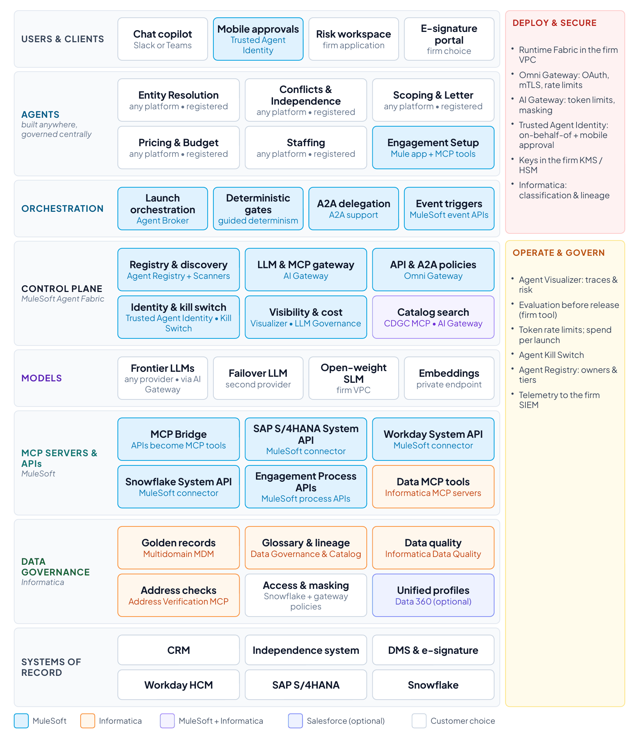
Figure 14. Use case 1 realized with MuleSoft Agent Fabric and Informatica. Colors show which vendor fills each role (handbook Figure 12).
Why it is filled this way
The mapping is one-to-one with the vendor-neutral design. MuleSoft supplies the control plane, the A2A and MCP paths and the governed APIs into SAP, Workday and Snowflake. Informatica supplies the golden records, semantics and quality that make independence checks trustworthy.
Approval binding is labeled custom: it is a custom Omni Gateway policy built with the Policy Development Kit, so the firm or a partner owns its build, testing and support.⁷⁸
Coexistence is settled in writing: other platforms keep their own controls and identities, and Agent Fabric is authoritative for the launch agents, every call into the firm’s systems, and cost and audit.

T11 filled: phased implementation with ROI and business value
Milestone | What goes live | KPIs at the milestone | Value (illustrative) | Formula | Foundations left behind
Month 3 (phase 1) | One service line in one region, about a tenth of launches. Entity resolution and independence agents work read-only at tiers 1–2, while people draft letters and set up SAP as today. Every model and tool call goes through the gateway from day one. | Manual effort per launch down from 14 to about 10 hours in scope  Governed AI traffic 100% in scope | About $0.5M a year | 1,000 launches × 4 hours × $120 | Agents registered with owners and tiers  Spend visible by use case  The gateway live
Month 8 (phase 2) | Half of all launches. Scoping and pricing agents draft letters and budgets from approved clauses and rate cards, and the staffing agent proposes teams from Workday. The launch capabilities are published as governed MCP tools. | Manual effort about 8 hours in scope  Staffing within 48 hours rising toward 70% | About $8M a year | Capacity about $3.6M (5,000 × 6 hours × $120)  Utilization about $4.5M | Governed APIs and MCP tools reusable by the next use case  Routing and token-based rate limits on
Month 12 (phase 3) | Every launch. The setup agent creates the SAP project, WBS and billing plan at tier 3 once the partner’s approval, bound to that exact request, and the client’s signature are in place. | All KPI targets met, including win-to-ready-to-charge in 2 days and 5 hours of effort per launch | About $30M a year | The full business case | Agent identities, bound approvals, drills and evaluation in every release
Month 24 (phase 4): all goals met | Run rate and KPI targets are sustained. Adjacent processes, such as engagement changes and closure, are added on the same controls, and models are swapped without application changes. | All KPIs held at target | About $33M cumulative by month 24 | Each run rate counted from its milestone | Federated control plane  Post-quantum plan on track

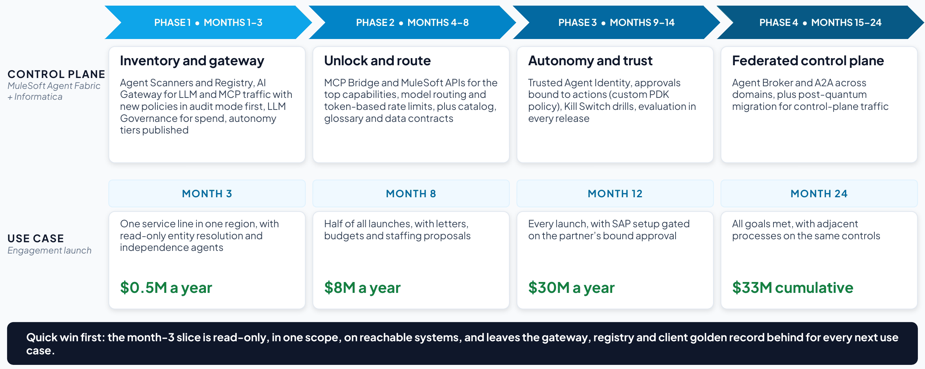
Figure 15. The platform and the use case, phased together (client deck, Part 1). Values are illustrative, before platform, model and change costs.

Quick-win test for the month-3 slice
Test | Result | Evidence
Shows measurable value within 90 days in one scope (one service line, market, region or site). | Yes | One service line in one region, about 1,000 launches a year  Effort down from 14 to about 10 hours in scope
Runs read-only or propose-only (tiers 1 and 2): no writes to systems of record yet. | Yes | Entity resolution and independence agents at tiers 1–2, while people still draft letters and set up SAP
Uses systems and data that are reachable now, or with one connector. | Yes, with one build | MDM and the independence search API (the search API is built in phase 1)
Saves time or money that the users and the sponsor can see. | Yes | About four hours saved per launch for managers and Risk reviewers
Leaves a reusable foundation behind: a registered agent, a governed MCP tool, a golden record or the gateway itself. | Yes | Registry, AI Gateway, the client golden record and the first MCP tools
Has a baseline taken before it starts, so the movement can be proved. | Yes | Cycle time and effort measured in the service line before go-live

Cumulative value and ROI
Period | Run rate in force | Value
Months 3–8 | $0.5M a year for 5 months | About $0.2M
Months 8–12 | $8M a year for 4 months | About $2.7M
Months 12–24 | $30M a year for 12 months | About $30.0M
Total by month 24 |  | About $33M

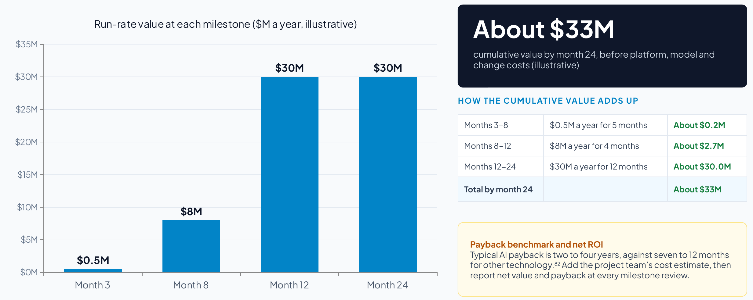
Figure 16. Run-rate value at each milestone and how the cumulative value adds up (client deck, Part 1; illustrative).
Net ROI and payback follow once the project team has estimated platform, model and change costs: ROI = (cumulative value − cumulative cost) ÷ cumulative cost, and payback is the month in which cumulative value first exceeds cumulative cost. Report both at every milestone review.
Payback benchmark | Typical AI payback is two to four years, against seven to 12 months for other technology investments, while 67% of CEOs expect AI returns within one to three years^{82,83}
This plan | Value from month 3 in one service line and the full run rate from month 12, with the payback month following once costs are estimated (illustrative)
Horizons | Read-only and drafting slices (months 3 and 8) judged in months  The gated SAP setup, which acts in a system of record, judged on the 12-month horizon
Cost data | AI spend attributed to each engagement from phase 1 (NFR-02)  Billing data in the FOCUS format where the providers support it

Why it is filled this way
The first slice passes every quick-win test, so value is visible within a quarter while the platform’s foundations go in.
Capacity and utilization gains start early, from assembling, checking and drafting. The revenue protected by timely charge codes arrives in phase 3, when agents can write to SAP under bound approvals, which is why month 12 carries most of the value.
Cumulative value counts each run rate only from its milestone. Costs are left to the project team’s estimate and are not guessed.

T12 filled: decisions, risks and next steps
Decision | What it covers | Owner | By when
Name an owner | One accountable executive and an AI governance council spanning architecture, security, data and the business, covering agents, models and AI spend, with a sponsor for every agent. | Managing partner, operations | Readout plus two weeks
Fund phase 1 | A 90-day program in one service line in one region. Entity resolution and independence agents run in read-only mode, every model and tool call goes through AI Gateway, and KPIs are baselined with finance. | Managing partner, operations | Readout plus two weeks
Adopt the standards | API-led connectivity, MCP and A2A as enterprise policy, with every agent registered and routed through the control plane, whatever platform built it. | Chief architect | Readout plus two weeks
Agree how value is reported | Baseline the KPIs with finance now and report value at every milestone review | Finance partner | Before phase 1 starts

Risks
Risk | Impact | Mitigation | Owner
Hierarchy data quality | A missed subsidiary is a missed conflict | Data-quality rules for freshness, duplicates and missing identifiers  Stewardship before phase 1 goes live | Data governance
MCP coverage for data services | The Informatica MCP servers may not cover every master data operation the agents need, such as resolve_entity and get_hierarchy | Map each data operation to an Informatica MCP server or an MDM API during planning, and expose the APIs as MCP tools through MCP Bridge | Lead architect
Evaluation tooling | Promotion depends on evaluation suites, and the firm has no evaluation tool today | Choose an evaluation tool and agree the thresholds before phase 2  Record the results with each promotion decision | Lead architect  AI governance council
Connector coverage | The independence system and document management may need custom APIs | Confirm connector coverage for every system and size custom API work in phase 1 | Lead architect
Custom policy ownership | Approval binding is a custom Omni Gateway policy, not a MuleSoft product | Agree who builds, tests and supports it before phase 3⁷⁸ | Enterprise architect
Adoption | Risk & Quality must trust agent-assembled findings  Partners must use mobile approvals | Start in assist mode, show evidence and lineage, and train reviewers and partners | Business owner
Takeover readiness | If the setup agent is stopped, launches in flight could stall at the last step | Write and drill the takeover runbook before tier 3 (OR-03), with finance setting up SAP by hand meanwhile | Finance

Assumptions and dependencies
- Assumption. 10,000 launches a year, 5,000 client-facing staff and 1,800 hours per person a year (illustrative until measured).
- Assumption. $120 an hour loaded cost and a $200 an hour average rate (illustrative until agreed with finance).
- Assumption. About a quarter of launches (2,500 a year) start work before charge codes exist, at about 20 hours each.
- Assumption. Values are before platform, model and change costs, which the project team estimates with the client.
- Dependency. API access to SAP S/4HANA, Workday, Snowflake, the CRM and the independence system, with private connectivity.
- Dependency. Single sign-on with phishing-resistant MFA and step-up authentication for partners.
- Dependency. Model contracts under enterprise terms with zero data retention and approved regions.
- Dependency. A runtime inside the firm’s VPC for gateways and MCP servers where confidentiality requires.
- Dependency. Named data stewards for the client, worker and engagement masters.

The first 90 days
Weeks | Step | Activities
Weeks 1–2 | Pick the scope and baseline | One service line in one region. Measure today’s cycle time, effort and exceptions with finance.
Weeks 3–6 | Govern the traffic | Run Agent Scanners and register agents with owners and tiers. Route every model and tool call through AI Gateway, and stand up the client hierarchy.
Weeks 7–10 | Start read-only | Entity resolution and independence agents at tiers 1–2 in assist mode, with evidence and lineage for reviewers.
Weeks 11–13 | Prove and decide | Report the KPIs against the baseline, the run-rate value and the AI cost per launch, then decide on phase 2.

Why it is filled this way
The decisions are the handbook’s three for the first 90 days, plus agreeing how value is reported, which makes the business case provable from the start.
Every risk has an owner and a mitigation, including the implementation ones (MCP coverage for data services, evaluation tooling, connector coverage and custom policy ownership) and takeover readiness before tier 3.
The 90-day plan ends with a decision on phase 2 based on measured KPIs, run-rate value and AI cost per launch.

T13 filled: operating model and adoption plan

Roles and decision rights
Role | Named person or team | Owns | Decides
Accountable executive | Managing partner, operations | The launch program, its funding and its business case | Which phases proceed, and when
AI governance council | Chief architect (chair), CISO, Risk & Quality, data governance, finance and practice leaders | Policy, autonomy tiers, standards and no-go zones, such as “no agent decides independence” | Promotions to tier 3  Exceptions
Business owner | Head of practice operations | The launch KPIs, the value and the process | Which stages stay human-led, AI-assisted or AI-led  Acceptance of results
Agent sponsors | One named person per agent (T3d) | Their agent from registration to retirement | Recertification and retirement  The first call in an incident
Platform team | Integration and AI platform team (proposed) | Agent Registry, AI Gateway, identity, evaluation and observability | Shared policies and onboarding standards
Security and risk | CISO, with Risk & Quality | Threat model, red-teaming, incident response and drills | Blocking a release  Demoting or stopping an agent
Finance | Finance partner | AI cost attribution and value tracking | How value is reported  AI budget thresholds
Skills and change | Talent and learning | Training for partners, reviewers, managers and sponsors | When each group is ready to go live

RACI for the control plane
Activity | Accountable | Responsible | Consulted | Informed
Register a launch agent with its owner, sponsor, tier and system card | Agent sponsor | Platform team | CISO  Risk & Quality | AI governance council
Promote the setup agent to tier 3 | AI governance council | Finance partner (its sponsor) | CISO  Risk & Quality  Head of practice operations | Managing partner, operations
Recertify or retire a launch agent | Agent sponsor | Platform team | Head of practice operations | AI governance council
Change a shared policy, or approve a new MCP server or model provider | AI governance council | Platform team | CISO  Chief architect | Agent sponsors
Stop an agent and run the takeover | CISO | Agent sponsor  Finance setup team or practice operations | Platform team | Head of practice operations  Managing partner, operations
Report value and AI cost per launch at each milestone | Head of practice operations | Finance partner | Platform team | Managing partner, operations

Training plan
Audience | What they need to learn | When
Partners | Approving letters, budgets and SAP setups on mobile: what an approval binds, when it expires and how to stop a launch | Phase 1 for letters and budgets  Before tier 3 for setups
Risk & Quality reviewers | Reading agent-assembled findings critically: evidence, lineage and the limits of the agent | Before phase 1 goes live
Engagement managers | Working with the launch copilot: editing drafts, confirming teams and taking over a launch | Before their service line goes live
Agent sponsors | The agent lifecycle, recertification and the takeover runbook | Before they register their agent
Platform team | Operating Agent Registry, AI Gateway, identity, evaluation and cost controls | Phase 1

Adoption measures
Measure | Definition | Target
Acceptance rate | Letters and budgets accepted without significant edits | Tracked from month 8  Target agreed with Risk & Quality
Takeover rate | Launch tasks a manager or reviewer had to take over | Falling quarter on quarter
Verification latency | Time from an assembled independence finding to the reviewer’s decision | Very short times reviewed, as they can mean approval without review
Trained before go-live | Partners, reviewers and managers trained before their service line goes live | 100%

Why it is filled this way
Every agent has a named sponsor, and the council’s first no-go zone is written down: no agent decides independence.
The RACI makes the one step that raises autonomy explicit: promoting the setup agent to tier 3 needs the council, with the CISO and Risk & Quality consulted.
Adoption is measured by acceptance and takeovers, not logins, and partners are trained before they approve their first SAP setup on mobile.

Sources
The sources cited in this document, with the numbers of the shared endnote list in The AI Control Plane Handbook (Appendix B): https://johnfisher-ai.github.io/ai-control-plane-handbook/handbook/appendix-b.html. Vendor-authored sources are cited for product facts, not as independent validation.
12. Microsoft, “Introducing the First Frontier Suite built on Intelligence + Trust,” Official Microsoft Blog, March 9, 2026; see also Microsoft, “What’s new in Microsoft Entra Agent ID,” Microsoft Learn, updated May 1, 2026, and Microsoft, “Microsoft Agent Framework overview,” Microsoft Learn, updated August 25, 2026. https://blogs.microsoft.com/blog/2026/03/09/introducing-the-first-frontier-suite-built-on-intelligence-trust/ https://learn.microsoft.com/en-us/entra/agent-id/whats-new-agent-id https://learn.microsoft.com/en-us/agent-framework/overview/
21. MuleSoft, “Agent Fabric,” product page, accessed October 2026; see also the MuleSoft documentation pages “Agent Fabric release notes,” “Agent Scanners,” “Adding an MCP Bridge Instance,” “Creating and Managing Model Proxies” and “Detect and Contain Rogue Agents,” and MuleSoft, “AI Cost Management,” accessed October 2026. https://www.mulesoft.com/ai/agent-fabric https://docs.mulesoft.com/general/agent-fabric-release-notes https://docs.mulesoft.com/exchange/agent-scanners https://docs.mulesoft.com/api-manager/latest/create-instance-task-mcp-bridge https://docs.mulesoft.com/gateway/latest/flex-gateway-llm-proxy https://docs.mulesoft.com/general/exp-detect-and-contain-rogue-agents https://www.mulesoft.com/ai/agent-fabric/cost-management
26. Model Context Protocol, specification (revision 2026-07-28), including “Authorization” for MCP servers and “Key changes” for that revision, Agentic AI Foundation (Linux Foundation). https://modelcontextprotocol.io/specification https://modelcontextprotocol.io/specification/2026-07-28/changelog
27. Agent2Agent (A2A) Protocol, specification and project repository, Agentic AI Foundation (Linux Foundation); version 1.0, March 2026; see also Agentic AI Foundation, “A2A joins AAIF’s open agentic stack,” August 17, 2026. https://github.com/a2aproject/A2A https://aaif.io/blog/a2a-joins-aaif
46. Pieter Kasselman, Jeff Lombardo, Yaroslav Rosomakho, Brian Campbell, Nick Steele, and Aaron Parecki, “AI Identity Management System,” IETF Internet-Draft draft-ietf-wimse-aims-00, September 15, 2026 (work in progress). https://datatracker.ietf.org/doc/draft-ietf-wimse-aims/
47. Kanchana Patlolla and Greg Brosman, “20 questions for the agentic enterprise (and how Agent Platform can help),” Google Cloud Blog, July 7, 2026. https://cloud.google.com/blog/products/ai-machine-learning/20-questions-for-the-agentic-enterprise
60. Benazir Fateh and Amy Liu, “The KPIs that actually matter for production AI agents,” Google Cloud, February 26, 2026. https://cloud.google.com/transform/the-kpis-that-actually-matter-for-production-ai-agents
62. Amazon Web Services, “What is Amazon Bedrock AgentCore?” and “Evaluate agent performance with Amazon Bedrock AgentCore Evaluations,” Amazon Bedrock AgentCore Developer Guide, accessed October 2026. https://docs.aws.amazon.com/bedrock-agentcore/latest/devguide/what-is-bedrock-agentcore.html https://docs.aws.amazon.com/bedrock-agentcore/latest/devguide/evaluations.html
72. ISO/IEC 42001:2023, “Information technology — Artificial intelligence — Management system,” December 2023; and ISO/IEC 42005:2025, “Information technology — Artificial intelligence (AI) — AI system impact assessment,” May 2025. https://www.iso.org/standard/44545.html
73. National Institute of Standards and Technology, “Artificial Intelligence Risk Management Framework (AI RMF 1.0),” NIST AI 100-1, January 26, 2023; see also “Artificial Intelligence Risk Management Framework: Generative Artificial Intelligence Profile,” NIST AI 600-1, July 26, 2024. https://www.nist.gov/itl/ai-risk-management-framework https://nvlpubs.nist.gov/nistpubs/ai/NIST.AI.100-1.pdf
77. Informatica, “Informatica from Salesforce: Trusted context for agents,” accessed September 2026; see also Informatica, “New features and enhancements,” Informatica MCP servers, What’s New, April 2026 (Address Verification, CDGC Metadata Search and other MCP servers). https://www.informatica.com/salesforce.html https://onlinehelp.informatica.com/IICS/prod/agentic-ui/en/aa-aiae-mcp-whats-new/New_features_and_enhancements_2.html
78. MuleSoft, “Omni Gateway Policy Development Kit (PDK)” and “Omni Gateway agent policies,” product documentation, accessed September 2026. https://docs.mulesoft.com/pdk/latest/policies-pdk-develop-custom-policies https://docs.mulesoft.com/gateway/latest/agent-policies
82. Deloitte, “AI ROI: The paradox of rising investment and elusive returns,” 2025 (survey of 1,854 executives in Europe and the Middle East, August–September 2025). https://www.deloitte.com/global/en/issues/ai/ai-roi-the-paradox-of-rising-investment-and-elusive-returns.html
83. KPMG International, “KPMG 2025 Global CEO Outlook,” October 2025 (survey of 1,350 CEOs, August 5 to September 10, 2025). https://kpmg.com/kz/en/insights/2025/10/kpmg-2025-ceo-outlook.html
85. Nina Kataeva, Vinciane Beauchene, Christoph Hilberath, Kevin Kelley, and Sophie Strelczyk, “Design your company for AI, not AI for your company,” Boston Consulting Group, April 23, 2026. https://www.bcg.com/publications/2026/design-your-company-for-ai-not-ai-for-your-company
88. Vinciane Beauchene, Sylvain Duranton, David Martin, Vanessa Lyon, and Jeff Walters, “AI at work: Why strategy matters more than tools,” Boston Consulting Group, June 2, 2026 (survey of close to 12,000 employees, managers and leaders). https://www.bcg.com/publications/2026/ai-at-work-why-strategy-matters-more-than-tools
89. US Securities and Exchange Commission, Regulation S-X Rule 2-01, “Qualifications of accountants” (auditor independence), 17 CFR 210.2-01. https://www.ecfr.gov/current/title-17/chapter-II/part-210/subject-group-ECFR2f5dcb24c1c571e/section-210.2-01
90. Scott Rose, Oliver Borchert, Stu Mitchell, and Sean Connelly, “Zero Trust Architecture,” NIST Special Publication 800-207, August 2020. https://csrc.nist.gov/pubs/sp/800/207/final
91. SPIFFE: Secure Production Identity Framework for Everyone, Cloud Native Computing Foundation. https://spiffe.io
92. Michael B. Jones et al., “OAuth 2.0 Token Exchange,” IETF RFC 8693, January 2020. https://www.rfc-editor.org/rfc/rfc8693
93. OWASP GenAI Security Project, “Top 10 for LLM Applications 2026,” August 3, 2026. https://genai.owasp.org/resource/owasp-genai-llm-top-10-2026/
94. OpenTelemetry, “Semantic conventions for generative AI systems” (development status), semantic-conventions-genai repository, accessed September 2026. https://github.com/open-telemetry/semantic-conventions-genai

Notices and disclosures
Copyright and license. © 2026 John Fisher. This document is part of the AI Control Plane Assessment toolkit, with the guide Assessing an AI Control Plane Project, the client report template and the client deck. The toolkit is licensed under the Creative Commons Attribution-NonCommercial-NoDerivatives 4.0 International License (CC BY-NC-ND 4.0), https://creativecommons.org/licenses/by-nc-nd/4.0/. You may copy and share it, in whole or in part, without changes and for non-commercial purposes, if you credit John Fisher and link to the license. Suggested credit: John Fisher, AI Control Plane Assessment toolkit (2026), CC BY-NC-ND 4.0. The license covers John Fisher’s own text and figures; it does not cover trademarks, the icons credited below, or the quotations, data and other material of the sources cited, which belong to their owners.
Additional permission for the toolkit. In addition to the license, and without changing it, John Fisher permits you to use the toolkit to run AI control plane assessments, inside your organization or for clients, including in paid work. For those assessments you may fill in and adapt the templates and slides and give the completed reports and readouts to the organization assessed, which may use them for its own purposes, provided each one carries this credit: “Based on the AI Control Plane Assessment toolkit by John Fisher, used with his permission.” This permission does not cover selling the toolkit or publishing changed versions of it. The license’s disclaimer of warranties and limitation of liability apply to this permission too.
Additional permission for the Word templates. In addition to the license, and without changing it, John Fisher permits you to adapt the downloadable Word document of templates T1 to T13 for your own work, in an assessment or outside one. You may edit, shorten, translate or restyle the templates, combine them with your own material, and share the adapted versions inside your organization or with clients, including in paid work, provided each one carries this credit: “Adapted from the AI Control Plane Assessment toolkit by John Fisher, used with his permission.” This permission does not cover selling the templates or publishing changed versions of them, for example on a website. The license’s disclaimer of warranties and limitation of liability apply to this permission too.
Disclosure. John Fisher works for Salesforce. He wrote this toolkit independently, on his own time and not as part of his work at Salesforce, using only public information. The views in it are his own, not those of Salesforce or any other company named, and it is not sponsored or endorsed by Salesforce or any of them.
Trademarks. Salesforce, Agentforce, MuleSoft, MuleSoft Agent Fabric, CloudHub, Runtime Fabric, Omni Gateway, Slack and Informatica are trademarks of Salesforce, Inc. or its affiliates. Other Salesforce, MuleSoft and Informatica product names may also be trademarks of Salesforce, Inc. or its affiliates. SAP and SAP S/4HANA are the trademarks or registered trademarks of SAP SE or its affiliates in Germany and in other countries. Microsoft, Azure, Microsoft 365, Microsoft Agent 365, Microsoft Copilot Studio, Microsoft Entra, Microsoft Foundry and Microsoft Teams are trademarks of the Microsoft group of companies. Amazon, Amazon Web Services, AWS, Amazon Bedrock and AgentCore are trademarks of Amazon.com, Inc. or its affiliates. Google, Google Cloud and Gemini are trademarks of Google LLC. Snowflake is a trademark of Snowflake Inc. Workday is a trademark of Workday, Inc. OpenTelemetry and SPIFFE are trademarks of The Linux Foundation. OWASP is a registered trademark of the OWASP Foundation, Inc. MITRE and MITRE ATLAS are trademarks of The MITRE Corporation. Rust is a trademark of the Rust Foundation. Other product, company and organization names may be trademarks of their respective owners. Names are used only to identify the products, services, standards and organizations discussed; their use does not imply endorsement or sponsorship by any of them, or any affiliation beyond the employment disclosed above, and citing a research firm, publisher, standards body or regulator does not mean it reviewed or endorses this toolkit.
Sources and quotations. Statistics, findings and short quotations from other publications remain their owners’ work; they are cited for commentary and research, and each source is listed under Sources. Links were checked when this edition was prepared and may change.
Illustrative material. The reference use cases are illustrative: their organizations and people are fictional, and their business cases, baselines, costs and phased values are not results from any customer or company. Measure your own baseline before relying on any illustrative figure.
Product information. Capability descriptions are based on public vendor documentation checked in September and October 2026. Products, names and features change, so check current vendor documentation before relying on any capability. Policies labeled custom are designs that an organization would build, test and support itself with the MuleSoft Policy Development Kit; they are not MuleSoft products.
Not professional advice. This document is general information for architecture and technology planning. It is not legal, regulatory, compliance, financial or investment advice, or a security assessment of any organization; seek qualified advice before acting on those matters. It is provided as is, without warranty of any kind, and to the extent the law allows, John Fisher is not liable for any loss arising from its use.
Credits. Some figures use icons from Font Awesome Free by Fonticons, Inc., recolored, licensed under CC BY 4.0, https://creativecommons.org/licenses/by/4.0/.

About John Fisher
I’m John Fisher. At Salesforce, I help enterprises architect the data foundation that AI depends on: MuleSoft for integration and APIs, Informatica for data management, and the MCP and A2A protocols that connect agents to tools, data and each other. Before Salesforce, I spent fourteen years at TIBCO leading solution engineering for enterprise accounts. Across both companies, my work has sat where enterprise architecture, integration and data meet business strategy.
I’m also a statistician. I hold a master’s in computer science and mathematics from Drexel University and a master’s in applied statistics and data science from West Chester University of Pennsylvania. At the West Chester Statistical Institute, I lead the statistical analysis for research teams publishing peer-reviewed studies. And I’m building Aethos, an open-source, AI-first programming language for data cleaning, machine learning and AI.
My writing is where I work through what happens when AI agents move past experiments and start acting across real enterprise systems. The questions that interest me most are architectural: how an agent proves who it is, what policy decides what it may reach, how its cost is measured and controlled, what evidence it leaves behind, how agents built on different platforms work together, and what it takes to run all of that at scale.
Some of what I write names Salesforce, MuleSoft or Informatica technology. It’s the technology I know most deeply, so it’s often the quickest way to make an idea concrete. I use it as one example of a broader pattern, not as the only answer, and the target architectures I start from are vendor-neutral by design.
The views here are my own, drawn from public information, and they don’t represent Salesforce. Some of these ideas are settled; others are still taking shape, and I expect to revise them as the technology and the standards change. If you see things differently, or have seen something work in practice, I’d like to hear from you on LinkedIn: linkedin.com/in/johnrfisher.

