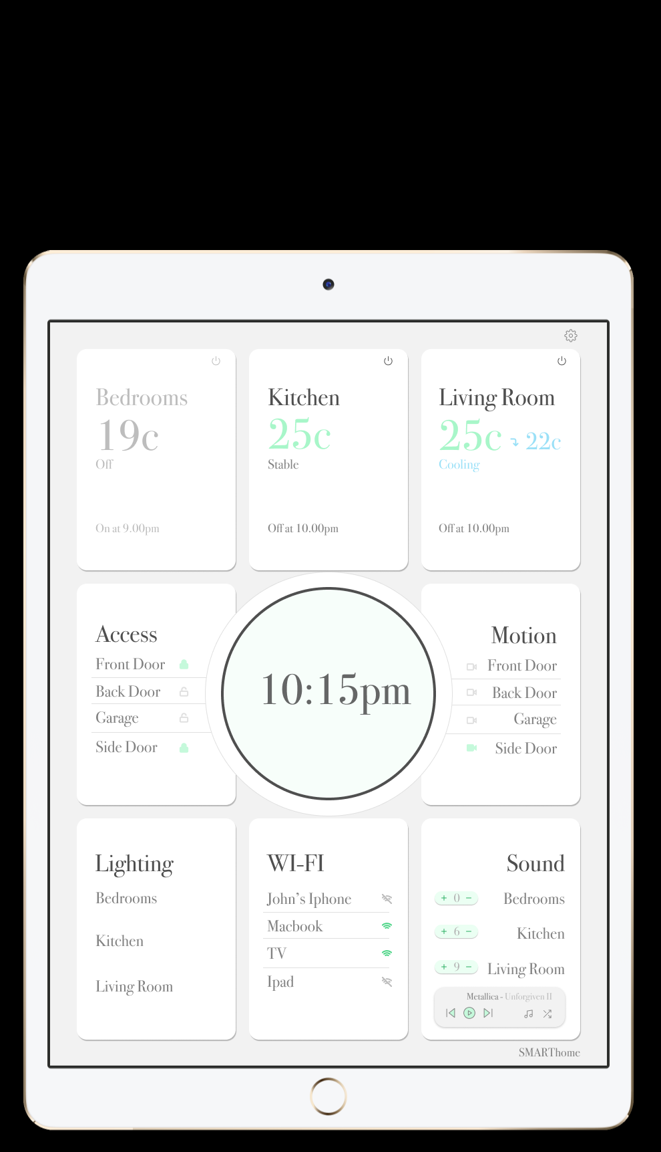

The

SMARTHome

Control Panel

Better living, simply.

Contents

1. The Fundamental Soul of the SMARTHome System: Design considerations and conceptual model
   1. User Centred Design
   2. Design Considerations and Conceptual Model
2. Finding the Way Home: Navigating the SMARTHome system
3. Bibliography

The Fundamental Soul of the SMARTHome System: Design considerations and conceptual model

User Centred Design

The SMARTHome system was designed after a thorough user assessment was completed.

As in-person user interviews were beyond the budget of this project, several methods were used to inform our user profiles:

* An assessment of the social media profiles that interacted with our competitors
* A literature review
* As we are targeting homeowners with this product the age range of the user profiles are based on data from the Australian Parliament’s (2017) Whitepaper on Home Ownership

In summary, the following themes emerged from the user assessment:

* Users are homeowners of varied ages and levels of technology experience
* It was found that existing smart home devices were overly complex
* Users are after a “stress free experience”
* The system should engender positive emotions including relaxation, calmness, happiness as well as comfort
* Users should feel that there is some “personality” to the SMARTHome system, reducing the techy-ness of the experience; but also avoiding the impression of a childish or cutesy interface
* Users should feel empowered with interaction with the system building the feeling of an internal locus of control
* The system should also meet the usability goals of: effectiveness, efficiency, learnability, safety, utility and memorability

The system was then designed with constant consideration of the above themes as detailed below.

Design Considerations and Conceptual Model

Accessibility

We will ensure our device is as accessible by having appropriate colour contrast ratios (Kopacz, 2018) to allow for those with impaired vision and colour blindness to easily interact with the system. Within the system settings, users will also be able to adjust their font size to ensure it is appropriate. Additionally, users will be able to selectively disable animation effects to ensure that those users with vestibular disorders won’t be adversely affected (Kopacz, 2019).

Typography

The Bodoni font was first designed by Giambattisa Bodoni in 1798. It is a popular and well-known serif typeface series that has an extensive history of interpretations by several design houses (Strizver, 2013). Respected typographer Ilene Strizver (2016) described it as elegant, sophisticated and timeless in appearance.

*Figure 1: An example of the Bodoni typeface*

Bodoni’s *Manuale Tipografico,* arguably one of the greatest specimen books ever printed, shows an impressive array of 142 roman alphabets including some foreign language versions (Strizver, 2016). Bodoni’s Papale from his Manuale Tipografico was the model for ITC Bodoni Seventy-Two, the high-quality variant of this typeface we have used in the design of this project to fit with our brand identity (Strizver, 2016). This will also support our user experience goals of giving the device personality without being childish or cutesy.

Colour

Researchers such as Kaya (2004) have found that green elicits many of the emotional responses we desire in engendering a relaxed and calm user experience and as such will be used as the primary accent colour for the SMARTHome system. In addition to the primary accent colour a contrasting colour in a shade of pastel yellow will be used for accents and several shades of neutral colours ranging from white, grey to black will be used. A red will also be chosen to indicate errors and destructive or dangerous user actions.

Metaphor

Several interface metaphors will be employed to increase the learnability, perception of ease of use and memorability of the system (Preece et al., 2015). The metaphors of cards and material design will be applied throughout the system. Babich (2016) indicates that due to their success as a metaphor cards have become “almost a default option when it comes to balancing UI aesthetics with good usability.” Additionally, the Material Design metaphor provides for cue-rich features and natural details that mimic real-world objects (Google, 2019; The Interaction Design Foundation, 2019). Designers such as Awwad et al. (2017) have found that implementing the Material Design principles has significantly improved usability in their applications.

Interaction

The SMARTHome system will employ both the instructing and manipulating interaction types. This will assist the user to port their skills relating to interactions with real world objects to their interactions with the system (Preece et al., 2015).

Iconography

A high quality, unique icon set such as Feather Icons (2019) will be used to further engender personality into the SMARTHome system.

*Figure 2: A sample of icons from the Feather set of icons*

Consistency

We will employ consistency in all aspects of the design, including colours, white space, layout and font size. Consistency not only ensures that a system is visually appealing, it also increases memorability and learnability (Wong, 2019).

Motion

Animation will be used sparingly in the SMARTHome system in order to assist users to better understand the interface metaphors of cards and material space, draw attention to and explain changes on the page and to add fun and whimsy to the design (Harley, 2014; Pratt, 2010). An example of this is that cards will appear to raise up on selection.

Spacing

Consistent spacing will be used throughout the system will specified values and ratios for gutters, padding and margins.

Confirmation

Confirmation, in the form of modals, will be implemented for any important or irreversible actions to prevent errors and ensure user safety (Preece et al, 2015). An example of this will be when a user is performing the ‘Remove Subsystem’ action.

Immediate Feedback

In order to increase learnability and memorability and strongly engender an internal locus of control in users (Poelman, 2010), all actions will provide immediate visual feedback to users including using the primary colour for emphasis and animation where appropriate.

Primary

All primary actions will be immediately available on the screen without a need to click through. These will be identified with primary colours and other design motifs (Wathan & Schoger, 2018). Even secondary actions should not be more than three clicks from the main screen. Primary actions will be identified through having a background colour or outline in the primary colour. This nesting of primary and secondary information and actions reduces visual noise and so allows the system to remain simple and easy to use.

Hierarchy

Visual hierarchy refers to how important the elements in an interface appear in relation to one another (Wathan & Schoger, 2018). Wathan and Schoger further argue that, in interface design “When you deliberately de-emphasize secondary and tertiary information and make an effort to highlight the elements that are most important, the result is immediately more pleasing.” A consistent visual hierarchy will be employed to help users navigate more easily within the system.

Touch Screen

The control panel consists of an edge-to-edge energy efficient LCD touchscreen of a maximum size of 240mm by 170mm to reduce complexity.

Finding the Way Home: Navigating the SMARTHome system

*Figure 3: Smart Home System when in unselected mode*

1. The above wireframe presents the design for the SMARTHome system when no subsystem is currently selected. All subsystems (aside from the add/remove subsystem functionality) are represented by cards on the screen and primary actions for each subsystem are immediately available.
   1. For example, users can open any of the monitored doors by pressing the relevant toggle button.
2. In order to access any of the subsystems a user is required to press with a finger on the card relating to the relevant subsystem. Further controls relating to the subsystem will then be shown in the central control circle as demonstrated in the figure below showing the kitchen temperature subsystem after activation.

*Figure 4: Temperature subsystem*

1. A user can then either press on the selected card again to put it back into unselected mode. If the user does not take any action for 5 minutes the system will also transfer into unselected mode.
2. If a user wants to access any of the other subsystem controls, they simply select the card relevant to that subsystem. Shown below is a view of the system when the access subsystem has been selected.

*Figure 5: The Access subsystem*

1. The only subsystem that has a different access method than that described above is the Add Remove subsystem mode which is displayed below. Although this introduces some inconsistency into the design, it was determined that this was the most appropriate system with which to introduce this inconsistency as it is likely to be the least often utilised.
2. A user accesses this subsystem by selecting the button on the top right of the screen.

*Figure 6: Add/Remove subsystem mode*

Bibliography

1. Hall, A. (2017). Trends in home ownership in Australia: a quick guide. Retrieved from <https://www.aph.gov.au/About_Parliament/Parliamentary_Departments/Parliamentary_Library/pubs/rp/rp1617/Quick_Guides/TrendsHomeOwnership>
2. Strizver, I. (2013). *Type Rules: The Designer's Guide to Professional Typograph*y (4th ed.). Hoboken, New Jersey: Wiley.
3. Strizver, I. (2016). TypeTalk: Good Looking Bodoni at Any Size. Retrieved from <https://creativepro.com/typetalk-good-looking-bodoni-at-any-size/>
4. Kaya, N. (2004). Relationship between color and emotion: a study of college students. *College Student Journal, 38(3),* 396-405*.*
5. Kopacz, L. (2018). Reducing Motion to Improve Accessibility. Retrieved from <https://www.a11ywithlindsey.com/blog/reducing-motion-improve-accessibility>
6. Kopacz, L. (2018). Design Tips - Color and Accessibility. Retrieved from <https://www.a11ywithlindsey.com/blog/design-tips-color-accessibility>
7. Feather Icons. (2019). Feather Icons. Retrieved from <https://feathericons.com/>
8. Wong, E. (2019). Principle of Consistency and Standards in User Interface Design. Retrieved from <https://www.interaction-design.org/literature/article/principle-of-consistency-and-standards-in-user-interface-design>
9. Preece, J., Rogers, Y., & Sharp, H. (2015). *Interaction Design: Beyond Human Computer Interaction.* Chichester: Wiley.
10. Babich, N. (2016). Using Card-Based Design To Enhance UX. Retrieved from <https://uxplanet.org/using-card-based-design-to-enhance-ux-51f965ab70cb>
11. Google. (2019). Design: Create intuitive and beautiful products with Material Design. Retrieved from <https://material.io/design/>
12. Interaction Design Foundation. (2019). Material Design: Your constantly-updated definition of Material Design and collection of topical content and literature. Retreived from <https://www.interaction-design.org/literature/topics/material-design>
13. Awwad, A., Schindler, C., Luhana, K., Ali, Z., & Spieler, B. (2017). Improving pocket paint usability via material design compliance and internationalization & localization support on application level. *Proceedings of the 19th International Conference on Human-Computer Interaction with Mobile Devices and Services*. *99*, 4-7.
14. Harley, A. (2014). Animation for Attention and Comprehension. Retrieved from <https://www.nngroup.com/articles/animation-usability/>
15. Pratt, J., Radulescu, P., Guo, R. M., & Abrams, R.A. (2010). [It's Alive! Animate motion captures visual attention](http://abrams.wustl.edu/artsci/reprints/PrattRadulescuGuoAbrams2010.pdf). *Psychological Science*, *21,* 1724–1730.
16. Poelman, R., Rusák, Z., Verbraeck, A., Sorasu A. (2010). The Effect of Visual Feedback on Learnability and Usability of Design Methods. *Strojniski Vestnik*, *56(11),* 744-753.
17. Wathan, A. & Schoger, S. (2018). Refactoring UI. Retrieved from https://refactoringui.com/book/