***WEEK 5***

***Microservices***

**Creating Microservices for account and loan *-* Account Microservice**

***AccountApplication.java***

package com.cognizant.account;

import org.springframework.boot.SpringApplication;

import org.springframework.boot.autoconfigure.SpringBootApplication;

*@SpringBootApplication*

public class AccountApplication {

public static void main(String[] args) {

SpringApplication.*run*(AccountApplication.class, args);

}

}

***AccountController.java***

package com.cognizant.account;

import org.springframework.http.HttpStatus;

import org.springframework.http.ResponseEntity;

import org.springframework.web.bind.annotation.GetMapping;

import org.springframework.web.bind.annotation.PathVariable;

import org.springframework.web.bind.annotation.RequestMapping;

import org.springframework.web.bind.annotation.RestController;

import java.util.HashMap;

import java.util.Map;

*@RestController* // Marks this class as a REST controller

*@RequestMapping*("/accounts") // Base path for all endpoints in this controller

public class AccountController {

*@GetMapping*("/{number}") // Maps GET requests to /accounts/{number}

public ResponseEntity<Map<String, Object>> getAccountDetails(*@PathVariable* String number) {

// Simulate fetching account details - dummy response

Map<String, Object> accountDetails = new HashMap<>();

accountDetails.put("number", number);

accountDetails.put("type", "savings");

accountDetails.put("balance", 234343);

return new ResponseEntity<>(accountDetails, *HttpStatus*.***OK***);

}

}

**OUTPUT**

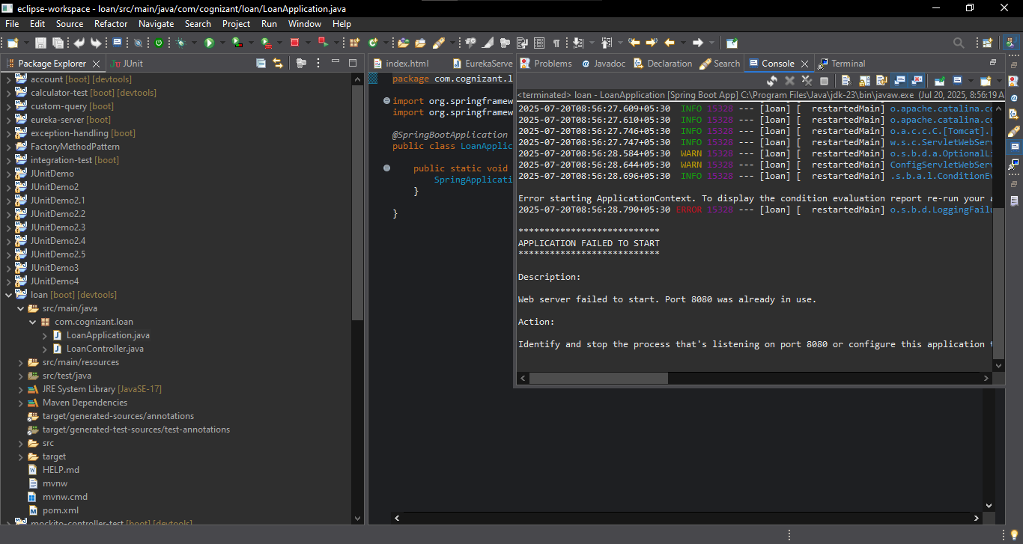

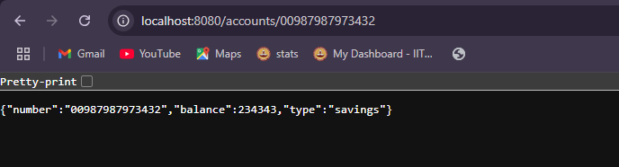

**Loan Microservice**

***LoanApplication.java***

package com.cognizant.loan;

import org.springframework.boot.SpringApplication;

import org.springframework.boot.autoconfigure.SpringBootApplication;

*@SpringBootApplication*

public class LoanApplication {

public static void main(String[] args) {

SpringApplication.*run*(LoanApplication.class, args);

}

}

***LoanController.java***

package com.cognizant.loan;

import org.springframework.http.HttpStatus;

import org.springframework.http.ResponseEntity;

import org.springframework.web.bind.annotation.GetMapping;

import org.springframework.web.bind.annotation.PathVariable;

import org.springframework.web.bind.annotation.RequestMapping;

import org.springframework.web.bind.annotation.RestController;

import java.util.HashMap;

import java.util.Map;

*@RestController*

*@RequestMapping*("/loans")

public class LoanController {

*@GetMapping*("/{number}")

public ResponseEntity<Map<String, Object>> getLoanDetails(*@PathVariable* String number) {

// Simulate fetching loan details - dummy response

Map<String, Object> loanDetails = new HashMap<>();

loanDetails.put("number", number); // Use the number from the path

loanDetails.put("type", "car");

loanDetails.put("loan", 400000);

loanDetails.put("emi", 3258);

loanDetails.put("tenure", 18);

return new ResponseEntity<>(loanDetails, *HttpStatus*.***OK***);

}

}

**OUTPUT**

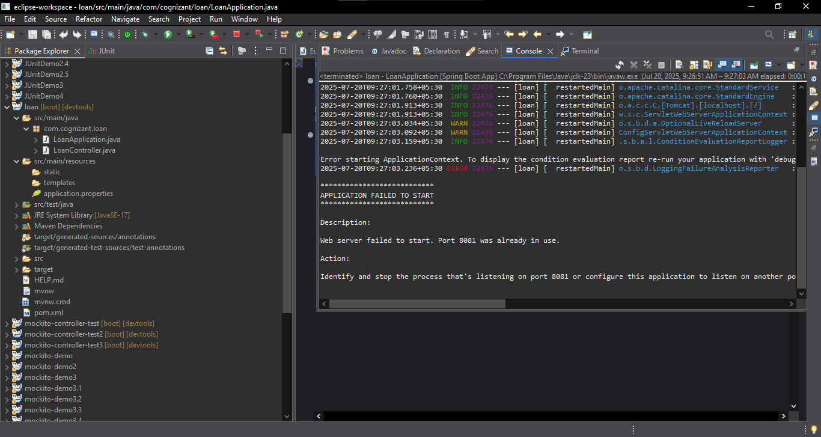

**Change the port number in application.properties**

spring.application.name=loan

server.port=8082

