**GROUP 12**

**PROBLEM NO.1 MATLAB**

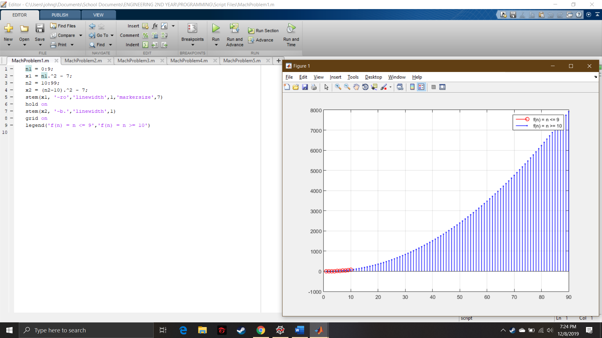

Script File



Graph