**GROUP 12**

**PROBLEM NO.2 MATLAB**

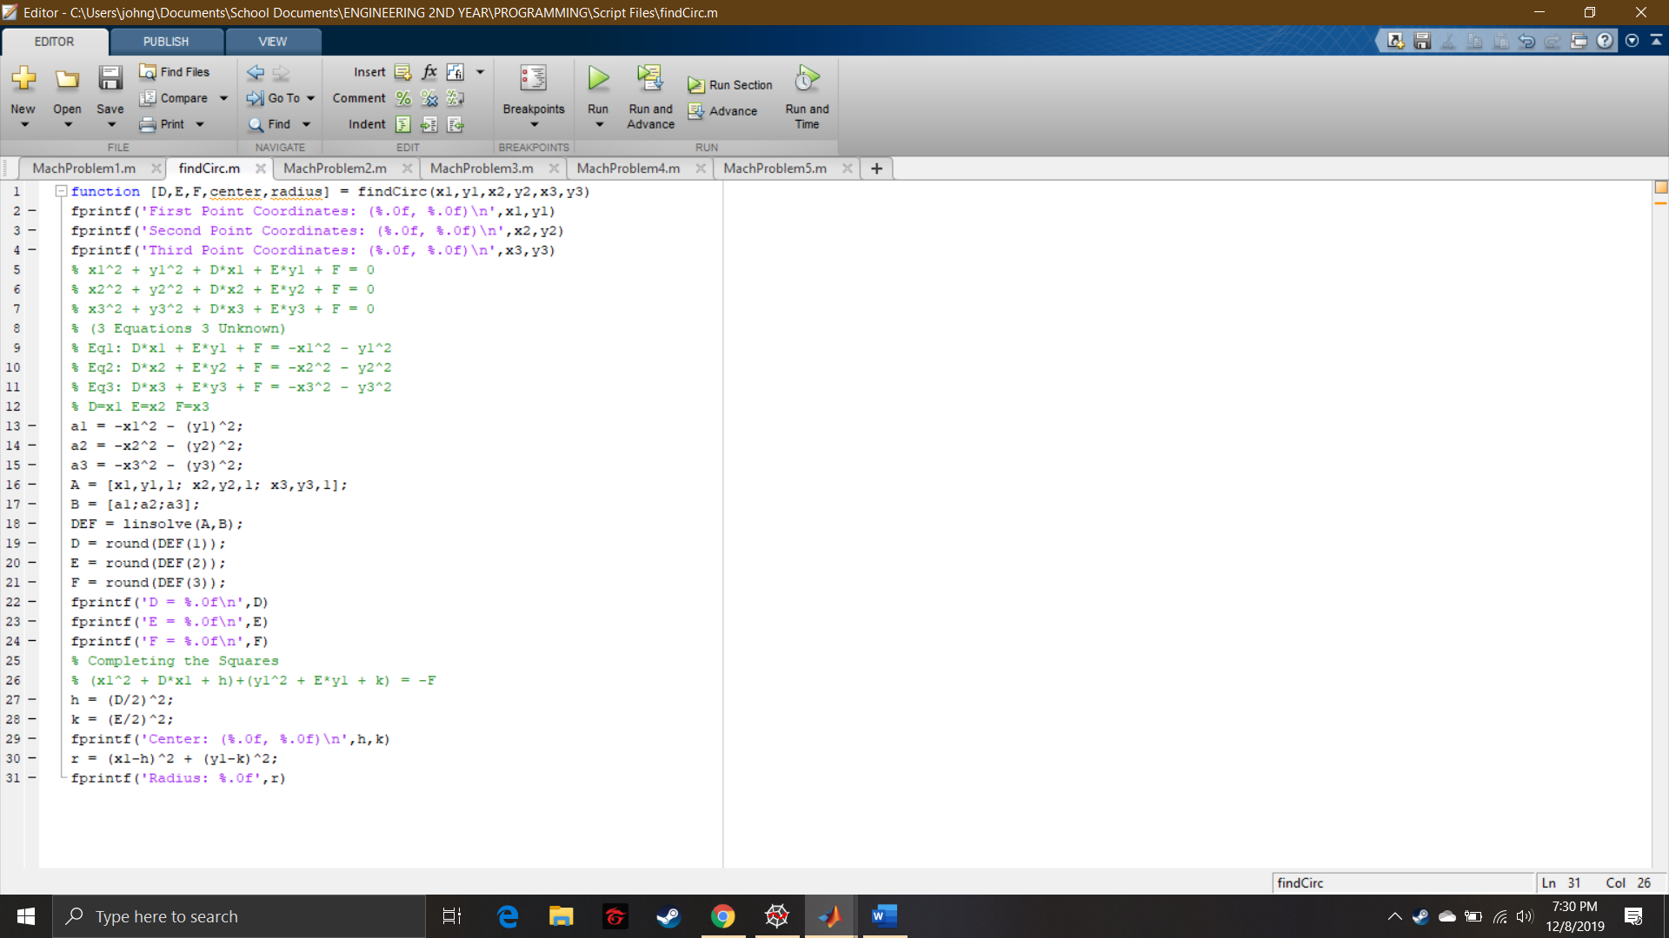

Script File

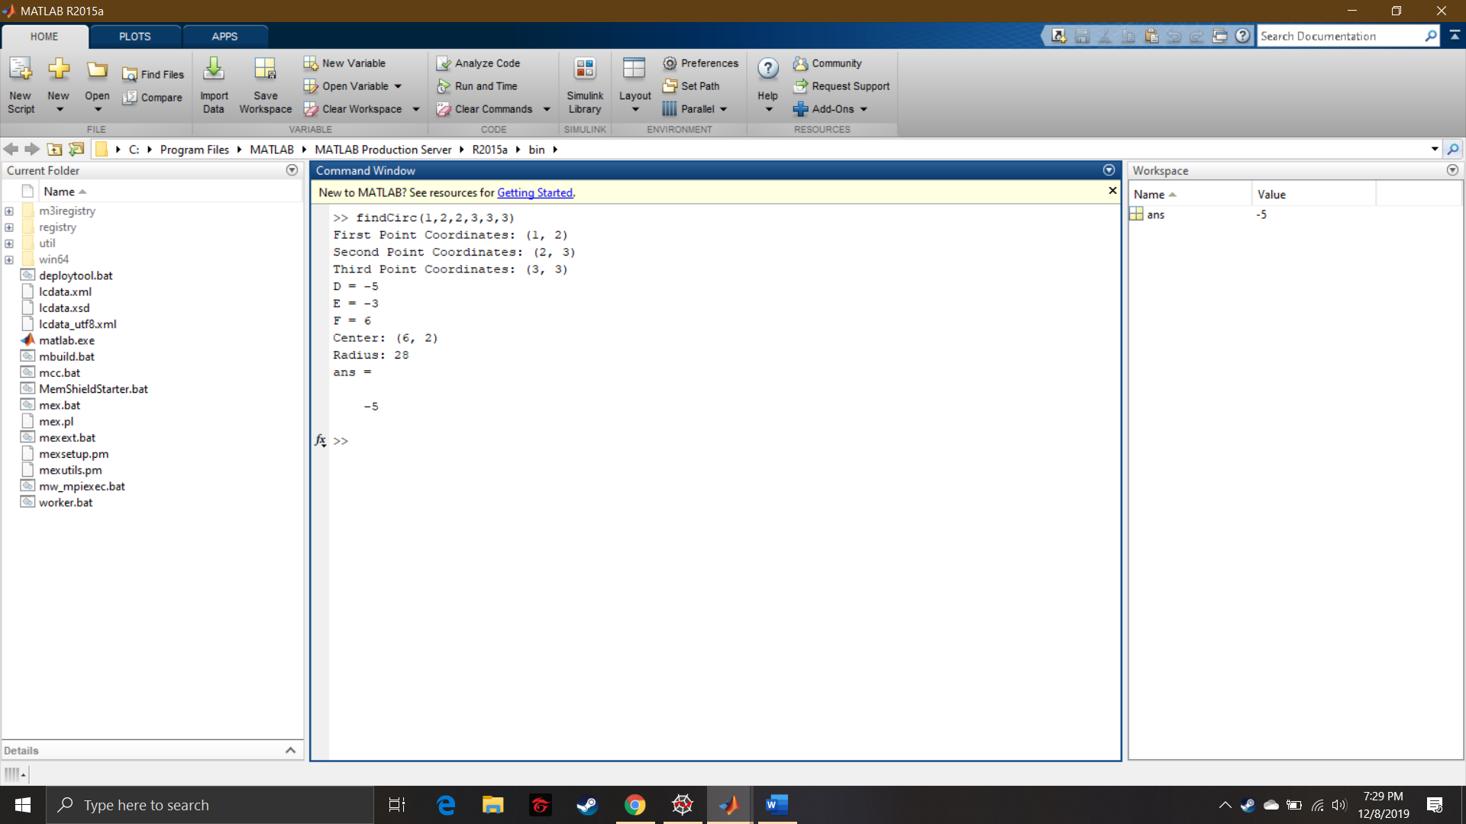

Command Window

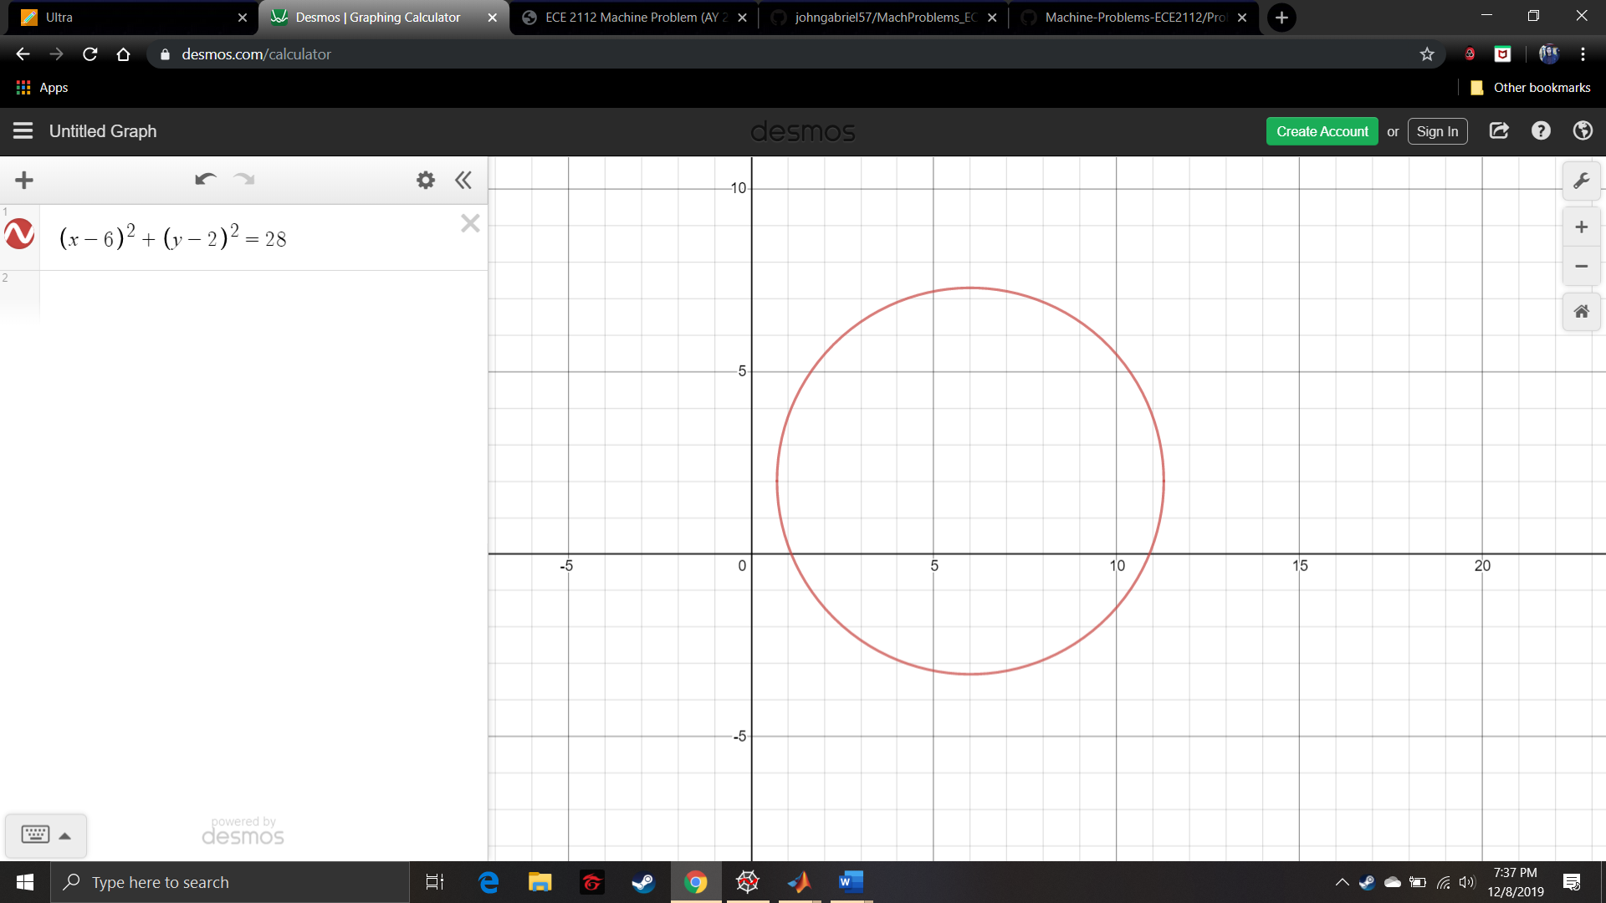

Desmos Prooff