**GROUP 12**

**PROBLEM NO.3 MATLAB**

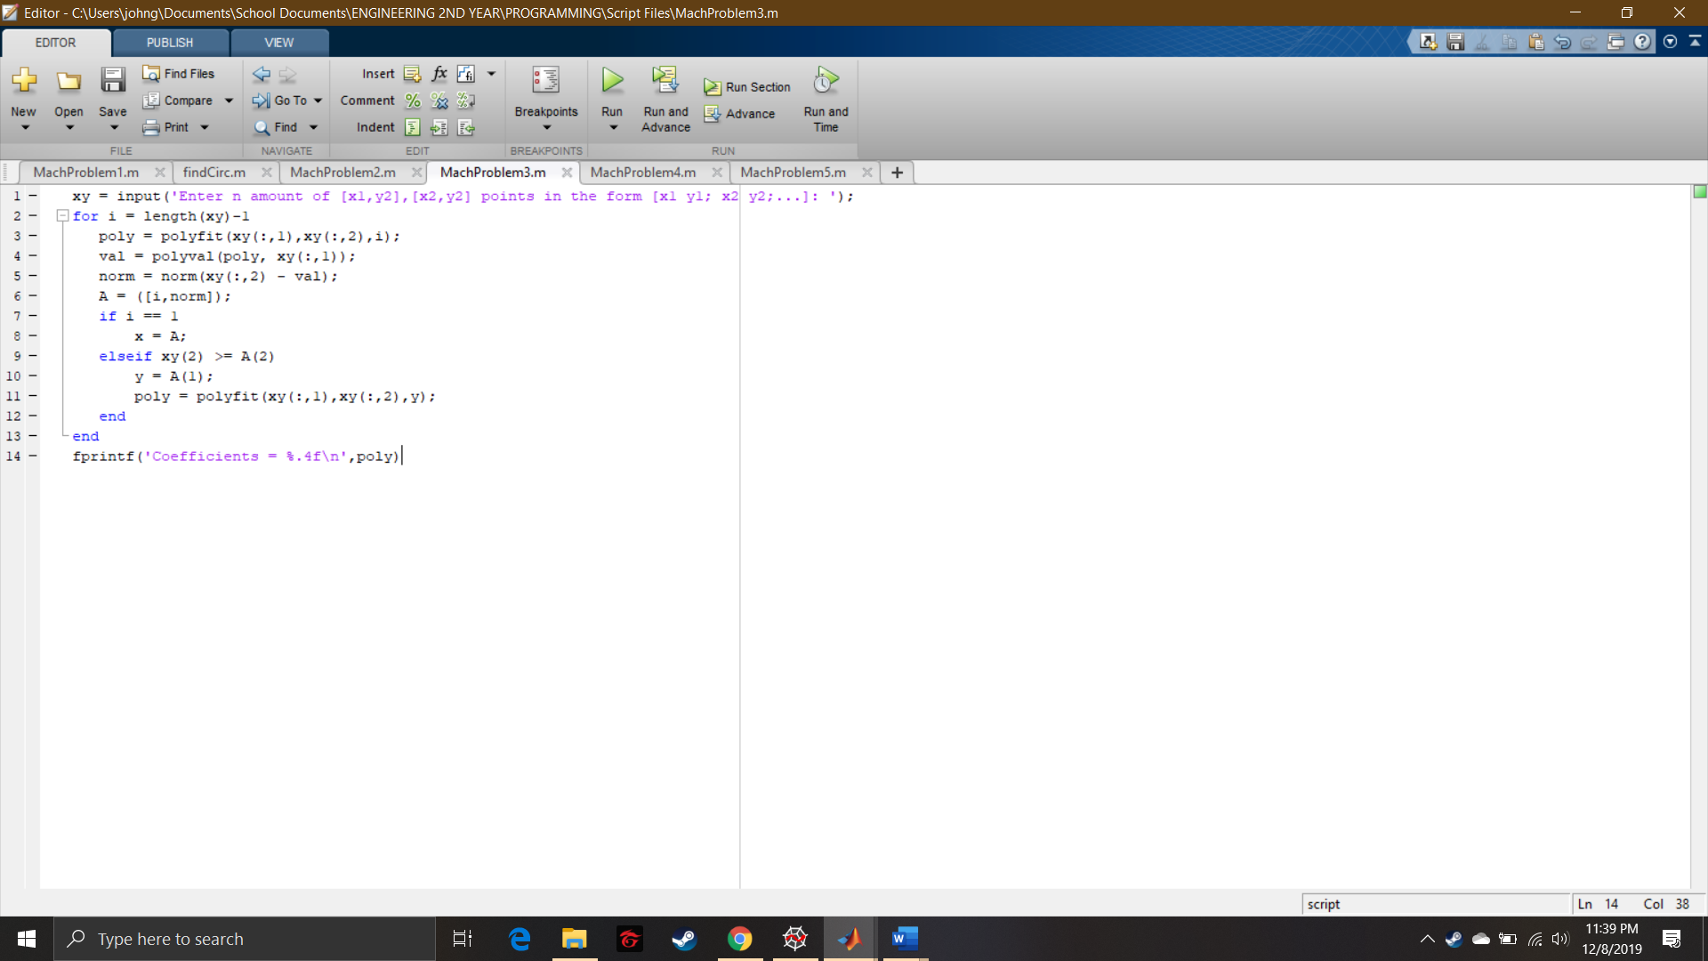

Script File

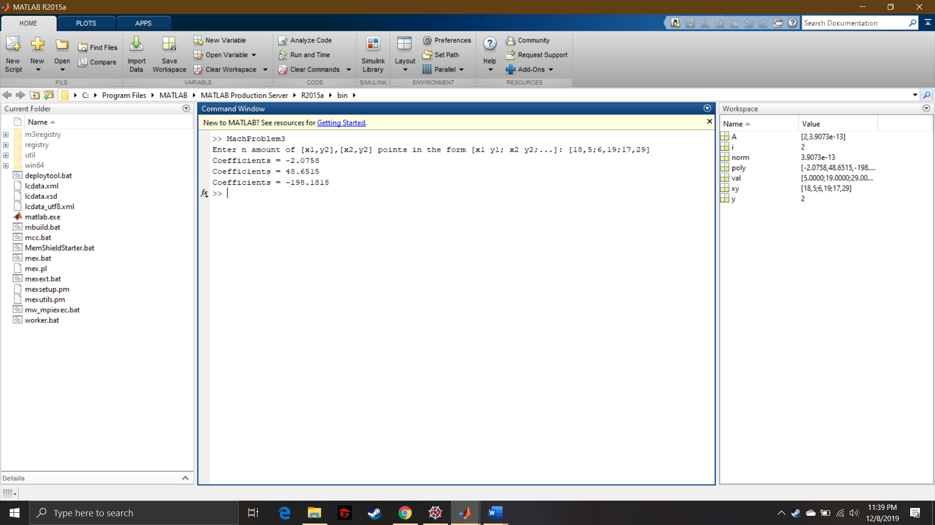

Command Window