**GROUP 12**

**PROBLEM NO.4 MATLAB**

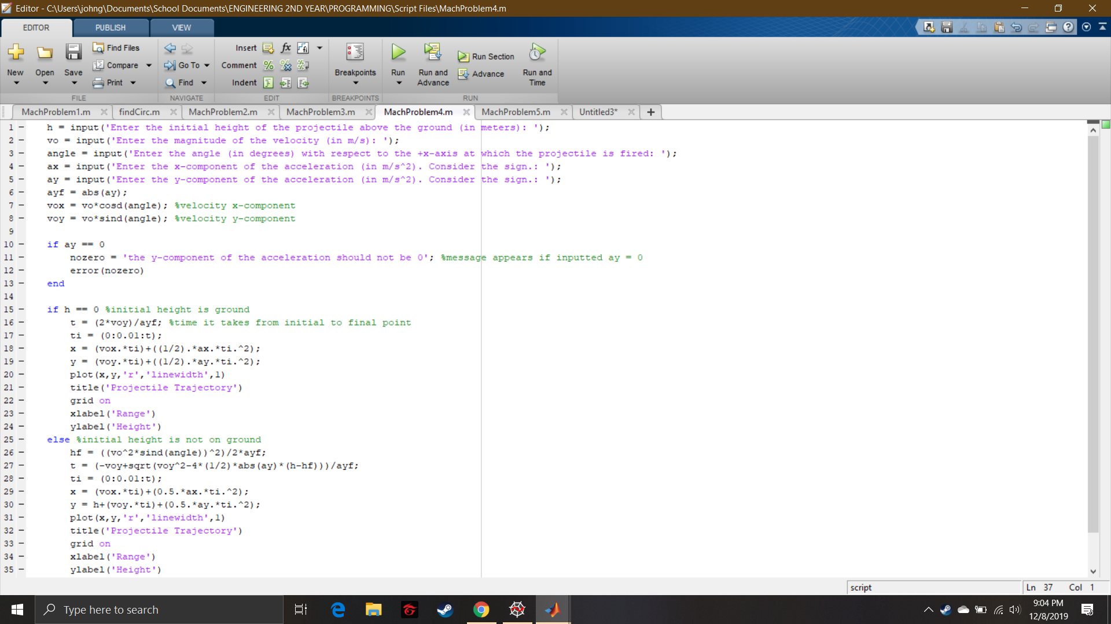

Script File 1

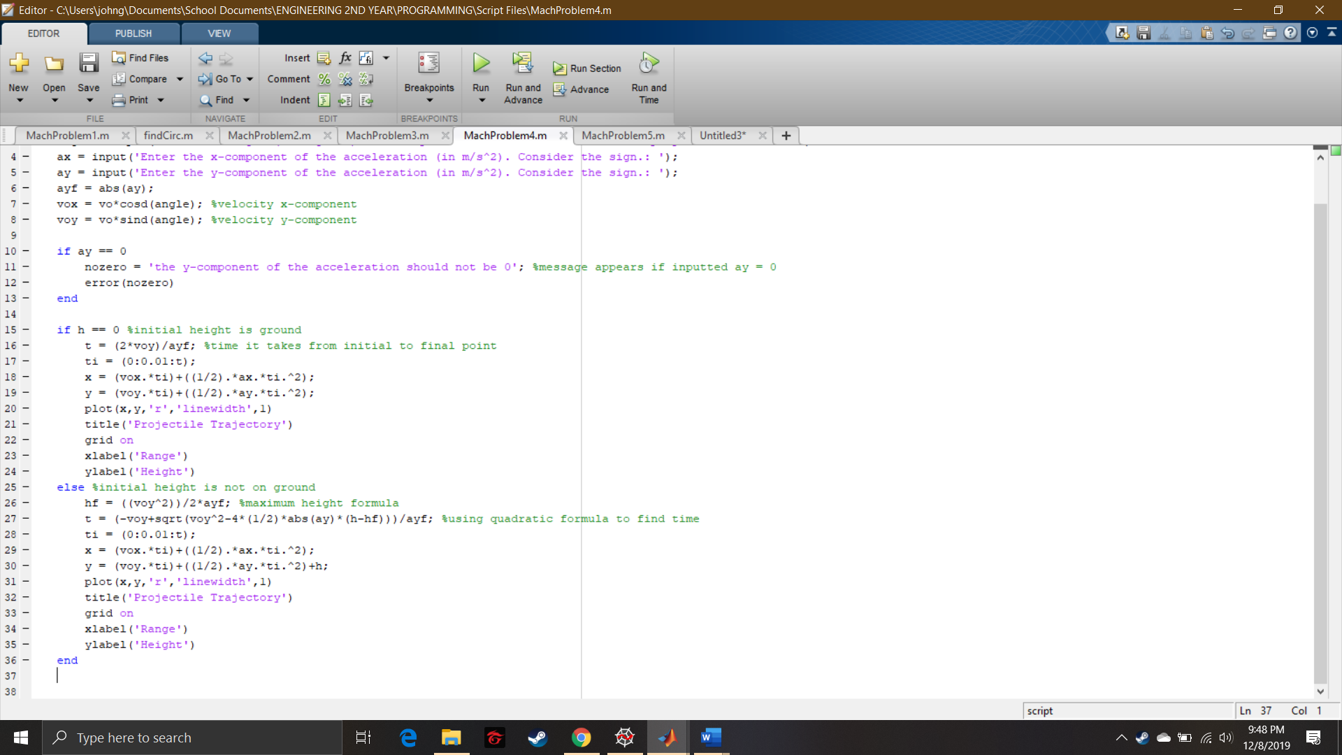

Script File 2

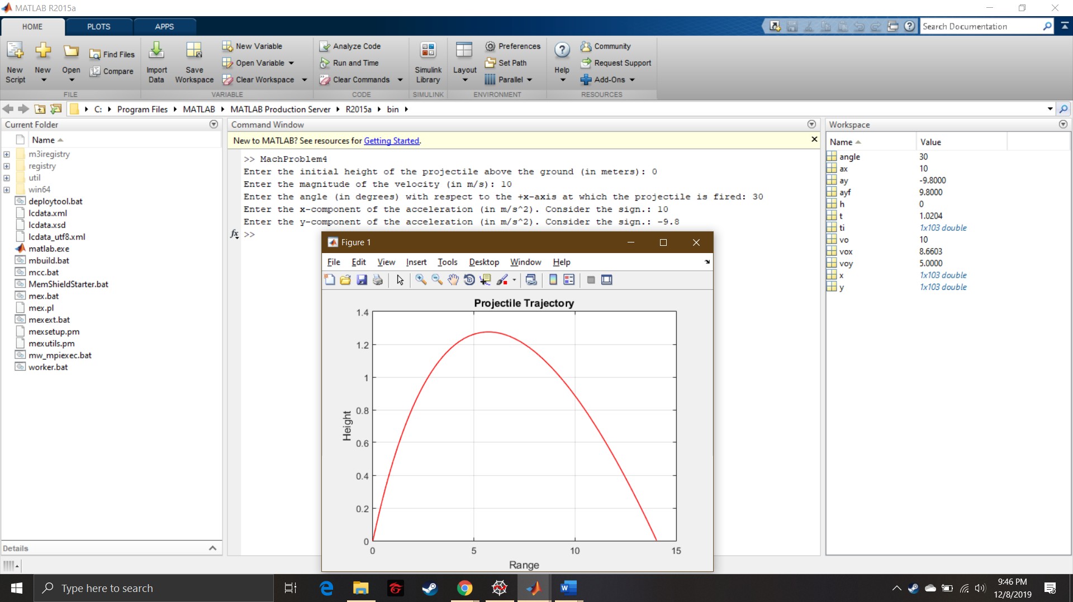

Command Window and Graph 1

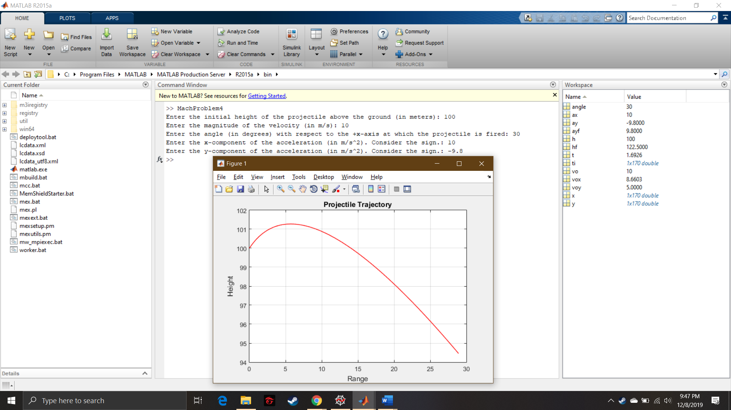

Command Window and Graph 2