**GROUP 12**

**PROBLEM NO.5 MATLAB**

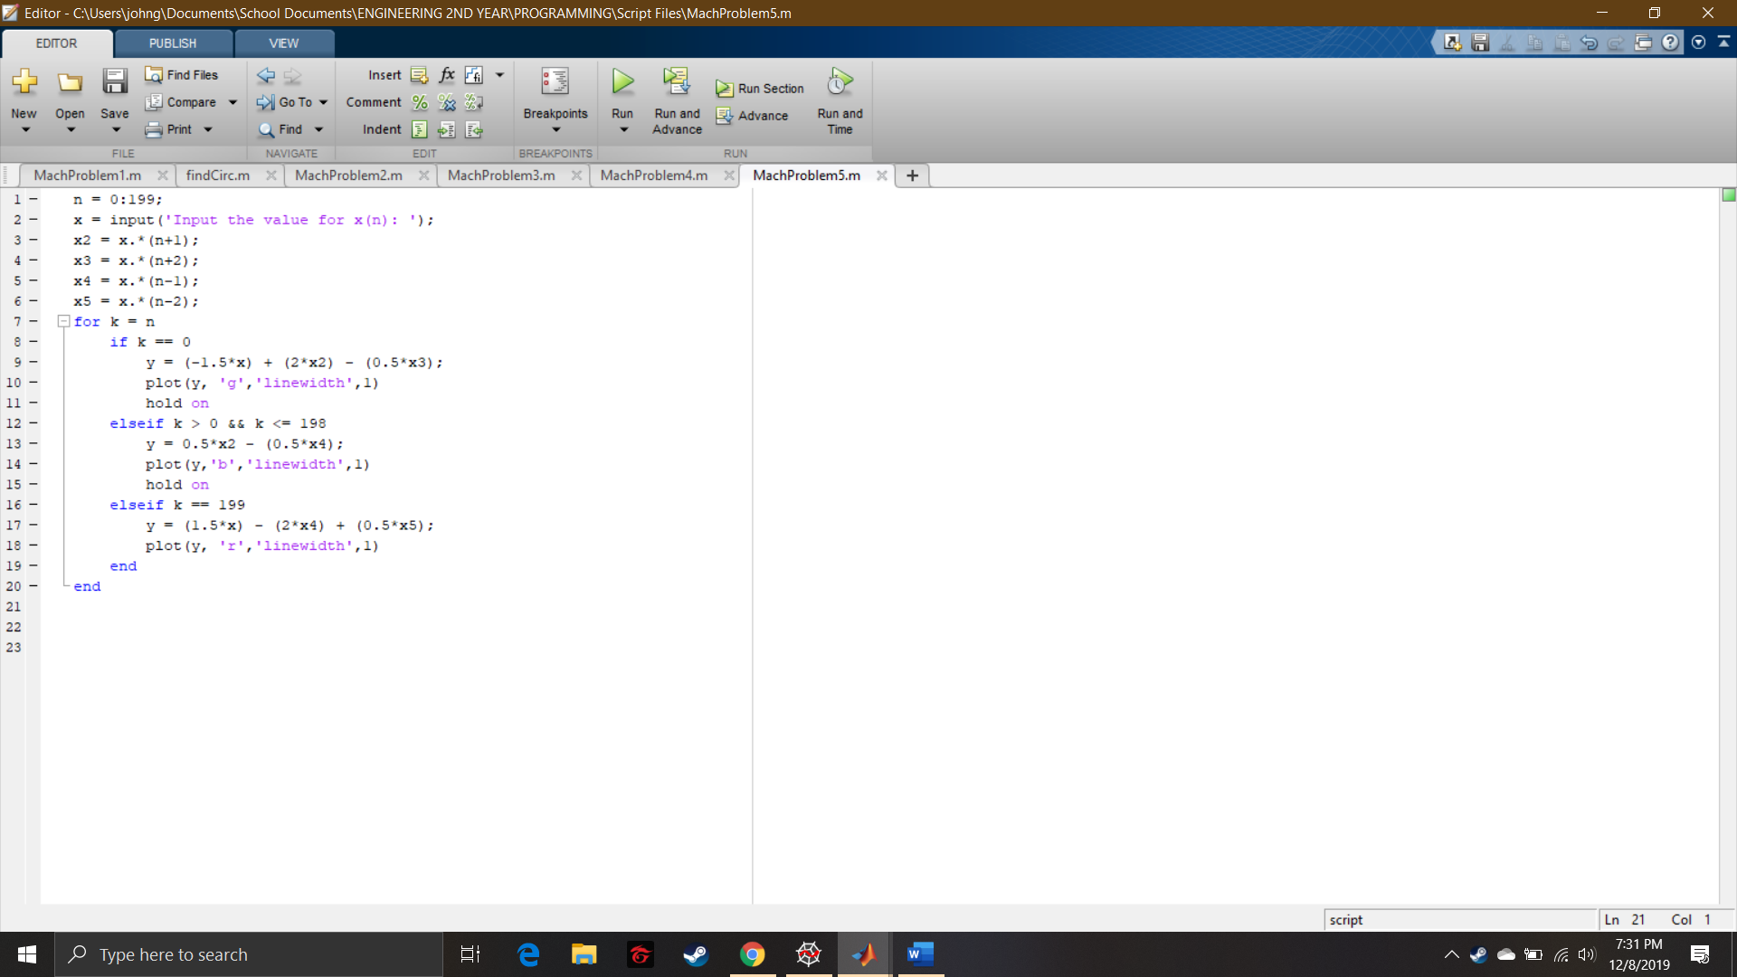

Script File

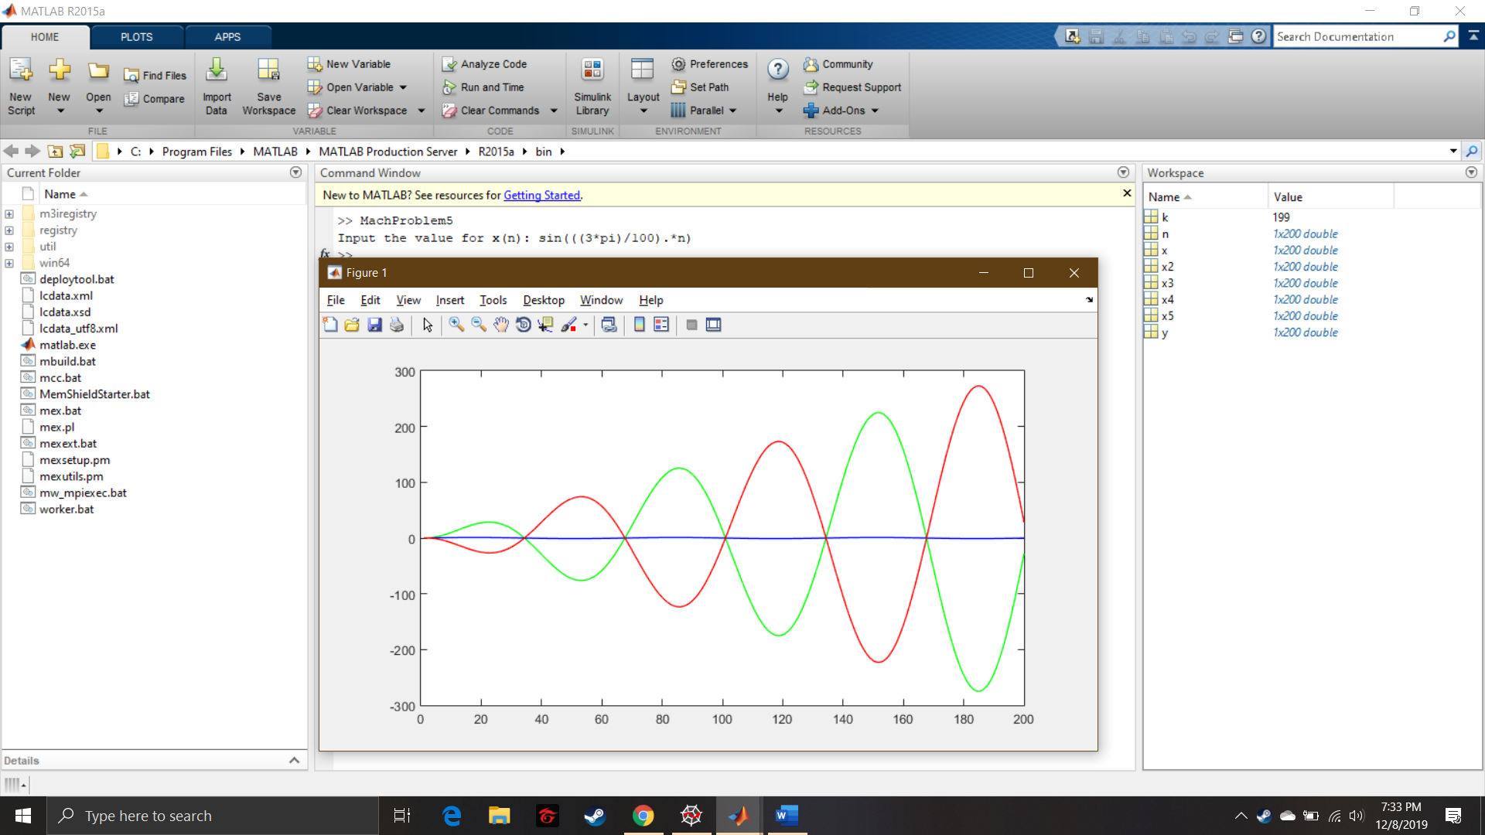

Command Window and Graph