**Web-Based Barangay Management System with Certificate Issuance for Barangay San Agustin**

A Capstone Project

Presented to the Faculty of Makati Science

Technological Institute of the Philippines

In Partial Fulfillment of the Requirements

For the Degree of Bachelor of Science in

Information System

by:

Jerald V. Esguerra

John Gilbert B. Serdan

Jaimee Anne R. Magno

Brian P. Sanchez

**TABLE OF CONTENT**

**CHAPTER - I**

**INTRODUCTION**

1. Background of the study …………………………………………. 1
2. Scope and limitation ………………………………………… 2
3. Significance of the study ……………………………………….... 3

**CHAPTER – II**

**REVIEW OF RELATED LITERATURE**

1. Foreign Literature ………………………………………….
2. Local Literature ………………………………………….
3. Paradigm ………………………………………….
4. Conclusion ………………………………………….

**CHAPTER-1**

**INTRODUCTION**

1. **BACKGROUND OF THE STUDY**

Most of the private and public places such as banks and schools, as well as to conduct business required clearance or license that can only acquire at their barangay. A**Barangay Clearance** is a document issued by the Barangay Secretary and signed by the Barangay Captain stating that you are a living at that specific place and you have a good moral character. Somehow, a smaller version of NBI or Police clearance. While, the business licenses are permits issued by the government that give authorize permission to an individual to start a business. These local licenses and certificate are typically very easy to obtain. Residency just needs to present a valid I.D… In addition, just present the Department of Trade and Industry (DTI) or Security Exchange Commission (SEC) and wait for the Barangay Captain to do an ocular inspection and if approved just pay the required amount based on starting capital of the barangay.

In this time of the pandemic, people can’t go outside without worrying about their health. The researchers found that the Barangay San Agustin regular visitor daily accounted for about 10 to 30 per day and depend on the situation and several lines of people normally exist in the barangay during some occasion. Several officials are busy dealing with these people. It takes a lot of time and effort for the official and volunteers to attend and entertain a single individual since their job is all done manually. In addition, the residence required to have all documents needed for a particular certificate to acquire, leading them to several places just to complete. All information is manually save, keep and encodes on papers and retrieving these data take a lot of time as they have to search manually and a lot of people with similar name exist in a barangay, in the end, lead to more mistakes.

However, with the help of science and technology, the researchers aim to design a Web-Based Barangay Management System with Certificate Issuance that can help the residents of Barangay San Agustin to have easier access to the document or license. In addition, this project can also help the barangay to easily inform their people about the news and event in the barangay which can be found on the home page of the system.

Barangay San Agustin is one of the competitive barangay in the center of Sto Tomas, Batangas. The barangay name represents a man saint who offers her eyes. The Barangay San Agustin current population is 3,185 people in total and there is a total of 53 governments official working in the barangay. The social status of the barangay resident mainly middle-class and working-class people.

The software and technology that the researchers will be using are ‘HTML’, ‘PHP’ and ‘MYSQL’. Notepad++ and Visual Studio Code(VSC) will be the editor for the website.

1. **OBJECTIVES**
2. Issue certificates/permits and other related records.
3. To save residents confidential records
4. To easily update the resident’s profile
5. Fast and easy to locate resident’s record
6. **SCOPE AND LIMITATION**

**b.1. SCOPE**

The webpage will help the users to connect and communicate with barangay officials. As follows this, the researcher’s proposed study is intent on developing a web-based system that will help the barangay to automate their traditional system, which is the manually written and encoding of resident files. Furthermore, this study also helps the resident to be notified of the news and event posted by the Barangay San Agustin

**b.2 LIMITATION**

Web-based is only working with the use of the internet. Furthermore, the researcher had a little background about the software technologies they will use and the design of the webpage itself relies mainly on the researcher's reference.

1. **SIGNIFICANCE OF THE STUDY**

These days, most of the residents of the barangay form several lines of people in front of the barangay office especially during the renewal of a certificate or giving of government assistance during pandemic or disaster.

The Significance of this project is to develop a Web-Based Barangay Management System with Certificate Issuance to make the work of barangay staff more efficient and effective and also to provide a record or files that the residents need.

In addition, it will help the barangay officials in managing and recording all the given files of the residents. This project also aims to provide a system that can help the barangay officials to give a good and better service systematically by manipulating all the information gathered from the residents. This also can help the barangay to do their vision, mission, and goals by providing a good service to the residents and community of the barangay.

Furthermore, it will automate the traditional writing system into a modern system. The Barangay Management System will organize the files and records. It can also provide information about the available job in the vicinity of the barangay.

The barangay residents can file a report online. The Barangay Residents can see the announcements of the Barangay officials through the website.

The Barangay Management System will organize the files and records. It can also provide information about the available job in the vicinity of the barangay. The Barangay residents can file a report online. The Barangay Residents can see the announcements of the Barangay officials through the website.

**The Following are the lists that will benefit from the research:**

**Local Government.** This researchwill help the local government or agencies to develop new perspectives regarding the automation of bookkeeping

**Barangay Officials/Administration.** This research would allow the barangay official to have a right to upload information on the webpage. This could also help them notify the ordinary citizen, voters, barangay official, and other users of the webpage. This could also save them time and effort. This also gives them access to the official master list of the barangay resident.

**San Agustin Citizen.** This research will help the barangay San Agustin Citizen to have easy access to the event and activities happen in the barangay. It also helps them to request important documents earlier.

**Future Researcher.** This research can be used as a reference for future related studies and can use the data in conducting new researches.

**CHAPTER – II**

**REVIEW OF RELATED LITERATURE**

1. **FOREIGN LITERATURE**

According to Karlheinz Kautz, community information systems have the power to transform communities. However, without fully understanding the pre- requisite factors affecting community information system viability, and the complex relationships between these factors, communities struggle to manage such projects in a way that leads to viable systems that deliver real benefits. This paper develops and presents a Model of Community Information System Viability Pre- Requisite Factors, based on both existing literature and the study of three community information system projects. This Model represents the generic factors that inform viability (i.e., leadership, active membership, funding, awareness, and system design and functionality), and also considers the impact of community context. This study argues that the viability of a Community Information System cannot be considered in isolation. All factors are directly impacted by the value of the Community Information System to the community. Management can also heavily impact the success of a Community Information System

According to Measure Evaluation, typically, community-based programs provide a wide range of services at the household level to targeted participants. Participant targets may reside in a defined geographic area or exhibit similar behavioral or occupational characteristics (e.g., men who have sex with men, sex workers, truck drivers). They may share demographic traits (e.g., children under age five, pregnant or nursing mothers), situational factors (e.g., orphans or incarcerated individuals), or any combination thereof. Community health workers often act as frontline care providers for a wide range of services, including family planning, maternal and child care, childhood illness, malaria, HIV/AIDS, and tuberculosis. The data collected in a CBIS can be used to inform programming and policy, identify populations in need, monitor the continuum of care, and address equity, access, and accountability. When community members have access to information in a CBIS, they have the potential to define and prioritize the community’s needs; set objectives and targets for meeting those needs; and participate in planning, implementing, and monitoring programs. A well- functioning CBIS can support civil registration and vital statistics, by providing information on births and deaths. MEASURE Evaluation’s work on CBIS aligned with larger health goals of its funder, the United States Agency for International Development (USAID), as these systems operate at the community level, where health services are closest to the people who need them. Related to CBIS was MEASURE Evaluation’s work on routine health information systems (RHIS). THIS

comprises data collected at health facilities (public, private, and community-level), health programs, and institutions. These data give a picture of health status, health services, and health resources provided in the formal health sector.

According to Dennis Culhane, “Community information systems” are becoming an increasingly common way to distribute administrative data from local governments. These Web-based systems are using these administrative data to create and distribute valuable community and social indicator data to concerned individuals, social service organizations, community development professionals, and planners. Using the infrastructure provided by Geographic Information Systems (GIS) software and the Internet, these systems distribute important and detailed neighborhood data via maps, tables, and sometimes downloadable files. Some also provide analysis tools for users to manipulate or extract key neighborhood indicator data. Such systems have become popular in some municipal agencies because they are inexpensive and don’t require desktop GIS software or expertise (Hillier, McKelvey, and Wernecke, forthcoming).

According to Harrison and Zappen, new technologies make it feasible and, in many cases, practical for individuals, groups, and organizations to collaborate in the development of joint information systems. In fact, over the last three decades of evolution, few applications of information technology have stimulated so much interest on the part of so many. Collaborative information systems are

attractive to users because they make it possible to find information from diverse sources easily and efficiently. Such systems make good sense for information providers because it becomes possible to attract a larger audience than a solitary effort might otherwise be able to command and to pool resources to achieve certain economies in scale and technology expense. The advantages of collaborative computerized information systems have been widely recognized, but this has been particularly the case for those to make community information more available, accessible, and oriented toward community development. Computerized community information systems are diverse in form and, over time, have come to be known by many different names, including community bulletin boards, civic networks, community networks, community information networks, televillages, smart communities, and Free-Nets. They have been initiated by many different sponsors, including government organizations at the federal, state, and local levels, academic organizations, libraries, and ad hoc groups of citizens that may or may not later transform their enterprises into not-for-profit organizations. Concerning longevity, these projects have come and gone, only to be replaced by newer and more sophisticated manifestations of the same basic information- sharing capabilities.

According to a study in Community Management Systems for Social Deliberation and Action by Bozzon et. al (2012), the advent and massive diffusion

of social networks, and more generally of networked social media, has determined an unprecedented level of activity and contribution of citizens to the construction, curation, verification, and even analysis and enrichment of content; this phenomenon offers a unique opportunity for improving the quality of public life, thanks to a better and more symmetric dialogue between citizens and institutions. The capability of harnessing the cooperation power of citizens through social media interaction offers great potential benefits to organizations in general, and more specifically to the Public Administrations (PAs), which are facing several challenging issues in their operations: increasing the efficiency, effectiveness, and transparency of their processes; involving the citizens into the planning, management and quality evaluation of public services, e.g., by collecting feedback and suggestions from stakeholders; exercising more effective control over the territory and the natural resources, collecting timely data and delivering more effective alerts in presence of hazards; and motivating their employees by improving the link between them and the final users of the PA services.

According to an article in Online Community Management as Social Network Design: Testing for The Signature of Management Activities in Online Communities by Cottica et. al (2017), Online communities are used across several fields of human activities, as environments for large-scale collaboration. Most successful ones employ professionals, sometimes called “community managers” or

“moderators”, for tasks including onboarding new participants, mediating conflict, and policing unwanted behavior. Network scientists routinely model interaction across participants in online communities as social networks. We interpret the activity of community managers as (social) network design: they take action- oriented at shaping the network of interactions in a way conducive to their community’s goals. It follows that, if such action is successful, we should be able to detect its signature in the network itself. Growing networks where links are allocated by a preferential attachment mechanism are known to converge to networks displaying a power-law degree distribution. Growth and preferential attachment are both reasonable first-approximation assumptions to describe interaction networks in online communities. Our main hypothesis is that managed online communities are characterized by in-degree distributions that deviate from the power-law form; such deviation constitutes the signature of successful community management. Our secondary hypothesis is that said deviation happens predictably, once community management practices are accounted for. If true, these hypotheses would give us a simple test for the effectiveness of community management practices.

According to Li et. al (2017), natural and man-made disasters, such as tsunamis, earthquakes, floods, and epidemics pose a significant threat to human societies. To respond to emergencies in a fast and effective manner, Multi-Criteria

Decision Making (MCDM) is very important for the decision-making process. The provision of information concerning the “ground-zero” situation to the emergency management stakeholders is an essential prerequisite for MCDM. In this paper, they propose a strategy to form a community-based virtual database, which connects local resource databases of suppliers that provide information and human resources for emergency management. Such a virtual database enables collaborative information sharing among community-based NGOs, public, and private organizations within a community. Moreover, to mobilize resources, the aforementioned process raises awareness within the community and aids in assessing local knowledge and resources. In their work, they present the design, implementation, and evaluation of such a community-based database, which maximally utilizes all the available information and network resources of a community to better manage natural and man-made disasters.

1. **LOCAL LITERATURE**

Based on a recent study in Barangay Office Management System by barangay is considered the smallest unit of the government in the Philippines. It performs the initial operations such as the formation and employing of programs, activities, policies, and others that involved the community. Due to the increase of population, the household in each barangay also increase. it also increased the load work of the barangay staff. The barangay decides to increase the number of people that will attend the resident needs. with the participation of few barangay, they decided to developed a barangay management system that could manage and print barangay citizen's request and financial reports and record. Pulumbarit et., al. (2017).

Claire Carpio stated that barangay is where the crucial start of planning and implementation of project and operation in the community takes place, through by a barangay management system or e-barangay will help the government to reduce the barangay load work due to the increasing pressure of rapid increase of load work. It also pointed that the barangay management system reinvents the barangay management from a traditional and centrally dependent unit towards a more inclusive and citizens-oriented scheme. In addition, the e-barangay focus in requesting documents, filing complains, and generating accurate local statistics. Carpio. (2020).

Imus, Magleo and Soriano stated that information management system eases the transmit of information from the barangay to another barangay as well as barangay to the city. Imus et., al. (2018).

1. **PARADIGM**

The computerized of information management and constant changes for the development of science and technology especially information technology contribute a lot for different human field. Nowadays, technology solved a lot of human problem and save a lot of time. In addition, our world has been innovated in all field by the technology.

In information management technology, several work has been published and utilized, locally and outside of the country. It provides help in various country and daily operation of several businesses. In the Philippines, some barangay employ and implement various information system. These information systems called in various naming such as e-barangay, barangay management system, barangay information system, barangay management information system and, etc. These system possess different usage which use and utilized in several business and organization.

Based on a recent study in Barangay Office Management System, barangay is considered the smallest unit of the government in the Philippines. Pulumbarit et., al. (2017). And where the crucial start of planning and implementation of project and operation in the community takes place. Carpio. (2020).

According to Kautz a community information system had the ability to influences the direction of the community management. Ferdinand (2018) stated that a barangay management system can reduce the and improve the time and result expecting from the manual labor of

The barangay management system of Pulumbarit enables the user to print and download the relevant document or license in the barangay. According to Carpio the management system from traditional and centrally dependent units to inclusive and citizenship-oriented schemes. According to Lado, Barangay Management System is easier to access. In addition, it automates the recordkeeping process. the system offers assurance that the file will be protected and safe for it also requires authorization to gain access to the system and with backup data file if a technical problem occurs. The barangay management system of Pulumbarit, Carpio, and Lado circulate about the automation of the traditional system of requesting barangay documents. In addition to automation of recordkeeping process. It also allows the user to print or download the document with the authorized permission in the barangay. Moreover, this will also bring ease to them, especially in generating reports to the municipality about the status of the barangay. The implementation of the system will change the method and process that the barangay has been accustomed to in keeping their files. This will also ensure that all the records will be intact and updated.

Based on Li and PNA, the community management system can provide information about the data gathered from the resident and provide immediate help, and utilized all the available information and network resources of a community to better manage the various hazard which is very similar to our research. During this transaction a brief online consultation with the authority is needed to approved the resident request regarding the license and certificate.

The importance of the community management system of Li and Bozzon is the benefit of the interaction of the official and resident online, while the ‘Measure Evaluation’ describes the CMS that can provide a wide range of services. In addition, it has the potential to define those people in need due to the information provided.

1. **CONCLUSION**

The similarity of this barangay management system to the work of Pulumbarit, Carpio and, Lado are the revolution of the original traditional system of requesting barangay documents or license to a computerized. It allowed the user, to print or download with the authorized permission from the barangay. This project will automatically create a backup record of all information submit by the user and arrange it cleanly for future use.

**CHAPTER III**

**TECHNICALLY OF THE STUDY**

Figure 1.0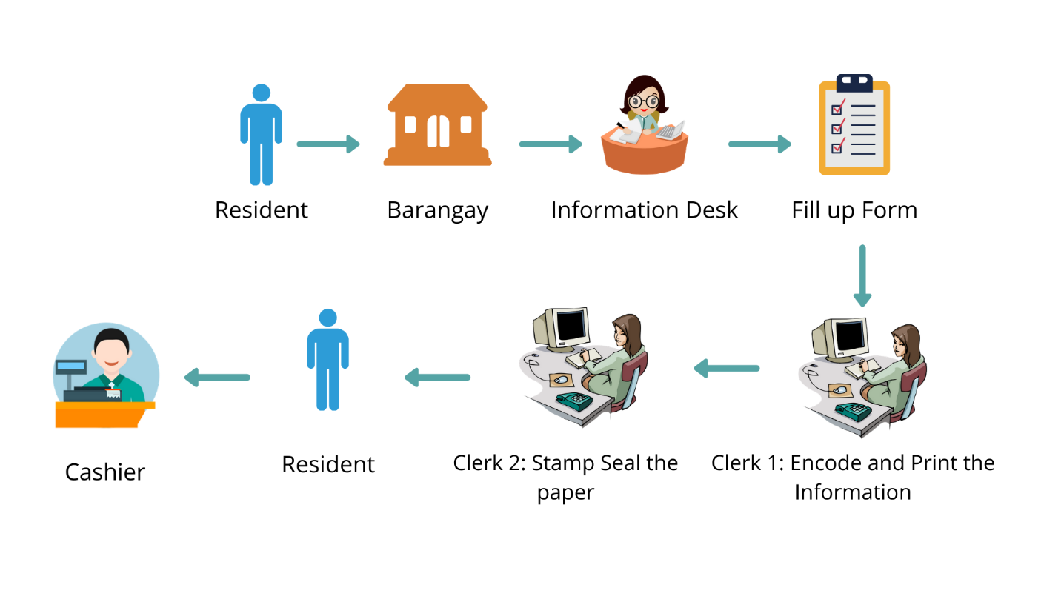

The resident will go to the barangay hall and ask the information desk and after asking, the information desk will give him a form to fill up and after filling up the form the resident will submit it to the clerk, and the clerk will encode and print his certificate and stamp it with the seal of the barangay after that the clerk will give the certificate to the resident and the resident will pay the for the certificate

Figure 2.0

.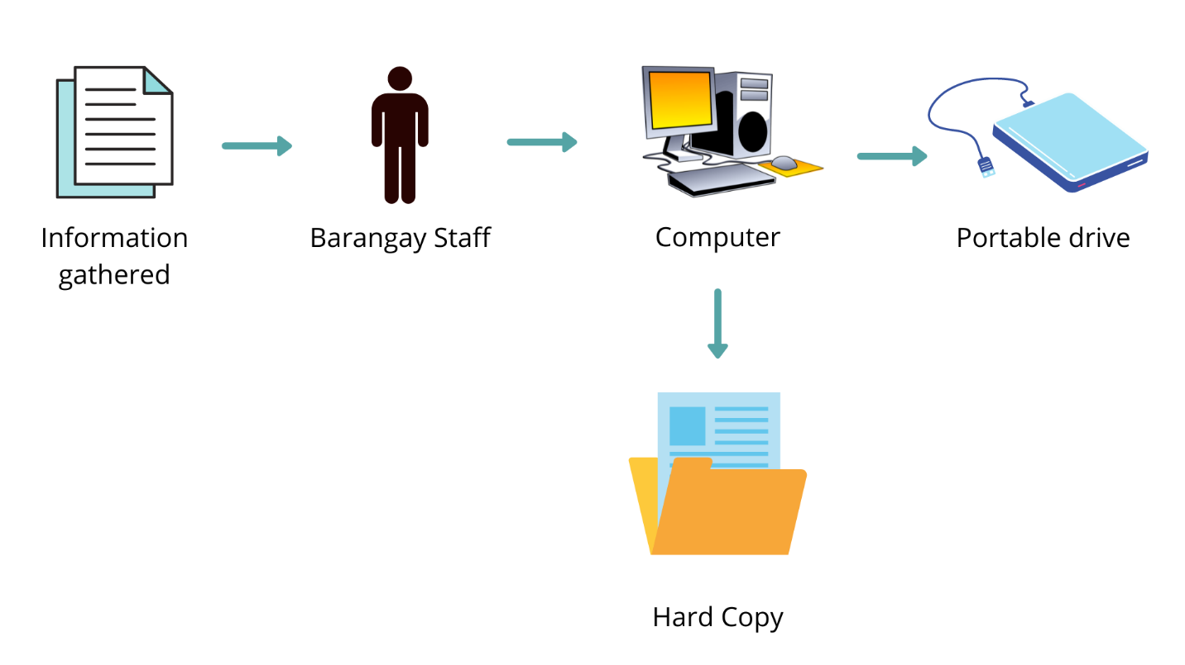

In the figure 2.0 above and figure 2.1 below the resident will go to the website and sign up. After signing up the resident can now log in and after that, the resident can request a certificate he needed and after requesting, the barangay staff will print his certificate and stamp it with the seal of the barangay and after that, the barangay staff will inform the resident to get and pay for the certificate.

Figure 2.1

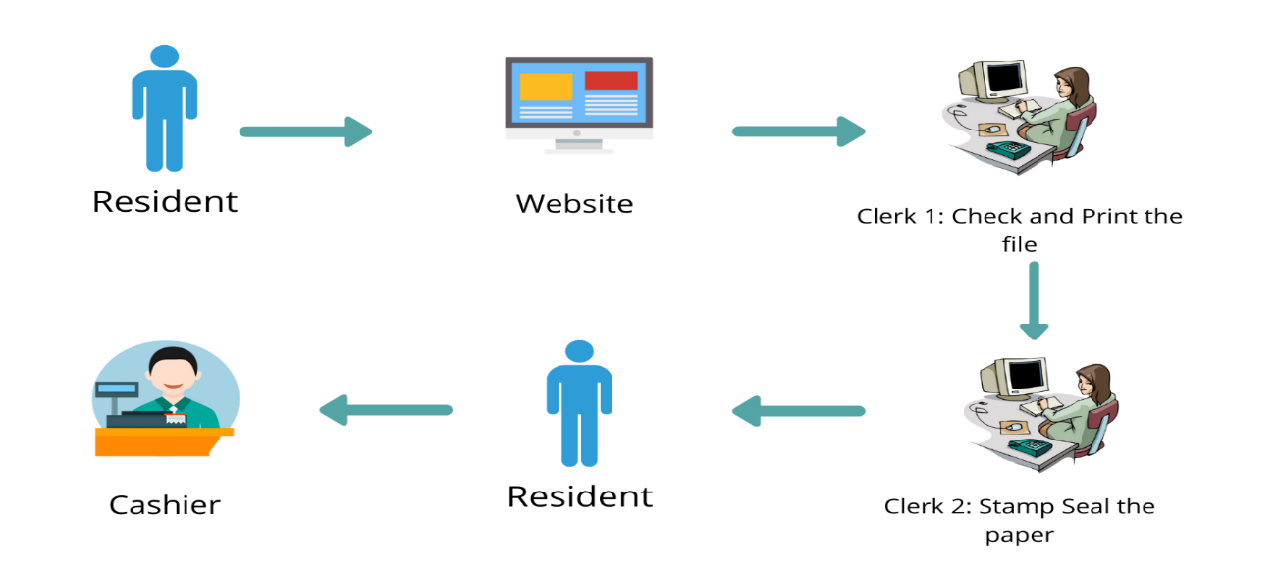

Figure 2.2

And figure 2.2 below which is process by the system and the information gathered by the barangay is encoded save and keep in a database.

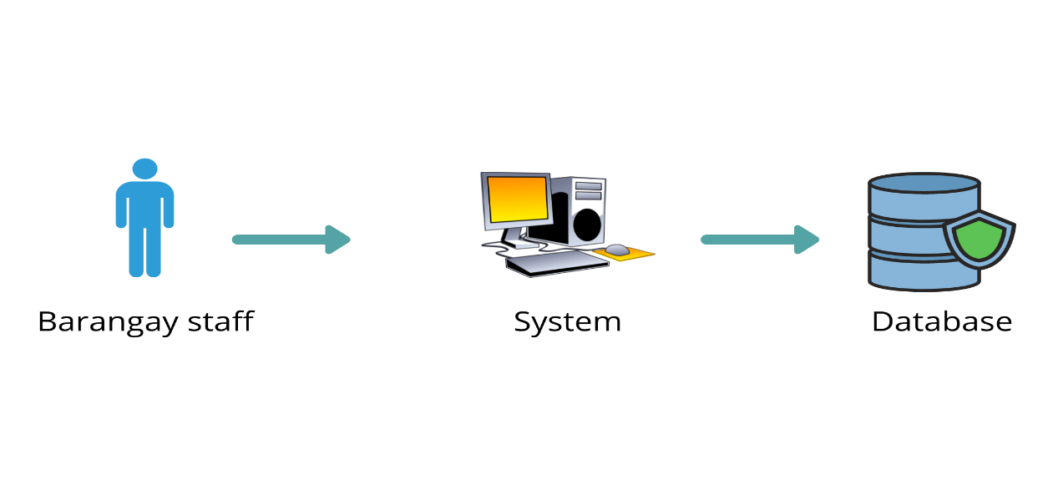

Technologies

1. Software

|  |  |
| --- | --- |
| Xampp |  |
| Image result for xampp | The Researcher Using XAMPP APACHE as the platform for the SQL and database of the webpage. Also, it was responsible for translating the PHP in the webpage. In addition it will be the temporary hosting Site for the webpage |
| Visual Studio Code and Notepadd++ | |
| logowik.com/content/uploads/images/visual-studi... | Notepad++ and Visual Studio Code is will be the code editor for the webpage |
|  |
|  |

1. Hardware

|  |  |
| --- | --- |
| **Aspire- 3A314 – 31**  A314-31-P2ZB - Tech Specs | Laptops | Acer New Zealand | Processor: Intel® Pentium® CPU N4200  Memory: 5GB RAM  Operating System:  Windows 10 Home |