**Authorship Change Form**

We have added one author to the paper, Mr. Thom Brade, of the School of GeoSciences, University of Edinburgh ([Thom.Brade@ed.ac.uk](mailto:Thom.Brade@ed.ac.uk)), who was critical in setting up some of the plots used in the study. He also contributed substantially to the revisions. All co-authors agree that he should be added as an author.

On behalf of all co-authors, thank you in advance for approving this request,

John L. Godlee

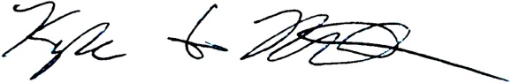

Kyle G. Dexter

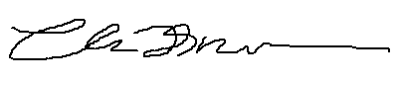

Thomas K. Brade

Casey M. Ryan

António Valter Chisingui

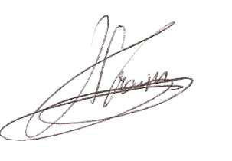

Francisco M. P. Gonçalves

Jonathan Ilunga Muledi



Mylor N. Shutcha

José J. Tchamba