String Content Extraction Language (SCOEL)
Goal Directed String Scanning and Logical Programming Objects

by John Goettsche, PLS
New Mexico Tech

Table of Contents
Table of Contents 2
Introduction 4
Background 4
Goals of SCOEL 6
String Analysis 6
Information Extraction 7
Scanning and Iterating through a String of Characters 9
Singular Sentinel Iteration 9
Multiple Sentinel or Pattern Iteration 12
Unconditional Iteration 14
Unicon String Scanning 15
Unicon Pattern Matching 16
SCOEL Scanning 16
Scanning Functions and Objects: 17
Backtracking 18
Unicon 18
Prolog 19
Goal Directed Extraction 19
Pattern Definitions 22
Additional Matching Objects available in Patterns only: 22
Structural Matching Objects available in Patterns only: 24
Assignments 26
Immediate Assignment 27
Index Assignment 27
Conditional Assignment 28
Anchoring 28
Back Scanning 29
Strings and Lists 30
Collection Methods: 30
Iteration Methods: 30
Logical Programming Elements 31
Object Oriented Programming 33
Unicon 33
Packages 33
Classes 33
Variable Scope 33
SCOEL 33
Interfaces 33
Abstract Classes 33
Variable Scope and Permissions 33
Conclusions 33
Related Research 34
Bibliography 35
Table of Figures
Figure 1: Scanning a single element based upon a set 10
Figure 2: Scanning a number of elements based upon a set 10
Figure 3: Scanning any number of elements based upon a set 11
Figure 4: Scanning any number of characters until an element matches a member of a set 11
Figure 5: Scanning elements which match another string of elements 12
Figure 6: Pattern Example 13
Figure 7: Scanning the next element 14
Figure 8: Prolog Predicate Internal Operations 19
Figure 9: SCOEL Matching object and its internal workings 20
Figure 10: Back Matching Object 21
Figure 11: Pattern Structure 22
Figure 12: Pattern Scan Matching Function 23
Figure 13: Fence Matching Object 24
Figure 14: Or Structural Matching Function 25
Figure 15: Parenthesis Structural Match Function 26
Figure 16: Immediate Assignment 27
Figure 17: Conditional Assignment 28
Figure 18: Matching Object 29

Introduction
The problem of extracting information from a string of characters is a problem as old as computers themselves. Computing technology has greatly enhanced the process by increasing its speed, complexity, specificity, and accuracy. It has taken a once tedious task of reading many articles to analyze data and is automating the process. Whether someone is looking to identify names and addresses, references to other legal or research documents, or determining how many times a company has been referenced in newspaper articles; software is being developed to handle the task.

Background
Several years ago, while I was working as a land surveyor, I was tasked with doing some legal research on a particularly large project. It was a redevelopment project for the Mission Bay District in San Francisco. The Mission Bay District was condemned as a result of the destruction of the 1989 earthquake. It was my task to map all the known and recoverable right-of-ways and easements in the district and prepare a boundary and topographic survey of the district. The boundary was not the difficult part, the City and County of San Francisco had condemned all the properties in the district and purchased the properties by imminent domain. It was all owned by the City and County of San Francisco.
The difficult task was to identify the rights-of-way and easements of the various entities that had them and do my best to locate them on the ground. A developer does not want to build a forty story building over an easement a utility company owns, because the utility company has a right to access it and a forty story building gets in the way of that. So it is in the interest of the developer to have the unity company abandon some easements while getting new ones that are more amenable to the development.
When I started the project, as is standard operating procedure for a land survey, I received all the pertinent deeds that were recorded at the courthouse along with any supplemental information which may affect property rights on the site. The initial set of documents arrived in seven boxes, enough to fill one and a half filing cabinets full of papers. It was my job to read them and identify any easement or right-of-way which may have been granted as some time. It was a majorly tedious task. It would have been a major savings in my time, which was being billed out at over a hundred dollars and hour, if this task could have been automated in some way. Unfortunately, I was did not have the benefits of automated information extraction at the time. I read it all, much of it several times to confirm references from several documents.
Typically a deed will contain a property description and its exceptions, easements, and so forth. Both the property description and its exceptions and easements make references to other documents to identify sources of others’ parties interest in the property or adjoining property. It was these references which were of interest to me.
The problem with San Francisco was that there had been an earlier, much more destructive earthquake in 1906 with a fire that destroyed much of the public records. People still had their property rights and ownership was determined at that time through recovering personal documents and a series of state and federal acts to establish who owned what.
There as this utility company in the area which had several easements in the area, the San Francisco Gas Light Company. It had easements along all the roads, prior to 1906, and across several parcels of land. Unfortunately, the records specifically describing these easements were destroyed in 1906, yet the San Francisco Gas Light Company still owned these easements, at least on paper. As it turns out, we quit using gas lights and switched to electric lights at about the time of the 1906 earthquake and the San Francisco Gas Light Company no longer existed, other than as a paper entity. The developer was able to get those easements abandoned.
This project took months to perform, an information extraction system would have saved tens, possibly more than a hundred thousand dollars in billable hours. And a programming language designed for information extraction would save the software developer time and money in developing that software.

Goals of SCOEL
Many programming languages and software have been developed to handle problems associated with information extraction. These systems are designed to identify terms, relationships between terms, relationships between other relationships and collections of terms and relationships.
The String Content Extraction Language (SCOEL) will be designed to allow the user to extract complex distributions of information in strings of data. It will include a set of objects for logical programming which will enhance of identifying relationships between entities and other relationships.
An example would be extracting the digits of a phone number with hyphens and parenthesis, which are typically used to make them more readable for human readers, and are found somewhere in a string of text.
SCOEL will be an object oriented language with goal directed evaluation and some elements of logical programming. It will be derived from the Unicon programming language by Dr. Clinton Jeffery, et al., also an object oriented programming language with goal directed evaluation.
****More Strictly Object Oriented than Unicon****
****Unified Scanning System and Easily Expandable****
****Adding Logical Programming through Classes and Objects****
The implementation of SCOEL will be done by working from the Unicon13 compiler and virtual machine and moving some features to class definitions and objects. It will also require some changes to the lexical, syntactic and semantic structure of the language.

String Analysis
The string analysis capabilities of Unicon 13 are in its string scanning environment and its pattern matching system with regular expressions and SNOBOL4 type functions. Both provide a robust method of finding tokens to extract from a particular string.[1], [2]⁠, [3]⁠ SCOEL will be working with a common primitive set of functions for string and pattern matching.
When extracting information from a string or the information being searched may be spread through out the stream and its relevance might be determinable without contextual information or some data may be broken up so it is easier for the human reader to understand. This can lead to more complex searches and normally require multiple searches for patterns and tokens.[4], [5]
The relationship between tokens or terms are can be difficult to find than the terms themselves. This is getting into the problem of what do the terms mean, rather than what they are. In my past work as a Professional Land Surveyor, I dealt with legal descriptions on a regular basis. There are legal definitions and centuries of court precedence establishing the meaning of many of the terms used in a property description; along with a hierarchy of which terms hold more weight in determining a boundary location.[6] As these are established relationships, they can be identified and analyzed. The goal of SCOEL is to make is to build a language with a more comprehensive system to identify terms and the relationships between those terms.

Information Extraction
In the area of Information Extraction, the user is attempting to extract information from a stream of data, which can be from any source: a large data base, stored research papers, the internet, or anything else which contains textural data. Searches are generally performed with some keywords or patterns which are searched.[7], [8]
There are different types of information which can be extracted from a stream of data beyond names, places and so forth. From the 1980’s to the 2000’s, information extraction identifies the entities referenced in a text and the relationships between those entities at varying levels of complexity.[4]⁠
For example, how much information can be extracted about the computer science department by scanning its web pages? The entities would include the computer science department, its faculty, the department chair, topics of research, classes and areas of study the department offers, and so forth. Then what are the relationships? What courses are taught and by who? Who is researching each research topic? Who is new to the department, and who has been there a long time? How about the functions all these entities and relationships perform? What are the outside links to research and business sites and what can be said about those relationships? These are just a small set of questions which can be answered with a robust information extraction program. The goal in developing SCOEL is to create a language with a set of tools to improve upon the information extraction tools available in other languages.
Also, there is the question of how information is presented and stored. This affects how the search is to be performed. If the information is fully structured, it is in a predictable order such as XML documents and CSV (comma separated value) files., then the search algorithm is relatively simple. Semi-structured information, such as a short hand natural language with a fixed grammatical rules or older records which may have evolved over the years, may require more complex systems or pattern definitions to extract the data. As changes in data storage conventions change over time, so do the practices to extract that data changes. Unstructured information, such as the text from lengthy reports or legal documents, require very complex pattern matching schema.[5]
Should a project require batch processing such as billing changes for changes in the contracts of thousands of customers, the system will have to extract information on customer accounts and make the desired changes for each customer. This will require, extracting all the necessary information from the data stream and relaying the information in a format acceptable to the software handling the database. The data stream most likely be fairly structured and a pattern for each piece of information might be straight forward, some pieces of information may not be consistent depending who entered the data or the software requirements from data entry sources. Some data points may be stored in separate parts, like a phone number with hyphens and parenthesis. As the project requires the processing of thousands of customer changes, the system needs to be as automated as possible, so the information extraction needs to be complete.
The SCOEL programming language will expand and improve upon the existing tools for information extraction and other forms of lexical and semantic analysis. To do this, we need to look at basic functions of scanning and iterating through strings for string analysis. Since SCOEL is a byproduct of Icon and Unicon, we will also look at some examples of how they addressed these issues.

Scanning and Iterating through a String of Characters
There are three schema of iteration through a string of characters. There is the single sentinel method, where each character in the string is tested individually to see if it matches. The multi sentinel or pattern method, where the string or pattern is tested to see if an ordered set of characters or pattern is found. Finally the unrestricted method where a set number of characters or all remaining characters are accepted. Each of these iteration types are further described as follows:

Singular Sentinel Iteration
Sentinel Iteration is where each element of the scan is tested for a sentinel value in order to proceed. Sometimes it is looking for a specific value to advance, sometimes it will advance until the sentinel value if found. Here are some examples of sentinel iteration.
- The next character if it is in or is not in a set of characters. In this example the position is at index number 2, it checks to see if one of the letters in the set in the box is the next element in the string. If finds an ‘a’ which is in the set and advances to index number 3.
Unicon string scanning can accomplish this task with the following lines of code:
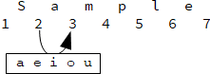Figure 1: Scanning a single element based upon a set
vowels := ‘aeiou’
str := “Sample”
str ? {
tab(2)
result := tab(any(vowels))
}

- The next number of characters if they are in or not in a set of characters. In this example the position is located in index 2 and it is looking for letters over the next three elements. It finds ‘amp’ and the position is advanced to index 5.
Unicon string scanning can accomplish this task with the following lines of code:
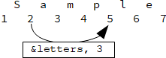Figure 2: Scanning a number of elements based upon a set
str := “Sample”
str ? {
tab(2)
result := “”
while *result <= 3 do {
result +:= tab(any(&letters))
}
}

- An undetermined number of characters if they are in or not in a set of characters. In this example the position is located in index 2 and it is looking for any letters. It finds ‘ample’ and the position is advanced to index 7. The space between indexes 7 and 8 is not a letter therefore it stops at index 7.
Unicon string scanning can accomplish this task with the following lines of code:
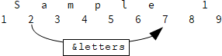Figure 3: Scanning any number of elements based upon a set
str := “Sample 1”
str ? {
tab(2)
result +:= tab(many(&letters))
}

- An undetermined number of characters until a character is in or not in a set of characters. In this example the position is at index 3 and it is searching for a vowel to stop at. It advances up to the ‘e’ and the position ends at index 6 just before the ‘e’.
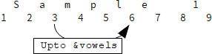Figure 4: Scanning any number of characters until an element matches a member of a set
Unicon string scanning can accomplish this task with the following lines of code:
vowels := ‘aeiou’
str := “Sample 1”
str ? {
tab(3)
result +:= tab(upto(vowels))
}

Multiple Sentinel or Pattern Iteration
Pattern Iteration it is looking for a complex collection of elements which match a pattern definition. Pattern Iteration differs from Single Sentinel iteration in that it is looking for a string of characters to match its definition, while Single Sentinel Iteration is only testing against a single character. This pattern definition can vary in size from a few characters to a very long string of characters with certain criteria defined to match. Here are some examples of Pattern Iteration.
- The characters which match an ordered set of characters. In this example the position is at the default index 1 and it is looks for the string of characters ‘ample’. As it passes through the characters in the subject string it finds an a and then checks to see if all the following elements match the pattern provided. When it does it assigns the value to result. Had there been elements out of order or had some other character not in the pattern it fails and does not make the assignment to result. In this example it finds each of the letters in the pattern and the position is advanced to where the pattern ends at index.
Unicon pattern matching can accomplish this task with the following lines of code:
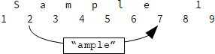Figure 5: Scanning elements which match another string of elements
str := “Sample 1”
pat := “ample” -> result
str ?? pat

- The characters which match a predefined pattern. Unlike matching a string of characters, the predefined pattern may or may not result in the same result every time. For example a pattern may start with either a ‘b’ or an ‘r’ followed by an ‘e’ or an ‘ea’ then concludes with a ‘d’. This can result in four possible results: ‘bed’, ‘red’, ‘bead’, or ‘read’. Finding any of these words in the string would be a successful result. In Unicon the code would look something like this
str := “read”
pat := (“b” .| “r” || “e” .| “ea” || “d”) -> result
str ?? pat

A diagram of the pattern is shown in Figure 6 below.
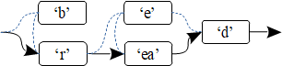Figure 6: Pattern Example
When the pattern match is run, it first tries to find a ‘b’ in the string. It does not find one so it tries to find an ‘r’, which it does. Being successful, it moves to the next piece of the pattern definition, where it needs to find either an ‘e’ or an ‘ea’. It tries the ‘e’ and succeeds, then it tries to find a ‘d’ and fails. So, it tries the second argument in the or ‘ea’ and succeeds. Then it tries to find an ‘d’ and succeeds. The pattern match being a success, it assigns the value it found to the variable result.
- The characters which match an ordered set of characters or a predefined pattern a certain number of times. A pattern or string similar to the examples in 1 and 2, which repeats a given number of times. For example you want to check to see if the string ‘ssi’ appears at least twice in ‘Mississippi’. A pattern can be defined to make that search and it would return ‘ssissi’. A Unicon patter definition would look something like this:
pat := “ssi” || “ssi”
- The characters which match an ordered set of characters or a predefined pattern an indeterminate number of times. A pattern or string similar to the examples in 1 and 2, which is found repeating at least zero times. A Unicon patter definition would look something like this:
pat := Arbno(“ssi”)

- The characters before an ordered set of characters or a predefined pattern is found. In this case the system must identify the beginning of the set or pattern and store that location, then it has to test to see if the following elements make the desired set or pattern. If it does it has to go back to the saved index at the beginning of the set or pattern.
- There is also the issue of parenthesis, Brackets and Quotation marks, where the system has to pair up the opening and closing elements of each type. It has to find the opening character and a matching closing.

Unconditional Iteration
- The next character. In this example the position is at index number 2 and it accepts what ever is located in the next element of the string and advances to index number 3.
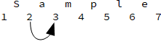Figure 7: Scanning the next element
- The next number of characters. If the next three characters of a string are needed then a Unicon pattern definition would be:
pat := Len(3)

- All the characters from the current index to the a specified index. An example of such a pattern definition would be
pat := Arb() || Pos(25)

In this case the pattern would match all the elements from the current cursor position to cursor position 25.
- All remaining characters.
All of the above is about iterating through a string of characters. What is done with these sub-strings has not been discussed, which will be discussed in the next section.

Unicon String Scanning
The string scanning environment in Unicon was inherited from the Icon programming language. In Unicon a string is put into the string scanning environment by typing:

str ? <expressions>

The string scanning environment sets the &subject to ‘str’ and the &pos, or index location, is set at the beginning of the string.
There is a set of string scanning functions which are available for the programmer inside this environment, some are: any(<CSet/string>), bal(), find(<CSet/string>), many(<CSet/string>), move(<int>), tab(<int>), upto(<CSet/string>), and can be used as follows:
str := “My phone number is 555-1234”
str ? {
tab(upto(&digits))
number := tab(many(&digits))
tab(upto(&digits))
number ||:= tab(many(&digits))
}

In this case all the characters in the sentence would be passed over until a digit was found, then number would be assigned ‘5551234’. Then it exits the string scanning environment.
The Unicon string scanning environment is declarative and is designed to progress through the string much like an iterator can move forward and backwards through a list. If the user wants to go backwards through the test it can by using negative values in move() or tab(), or some other combination of functions.

Unicon Pattern Matching
The pattern matching system in Unicon is similar to the pattern matching system in SNOBOL4. A pattern is a primitive data type which can be defined and assigned to a variable. If you wanted to define a pattern to retrieve a phone number from a string you would type:
pat := Span(&digits) || ‘-’ || Span(&digits)

In this case ‘pat’ is assigned the pattern definition on the right. To find that pattern in ‘str’ above, you would enter:
str ?? pat

Therefor:
number := str ?? pat

Results in ‘number’ being assigned ‘555-1234’. If the user wants to perform the match anchored at the current location within the string scanning environment, the ‘=<pattern>’ operator is used.
Str ? {
tab(upto(&digits))
write(=pat)
}
In this example the tab-upto function would move the cursor location forward until a digit is found. Then it would write the results of the pattern match, ‘555-1234’.

SCOEL Scanning
The SCOEL scanning objects which elements are collected is a component of a Matching object which decides what do with the data.
The first option is the simplest, there is no need to keep track of anything other than update the position to the appropriate index number.
The second option can be easily handled by assigning the result to a variable, whether the operation is the result of string scanning tool, a scan or a match. An example would be as follows:
foo := str.fetch(many(&letters))

The variable foo is assigned the result of the fetch matching operation which calls the scan many() using &letters as the argument. It would start at the current index of the string and would return a sub-string of letters until it reaches a character which is not a letter. The fetch matching operation instructs SCOEL to return results of its scan (this will be discussed in more detail in Goal Directed Extraction.
The third option is placing the sub-string on a stack to be combined later. This is what happens when the scan() or match() string functions are used. Each sub-string created by each element in the pattern definition is stored on a stack. When the pattern is completed and it is a success, then each sub-string is popped off the stack to create a new string.

Scanning Functions and Objects:
The scanning functions key words are any(), many(), and upto(). Below is a more specific definition what each one does based upon the arguments they receive.
any() returns the next element, advances the pos, and succeeds.
any(<set>) returns the next element, advances the pos, and succeeds if it matches an element of the set.
many() returns all remaining elements, advances the pos to the end, and succeeds.
many(<int>) returns a string of n elements matching the integer argument, advances the pos, and succeeds if there are enough elements remaining.
many(<set>) returns a string of elements as long as the set contains them, advances the pos, and succeeds if elements are found.
many(<str>) returns a string of elements which match the string argument, advances the pos, and succeeds if the string is found.
many(<pat>) returns a string of elements which match the pattern definition, advances the pos, and succeeds if the pattern is found.
many(<set, int>) returns a string of a certain number of elements which all are contained in a set, advances the pos, and succeeds if a string of elements of an appropriate length are found.
many(<str, int>) returns a string of elements that match the string argument a specified number of times, advances the pos, and succeeds if the repeated string is found the specified number of times.
many(<pat, int>) returns a string of elements that match the pattern definition a specified number of times, advances the pos, and succeeds if the repeated string matches the pattern definition the specified number of times.
upto(<int>) returns a string of elements upto the specified index, advances the pos up to the specified index, and succeeds if any elements are found.
upto(<set>) returns a string of elements upto an element which is a member of the set, advances the pos to the first element of the set is found, and succeeds if members of the set are found.
upto(<str>) returns a string of elements upto a string of elements match the string argument, advances the pos to where the string argument begins, and succeeds if the string argument is found.
upto(<pat>) returns a string of elements upto a string of elements match the pattern definition, advances the pos to where the pattern definition, and succeeds if the pattern definition is found.

Backtracking

Unicon
Unicon’s matching functions, tab() and move(), are generators which suspend results. Backtracking occurs when it fails to get a match from the scanning instructions in their perameters by reseting the &pos in to the scanning environment. This allows alternative matches to be tried from the same position.[1]
str ? {
tab(many(&letters))
tab(many(&digits))
}
In the above example, str is a string and a string scanning environment is created with two tab() matching functions. If at the beginning of the string there are a collection of letters, then it would succeed and the &pos would be advanced to the end of the letters. On the other hand if there weren’t any letters at the beginning of the string, it would fail and the &pos would not be advaned, had there been any advancement of the &pos during the scan for the letters &pos would be reset to its orignal location. Then it would perform the next tab() matching function where it would look for digits.

Prolog
In the Prolog language, facts and rules are stored as predicates. Backtracking is used in the evaluation of these predicates. As the diagram below shows:
A call is made to a rule or predicate and in the upper left diamond it evaluates its goal. If it succeeds then it exits to the next predicate; if it fails, it returns to the previous predicate with a fail message. Should Prolog reach the end of the set of rules or predicates, it returns back along the executing the instructions for the redo. This allows additional evaluation and commands to be performed as Prolog backtracks past the predicate.[9]⁠
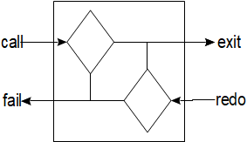Figure 8: Prolog Predicate Internal Operations

Goal Directed Extraction
SCOEL’s string analysis system was designed to take advantage of the backtracking structure of Prolog while having a similar functionality of Unicon’s string scanning. It will also allow scanning to be performed on the forward iteration through a pattern definition and during its backtracking process. This is achieved by creating a linked list of Matching objects where each can contain one or two Scan objects which determines which elements are under consideration for Matching. The first Scan object, (shown in the top half of the diagram below), is encountered as the string analysis system enters the Matching object. Later, once all the Matching objects have been completed or a scan fails, it backtracks to perform any back scan objects, if there are any, and resolve the results. Relational information on tokens or identifying opening and closing tags. Back scanning will be described in more detail later.
The internal structure of a Matching object consists of either one or two Scan objects which determines which sub-string is to be identified for the resolution process. If the scan succeeds, the extraction process exits the Matching object and proceeds to the next Matching object. If the scan fails, it begins the backtracking process with a &fail message.
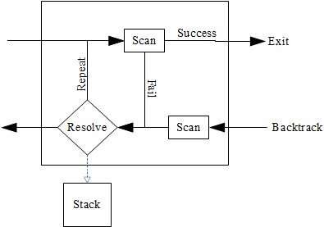Figure 9: SCOEL Matching object and its internal workings
The Matching objects which are used to determine whether the information collected in the scan are stored on the stack, counted or disregarded. The available Matching objects or string functions are described as follows:
collate(<scan()>[, scan()]) stores the elements collected from a successful scan to the stack and combines them into a list of tokens.
fetch(<scan()>[, scan()]) anchored match described further below, stores the elements collected from a successful scan to the stack.
Fetch(<scan()>[, scan()]) unanchored match described further below, stores the elements collected from a successful scan to the stack.
pair(<scan(),scan()>) anchored match linking both scans together and identifying what came between them.
Pair(<scan(),scan()>) unanchored match linking both scans together and identifying what came between them.
pass(<scan()>[, scan()]) anchored match described further below, does not store the elements collected from a successful scan to the stack.
Pass(<scan()>[, scan()]) unanchored match described further below, does not store the elements collected from a successful scan to the stack.
tabulate(<scan()>[, scan()]) returns the number of times it can find the scan successfully.

While back tracking each Matching object determines whether to save the results of the scan, discard them, tabulate them or collate each individual sub-string, in some conditions which will be discussed later it may decide to either fail and repeat, fail and proceed with backtracking, or terminate the operation. It it decides to save the results, they are pushed on to a stack for combining into a final String.
Eventually the chain of Matching objects is capped with a Back Matching object. If one is not included in a pattern definition or a string matching function is used, then a Back Matching object with a &success argument is automatically used. But, when defining a pattern definition if a Back Matching object is added to the end of the definition, it can hold either a &success, &fail or &terminate argument for backtracking. While backtracking if a &success message is passed back to the previous match object, its Back Scan object will be performed. If the Back Scan succeeds, then sub-strings of the scans will be stored to the stack. When a &fail or &terminate is sent back to the previous Matching object, the Back Scan object is skipped and nothing is stored to the stack.
back(&fail/&success/&terminate) Sets up the necessary components for backtracking and sends a message to identify the status of the string analysis.

Below is a diagram of the Back Matching object, the End box is where the object sets up the required components to track the back tracking process.
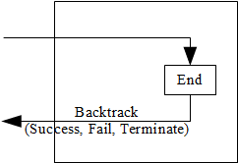Figure 10: Back Matching Object

Pattern Definitions
When complex sets of instruction are required, those instructions can be combined into a pattern definition. A pattern definition is a series of Matching instructions with their respective scanning operations.
pat := pass(many(&letters)) fetch(many(&digits, 3)) fetch(any(&letters))

In the above example a pattern definition called pat has two Matching instructions; the first passes a set of letters and fetches the next three digits followed by a single letter. When SCOEL comes across this instruction it creates four Matching objects, three being for the pass, the two fetchs and one for the end of the pattern definition.
It is not necessary to include a Back object in the pattern definition. If one does not appear, it is assumed to it will pass back a success message during backtracking. A Back object can be given either of the &success, &fail, or &terminate keywords.
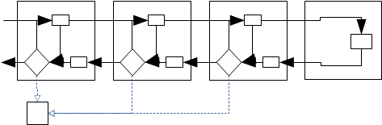Figure 11: Pattern Structure
back(&success|&fail|&terminate) signifies the end of a pattern definition and what message to send when backtracking begins.

The following code illustrates how a fail message can be sent from the Back object:
pat := pass(many(&letters)) fetch(many(&digits, 3)) fetch(any(&letters)) back(&fail)

Additional Matching Objects available in Patterns only:
When using a pattern argument in a Scan object
Should it be necessary to change the message from either success or fail, the Fence object can be used to change the backtrack message to either success, fail or terminate. If SCOEL runs across one these objects during backtracking, it will change the message, but during the forward matching process it will do nothing.
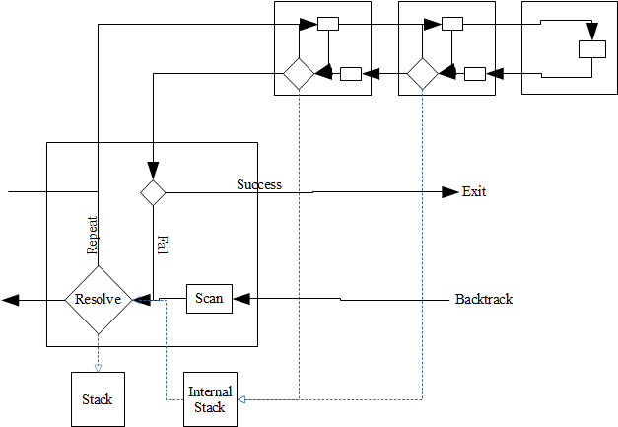Figure 12: Pattern Scan Matching Function
fence(&fail/&success/&terminate) changes the backtracking message at this point if it is either &success or &fail to the message selected.

The following code is an example how this code could be used:
pat := pass(many(&letters)) fence(&fail) fetch(many(&digits, 3)) fetch(any(&letters))

str := fetch(subject, pat)

In this example, the backtracking process would start by receiving a success message if all pass and fetch objects were successful in their scans. Going back from the end, the first Match object would put a letter on the stack and return a success message. The second Match object would put three digits on the sack. The fence would receive a success message and would send a fail message back. This will result in SCOEL signaling that the string scan failed and str would be assigned to &null
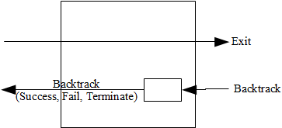Figure 13: Fence Matching Object

Structural Matching Objects available in Patterns only:
SCOEL uses implicit concatenation. Therefor, it is not necessary to create a Matching class to handle concatenation. By placing a match operation followed by another match operation in a pattern definition SCOEL will combine the results of both match operations if they are both successful.
The Or Matching object is called whenever an or symbol ‘|’ is used in a pattern definition. With an instruction of:
fetch(upto(&letters)) | pass(many(&digits))

SCOEL will try to fetch all the symbols up to a point where a letter is found. If it is success full in finding a letter, then it will store that information and proceed past the pass() match object. Should it fail, then it will move to the pass match object and attempt read some digits. If it finds any digits, then it will succeed, otherwise it will fail.
The Or ‘|’ Matching object succeeds when either branch of a pattern succeeds. Should the first branch succeeds then it does not try the second branch and reports the success.To use an Or Matching object it is placed in a pattern definition as follows
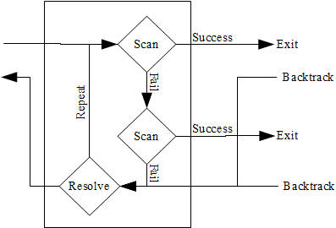Figure 14: Or Structural Matching Function
pat := fetch(any(‘a’)) | fetch(any(“bcd”))
str := fetch(subject, pat)

In this example, there is a definition for pat in the first line. When the second line executed, the fetch will will first check to see if the next character in subject, if it is an ‘a’ then it will succeed and push the “a” to the stack. If it does not succeed, then it will try to find the sub-string “bcd”.
While defining a pattern it is sometimes necessary and useful to group some Matching objects together with the use of parenthesis. When this is done, a Parenthesis Structural Matching Object is created which controls the flow of the extraction process to keep those items within the parenthesis combined together. The figure below shows the flow of the extraction process when a parenthesis are used. When the extraction process enters the Parenthesis Structural Matching object it is immediately directed to the first Match object in the parenthesis and performs the scans for each object in order until it reaches the last item. It then exits upon success to continue down the pattern definition. When it returns during backtracking it is sent to the last Matching object in the parenthesis and performs any back scanning and resolution as defined.
In the example below, the pattern will find either a token with ‘abc’ followed by a bunch of letters followed by a bunch of digits or a token which starts with a ‘d’ followed by a bunch of digits. The parenthesis group the fetch and pass Matching objects together.
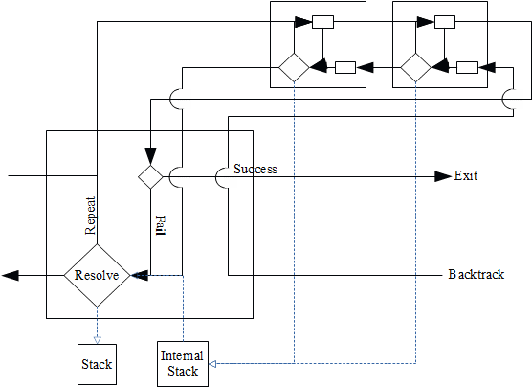Figure 15: Parenthesis Structural Match Function
Pat := ( fetch(any(“abc”)) pass(many(&letters)) ) | fetch(any(”d”)) fetch(many(&digits))

Assignments
The ability to assign the results of internal scans of a pattern is useful in being able to control the flow of pattern recognition. For example, you scan an integer value which tells you how many characters that follow, it can be assigned to a variable and then passed as an argument later in a scan later in the pattern. The three types of pattern assignments are the immediate assignment, the conditional assignment and the index assignment; similar to what is available in SNOBOL4.

Immediate Assignment
An immediate assignment is made when a pattern contains the following expressions:
MatchFunction() => variable

This tells the information extraction system to assign the results of a match object to a variable called variable. It will make this assignment regardless to weather the complete matching operation is successful or whether the matching function stores the information on to the stack. The scan in the previous matching object must be successful.
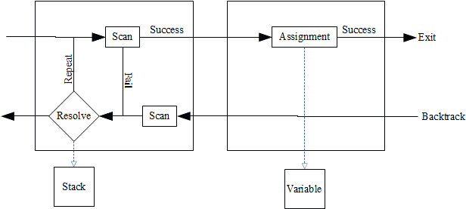Figure 16: Immediate Assignment

Index Assignment
Index Assinments work in the same way as the immediate assignment, but instead of assigning the results of the scan to the variable, it stores the index location which is the result of the successful scan. The index assignment operator is ‘.>’.

Conditional Assignment
The conditional assignment is structured slightly different than the other two. It will only make the assignment during backtracking if a ‘success’ message is sent back to the assignment matching object. The conditional assignment operator is ‘->’.
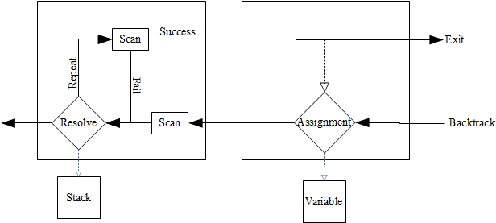Figure 17: Conditional Assignment

Anchoring
The pattern matching system of SNOBOL4 allowed the programmer to determine whether they wanted the pattern match to be tied to the current index location or to progress through the string until it finds a match. This concept is called anchoring. If the pattern match is anchored then it will not progress through the subject string until it finds a match, it will only test from the current location.[2]
In SNOBOL4 the default mode is unanchored, or to scan the string until it finds a match. In SCOEL the default mode is to be anchored, or to test for a match from the current index location only. Like SNOBOL4, SCOEL allows the programmer to set the anchor mode. SCOEL allows greater flexibility by allowing each match object to be set to either anchored or unanchored mode. To perform an unanchored Match This can be done by using a adding a ‘#’ symbol before the match object:
str := #fetch(pat)

In this example, SCOEL will look for a string of characters that match the pattern definition. Should it be necessary to differentiate which match objects in a pattern definition need to be anchored and others not it can be done as well:
pat := #pass(many(&letters)) fetch(many(&digits))
str := fetch(subject, pat)

In this example the pattern definition has an unanchored pass() Match object which will look for a set of letters in the string, then it will try to fetch a series of digits from the end of those letters.

Back Scanning
The pattern matching operations in SNOBOL4 and Unicon13 are limited by delivering a single token at a time. If there are bits of information spread through out a string, then separate pattern matching operations have to be performed.[1], [2], [10] When scanning information like HTML or XML may have opening and closing tags to identify different types of information. With SCOEL’s back scanning the opening tag can be scanned then some other information may be analyzed and when the extraction process backtracks back to the Matching object, it can perform a scan for the closing tag.
The above Matching Object figure shows the Scan object on the top half and is accessed when the Matching object is encountered. If successful it exits the Matching object. Upon its return it first encounters the Back Scan object where it can perform another scan. Should it succeed, it will push the results of the first scan on to the stack and put the results of the back scan on the stack.
Figure 18: Matching Object

Strings and Lists
Strings and Lists will be constructed as generator objects. They will store a value representing the current index location called a pos. There will be a set of “tools” or methods built-in which may be used to perform a number of tasks on them.

Collection Methods:
clear() removes all elements
member(elem) returns the elem if it is in the collection, otherwise fails
index(elem) returns the first index where the element is located
insert(elem, int) inserts the element in the index of the second argument and pushes the remaining elements back one index.
set(elem, int) replaces the element at the index of the second argument with the element of the first argument.
push(elem) adds the element to the head.
pop() returns and removes the element at the head.
put(elem) adds the element to the tail.
put(list/set) adds all the elements of the argument to the tail.
pull() returns and removes the element at the tail.
get(int) returns the element at the index matching the argument.
remove(int) removes the element at the index matching the argument.
remove(elem) removes the element with is the same as the argument.
remove(list/set) removes all elements that are the same and included in the argument
head() returns the element at the head.
tail() returns the element at the tail.
sort()
copy() returns a pointer to the source collection with the index set to the source index.
clone() creates and returns a copy of the source collection with the index set to the source index.

Iteration Methods:
reset() sets the pos to 1
setPos(int) sets the pos to the integer argument.
getPos()
incrument()
decrument()

Logical Programming Elements
The logical programming aspect of SCOEL will be handled by SCOEL_Logic object and is a singleton. Therefore, no matter how many times it is created, it will always refer to the same object which is handling the data for SCOEL’s logical programming. The Prolog programming language will be used as a model for creating a subset of logical functions and predicates. The most basic predicate which can be defined in logical programming is a fact.
First there needs a record created to store the fact. The following line defines a record called room with one piece of information in the record, called name.
record room(name)

After this has been done, rooms can be stored in the logic object by first creating a room record with an appropriate name.
kitchen :- room(“Kitchen”)
living :- room(“Living Room”)

Notice the assignment uses the :- operator. When the logical assignment operator is used, the system checks to make sure the SCOEL_Logic object has been created and assigned to the variable ‘logic’. The same operator is used to define relationships and queries, which will be discussed later. Predicates for facts can have any number of arguments and are similar to records in a database. Each predicate is stored as a record in a table called predicates in the logic or SCOEL_Logic object.
Relationships are also predicates which are stored as records. Again, they need to be defined in advance. If we want to locate things in the kitchen, we will have to create an object record and a location record.
record object(name)
record food(name)
record location(room, object)

Then we need to define them and add them to the logic object. In this example, the table and the couch are assigned to their appropriate variable. The location relationships are not assigned to a variable. It is not necessary to assign a predicate to a variable if it is not planned to be referenced directly. In this case the addPredicate() method is called and is passed a location record.
table :- object(“Table”)
logic.addPredicate(location(kitchen, table))
apple :- food(“Apple”)
logic.addPredicate(location(kitchen, apple))
couch :- object(“Couch”)
logic.addPredicate(location(living, couch))

Queries are used to identify facts and other information which matches a set of criteria. For example if someone wanted to see all the rooms that have been entered they could enter:
local x
?- room(x)

The question ?- operator signifies that a query is being performed. The ‘x’ being an unassigned variable, will be recognized as &null and therefore the query is looking for all the predicates which will match any value for ‘x’. In this case it would be the list:
[[Kitchen], [Living Room]]
Had ‘x’ been assigned a value such as “basement” it would return &null, but if it was assigned “Kitchen”) then it would return the kitchen record.
Compound queries can also be created by several queries in a row separated by commas.
local x
?- location(kitchen, x), object(x)

In this case the query is performed on all the location predicates who’s first argument is kitchen and the second argument can be anything, resulting in [[Table], [Apple]]. Then the second query of any object predicates which was part of the previous query’s result, resulting in [[Table]] as apple is a food predicate, not an object predicate.
The logic programming class will provide a set of powerful tools for the programmer to analyze relationships between terms and concepts discovered in the information extraction process.

Object Oriented Programming

Unicon

Packages

Classes

Variable Scope

SCOEL

Interfaces

Abstract Classes

Variable Scope and Permissions

Conclusions
SCOEL has its origins in Icon and Unicon, but it is a strictly object oriented language and it is designed to expand upon Icon and Unicon string scanning and pattern matching operations and provide a set of logical programming operations and object. SCOEL will be tailored to build programs for information extraction of collections of documents similar to the records search of the deeds in the Mission Bay District of San Francisco I experienced years ago. Having such tools would have greatly improved my productivity on that project.

Related Research
Future research as a result of the development of SCOEL would include: Goal Directed String Scanning, Website Information Extraction with Goal Directed String Scanning, Finding Partitioned Tokens with SCOEL, Evaluating Context of Extracted Information with SCOEL, Extracting Information from HTML Tables with SCOEL, and Extracting Information from Collections of Legal Records with SCOEL.

Bibliography
[1] C. Jeffery, S. Mohamed, J. Al-Gharaibeh, R. Perreda, and R. Parlett, Programming with Unicon. 2012.
[2] R. Griswold, J. F. Poage, and I. P. Polonsky, The SNOBOL4 Programming Language. Bell Telephone Laboratories, Inc., 1971.
[3] R. Griswold and M. Griswold, The Icon Programming Language, Third. 1996.
[4] H. Cunningham, “Information Extraction, Automatic,” Encyclopedia of Languages & Linguistics, vol. 5. Elserier, pp. 665–677, 2006.
[5] N. Vlahovic, “Information Retrieval and Information Extraction in Web 2 . 0 environment,” Int. J. Comput., vol. 5, no. 1, 2011.
[6] W. Robillard, D. Wilson, and C. Brown, Evidence and Procedures for Boundary Location, Fourth Edi. John Wiley & Sons, 2002.
[7] B. B. Seppe vanden Broucke, Practical Web Scraping for Data Science. Apress, 2018.
[8] G. L. Hajba, Website Scraping with Python. Apress, 2018.
[9] D. Merritt, Adventure in Prolog. .
[10] R. Griswold, M. Griswold, K. Walker, and C. L. Jeffery, The Implentation of Icon and Unicon. 2014.

