BIG MART SALES PREDICTION

Team Name : Team Surya
Project Name :Big Mart Sales Prediction
Team members:
- K V N Surya Teja (Team Lead)
- G Tejesh
- G John
- A Bhagyaraju
GITHUB:
https://github.com/Sur2004/-K V N Surya Teja
https://github.com/tejesh-gorajana -G Tejesh
https://github.com/johngouri8-sudo/ -G John
https://github.com/BhagiKarthik/ -A Bhagya Raju
https://github.com/Sur2004/Big-Mart-Sales-Prediction -Common repository

Problem Statement
Big Mart wants to understand the factors that affect the sales of its products in different outlets.
The aim of this project is to analyze the historical sales data and predict Item_Outlet_Sales using a machine learning model.

Dataset Description
- The dataset used is the Big Mart Sales dataset (train.csv).
- It has 8,523 rows and 12 columns, where each row represents one product sold at one outlet.
The columns in the dataset are:
- Item_Identifier - a unique code for each product
- Item_Weight - the weight of the product
- Item_Fat_Content - whether the product is Low Fat or Regular
- Item_Visibility - the percentage of display area given to the product
- Item_Type - the category the product belongs to (for example, Dairy, Meat)
- Item_MRP - the maximum retail price of the product
- Outlet_Identifier - a unique code for each outlet
- Outlet_Establishment_Year - the year the outlet was set up
- Outlet_Size - the size of the outlet (Small, Medium, or High)
- Outlet_Location_Type - the city tier the outlet is located in
- Outlet_Type - the type of outlet (for example, Grocery Store, Supermarket)
- Item_Outlet_Sales - the sales value of the product at that outlet (this is the target the models predict)

Data Inspection
- The dataset has 8,523 rows and 12 columns.
- 4 columns are numerical: Item_Weight, Item_Visibility, Item_MRP, and Outlet_Establishment_Year.
- The rest are text columns, along with the numeric target column, Item_Outlet_Sales.
Basic Statistics:
- Item_Weight: average-12.86, ranges from 4.56 to 21.35.
- Item_Visibility: average- 0.066, ranges from 0.000 to 0.328.
- Item_MRP: average - 140.99, ranges from 31.29 to 266.89.
- Item_Outlet_Sales: average - 2181.29, ranges from 33.29 to 13086.96.

Handling Missing Values
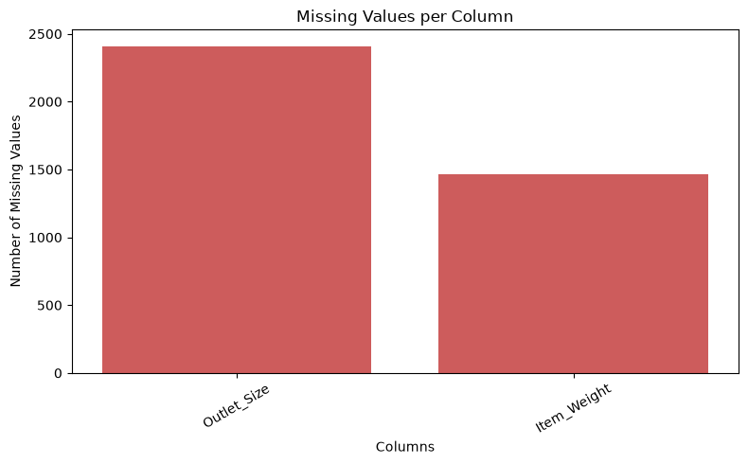
Figure 1: Number of missing values in each column

Two columns had missing values: Item_Weight (1,463 missing) and Outlet_Size (2,410 missing).
- Since “ Item_Weight” is a numerical column, it was filled with median value.
- Since “Outlet_Size” is a categorical column, it was filled with the mode value.
- After this step, the dataset had no missing values left.

Duplicate Records
- The dataset was checked for duplicate rows.
- No duplicates were found, so no rows needed to be removed.

Data Preprocessing
- The data was split into X (the features) and the target y ( Item_Outlet_Sales).
- Since sales values were large and spread out, a log transformation was applied so the models could learn the pattern more easily.
- All text columns were converted into numbers as follows:
- Item_Fat_Content: Cleaned up inconsistent labels (Low Fat, low fat, LF) into two clean categories, then encoded using LabelEncoder.
- Outlet_Identifier: Kept only the numeric part of the code (for example, OUT049 became 49).
- Outlet_Location_Type: Converted Tier 1, 2, and 3 into the numbers 1, 2, and 3.
- Outlet_Establishment_Year: Converted into a new feature, Outlet_Age (2013 minus the year), since how old an outlet is matters more than the exact year.
- Item_Identifier, Item_Type, Outlet_Size, and Outlet_Type: converted into numbers using label encoding.

Correlation Analysis
- A correlation heatmap was plotted to see how the features relate to each other and to sales.
- Item_MRP (price) and Outlet_Type had the strongest relationship with the target variable, with correlations of about 0.57 and 0.40.
- This suggests that price and outlet type play a big role in how much a product sells.

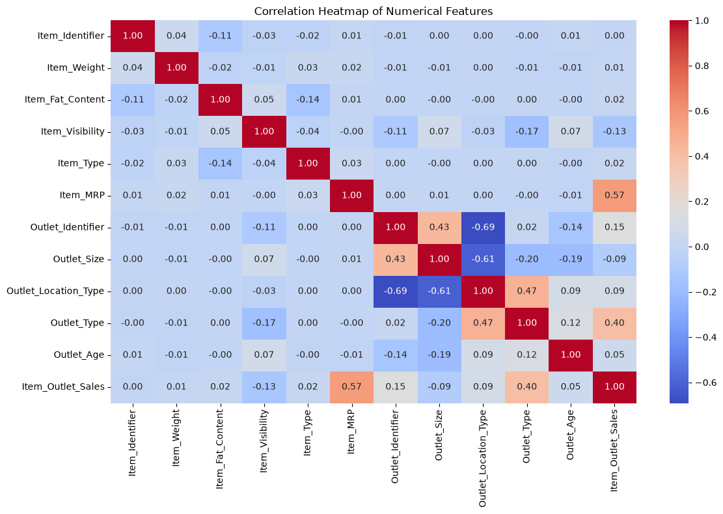
Figure 2: Correlation heatmap of features

The top correlated features are selected and plotted against the target variable.
1.Outlet_type VS Item_Outlet_Sales

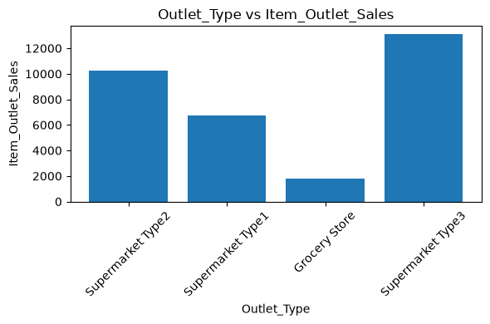

Key Finding: The Item_Outlet_Sales are varying very much across different outlet types.

2.Item_Sales VS Item_Outlet_Sales

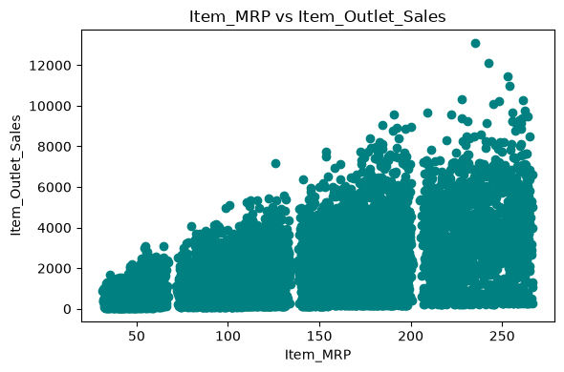
Figure 3: Item_MRP vs Item_Outlet_Sales
Key Finding:

Here, sales= quantity * price,

so the high MRP products can generate more revenue even though they are less sold.

Suggestions to Improve Outlet Sales
- Since Item_MRP has a strong link to sales, outlets could bundle lower-priced items with higher-value products to increase the overall basket value.
- Since Outlet_Type strongly affects sales, weaker-performing outlet formats could adopt practices used by the better-performing supermarket types.

Train-Test Split
- The data was split into a training set (80%, 6,818 rows) and a testing set (20%, 1,705 rows).

Model Training
- In this project we are using mainly three models. They are:
1.Random Forest Regressor
2.Gradient Boosting Regressor
3.XGBoost Regressor
- All three models were trained on the same training data and tested on the same test data, so the comparison would be fair.
- Two metrics were used to judge each model: R2 Score (higher is better, shows how much of the variation in sales the model explains) and MSE (lower is better, shows the average prediction error).

Model 1: Random Forest Regressor
- Builds many decision trees and averages their results to make a prediction.
- Trained with 100 trees on the training data.
- R2 Score: 0.7182
- MSE: 0.2962

Model 2: XGBoost Regressor
- Builds trees one after another, where each new tree tries to correct the mistakes of the previous ones.
- Trained with 100 trees on the same training and testing data.
- R2 Score: 0.7076
- MSE: 0.3074

Model 3: Gradient Boosting Regressor
- Also builds trees one after another to correct earlier mistakes, using a simpler, classic boosting approach.
- Trained with 100 trees on the same training and testing data.
- R2 Score: 0.7435
- MSE: 0.2697

Model Comparison
- Random Forest - R2 Score: 0.7182, MSE: 0.2962
- XGBoost - R2 Score: 0.7076, MSE: 0.3074
- Gradient Boosting - R2 Score: 0.7435, MSE: 0.2697
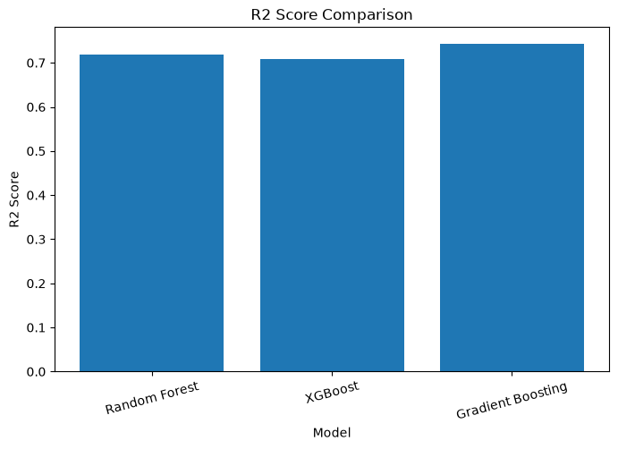
R2 Score comparison of the three models
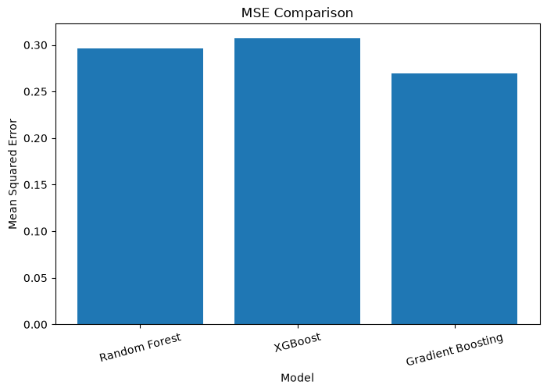
MSE comparison of the three models
Key finding: Gradient Boosting Regressor performed the best, with the highest R2 Score and the lowest MSE among the three models.

Conclusion:
● The analysis shows that product and outlet characteristics have an impact on Big Mart sales, with Item MRP showing a strong positive relationship with sales.
● Three models — Random Forest Regressor, Gradient Boosting Regressor, and XGBoost Regressor — were trained and compared for sales prediction. Gradient Boosting Regressor performed the best among the three models and can help improve sales and inventory planning.

