
loving nature
R E S E A R C H C O M P O U N D C A T A L O G U E
Reseller Price Schedule

Prepared: 30 July 2026
Pricing in South African Rand (ZAR),
Reconstituted (Pen).
Excludes courier delivery.
Subject to change without notice.
RESELLER PRICING — for approved resellers only (retail +25%; product codes shown)

1. Tissue Repair & Recovery
Peptides studied for healing, recovery and connective-tissue support.
Image | Product & Research Notes | Reseller (ZAR)
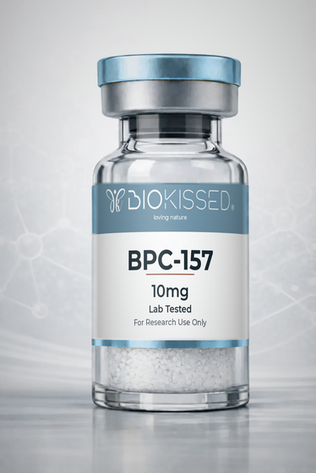 | BPC-157 10mg  Product Code: BPC10  Promotes blood-vessel formation, reduces inflammation and protects cells from damage — studied to speed the healing response in soft tissue, gut lining and joints. | R969
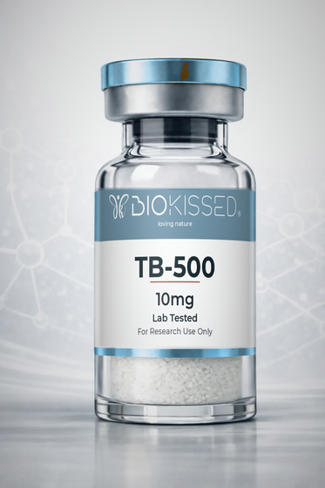 | TB-500 10mg  Product Code: TB10  Promotes migration of stem cells to injured areas, helps form new blood vessels, reduces inflammation and prevents excessive scar tissue; often studied alongside BPC-157 for combined soft-tissue recovery. | R1,344
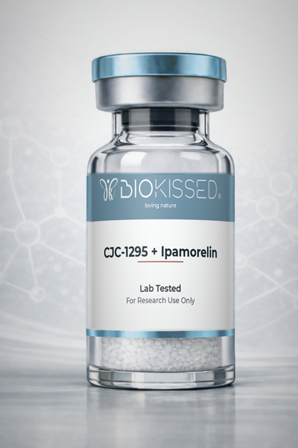 | CJC-1295 + Ipamorelin  Product Code: CJIP  CJC-1295 extends how long each natural growth-hormone pulse lasts while Ipamorelin adds extra pulses, together creating a sustained increase in natural GH release — researched for recovery, body composition and sleep quality. | R1,281
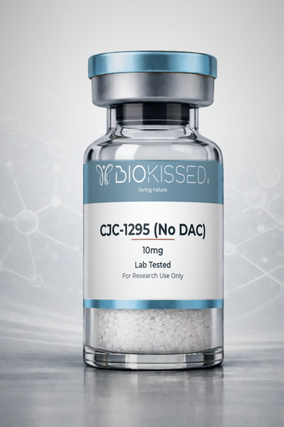 | CJC-1295 (No DAC) 10mg  Product Code: CJD10  Extends the duration of the body's natural growth-hormone pulse for more sustained release without shutting down natural production — a popular short-acting option for GH-pulse research. | R1,219
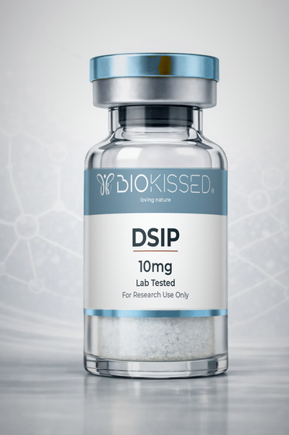 | DSIP 10mg  Product Code: DSP10  Crosses the blood-brain barrier and interacts with the central nervous system to promote delta-wave (deep, restorative) sleep — a key subject in sleep-cycle research. | R1,219
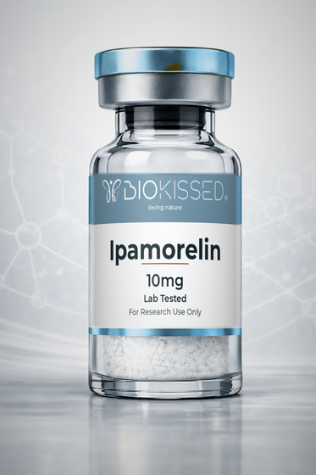 | Ipamorelin 10mg  Product Code: IPA10  Mimics ghrelin to selectively stimulate growth-hormone release; studied for increased GH without materially disturbing cortisol or appetite hormones. | R906
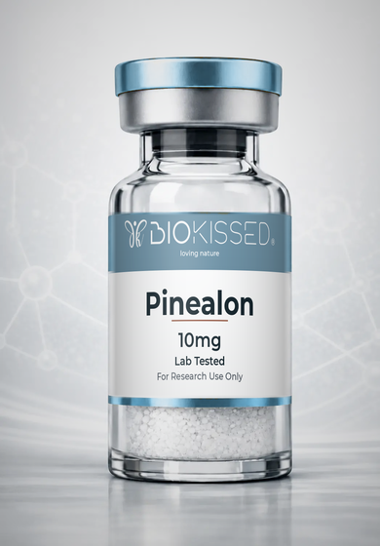 | Pinealon 10mg  Product Code: PIN10  Investigated for its potential to support neuronal health, cognitive performance and cellular resilience. | R1,031
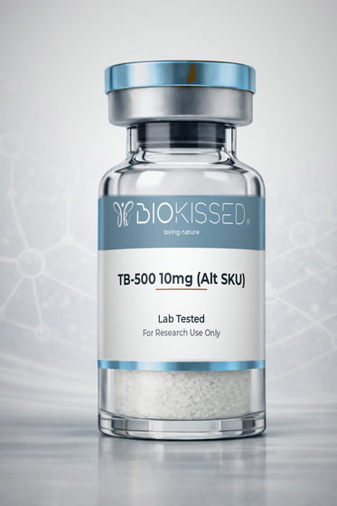 | TB-500 10mg (Alt SKU)  Product Code: TB10A  Promotes migration of stem cells to injured areas, helps form new blood vessels, reduces inflammation and prevents excessive scar tissue; often studied alongside BPC-157 for combined soft-tissue recovery. | R1,344
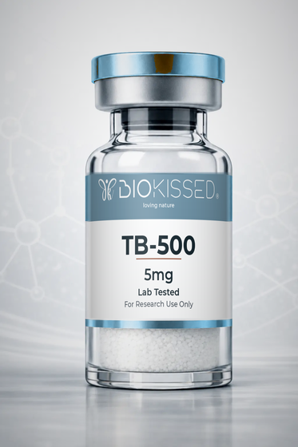 | TB-500 5mg  Product Code: TB5  Promotes migration of stem cells to injured areas, helps form new blood vessels, reduces inflammation and prevents excessive scar tissue; often studied alongside BPC-157 for combined soft-tissue recovery. | R969
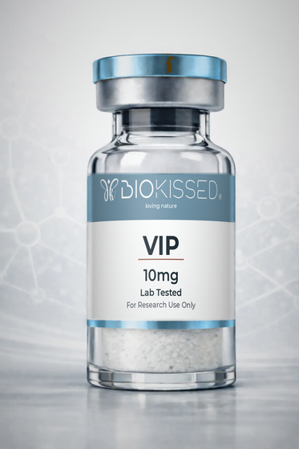 | VIP 10mg  Product Code: VIP10  Modulates immune responses, reduces inflammatory cytokines, improves gut-barrier function and protects neurons — studied in gut-immune-brain communication. | R1,969
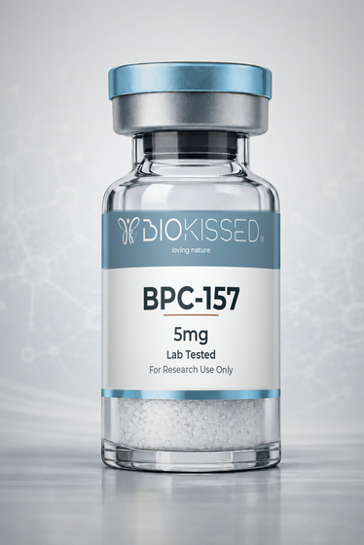 | BPC-157 5mg  Product Code: BPC5  Promotes blood-vessel formation, reduces inflammation and protects cells from damage — studied to speed the healing response in soft tissue, gut lining and joints. | R782
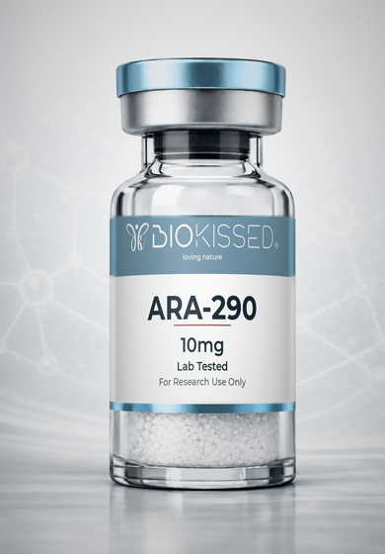 | ARA-290 10mg  Product Code: ARA10  A non-erythropoietic EPO derivative studied for activating the innate repair receptor to reduce inflammation and support nerve and tissue repair. | R931
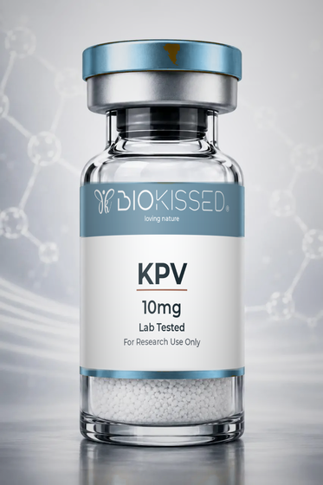 | KPV 10mg  Product Code: KPV10  A tripeptide fragment of alpha-MSH studied for its anti-inflammatory action in the gut and skin and for supporting tissue healing. | R844
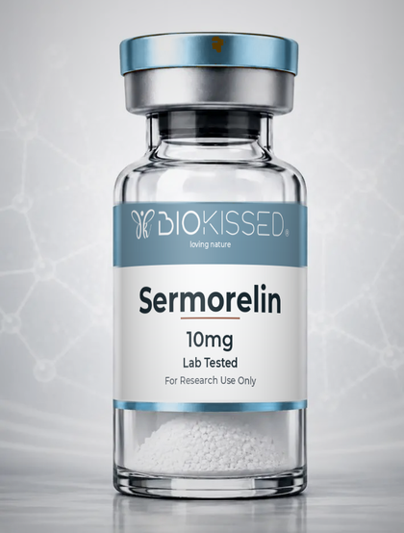 | Sermorelin 10mg  Product Code: SRM10  A growth-hormone-releasing hormone analogue that signals the pituitary to release growth hormone naturally; studied for recovery, body composition and sleep. | R1,344
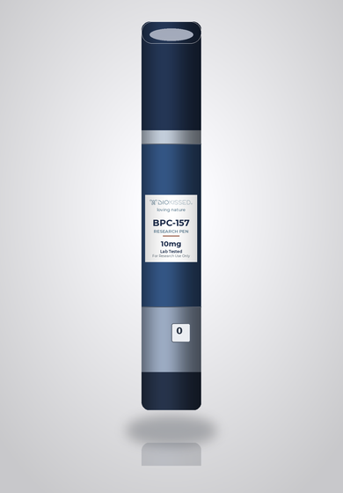 | BPC-157 10mg Research Pen  Product Code: BPC10P  Reconstituted research-pen format for convenient, pre-measured dosing. Promotes blood-vessel formation, reduces inflammation and protects cells from damage — studied to speed the healing response in soft tissue, gut lining and joints. | R1,406
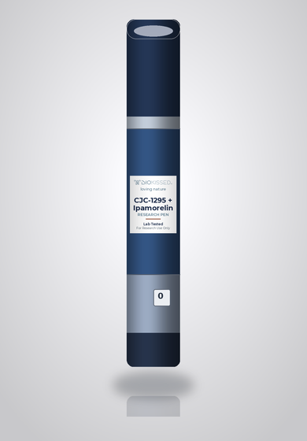 | CJC-1295 + Ipamorelin Research Pen  Product Code: CJIPP  Reconstituted research-pen format for convenient, pre-measured dosing. CJC-1295 extends how long each natural growth-hormone pulse lasts while Ipamorelin adds extra pulses, together creating a sustained increase in natural GH release — researched for recovery, body composition and sleep quality. | R1,719
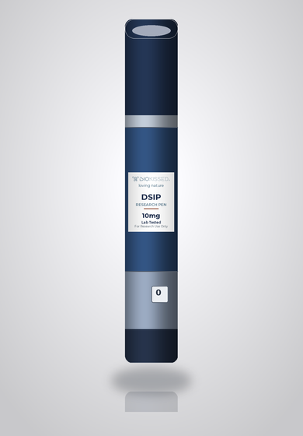 | DSIP 10mg Research Pen  Product Code: DSP10P  Reconstituted research-pen format for convenient, pre-measured dosing. Crosses the blood-brain barrier and interacts with the central nervous system to promote delta-wave (deep, restorative) sleep — a key subject in sleep-cycle research. | R1,656
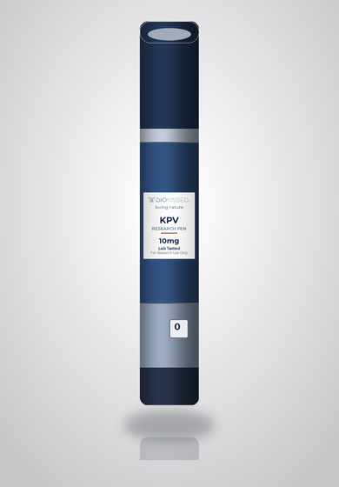 | KPV 10mg Research Pen  Product Code: KPV10P  Reconstituted research-pen format for convenient, pre-measured dosing. A tripeptide fragment of alpha-MSH studied for its anti-inflammatory action in the gut and skin and for supporting tissue healing. | R1,281
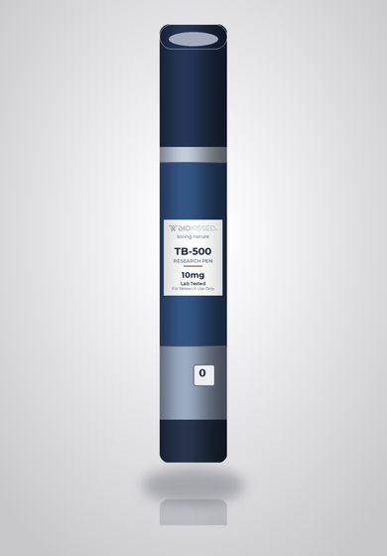 | TB-500 10mg Research Pen  Product Code: TB10P  Reconstituted research-pen format for convenient, pre-measured dosing. Promotes migration of stem cells to injured areas, helps form new blood vessels, reduces inflammation and prevents excessive scar tissue; often studied alongside BPC-157 for combined soft-tissue recovery. | R1,781

2. Metabolic & Weight Management
Compounds researched for metabolic, appetite and body-composition pathways.
Image | Product & Research Notes | Reseller (ZAR)
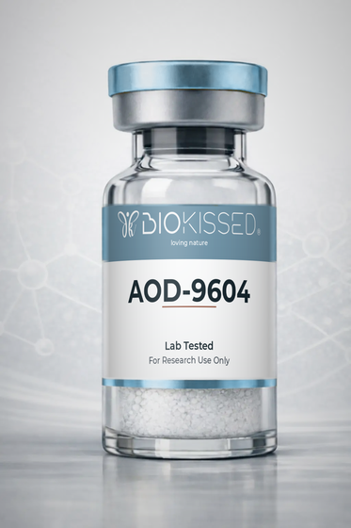 | AOD-9604  Product Code: AOD  Mimics the way natural growth hormone regulates fat metabolism, helping break down stored fat and prevent new fat formation without the broader effects of full-length GH. | R1,120
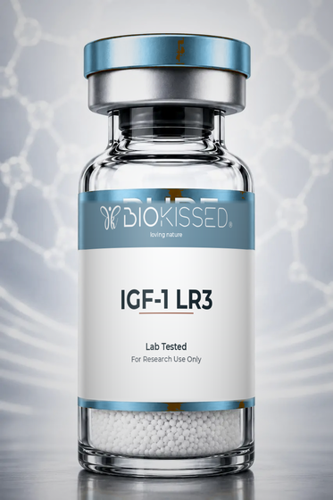 | IGF-1 LR3  Product Code: IGF1  Binds IGF-1 receptors to support anabolic signalling, protein synthesis, recovery pathways and metabolic regulation over an extended half-life. | R1,969
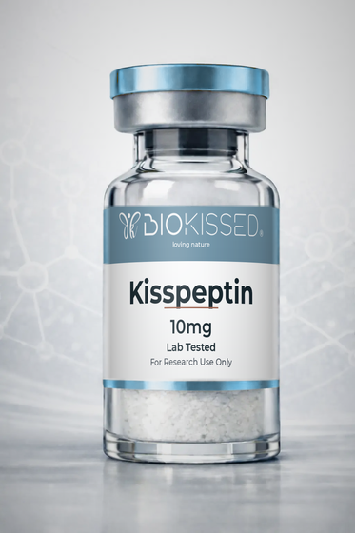 | Kisspeptin 10mg  Product Code: KS10  Activates the hypothalamic-pituitary-gonadal axis, stimulating release of LH and FSH — a core subject in reproductive-hormone research. | R1,219
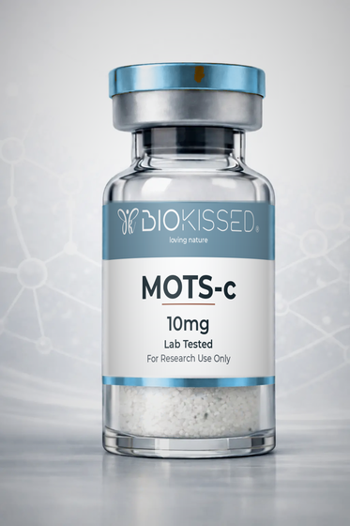 | MOTS-c 10mg  Product Code: MS10  Improves how mitochondria produce energy, helping cells burn fat and use glucose more efficiently, and activates AMPK — a key pathway in exercise and metabolic research. | R1,019
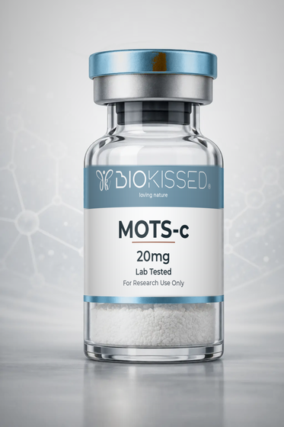 | MOTS-c 20mg  Product Code: MS20  Improves how mitochondria produce energy, helping cells burn fat and use glucose more efficiently, and activates AMPK — a key pathway in exercise and metabolic research. | R1,344
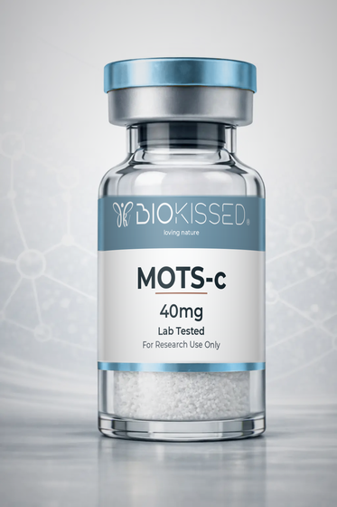 | MOTS-c 40mg  Product Code: MS40  Improves how mitochondria produce energy, helping cells burn fat and use glucose more efficiently, and activates AMPK — a key pathway in exercise and metabolic research. | R1,719
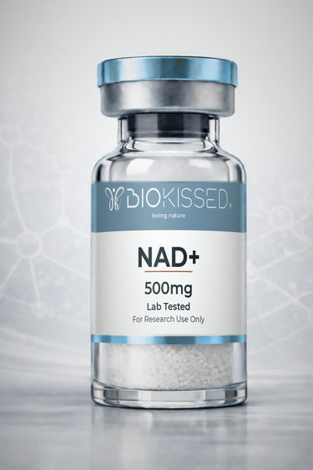 | NAD+ 500mg  Product Code: NAD500  Acts as a helper molecule in hundreds of metabolic processes, especially mitochondrial energy production; elevated NAD+ is studied for cellular energy and repair pathways central to longevity research. | R1,094
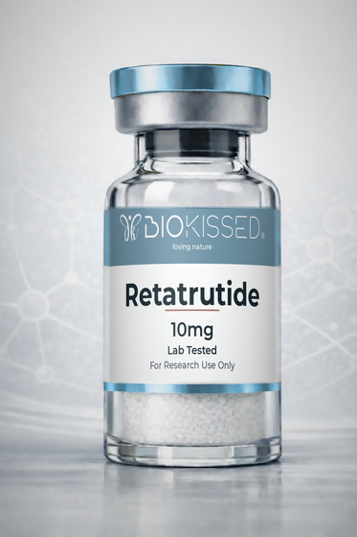 | Retatrutide 10mg  Product Code: RT10  Activates GIP, GLP-1 and glucagon receptors — supporting satiety, more effective insulin use and increased energy expenditure; one of the most closely watched compounds in current metabolic research. | R1,344
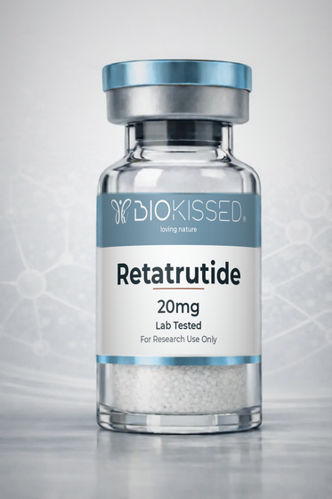 | Retatrutide 20mg  Product Code: RT20  Activates GIP, GLP-1 and glucagon receptors — supporting satiety, more effective insulin use and increased energy expenditure; one of the most closely watched compounds in current metabolic research. | R1,844
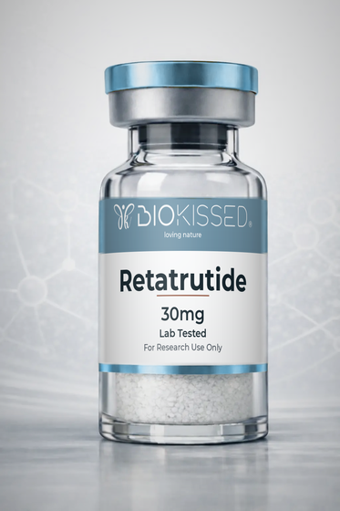 | Retatrutide 30mg  Product Code: RT30  Activates GIP, GLP-1 and glucagon receptors — supporting satiety, more effective insulin use and increased energy expenditure; one of the most closely watched compounds in current metabolic research. | R2,219
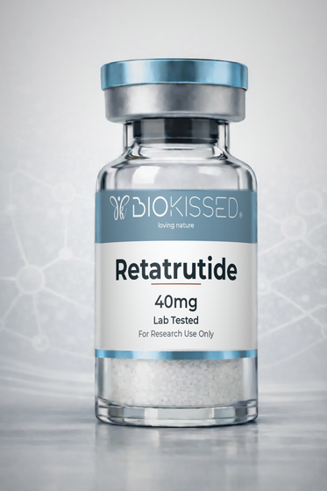 | Retatrutide 40mg  Product Code: RT40  Activates GIP, GLP-1 and glucagon receptors — supporting satiety, more effective insulin use and increased energy expenditure; one of the most closely watched compounds in current metabolic research. | R2,719
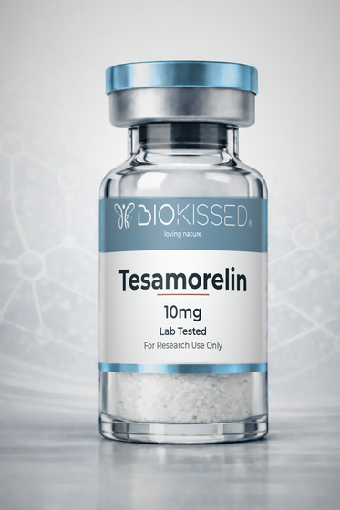 | Tesamorelin 10mg  Product Code: TS10  Signals the pituitary gland to release growth hormone naturally rather than introducing GH directly; studied for its effect on visceral belly fat linked to metabolic risk. | R1,470
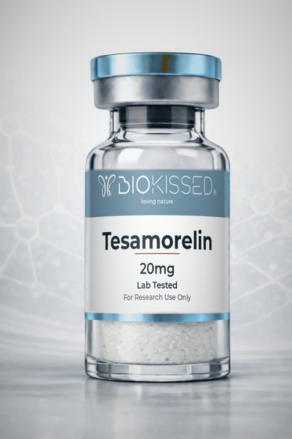 | Tesamorelin 20mg  Product Code: TS20  Signals the pituitary gland to release growth hormone naturally rather than introducing GH directly; studied for its effect on visceral belly fat linked to metabolic risk. | R2,219
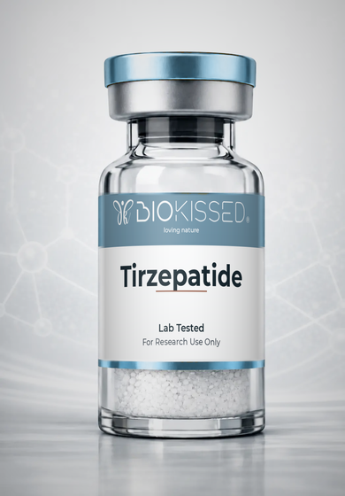 | Tirzepatide  Product Code: TZ  Investigated for its potential to support glucose-dependent insulin secretion, appetite regulation and gastric-emptying pathways. | R1,595
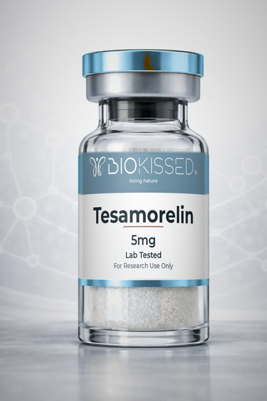 | Tesamorelin 5mg  Product Code: TS5  Signals the pituitary gland to release growth hormone naturally rather than introducing GH directly; studied for its effect on visceral belly fat linked to metabolic risk. | R1,158
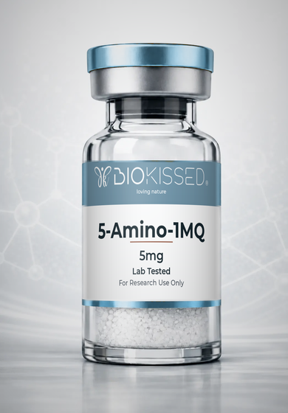 | 5-Amino-1MQ 5mg  Product Code: AMQ5  Investigated for whether influencing NNMT pathways may affect energy expenditure, fat metabolism and body-composition regulation. | R751
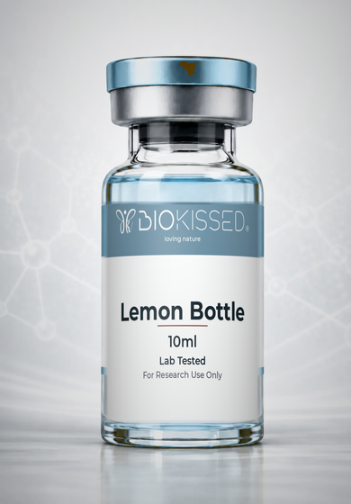 | Lemon Bottle 10ml  Product Code: LMB10  A lipolytic solution studied for localised fat breakdown; a research injectable investigated for body-contouring applications. | R1,031
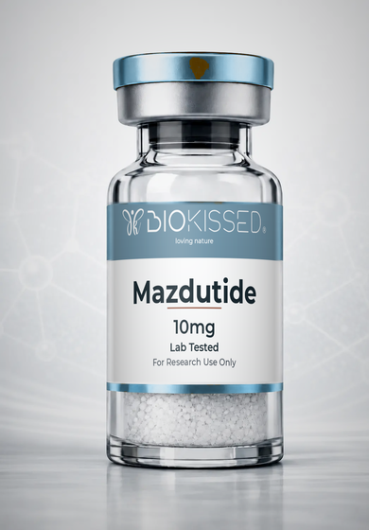 | Mazdutide 10mg  Product Code: MZ10  A dual GLP-1 and glucagon receptor agonist studied for appetite regulation, glucose control and increased energy expenditure. | R1,969
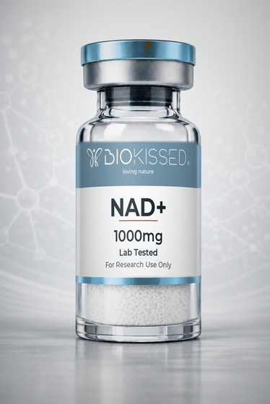 | NAD+ 1000mg  Product Code: NAD1000  Acts as a helper molecule in hundreds of metabolic processes, especially mitochondrial energy production; elevated NAD+ is studied for cellular energy and repair pathways central to longevity research. | R1,594
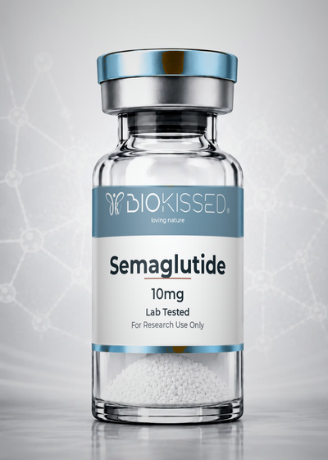 | Semaglutide 10mg  Product Code: SG10  A GLP-1 receptor agonist studied for glucose-dependent insulin secretion, appetite suppression and slowed gastric emptying. | POA
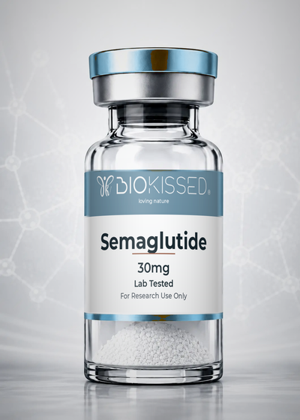 | Semaglutide 30mg  Product Code: SG30  A GLP-1 receptor agonist studied for glucose-dependent insulin secretion, appetite suppression and slowed gastric emptying. | R1,469
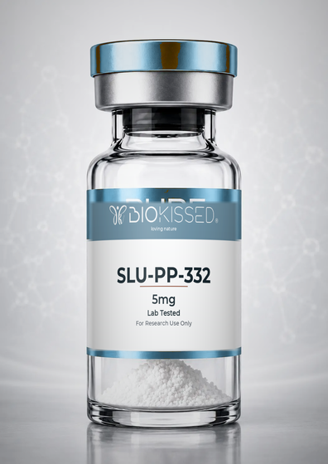 | SLU-PP-332 5mg  Product Code: SLU5  An ERR agonist ('exercise mimetic') studied for its potential to increase energy expenditure and fat oxidation without physical exertion. | R969
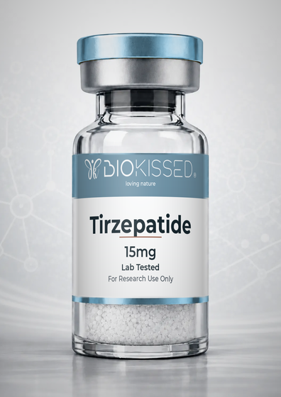 | Tirzepatide 15mg  Product Code: TZ15  Investigated for its potential to support glucose-dependent insulin secretion, appetite regulation and gastric-emptying pathways. | R1,219
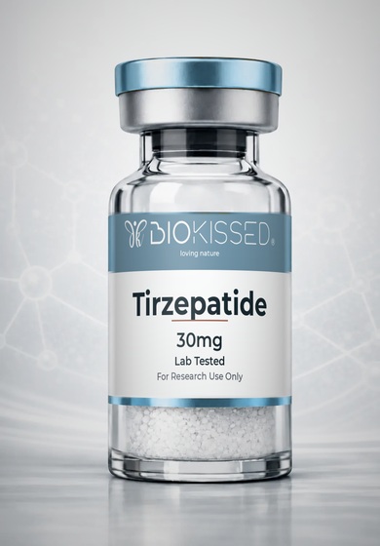 | Tirzepatide 30mg  Product Code: TZ30  Investigated for its potential to support glucose-dependent insulin secretion, appetite regulation and gastric-emptying pathways. | R1,658
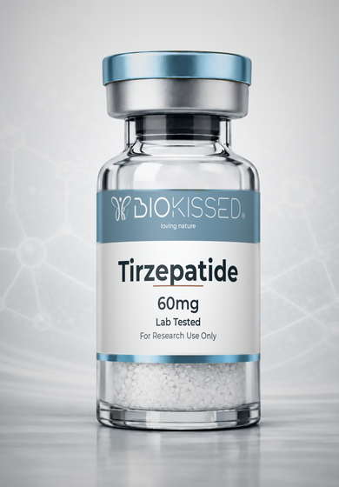 | Tirzepatide 60mg  Product Code: TZ60  Investigated for its potential to support glucose-dependent insulin secretion, appetite regulation and gastric-emptying pathways. | R2,344
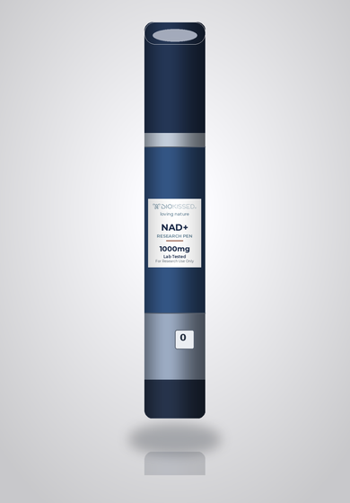 | NAD+ 1000mg Research Pen  Product Code: NAD1000P  Reconstituted research-pen format for convenient, pre-measured dosing. Acts as a helper molecule in hundreds of metabolic processes, especially mitochondrial energy production; elevated NAD+ is studied for cellular energy and repair pathways central to longevity research. | R2,031
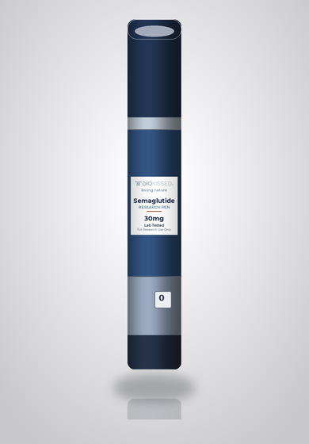 | Semaglutide 30mg Research Pen  Product Code: SG30P  Reconstituted research-pen format for convenient, pre-measured dosing. A GLP-1 receptor agonist studied for glucose-dependent insulin secretion, appetite suppression and slowed gastric emptying. | R1,906
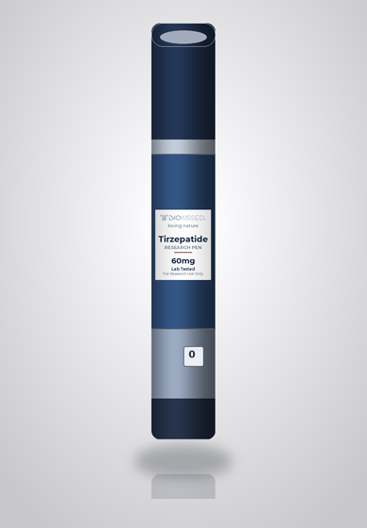 | Tirzepatide 60mg Research Pen  Product Code: TZ60P  Reconstituted research-pen format for convenient, pre-measured dosing. Investigated for its potential to support glucose-dependent insulin secretion, appetite regulation and gastric-emptying pathways. | R2,781

3. Longevity & Cellular Health
Research compounds explored for cellular ageing, repair and resilience.
Image | Product & Research Notes | Reseller (ZAR)
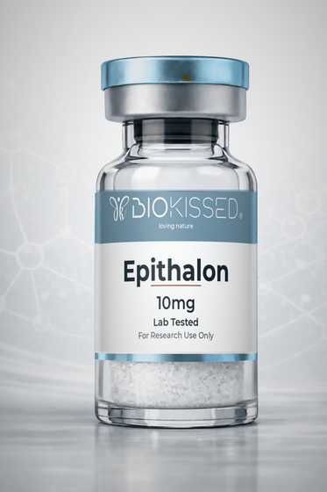 | Epithalon 10mg  Product Code: EP10  Activates telomerase to help lengthen telomeres and slow cellular ageing, and regulates melatonin production — linked to circadian and longevity research. | R858
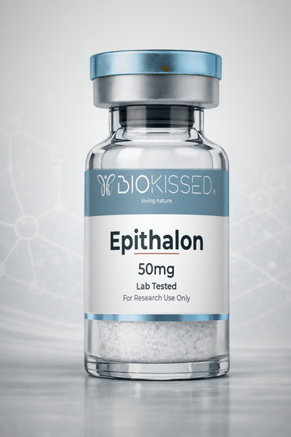 | Epithalon 50mg  Product Code: EP50  Activates telomerase to help lengthen telomeres and slow cellular ageing, and regulates melatonin production — linked to circadian and longevity research. | R1,469
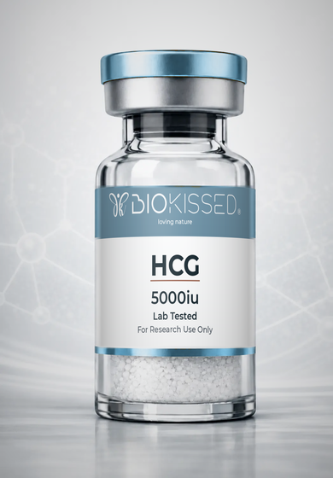 | HCG 5000iu  Product Code: G5K  Investigated for its ability to stimulate endogenous testosterone production and support reproductive function. | R969
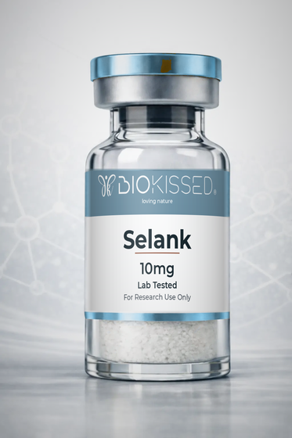 | Selank 10mg  Product Code: SLK10  Modulates GABA, serotonin and dopamine systems; studied for reducing anxiety and stress without sedation — a focus of cognitive and stress-response research. | R1,120
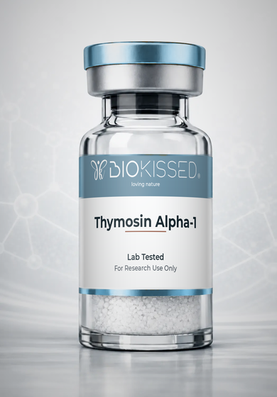 | Thymosin Alpha-1  Product Code: THA1  Investigated for its potential to support T-cell maturation, immune signalling and cytokine activity. | R1,656
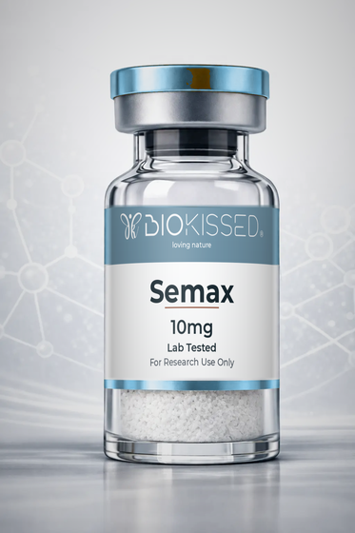 | Semax 10mg  Product Code: SEM10  Increases brain-derived neurotrophic factor (BDNF) to promote neuron growth and survival; studied for effects on focus, mood and cognitive performance. | R1,120
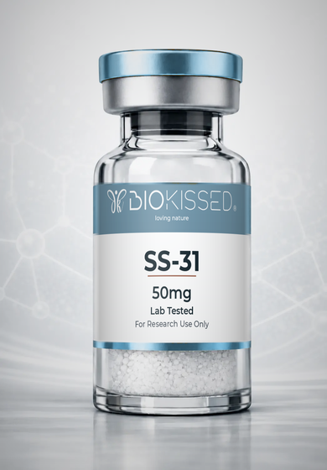 | SS-31 50mg  Product Code: SS50  Investigated for its ability to bind cardiolipin within the inner mitochondrial membrane, supporting mitochondrial efficiency and ATP production. | R2,344
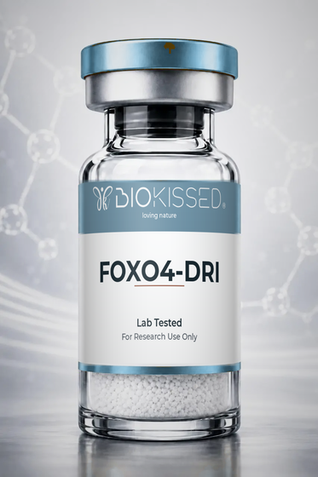 | FOXO4-DRI  Product Code: FOX  Disrupts the FOXO4-p53 interaction to allow apoptosis of senescent ('zombie') cells while largely sparing healthy cells — a focus of cellular-ageing research. | R2,719
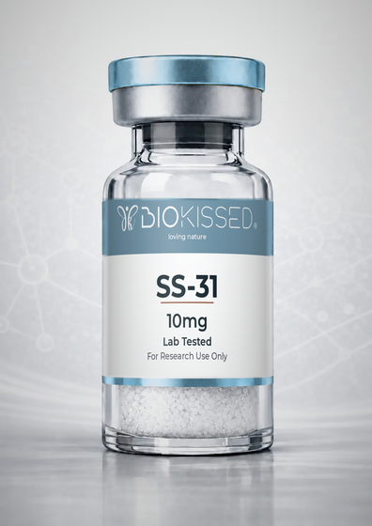 | SS-31 10mg  Product Code: SS10  Investigated for its ability to bind cardiolipin within the inner mitochondrial membrane, supporting mitochondrial efficiency and ATP production. | R1,344
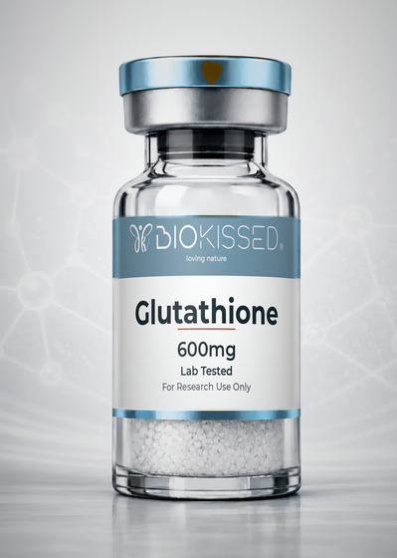 | Glutathione 600mg  Product Code: GLU600  The body's master antioxidant, studied for its role in cellular detoxification, oxidative-stress defence and skin brightening. | R844
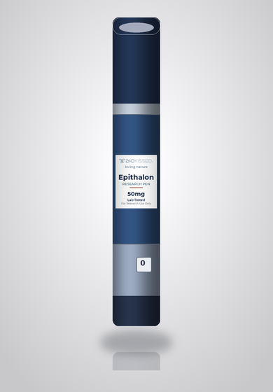 | Epithalon 50mg Research Pen  Product Code: EP50P  Reconstituted research-pen format for convenient, pre-measured dosing. Activates telomerase to help lengthen telomeres and slow cellular ageing, and regulates melatonin production — linked to circadian and longevity research. | R1,906

4. Specialty Combination Stacks
Pre-combined blends formulated for convenient multi-pathway research.
Image | Product & Research Notes | Reseller (ZAR)
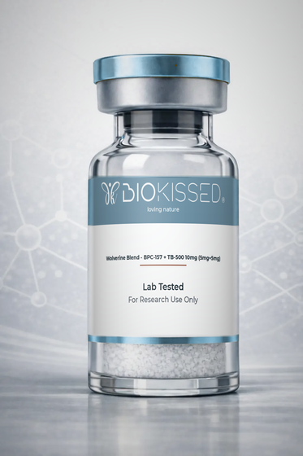 | Wolverine Blend - BPC-157 + TB-500 10mg (5mg+5mg)  Product Code: WLV10  A BPC-157 + TB-500 blend (5mg+5mg): BPC-157 targets rapid localised repair of gut, tendons and ligaments while TB-500 promotes whole-body healing, flexibility and blood-vessel formation — researched for accelerated recovery across multiple tissue types. | R1,220
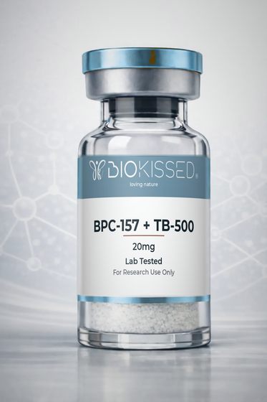 | BPC-157 + TB-500 20mg  Product Code: BT20  A BPC-157 + TB-500 blend: BPC-157 targets rapid localised repair while TB-500 promotes whole-body healing, flexibility and blood-vessel formation — researched for accelerated recovery across multiple tissue types. | R1,720
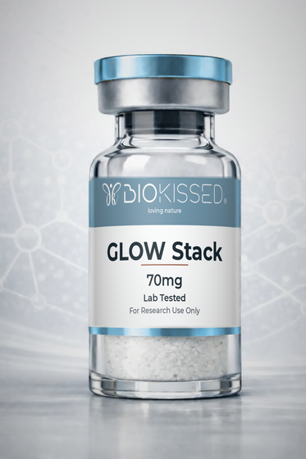 | GLOW Stack 70mg  Product Code: GLW70  A regeneration and skin-quality stack: GHK-Cu promotes collagen production and skin regeneration while companion peptides support tissue remodelling and structural repair as a combined formula. | R1,782
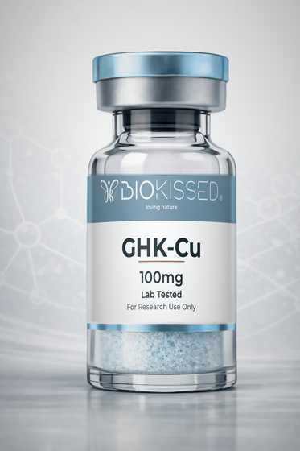 | GHK-Cu 100mg  Product Code: GHK100  Stimulates collagen and elastin production, promotes wound healing, reduces inflammation and acts as a powerful antioxidant; the copper complex is widely researched for skin, hair and tissue-remodelling applications. | R1,219
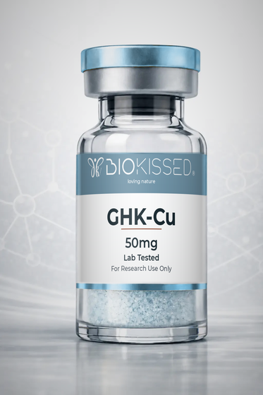 | GHK-Cu 50mg  Product Code: GHK50  Stimulates collagen and elastin production, promotes wound healing, reduces inflammation and acts as a powerful antioxidant; the copper complex is widely researched for skin, hair and tissue-remodelling applications. | R969
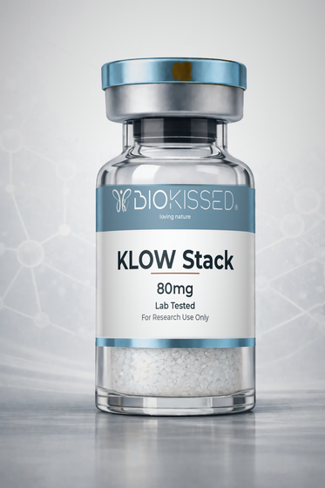 | KLOW Stack 80mg  Product Code: KLW80  A KLOW stack: GHK-Cu promotes collagen production and copper delivery for skin and tissue regeneration while partner peptides support recovery, hydration and structural repair as a combined formula. | R2,032

5. Hormonal & Vitality
Peptides investigated for hormonal, libido and pigmentation pathways.
Image | Product & Research Notes | Reseller (ZAR)
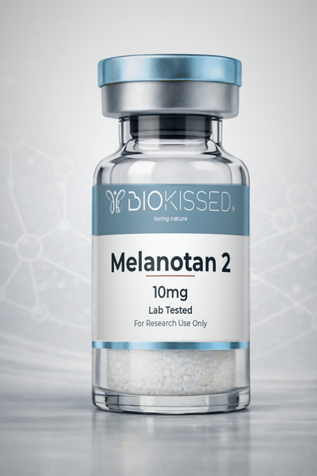 | Melanotan 2 10mg  Product Code: MT10  Activates melanocortin receptors in skin cells to trigger melanin production for a protective tan with UV exposure; also studied for effects on appetite and libido. | R970
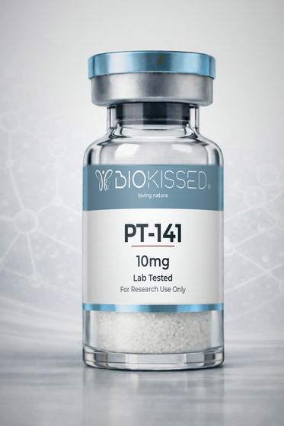 | PT-141 10mg  Product Code: PT10  Activates melanocortin receptors in the hypothalamus to trigger natural sexual arousal and desire; unlike some approaches it does not act directly on blood flow. | R944
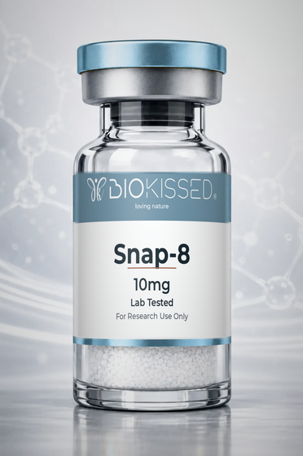 | Snap-8 10mg  Product Code: SNP10  Studied for its potential to influence neurotransmitter signalling associated with facial muscle contractions — a topical, cosmetic-research peptide. | R844

6. Accessories & Consumables
Reconstitution and delivery consumables for laboratory use.
Image | Product & Research Notes | Reseller (ZAR)
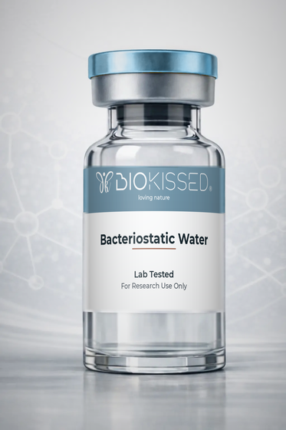 | Bacteriostatic Water  Product Code: BAC  Sterile water containing a small amount of benzyl alcohol, used to reconstitute freeze-dried peptides prior to research use. Not a peptide — an essential laboratory consumable. | Free
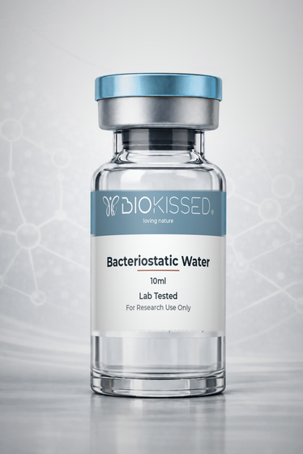 | Bacteriostatic Water 10ml  Product Code: BAC10  Sterile water containing a small amount of benzyl alcohol, used to reconstitute freeze-dried peptides prior to research use. Not a peptide — an essential laboratory consumable. | R408
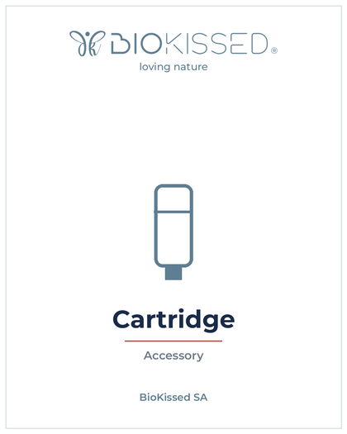 | Cartridge  Product Code: CRT  Replacement cartridge accessory for compatible pen-style reconstitution and delivery devices. | R90
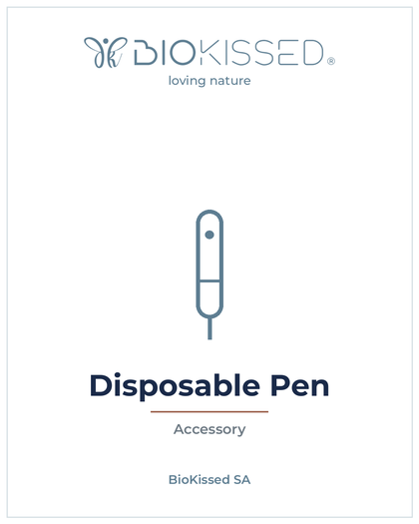 | Disposable Pen  Product Code: DPN  Single-use pen device for convenient reconstitution and measured delivery of research compounds. | R658
 | Bacteriostatic Water 3ml  Product Code: BAC3  Sterile water containing a small amount of benzyl alcohol, used to reconstitute freeze-dried peptides prior to research use. Not a peptide — an essential laboratory consumable. | R345

7. Options & Delivery
Cold-chain packaging and courier options added at checkout.
Image | Product & Research Notes | Reseller (ZAR)
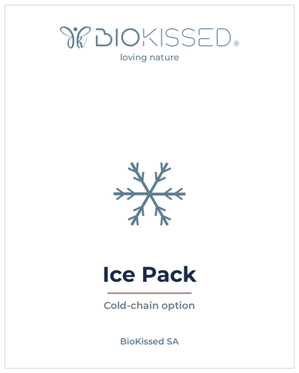 | Ice Pack  Product Code: ICE  Reusable ice pack for temperature-controlled shipping of research compounds. | R35
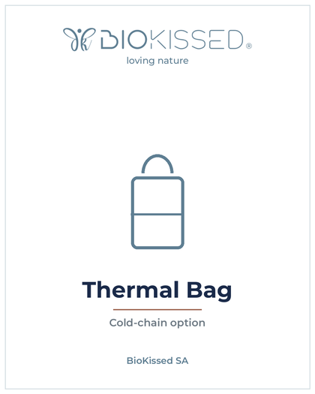 | Thermal Bag  Product Code: TBG  Insulated thermal bag for temperature-controlled delivery of research compounds. | R100
 | Delivery Local  Product Code: DLL  Local courier delivery within the metro area. | R145
 | Delivery National  Product Code: DLN  National courier delivery across South Africa. | R249

