THE MOLECULE CO.
RESEARCH COMPOUND CATALOGUE
Price Schedule
Prepared: 28 July 2026
Pricing in South African Rand (ZAR), Reconstituted (Pen).
Excludes courier delivery. Subject to change without notice.

Research Use & Compliance Notice
Every compound in this catalogue is sold strictly for laboratory and research purposes. None of these products are registered medicines, and they have not been evaluated by SAHPRA, the FDA, or any equivalent regulatory body. The research notes in this document describe published research interest in each compound.
How to read this catalogue
Products are grouped by research category. Each entry shows the product image, a unique product code, a plain-English summary of what researchers study the compound for, and the Retail reference price in ZAR. “POA” means Price On Application.
Contents
1. Tissue Repair & Recovery — 14 products
2. Metabolic & Weight Management — 25 products
3. Longevity & Cellular Health — 10 products
4. Specialty Combination Stacks — 6 products
5. Hormonal & Vitality — 3 products
6. Accessories & Consumables — 4 products
7. Options & Delivery — 4 products

1. Tissue Repair & Recovery
Image | Product & Research Notes | Retail (ZAR)
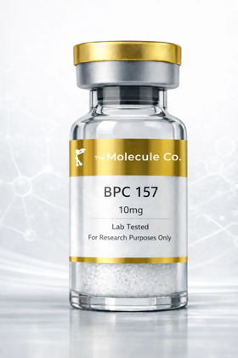 | BPC-157 10mg  Product Code: BPC10  Promotes blood-vessel formation, reduces inflammation and protects cells from damage — studied to speed the healing response in soft tissue, gut lining and joints. | R 775,00
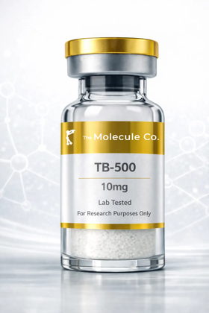 | TB-500 10mg  Product Code: TB10  Promotes migration of stem cells to injured areas, helps form new blood vessels, reduces inflammation and prevents excessive scar tissue; often studied alongside BPC-157 for combined soft-tissue recovery. | R 1 075,00
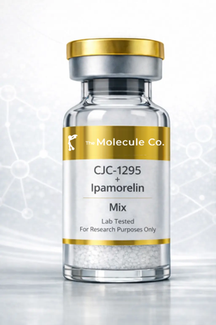 | CJC-1295 + Ipamorelin  Product Code: CJIP  CJC-1295 extends how long each natural growth-hormone pulse lasts while Ipamorelin adds extra pulses, together creating a sustained increase in natural GH release — researched for recovery, body composition and sleep quality. | R 1 025,00
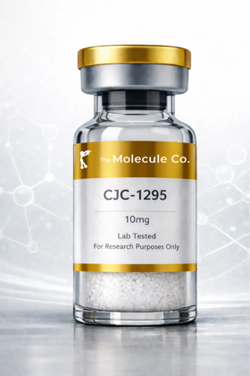 | CJC-1295 (No DAC) 10mg  Product Code: CJD10  Extends the duration of the body's natural growth-hormone pulse for more sustained release without shutting down natural production — a popular short-acting option for GH-pulse research. | R 975,00
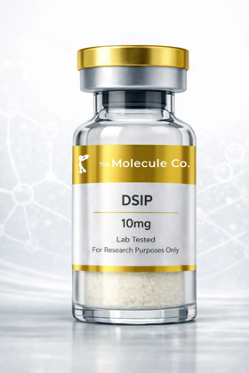 | DSIP 10mg  Product Code: DSP10  Crosses the blood-brain barrier and interacts with the central nervous system to promote delta-wave (deep, restorative) sleep — a key subject in sleep-cycle research. | R 975,00
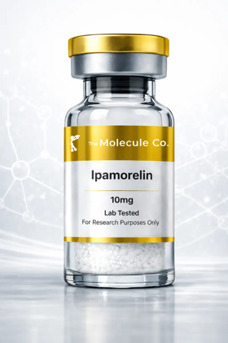 | Ipamorelin 10mg  Product Code: IPA10  Mimics ghrelin to selectively stimulate growth-hormone release; studied for increased GH without materially disturbing cortisol or appetite hormones. | R 725,00
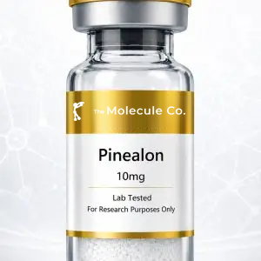 | Pinealon 10mg  Product Code: PIN10  Investigated for its potential to support neuronal health, cognitive performance and cellular resilience. | R 825,00
 | TB-500 10mg (Alt SKU)  Product Code: TB10A  Promotes migration of stem cells to injured areas, helps form new blood vessels, reduces inflammation and prevents excessive scar tissue; often studied alongside BPC-157 for combined soft-tissue recovery. | R 1 075,00
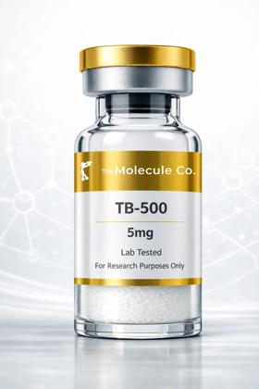 | TB-500 5mg  Product Code: TB5  Promotes migration of stem cells to injured areas, helps form new blood vessels, reduces inflammation and prevents excessive scar tissue; often studied alongside BPC-157 for combined soft-tissue recovery. | R 775,00
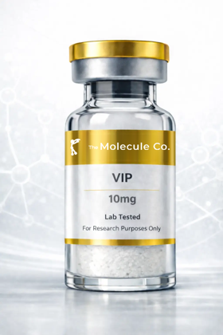 | VIP 10mg  Product Code: VIP10  Modulates immune responses, reduces inflammatory cytokines, improves gut-barrier function and protects neurons — studied in gut-immune-brain communication. | R 1 575,00
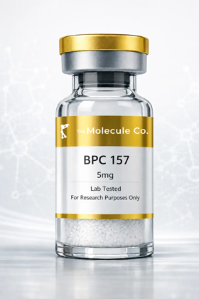 | BPC-157 5mg  Product Code: BPC5  Promotes blood-vessel formation, reduces inflammation and protects cells from damage — studied to speed the healing response in soft tissue, gut lining and joints. | R 626,00
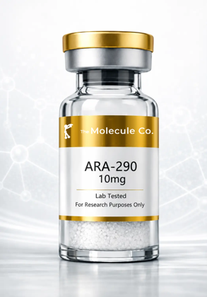 | ARA-290 10mg  Product Code: ARA10  A non-erythropoietic EPO derivative studied for activating the innate repair receptor to reduce inflammation and support nerve and tissue repair. | R 745,00
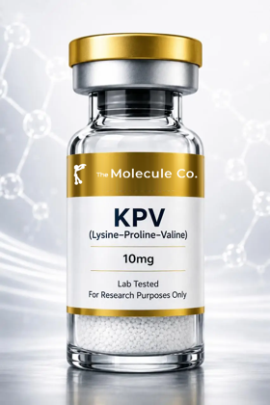 | KPV 10mg  Product Code: KPV10  A tripeptide fragment of alpha-MSH studied for its anti-inflammatory action in the gut and skin and for supporting tissue healing. | R 675,00
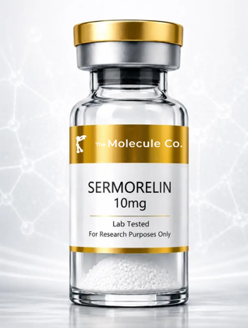 | Sermorelin 10mg  Product Code: SRM10  A growth-hormone-releasing hormone analogue that signals the pituitary to release growth hormone naturally; studied for recovery, body composition and sleep. | R 1 075,00

2. Metabolic & Weight Management
Image | Product & Research Notes | Retail (ZAR)
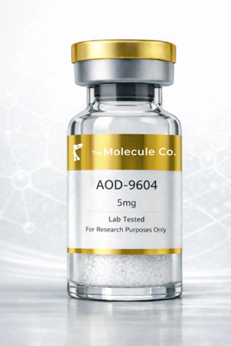 | AOD-9604  Product Code: AOD  Mimics the way natural growth hormone regulates fat metabolism, helping break down stored fat and prevent new fat formation without the broader effects of full-length GH. | R 896,00
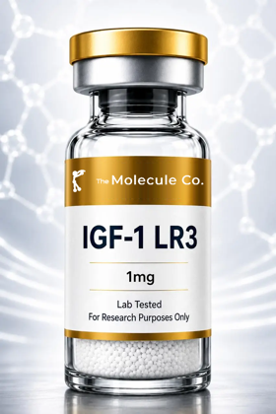 | IGF-1 LR3  Product Code: IGF1  Binds IGF-1 receptors to support anabolic signalling, protein synthesis, recovery pathways and metabolic regulation over an extended half-life. | R 1 575,00
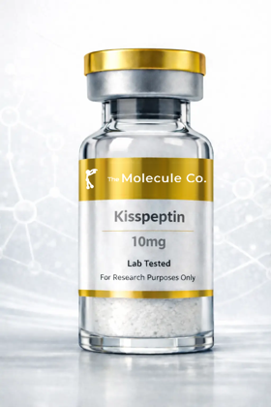 | Kisspeptin 10mg  Product Code: KS10  Activates the hypothalamic-pituitary-gonadal axis, stimulating release of LH and FSH — a core subject in reproductive-hormone research. | R 975,00
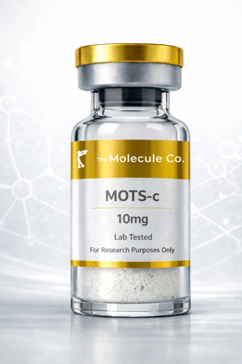 | MOTS-c 10mg  Product Code: MS10  Improves how mitochondria produce energy, helping cells burn fat and use glucose more efficiently, and activates AMPK — a key pathway in exercise and metabolic research. | R 815,00
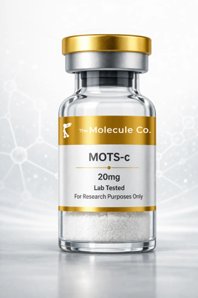 | MOTS-c 20mg  Product Code: MS20  Improves how mitochondria produce energy, helping cells burn fat and use glucose more efficiently, and activates AMPK — a key pathway in exercise and metabolic research. | R 1 075,00
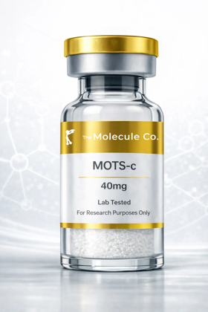 | MOTS-c 40mg  Product Code: MS40  Improves how mitochondria produce energy, helping cells burn fat and use glucose more efficiently, and activates AMPK — a key pathway in exercise and metabolic research. | R 1 375,00
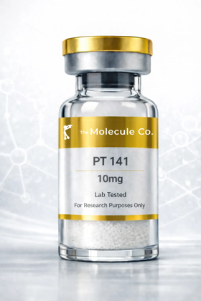 | NAD+ 500mg  Product Code: NAD500  Acts as a helper molecule in hundreds of metabolic processes, especially mitochondrial energy production; elevated NAD+ is studied for cellular energy and repair pathways central to longevity research. | R 875,00
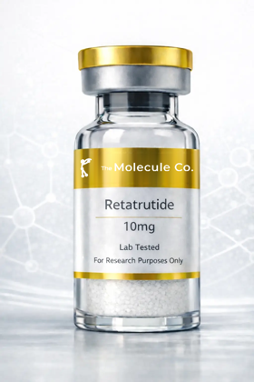 | Retatrutide 10mg  Product Code: RT10  Activates GIP, GLP-1 and glucagon receptors — supporting satiety, more effective insulin use and increased energy expenditure; one of the most closely watched compounds in current metabolic research. | R 1 075,00
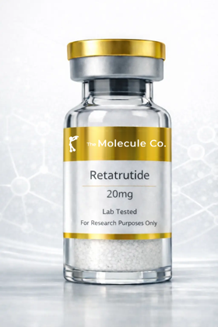 | Retatrutide 20mg  Product Code: RT20  Activates GIP, GLP-1 and glucagon receptors — supporting satiety, more effective insulin use and increased energy expenditure; one of the most closely watched compounds in current metabolic research. | R 1 475,00
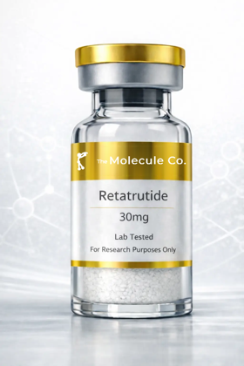 | Retatrutide 30mg  Product Code: RT30  Activates GIP, GLP-1 and glucagon receptors — supporting satiety, more effective insulin use and increased energy expenditure; one of the most closely watched compounds in current metabolic research. | R 1 775,00
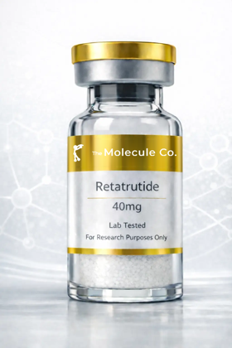 | Retatrutide 40mg  Product Code: RT40  Activates GIP, GLP-1 and glucagon receptors — supporting satiety, more effective insulin use and increased energy expenditure; one of the most closely watched compounds in current metabolic research. | R 2 175,00
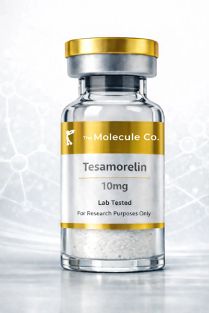 | Tesamorelin 10mg  Product Code: TS10  Signals the pituitary gland to release growth hormone naturally rather than introducing GH directly; studied for its effect on visceral belly fat linked to metabolic risk. | R 1 176,00
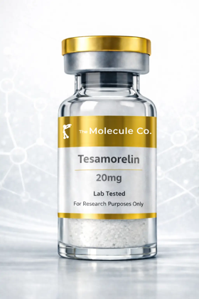 | Tesamorelin 20mg  Product Code: TS20  Signals the pituitary gland to release growth hormone naturally rather than introducing GH directly; studied for its effect on visceral belly fat linked to metabolic risk. | R 1 775,00
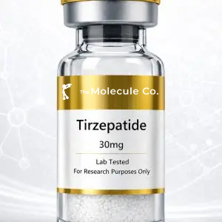 | Tirzepatide  Product Code: TZ  Investigated for its potential to support glucose-dependent insulin secretion, appetite regulation and gastric-emptying pathways. | R 1 276,00
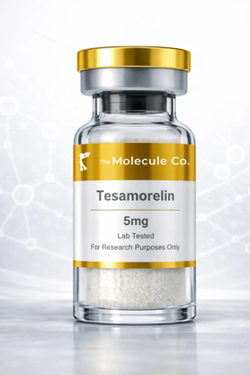 | Tesamorelin 5mg  Product Code: TS5  Signals the pituitary gland to release growth hormone naturally rather than introducing GH directly; studied for its effect on visceral belly fat linked to metabolic risk. | R 926,00
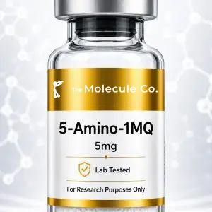 | 5-Amino-1MQ 5mg  Product Code: AMQ5  Investigated for whether influencing NNMT pathways may affect energy expenditure, fat metabolism and body-composition regulation. | R 601,00
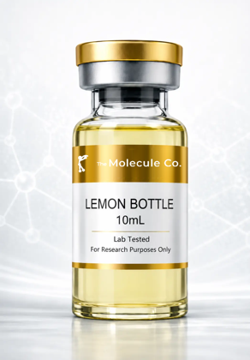 | Lemon Bottle 10ml  Product Code: LMB10  A lipolytic solution studied for localised fat breakdown; a research injectable investigated for body-contouring applications. | R 825,00
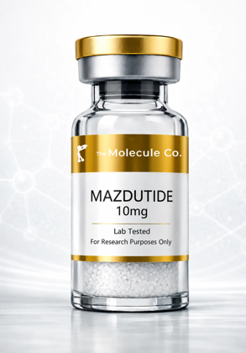 | Mazdutide 10mg  Product Code: MZ10  A dual GLP-1 and glucagon receptor agonist studied for appetite regulation, glucose control and increased energy expenditure. | R 1 575,00
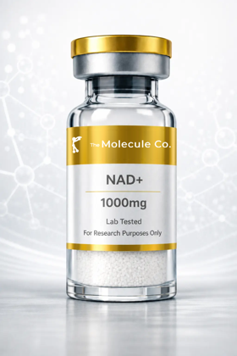 | NAD+ 1000mg  Product Code: NAD1000  Acts as a helper molecule in hundreds of metabolic processes, especially mitochondrial energy production; elevated NAD+ is studied for cellular energy and repair pathways central to longevity research. | R 1 275,00
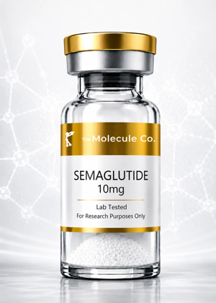 | Semaglutide 10mg  Product Code: SG10  A GLP-1 receptor agonist studied for glucose-dependent insulin secretion, appetite suppression and slowed gastric emptying. | POA
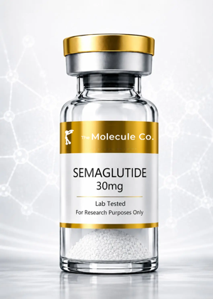 | Semaglutide 30mg  Product Code: SG30  A GLP-1 receptor agonist studied for glucose-dependent insulin secretion, appetite suppression and slowed gastric emptying. | POA
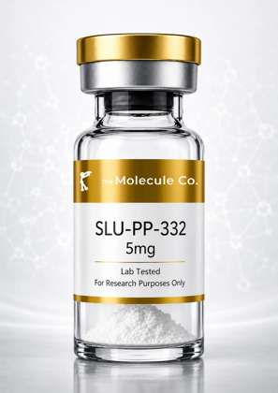 | SLU-PP-332 5mg  Product Code: SLU5  An ERR agonist ('exercise mimetic') studied for its potential to increase energy expenditure and fat oxidation without physical exertion. | POA
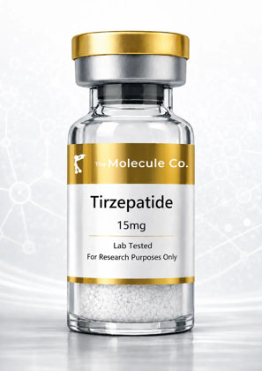 | Tirzepatide 15mg  Product Code: TZ15  Investigated for its potential to support glucose-dependent insulin secretion, appetite regulation and gastric-emptying pathways. | R 975,00
 | Tirzepatide 30mg  Product Code: TZ30  Investigated for its potential to support glucose-dependent insulin secretion, appetite regulation and gastric-emptying pathways. | R 1 326,00
 | Tirzepatide 60mg  Product Code: TZ60  Investigated for its potential to support glucose-dependent insulin secretion, appetite regulation and gastric-emptying pathways. | R 1 875,00

3. Longevity & Cellular Health
Image | Product & Research Notes | Retail (ZAR)
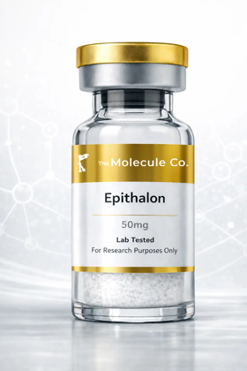 | Epithalon 10mg  Product Code: EP10  Activates telomerase to help lengthen telomeres and slow cellular ageing, and regulates melatonin production — linked to circadian and longevity research. | R 686,00
 | Epithalon 50mg  Product Code: EP50  Activates telomerase to help lengthen telomeres and slow cellular ageing, and regulates melatonin production — linked to circadian and longevity research. | R 1 175,00
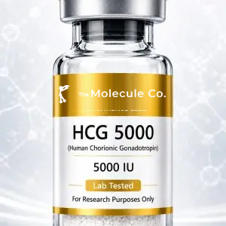 | HCG 5000iu  Product Code: G5K  Investigated for its ability to stimulate endogenous testosterone production and support reproductive function. | R 775,00
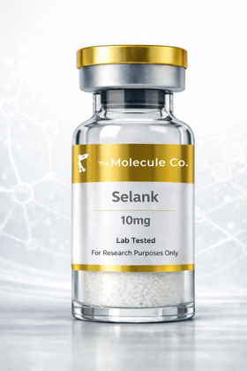 | Selank 10mg  Product Code: SLK10  Modulates GABA, serotonin and dopamine systems; studied for reducing anxiety and stress without sedation — a focus of cognitive and stress-response research. | R 896,00
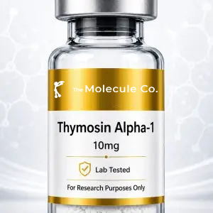 | Thymosin Alpha-1  Product Code: THA1  Investigated for its potential to support T-cell maturation, immune signalling and cytokine activity. | R 1 325,00
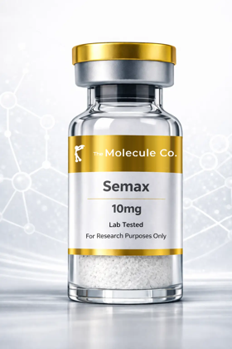 | Semax 10mg  Product Code: SEM10  Increases brain-derived neurotrophic factor (BDNF) to promote neuron growth and survival; studied for effects on focus, mood and cognitive performance. | R 896,00
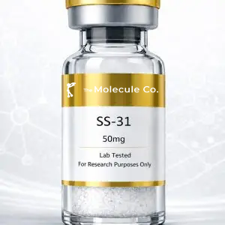 | SS-31 50mg  Product Code: SS50  Investigated for its ability to bind cardiolipin within the inner mitochondrial membrane, supporting mitochondrial efficiency and ATP production. | R 1 875,00
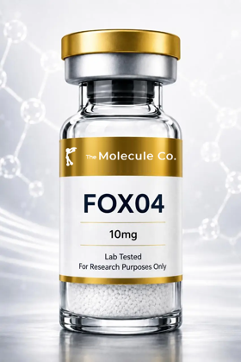 | FOXO4-DRI  Product Code: FOX  Disrupts the FOXO4-p53 interaction to allow apoptosis of senescent ('zombie') cells while largely sparing healthy cells — a focus of cellular-ageing research. | R 2 175,00
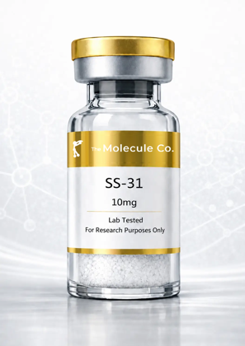 | SS-31 10mg  Product Code: SS10  Investigated for its ability to bind cardiolipin within the inner mitochondrial membrane, supporting mitochondrial efficiency and ATP production. | R 1 075,00
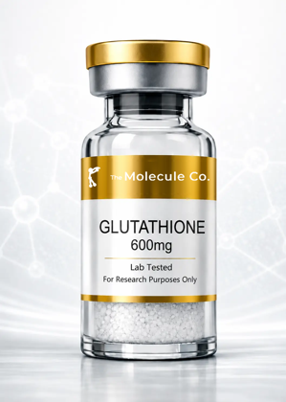 | Glutathione 600mg  Product Code: GLU600  The body's master antioxidant, studied for its role in cellular detoxification, oxidative-stress defence and skin brightening. | R 675,00

4. Specialty Combination Stacks
Image | Product & Research Notes | Retail (ZAR)
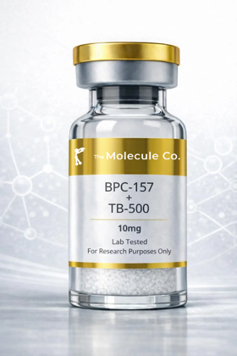 | Wolverine Blend - BPC-157 + TB-500 10mg (5mg+5mg)  Product Code: WLV10  A BPC-157 + TB-500 blend (5mg+5mg): BPC-157 targets rapid localised repair of gut, tendons and ligaments while TB-500 promotes whole-body healing, flexibility and blood-vessel formation — researched for accelerated recovery across multiple tissue types. | R 976,00
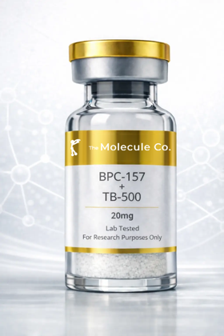 | BPC-157 + TB-500 20mg  Product Code: BT20  A BPC-157 + TB-500 blend: BPC-157 targets rapid localised repair while TB-500 promotes whole-body healing, flexibility and blood-vessel formation — researched for accelerated recovery across multiple tissue types. | R 1 376,00
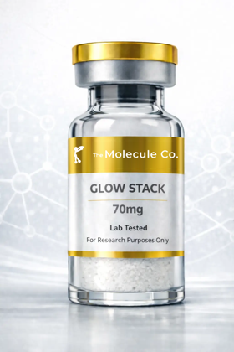 | GLOW Stack 70mg  Product Code: GLW70  A regeneration and skin-quality stack: GHK-Cu promotes collagen production and skin regeneration while companion peptides support tissue remodelling and structural repair as a combined formula. | R 1 426,00
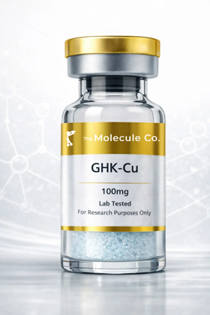 | GHK-Cu 100mg  Product Code: GHK100  Stimulates collagen and elastin production, promotes wound healing, reduces inflammation and acts as a powerful antioxidant; the copper complex is widely researched for skin, hair and tissue-remodelling applications. | R 975,00
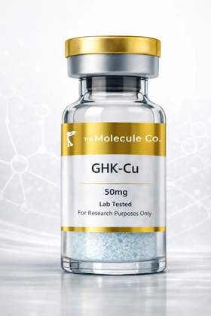 | GHK-Cu 50mg  Product Code: GHK50  Stimulates collagen and elastin production, promotes wound healing, reduces inflammation and acts as a powerful antioxidant; the copper complex is widely researched for skin, hair and tissue-remodelling applications. | R 775,00
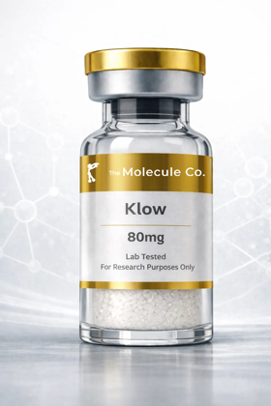 | KLOW Stack 80mg  Product Code: KLW80  A KLOW stack: GHK-Cu promotes collagen production and copper delivery for skin and tissue regeneration while partner peptides support recovery, hydration and structural repair as a combined formula. | R 1 626,00

5. Hormonal & Vitality
Image | Product & Research Notes | Retail (ZAR)
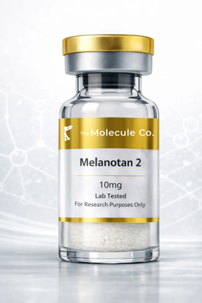 | Melanotan 2 10mg  Product Code: MT10  Activates melanocortin receptors in skin cells to trigger melanin production for a protective tan with UV exposure; also studied for effects on appetite and libido. | R 776,00
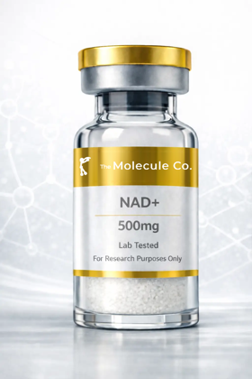 | PT-141 10mg  Product Code: PT10  Activates melanocortin receptors in the hypothalamus to trigger natural sexual arousal and desire; unlike some approaches it does not act directly on blood flow. | R 755,00
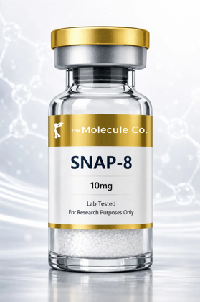 | Snap-8 10mg  Product Code: SNP10  Studied for its potential to influence neurotransmitter signalling associated with facial muscle contractions — a topical, cosmetic-research peptide. | R 675,00

6. Accessories & Consumables
Image | Product & Research Notes | Retail (ZAR)
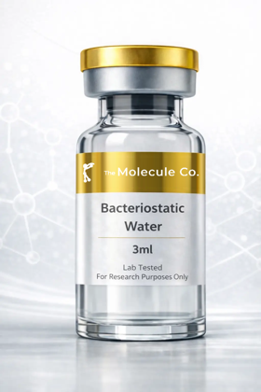 | Bacteriostatic Water  Product Code: BAC  Sterile water containing a small amount of benzyl alcohol, used to reconstitute freeze-dried peptides prior to research use. Not a peptide — an essential laboratory consumable. | POA
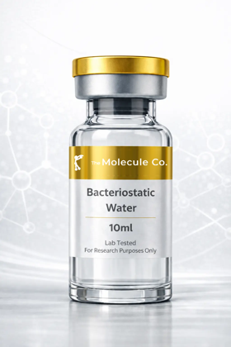 | Bacteriostatic Water 10ml  Product Code: BAC10  Sterile water containing a small amount of benzyl alcohol, used to reconstitute freeze-dried peptides prior to research use. Not a peptide — an essential laboratory consumable. | R 326,00
 | Cartridge  Product Code: CRT  Replacement cartridge accessory for compatible pen-style reconstitution and delivery devices. | R 72,00
No image | Disposable Pen  Product Code: DPN  Single-use pen device for convenient reconstitution and measured delivery of research compounds. | R 526,00

7. Options & Delivery
Image | Product & Research Notes | Retail (ZAR)
 | Ice Pack  Product Code: ICE  Reusable ice pack for temperature-controlled shipping of research compounds. | R 35,00
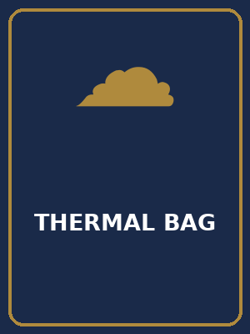 | Thermal Bag  Product Code: TBG  Insulated thermal bag for temperature-controlled delivery of research compounds. | R 100,00
 | Delivery Local  Product Code: DLL  Local courier delivery within the metro area. | R 145,00
 | Delivery National  Product Code: DLN  National courier delivery across South Africa. | R 249,00

