
R E S E A R C H C O M P O U N D C A T A L O G U E
Price Schedule

Prepared: 28 July 2026
Pricing in South African Rand (ZAR),
Reconstructed (Pen),
excludes courier delivery,
Subject to change without notice.

1. Tissue Repair & Recovery
Compounds researched for soft-tissue, joint and general recovery support.
Image | Product & Research Notes | Retail (ZAR)
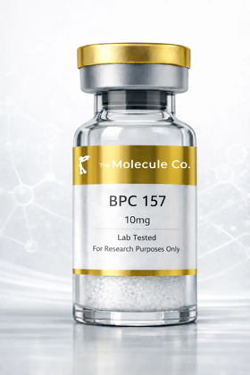 | BPC-157 10mg  Promotes blood-vessel formation, reduces inflammation and protects cells from damage — studied to speed the healing response in soft tissue, gut lining and joints. | R 775,00
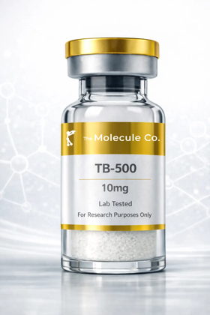 | TB-500 10mg  Promotes migration of stem cells to injured areas, helps form new blood vessels, reduces inflammation and prevents excessive scar tissue; often studied alongside BPC-157 for combined soft-tissue recovery. | R 1075,00
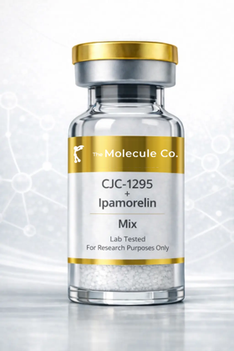 | CJC-1295 + Ipamorelin  CJC-1295 extends how long each natural growth-hormone pulse lasts while Ipamorelin adds extra pulses, together creating a sustained increase in natural GH release — researched for recovery, body composition and sleep quality. | R 1025,00
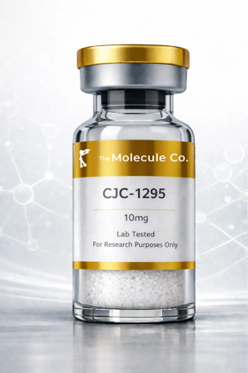 | CJC-1295 (No DAC) 10mg  Extends the duration of the body's natural growth-hormone pulse for more sustained release without shutting down natural production — a popular short-acting option for GH-pulse research. | R 975,00
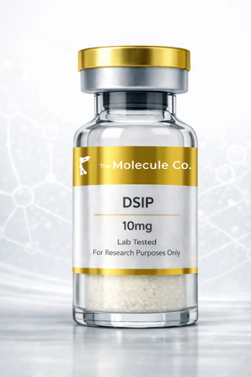 | DSIP 10mg  Crosses the blood-brain barrier and interacts with the central nervous system to promote delta-wave (deep, restorative) sleep — a key subject in sleep-cycle research. | R 975,00
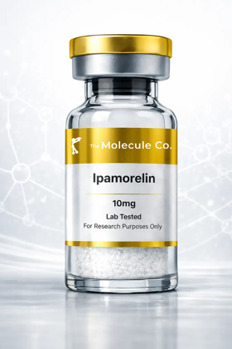 | Ipamorelin 10mg  Mimics ghrelin to selectively stimulate growth-hormone release; studied for increased GH without materially disturbing cortisol or appetite hormones. | R 725,00
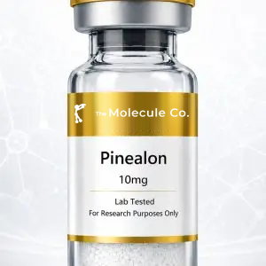 | Pinealon 10mg  Investigated for its potential to support neuronal health, cognitive performance and cellular resilience. | R 825,00
 | TB-500 10mg (Alt SKU)  Promotes migration of stem cells to injured areas, helps form new blood vessels, reduces inflammation and prevents excessive scar tissue; often studied alongside BPC-157 for combined soft-tissue recovery. | R 1075,00
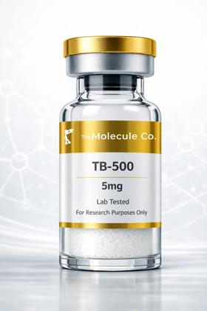 | TB-500 5mg  Promotes migration of stem cells to injured areas, helps form new blood vessels, reduces inflammation and prevents excessive scar tissue; often studied alongside BPC-157 for combined soft-tissue recovery. | R 775,00
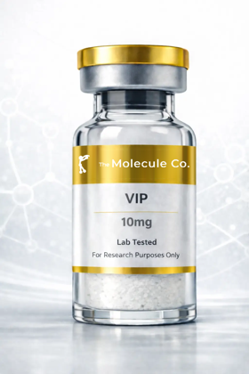 | VIP 10mg  Modulates immune responses, reduces inflammatory cytokines, improves gut-barrier function and protects neurons — studied in gut-immune-brain communication. | R 1575,00
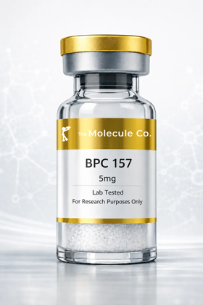 | BPC-157 5mg  Promotes blood-vessel formation, reduces inflammation and protects cells from damage — studied to speed the healing response in soft tissue, gut lining and joints. | R 626,00
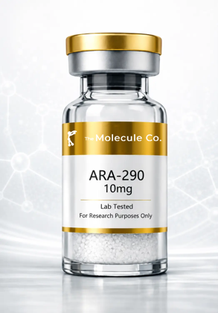 | ARA-290 10mg  A non-erythropoietic EPO derivative studied for activating the innate repair receptor to reduce inflammation and support nerve and tissue repair. | R 745,00
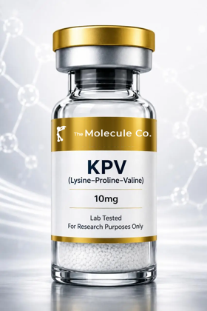 | KPV 10mg  A tripeptide fragment of alpha-MSH studied for its anti-inflammatory action in the gut and skin and for supporting tissue healing. | R 675,00
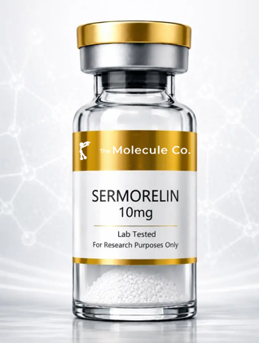 | Sermorelin 10mg  A growth-hormone-releasing hormone analogue that signals the pituitary to release growth hormone naturally; studied for recovery, body composition and sleep. | R 1075,00

2. Metabolic & Weight Management
Compounds researched for fat metabolism, appetite regulation and body composition.
Image | Product & Research Notes | Retail (ZAR)
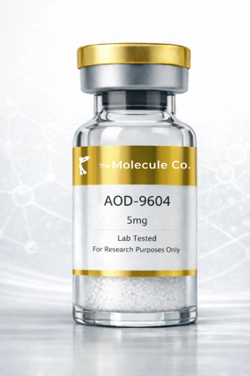 | AOD-9604  Mimics the way natural growth hormone regulates fat metabolism, helping break down stored fat and prevent new fat formation without the broader effects of full-length GH. | R 896,00
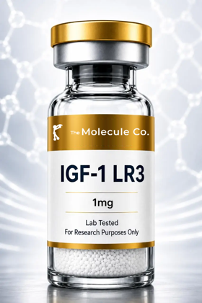 | IGF-1 LR3  Binds IGF-1 receptors to support anabolic signalling, protein synthesis, recovery pathways and metabolic regulation over an extended half-life. | R 1575,00
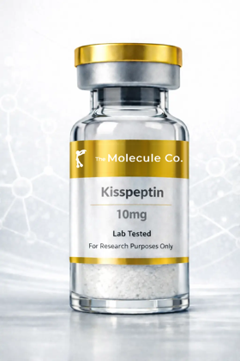 | Kisspeptin 10mg  Activates the hypothalamic-pituitary-gonadal axis, stimulating release of LH and FSH — a core subject in reproductive-hormone research. | R 975,00
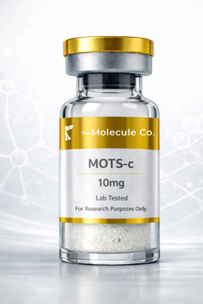 | MOTS-c 10mg  Improves how mitochondria produce energy, helping cells burn fat and use glucose more efficiently, and activates AMPK — a key pathway in exercise and metabolic research. | R 815,00
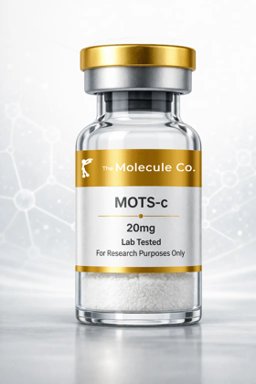 | MOTS-c 20mg  Improves how mitochondria produce energy, helping cells burn fat and use glucose more efficiently, and activates AMPK — a key pathway in exercise and metabolic research. | R 1075,00
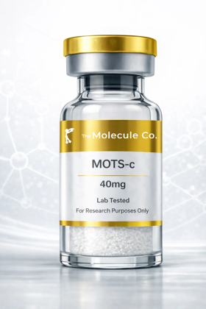 | MOTS-c 40mg  Improves how mitochondria produce energy, helping cells burn fat and use glucose more efficiently, and activates AMPK — a key pathway in exercise and metabolic research. | R 1375,00
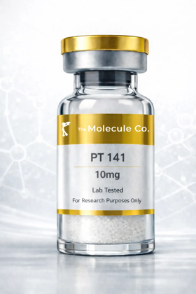 | NAD+ 500mg  Acts as a helper molecule in hundreds of metabolic processes, especially mitochondrial energy production; elevated NAD+ is studied for cellular energy and repair pathways central to longevity research. | R 875,00
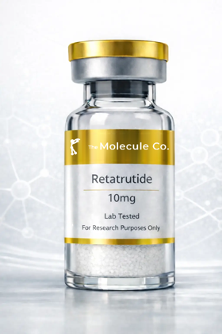 | Retatrutide 10mg  Activates GIP, GLP-1 and glucagon receptors — supporting satiety, more effective insulin use and increased energy expenditure; one of the most closely watched compounds in current metabolic research. | R 1075,00
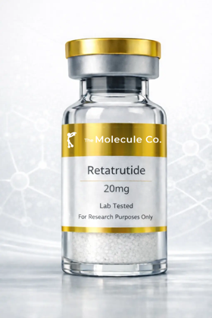 | Retatrutide 20mg  Activates GIP, GLP-1 and glucagon receptors — supporting satiety, more effective insulin use and increased energy expenditure; one of the most closely watched compounds in current metabolic research. | R 1475,00
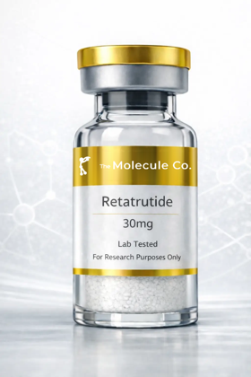 | Retatrutide 30mg  Activates GIP, GLP-1 and glucagon receptors — supporting satiety, more effective insulin use and increased energy expenditure; one of the most closely watched compounds in current metabolic research. | R 1775,00
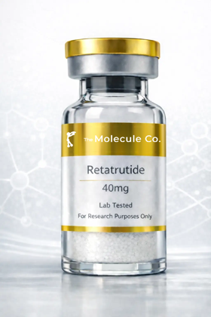 | Retatrutide 40mg  Activates GIP, GLP-1 and glucagon receptors — supporting satiety, more effective insulin use and increased energy expenditure; one of the most closely watched compounds in current metabolic research. | R 2175,00
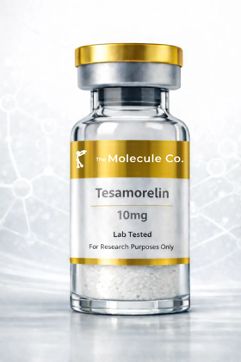 | Tesamorelin 10mg  Signals the pituitary gland to release growth hormone naturally rather than introducing GH directly; studied for its effect on visceral belly fat linked to metabolic risk. | R 1176,00
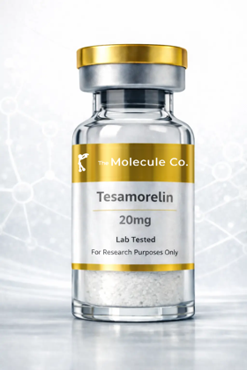 | Tesamorelin 20mg  Signals the pituitary gland to release growth hormone naturally rather than introducing GH directly; studied for its effect on visceral belly fat linked to metabolic risk. | R 1775,00
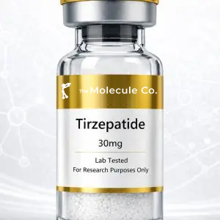 | Tirzepatide  Investigated for its potential to support glucose-dependent insulin secretion, appetite regulation and gastric-emptying pathways. | R 1276,00
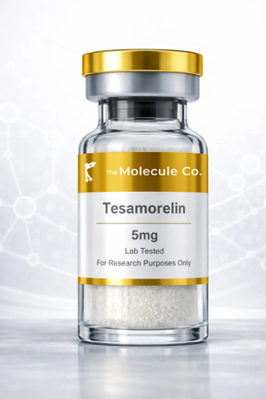 | Tesamorelin 5mg  Signals the pituitary gland to release growth hormone naturally rather than introducing GH directly; studied for its effect on visceral belly fat linked to metabolic risk. | R 926,00
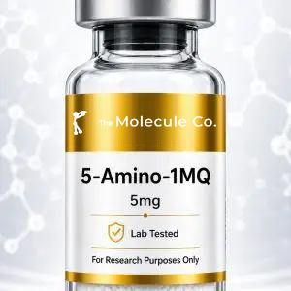 | 5-Amino-1MQ 5mg  Investigated for whether influencing NNMT pathways may affect energy expenditure, fat metabolism and body-composition regulation. | R 601,00
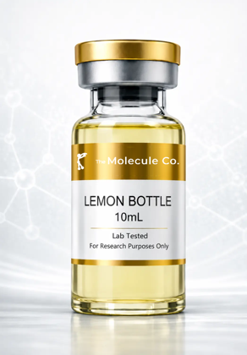 | Lemon Bottle 10ml  A lipolytic solution studied for localised fat breakdown; a research injectable investigated for body-contouring applications. | R 825,00
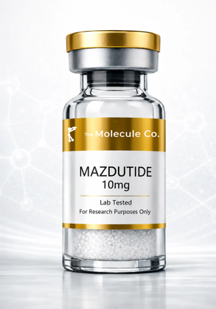 | Mazdutide 10mg  A dual GLP-1 and glucagon receptor agonist studied for appetite regulation, glucose control and increased energy expenditure. | R 1575,00
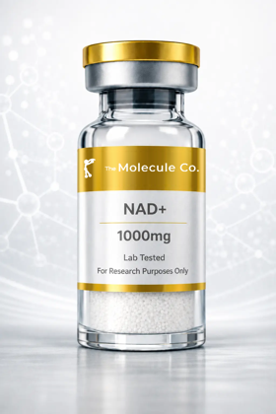 | NAD+ 1000mg  Acts as a helper molecule in hundreds of metabolic processes, especially mitochondrial energy production; elevated NAD+ is studied for cellular energy and repair pathways central to longevity research. | R 1275,00
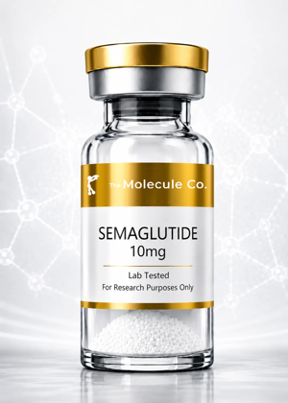 | Semaglutide 10mg  A GLP-1 receptor agonist studied for glucose-dependent insulin secretion, appetite suppression and slowed gastric emptying. | POA
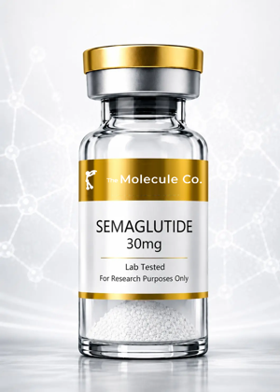 | Semaglutide 30mg  A GLP-1 receptor agonist studied for glucose-dependent insulin secretion, appetite suppression and slowed gastric emptying. | POA
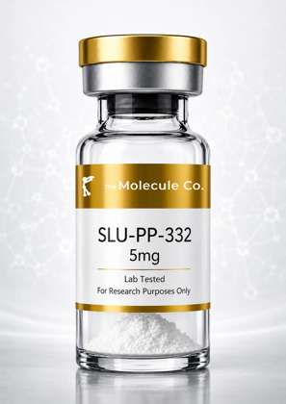 | SLU-PP-332 5mg  An ERR agonist ('exercise mimetic') studied for its potential to increase energy expenditure and fat oxidation without physical exertion. | POA
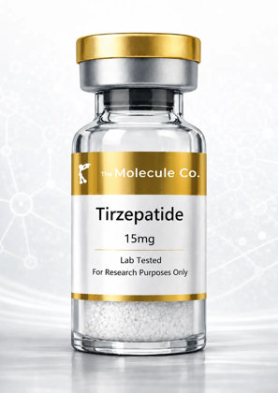 | Tirzepatide 15mg  Investigated for its potential to support glucose-dependent insulin secretion, appetite regulation and gastric-emptying pathways. | R 975,00
 | Tirzepatide 30mg  Investigated for its potential to support glucose-dependent insulin secretion, appetite regulation and gastric-emptying pathways. | R 1326,00
 | Tirzepatide 60mg  Investigated for its potential to support glucose-dependent insulin secretion, appetite regulation and gastric-emptying pathways. | R 1875,00

3. Longevity & Cellular Health
Compounds researched for cellular ageing, mitochondrial function and immune signaling.
Image | Product & Research Notes | Retail (ZAR)
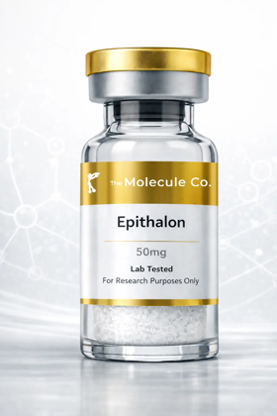 | Epithalon 10mg  Activates telomerase to help lengthen telomeres and slow cellular ageing, and regulates melatonin production — linked to circadian and longevity research. | R 686,00
 | Epithalon 50mg  Activates telomerase to help lengthen telomeres and slow cellular ageing, and regulates melatonin production — linked to circadian and longevity research. | R 1175,00
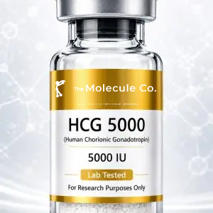 | HCG 5000iu  Investigated for its ability to stimulate endogenous testosterone production and support reproductive function. | R 775,00
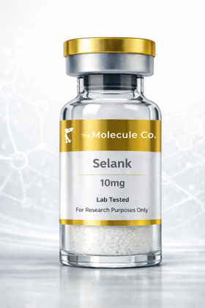 | Selank 10mg  Modulates GABA, serotonin and dopamine systems; studied for reducing anxiety and stress without sedation — a focus of cognitive and stress-response research. | R 896,00
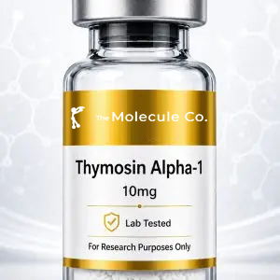 | Thymosin Alpha-1  Investigated for its potential to support T-cell maturation, immune signalling and cytokine activity. | R 1325,00
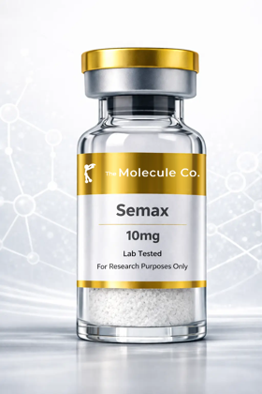 | Semax 10mg  Increases brain-derived neurotrophic factor (BDNF) to promote neuron growth and survival; studied for effects on focus, mood and cognitive performance. | R 896,00
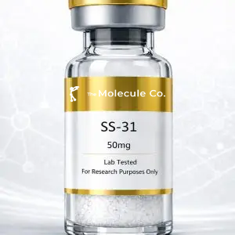 | SS-31 50mg  Investigated for its ability to bind cardiolipin within the inner mitochondrial membrane, supporting mitochondrial efficiency and ATP production. | R 1875,00
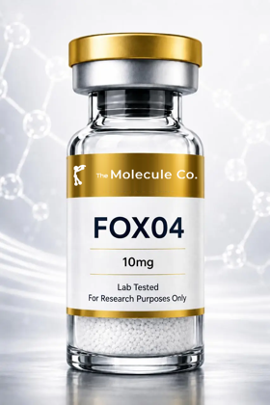 | FOXO4-DRI  Disrupts the FOXO4-p53 interaction to allow apoptosis of senescent ('zombie') cells while largely sparing healthy cells — a focus of cellular-ageing research. | R 2175,00
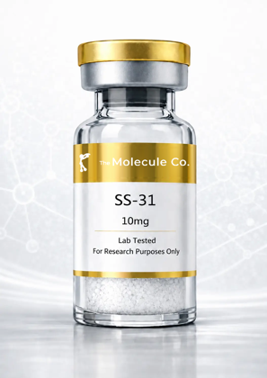 | SS-31 10mg  Investigated for its ability to bind cardiolipin within the inner mitochondrial membrane, supporting mitochondrial efficiency and ATP production. | R 1075,00
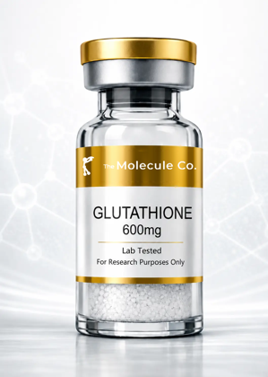 | Glutathione 600mg  The body's master antioxidant, studied for its role in cellular detoxification, oxidative-stress defence and skin brightening. | R 675,00

4. Specialty Combination Stacks
Pre-combined multi-peptide blends researched for compounded effects across skin, tissue and recovery pathways.
Image | Product & Research Notes | Retail (ZAR)
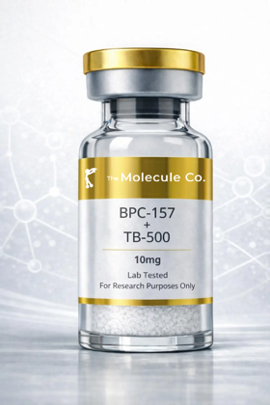 | Wolverine Blend - BPC-157 + TB-500 10mg (5mg+5mg)  A BPC-157 + TB-500 blend (5mg+5mg): BPC-157 targets rapid localised repair of gut, tendons and ligaments while TB-500 promotes whole-body healing, flexibility and blood-vessel formation — researched for accelerated recovery across multiple tissue types. | R 976,00
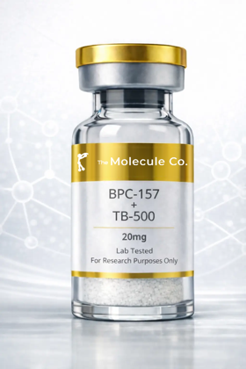 | BPC-157 + TB-500 20mg  A BPC-157 + TB-500 blend: BPC-157 targets rapid localised repair while TB-500 promotes whole-body healing, flexibility and blood-vessel formation — researched for accelerated recovery across multiple tissue types. | R 1376,00
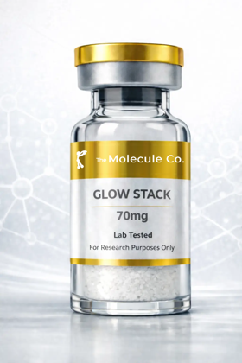 | GLOW Stack 70mg  A regeneration and skin-quality stack: GHK-Cu promotes collagen production and skin regeneration while companion peptides support tissue remodelling and structural repair as a combined formula. | R 1426,00
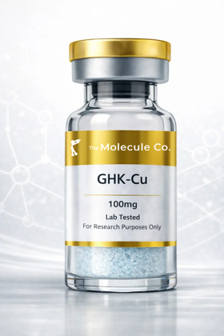 | GHK-Cu 100mg  Stimulates collagen and elastin production, promotes wound healing, reduces inflammation and acts as a powerful antioxidant; the copper complex is widely researched for skin, hair and tissue-remodelling applications. | R 975,00
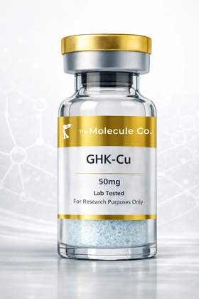 | GHK-Cu 50mg  Stimulates collagen and elastin production, promotes wound healing, reduces inflammation and acts as a powerful antioxidant; the copper complex is widely researched for skin, hair and tissue-remodelling applications. | R 775,00
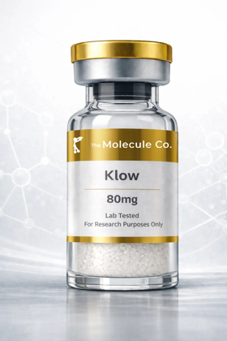 | KLOW Stack 80mg  A KLOW stack: GHK-Cu promotes collagen production and copper delivery for skin and tissue regeneration while partner peptides support recovery, hydration and structural repair as a combined formula. | R 1626,00

5. Hormonal & Vitality
Compounds researched for hormonal signalling, pigmentation and vitality pathways.
Image | Product & Research Notes | Retail (ZAR)
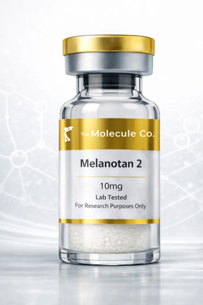 | Melanotan 2 10mg  Activates melanocortin receptors in skin cells to trigger melanin production for a protective tan with UV exposure; also studied for effects on appetite and libido. | R 776,00
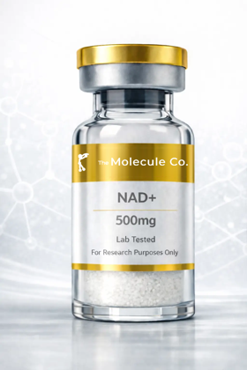 | PT-141 10mg  Activates melanocortin receptors in the hypothalamus to trigger natural sexual arousal and desire; unlike some approaches it does not act directly on blood flow. | R 755,00
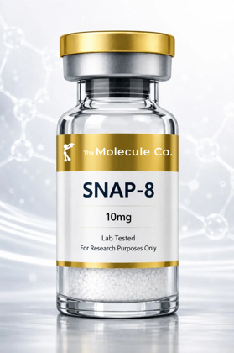 | Snap-8 10mg  Studied for its potential to influence neurotransmitter signalling associated with facial muscle contractions — a topical, cosmetic-research peptide. | R 675,00

6. Accessories & Consumables
Essential lab consumables and delivery accessories used alongside research compounds.
Image | Product & Research Notes | Retail (ZAR)
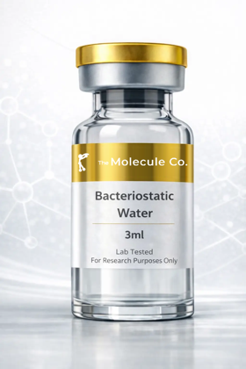 | Bacteriostatic Water  Sterile water containing a small amount of benzyl alcohol, used to reconstitute freeze-dried peptides prior to research use. Not a peptide — an essential laboratory consumable. | POA
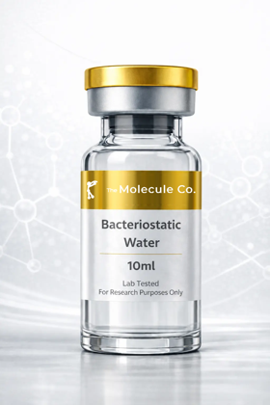 | Bacteriostatic Water 10ml  Sterile water containing a small amount of benzyl alcohol, used to reconstitute freeze-dried peptides prior to research use. Not a peptide — an essential laboratory consumable. | R 326,00
 | Cartridge  Replacement cartridge accessory for compatible pen-style reconstitution and delivery devices. | R 72,00
No image | Disposable Pen  Single-use pen device for convenient reconstitution and measured delivery of research compounds. | R 526,00

7. Options & Delivery
Temperature-controlled packaging and courier delivery options for your order.
Image | Product & Research Notes | Retail (ZAR)
 | Ice Pack  Reusable ice pack for temperature-controlled shipping of research compounds. | R 35,00
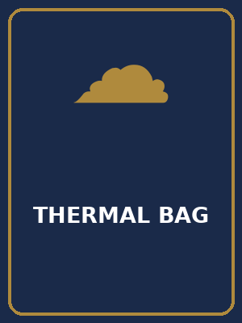 | Thermal Bag  Insulated thermal bag for temperature-controlled delivery of research compounds. | R 100,00
 | Delivery Local  Local courier delivery within the metro area. | R 145,00
 | Delivery National  National courier delivery across South Africa. | R 249,00

