ADA
Compiled reviewer — 1 lesson(s)

Lesson 1: Module 6 ML

Module 6
Machine Learning Giralyn R Ongco PhD TM  Machine Learning (ML) is a field of computer science that enables systems to learn from data and improve performance without being explicitly programmed Introduction to Machine Machine Learning is a subset of artificial intelligence that focuses on building systems that can: Learning ❑ Learn from data ❑ Identify patterns ❑ Make predictions or decisions Giralyn R Ongco PhD TM Machine learning usually follows these steps:
Keywords: Module, Machine Learning Giralyn, Ongco PhD TM, Machine Learning, Machine Machine Learning, Learning, Learn, Identify

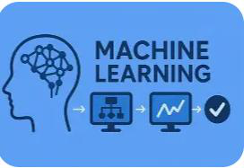

Page 2
Keywords: Page
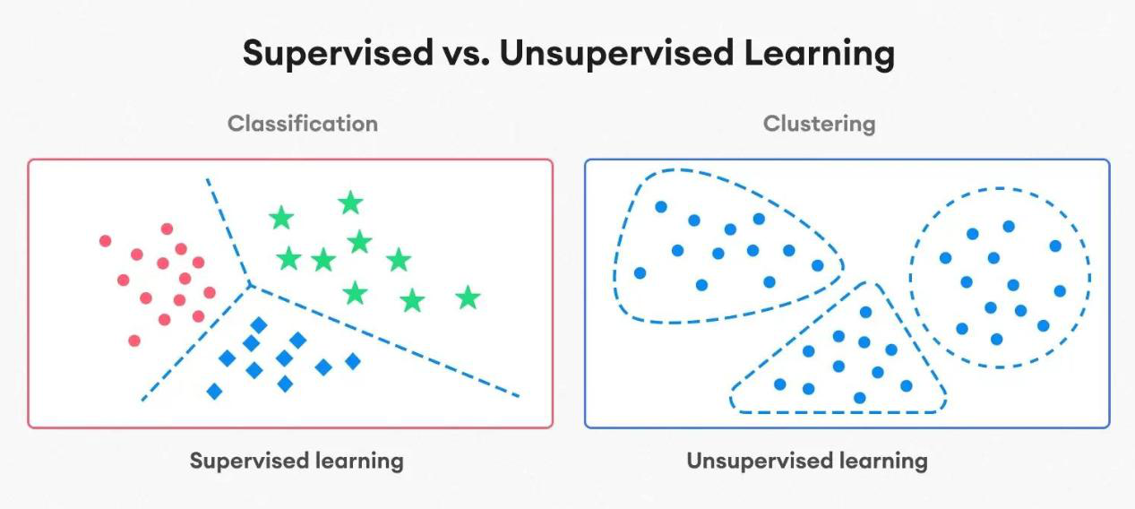
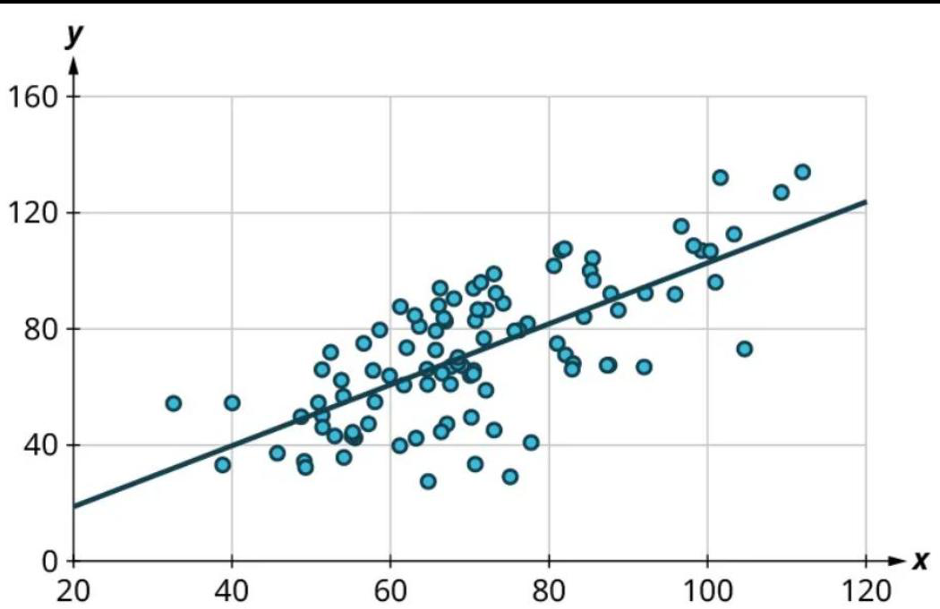

2. Training
How Machine Learning Works
Keywords: Training How Machine Learning, Works

1. Data Collection: 2. Training 3. Prediction
The system gathers The computer analyzes After learning patterns, data such as: the data to find patterns. the model can make better grades. buy a product Giralyn R Ongco PhD TM Visual flow: Basic Formula Idea in Data → Train Model → Prediction Machine Learning Where: •y = predicted value •m = relationship strength •x = input variable •b = starting value Example: Predicting salary based on years of experience. Giralyn R Ongco PhD TM Data The foundation of ML. Example: student records, sales data, images Features Input variables used to make predictions Example: study hours, attendance Target (Label) Key Components The output we want to predict of ML Example: GPA, pass/fail Model A mathematical representation of the relationship between inputs and outputs Training The process of teaching the model using data Prediction Using the trained model to estimate outcomes for new data Giralyn R Ongco PhD TM Supervised vs Unsupervised Learning Supervised Learning Supervised learning is a type of machine learning where a model is trained using labeled data, meaning each input has a known correct output How This Works 1.Provide the model with input data (features) Input (X): Study Hours 2.Provide the corresponding correct output (labels) Output (Y): GA
- images predictions on new data.
- text Example:
- numbers The system may discover: Example:
- audio • Students with high The system can predict:
- sensor readings attendance often get •Which students may
- student attendance •Which email is spam
- quiz scores
- assignment grades
ƒ y = predicted value •m = relationship strength •x = input variable •b = starting val
Keywords: Data Collection, Training, Prediction The, After, Example, Students, Which, Giralyn

Page 4
Keywords: Page
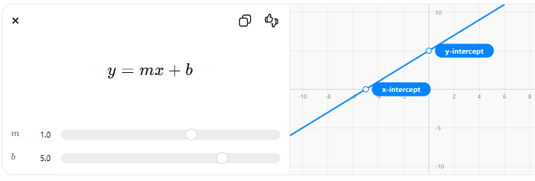

4.The model can then predict outputs for new data
The model learns how study hours affect GA and can predict GA for a new student Study GA Hours 5 2.8 8 3.2 10 3.6 Giralyn R Ongco PhD TM Types of Supervised Learning 1️⃣Regression •Predicts continuous values •Example: Predict GA, salary, temperature 2️⃣ Classification •Predicts categories •Example: Giralyn R Ongco PhD TM Supervised vs Unsupervised Learning Unsupervised Learning Unsupervised learning is a type of machine learning where the model is trained using unlabeled data, meaning there are no predefined answers or There are no labels like outputs. “Good” or “Poor” students. How It Works The model groups them into 1.Provide the model with input data only (no labels) clusters: 2.The model analyzes the data
- Pass / Fail
- Spam / Not Spam
Keywords: Study GA Hours, Giralyn, Ongco PhD TM Types, Supervised Learning, Regression, Predicts, Example, Predict GA

Page 7
Keywords: Page
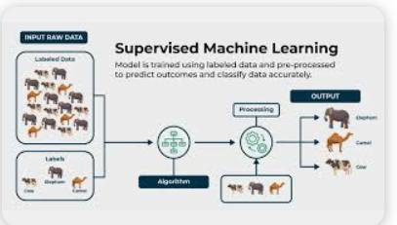

4.Outputs are clusters or structures, not exact answers
•Group 1: Lower performance •Group 2: Higher Study Hours GA performance 5 2.8 6 3.0 10 3.7 11 3.8 Giralyn R Ongco PhD TM Types of Supervised Learning 1️⃣ Clustering Groups similar data points together Example: Grouping students by performance Customer segmentation 2️⃣ Association (Pattern Discovery) Finds relationships between variables Example: “Students who study more also attend classes more Giralyn R Ongco PhD TM Linear Regression Linear regression is a machine learning and statistical method used to predict a continuous value by modeling the relationship between variables using a straight line. Equation of Linear Regression Study GA 𝑦 = 𝑚𝑥 + 𝑏 Hours Where: •y = predicted value (e.g., GPA) 5 2.8 •x = input variable (e.g., study hours) •m = slope (rate of change) 8 3.2 •b = intercept (starting point 10 3.6 Interpretation •If m is positive → as x increases, y increases •If m is negative → as x increases, y decreases Example: •More study hours → higher GPA Giralyn R Ongco PhD TM Classification (Logistic Regression) Classification is used to predict categories or classes. Logistic Regression is a classification algorithm that predicts outcomes like: Study Hours Result •Yes / No •Pass / Fail 3 Fail •Fraud / Not Fraud 6 Pass Output Instead of predicting numbers, it predicts probability: •0 → Fail •1 → Pass Giralyn R Ongco PhD TM
ƒ y = predicted value (e.g.
ƒ x = input variable (e.g.
ƒ m = slope (rate of change) 8 3.2 •b = intercept (starting point 10 3.6 Interpretatio
Keywords: Outputs, Group, Lower, Higher Study Hours GA, Giralyn, Ongco PhD TM Types, Supervised Learning, Clustering Groups

Page 9
Keywords: Page
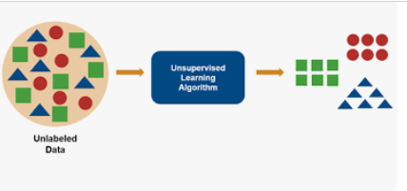

Page 10
Keywords: Page
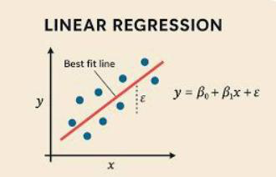

Page 11
Keywords: Page
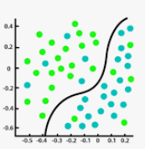

YOU
Giralyn R Ongco PhD TM
Keywords: YOU Giralyn, Ongco PhD TM

